**Name: Carl Fung**

**Device (include part number): RGB LED (Part ID: YSL-R596CR3G4B5C-C10)**

Summary (What does it do? What’s it good for?):

* A Light Emitting Diode that produces light with 2-3V, 20mA input
* Can produce a variety of light colors through RGB value combinations
* Has 4 leads, one for ground, one for red, green, and blue each.
* Outputs 625 nm wavelength for red light
* Outputs 520 nm wavelength for green light
* Outputs 465.7 nm wavelength for blue light
* Is used in a variety of visual displays to indicate current flow or produce light in an environment.

I/O (How do you connect the device? How do you talk to it? Find data sheet on google):

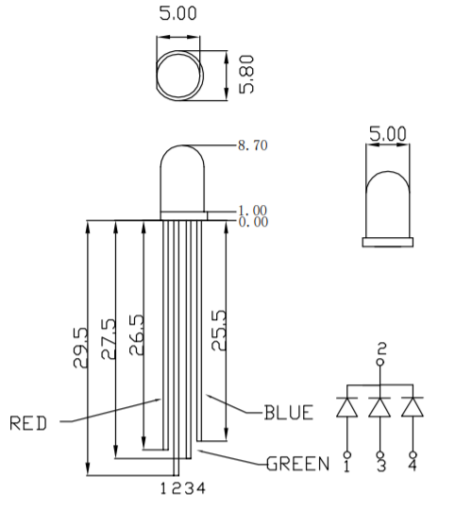

When connecting an RGB LED to an Arduino board, the ground wire must be directly connected to the ground port on the Arduino board, and the Red, Blue, and Green wires to separate digital ports. Lead 1 is signified as RED, Lead 2 is signified as GROUND, Lead 3 is signified as GREEN, and Lead 4 is signified as BLUE. Typically, a 1kΩ resistor is placed in series with each of the color leads to reduce the current flow through the LEDs so that they don’t burn out. Communication through the Arduino to the RGB LED is typically done through establishing a pinMode declaration for each color lead and sending Pulse Width Modulation values (0-255) through analogWrite or LOW or HIGH using digitalWrite to each of the LED leads. No information is being sent back through the LED leads from the LED itself, so communication is one-way with this device.

Part specific functions and libraries (What code exists for this thing? Check Arduino.cc for this):

Instead of having to write analogWrite 3 times over for each of the RGB inputs, a function “RGB_color” can be used to input 3 numeric values (0-255) to change each of the RGB inputs using one line of code instead of redundant calls of analogWrite. Otherwise, no highly specific functions and libraries exist for RGB LEDs, except for normal pin call functions.

Neopixels, a more sophisticated RGB LED, operates in a similar fashion.

int red_light_pin= 11;

int green_light_pin = 10;

int blue_light_pin = 9;

void setup() {

pinMode(red_light_pin, OUTPUT);

pinMode(green_light_pin, OUTPUT);

pinMode(blue_light_pin, OUTPUT);

}

void loop() {

RGB_color(255, 0, 0); // Red

delay(1000);

RGB_color(0, 255, 0); // Green

delay(1000);

RGB_color(0, 0, 255); // Blue

delay(1000);

RGB_color(255, 255, 125); // Raspberry

delay(1000);

RGB_color(0, 255, 255); // Cyan

delay(1000);

RGB_color(255, 0, 255); // Magenta

delay(1000);

RGB_color(255, 255, 0); // Yellow

delay(1000);

RGB_color(255, 255, 255); // White

delay(1000);

}

void RGB_color(int red_light_value, int green_light_value, int blue_light_value)

{

analogWrite(red_light_pin, red_light_value);

analogWrite(green_light_pin, green_light_value);

analogWrite(blue_light_pin, blue_light_value);

}

(Sourced from Arduino.cc , Muhammad Aqib)

Questions:

1. Is the device analog or digital?

The RGB LED is an analog device, due to the adjustability of the light values for each color, which allows most colors in the rainbow to be represented by different combinations of Red, Green, and Blue light.

1. Is it a sensor an actuator or neither? What’s its purpose?

The RGB LED is neither, because it is not sending data back to the Arduino or controlling another circuit, only producing light.

Reference section (Include URLs you got information from below):

<https://www.arduino.cc/en/Tutorial/PWM>

<https://www.sparkfun.com/datasheets/Components/YSL-R596CR3G4B5C-C10.pdf>

<https://create.arduino.cc/projecthub/muhammad-aqib/arduino-rgb-led-tutorial-fc003e>