

ake

**medi**

**N**

**B**

N

G

C:\Users\darle\AppData\Local\Microsoft\Windows\INetCache\Content.Word\syrup_white_large.pngC:\Users\darle\AppData\Local\Microsoft\Windows\INetCache\Content.Word\capsule_white_large.pngC:\Users\darle\AppData\Local\Microsoft\Windows\INetCache\Content.Word\capsule_white_large.pngC:\Users\darle\AppData\Local\Microsoft\Windows\INetCache\Content.Word\capsule_white_large.pngC:\Users\darle\AppData\Local\Microsoft\Windows\INetCache\Content.Word\syrup_white_large.pngC:\Users\darle\AppData\Local\Microsoft\Windows\INetCache\Content.Word\capsule_white_large.pngC:\Users\darle\AppData\Local\Microsoft\Windows\INetCache\Content.Word\syrup_white_large.pngC:\Users\darle\AppData\Local\Microsoft\Windows\INetCache\Content.Word\capsule_white_large.pngC:\Users\darle\AppData\Local\Microsoft\Windows\INetCache\Content.Word\syrup_white_large.pngC:\Users\darle\AppData\Local\Microsoft\Windows\INetCache\Content.Word\syrup_white_large.pngC:\Users\darle\AppData\Local\Microsoft\Windows\INetCache\Content.Word\tablet_white_large.pngC:\Users\darle\AppData\Local\Microsoft\Windows\INetCache\Content.Word\tablet_white_large.pngC:\Users\darle\AppData\Local\Microsoft\Windows\INetCache\Content.Word\capsule_white_large.pngC:\Users\darle\AppData\Local\Microsoft\Windows\INetCache\Content.Word\capsule_white_large.pngC:\Users\darle\AppData\Local\Microsoft\Windows\INetCache\Content.Word\capsule_white_large.pngC:\Users\darle\AppData\Local\Microsoft\Windows\INetCache\Content.Word\syrup_white_large.pngC:\Users\darle\AppData\Local\Microsoft\Windows\INetCache\Content.Word\syrup_white_large.pngC:\Users\darle\AppData\Local\Microsoft\Windows\INetCache\Content.Word\syrup_white_large.pngC:\Users\darle\AppData\Local\Microsoft\Windows\INetCache\Content.Word\tablet_white_large.pngC:\Users\darle\AppData\Local\Microsoft\Windows\INetCache\Content.Word\tablet_white_large.pngC:\Users\darle\AppData\Local\Microsoft\Windows\INetCache\Content.Word\capsule_white_large.pngC:\Users\darle\AppData\Local\Microsoft\Windows\INetCache\Content.Word\capsule_white_large.pngC:\Users\darle\AppData\Local\Microsoft\Windows\INetCache\Content.Word\tablet_white_large.pngC:\Users\darle\AppData\Local\Microsoft\Windows\INetCache\Content.Word\capsule_white_large.pngC:\Users\darle\AppData\Local\Microsoft\Windows\INetCache\Content.Word\syrup_white_large.pngC:\Users\darle\AppData\Local\Microsoft\Windows\INetCache\Content.Word\tablet_white_large.pngC:\Users\darle\AppData\Local\Microsoft\Windows\INetCache\Content.Word\capsule_white_large.pngC:\Users\darle\AppData\Local\Microsoft\Windows\INetCache\Content.Word\syrup_white_large.pngC:\Users\darle\AppData\Local\Microsoft\Windows\INetCache\Content.Word\syrup_white_large.pngC:\Users\darle\AppData\Local\Microsoft\Windows\INetCache\Content.Word\capsule_white_large.pngC:\Users\darle\AppData\Local\Microsoft\Windows\INetCache\Content.Word\capsule_white_large.pngC:\Users\darle\AppData\Local\Microsoft\Windows\INetCache\Content.Word\syrup_white_large.pngC:\Users\darle\AppData\Local\Microsoft\Windows\INetCache\Content.Word\syrup_white_large.pngC:\Users\darle\AppData\Local\Microsoft\Windows\INetCache\Content.Word\capsule_white_large.pngC:\Users\darle\AppData\Local\Microsoft\Windows\INetCache\Content.Word\tablet_white_large.pngC:\Users\darle\AppData\Local\Microsoft\Windows\INetCache\Content.Word\capsule_white_large.pngC:\Users\darle\AppData\Local\Microsoft\Windows\INetCache\Content.Word\syrup_white_large.pngC:\Users\darle\AppData\Local\Microsoft\Windows\INetCache\Content.Word\syrup_white_large.pngC:\Users\darle\AppData\Local\Microsoft\Windows\INetCache\Content.Word\syrup_white_large.pngC:\Users\darle\AppData\Local\Microsoft\Windows\INetCache\Content.Word\syrup_white_large.pngC:\Users\darle\AppData\Local\Microsoft\Windows\INetCache\Content.Word\tablet_white_large.pngC:\Users\darle\AppData\Local\Microsoft\Windows\INetCache\Content.Word\tablet_white_large.pngC:\Users\darle\AppData\Local\Microsoft\Windows\INetCache\Content.Word\capsule_white_large.pngC:\Users\darle\AppData\Local\Microsoft\Windows\INetCache\Content.Word\capsule_white_large.png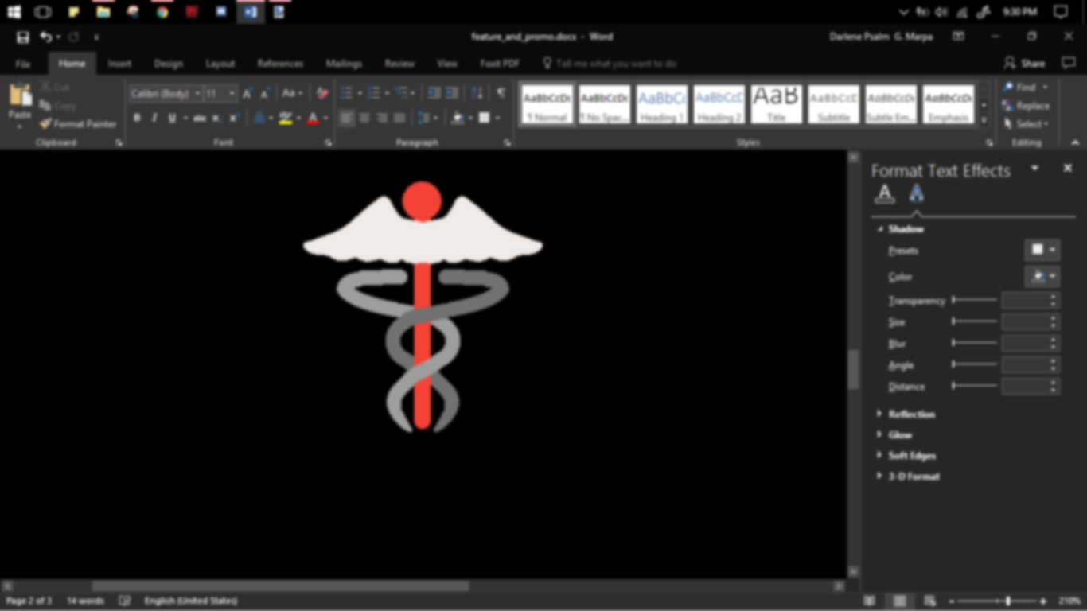

**medi**

ake



ake

**medi**

**N**

**B**

N

G