Software Design Document (SDD)
Module: <DRIVER_NAME> Driver
Version: <VERSION>
Author: <AUTHORS_NAMES>

1. Introduction
1.1. Purpose
This document describes the design and architecture of the <DRIVER_NAME> driver module, based on the requirements defined in the SRS. It provides details on data structures, algorithms, and control flow to guide implementation and testing.
1.2. Scope
The <DRIVER_NAME> driver is a low-level software component for embedded systems. It abstracts hardware registers and provides a clean API for higher-level modules to <BASIC_DESCRIPTION_OF_THE_DRIVER>.
1.3. Definitions and Acronyms
Term | Definition
e.g., GPIO | General Purpose Input/Output
1.4. Requirements
All requirements specific to his module are allocated in <PATH_TO_THE_DRIVER_SRS>.

2. System Architecture
2.1. High-Level Design
- Layered Architecture:
  - Application Layer: Calls <DRIVER_NAME> driver functions.
  - DRIVER_NAME Driver Layer: Provides APIs (<DRIVER_NAME>_init, etc.).
  - Hardware Layer: Actual microcontroller <DRIVER_NAME> registers.
2.2. Module Interfaces
- Public API: Functions defined in <DRIVER_NAME>.h.
- Dependencies: MCU-specific register definitions (CMSIS_DEFINE_EXAMPLES, etc.), another module drivers (GPIO_DRIVER, TIMER_DRIVER, etc.).

3. Detailed Design
3.1. Class Diagram
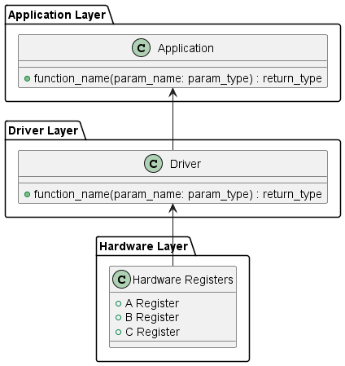
Figure 1. Class Diagram - Driver

3.2. Module Behavior (Sequence Diagrams, State Machines, etc.)
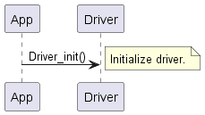
Figure 2. Sequence Diagram - Driver Init
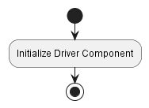
Figure 3. Activity Diagram - Driver Init
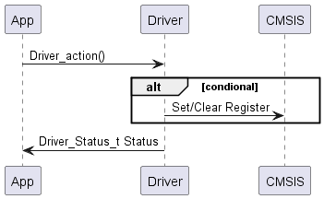
Figure 4. Sequence Diagram - Driver Action with Conditional
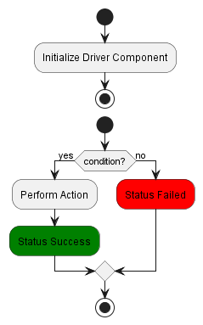
Figure 5. Activity Diagram - Driver Action with Conditional
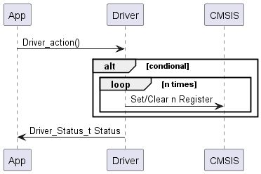
Figure 6. Sequence Diagram - Driver Action with Loop
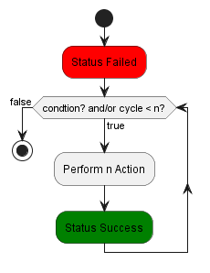
Figure 7. Activity Diagram - Driver Action with Loop
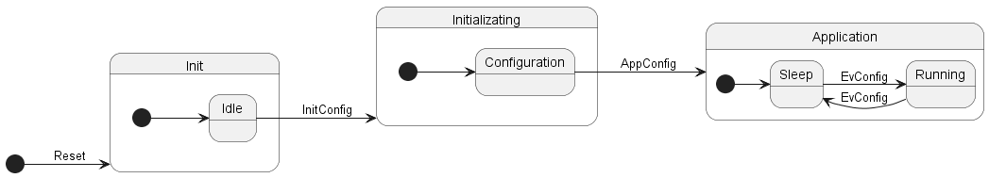
Figure 8. State Diagram - Driver
3.3. <DRIVER_NAME> Driver
Explain in detail what the driver does, referencing the diagrams above to help the developer understand the logic of the design.

4. Application Programming Interfaces
4.1. Data Types and Macros
- <data_type>: This <data_type> represents a specific type of values used in this driver for this specific function.
- <structure_type>: This <structure_type> contains the following configuration for this specific function.
Member Name | Type | Notes/Definition
e.g., idx | uint8_t | Device driver index.
- <macro_name>: This <macro_name> represents a specific value within this driver for this specific reason. The <macro_name> value is <macro_value>.
4.2. Error Codes
The <DRIVER_NAME> APIs have a return type of the <data_type> error code. Error codes relevant to this module are listed below.
Code | Notes/Definition
e.g., DRIVER_STATUS_E_OK | 0x00 - Operation was successful.

4.3. Function Definitions
Function Name (e.g., driver_init)
Function Name | Function name (e.g., driver_init)
Syntax | Function declaration (e.g., void driver_init(void))
Parameters (in) | Name of input parameters | Brief description of input parameters.
Parameters (inout) | Name of parameters used as input and output in the function (e.g., a pointer whose initial value is used) | Brief description of inout parameters.
Parameters (out) | Name of output parameters (e.g., a pointer whose initial value is not used) | Brief description of output parameters.
Return value | Data type of the return value | Brief description of return value and/or possible return values.
Description | Brief description of the function's purpose.
Constraints | List any constraint found in the function (e.g., it does not return the real reason why the operation failed)
Available via | Header file where the function is declared (e.g., DRIVER_NAME.h)
4.4. Internal Function Definitions
Function Name (e.g., driver_init)
Function Name | Function name (e.g., driver_init)
Syntax | Function declaration (e.g., void driver_init(void))
Parameters (in) | Name of input parameters | Brief description of input parameters.
Parameters (inout) | Name of parameters used as input and output in the function (e.g., a pointer whose initial value is used) | Brief description of inout parameters.
Parameters (out) | Name of output parameters (e.g., a pointer whose initial value is not used) | Brief description of output parameters.
Return value | Data type of the return value | Brief description of return value and/or possible return values.
Description | Brief description of the function's purpose.
Constraints | List any constraint found in the function (e.g., it does not return the real reason why the operation failed)

5. Future Enhancements
- List any future enhancements that may be needed soon.

