Mission 5 build guide
Z Energy finder — Home, Find a station, Plan a trip
Team: Rodrigo (scaffold + PRs + Home), Siobhan (Find a station), Koni (Plan a trip)
This is the team plan for building the Z Energy finder from a new GitHub repository. We build it with TDD, shared architecture, and one pull request at a time.
Figma file: HIGH-FIDELITY ---- MISSION 5
File key: EW5M7T7a9luJJcJmDEaKN8

1. How this team works
Person | Owns | Also does
--- | --- | ---
Rodrigo | Repo skeleton, shared layout, Home screen, auth API + login UI, CI/CD, PR review | Creates GitHub repo, Vercel project, Atlas production DB
Siobhan | Find a station (Fuel / Service / details / overlays / map pins) | Geocode API, station filter tests
Koni | Plan a trip (route, cheapest stop, save trip, trip nav) | Mapbox Directions, /route + /trips APIs

Everyone still builds the whole product: clone, install, run, test, and wire their screen end-to-end to the API and database. Nobody works only in Figma or only in CSS.
Rule: Rodrigo lands the skeleton on main first. Siobhan and Koni branch from that, not from empty folders.
Roadmap (rectangles) and folder tree are in section 3 and section 6.

2. Direct answers (read this first)

Do Siobhan and Koni need the same database in Compass?
Same schema, not the same laptop database.
- Each person installs MongoDB Community locally and may install Compass as a GUI.
- Everyone uses the same database name z-energy-db and the same collections:
- user-credentials
- saved-trips
- Compass on your machine talks to mongodb://127.0.0.1:27017. That is your data. You cannot see Rodrigo’s local Compass from another computer.
- For a shared dataset (demo users, saved trips across laptops), Rodrigo creates one free MongoDB Atlas cluster and puts the URI in a private team channel. Each person pastes it into their own .env as MONGODB_URI. Compass can also connect to Atlas with that URI.
Local Compass is for inspecting your own data while coding. Production never uses Compass or localhost.

Do they need to download packages?
Yes. After every clone and after pulling main:
npm ci
Use npm ci (not a random mix of npm install versions) so everyone matches package-lock.json. Adding a package is a PR. Do not install Mapbox/Leaflet/Mongo only on one laptop.

Do they need Mapbox accounts and their own tokens?
Yes for local work. One team token for Vercel.
Environment | Who | What
--- | --- | ---
Each laptop | Siobhan, Koni, Rodrigo | Free account at [account.mapbox.com](https://account.mapbox.com). Put your default public token (pk.…) in your .env. Never commit it.
Vercel production / preview | Rodrigo | One team token stored in the Vercel dashboard as VITE_MAPBOX_TOKEN and MAPBOX_TOKEN. Restrict the URL in Mapbox to the Vercel domains.

Why separate local tokens: Mapbox rate-limits and usage show up per token. If one token is leaked in a screenshot, only that laptop is rotated.
Leaflet still draws the map. Mapbox is used for Directions (real driving geometry). Without a token the API falls back to OSRM, then a rough highway path — that is not the finished product.

Do we need CI/CD for Vercel?
Yes. GitHub Actions runs tests on every PR. Vercel deploys:
- Preview URL on every PR (so Rodrigo can review UI + API against Atlas).
- Production on merge to main.
Details in section 12.

3. Roadmap (do it in this order)
Each box is one phase. Do 0 → 1, then 2a / 2b / 2c in parallel, then 3 → 4.
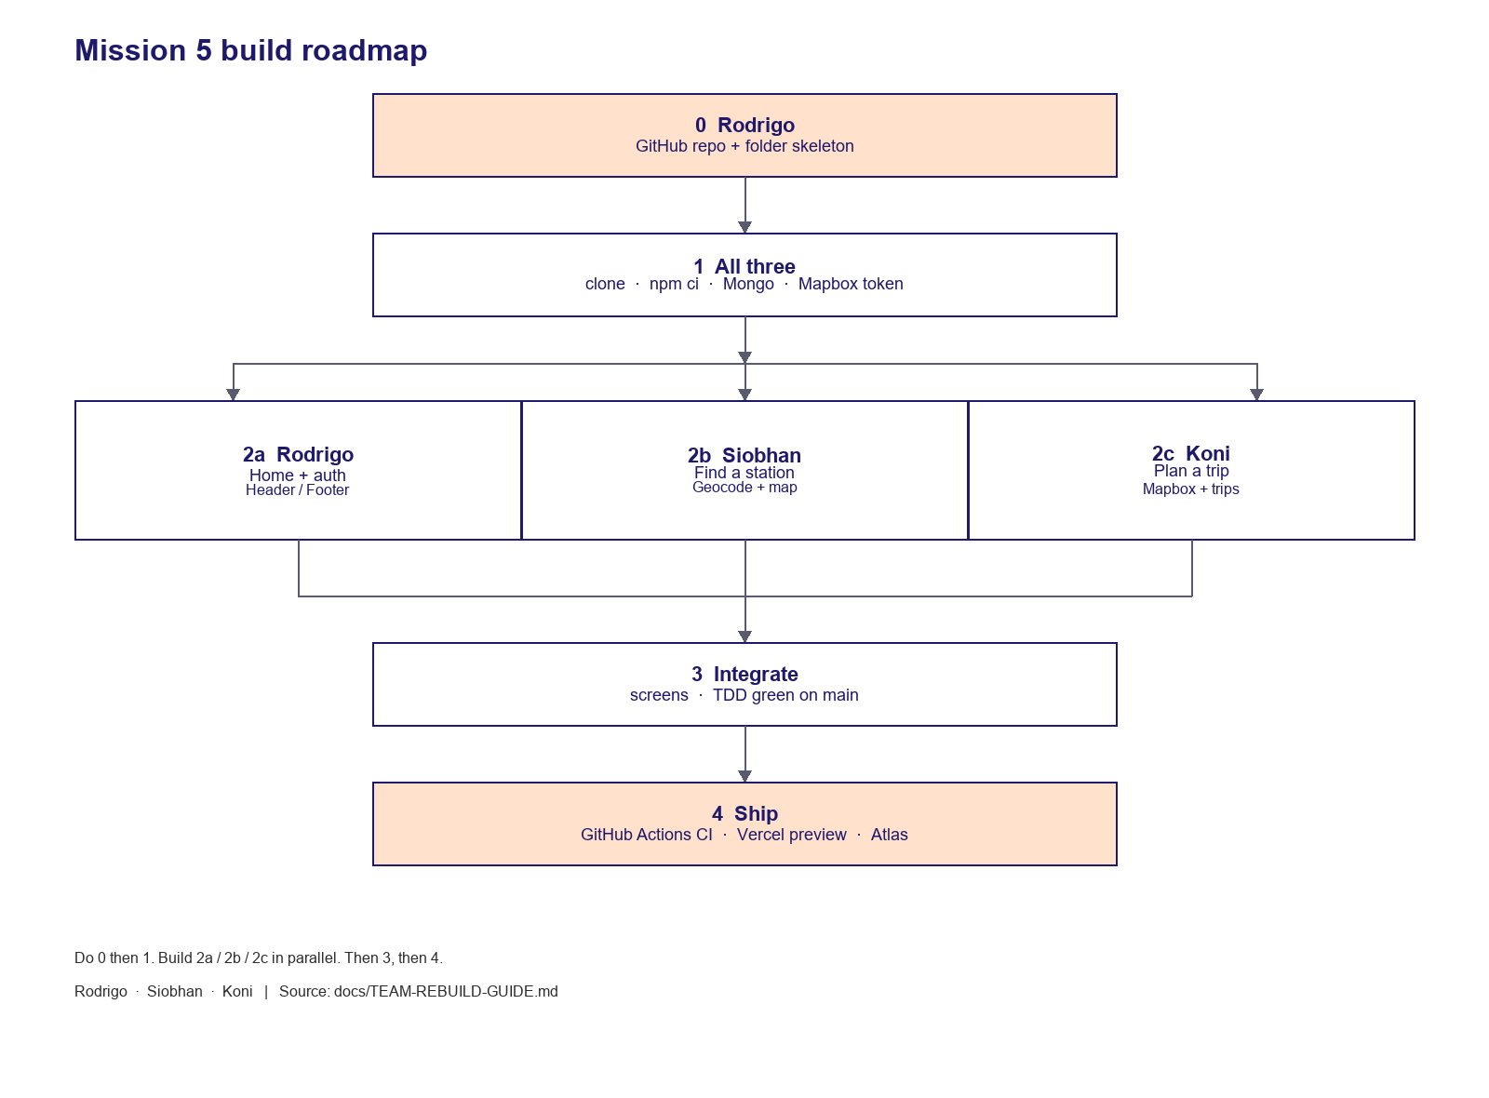
Mission 5 build roadmap
┌──────────────────────────────────────────────────┐
│ 0 Rodrigo: GitHub repo + folder skeleton │
└────────────────────────┬─────────────────────────┘
│
▼
┌──────────────────────────────────────────────────┐
│ 1 All: clone · npm ci · Mongo · Mapbox token │
└────────────────────────┬─────────────────────────┘
┌────────────┼────────────┐
▼ ▼ ▼
┌─────────────────┐ ┌─────────────────┐ ┌─────────────────┐
│ 2a Rodrigo │ │ 2b Siobhan │ │ 2c Koni │
│ Home + auth │ │ Find a station │ │ Plan a trip │
│ Header / Footer │ │ Geocode + map │ │ Mapbox + trips │
└────────┬────────┘ └────────┬────────┘ └────────┬────────┘
└─────────────┬─────┴─────────────┘
▼
┌──────────────────────────────────────────────────┐
│ 3 Integrate screens · TDD green on main │
└────────────────────────┬─────────────────────────┘
│
▼
┌──────────────────────────────────────────────────┐
│ 4 GitHub Actions CI · Vercel preview + Atlas │
└──────────────────────────────────────────────────┘
Diagram source (Mermaid) is in the markdown guide. See the PNG above for the visual.
Phase | When it is done
--- | ---
0 Scaffold | Empty app boots, folders exist, failing API tests exist, .env.example committed
1 Machines | npm run test and npm run dev work on all three laptops
2 Screens | Each owner’s Figma frames match at 430px and 1440px (lg = 1024px)
3 E2E | Home → Find → Details → Plan trip → Save trip (logged in) works
4 Ship | PR checks required; Vercel preview; production uses Atlas + Mapbox

TDD loop on every feature: red (write the test) → green (smallest code) → refactor → PR.

4. How to analyse Figma (all three of you)
Open the file in Dev Mode. Do not invent colours, radii, or icons.

Pages
Page | Node | Use it for
--- | --- | ---
UI Kit | 4:2 | Colour, type, buttons, chips before coding a screen
Components | 136:462 | Reusable pieces (header, pills, pins)
High Fidelity - Desktop | 581:842 | 1440px layouts
High Fidelity - Mobile | 394:2362 | 430–444px layouts

How to pull a frame into code
- Click the named frame (not a nested “Frame 275”).
- Note width / height / padding / gap / font / colour.
- Export SVG/PNG into src/assets/figma/ with a stable name (chip-toilet.svg, not Frame 331.svg).
- Implement with Tailwind tokens from src/index.css (z-orange, z-navy, Plus Jakarta Sans).
- Check 430px (mobile phone frame) and 1440px (full width). Breakpoint is lg = 1024px.

Owner frames (start here)
Rodrigo — Home + chrome + login
Frame | Node | Link
--- | --- | ---
Home desktop | 601:4350 | [open](https://www.figma.com/design/EW5M7T7a9luJJcJmDEaKN8/HIGH-FIDELITY----MISSION-5?node-id=601-4350)
Login in header | 601:4475 | [open](https://www.figma.com/design/EW5M7T7a9luJJcJmDEaKN8/HIGH-FIDELITY----MISSION-5?node-id=601-4475)
Login dropdown | 1125:4808 | [open](https://www.figma.com/design/EW5M7T7a9luJJcJmDEaKN8/HIGH-FIDELITY----MISSION-5?node-id=1125-4808)
Search overlay desktop | 742:14333 | [open](https://www.figma.com/design/EW5M7T7a9luJJcJmDEaKN8/HIGH-FIDELITY----MISSION-5?node-id=742-14333)
Main page mobile | 599:3632 | [open](https://www.figma.com/design/EW5M7T7a9luJJcJmDEaKN8/HIGH-FIDELITY----MISSION-5?node-id=599-3632)
Burger menu | 697:12669 | [open](https://www.figma.com/design/EW5M7T7a9luJJcJmDEaKN8/HIGH-FIDELITY----MISSION-5?node-id=697-12669)
Login screens | 1125:5086 family | Desktop 1125:3732, 1125:5213, 1125:4946, 1125:5039, 1125:4968

Siobhan — Find a station
Frame | Node | Link
--- | --- | ---
Looking for station (desktop) | 593:1769 | [open](https://www.figma.com/design/EW5M7T7a9luJJcJmDEaKN8/HIGH-FIDELITY----MISSION-5?node-id=593-1769)
Find fuel and service (desktop) | 593:2190 | [open](https://www.figma.com/design/EW5M7T7a9luJJcJmDEaKN8/HIGH-FIDELITY----MISSION-5?node-id=593-2190)
Addington station details | 593:2875 | [open](https://www.figma.com/design/EW5M7T7a9luJJcJmDEaKN8/HIGH-FIDELITY----MISSION-5?node-id=593-2875)
Fuel dropdown | 623:1422 | [open](https://www.figma.com/design/EW5M7T7a9luJJcJmDEaKN8/HIGH-FIDELITY----MISSION-5?node-id=623-1422)
Services dropdown | 593:2023 | [open](https://www.figma.com/design/EW5M7T7a9luJJcJmDEaKN8/HIGH-FIDELITY----MISSION-5?node-id=593-2023)
Sort dropdown | 593:2020 | [open](https://www.figma.com/design/EW5M7T7a9luJJcJmDEaKN8/HIGH-FIDELITY----MISSION-5?node-id=593-2020)
Fuel / Service / Selected (mobile) | 637:6730, 637:6876, 637:6784, 637:6498 | Fuel, Service, Fuel-Selected, Service-Selected
Station details / nav | 637:7253, 637:7334, 637:6607 | Fuel details, Fuel start nav, Service details
Overlays | 632:3903, 641:8271 | Fuel overlay, Service overlay

Koni — Plan a trip
Frame | Node | Link
--- | --- | ---
Plan trip desktop | 593:2821 | [open](https://www.figma.com/design/EW5M7T7a9luJJcJmDEaKN8/HIGH-FIDELITY----MISSION-5?node-id=593-2821)
Make a trip desktop | 593:2607 | [open](https://www.figma.com/design/EW5M7T7a9luJJcJmDEaKN8/HIGH-FIDELITY----MISSION-5?node-id=593-2607)
Plan my trip mobile | 637:6924 / 692:12223 | [open](https://www.figma.com/design/EW5M7T7a9luJJcJmDEaKN8/HIGH-FIDELITY----MISSION-5?node-id=692-12223)
Plan my trip 2 | 632:2578 | [open](https://www.figma.com/design/EW5M7T7a9luJJcJmDEaKN8/HIGH-FIDELITY----MISSION-5?node-id=632-2578)
Start my trip | 718:3226 / 637:6976 | [open](https://www.figma.com/design/EW5M7T7a9luJJcJmDEaKN8/HIGH-FIDELITY----MISSION-5?node-id=718-3226)
Trip start navigation | 637:7154 | [open](https://www.figma.com/design/EW5M7T7a9luJJcJmDEaKN8/HIGH-FIDELITY----MISSION-5?node-id=637-7154)
Cheapest stop card | 632:3173 | [open](https://www.figma.com/design/EW5M7T7a9luJJcJmDEaKN8/HIGH-FIDELITY----MISSION-5?node-id=632-3173)
From / To fields | 632:7429, 632:7441 | Starting point, Destination

Design tokens (from Figma)
- Orange #ff5a00 / deep #ff4d00 / amber #ff8a1a
- Navy #1e196a
- Ink #2b2b2b, muted #5c5c5c, peach #ffe1cc
- Font: Plus Jakarta Sans 400–800
- Mobile shell: max-w-[430px] centred on grey #ececec
- Desktop: full width, content max-w-[1440px], horizontal padding px-16
Export icons from Figma into src/assets/figma/ with stable names. Re-export if the design file changes.

5. Architecture
Diagram source (Mermaid) is in the markdown guide. See the PNG above for the visual.
Dev: Vite plugin starts Express. Browser calls /api/...; Vite rewrites to http://127.0.0.1:3001.
Prod: static Vite build on Vercel + API as Vercel serverless (or Express on Render). Mongo is Atlas. Mapbox tokens come from Vercel env.

API contract (implement with tests first)
Method | Path | Owner | Needs Mongo | Needs Mapbox
--- | --- | --- | --- | ---
GET | /health | Rodrigo | reports status | reports whether token is set
POST | /auth/register | Rodrigo | yes | no
POST | /auth/login | Rodrigo | yes | no
POST | /auth/reset | Rodrigo | yes | no
POST | /auth/avatar | Rodrigo | yes | no
GET | /geocode?q= | Siobhan | no | no
POST | /route | Koni | no | yes (OSRM fallback)
GET | /trips?userId= | Koni | yes | no
POST | /trips | Koni | yes | no
DELETE | /trips/:id?userId= | Koni | yes | no

Auth: same register/login/reset routes for Personal and Business, plus /auth/avatar for the header photo. Body includes accountType. Login must not cross tiers. Reset is email-only and works for both.
Collections:
// user-credentials — ONE login table for both tiers. Never duplicate password hashes.
{
userId, // unique. Same field Koni stores on saved-trips
email, // unique, lowercase. Login / register / reset
accountType, // "personal" | "business"
name, // person who signed in — header chip ("Hi Jasmina")
avatarUrl, // optional
passwordHash,
salt,
createdAt
}

// business-profiles — extra company fields. One doc per business userId.
// Only created when accountType === "business". Personal users have no row here.
{
userId, // unique, FK to user-credentials.userId
businessName, // trading / display name (required for business signup)
legalName, // optional
gstNumber, // optional NZ GST / NZBN — ask UX
fleetSize, // optional
createdAt
}

// saved-trips
{ userId, from, to, stops, origin, destination, selectedStationIds, distanceKm, durationLabel, createdAt }
Indexes: unique user-credentials.userId, unique user-credentials.email, unique business-profiles.userId, trips { userId: 1, createdAt: -1 }.
Do not make a second business-credentials collection with its own password. Business is a tier on the same login. Register/login stay /auth/register and /auth/login.
Session payload: { userId, email, name, accountType, avatarUrl, businessName }. Header shows name (person). If UX wants the company on the chip too, use businessName as secondary text, not instead of name.
Passwords: scrypt on the server. Never store plain text.

6. Folder structure (Rodrigo creates this on day 0)
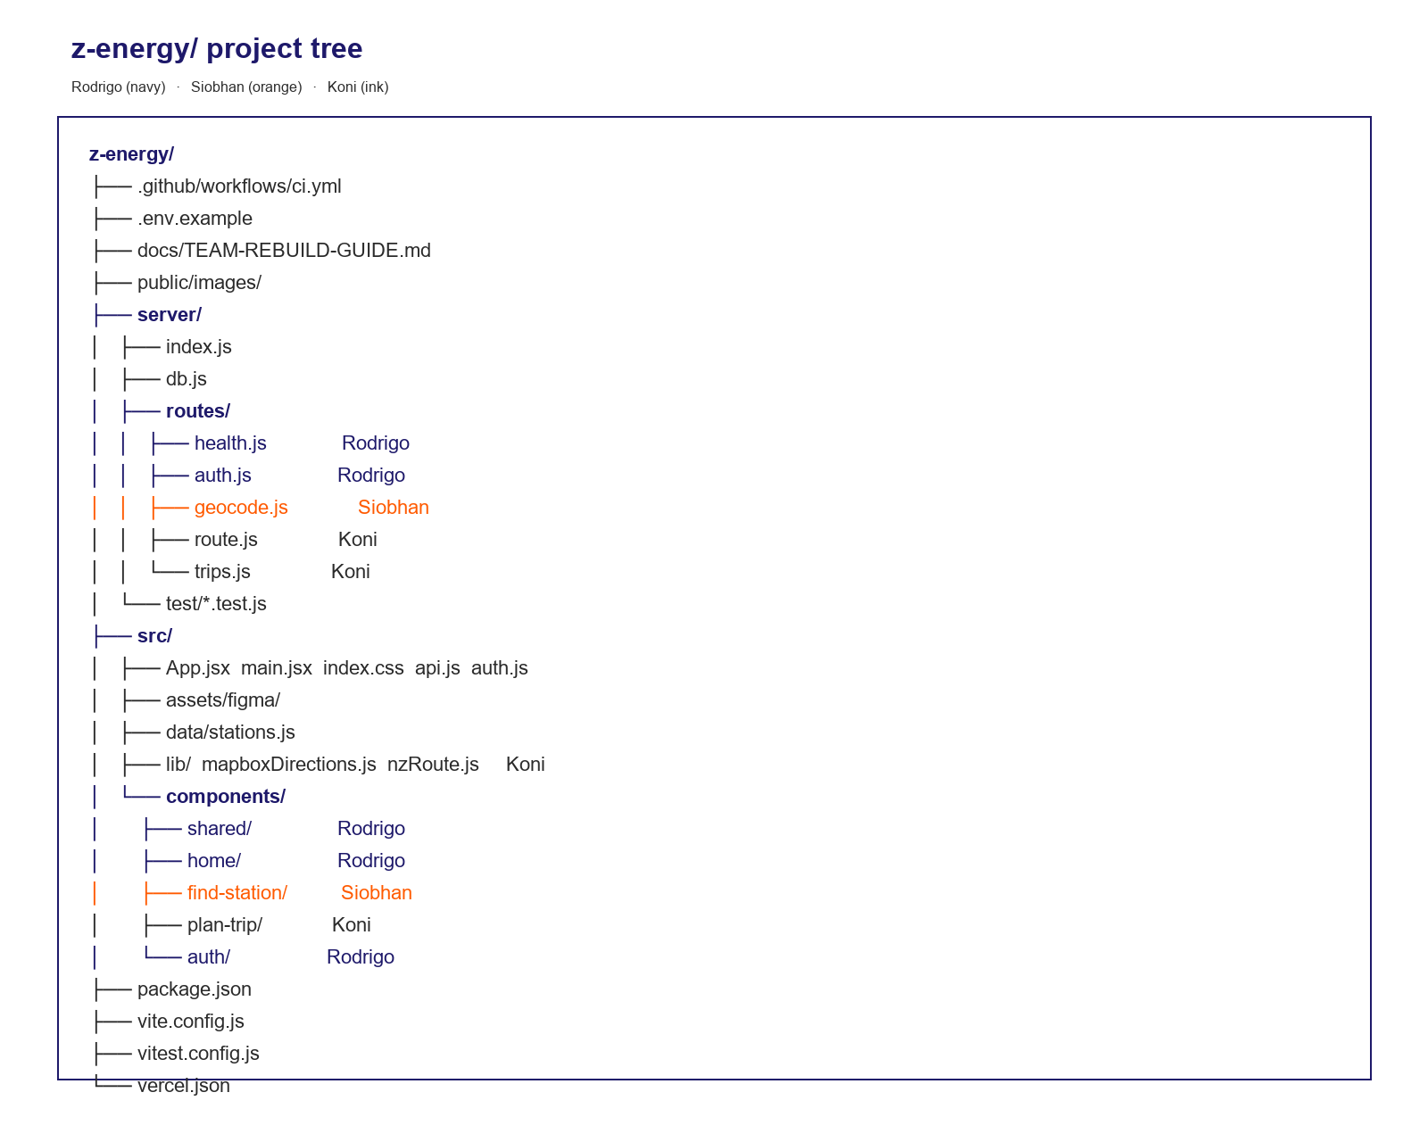
z-energy project folder tree
Owner map (rectangles):
Diagram source (Mermaid) is in the markdown guide. See the PNG above for the visual.
Project tree (create this on day 0):
z-energy/
├── .github/workflows/ci.yml
├── .env.example ← committed
├── .env ← gitignored, each laptop
├── docs/TEAM-BUILD-GUIDE.md
├── public/images/
├── server/
│ ├── index.js ← createApiApp(), connectDb(), startApi()
│ ├── db.js ← Mongo connect + indexes
│ ├── routes/
│ │ ├── health.js ← Rodrigo
│ │ ├── auth.js ← Rodrigo
│ │ ├── geocode.js ← Siobhan
│ │ ├── route.js ← Koni
│ │ └── trips.js ← Koni
│ └── test/
│ ├── memoryDb.js
│ ├── health.test.js
│ ├── auth.test.js
│ ├── geocode.test.js
│ ├── route.test.js
│ └── trips.test.js
├── src/
│ ├── main.jsx
│ ├── App.jsx ← page state; keep thin
│ ├── index.css ← tokens + breakpoints
│ ├── api.js ← fetch wrappers
│ ├── auth.js ← session + auth client
│ ├── assets/figma/ ← exported SVG/PNG
│ ├── data/stations.js ← station seed + filterStations()
│ ├── lib/
│ │ ├── mapboxDirections.js ← Koni
│ │ ├── nzRoute.js ← Koni (haversine, along-route)
│ │ └── *.test.js
│ └── components/
│ ├── shared/ ← Rodrigo
│ │ ├── Header.jsx
│ │ ├── Footer.jsx
│ │ ├── Logo.jsx
│ │ ├── Icons.jsx
│ │ └── CtaPill.jsx
│ ├── home/ ← Rodrigo
│ │ ├── Hero.jsx
│ │ └── Sections.jsx
│ ├── find-station/ ← Siobhan
│ │ ├── FindStation.jsx
│ │ ├── StationDetails.jsx
│ │ ├── StationMap.jsx
│ │ ├── FuelFilterOverlay.jsx
│ │ ├── ServiceOptionsOverlay.jsx
│ │ ├── FuelNavigation.jsx
│ │ └── ServiceStations.jsx
│ ├── plan-trip/ ← Koni
│ │ ├── PlanTrip.jsx
│ │ ├── TripNavigation.jsx
│ │ └── DesktopTripMap.jsx
│ └── auth/ ← Rodrigo
│ └── LoginPages.jsx
├── package.json
├── package-lock.json
├── vite.config.js
├── vitest.config.js
├── vercel.json
└── README.md
Do not edit another owner’s folder in the same PR unless you are fixing a merge conflict or a shared type. Change shared files (App.jsx, index.css, Header.jsx) in a small dedicated PR that Rodrigo reviews first.

7. Phase 0 — Rodrigo: scaffold (before anyone else codes screens)
- Create a new empty GitHub repo for the Mission 5 team project.
- git init, Node 20+, npm create Vite React, add Tailwind v4, Express, MongoDB driver, Leaflet, Vitest, Supertest.
- Commit the folder tree with stub components that render the screen name only.
- Add failing API tests for every route in the table above.
- Add .env.example (no secrets):
MONGODB_URI=mongodb://127.0.0.1:27017/z-energy-db
VITE_MAPBOX_TOKEN=pk.your_public_token
MAPBOX_TOKEN=pk.your_public_token
PORT=3001
- Add .gitignore with .env, .env.*, node_modules, coverage, dist.
- Push main. Open GitHub branch protection: PRs required, CI check required.
- Tell Siobhan and Koni: clone URL, Figma access, this guide.
Skeleton package.json scripts:
{
"scripts": {
"dev": "vite",
"api": "node server/index.js",
"build": "vite build",
"preview": "vite preview",
"test": "vitest run --reporter=verbose --coverage",
"test:watch": "vitest"
}
}
Vite must proxy /api → http://127.0.0.1:3001 and spawn the API in configureServer.

8. Phase 1 — every laptop (Siobhan and Koni included)

Install once
- Git, Node 20+, npm.
- MongoDB Community + Compass (mongodb.com/try).
- Start Mongo. In Compass connect to mongodb://127.0.0.1:27017 and confirm you can create database z-energy-db.
- Mapbox: create a free account, copy the default public token.

Clone and run
git clone <repo-url>
cd z-energy
npm ci
copy .env.example .env # Windows
# cp .env.example .env # macOS / Linux
Edit .env: paste your Mapbox token into both VITE_MAPBOX_TOKEN and MAPBOX_TOKEN.
npm test
npm run dev
Open http://localhost:5173. GET http://localhost:5173/api/health should show { ok: true, mongo: "connected", mapbox: true }.
If mongo is "error", Compass/Mongo is not running. If mapbox is false, the .env token is missing and you must restart npm run dev.

Daily loop
git checkout main
git pull
npm ci
git checkout -b feat/siobhan-find-filters
# TDD, implement, npm test
git push -u origin HEAD
# open PR → Rodrigo reviews

9. Screen + backend split (what to build)

Rodrigo — Home, shared chrome, auth
UI: Header (Personal / Business, nav, search, login), Hero, news, services, map CTA, feature columns, Footer, burger, search overlay, Personal + Business login-register-forgot.
Backend: /health, /auth/register, /auth/login, /auth/reset. Unique indexes on userId and email. Business signup also writes business-profiles.
Tests: personal vs business register fields, duplicate email, login cannot cross tiers, reset, 503 when Mongo is down.
Done when: desktop Home matches 601:4350, Contact us is a one-line orange pill with a white pin on orange (no white circle), login writes a session, Siobhan/Koni can call getSession().

Siobhan — Find a station
UI: address search, current location, Fuel / Service / Trip tabs, fuel-type / services / sort controls, station list + map, Apply filters → updated list, station details, fuel nav, service selected.
Backend: GET /geocode?q= (known NZ places + Nominatim). Station list can stay in src/data/stations.js; filterStations() must be unit-tested.
Tests: empty query returns known places; known city still works if Nominatim is down; street labels format; filters by fuel, services, price/distance.
Done when: desktop 593:1769 → apply filters → 593:2190 (or filtered list + map) matches Figma; mobile Fuel/Service selected states work.

Koni — Plan a trip
UI: From / To / add stop, service chips, cheapest-stop toggle, Mapbox polyline, station pins on route, save trip (requires login), trip navigation.
Backend: POST /route (Mapbox first, OSRM fallback, highway last), GET/POST/DELETE /trips.
Tests: reject missing from/to; Mapbox payload mapping; fallback highway when tokens empty; save/list/delete trips for one userId only.
Done when: desktop plan/make-trip frames match; a logged-in user can save a trip and see it after refresh (Mongo).

10. TDD rules (non-negotiable)
- New API behaviour starts as a failing test in server/**/*.test.js.
- New map/filter helper starts as a failing test in src/lib/*.test.js or src/api.test.js.
- Use the in-memory DB helper (server/test/memoryDb.js) — do not require Compass for unit tests.
- Mock fetch for Mapbox / Nominatim / OSRM. Tests must pass offline.
- npm test must stay green on main. Coverage include: server/index.js (or split route files), src/api.js, src/auth.js, src/lib/**.
Suggested first tests Rodrigo commits (red is OK on purpose):
- GET /health returns mongo + mapbox flags
- POST /auth/register with empty userId fails
- GET /geocode returns Auckland without network
- POST /route without from/to is 400
- GET /trips without userId fails
Owners then turn those red tests green in their PRs.

11. Packages (install once in the skeleton)
Keep this stack unless the team agrees to change it:
App: react, react-dom, leaflet, express, mongodb
Tooling: vite, @vitejs/plugin-react, tailwindcss, @tailwindcss/vite, vitest, @vitest/coverage-v8, supertest
Siobhan/Koni: do not npm install a second map library. Leaflet + Mapbox HTTP Directions is the plan.

12. CI/CD: GitHub Actions + Vercel

GitHub Actions (required on PRs)
.github/workflows/ci.yml:
name: CI
on:
pull_request:
push:
branches: [main]
jobs:
test:
runs-on: ubuntu-latest
steps:
- uses: actions/checkout@v4
- uses: actions/setup-node@v4
with:
node-version: 20
cache: npm
- run: npm ci
- run: npm test
No Mapbox or Mongo needed in CI if tests mock them.

Vercel
- Rodrigo: vercel.com → Import GitHub repo.
- Framework: Vite. Build vite build. Output dist.
- Environment variables (Production and Preview):
MONGODB_URI=<Atlas connection string>
MAPBOX_TOKEN=<team pk token>
VITE_MAPBOX_TOKEN=<same pk token>
- Enable Preview Deployments on pull requests.
- Rodrigo reviews the Vercel preview URL on each PR, not only localhost.
Mongo on Vercel must be Atlas, not Compass. Serverless functions cannot see your laptop’s 127.0.0.1.
API on Vercel: Express as a long-running :3001 process will not stay up on Vercel. Pick one:
- Preferred for this course: add Vercel functions under /api that call the same createApiApp() handlers, or
- Deploy Express to Render/Railway and set VITE_API_URL on Vercel.
vercel.json (static + SPA fallback):
{
"rewrites": [{ "source": "/((?!api/).*)", "destination": "/index.html" }]
}
If you keep Express on Render, add a rewrite or VITE_API_ORIGIN so /api in the browser hits that host.

PR checklist (Rodrigo uses this)
- [ ] Tests added/updated and CI green
- [ ] No .env or Mapbox token in the diff
- [ ] 430px and 1440px checked against the named Figma frame
- [ ] Does not rewrite another owner’s folder without a comment
- [ ] Vercel preview loads; /api/health is ok against Atlas

13. Git workflow
main ← protected, only squash-merge PRs
feat/rodrigo-home-hero
feat/siobhan-find-filters
feat/koni-mapbox-route
chore/rodrigo-vercel-env
- Branch from latest main.
- One concern per PR.
- Rodrigo reviews; Siobhan/Koni review each other on shared map/filter behaviour when the PR touches StationMap.jsx.

14. Definition of done (the whole app)
- [ ] Clone → npm ci → .env → npm test → npm run dev works on three laptops
- [ ] Home, Find a station, Plan a trip match Figma at mobile and desktop
- [ ] All API endpoints tested; Mongo used for auth + saved trips
- [ ] Mapbox Directions used when token is present
- [ ] GitHub Actions required; Vercel preview + production
- [ ] Secrets only in .env and Vercel/Atlas dashboards
Rodrigo: start at Phase 0. When main has the skeleton, send Siobhan and Koni the clone URL plus this file.

