***Abstract***: **Technological innovation has brought a massive leap in data processing. As information turns out to be broadly accessible, various tools have been produced to create more types of format on existing data. In information technology, audio is one of the most flexible types of data that could be manipulated into different forms. In this**

**light, this paper evaluates the conversion of multiple audio files in waveform audio file (.wav) formats to .mp3, wma, and . Aac formats using standard parameters.**

**Keywords: Audio Conversion, Audio Format, Audio Analysis**

**INTRODUCTION**

The sounds that human hear from nature are analog,

but if theses sounds would be stored, they would have to be converted in digital form.

Audio file is created through the PC either from a recording or produced naturally by a synthesizer.

There are many applications available nowadays where people can just select, listen, and sometimes download

songs they love.[1]

Music lovers can download the audio files in various formats. Even journal articles can be converted to audio files particularly in mp3 format so people with low-vision or no vision at all can have access to

the journals.

Data compression is a process where allowable number of bits is reduced for easy storage and transmission of data.[2]

Ordinary music listeners may not be able to distinguish compressed music from uncompressed music

most especially if these are digital audio files. Audio files in compact discs (CD’s) are uncompressed[3], and needs to be converted to compressed formats to be read on a computer or portable device. The quality of the audio file is dependent on the bit rate as better quality of the audio is achieved when it is higher.[4]

**RELATED WORKS**

There are many different types of Audio formats like mp3, Wave, ogg, etc Wave documents (wav) and

MPEG Layer-3 records (mp3) are two of the most common audio formats.

The way the sound is packed and put away is called the codec which decides how little the document size is.

**Data compression** can be classified as lossless or lossy. In lossy compression, the size of the compressed

file is very small as compared to the original data[5] because redundant and inaudible data is removed to reduce file size and improve transmission capabilities while maintaining the data quality. Compression of audio, video, and image use lossy methods.[6]

MP3 uses variable-length Huffman codes and tis results to a more effective data compression. The sampling rate can have values of be 32, 44.1, or 48 kHz. [7] It is very well appropriate for audio transmission over the internet. Different algorithm is used in converting audio data such as Run-length encoding (RLE) [8], Burrows-wheeler transform (BWT), Move to front transform (MTF), and Arithmetic coding (ARI). Other techniques are Shannon-Fano, Huffman Coding. The result of data compression is dependent on the data source while the characteristic of the output relies whether the converted format is lossy or lossless[9]

Methodology

a. Audio Conversion and Audio Analyzer Tool

The wav format audio files used were extracted using the online website www.onlinevideoconverter.com. The videos were randomly selected from the nursery rhymes in YouTube.com.[10]

This research utilizes an audio conversion tool known as format factory. Specifically, it converts audio data to mp3,wma and .aac format. As the research assess multiple audio files converted to four audio formats, another tool is then used for the analysis of the results.

b. Formulation

Experimental method was used in this research as it manipulates multiple data, and controls the rest of the

data. In this case, three songs (audio files) are used entitled Baa Baa Black Sheep and Hey Diddle Diddle.

The original data used are in wav file format and are subject for conversion using .mp3 .wma and .aac formats. After the conversion, the results are then analyzed in the MediaInfo application utilizing the accompanying parameters:

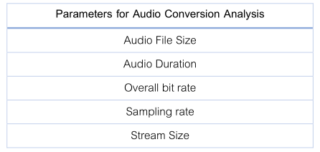

Table 1. Parameters for Identifying

Audio Conversion Findings

Waveform Audio File (.wav) format have uncompressed audio in Pulse-Code Modulation (PCM) format. In, PCM the signals can only have two values, 1 or 0. There are three steps involved in pulse code modulation as displayed in figure 1. The first step involves conversion of continuous amplitude signal into discrete-time-continuous signal. Followed by quantization where the excessive and redundant bits are reduced and compressed. And finally the analog signals are digitized in encoding, and therefore the bandwidth used by the signal is reduced.



Figure Block Diagram of Pulse Code Modulation

**RESULTS AND DISCUSSION**

This part of the study shows the extraction results based on the different parameters from the audio

conversion tool. The audio file size, and the audio stream size are both measured in megabytes (MB), the duration of the audio files are presented in seconds (sec), overall bit rate of the audio files is presented in bits per second (kbps), and the audio sampling rate is measured in kilohertz (kHz).

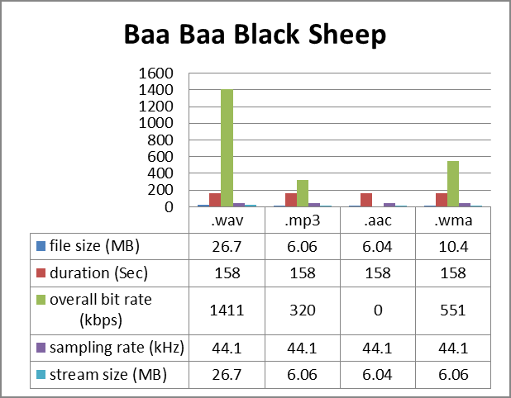

Figure Result of Audio Conversion of Baa Baa Black Sheep using Format factory as analyzed by Media Info

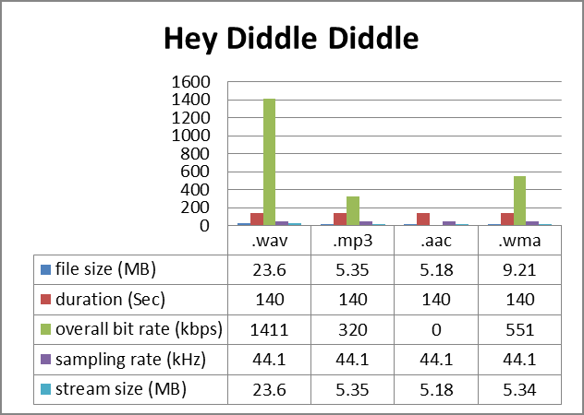

Figure 3 Result of Audio Conversion of Hey Diddle Diddle using Format factory as analyzed by MediaInfo

The following Figures 2 and 3 shows the data extracted from the Media Info in analyzing Baa Baa Black Sheep and Hey Diddle Diddle .

It can be noted that the .wav format has the biggest file size and stream size, and the .aac format has the smallest file size and stream size.

Duration and sampling rate did not change after the conversions of .wav file to other audio formats used in the study

**CONCLUSION**

From the given results and analysis on this study, it can be perceived that among the audio file format

evaluated, Waveform Audio File (.wav) format has the biggest file size, and stream size being the original file

contrary to the result of Advanced Audio Coding (.aac) format.

Furthermore, the audio duration and the audio sampling rate were not affected by the conversion of audio files from Waveform Audio File (.wav) format to .mp3, .wma, and .aac formats.

The audio overall bit rate changed upon the conversion applied to the audio files resulting to a 77.32% reduction. The highest value of overall bit rate is noted in the Waveform Audio File (.wav) format and the lowest value is on the MPEG-1 Audio Layer-3 (.mp3) format. Overall bit rate of Advanced Audio Coding (.aac) format is variable and so it was not measured exactly by Media Info.

**ACKNOWLEDGMENT**

The authors would like to thank Dr. Vikas Chowdhary, HOD,CSE Dept. and Mr. Pankaj Singh Yadav, Sr Professor , JIMS, GGSIP University, for their useful discussions and suggestions during the preparation of this technical paper.

**REFERENCES**

1. A. Kaur, N. S. Sethi at H. Singh, “A Review on Data Compression Techniques,” International Journal of Advanced
2. Research in Computer Science and Software Engineering, pp. 769-773, 2015.
3. N. Amal, “Light and easy with multimedia components,” Sunday Mail, p. 23, 29 August 1999.
4. C. Breen at J. Seff, “Rip, Store, Organize,” Macworld, pp. 60-63, 2004.
5. 20 October 2011. [Online]. Available: https://librarynews.marygrove.edu/2011/10/20/did-you-know-you-can-convert-journal-articles-to-audio-files/. [Na-access 14 March 2017]
6. K. Mc Elhearn, “Everything you need to knopw about digital audio files,” Macworld, pp. 128-129, 2016
7. S. R.Mahalakshmi, “Data Compression in Multimedia (Text,Image,Audio and Video),” nternational Journal ofEngineering Sciences & Research Technology, pp. 376-382, October 2014.
8. A. J. Maan, “Analysis and Comparison of Algorithms for Lossless Data Compression,” International Journal ofInformation and Computation Technology, vol. III, blg. 3, pp. 139-146, 2013.
9. K. Dangarwala at J. Shah, “C Implementation & comparison of companding & silence audio compression techniques,” International Journal of Computer Science Issues, vol. 7, blg. 2, pp. 26-30, 2010.
10. D. Sinha at A. H. Tewfik, “Low Bit Rate Transparent Audio Compression using Adapted Wavelets,” IEEE TRANSACTIONS ON SIGNAL PROCESSING, vol. 41, blg. 12, pp. 3463-3479, 1993
11. R. Milton. Extracting Data from mp3: Clean Air in Schools.(2011). Available: <http://genesis.blogs.casa.ucl.ac.uk/2011/07/18/extracting-data-from-mp3-clean-air-in-schools/>.
12. V. Gaikar. Zamzar: Convert Your Files to Any Format by Email.Tricks Machine, (2012).Available:http://www.tricksmachine.com/2012/03/zamzar-convert-yourfiles-by-mail.html/
13. Z. Ahmed, T. Dandekar. MSL: Facilitating automatic and physical analysis of published scientific literature in Audio format. F1000Research, 4, (2015).