Experiment No 1

**Aim:** Case Study on DevOps

**Theory:**

The DevOps is a combination of two words, one is software Development, and second is Operations. This allows a single team to handle the entire application lifecycle, from development to **testing, deployment**, and **operations**. DevOps helps you to reduce the disconnection between software developers, quality assurance (QA) engineers, and system administrators. DevOps promotes collaboration between Development and Operations team to deploy code to production faster in an automated & repeatable way.

DevOps helps to increase organization speed to deliver applications and services. It also allows organizations to serve their customers better and compete more strongly in the market. DevOps can also be defined as a sequence of development and IT operations with better communication and collaboration. DevOps is nothing but a practice or methodology of making "**Developers**" and "**Operations**" folks work together. DevOps represents a change in the IT culture with a complete focus on rapid IT service delivery through the adoption of agile practices in the context of a system-oriented approach.

**Why DevOps is Needed:**

* The operation and development team worked in complete isolation.
* After the design-build, the testing and deployment are performed respectively. That's why they consumed more time than actual build cycles.
* Without the use of DevOps, the team members are spending a large amount of time on designing, testing, and deploying instead of building the project.
* Manual code deployment leads to human errors in production.
* Coding and operation teams have their separate timelines and are not in synch, causing further delays.

**DevOps History:**

* In 2009, the first conference named **DevOpsdays** was held in Ghent Belgium. Belgian consultant and Patrick Debois founded the conference.
* In 2012, the state of DevOps report was launched and conceived by Alanna Brown at Puppet.
* In 2014, the annual State of DevOps report was published by Nicole Forsgren, Jez Humble, Gene Kim, and others. They found DevOps adoption was accelerating in 2014 also.
* In 2015, Nicole Forsgren, Gene Kim, and Jez Humble founded DORA (DevOps Research and Assignment).
* In 2017, Nicole Forsgren, Gene Kim, and Jez Humble published "Accelerate: Building and Scaling High Performing Technology Organizations".

**DevOps Phases**

DevOps defines an agile relationship between operations and Development. It is a process that is practiced by the development team and operational engineers together from beginning to the final stage of the product.

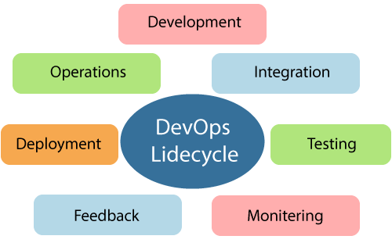

Learning DevOps is not complete without understanding the DevOps lifecycle phases. The DevOps lifecycle includes seven phases as given below:

1) Continuous Development

This phase involves the planning and coding of the software. The vision of the project is decided during the planning phase. And the developers begin developing the code for the application. There are no DevOps tools that are required for planning, but there are several tools for maintaining the code.

2) Continuous Integration

This stage is the heart of the entire DevOps lifecycle. It is a software development practice in which the developers require to commit changes to the source code more frequently. This may be on a daily or weekly basis. Then every commit is built, and this allows early detection of problems if they are present. Building code is not only involved compilation, but it also includes **unit testing, integration testing, code review**, and **packaging**.

The code supporting new functionality is continuously integrated with the existing code. Therefore, there is continuous development of software. The updated code needs to be integrated continuously and smoothly with the systems to reflect changes to the end-users.

3)Continuous Testing:

This phase, where the developed software is continuously testing for bugs. For constant testing, automation testing tools such as **TestNG, JUnit, Selenium**, etc are used. These tools allow QAs to test multiple code-bases thoroughly in parallel to ensure that there is no flaw in the functionality. In this phase, **Docker** Containers can be used for simulating the test environment.

4) Continuous Monitoring

Monitoring is a phase that involves all the operational factors of the entire DevOps process, where important information about the use of the software is recorded and carefully processed to find out trends and identify problem areas. Usually, the monitoring is integrated within the operational capabilities of the software application.

It may occur in the form of documentation files or maybe produce large-scale data about the application parameters when it is in a continuous use position. The system errors such as server not reachable, low memory, etc are resolved in this phase. It maintains the security and availability of the service.

5) Continuous Feedback:

The application development is consistently improved by analyzing the results from the operations of the software. This is carried out by placing the critical phase of constant feedback between the operations and the development of the next version of the current software application.The continuity is the essential factor in the DevOps as it removes the unnecessary steps which are required to take a software application from development, using it to find out its issues and then producing a better version. It kills the efficiency that may be possible with the app and reduce the number of interested customers.

6) Continuous Deployment:

In this phase, the code is deployed to the production servers. Also, it is essential to ensure that the code is correctly used on all the servers.

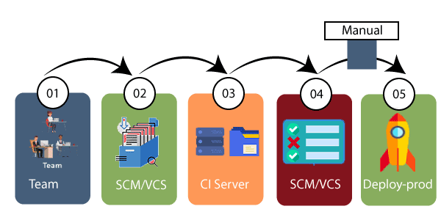

The new code is deployed continuously, and configuration management tools play an essential role in executing tasks frequently and quickly. Here are some popular tools which are used in this phase, such as **Chef, Puppet, Ansible**, and **SaltStack**.

Containerization tools are also playing an essential role in the deployment phase. **Vagrant** and **Docker** are popular tools that are used for this purpose. These tools help to produce consistency across development, staging, testing, and production environment. They also help in scaling up and scaling down instances softly.

7) Continuous Operation:

All DevOps operations are based on the continuity with complete automation of the release process and allow the organization to accelerate the overall time to market continuingly.

It is clear from the discussion that continuity is the critical factor in the DevOps in removing steps that often distract the development, take it longer to detect issues and produce a better version of the product after several months. With DevOps, we can make any software product more efficient and increase the overall count of interested customers in your product.

**DevOps Tools:**

1)Puppet:

Puppet is the most widely used DevOps tool. It allows the delivery and release of the technology changes quickly and frequently. It has features of versioning, automated testing, and continuous delivery. It enables to manage entire infrastructure as code without expanding the size of the team.

2)Ansible:

Ansible is a leading DevOps tool. Ansible is an open-source IT engine that automates application deployment, cloud provisioning, intra service orchestration, and other IT tools. It makes it easier for DevOps teams to scale automation and speed up productivity.

3)Docker:

Docker is a high-end DevOps tool that allows building, ship, and run distributed applications on multiple systems. It also helps to assemble the apps quickly from the components, and it is typically suitable for container management.

4)Nagios:

Nagios is one of the more useful tools for DevOps. It can determine the errors and rectify them with the help of network, infrastructure, server, and log monitoring systems.

**Benefits of Devops:**

* Faster delivery of features.
* More stable operating environments.
* Improved communication and collaboration.
* More time to innovate (rather than fix/maintain)

**Conclusion:** Thus, Concept of Devops has been understood in this experiment.