**Pokemon Ballerz**

Overview:

Pokémon is a game that is a based on the original Pokémon game, where the player has to explore the entire Pokémon Island battling small creatures along the way. The creatures can be defeated or caught to be used in future battles.

The main objective is to beat the final boss, Coroger, who can be battled at the end of the game.



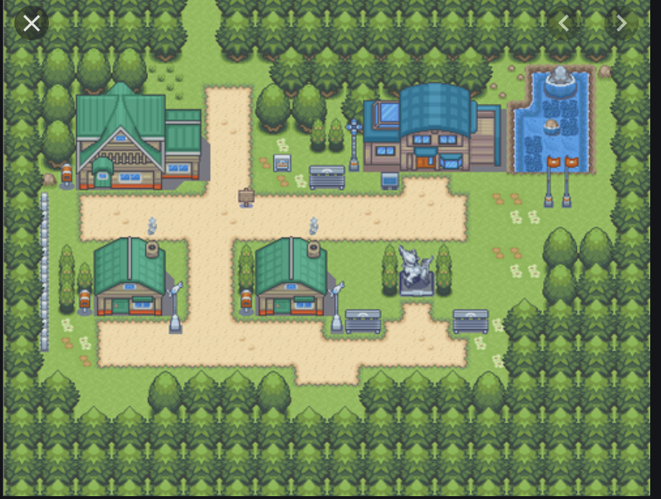

Image 3. This is a sample map where the player will walk through the game, battling creatures.

|  |  |  |
| --- | --- | --- |
| **Characters/objects** | **Type** | **Description** |
| Main Player | Character | - Can move in all directions through the map.  - The player can move using either the w, a, s, d keys or the arrow keys.  - Moving while pressing the shift button lets the main player run.  - The main player can battle creatures across the entire map.  -Uses captured creatures in battles against other creatures |
| Creatures | Character | - Waits in grass for main player to stubble across.  - Fights the main player when stumbled upon.  - Gradually get stronger as the game progresses.  - Can use multiple attacks.  - Has a finite hp bar. This provides the creature with health. If this bar hits 0, the creature is defeated. |
| Grass | Landscape | - Habitat for creatures to hide in  - If the main player crosses through the grass, there is a chance a creature will pop out. |
| Buildings | Structure | - Can be seen on the sides of pathways. (Image 1 & 2)  - Can enter some buildings  -Can provide many benefits such as advice, tips, hints and items etc. |
| Bosses | Character | - (Image 4)  - You have to battle the boss at the end  - He has a team of 4 pokemon and the goal is to train your pokemon to be strong enough to beat him.  - He is in a building and to get to him you have to battle your way through multiple opponents.  - By beating the boss, the player wins the entire game. |
| Pathway | Landscape | -Can be seen on the map (Image 3)  -The main player walks on these pathways to commute from place to place. |
| Side Characters | Character | - Are spread out all around the map in buildings and in the open  - Can battle you or give you advice/tips/hints |



Image 5. This is a sketch of what a building could look like

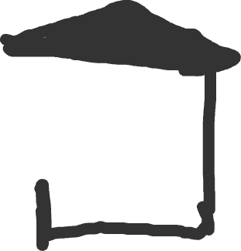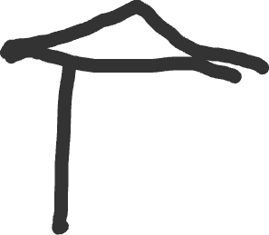

Image 4. This a sketch of what a boss’s pokemon could look like

