Salad - Eat

Tender, Crunchy, Sturdy, Bold
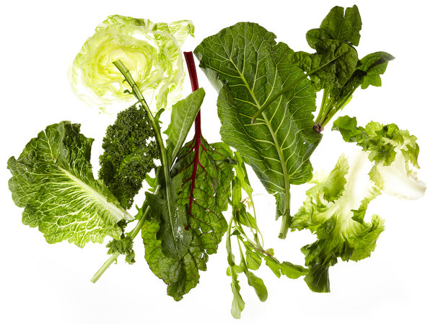
Yunhee Kim for The New York Times; Food Stylist: Maggie Ruggiero; Prop Stylist: Deborah Williams
When it comes to salad greens, iceberg lettuce is just the tip of the, well, you know.

By MARK BITTMAN

Multimedia
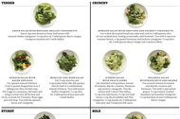Graphic

Bold Salads
Green Salad With Mustard-Shallot Vinaigrette
Toss 6 cups torn Boston or loose-leaf lettuce with mustard-shallot vinaigrette: 1/3 cup olive oil, 2 tablespoons sherry vinegar, 1 teaspoon mustard and 1 small shallot.
To me, the year’s first fresh radishes bring new meaning to bread, butter and salt (the combination is ethereal), and I eagerly await the first real tomato. But we should not allow the euphoria of roots, fruits and vegetables to distract us from the myriad of greens that are now flooding markets and that will continue to do so until at least Thanksgiving.
Romaine is fine. But dandelion, tender lettuces, chard and arugula (real arugula, not the “baby” kind they sell in most supermarkets) are all ubiquitous this time of year, and they can be as flavorful as the juiciest tomato. You can make a different salad every day for weeks without repeating yourself.
The chart on the next page highlights 12 of the season’s most available (and wonderful) greens, divided into four categories — tender, crunchy, sturdy and bold — though the distinctions are often blurred. (Watercress is arguably bold, crunchy and sturdy.) In any case don’t be constrained by my recommendations. And remember that this is not an exhaustive list; endive, radicchio, chicory, mizuna, mâche and others are also fresh and flavorful in early summer and will fill in here just fine.
You can turn any salad into a chopped salad by adding chopped things, but all you really need beside greens is vinaigrette — that basic French sauce of emulsified oil and acid (usually vinegar or citrus juice). The standard ratio is three parts oil to one part acid, but there’s wiggle room; four to one can be too mild, and two to one downright assaultive, so this is an apt occasion for the phrase “to taste.”
To make any of the vinaigrettes described here, process all the ingredients, along with salt and pepper, in a blender or food processor until the mixture becomes thick and creamy. Or you can finely chop the ingredients and whisk everything together in a bowl. Hand-mixed vinaigrette isn’t as creamy as machine-blended, but it tastes just as good.
Spinach Salad With Bacon and Eggs
Use spinach instead of lettuce. Cook ¼ pound chopped bacon in 2 tablespoons olive oil until crisp. Put 4 eggs in a saucepan, add water and bring to a boil; turn off the heat and let sit, covered, for 9 minutes. Rinse eggs, peel and chop. Toss with the spinach, bacon and vinaigrette.
Mesclun-and-Herb Salad
Use 5 cups mesclun and 1 cup tender herbs (like dill, parsley, chervil, basil or a combination) instead of lettuce. Toss with lemon-shallot vinaigrette: 1/3 cup olive oil, 2 tablespoons lemon juice and 1 small shallot.
Romaine Salad With Croutons and Anchovy Vinaigrette
Cut 4 thick slices good bread into cubes and cook in 2 tablespoons olive oil over medium heat, tossing occasionally, until browned. Toss with 6 cups torn romaine lettuce, 1 cup grated Parmesan and anchovy vinaigrette: 1/3 cup olive oil, 2 tablespoons sherry vinegar and 3 anchovy fillets.
Iceberg Salad With Thai Flavors
Use shredded iceberg lettuce instead of romaine; skip the croutons, Parmesan and anchovy vinaigrette. Toss the lettuce with 2 sliced Thai chilies, 1/2 cup torn mint leaves, 1/2 cup torn basil leaves, 1 cup sliced radishes and Thai vinaigrette: 1/3 cup peanut oil, 2 tablespoons lime juice and 2 teaspoons fish sauce.
Escarole Salad With Hazelnuts and Grapes
Use escarole instead of romaine and skip the croutons and Parmesan. Toss with 2 cups halved grapes, 3/4 cup toasted, crushed hazelnuts and hazelnut vinaigrette: 1/3 cup hazelnut oil and 2 tablespoons sherry vinegar.
Cooked Chard Salad With Lemon-Caper Vinaigrette
Cook 1 to 1 1/2 pounds trimmed chard in boiling salted water until tender, 2 to 3 minutes, then drain, rinse, squeeze dry and chop. Drizzle with lemon-caper vinaigrette: 1/3 cup olive oil, 2 tablespoons lemon juice, 1 teaspoon capers with a drop of their brine and 1 tablespoon chopped parsley.
Kale Salad With Raisins and Blue Cheese
Use kale, not chard; instead of cooking, chop and drizzle kale with 1 teaspoon each olive oil and sherry vinegar; knead until tender. Toss with 2 grated carrots, 1/2 cup raisins, 1/2 cup blue cheese and honey-garlic vinaigrette: 1/3 cup olive oil, 2 tablespoons sherry vinegar, 1 garlic clove and 2 teaspoons honey.
Cooked Collard Salad With Peanut Vinaigrette
Use collards instead of chard (it will take longer to cook). Drizzle with peanut vinaigrette: 1/3 cup peanut oil, 2 tablespoons lime juice, 3 tablespoons dry-roasted peanuts and 1 garlic clove. Garnish with 1/4 cup chopped scallions.
Dandelion Salad With Feta
Toss 6 cups torn dandelion greens with 1/3 cup olive oil, 2 tablespoons lemon juice and 3/4 cup crumbled feta (or ricotta salata) cheese.
All-Green Watercress Salad
Use watercress, not dandelions; skip olive oil, lemon juice and feta. Cook 1 cup snow peas in boiling salted water until bright green; rinse and dry. Toss with the watercress, 1 cup sliced cucumber, 1 tablespoon toasted sesame seeds and soy-sesame vinaigrette: 1/3 cup neutral oil, 1 teaspoon sesame oil, 2 tablespoons rice vinegar and 2 teaspoons soy sauce.
Southwestern Arugula Salad
Use arugula, not dandelions; skip the lemon juice and feta. Cook 1 cup corn kernels in 1 tablespoon olive oil over medium-high heat until brown, about 5 minutes; cool slightly. Toss with the arugula, 1/2 cup cooked black beans and chipotle vinaigrette: 1/3 cup olive oil, 2 tablespoons lime juice and 1 canned chipotle pepper with a drop of its adobo.

A version of this article appeared in print on June 19, 2011, on page 50 of the Sunday Magazine with the headline: Tender, Crunchy, Sturdy, Bold.

