CLASS-8
LESSON-9 MENSURATION
(This PDF Based on NCERT Book)
AREA OF A POLYGON()-

1. Triangle (3 Sides)
The most basic polygon. The formula depends on what information you have.
- General Formula:
Area = × base × height
- Equilateral Triangle (Regular):
Area = × s²
Example: If an equilateral triangle has a side of 4 cm:
Area = × 4²= × 16 = 4 6.93 cm²

2. Quadrilaterals (4 Sides)
These formulas vary based on the properties of the four-sided shape.
Shape | Area Formula | Variables
Square | S² | s = side
Rectangle | l × w | l = length, w = width
Parallelogram | b × h | b = base, h = vertical height
Rhombus |  | d₁, d₂ = lengths of diagonals
Trapezoid | × h | a, b = parallel sides, h = height
Example (Trapezoid): A trapezoid has parallel bases of 8 cm and 12 cm, and a height of 5 cm.
Area = × × 5 = × × 5 = 10 × 5 = 50 cm²

3. Regular Hexagon (6 Sides)
Hexagons are common in geometry because they are made of six equilateral triangles.
- Formula:
Area = × s²
Example: A regular hexagon with a side of 2 cm.
Area = × 2² = × 4 = 6 10.39 cm²

4. Regular Octagon (8 Sides)
Often seen in "Stop" signs.
- Formula:×
Area = 2(1 + ) × s²
Example: A regular octagon with a side of 3 cm.
Area = 2(1 + 1.414) × 3² = 2(2.414) × 9 = 4.828 × 9 43.45 cm²

SOLID SHAPES()-
Solid shapes (also known as 3D shapes) are objects that take up space. Unlike flat shapes (2D) like a square or a circle, which only have length and width, solid shapes have three dimensions: length, width, and height.
Think of a flat circle drawn on paper versus a basketball you can hold—the basketball is a solid shape.

Key Parts of a Solid Shape
To understand these shapes, we look at three main features:
- Face: The flat or curved surface of the shape.
- Edge: The line where two faces meet.
- Vertex (Corner): The point where edges meet.

Common Solid Shapes

1. Cube
A cube is like a box where every side is a perfect square. It has 6 faces, 12 edges, and 8 vertices.
- Real-life example: A die (from a board game) or a Rubik's cube.

2. Sphere
A sphere is perfectly round, like a ball. It has no flat faces, no edges, and no corners. It only has one curved surface.
- Real-life example: A football, a marble, or the Earth.
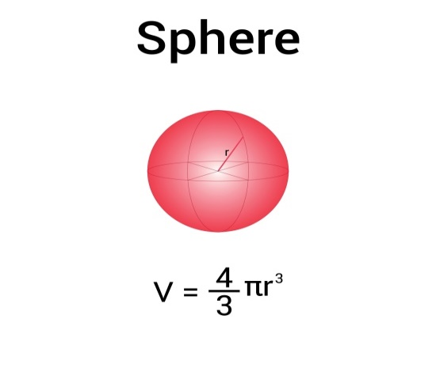

3. Cylinder
A cylinder has two flat circular ends and one curved side connecting them. It’s shaped like a tube.
- Real-life example: A soda can, a battery, or a glue stick.
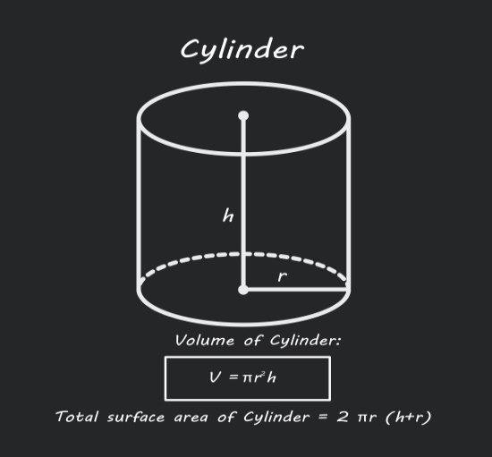

4. Cone
A cone has a flat circular base that narrows down to a single point at the top.
- Real-life example: An ice cream cone or a party hat.
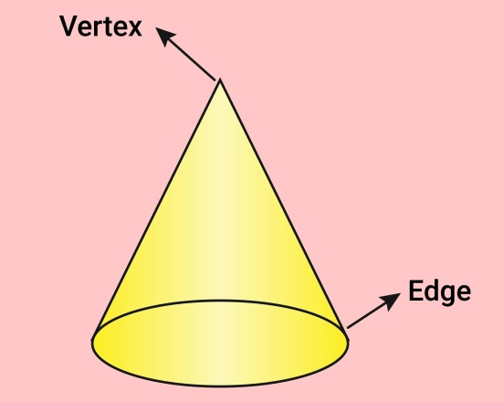

5. Rectangular Prism (Cuboid)
This is like a cube but stretched out. Its faces are rectangles.
- Real-life example: A brick, a cereal box, or a textbook.
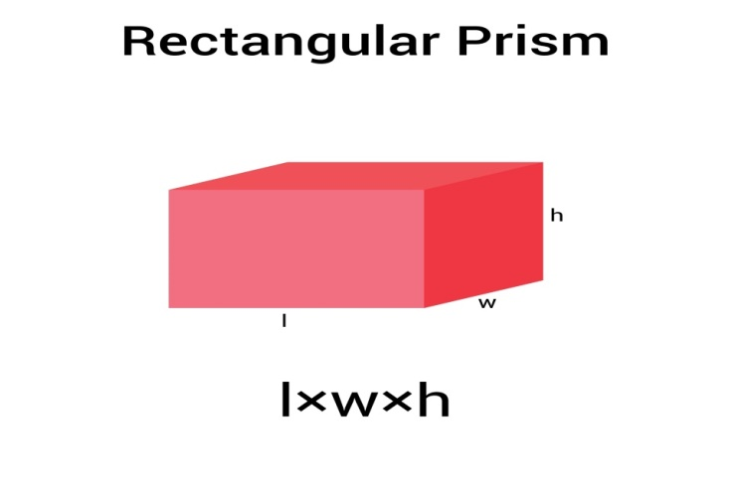

6. Pyramid
A pyramid has a flat base (usually a square) and triangular sides that meet at a point at the top.
- Real-life example: The Great Pyramids of Egypt or a tent.
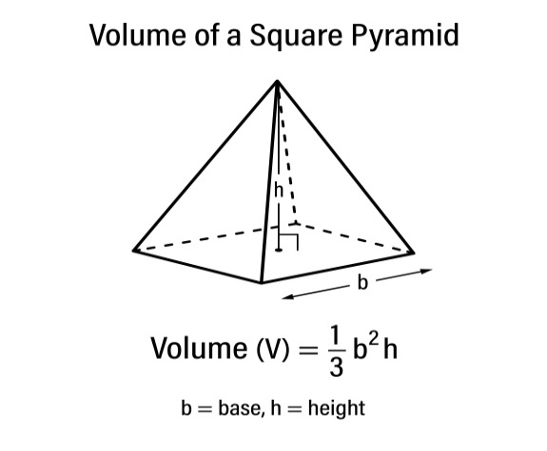

Summary Table
Shape | Faces | Edges | Vertices
Cube | 6 | 12 | 8
Sphere | 1 (curved) | 0 | 0
Cylinder | 3 (2 flat, 1 curved) | 2 | 0
Cone | 2 (1 flat, 1 curved) | 1 | 1
Rectangular Prism | 6 | 12 | 8

SUFACE AREA OF A CUBE, CUBOID AND CYLINDER()-
Surface area is the total area of all the outside faces of a 3D object. Imagine you are wrapping these shapes in paper; the amount of paper needed to cover them completely is the surface area.

1. Cube
A cube has 6 identical square faces. Since the area of one square is side × side (s²), we simply multiply that by 6.
- Formula:
Total Surface Area = 6s²
- Variable: s = length of a side (edge)
Example:
If you have a Rubik's cube where each side is 5 cm:
- Area = 6 × 5²
- Area = 6 × 25
- Total Surface Area = 150 cm²

2. Cuboid (Rectangular Prism)
A cuboid has 6 rectangular faces. These faces come in 3 matching pairs (top/bottom, front/back, and left/right).
- Formula:
Total\ Surface\ Area = 2(lb + bh + hl)
- Variables: l = length, b = breadth (width), h = height
Example:
Imagine a shoebox with length 10 cm, breadth 6 cm, and height 4 cm:
- Area = 2 × (10 × 6 + 6 × 4 + 4 × 10)
- Area = 2 × (60 + 24 + 40)
- Area = 2 × (124)
- Total Surface Area = 248 cm²

3. Cylinder
A cylinder has two circular bases and one curved side.
- Curved Surface Area (CSA): 2πrh (just the "tube" part)
- Total Surface Area (TSA):
2πr(r + h)
- Variables: r = radius of the base}, h = height of the cylinder}, π ≈ 3.14
Example:
A soda can has a radius of 3 cm and a height of 10 cm:
- Area = 2 × 3.14 × 3 × (3 + 10)
- Area = 18.84 × 13
- Total Surface Area ≈ 244.92 cm²

Quick Comparison Table
Shape | Formula | Key Feature
Cube | 6s² | All sides are equal
Cuboid | 2(lb + bh + hl) | Opposite faces are equal
Cylinder | 2πr(r + h) | Includes 2 circles and 1 curved side

