CRM
# BACK-OFFICE MODULE:
Once we add the Employee Master, we’ll have 3 Departments, Equity, Mutual Funds and Back-Office.
Once a back-office employee logs-in he/she should have a different landing page as their performance judging matrix is different.
The back-office performance will mostly be judged on the basis of task completion.
The back-office can receive tasks from the following Departments/Entities.
a) Equity.
b) Administration (Admin).
c) Mutual Fund.
The back-office Dashboard should contain 2 Boxes.
a) Number of Task completed (Task completed).
b) Task assigned (Task pending).
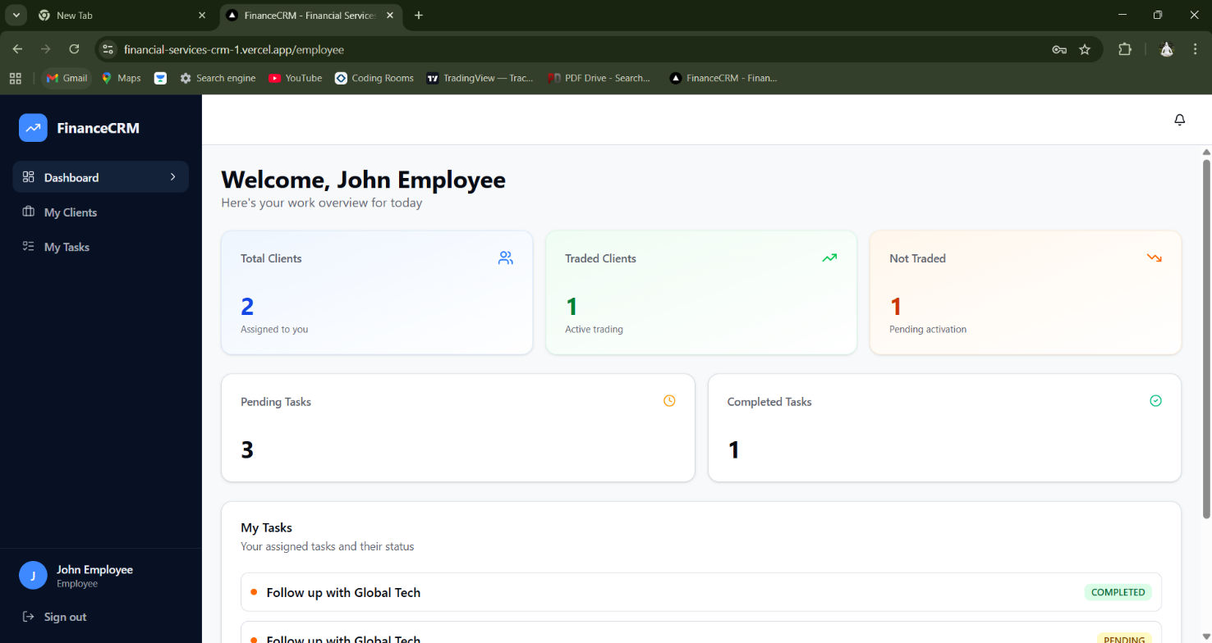

Things to keep on dashboard.
- Display name of Employee.
- His designation.
- Day and date (It should be auto).
- Then Task pending and Task completed tab.
- Give a small view button on both the tabs.
Reason: if user clicks (view) button on Task pending tab, he’ll only be able to see and work on his pending task, similarly if he clicks the view button on Completed task he/she will see only the completed task, this functionality adds ease of use for the user.
- In my task section, give a drop down for selecting day, week and month. Once the user selects any of the option, he should see only the ***PENDING***
Tasks for the (day, week, month).
- NOTE: THE DASHBORD SHOULD RESET EVERY MONTH.

The SIDE-BAR should include 3 options for Back-office personnel
- Dashboard. (all things to be included are mentioned above).
- Tasks.
- Reports.
TASK-SECTION:
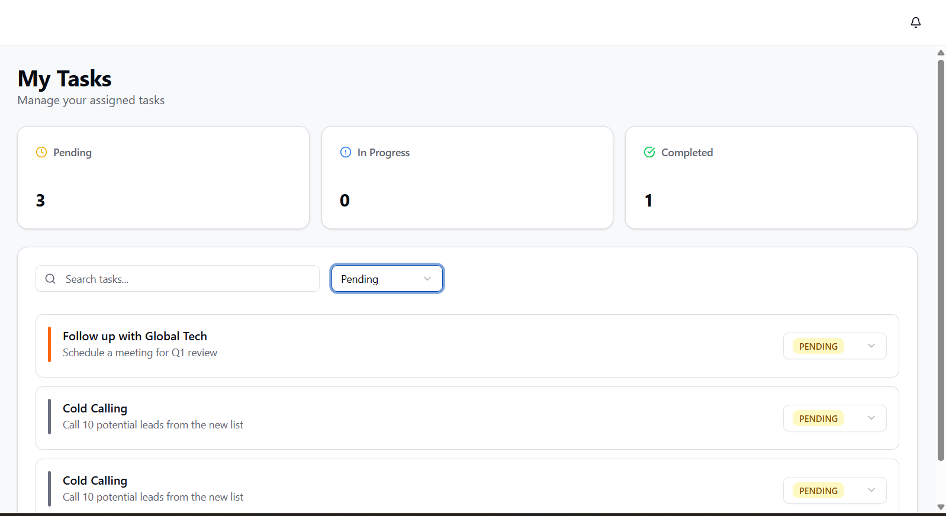
- Keep pending and completed tab.
- Show the tasks as shown above. (add days for expiry column, date of expiry column, department name from which the task is assigned(assignee)).
- Give 2 drop downs first Pending/Completed and second should be Admin, Mutual-fund, Equity. (NOTE: handle the filtering process here, if employee selects Equity and pending then he should only see pending tasks from equity department).
- Do not give drop down for changing task status as you have given here (Pending/ Completed).
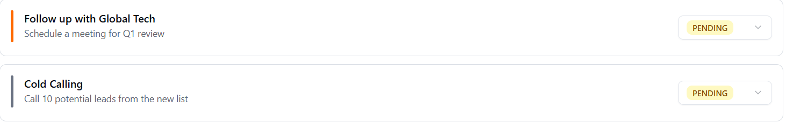
- Make the task bar in the above image clickable.
- Once the employee clicks it, he should see the task details and functionality as follows. (Name and Department of assignee, Days to expire, Date of expiry, a tab where the task has been mentioned.
- Below this you will give a click button of (Complete task).
- Once the employee clicks it a pop-up window appears in front of him where there should be a **warning message** that actions done cannot be reversed and give a submit button below it.
- Note: IF THE TASK EXPIRES (CROSSES THE DUE DATE, IT SHOULD AUTOMATICALLY GO IN PENDING TASKS AND THE EMPLOYEE SHOULD NOT BE ABLE TO CHANGE THE STATUS).
- Show all the tasks in my task section. (Note: expired, completed, pending) all should be visible.
- Note: TASKS SECTION SHOULD RESET EVERY MONTH.

REPORT-SECTION:
- Save all the Monthly data of pending and completed tasks.
- Show total tasks completed (example : we are in march we have monthly stored data for Jan and feb , when the employee see’s it he should have a bird’s eye view that how many tasks he has completed in 2 months and how many were pending.)

