CRM:
# Equity Department:
The performance of Equity department mostly depends on the Monthly Brokerage, Traded/Not-traded clients from their particular list.

# Functionality:
Daily brokerage updating and dashboard for the same.
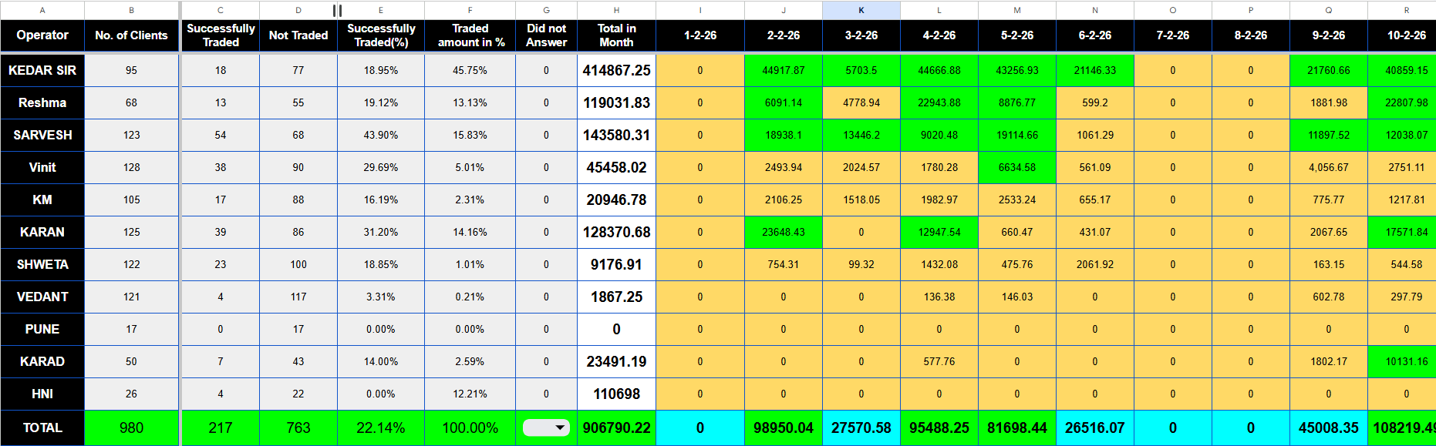
- This is the dashboard for dail brokerage updation.
- Give functionality for the **ADMIN** to update daily brokerage of every operator.
- FLOW :
The admin downloads the excel sheet of brokerage.
set of clients are assigned to every Operator in Equity.
The admin pastes the daily brokerage in rough sheet and then based on excel formulae the sheet maps and sums up the brokerage to every operator.
NOTE : The clients code is the common link here which can be used for reference in determining which operator has which client and to which operator’s account shall the system add-up/allocate the daily brokerage.

EXAMPLE:
A1, A2, A3 are three clients in Karan’s list, on 20 February karan executes their trade and each clients gives 50rs brokerage. The sheet is downloaded from SNAP (Ventura’s ERP system) it includes client code and brokerage. It is pasted in rough sheet and then the rough sheet maps the data to the main dashboard with proper cleaning process.
So, Karan’s brokerage for **20FEB** was 150rs (50+50+50) which is updated on 21 FEB by the admin.

NOTE:
Cleaning process includes handling duplicate/repeating client codes.
Example:
Karan executes 3 trades for A1 on 20Feb, brokerage for each trade is as follows. T1 10, T2 20, T3 25, so the sheet adds up the total brokerage for A1 for 20 FEB and directly updates the brokerage for A1 as (10+20+25)=55.

- This functionality will be refreshed every month , so once new month starts the brokerage sum will be 0 for every Operator , but make sure that the data of that month is stored.

- COLUMNS TO INCLUDE IN THIS DASHBOARD:
Operator name.
Total clients.
Traded clients (will be calculated when operator changes the status to traded form non-traded).
Non-traded clients (Total-Traded).
Percentage of traded clients (karan has 100 clients 10 are traded from them hence his % of traded clients is 10%).
at the bottom include total brokerage of company.
and total daily brokerage of the company.
Refer google sheet for complete understanding.

TRADED, NON-TRADED FUNCTIONALITY:

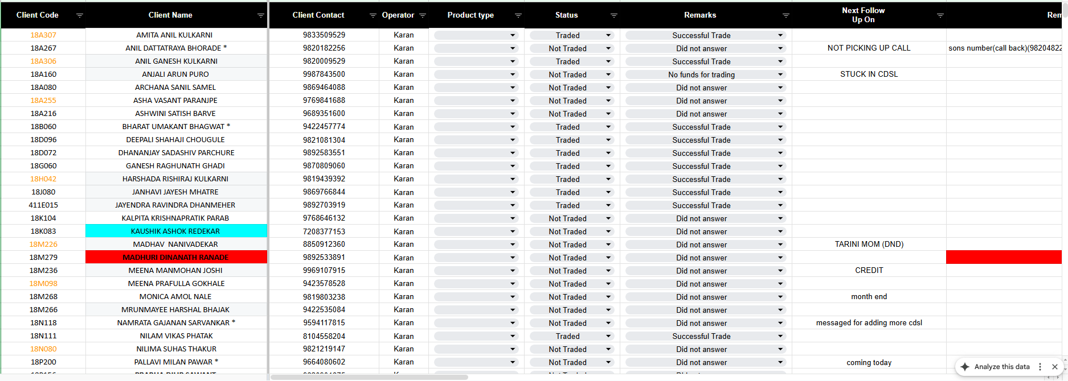

- COLUMNS:
CLIENT CODE.
CLIENT NAME.
CLIENT CONTACT NUMBER.
OPERATOR NAME.
STATUS (TRADED/NOT TRADED).
REMARK (successfully traded, not traded, no funds for trading, did not answer, self trading)
EXTRA TEXT BOX FOR ADDING NOTES.

- How this works?
once the operator executes the trade for particular client, he updates the status from “not traded” to “traded” in status and from “did not answer “to “successfully traded” in remark.
by default, the status should be “not traded” and remark should be “did not answer”.
note: when client master is added by developer / when client is assigned by the admin to the operator, the client should only reflect in the assigned operator’s list.
This sheet is to be refreshed monthly when all clients are not traded.

REPORTS SECTION:
- Monthly brokerage of the operator.
- Chart for the same.
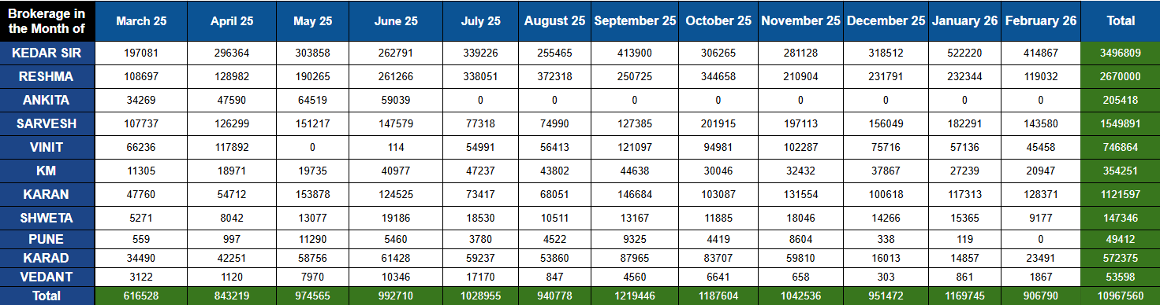

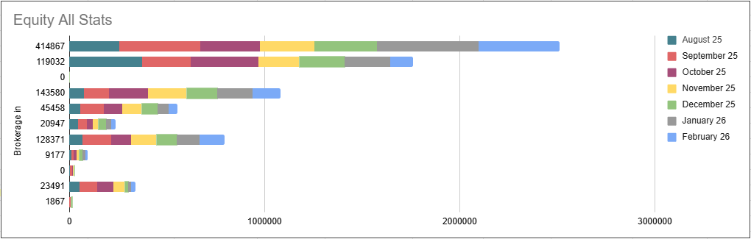

NOTE: The way you display the reports is on you, if you can make it more easy to understand then go for it , make sure all the functionality is covered

NOTE: The reference for these reports will come from the stored data of the monthly data for brokerage stored.

MASTERS DATA TO BE PROVIDED:
- Employee master for Equity
- Client master with (client code, phone number , name of clients , name of operator).
NOTE: when admin assigns a client , give him/her the option to add name of client (first, last, middle) , client code, phone number, default status will be not traded, drop down menu to select department (Equity and MF) and then once it is selected then provide drop down menu for particular employee from that department.

Client code formats:
- 18K099 : 18 branch code, K first letter of clients first name, 099 number. (pune and Mumbai branch)

- 91383117: only 8-digit number.(pune and Mumbai branch)

- 18KS008: 18 branch code, KKarad, S first name letter, 008 serial number. (specially for karad and pune branch).

NOTE: give wrong client code pop-up to admin if format other than this is mentioned.

