**Online Medical Health Service During COVID-19 (use style: *paper title*)**

*Abstract*—Under Consruction…

*Index Terms*—About four key words or phrases in alphabetical order, separated by commas.

1. INTRODUCTION

Online medical health  benefit is the utilize of restorative data traded from one location to another through electronic communications to move forward a patient’s clinical wellbeing status. Online medical health service benefit incorporates a developing assortment of applications and administrations utilizing two-way video, email, phones, remote devices, and other shapes of broadcast communications innovation.

Coronavirus illness 2019 (COVID-19) has definitely influenced healthcare over the globe.  Apparently, there's a concern almost the over-burdening of the wellbeing care capacity . These virtual care services provide a variety of non-dispensing functions, enabling physician to provide quality medical-care services during the COVID-19 pandemic.  Online medical health care can be coordinates into the healthcare framework as an approach to maximize the productivity of healthcare conveyance . It advances social removing degree and offer assistance restorative center in overseeing delayed holding up times and chance of illness movement . Train providers and staff on policies, practices, and protocols for using online health services, including appointment scheduling, documentation and billing, referral processes for specialty care, urgent and emergent care, laboratory services, pharmacy prescriptions, medical equipment, and follow-up visits. Future works will envelop recovering more writing on how to progress online health service  utilization. Online service gives a secure, available, and helpful medical-care.

1. METHODOLOGY

This survey was performed by preparing some questions based on “ online Medical health service during COVID-19 situation” .The survey has been conducted by mean of primary data collection measures. A survey was conducted by means of Google forms where some questions and answers were asked about the online Medical health service. At first a link was shared via facebook messenger and email. The survey was disseminated more than 80 pepole. The respondents were mixed in terms of age groups as well as profession. All the information was collected from everyone and then analyzed and conclusion was reached .

1. SURVEY RESPONSE & RESULTS

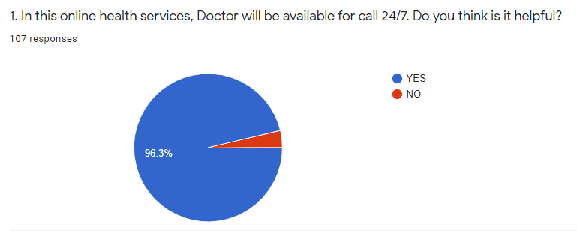

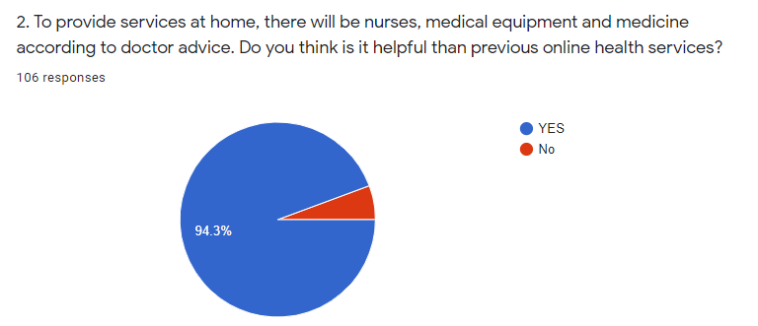

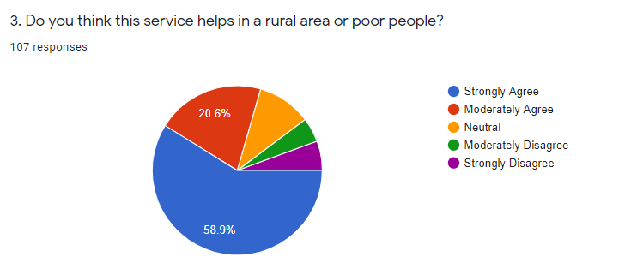

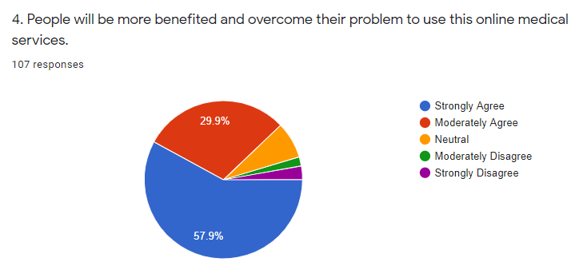

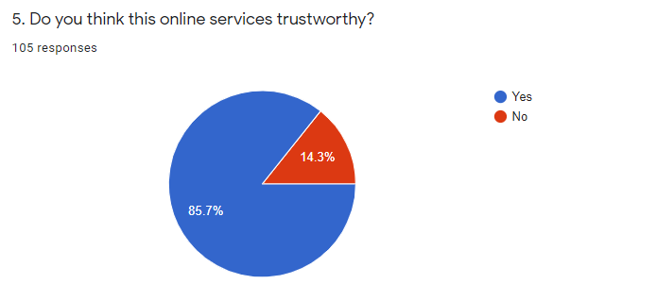

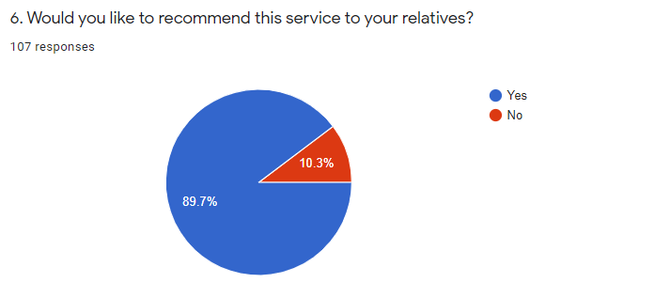

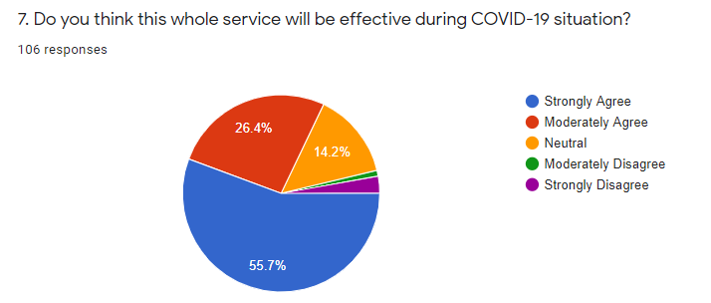

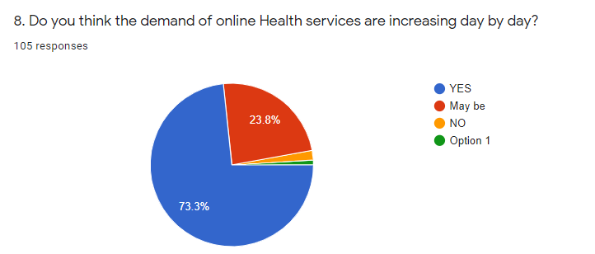

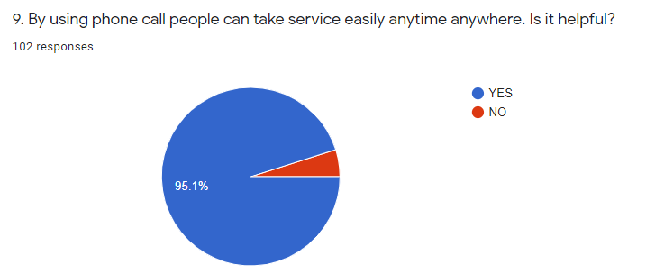

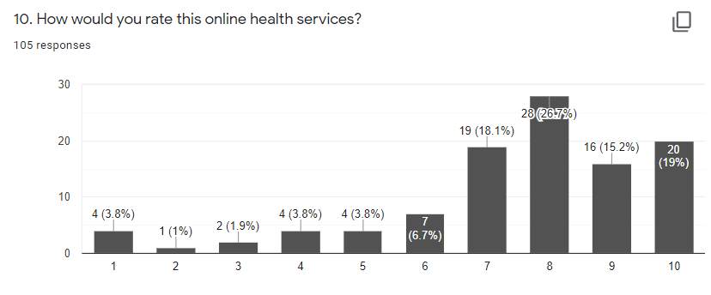

result will write Dohan

1. CONCLUSION AND RECOMMENDATION

Conclusion will write Shaily

REFERENCES