**Mobile Orb for Omnidirectional Navigation - MOON**

**21BRS1251 - Kartikey Prasad**

**21BRS1435 - Saatvik Sumanta**

**Circuit Schematic**

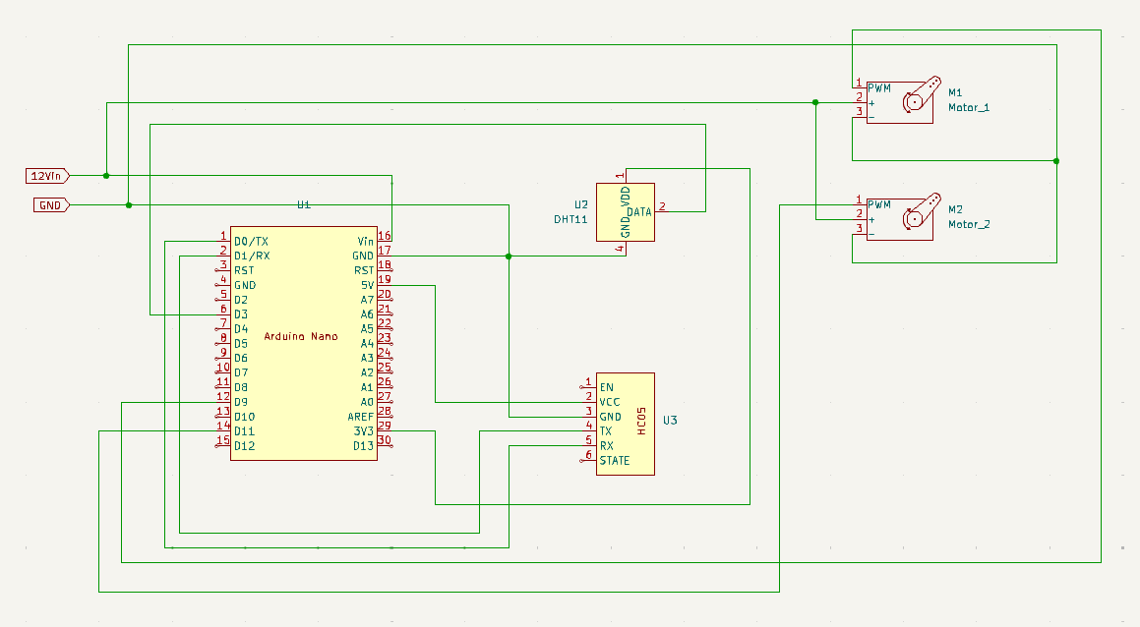

**PCB Schematic**

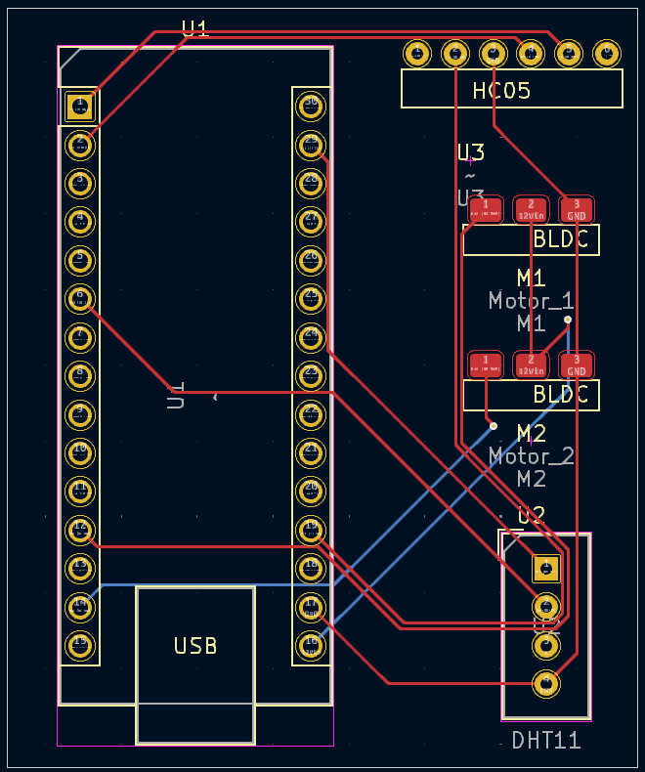

**3D View of PCB**

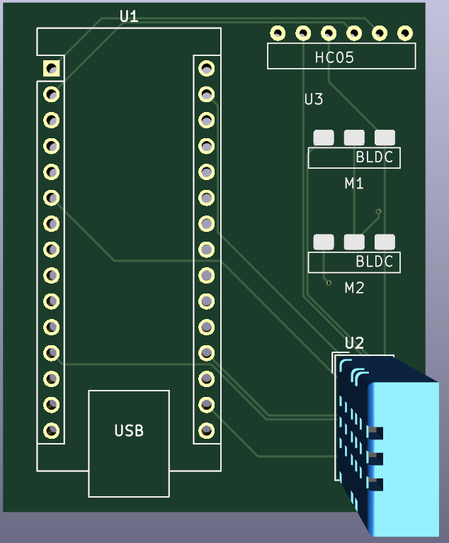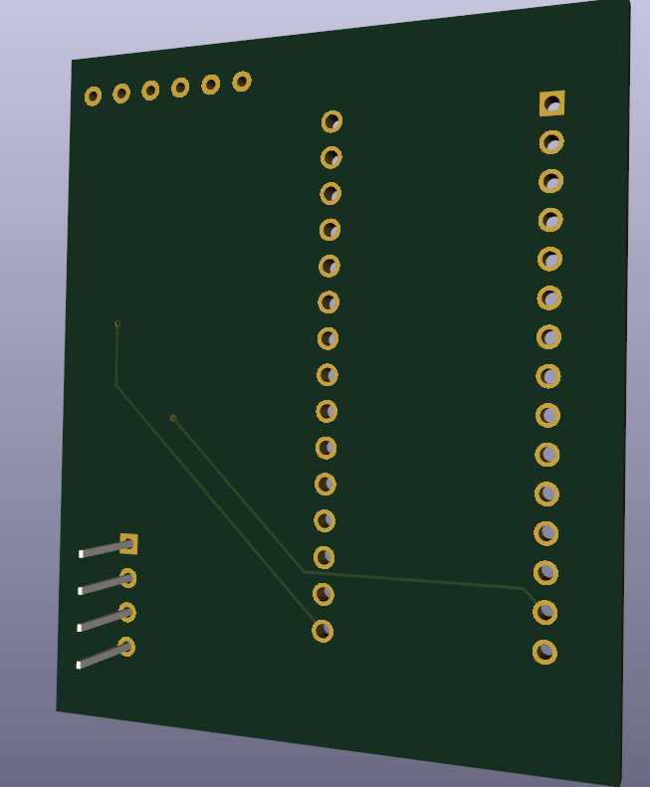

**3D Model of MOON**

