intro_to_ggplot
2026-01-21
First we are going to add our libraries. This includes openintro, tidyverse and palmerpenguins.
library(openintro)
## Loading required package: airports
## Loading required package: cherryblossom
## Loading required package: usdata
library(tidyverse)
## ── Attaching core tidyverse packages ──────────────────────── tidyverse 2.0.0 ──
## ✔ dplyr 1.1.4 ✔ readr 2.1.5
## ✔ forcats 1.0.1 ✔ stringr 1.5.2
## ✔ ggplot2 4.0.0 ✔ tibble 3.3.0
## ✔ lubridate 1.9.4 ✔ tidyr 1.3.1
## ✔ purrr 1.1.0
## ── Conflicts ────────────────────────────────────────── tidyverse_conflicts() ──
## ✖ dplyr::filter() masks stats::filter()
## ✖ dplyr::lag() masks stats::lag()
## ℹ Use the conflicted package (<http://conflicted.r-lib.org/>) to force all conflicts to become errors
library(palmerpenguins)
##
## Attaching package: 'palmerpenguins'
##
## The following objects are masked from 'package:datasets':
##
## penguins, penguins_raw
Call up the library. The package of palmerpenguins shows different species of penguin on the Palmer Archipelago, and provides measurements of each species, their sex and year.
Description of Dataser: The data was collected by Dr. Kristen Gorman at the Palmer Station, Antarctica LTER, a member of the Long Term Ecological Research Network. The data was collected as part of the US Long Term Ecological Research Network asking about foraging among adult male and female penguins. Data was collected in the Palmer Archipelago for PHD students.
glimpse(penguins)
## Rows: 344
## Columns: 8
## $ species <fct> Adelie, Adelie, Adelie, Adelie, Adelie, Adelie, Adel…
## $ island <fct> Torgersen, Torgersen, Torgersen, Torgersen, Torgerse…
## $ bill_length_mm <dbl> 39.1, 39.5, 40.3, NA, 36.7, 39.3, 38.9, 39.2, 34.1, …
## $ bill_depth_mm <dbl> 18.7, 17.4, 18.0, NA, 19.3, 20.6, 17.8, 19.6, 18.1, …
## $ flipper_length_mm <int> 181, 186, 195, NA, 193, 190, 181, 195, 193, 190, 186…
## $ body_mass_g <int> 3750, 3800, 3250, NA, 3450, 3650, 3625, 4675, 3475, …
## $ sex <fct> male, female, female, NA, female, male, female, male…
## $ year <int> 2007, 2007, 2007, 2007, 2007, 2007, 2007, 2007, 2007…

Question 1
ggplot(
# dataset
penguins,
# aes stands for aesthetics, first layer that defines axis and color
aes(x = bill_depth_mm,y = bill_length_mm,colour = species)) +
# scatterplot
geom_point() +
# titles to make the graphs clear and easy to read
labs(
title = "Bill depth and length",
subtitle = "Dimensions for Adelie, Chinstrap, and Gentoo Penguins",
x = "Bill depth (mm)", y = "Bill length (mm)",
colour = "Species",
caption = "Source: Palmer Station LTER / palmerpenguins package"
)
## Warning: Removed 2 rows containing missing values or values outside the scale range
## (`geom_point()`).
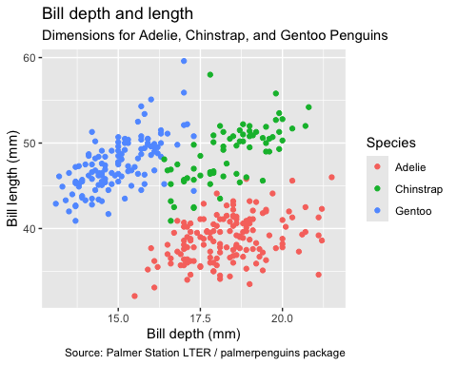 We are looking at three different species of penguin (Adelie, Chinstrap, and Gentoo). We are then looking at the Bill Length v.s Bill Depth graph to see the correlation.
- 3 variables
- Bill Length (y-axis), Bill Depth (x-axis), and Species (color)
- It is a scatterplot
- Each variable is represented as a specific individual penguin species.

Question 2
- The following data was collected by Dr. Kristen Gorman.
- The data was collected in the Palmer Station in the Palmer Archipelago
- They collected data by measuring the penguin bill length, bill depth, fipper length, body mass, sex, and age.

