DIGITAL GEOMETRY
UGE M2 INFORMATIQUE “IMAGERY SCIENCE”

TP1 : Counting and measuring grains

Step 1 - DOWNLOAD AND OBSERVE SEGMENTED IMAGES

Characteristics of rice grains with the naked eye :
- (A) - Basmati rice is long and thin.
- (C) - Japanese rice is the opposite of basmati rice, it is small and thick, it looks light like a ball in general.
- (B) - Camargue rice is between basmati rice and Japanese rice, it is a little long and a little thick.

Step 2 - COUNT GRAINS

- Basmati rice : 141 components detected → 124 after elimination
- Camargue rice : 132 components detected → 112 after elimination
- Japanese rice : 147 components detected → 138 after elimination

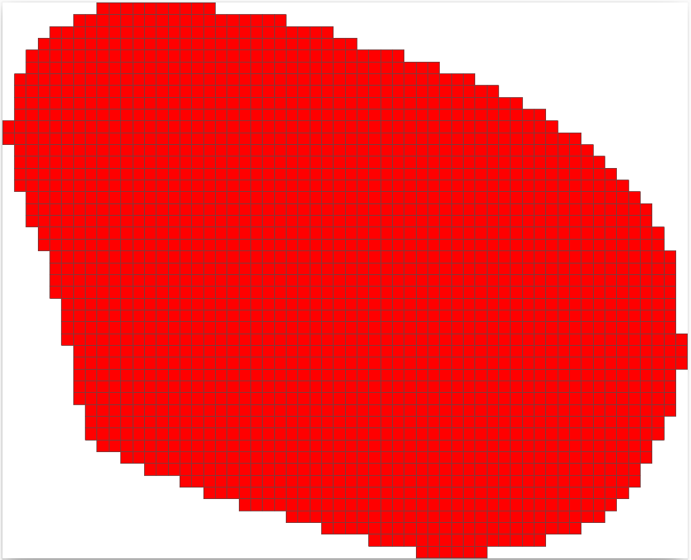Japanese
Basmati
Camargue

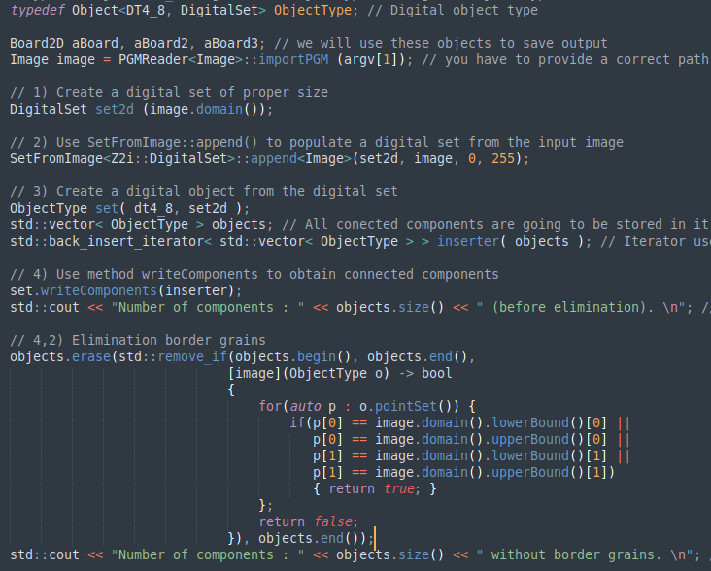

Step 3 - EXTRACT DIGITAL OBJECT BOUNDARY
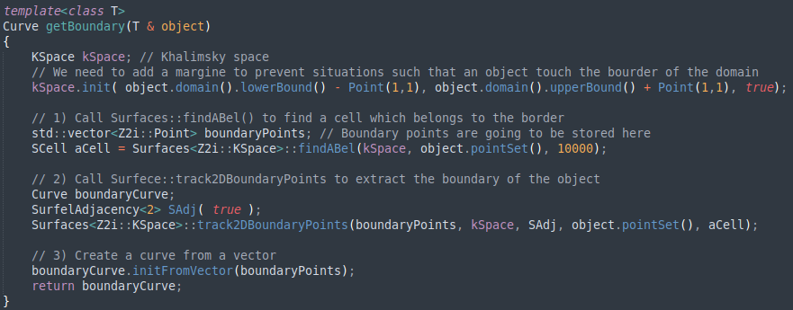

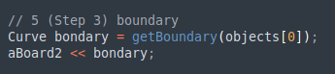

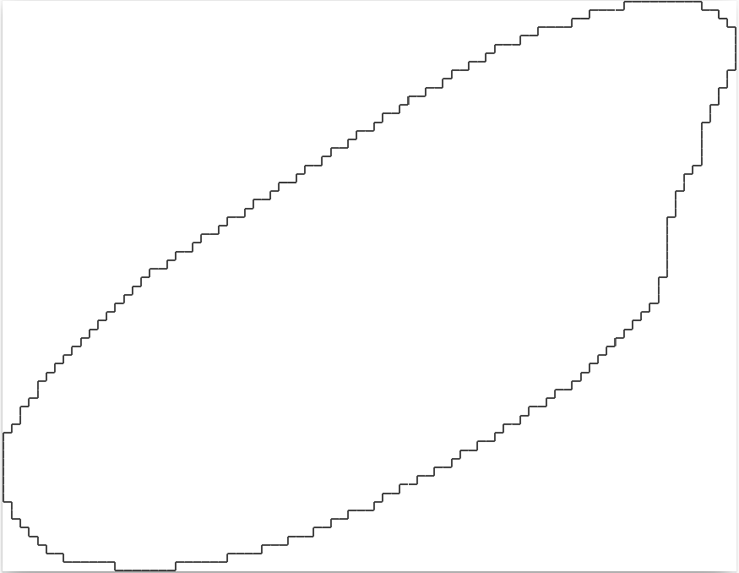Camargue
Japanese
Basmati

Step 4 - POLYGONIZE DIGITAL OBJECT BOUNDARY

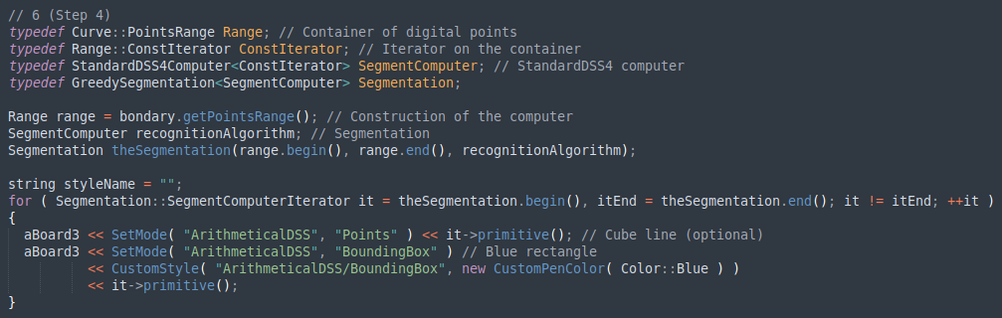

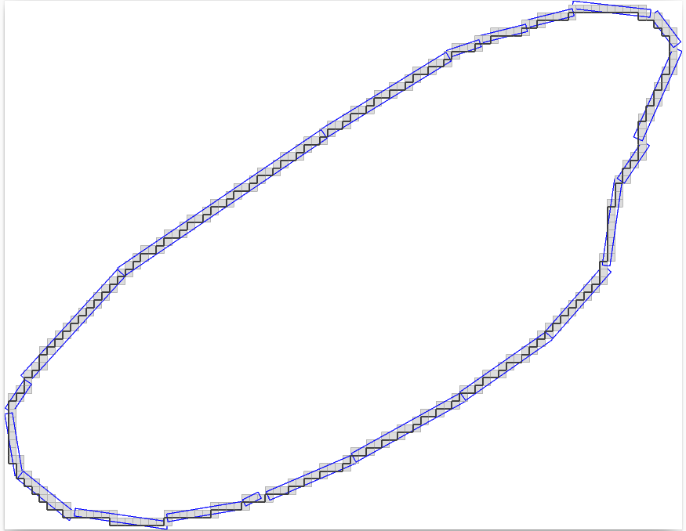Camargue
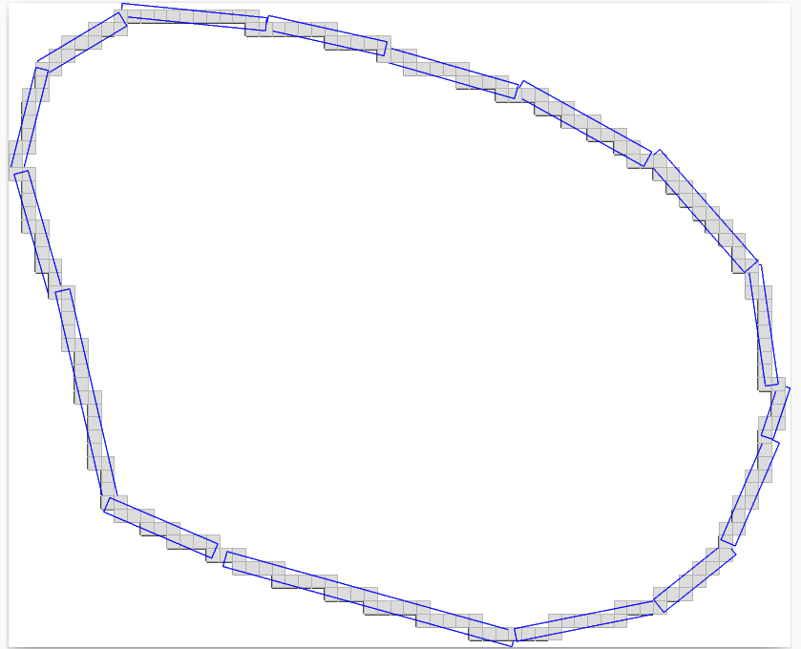Japanese
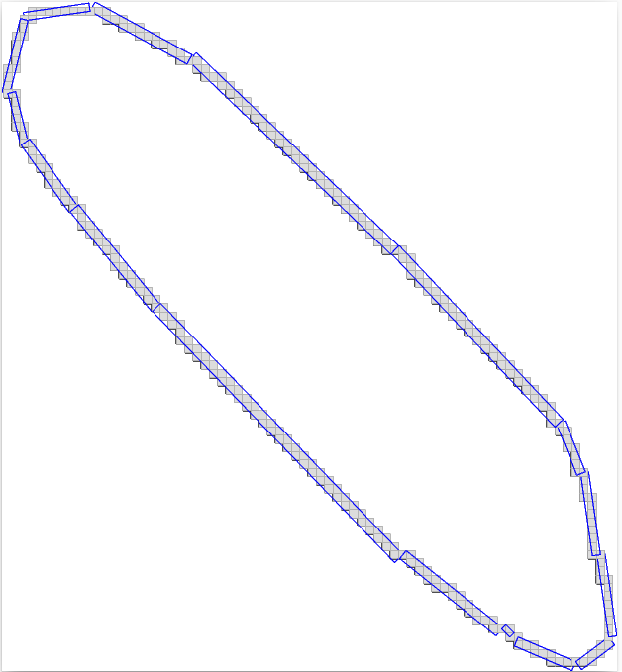Basmati

Step 4.2 and 5 - CALCULATE AREA AND PERIMETER

- Average area of Basmati rice :
  - With number of grid points → 2249.97
  - With area of the polygon → 2229.69
- Average area of Camargue rice :
  - With number of grid points → 2693.56
  - With area of the polygon → 2671.89
- Average area of Japanese rice :
  - With number of grid points → 2068.46
  - With area of the polygon → 2048.06

- Average perimeter of Basmati rice :
  - With the boundary → 292.048
  - With the perimeter of the polygon → 222.056
- Average perimeter of Camargue rice :
  - With the boundary → 272.107
  - With the perimeter of the polygon → 204.839
- Average perimeter of Japanese rice :
  - With the boundary → 220.362
  - With the perimeter of the polygon → 165.848
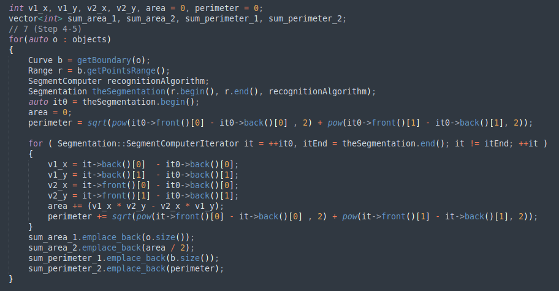
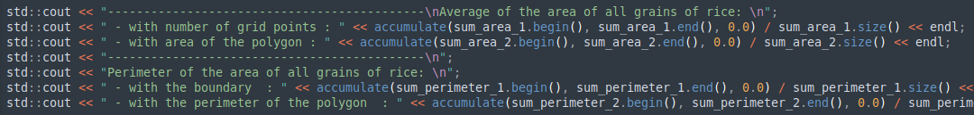

Step 6 - PROPOSE AND CALCULATE CIRCULARITY

For calcul .. I will use this a mathematical formulation : 4π × Area / Perimeter2
This formulation give a number between 1 and 0, the number 1 correspond to a perfect circle and 0 to the opposite.

