Evaluating low cost hyperspectral and RGB imaging of inoculated Arabidopsis plants under controlled conditions
Gabriel U. Crabb^{1,*}, Yiding Zhao^{2,3,*}, Nicholas K. Priest^{1,†}, Xi Chen^{2,3,4,†}, Volkan Cevik^{1,†}
*These authors contributed equally to this work. †Corresponding authors.
¹ Milner Centre for Evolution, Department of Life Sciences, University of Bath, Claverton Down, Bath, BA2 7AY, United Kingdom
² Artificial Intelligence Innovation and Incubation Institute, Fudan University, Shanghai, China
³ Shanghai Academy of AI for Science, Shanghai, China
⁴ Department of Computer Science, University of Bath, Claverton Down, Bath, BA2 7AY, United Kingdom
Corresponding authors: Volkan Cevik (v.cevik@bath.ac.uk); Xi Chen (xi_chen@fudan.edu.cn); Nicholas K. Priest (N.Priest@bath.ac.uk)

Highlights
- Low-cost Raspberry Pi hyperspectral camera paired with RGB imaging
- Inoculated and mock plants compared within each dpi using plant-disjoint folds
- At 4 dpi, before symptoms, RGB-based models reached 84–92% balanced accuracy
- A benefit of hyperspectral information over RGB was not demonstrated
- Needs a dark room and lamp: a controlled-environment tool, not field-ready

Abstract
Early detection of plant infection requires evaluation that separates treatment-associated signals from repeated observations and acquisition effects. We evaluated a Raspberry Pi hyperspectral imaging (HSI) unit paired with RGB imaging in a single controlled experiment with Arabidopsis thaliana inoculated with Albugo candida. The documented camera components cost £489.20, excluding printing, illumination and supporting equipment. The design comprised 96 plants (72 inoculated and 24 mock-inoculated) imaged at 2, 4 and 6 days post inoculation (dpi); the archived analysis used 569 paired observations. Date-matched binary tasks were evaluated with five plant-disjoint folds and three training seeds, with probabilities aggregated within plants. The dual-stream PSNet model achieved balanced accuracies of 56.16%, 83.56% and 95.37% at 2, 4 and 6 dpi, respectively, and corresponding AUROCs of 0.605, 0.939 and 0.990. RGB-only models performed within the range of multimodal models, and no architectural component showed a consistent benefit across tasks. Exploratory whole-cube spectral comparisons identified 302 of 313 computational bands at 2 dpi, but none at 4 or 6 dpi, after within-date false-discovery-rate correction. This reversed temporal pattern does not establish an infection-specific spectral signal. A separate single-seed, pooled-date experiment found that selecting ten bands on fitting plants retained high classification scores, but paired intervals did not establish an advantage over its full-band reference. Treatment was confounded with tray and acquisition order, and no independent cultivation run was available. The results demonstrate within-run group discrimination under controlled conditions and do not establish field performance or infection-specific diagnosis.
Keywords: hyperspectral imaging; presymptomatic detection; plant disease; Albugo candida; Arabidopsis thaliana; low-cost sensing; multimodal deep learning; plant-level cross-validation

1 Introduction
Plant diseases pose a persistent threat to food security: pests and pathogens are together responsible for up to 40% of annual crop losses worldwide [1,2], and climate change and expanding trade are altering host–pathogen dynamics and increasing outbreak frequency [3,4]. Infection is usually recognised only after visible symptoms emerge, when intervention is less effective and yield loss may already be unavoidable. In practice, growers therefore often rely on prophylactic or calendar-based fungicide and pesticide applications, which raise production costs, cause environmental contamination and non-target effects, and accelerate the evolution of resistance in pathogen populations [5,6]. Reliable presymptomatic diagnostics would allow interventions to be targeted rather than blanket.
Existing diagnostic approaches trade sensitivity against deployability. Visual scouting is subjective and detects disease only after symptoms develop [7]. Molecular assays, including PCR-based tests and isothermal amplification, are sensitive but need specialised equipment, laboratory conditions and technical expertise [8,9], and CRISPR-based diagnostics remain at an early stage of field validation [10]. Hyperspectral imaging (HSI) is a non-destructive alternative that records a reflectance spectrum for each pixel and can register changes in pigment content, water status and tissue structure associated with biotic stress [11–14], and presymptomatic detection has been reported in several host–pathogen systems, including tobacco and tomato [15,16]. Its adoption is limited, however, by the cost of commercial systems, by the computational demands of the data, and by wide variation in reported accuracy that reflects differences in sensor design, calibration standards and analytical pipelines [17].
Two features of experimental design further complicate the interpretation of published accuracies. First, hyperspectral datasets usually contain several images of the same plant, so evaluation must partition data at the plant level; otherwise near-duplicate samples appear in both training and test sets and generalisation is overestimated. Second, if controls from every time point are pooled into a single healthy class while inoculated plants are separated by time after inoculation, a classifier can succeed by learning plant age, imaging session or acquisition conditions rather than infection. A credible test of presymptomatic detection therefore compares inoculated and mock-inoculated plants imaged at the same time point, and reports the presymptomatic time points separately from those at which symptoms are already visible. Even then, a random hold-out of plants from one experimental run shares its cultivation cycle, inoculum, calibration session and illumination with the training data, and is not an external test set.
Most deep-learning approaches to hyperspectral classification use spectral information alone [18,19]. Combining HSI with inexpensive RGB imaging is an obvious way to add spatial context, and fusion of complementary modalities is generally expected to help. Whether the hyperspectral stream contributes information beyond the RGB stream for early infection, under a design that controls for the confounds above, has been examined less often.
Here we describe and evaluate a low-cost imaging unit adapted from an open-source 3D-printed hyperspectral camera [20] and used, together with RGB imaging, on the Arabidopsis thaliana–Albugo candida pathosystem. A. thaliana is a genetically tractable host with a well-characterised immune system [21], and A. candida has a defined latent phase before visible symptoms appear [22]. Plants were imaged at 2 and 4 days post inoculation (dpi), before visible symptoms, and at 6 dpi, when sporulation has begun on the abaxial leaf surface although the imaged upper surface remains symptom-free. Our aims were to (i) document the imaging unit, its cost boundary and the acquisition conditions it requires; (ii) evaluate inoculated versus mock-inoculated classification separately at each time point under plant-disjoint cross-validation with several random seeds; (iii) test, with RGB-only, HSI-only and multimodal baselines and ablations, whether the hyperspectral stream adds information; and (iv) state explicitly what this single-run dataset can and cannot show. We evaluated a dual-stream HSI–RGB Transformer, PSNet, as the multimodal model, and we report all baselines and variants for which complete results are available, including those in which PSNet does not perform best.

2 Materials and methods
Sections 2.1–2.4 describe the biological material, the imaging unit, the acquisition protocol and the calibration and preprocessing. Section 2.5 defines the dataset, the classification tasks and the plant-level evaluation design. Section 2.6 describes the computational framework (PSNet, baselines and ablations) and section 2.7 the spectral statistics.
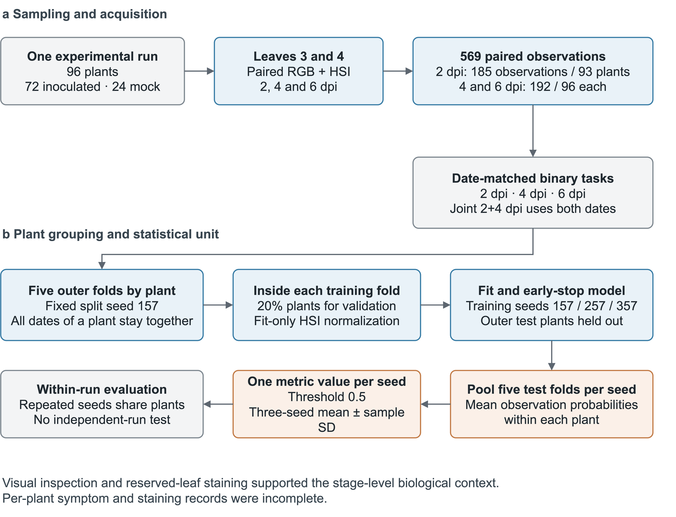
Figure 1. Experimental design and analysis workflow. Arabidopsis thaliana plants were inoculated with Albugo candida or mock-inoculated and imaged at 2, 4 and 6 dpi. Paired HSI and RGB observations were partitioned by plant and evaluated in date-matched binary tasks. Microscopy was reported for a reserved leaf subset; it was not a quantitative per-plant reference standard for the classification labels.

2.1 Plant material, inoculation and infection validation
The host was the fully susceptible A. thaliana line Col-eds1.2 wrr7 [23], which is highly susceptible to the oomycete A. candida (white blister rust) race 4 isolate AcEM2. Seeds were obtained from a certified stock centre. Five 6 × 4 cell trays were filled with a well-drained soil:sand substrate (F2s), and an additional pot with the same mix was used for germination. Seeds were broadcast, vernalised at 4 °C in darkness for 72 h, and transplanted at one plant per cell. Trays stood in water-filled catch trays to maintain uniform moisture by capillarity. Humidity lids were removed at the first true-leaf stage. Unless stated otherwise, conditions were 22 °C, 16 h light/8 h dark, ~60% relative humidity and 120–150 μmol m⁻² s⁻¹ photosynthetic photon flux density. Seedlings were inoculated about three weeks after transplanting, when rosettes bore four to five true leaves.
Spray guns, flasks and bottles were wiped with 100% ethanol before use. Leaves bearing visible A. candida pustules were suspended in chilled sterile water, and sporangia were dislodged by gentle agitation, filtered through nylon mesh and diluted on ice to 10⁵ spores ml⁻¹. Controls received sterile water only. A single run used 96 seedlings (72 inoculated, 24 mock-inoculated). Both leaf surfaces were misted to run-off. Trays were held at 4 °C for 24 h and then at 22 °C with 10 h light and 18 °C with 14 h dark until 2 dpi, after which standard growth conditions resumed. Symptoms were assessed visually; abaxial sporulation was observed around 6–8 dpi. Trypan blue staining and microscopy were reported for a reserved subset at 2, 4 and 6 dpi, following the previously cited workflow [24]. The available records do not establish stained-leaf denominators, matched mock results or a per-plant infection confirmation rate. Accordingly, the computational labels denote inoculation treatment, not independently confirmed infection in every plant.

2.2 Low-cost imaging unit
The hyperspectral camera was adapted from the open-source 3D-printed design of Salazar-Vazquez and Mendez-Vazquez [20]. The camera, controller and software were updated (Table 1). The camera mount, Part07_Camera, was redesigned as Part07_Camera_Module_3 to accommodate the different lens and autofocus geometry while retaining the PCB mounting-hole positions. The remaining enclosure and optical components were retained except for the objective-lens upgrade described below. Alternative case and lid variants were prototyped but were not used in the final system. The unit is an engineering adaptation of an existing design; the original design files are described in [20].
The optical train (Fig. 2b) comprises a 35 mm Edmund Optics C Series VIS–NIR fixed-focal-length lens (part 67-716; component 2), a front lens (3), a square aperture (4), two extension tubes (5, 6), a +10 macro lens of 52 mm diameter (7) and a diffraction grating (8), mounted on the camera base (9) that carries the sensor board (10). The processing software of the original design (squareHSIBetaV1) extracts the zero-order and first-order diffraction regions from each exposure and, after wavelength calibration and dark correction, assembles them into a spectral cube [20]. The original design used a different 35 mm Edmund Optics lens (part 59872); the VIS–NIR lens was a deliberate optical upgrade. The +10 close-up lens and the diffraction grating were retained from the original build. Source images were acquired at 2592 × 1944 pixels and reconstructed into cubes of 132 × 135 spatial pixels. The Camera Module 3 (IMX708) supports a higher native resolution than the 2592 × 1944 output used here. We retained that output size because the reconstruction software (squareHSIBetaV1) was developed around the earlier camera and expects this image format, and we could not modify it sufficiently within this study to use the full native output. The spatial resolution of the sensor was therefore not fully exploited (Section 4.6). Sensor readout and exposure are controlled by a Raspberry Pi 4B through the libcamera stack.
Table 1. Modifications to the open-source 3D-printed hyperspectral camera design of Salazar-Vazquez and Mendez-Vazquez [20].
Component | Original design | This build | Purpose or effect
Camera module | Raspberry Pi Camera Module 2 NoIR | Raspberry Pi Camera Module 3 NoIR (12 MP, Sony IMX708) | NoIR variant omits the infrared-blocking filter, preserving response beyond the visible range
Controller | Raspberry Pi 3B | Raspberry Pi 4B (8 GB RAM) | Processing stability; power delivery through USB-C
Objective lens | Edmund Optics 35 mm C Series fixed-focal-length lens, #59872 | Edmund Optics 35 mm C Series VIS–NIR fixed-focal-length lens, #67-716 (£382.50) | Deliberate VIS–NIR upgrade; transmission in the red and near-infrared
Close-up lens and grating | +10 close-up lens; diffraction grating | Both retained from the original build | No change
Focusing | — | External lens fixed for imaging geometry; Camera Module 3 autofocus (macro range) for fine focus | Consistent focus on small leaves at close range
Acquisition software | raspistill / raspivid utilities | libcamera stack | Stable preview and fine-grained control under current Raspberry Pi OS
Camera mount | Part07_Camera | Redesigned as Part07_Camera_Module_3 | Same PCB hole positions; different lens and autofocus geometry. All other structural parts unchanged
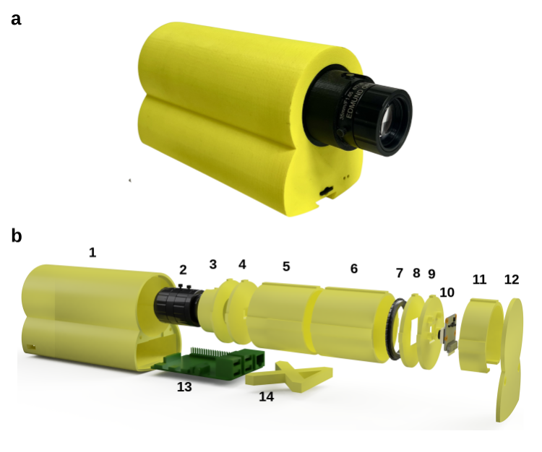
Figure 2. The low-cost hyperspectral imaging (HSI) unit. (a) Assembled unit. (b) Exploded view (CAD render) of the optical, structural and electronic components: 1 case; 2 35 mm Edmund Optics C Series VIS–NIR fixed-focal-length lens (67-716); 3 front lens; 4 square aperture; 5, 6 extension tubes; 7 +10 macro 52 mm lens; 8 diffraction grating; 9 camera base; 10 Raspberry Pi Camera Module 3 NoIR (12 MP); 11 seal extension; 12 lid; 13 Raspberry Pi 4 Model B; 14 X-axis extension.
The documented components total £489.20: the Edmund Optics VIS–NIR lens (£382.50), Raspberry Pi 4 Model B with 8 GB RAM (£62.50), Camera Module 3 NoIR (£21.70), and replacement-price estimates for the reused +10 close-up lens (£13.50) and grating (£9.00). Storage and power accessories were supplied with the Raspberry Pi. Printing costs and the price-record date were not retained, so this is a component subtotal rather than a verified total build cost. The laboratory illumination source, copy stand and cube-assembly workstation are excluded.

2.3 Acquisition set-up and protocol
All imaging was performed in a dark room to exclude ambient light. Both the HSI and RGB data were acquired top-down from the adaxial (upper) leaf surface only. Samples were illuminated with the Leica CLS 150 X source through dual fibre-optic arms placed symmetrically at approximately 45° to the sample plane. The camera was mounted on a copy stand about 10 cm above a matte-black background, and the source was warmed up for about 15 min at the start of each session and then left running continuously. Camera height and imaging geometry were kept consistent throughout a session and were not deliberately reset between trays. The external 35 mm lens was positioned for the required imaging geometry, and the Camera Module 3 autofocus was enabled in macro mode for fine focus, so focus was not fixed at infinity; live preview was used to position each sample. Images were captured with libcamera-still (JPEG quality 100, tungsten white-balance mode, cdn_hq denoising, 20 s preview, 2592 × 1944 pixels, macro autofocus range, RGB888 output). Exposure was fixed at 2 s (2,000,000 µs). Analogue gain was not set in the command and was under automatic control; it was not independently logged. Samples were processed sequentially and we tried to keep a similar acquisition order between sessions, but the order was not strictly fixed, formally randomised or logged. Inoculated and mock-inoculated plants were kept on separately marked trays and imaged with the same acquisition workflow. The mock tray was always imaged first and the inoculated tray second, at every session (2, 4 and 6 dpi), to reduce the risk of cross-contamination from inoculated material. Treatment was therefore consistently correlated with acquisition order, which is a potential acquisition-time confound (Section 4.7).
The design comprised 96 plants (72 inoculated and 24 mock-inoculated), each scheduled for imaging at 2, 4 and 6 dpi. Two designated leaves (leaves 3 and 4 of the rosette) were followed across sessions using physical leaf markers, giving 576 planned HSI–RGB image pairs. The RGB inventory contains 576 observations, whereas the archived paired-data analysis manifest contains 569: 185 at 2 dpi (137 from 69 inoculated plants and 48 from 24 mock-inoculated plants), and 192 at each of 4 and 6 dpi (144 from 72 inoculated plants and 48 from 24 mock-inoculated plants). Seven observations present in the RGB inventory are absent from the paired-data manifest, all at 2 dpi: leaf 4 of inoculated plant 69 and leaves 3 and 4 of inoculated plants 70–72. The surviving records do not establish why these observations are absent from the paired-data analysis. Analysis identifiers were reconstructed from source filenames encoding plant number, treatment, leaf and dpi. Inoculated plant numbers were retained across dates. Mock source numbers 1–24, 25–48 and 49–72 at 2, 4 and 6 dpi, respectively, were mapped to analysis plant numbers 1–24 using ((source number − 1) modulo 24) + 1. Treatment was included in each plant identifier. This computational mapping was checked against the archived manifest; the original tray-position-to-plant-ID record was not available for independent verification. The two leaves of a plant were not guaranteed to have been imaged in the same within-plant order at every session.

2.4 Spectral calibration and preprocessing
The reconstruction workflow followed Salazar-Vazquez and Mendez-Vazquez [20], using fluorescent-lamp emission peaks, an incandescent-lamp spectrum and lens-covered dark frames for wavelength calibration and dark correction. The available records do not establish the timing of each calibration frame relative to individual trays. Archived model inputs contain 313 computational bands. Acquisition documentation reports 273 calibrated positions spanning 400.000–968.487 nm, but their correspondence to the historical PT tensor axis has not been independently verified. The subsequently recovered MAT files contain a nominal 313-position axis spanning 400.000–1052.090 nm; this alone does not validate the calibration range or the historical band mapping. Analyses therefore use computational band index. No white reference was used, and the data must not be interpreted as absolute reflectance. Spectral resolution, signal-to-noise ratio, linearity, repeatability, saturation behaviour and RGB–HSI registration accuracy were not independently characterised (Table 2).
Archived HSI tensors have 313 channels and 132 × 135 spatial pixels. The retained training code reads these tensors directly; the upstream masking and intensity-transformation provenance is incomplete, so the spectral summaries are described as whole-cube rather than verified leaf-only measurements. Per-band standardisation statistics were estimated using only the fitting plants inside each outer fold, excluding both inner-validation and outer-test plants, and then applied unchanged. RGB images were resized to 224 × 224 pixels and normalised with the ImageNet channel means and standard deviations.
Table 2. Acquisition settings and instrument characteristics.
Characteristic | Value | Status or note
Illumination | Leica CLS 150 X, 150 W halogen, 3400 K; dual fibre-optic arms at ~45° | Excluded from the £489.20 component subtotal
Geometry and environment | Camera ~10 cm above sample on a copy stand; matte-black background; dark room; 15 min warm-up | Controlled conditions
Exposure | 2 s (2,000,000 µs), fixed | Fixed in the acquisition command
Analogue gain | Automatic (not set in the command) | Not independently logged
Acquisition command | libcamera-still: quality 100, tungsten white balance, cdn_hq denoising, 20 s preview, macro autofocus | Camera Module 3 autofocus enabled
Image and cube size | Source 2592 × 1944 px; cube 132 × 135 px | Below the native IMX708 resolution (Section 4.6)
Spectral positions | 313 computational; 273 with calibrated wavelengths | Historical tensor-to-wavelength mapping unverified
Calibrated wavelength range | 400.000–968.487 nm | Lens specified ~425–1000 nm
Mean spacing of calibrated positions | ≈2.1 nm | Sampling interval, not spectral resolution
Spectral resolution | Not characterised | Not measured in this experiment; limitation
Wavelength calibration error | Not characterised | Not measured in this experiment; limitation
Signal-to-noise ratio | Not characterised | Not measured in this experiment; limitation
Spatial resolution | Not characterised | Not measured in this experiment; limitation
Repeatability | Not characterised | Not measured in this experiment; limitation
Sensor linearity and saturation | Not characterised | Not measured in this experiment; limitation
RGB–HSI registration accuracy | Not characterised | Not measured in this experiment; limitation

2.5 Dataset and plant-level evaluation design
Tasks. The primary analysis is a binary classification of inoculated (positive class) versus mock-inoculated plants, performed separately at 2, 4 and 6 dpi. We treat 2 and 4 dpi as presymptomatic because no sporulation was visible on either leaf surface at those times. Visible symptoms were not observed on the imaged adaxial surface at any time point, including 6 dpi; at 6 dpi, however, sporulation was visible on the abaxial surface, so 6 dpi is a transitional, later infection-stage reference and not a visually symptomatic imaging condition. We also evaluated a joint 2+4 dpi task, which combines the two presymptomatic time points and excludes 6 dpi, and, for one seed, a task with all dates pooled, which includes 6 dpi observations from a later infection stage (Table 3). Because the joint task uses information acquired at 4 dpi, it does not measure detection at 2 dpi alone. Within each time point, inoculated and mock-inoculated plants were imaged concurrently, so plant age and session are shared by both classes. The tasks share plants and are not independent of one another; the available paired observations differ at 2 dpi as specified in Table 3.
The unit of analysis is the plant. Predicted positive-class probabilities were averaged over its available observations, including available dates in pooled tasks, and thresholded at 0.5; AUROC used the unthresholded means. Missing observations were not imputed. Five treatment-stratified, plant-disjoint outer folds were generated with split seed 157 and held fixed across models and training seeds within each task. Different tasks need not have identical fold assignments. Each outer-training partition was further split by plant into fitting and inner-validation sets, using a stratified 20% inner-validation fraction and random state equal to the training seed plus fold index. The checkpoint with the highest inner-validation plant-level balanced accuracy was retained. The outer-test fold was not used for checkpoint selection. The five held-out prediction sets were pooled to compute one plant-level metric per training seed (157, 257 or 357).
Metrics. In the complete experimental design, 75% of plants were inoculated; the corresponding proportion in the available 2 dpi paired-data subset is 74.19% (Table 3). A classifier that labels every plant inoculated therefore obtains 74.19% accuracy at 2 dpi and 75% in the other tasks, with 100% sensitivity, 0% specificity and a balanced accuracy of 50%. Balanced accuracy (BA, the mean of sensitivity and specificity) and the area under the receiver operating characteristic curve (AUROC) are therefore our primary metrics. We also report accuracy, F1, precision, sensitivity (recall of inoculated plants) and specificity (recall of mock-inoculated plants). Unless stated otherwise, results are mean ± sample standard deviation (SD) across the three seeds. This SD reflects variability from training randomness and does not capture sampling variability of plants or variability between experimental runs. To quantify plant-sampling variability we computed 95% percentile intervals from 5,000 treatment-stratified bootstrap resamples of plants, applied to the fixed out-of-fold predictions of seed 157 without retraining. These intervals are not confidence intervals for the three-seed mean and do not include between-run variability.
Scope of the evaluation. Plant-disjoint folds drawn from one cultivation run share the growth cycle, inoculum preparation, calibration session, illumination set-up and operator. They guard against leakage between images of the same plant but are not independent of batch effects, and we do not present them as evidence of generalisation to other runs, sites or conditions.
Table 3. Classification tasks and plant-level dataset composition. Plant numbers were counted from the archived paired-data manifest. The 2 dpi total is shown as the sum of the inoculated and mock groups; the experimental design comprised 96 plants, but the paired-data subset at this time point lacks the seven observations specified in section 2.3.
Task | Time point(s) (dpi) | Plants | Inoculated | Mock | Majority-class accuracy (%) | Includes 6 dpi (later infection stage)
2 dpi | 2 | 69 + 24 | 69 | 24 | 74.19 | No
4 dpi | 4 | 96 | 72 | 24 | 75.00 | No
6 dpi | 6 | 96 | 72 | 24 | 75.00 | Yes
Joint 2+4 dpi | 2, 4 | 96 | 72 | 24 | 75.00 | No
All dates pooled (seed 157 only) | 2, 4, 6 | 96 | 72 | 24 | 75.00 | Yes

2.6 Computational framework

2.6.1 Overview
The multimodal model, PSNet, is a dual-stream network (Fig. 3). A spatial branch encodes the RGB image with a ResNet34, and a spectral branch (HSNet) encodes the hyperspectral cube with a Transformer. The two embeddings are concatenated and classified by a small multilayer perceptron. The remainder of this section defines each part, the baselines and ablation variants that were compared with it, and the training settings.
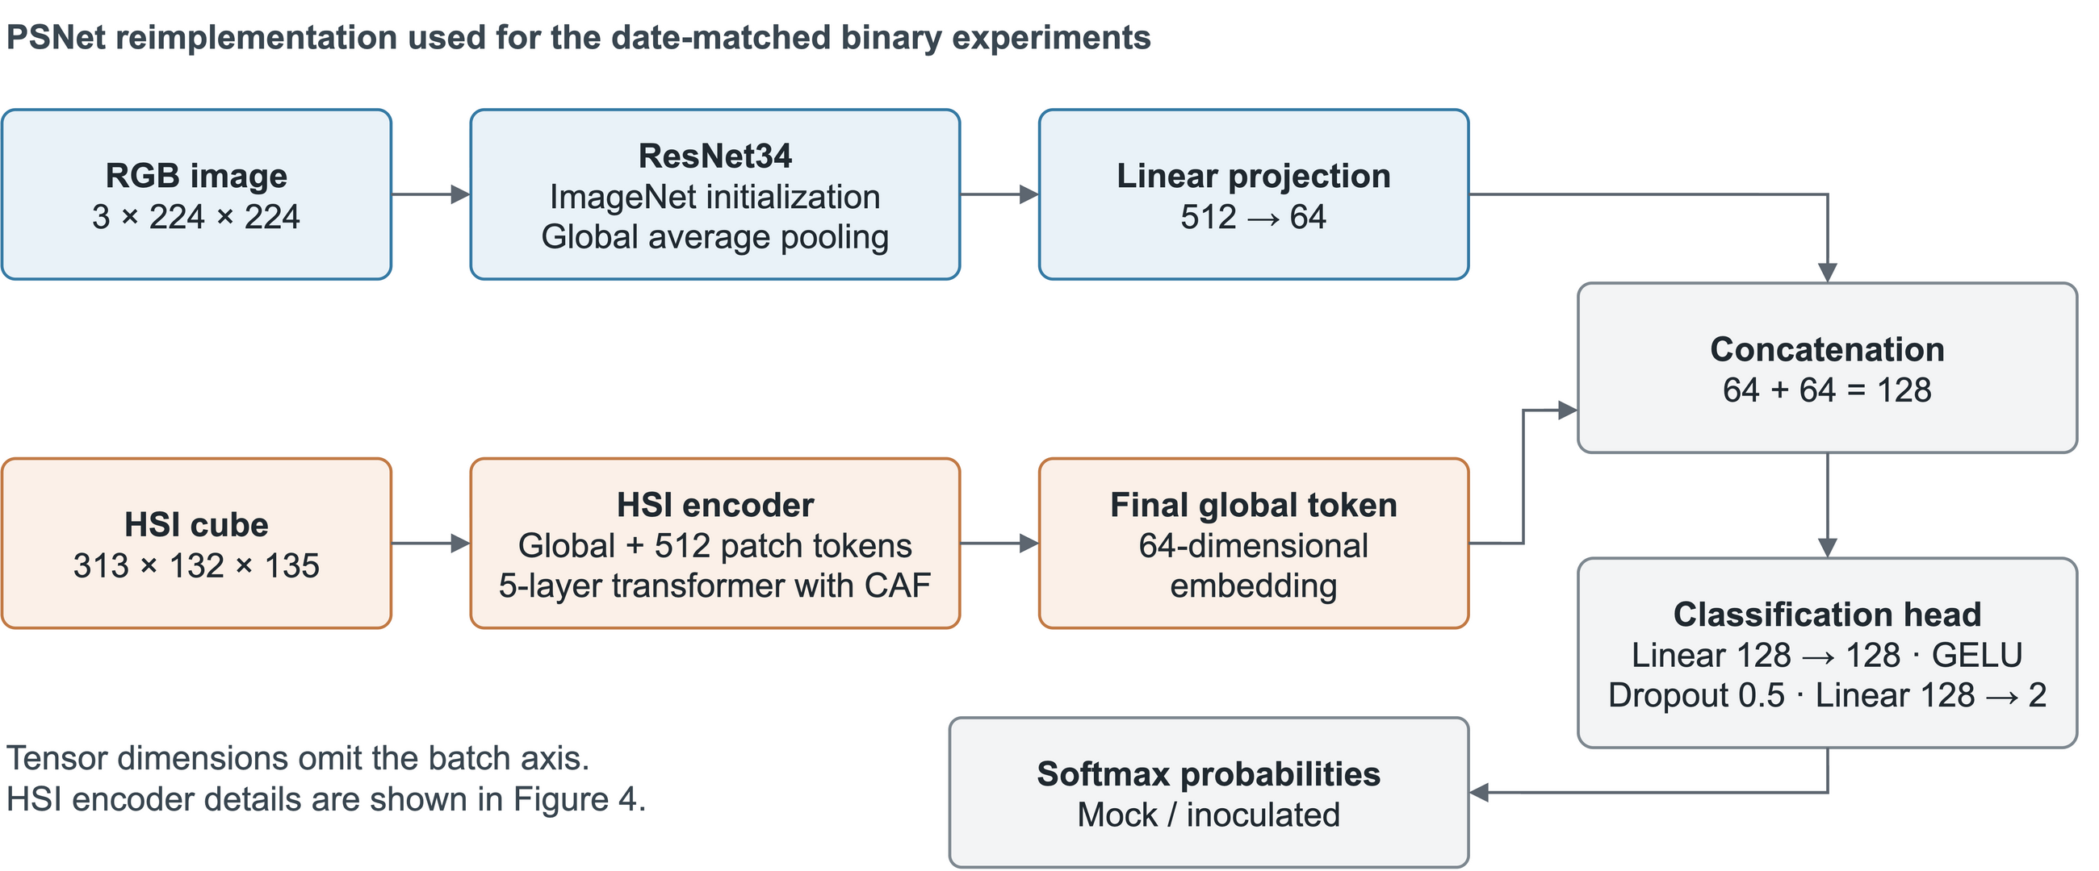
Figure 3. Binary PSNet reimplementation evaluated in this revision. The RGB ResNet34 and HSI Transformer produce 64-dimensional embeddings. Concatenation and a 128 → 128 → 2 head yield mock-versus-inoculated logits. Tensor dimensions omit the batch axis. The model diagram and equations describe the released binary implementation rather than the earlier four-class prototype.

2.6.2 Spatial branch
The RGB branch is an ImageNet-pretrained ResNet34. The RGB image $X_{rgb}∈R^{224×224×3}$ passes through the convolutional and residual stages, the final feature map is aggregated by global average pooling (GAP), and a projection head produces the RGB embedding $z_{rgb}$.

2.6.3 Spectral branch
The spectral encoder accepts X with shape C × H × W, where C = 313, H = 132 and W = 135. It constructs one global token from the spatial mean spectrum and 512 local tokens from learned feature channels (Fig. 4). All tokens have dimension 64.
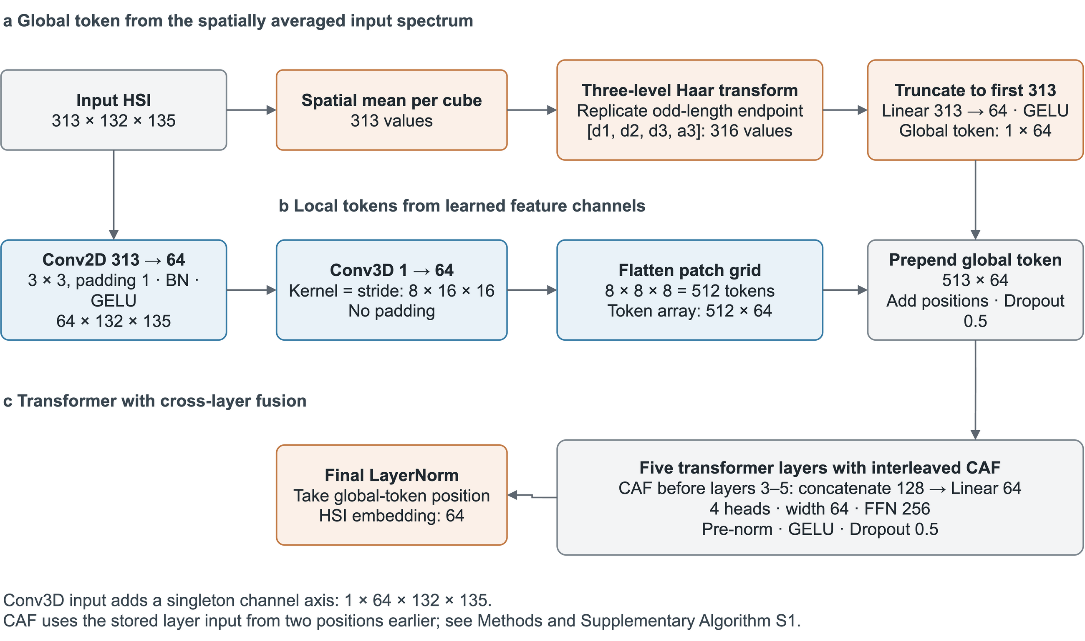
Figure 4. Implemented HSI encoder. A three-level Haar transform acts on the spatially averaged input spectrum. A separate 3 × 3 convolution reduces the cube to 64 learned feature channels, followed by 3D patch embedding. Five Transformer layers use four attention heads and CAF before layers 3–5. The feature-channel axis after reduction is not a physical wavelength axis. Supplementary Algorithm S1 specifies the global-token and CAF operations.
Global token. The input is first averaged spatially. A three-level Haar transform, not a Daubechies-4 transform, is then applied to this mean spectrum. At each level, the final value is replicated if the length is odd. For paired values u and v, approximation and detail coefficients are (u + v)/√2 and (u − v)/√2, respectively:
$s = {mean}_{HW}(X); [d_{1}, d_{2}, d_{3}, a_{3}] = {Haar}_{3}(s)$ (1)
The detail vectors from levels 1, 2 and 3 are concatenated in that order, followed by the level-3 approximation. For 313 input bands, the concatenation has 316 elements; the implementation keeps the first 313 elements. A learned linear projection and GELU produce the global token:
$g = GELU(W_{g} · concat(d_{1}, d_{2}, d_{3}, a_{3})[0:313] + b_{g})$ (2)
The resulting token has 64 elements and depends on the input cube. This differs from a freely learned CLS vector and from taking the mean of patch tokens. Spatial averaging precedes the Haar transform in the released implementation.
Patch tokens. A Conv2D layer with 313 input channels, 64 output channels, kernel 3 × 3 and padding 1, followed by batch normalisation and GELU, produces a 64 × 132 × 135 feature tensor. A singleton channel axis is inserted for a Conv3D layer with 64 output channels, kernel and stride 8 × 16 × 16, and no padding. Thus:
$N = floor(64/8) × floor(132/16) × floor(135/16) = 512$ (3)
The 3D convolution spans blocks of eight learned feature channels and 16 × 16 spatial positions. Spatial remainders are discarded; the output grid is 8 × 8 × 8. These blocks do not represent groups of eight adjacent physical wavelengths after the learned channel reduction.
$T = flatten(Conv3D(reduce(X))) ∈ ℝ^{512×64}$ (4)
Flattening this grid gives 512 patch tokens, each of dimension 64. The global token is prepended and positional embeddings are added to form the Transformer input:
$Z_{0} = Dropout(concat(g, T) + P[0:513]) ∈ ℝ^{513×64}$ (5)
The positional parameter stores 1,025 × 64 elements, but only the first 513 positions are used in this path. The remaining 32,768 elements are registered but unused. Token dropout is 0.5.
Encoder and cross-layer adaptive fusion. Five pre-normalisation Transformer layers use four attention heads, a feed-forward width of 256, GELU and dropout 0.5. CAF, adapted from SpectralFormer [25], concatenates the current representation with an earlier stored layer input and applies a learned 128 → 64 linear projection before layers 3, 4 and 5:
$u_{j} = W_{j} · concat(h_{j−1}, u_{j−2}) + b_{j}, j ∈ \{3,4,5\}$ (6)
Here h denotes the current layer representation and u denotes the stored layer input. The earlier inputs are those of layers 1, 2 and 3, respectively. The post-fusion input is stored before applying each Transformer layer. A final layer normalisation is applied, and the global-token position supplies the 64-dimensional HSI embedding.

2.6.4 Fusion and classification
The RGB and HSI embeddings are concatenated into 128 elements. The classification head comprises Linear(128, 128), GELU, dropout 0.5 and Linear(128, 2). Training minimises ordinary, unweighted cross-entropy:
$L = −{mean}_{i} log softmax({logits}_{i})[y_{i}]$ (7)
There are two classes: mock (0) and inoculated (1). No class weighting or class-balanced resampling is implemented. Balanced accuracy and AUROC, rather than accuracy alone, are used to interpret the unequal treatment groups.

2.6.5 Baselines and ablation variants
Baselines use the same within-task outer folds and metrics. RGB-only ResNet18 and ResNet34 use ImageNet initialisation, global pooling, a 64-dimensional projection and a two-class head. The HSI Transformer uses the spectral branch defined above without RGB. The spectral 1D CNN averages each cube spatially and applies convolutional widths 32, 64 and 64 with kernels 7, 5 and 3, followed by global pooling and classification. The compact 3D CNN processes a singleton-channel cube with output widths 16, 32 and 64 and global pooling. The simple multimodal baseline combines ResNet18 and the spectral 1D CNN. The plain multimodal model uses a learnable CLS token and disables CAF. Historical PSNet variants disable CAF, substitute the mean patch token or a learnable CLS vector, or use direct 2D tokenisation. The latter changes capacity and token count as well as patching, so it is not an isolated test of 3D patching. Additional controlled substitutions are implemented in the public rerun code but have no completed real-data results in this manuscript.
Table 4. Configurations and registered parameter counts at embedding dimension 64. Counts include 24,768 bypassed CAF parameters where CAF is disabled and 32,768 unused positional parameters in the full 3D path. Equal registered counts do not imply equal active capacity. Standalone baseline counts include their classification heads.
Configuration | Global token | Patch tokens | Registered parameters | Change relative to full PSNet
Full PSNet | Wavelet-initialised | 512 | 22,006,402 | —
CAF disabled | Wavelet-initialised | 512 | 22,006,402 | Cross-layer adaptive fusion bypassed
Mean patch token | Mean of patch tokens | 512 | 21,986,306 | Wavelet-initialised token replaced by mean of patch tokens
Alternative 2D tokenisation | Wavelet-initialised | 64 | 26,823,042 | 2D tokenisation (changes reduction stage, token number and capacity)
Learnable CLS | Learnable parameter | 512 | 21,986,370 | Wavelet-initialised token replaced by learnable CLS token
Plain multimodal | Learnable parameter | 512 | 21,986,370 | Learnable CLS token and CAF disabled
RGB ResNet18 | — | — | 11,209,474 | RGB only
RGB ResNet34 | — | — | 21,317,634 | RGB only
HSI Transformer | — | — | 672,258 | HSI branch only
Spectral 1D CNN | — | — | 23,234 | Spatial mean spectrum
Compact 3D CNN | — | — | 81,474 | Whole cube
Simple multimodal | — | — | 11,240,834 | ResNet18 + spectral 1D CNN

2.6.6 Training and reproducibility
Table 5 distinguishes settings recoverable from archived configurations from the documented rerun protocol. The archived configuration files verify embedding dimension 64, five Transformer layers, four attention heads, dropout 0.5 and pretrained RGB initialisation. The released training implementation uses AdamW, paired horizontal and vertical flips, inner-validation checkpoint selection and early stopping; it contains no learning-rate warm-up or scheduler, label smoothing or stochastic depth. Some historical run records do not retain every optimiser and training-budget argument, so the documented defaults cannot certify every historical invocation. New runs save the configuration, source snapshot, task hashes, fitted preprocessing, checkpoints and held-out predictions. No hyperparameter search is specified in the rerun protocol.
Table 5. Audited architecture and documented rerun settings. Architecture settings are recovered from the archived configurations; optimiser and budget values specify the released rerun protocol where historical invocation records are incomplete.
Item | Setting and evidence status
RGB / HSI input | 3 × 224 × 224 / 313 × 132 × 135
Patch kernel and stride | 8 × 16 × 16 after reduction to 64 learned channels
Tokens / embedding | 513 total / 64 dimensions
Transformer depth / heads | 5 / 4 (archived configuration)
Classification head | 128 → 128 → 2; GELU; dropout 0.5
Optimiser | AdamW; learning rate 3 × 10⁻⁴; weight decay 10⁻⁴ (rerun protocol)
Batch / maximum epochs | 8 / 100 (rerun protocol)
Checkpoint / early stopping | Inner-validation plant BA; patience 12 epochs; fraction 0.2
Scheduler / loss | No scheduler or warm-up; unweighted cross-entropy
Training seeds | 157, 257, 357; outer split seed 157
Augmentation / regularisation | Paired horizontal/vertical flips; dropout 0.5; no label smoothing or stochastic depth
Hardware evidence | A100-SXM4-80GB for recorded latency; not a verified inventory of all training runs

2.7 Spectral statistics
For exploratory spectral analysis, each archived cube was averaged over all spatial positions, and the available leaf means were averaged within each plant and date. No additional masking was assumed. At each computational band and separately within each dpi, inoculated and mock plants were compared with a two-sided Welch test. Benjamini–Hochberg correction was applied independently to the 313 tests at each date. Hedges’ g describes the inoculated-minus-mock standardised difference with small-sample correction. Figure 7 shows pointwise 95% t-based intervals for group means, not simultaneous confidence bands. The same plants recur across dates, so the three analyses are not independent. No red-edge wavelength, physiological attribution or gain-adjusted effect is claimed because the historical band mapping, masks and per-image gain records are not verified. Separately, an exploratory pooled-date experiment selected the 3, 10 or 30 bands with the largest absolute treatment-mean differences using fitting plants only inside each outer fold. Band selection and standardisation excluded inner-validation and outer-test plants. Each selection was retrained and compared with its own full-band control using seed 157 and five folds. Paired 95% percentile intervals used 20,000 treatment-stratified plant resamples of the fixed predictions, without retraining.

3 Results

3.1 Dataset, symptom status and infection validation
No visible symptoms were present at 2 or 4 dpi. The HSI and RGB images were acquired from the adaxial (upper) leaf surface in a top-down configuration. Visible white-blister sporulation was not observed on this surface at any time point, including 6 dpi. At 6 dpi, however, sporulation was visible on the abaxial (lower) surface (Fig. 5), and obvious symptoms developed at approximately 6–8 dpi, varying between leaves. Accordingly, 6 dpi is a transitional, later infection-stage reference and not a visually symptomatic imaging condition. The paired-data evaluation subset comprised 69 inoculated and 24 mock-inoculated plants at 2 dpi, and 72 inoculated and 24 mock-inoculated plants at each of 4 and 6 dpi (Table 3). These counts were verified against the archived analysis manifest; the missing observations are listed in section 2.3.
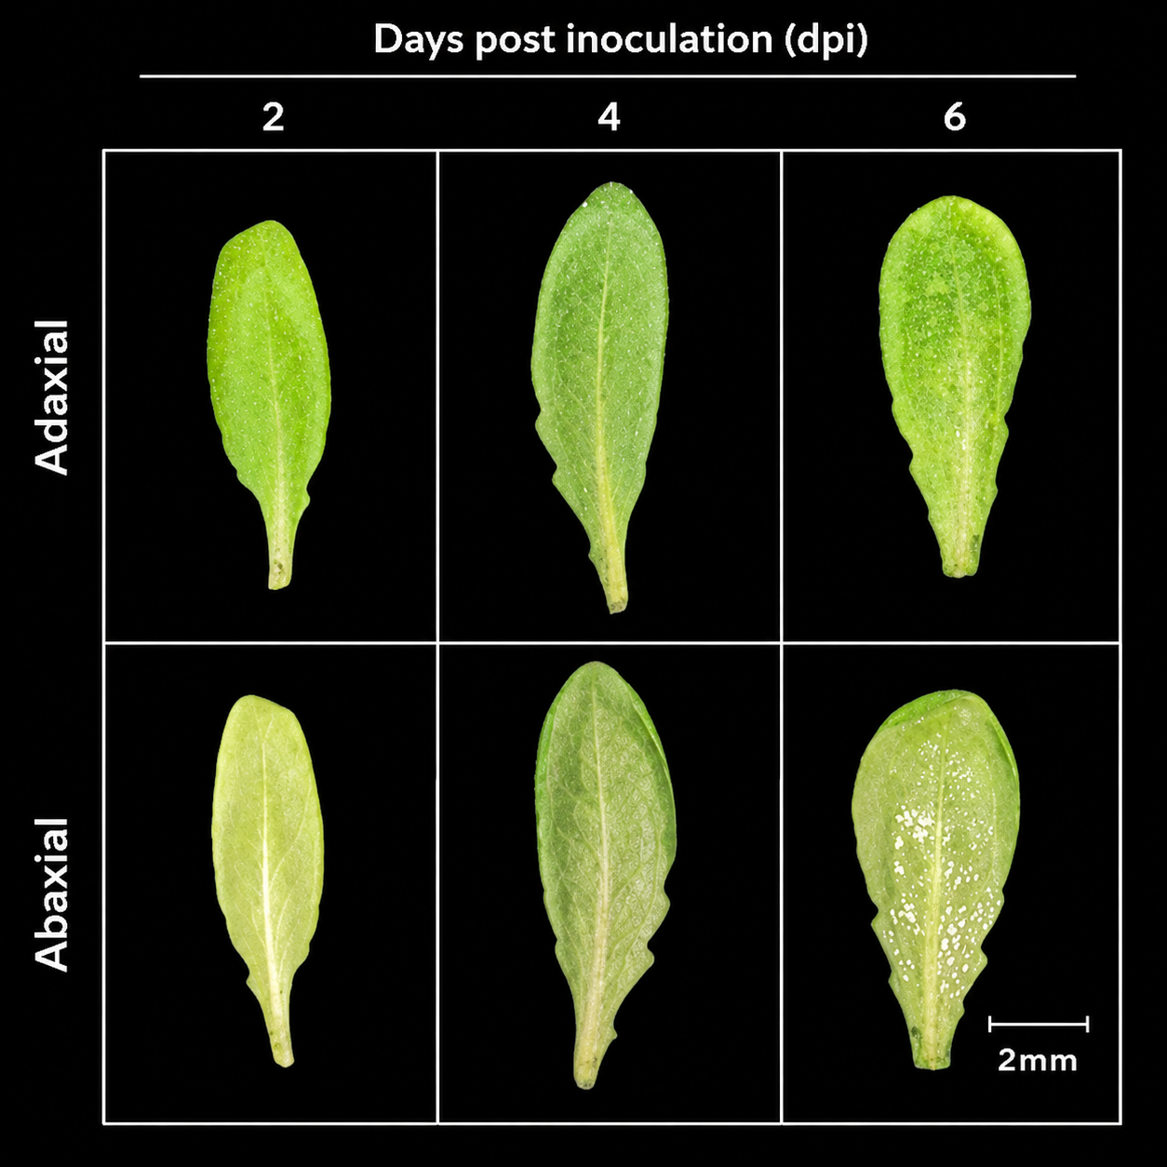
Figure 5. Representative inoculated leaves at 2, 4 and 6 dpi with Albugo candida. White sporulation is visible on the abaxial surface at 6 dpi, whereas the imaged adaxial surface remains symptom-free. Scale bar, 2 mm. The panel documents representative inoculated material and does not provide a matched mock microscopy comparison or per-plant infection confirmation.

3.2 Instrument characterisation
Table 2 lists the instrument characteristics that were available at the time of writing. Spectral resolution, wavelength calibration error, signal-to-noise ratio at the final exposure, spatial resolution, repeatability, sensor linearity and RGB–HSI registration accuracy have not yet been measured or verified, and we therefore make no claims about them. Preliminary exposure tests at 10–100 ms did not use the final 2 s setting and are not sufficient to establish signal-to-noise ratio or the absence of saturation.

3.3 Classification at each time point
PSNet separated inoculated from mock-inoculated plants poorly at 2 dpi, moderately at 4 dpi and well at 6 dpi (Table 6, Fig. 6). At 2 dpi, PSNet labelled most plants as inoculated, giving high sensitivity (84.54%) but low specificity (27.78%). Its balanced accuracy was 56.16 ± 4.09% and its AUROC 0.605 ± 0.049, and its accuracy of 69.89 ± 4.69% was lower than the 74.19% obtained by calling every plant inoculated. At 4 dpi, before visible symptoms, PSNet reached a balanced accuracy of 83.56 ± 4.24% and an AUROC of 0.939 ± 0.026, with sensitivity 93.52% and specificity 73.61%. At 6 dpi, a later infection stage at which the imaged surface remained symptom-free, balanced accuracy was 95.37 ± 0.80% and AUROC 0.990 ± 0.006. On the joint task that combines the two presymptomatic time points, balanced accuracy was 74.07 ± 5.21% and AUROC 0.821 ± 0.064; because this task uses information from 4 dpi, it should not be read as detection at 2 dpi.
Table 6. Classification performance of PSNet for inoculated versus mock-inoculated plants. Mean ± SD across three seeds (157, 257, 357), each evaluated with five plant-disjoint folds; predictions aggregated within plants. Majority-class reference: accuracy 74.19% at 2 dpi and 75.00% for the other tasks, BA 50%, AUROC 0.5. The joint 2+4 dpi task uses information acquired at 4 dpi and is not a measure of detection at 2 dpi. BA, balanced accuracy.
Task | Accuracy (%) | BA (%) | AUROC | F1 | Precision (%) | Sensitivity (%) | Specificity (%)
2 dpi | 69.89 ± 4.69 | 56.16 ± 4.09 | 0.605 ± 0.049 | 0.805 ± 0.038 | 77.12 ± 2.03 | 84.54 ± 7.98 | 27.78 ± 10.49
4 dpi | 88.54 ± 2.08 | 83.56 ± 4.24 | 0.939 ± 0.026 | 0.925 ± 0.013 | 91.46 ± 2.61 | 93.52 ± 0.80 | 73.61 ± 8.67
6 dpi | 95.14 ± 1.20 | 95.37 ± 0.80 | 0.990 ± 0.006 | 0.967 ± 0.009 | 98.60 ± 1.39 | 94.91 ± 2.89 | 95.83 ± 4.17
Joint 2+4 dpi | 78.47 ± 5.92 | 74.07 ± 5.21 | 0.821 ± 0.064 | 0.851 ± 0.046 | 87.68 ± 2.16 | 82.87 ± 6.85 | 65.28 ± 4.81

3.4 Comparison with RGB-only, HSI-only and multimodal baselines
Model rankings changed markedly with time after inoculation (Table 7, Fig. 6; full metrics in Tables S1–S3). Four observations stand out. First, no model that received RGB input exceeded a balanced accuracy of 63.4% at 2 dpi (range 50.7–63.4%; AUROC 0.509–0.711). Second, at 4 dpi every model with an RGB stream, including RGB-only ResNets, reached balanced accuracies of 83.6–92.4% (AUROC 0.930–0.974); PSNet had the lowest balanced accuracy in this group (83.56%), and the plain multimodal model the highest (92.36%), with an RGB-only ResNet18 close behind (90.28%). Third, at 6 dpi the same models reached 91.2–97.5% balanced accuracy, and again the RGB-only models were within the range of the multimodal models. Fourth, the HSI-only models behaved differently from all others. The HSI Transformer and the compact 3D CNN were the only models to discriminate well at 2 dpi (balanced accuracy 76.15% and 86.05%; AUROC 0.850 and 0.916), yet at 4 dpi their balanced accuracy fell to 58.80% and 58.56%, and at 6 dpi to 54.17% and 50.00%. At 6 dpi the compact 3D CNN labelled every plant as inoculated in all three seeds. The one-dimensional spectral CNN was at or near chance at every time point (balanced accuracy 54.80%, 50.00% and 50.23% at 2, 4 and 6 dpi).
Model rankings are descriptive. Between-seed variability and the conditional plant-bootstrap intervals in Table 11 indicate uncertainty, but neither constitutes a paired hypothesis test between models. Formal superiority or equivalence is not claimed. The HSI-only scores were highest at 2 dpi and close to chance later, including when abaxial sporulation was visible; this temporal pattern motivates the spectral and acquisition-confound analyses below.
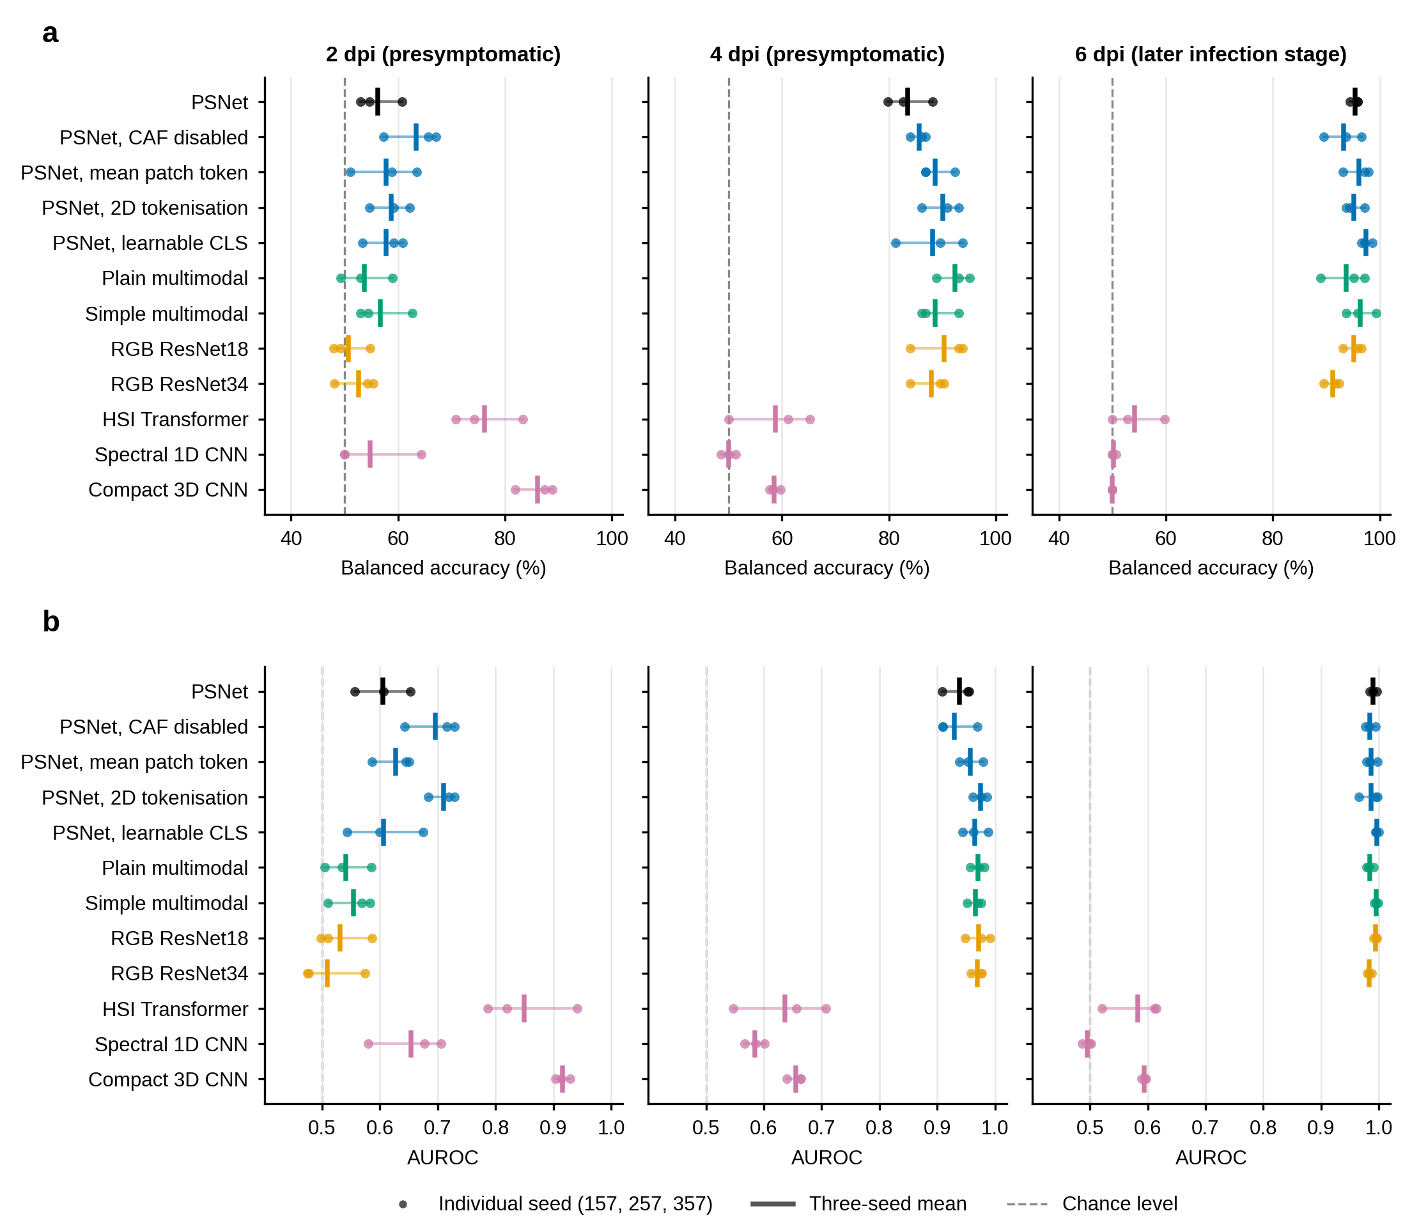
Figure 6. Classification performance of all models at each time point. (a) Balanced accuracy and (b) AUROC for inoculated versus mock-inoculated classification at 2, 4 and 6 days post inoculation (dpi). Dots show the three training seeds (157, 257, 357), bars show the three-seed mean, and the dashed line marks chance level. Metrics were computed from pooled out-of-fold, plant-level predictions.
Table 7. Balanced accuracy (BA) and AUROC of all models at 2, 4 and 6 dpi. Mean ± SD across three seeds, each with five plant-disjoint folds. Rankings are descriptive; differences between means alone do not establish statistical significance. All metrics are in Tables S1–S3.
Model | 2 dpi BA (%) | 2 dpi AUROC | 4 dpi BA (%) | 4 dpi AUROC | 6 dpi BA (%) | 6 dpi AUROC
PSNet | 56.16 ± 4.09 | 0.605 ± 0.049 | 83.56 ± 4.24 | 0.939 ± 0.026 | 95.37 ± 0.80 | 0.990 ± 0.006
CAF disabled | 63.35 ± 5.33 | 0.696 ± 0.046 | 85.65 ± 1.45 | 0.930 ± 0.034 | 93.29 ± 3.50 | 0.985 ± 0.009
Mean patch token (replaces wavelet token) | 57.82 ± 6.27 | 0.627 ± 0.035 | 88.66 ± 3.21 | 0.957 ± 0.021 | 96.06 ± 2.63 | 0.987 ± 0.010
Alternative 2D tokenisation | 58.70 ± 3.74 | 0.711 ± 0.024 | 90.05 ± 3.56 | 0.974 ± 0.012 | 95.14 ± 1.84 | 0.986 ± 0.017
Learnable CLS token | 57.79 ± 3.94 | 0.606 ± 0.066 | 88.19 ± 6.36 | 0.965 ± 0.022 | 97.45 ± 1.06 | 0.996 ± 0.003
Plain multimodal | 53.74 ± 4.89 | 0.541 ± 0.041 | 92.36 ± 3.18 | 0.971 ± 0.013 | 93.75 ± 4.34 | 0.984 ± 0.007
Simple multimodal | 56.70 ± 5.23 | 0.554 ± 0.038 | 88.66 ± 3.82 | 0.966 ± 0.013 | 96.30 ± 2.81 | 0.996 ± 0.004
RGB ResNet18 | 50.69 ± 3.61 | 0.531 ± 0.047 | 90.28 ± 5.42 | 0.972 ± 0.022 | 95.14 ± 1.84 | 0.994 ± 0.003
RGB ResNet34 | 52.63 ± 3.96 | 0.509 ± 0.057 | 87.96 ± 3.43 | 0.970 ± 0.011 | 91.20 ± 1.45 | 0.984 ± 0.004
HSI Transformer | 76.15 ± 6.46 | 0.850 ± 0.081 | 58.80 ± 7.90 | 0.637 ± 0.081 | 54.17 ± 5.01 | 0.582 ± 0.053
Spectral 1D CNN | 54.80 ± 8.32 | 0.654 ± 0.066 | 50.00 ± 1.39 | 0.585 ± 0.017 | 50.23 ± 0.40 | 0.496 ± 0.009
Compact 3D CNN | 86.05 ± 3.68 | 0.916 ± 0.012 | 58.56 ± 1.06 | 0.656 ± 0.014 | 50.00 ± 0.00 | 0.594 ± 0.004

3.5 Effect of including the 6 dpi time point
Pooling all dates, and thereby including 6 dpi observations from a later infection stage, produced much higher scores than the presymptomatic-only tasks (Table 8). For seed 157, PSNet reached 93.75% accuracy and an AUROC of 0.980 with all dates pooled, but 71.88% accuracy and an AUROC of 0.753 when 6 dpi was excluded. Across the three seeds, the joint 2+4 dpi task gave 78.47 ± 5.92% accuracy, only a few points above the 75.00% majority-class rate. Accuracy on a pooled task that includes 6 dpi samples is therefore not a measure of presymptomatic detection. The pooled result is available for one seed only, so no between-seed SD can be given.
Table 8. Effect of including the 6 dpi time point (later infection stage) on PSNet performance. Seed 157 values are from one complete five-fold run; between-seed SD is unavailable for the pooled task.
Task | Accuracy (%) | BA (%) | AUROC | F1
All dates pooled, includes 6 dpi (seed 157) | 93.75 | 93.06 | 0.980 | 0.958
Joint 2+4 dpi, 6 dpi excluded (seed 157) | 71.88 | 68.75 | 0.753 | 0.800
Joint 2+4 dpi, 6 dpi excluded (three-seed mean ± SD) | 78.47 ± 5.92 | 74.07 ± 5.21 | 0.821 ± 0.064 | 0.851 ± 0.046

3.6 Contribution of individual PSNet components
Table 9 compares PSNet with four variants for which complete three-seed results are available. The full model did not exceed any of the variants in balanced accuracy at 2 dpi, at 4 dpi or on the joint task. At 6 dpi, disabling CAF (93.29%) or using the 2D tokenisation (95.14%) gave lower balanced accuracy than the full model (95.37%), whereas replacing the wavelet-initialised token by the mean patch token (96.06%) or a learnable CLS token (97.45%) gave higher values. All of these differences are of similar size to the between-seed SD (1–6 percentage points), and the ranking of variants changed from one task to another. The results therefore do not identify any component as beneficial, and they do not support attributing the performance of PSNet to its wavelet-initialised token or to CAF. Parameter counts (Table 4) were similar for all variants except the 2D tokenisation (26.8 million versus 22.0 million); however, the registered counts include bypassed and unused parameters, so they do not establish equal active capacity.
Table 9. Balanced accuracy (%) of PSNet and variants with three complete seeds. Mean ± SD. The alternative 2D tokenisation changes the reduction stage, token number and capacity together and does not isolate the contribution of 3D patching. Full metrics for the joint task are in Table S4.
Configuration | 2 dpi | 4 dpi | 6 dpi | Joint 2+4 dpi
PSNet | 56.16 ± 4.09 | 83.56 ± 4.24 | 95.37 ± 0.80 | 74.07 ± 5.21
CAF disabled | 63.35 ± 5.33 | 85.65 ± 1.45 | 93.29 ± 3.50 | 79.17 ± 1.39
Mean patch token (replaces wavelet token) | 57.82 ± 6.27 | 88.66 ± 3.21 | 96.06 ± 2.63 | 75.46 ± 3.13
Alternative 2D tokenisation | 58.70 ± 3.74 | 90.05 ± 3.56 | 95.14 ± 1.84 | 79.17 ± 4.34
Learnable CLS token | 57.79 ± 3.94 | 88.19 ± 6.36 | 97.45 ± 1.06 | 74.31 ± 4.34
A separate, completed pooled-date band-selection experiment is summarised in Table 10. Its full-band control achieved 92.36% balanced accuracy; top-3, top-10 and top-30 inputs achieved 93.75%, 95.14% and 90.97%, respectively. Top-10 selection gave 96.88% accuracy but a lower AUROC than the full-band control (0.983 versus 0.991). The paired balanced-accuracy differences for top-3, top-10 and top-30 were +1.39, +2.78 and −1.39 percentage points, with 95% intervals of −6.25 to 9.03, −4.17 to 10.42 and −9.03 to 6.94. All include zero. These results show that reduced inputs can retain discrimination in this pooled task; they do not establish improved performance or a validated physiological band set. This full-band reference belongs to a separate experiment and must not be substituted for the earlier pooled result in Table 8.
Table 10. Separate pooled-date band-selection experiment, seed 157 and five plant-disjoint folds. Selection uses fitting plants only. All dates include 6 dpi; these scores are not a measure of detection at 2 dpi. Each reduced-input model is compared with the full-band control from this experiment.
Input | Bands | Accuracy (%) | BA (%) | AUROC | F1
full | 313 | 94.79 | 92.36 | 0.991 | 0.966
top3 | 3 | 94.79 | 93.75 | 0.989 | 0.965
top10 | 10 | 96.88 | 95.14 | 0.983 | 0.979
top30 | 30 | 90.63 | 90.97 | 0.969 | 0.935

3.7 Uncertainty of the estimates
Plant-bootstrap intervals for PSNet (seed 157) were wide because only 24 plants are mock-inoculated (Table 11). At 2 dpi the intervals for balanced accuracy (42.6–63.5%) and AUROC (0.423–0.687) include chance level. At 4 dpi they were 72.9–91.7% for balanced accuracy and 0.913–0.986 for AUROC. Even at 6 dpi the lower bound of balanced accuracy was 90.3%. The interval for the joint 2+4 dpi task (balanced accuracy 57.6–79.2%) is also wide. These intervals describe sampling variability of plants within this run and do not include variability between experimental runs. Raw plant-level confusion counts for each seed are given in Table S5.
Table 11. PSNet, seed 157: 95% plant-bootstrap intervals. Intervals come from 5,000 treatment-stratified resamples of fixed out-of-fold plant predictions without retraining. They do not quantify variability between independent experimental runs and are not confidence intervals for the three-seed mean.
Task | Accuracy (%) | BA (%) | AUROC | F1
2 dpi | 55.91–73.12 | 42.57–63.50 | 0.423–0.687 | 0.692–0.823
4 dpi | 82.29–93.75 | 72.92–91.67 | 0.913–0.986 | 0.884–0.959
6 dpi | 91.67–98.96 | 90.28–99.31 | 0.973–1.000 | 0.942–0.993
Joint 2+4 dpi | 62.50–80.21 | 57.64–79.17 | 0.625–0.863 | 0.727–0.865
All dates pooled | 88.54–97.92 | 86.11–98.61 | 0.950–1.000 | 0.921–0.986

3.8 Within-time-point spectral differences
At 2 dpi, 302 of 313 computational bands differed between groups at within-date BH q < 0.05; the minimum q was 0.000317 and the median absolute Hedges’ g was 0.786. At 4 and 6 dpi, no bands met this threshold; minimum q values were 0.0892 and 0.170, and median absolute effect sizes were 0.444 and 0.158, respectively (Table 12; Fig. 7). These are whole-cube intensity differences and can include background, illumination and acquisition effects. The absence of significant bands at later dates does not demonstrate absence of biological change. The particularly strong 2 dpi differences, together with the HSI-only classification pattern, warrant caution about an acquisition-specific signal.
Table 12. Exploratory whole-cube spectral statistics. Welch tests and BH correction were performed separately for 313 computational bands within each dpi. Counts refer to available paired-data plants. Effect sizes are descriptive; bands are correlated and do not constitute independent biological replicates.
dpi | Inoculated / mock | Bands | BH q < 0.05 | Minimum q | Median |g|
2 | 69 / 24 | 313 | 302 | 0.000317 | 0.786
4 | 72 / 24 | 313 | 0 | 0.089157 | 0.444
6 | 72 / 24 | 313 | 0 | 0.170346 | 0.158
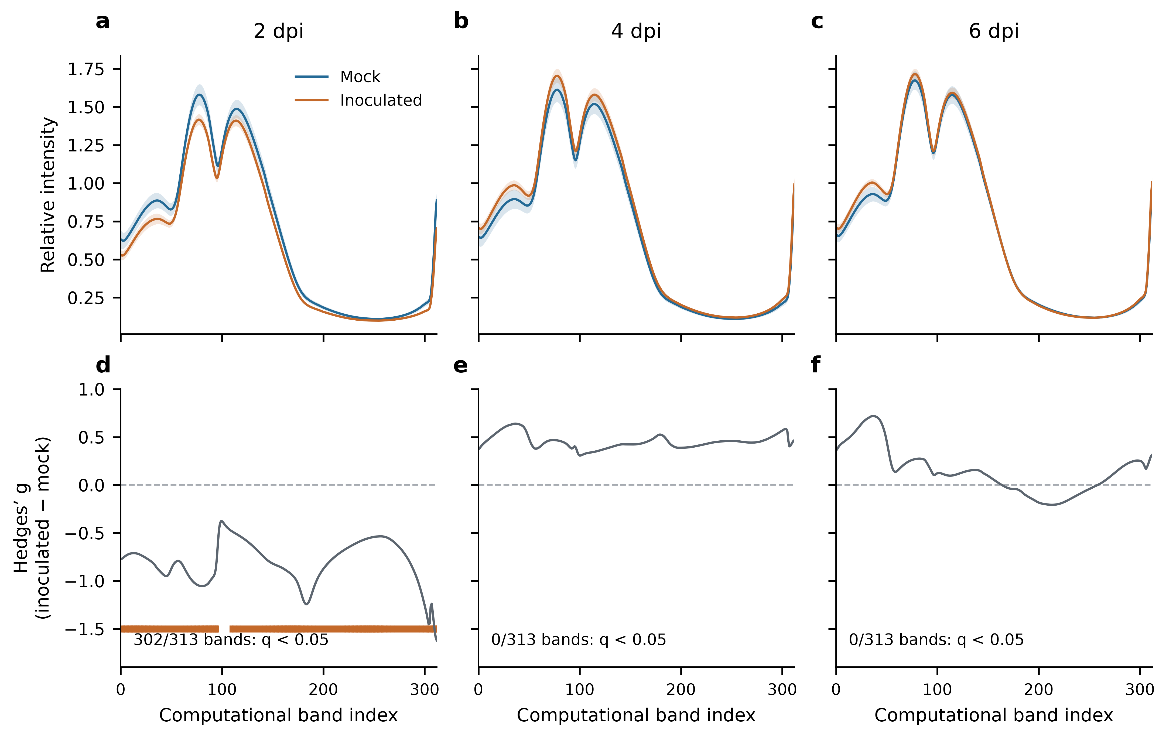
Figure 7. Whole-cube spectral summaries at 2, 4 and 6 dpi. (a–c) Group mean intensity with pointwise 95% t-based confidence intervals over plant means. (d–f) Hedges’ g for inoculated minus mock plants; orange marks identify within-date BH q < 0.05. The x-axis denotes computational band index, not validated wavelength. Counts are 69 inoculated and 24 mock plants at 2 dpi, and 72 inoculated and 24 mock plants at 4 and 6 dpi.

3.9 Limits of model attribution
Archived band-group occlusion summaries reported no change in balanced accuracy or AUROC, but the corresponding masked probabilities were not retained and whole-modality interventions were not validated. We therefore do not use these summaries to infer that HSI is unused or to assign physiological meaning to particular bands. The band-selection experiment in Table 10 tests predictive sufficiency after retraining, which is distinct from attribution in an already trained model. No validated attribution result is presented.

3.10 Computational cost
The full PSNet has 22,006,402 registered parameters (Table 4). Archived model-only inference on an NVIDIA A100-SXM4-80GB GPU with batch size 1 and synthetic input took 4.70 ms with peak GPU memory of 142.8 MiB. Acquisition and preprocessing are excluded. Comparable baseline timings, end-to-end latency and edge-device performance were not established, so these measurements cannot support a Raspberry Pi deployment claim.

4 Discussion

4.1 Principal findings
RGB-containing models distinguished the inoculated and mock groups at 4 dpi, before visible symptoms, and at 6 dpi, when sporulation was present on the lower surface but not on the imaged upper surface. PSNet was close to chance at 2 dpi. RGB-only models performed within the range of multimodal models, and the reported comparisons do not demonstrate an incremental benefit from HSI. The results establish within-run treatment-group discrimination, not confirmed infection-specific detection: tray, imaging order and unrecorded gain could also contribute.

4.2 The 2 dpi result and the reversed time course of the HSI-only models
The HSI Transformer and compact 3D CNN achieved AUROCs of 0.850 and 0.916 at 2 dpi and then performed much less well at later dates. Whole-cube spectral differences were also strongest at 2 dpi. A transient biological response is one possible explanation, but acquisition-specific variation, background, automatic gain and overfitting remain alternatives. Mock plants were always imaged first, so treatment and acquisition order were inseparable. Neither the spectral summaries nor the classification scores identify the cause. The incomplete 2 dpi paired-data coverage and unverified upstream preprocessing further limit interpretation. We therefore do not treat the 2 dpi HSI-only scores as evidence of an infection-specific early signal.

4.3 Role of the hyperspectral and RGB streams
The dominance of RGB models is consistent with the practical difficulty of learning from a high-dimensional spectral cube in fewer than 100 plants, whereas pretrained ResNets bring spatial priors learned from natural images. It is also consistent with limitations of the hyperspectral data themselves: the cubes are uncalibrated intensities without a white reference, the band–wavelength mapping must be restored, and radiometric performance has not been characterised (Table 2). Because no visible symptoms were seen on the imaged upper surface at any time point, the RGB discrimination at 4 and 6 dpi cannot be attributed to visible lesions or pustules. It may reflect subtle differences in leaf colour, texture or posture caused by infection. It may equally reflect non-biological structure that a within-run split cannot exclude: inoculated and mock-inoculated plants were on separate trays, and the mock tray was always imaged first, so tray position, local growth conditions and any drift during a session all correlate with treatment. We therefore treat the 4 and 6 dpi RGB results as evidence that the two groups were separable in this dataset, and not as evidence of a spectral or biochemical signature. In this study the multimodal design offered no measurable benefit over RGB alone at 4 or 6 dpi, which contrasts with the commonly held expectation that fusion improves on single modalities. A definitive test of the value of HSI needs reflectance-calibrated acquisition and independent runs.

4.4 Architectural components
The historical ablations do not establish a consistent benefit of individual PSNet components. Rankings change across tasks, and the alternative 2D path changes token count and parameterisation together. The controlled raw-spectrum token, current-layer CAF and fixed depth-averaging substitutions in the released code would address some of these ambiguities, but they have not produced completed results for this revision. The separate top-k experiment addresses input dimensionality rather than these architectural mechanisms. Its paired intervals include zero, its band sets vary by fold, and it uses only one training seed and pooled dates.

4.5 Effect of time-point pooling
Pooling all dates raised PSNet’s accuracy from 71.88% (2+4 dpi) to 93.75% (all dates) for the same seed. The difference shows how strongly a headline accuracy depends on the inclusion of 6 dpi samples, and why the pooled figure cannot be presented as presymptomatic detection. The presymptomatic-only tasks are the relevant benchmark for this application. For these tasks, PSNet’s accuracy on the joint 2+4 dpi task (78.47%) was only modestly above the majority-class rate of 75%.

4.6 Implications for smart agriculture
The imaging unit is inexpensive, repairable, compact and powered by USB-C, and it derives from an open design. These features make it attractive as a platform for controlled-environment phenotyping and for testing spectral sensing in greenhouse research, and the open, plant-level evaluation protocol used here can be reused for other sensors. The £489.20 documented component subtotal excludes printing, illumination and supporting equipment. Acquisition here required a dark room, fixed geometry, a 15 min warm-up and a 150 W halogen source (Table 13). The present work is therefore a low-cost imaging unit for controlled conditions and not a field-deployable system. Extension to greenhouse or field settings would require illumination that is either low-cost and stable or compensated for ambient light, reflectance standards in every session, logging of exposure and gain, tolerance to variable leaf orientation, and demonstration of performance across crops, genotypes, growth stages and confounding stresses [17,26,27]. Because the RGB stream alone provided most of the discrimination in this dataset, a practical consequence for system design is that inexpensive RGB sensing should be evaluated in parallel with hyperspectral sensing, but with the same caution about confounds.
Table 13. Conditions of the present study compared with what greenhouse or field use would require.
Aspect | This study | Needed for greenhouse or field use
Illumination | Laboratory halogen source (150 W, 3400 K) with fibre-optic arms; excluded from the £489.20 component subtotal | Low-cost stable illumination, or compensation for ambient light
Environment and geometry | Dark room; camera ~10 cm above sample; fixed geometry; 15 min warm-up | Operation under variable ambient light, leaf orientation and distance
Radiometric calibration | Dark-corrected intensity; no white reference; exposure fixed at 2 s, gain automatic and not logged | Reflectance standard in every session; complete acquisition log
Biological scope | One susceptible Arabidopsis line; one pathogen isolate; no abiotic stress controls | Crops, genotypes, growth stages, co-occurring stresses
Validation | One run of 96 plants; plant-disjoint folds within the run | Independent runs, sessions and sites
Compute | Model inference benchmarked on a data-centre GPU only | Timing and accuracy on the deployment hardware

4.7 Limitations
This study has several limitations. (i) The data come from a single experimental run of 96 plants, with only 24 mock-inoculated plants, so estimates are imprecise (Table 11). Inoculated and mock-inoculated plants were also kept on separate trays, so treatment is confounded with tray position and local growth conditions, and the mock tray was always imaged before the inoculated tray, so treatment was consistently correlated with acquisition order. The lamp was left running after a 15 min warm-up and the camera geometry was not reset between trays, which lowers the chance of a tray-specific set-up difference, but drift within a session cannot be excluded. Plant-disjoint folds are not independent of batch, cultivation cycle, inoculum preparation, calibration session, illumination or operator; the results are not evidence of generalisation. (ii) The host was a single, highly susceptible mutant line and the pathogen a single isolate, so the effect sizes may not transfer to crops or to partially resistant genotypes. (iii) The same plants were imaged at each time point, so the tasks are not independent. (iv) Spectra were dark-corrected and wavelength-calibrated but not converted to reflectance, which limits comparison across sessions and the interpretation of spectral magnitudes. (v) Exposure was fixed at 2 s but analogue gain was automatic and not logged, the band–wavelength mapping must be restored, and instrument characteristics such as spectral resolution, signal-to-noise ratio and registration accuracy were not characterised (Table 2). The acquisition size (2592 × 1944 pixels) is below the native resolution of the sensor, and autofocus means focus was not identical across samples. (vi) No abiotic stresses were included, although drought and nutrient deficiency produce overlapping spectral responses [7,28]. (vii) Only one optical configuration and illumination geometry were evaluated, and infection was sampled at three discrete time points. (viii) Model timing was measured on a data-centre GPU only. (ix) Whole-cube spectral statistics do not isolate leaf tissue or establish physiological causation. Validated model attribution, quantitative per-plant infection confirmation and an independent acquisition run are unavailable.

4.8 Future work
Priorities are independent experimental runs and imaging sessions with mock-inoculated controls interleaved and randomised in position and order; reflectance-calibrated acquisition with a white reference and per-sample logs of exposure and gain; updating the reconstruction software to use the full native output of the Camera Module 3, which would raise spatial sampling with the same low-cost hardware; characterisation of spectral resolution, signal-to-noise ratio, linearity and registration; evaluation across genotypes, crops and growth stages; explicit tests for acquisition-related confounds, such as leave-one-session-out validation; and stronger interpretability through spectral attribution, class prototypes and physiologically grounded indicators such as red-edge position [12,25,29]. Self-supervised pretraining on unlabelled hyperspectral data might reduce sample requirements [25]. Thermal or fluorescence imaging may add robustness outside controlled conditions.

5 Conclusions
A low-cost adaptation of an open-source hyperspectral camera, paired with RGB imaging, was evaluated using date-matched comparisons and plant-disjoint folds. Inoculated and mock groups were distinguishable at 4 and 6 dpi in one controlled run, but PSNet was near chance at 2 dpi and a benefit of HSI beyond RGB was not demonstrated. Whole-cube spectral differences were strongest at 2 dpi and cannot be assigned an infection-specific cause. Reduced-band models retained high pooled-date scores without establishing superiority. Independent experimental runs with interleaved acquisition, verified plant identity, reflectance calibration and appropriate stress controls are required before these results can support presymptomatic diagnosis in greenhouse or field conditions.

CRediT authorship contribution statement
Proposed CRediT statement for author verification: Gabriel U. Crabb: Methodology (imaging and biological workflow), Investigation, Data curation, Formal analysis (exploratory modelling), Writing – original draft. Yiding Zhao: Software, Methodology (computational framework), Formal analysis (revised evaluation), Writing – review and editing. Xi Chen: Supervision, Methodology. Nicholas K. Priest: Supervision. Volkan Cevik: Conceptualization, Supervision. Final roles and approval remain to be confirmed by all authors.

Declaration of competing interest
The competing-interest declaration remains subject to confirmation by all authors before submission.

Declaration of generative AI and AI-assisted technologies in the writing process
OpenAI Codex was used during preparation of this revision to assist with language editing, code organisation and checks against supplied analysis records. The authors must review the resulting text and code and take responsibility for the final submitted content. This disclosure is provided for author approval before submission.

Funding
This research was supported by the University of Bath.

Acknowledgements
The authors thank the CFFF platform of Fudan University for providing computational resources and the University of Bath for supporting this research.

Data availability
The computational code, revision manuscript and non-identifying summary tables are available at https://github.com/MasterSummer/hsi-PSnet. Raw paired images, cubes and model checkpoints are not included in the public revision package and may be requested from the corresponding authors. This manuscript reports the archived cohort and completed band-selection experiment; newly supplied raw files have not been incorporated into its classification results. The public recovery utility exports recovered MAT cubes and requires numerical agreement on overlapping observations before merging with historical inputs. Missing acquisition logs and incomplete upstream preprocessing provenance are described in the Methods.

References
[1] Savary, S. et al. The global burden of pathogens and pests on major food crops. Nat. Ecol. Evol. 3, 430–439 (2019). https://doi.org/10.1038/s41559-018-0793-y
[2] FAO. The Impact of Disasters and Crises on Agriculture and Food Security: 2021 (Rome, 2021).
[3] Hossain, M. M. et al. Plant disease dynamics in a changing climate: impacts, molecular mechanisms, and climate-informed strategies for sustainable management. Discover Agriculture 2, 132 (2024). https://doi.org/10.1007/s44279-024-00144-w
[4] Ristaino, J. B. et al. The persistent threat of emerging plant disease pandemics to global food security. Proc. Natl Acad. Sci. USA 118, e2022239118 (2021). https://doi.org/10.1073/pnas.2022239118
[5] Fisher, M. C., Hawkins, N. J., Sanglard, D. & Gurr, S. J. Worldwide emergence of resistance to antifungal drugs challenges human health and food security. Science 360, 739–742 (2018). https://doi.org/10.1126/science.aap7999
[6] Lucas, J. A., Hawkins, N. J. & Fraaije, B. A. The evolution of fungicide resistance. Adv. Appl. Microbiol. 90, 29–92 (2015). https://doi.org/10.1016/bs.aambs.2014.09.001
[7] Mahlein, A.-K. Plant disease detection by imaging sensors: parallels and specific demands for precision agriculture and plant phenotyping. Plant Dis. 100, 241–251 (2016). https://doi.org/10.1094/PDIS-03-15-0340-FE
[8] Lau, H. Y. & Botella, J. R. Advanced DNA-based point-of-care diagnostic methods for plant diseases detection. Front. Plant Sci. 8, 2016 (2017). https://doi.org/10.3389/fpls.2017.02016
[9] Notomi, T., Mori, Y., Tomita, N. & Kanda, H. Loop-mediated isothermal amplification (LAMP): principle, features, and future prospects. J. Microbiol. 53, 1–5 (2015). https://doi.org/10.1007/s12275-015-4656-9
[10] Hak, H. et al. Rapid on-site detection of crop RNA viruses using CRISPR/Cas13a. J. Exp. Bot. (2024). https://doi.org/10.1093/jxb/erae495
[11] Lowe, A., Harrison, N. & French, A. P. Hyperspectral image analysis techniques for the detection and classification of the early onset of plant disease and stress. Plant Methods 13, 80 (2017). https://doi.org/10.1186/s13007-017-0233-z
[12] Mahlein, A.-K., Kuska, M. T., Behmann, J., Polder, G. & Walter, A. Hyperspectral sensors and imaging technologies in phytopathology: state of the art. Annu. Rev. Phytopathol. 56, 535–558 (2018). https://doi.org/10.1146/annurev-phyto-080417-050100
[13] Terentev, A., Dolzhenko, V., Fedotov, A. & Eremenko, D. Current state of hyperspectral remote sensing for early plant disease detection: a review. Sensors 22, 757 (2022).
[14] Ram, B. G., Oduor, P., Igathinathane, C., Howatt, K. & Sun, X. A systematic review of hyperspectral imaging in precision agriculture: analysis of its current state and future prospects. Comput. Electron. Agric. 222, 109037 (2024). https://doi.org/10.1016/j.compag.2024.109037
[15] Zhu, H. et al. Hyperspectral imaging for presymptomatic detection of tobacco disease with successive projections algorithm and machine-learning classifiers. Sci. Rep. 7, 4125 (2017). https://doi.org/10.1038/s41598-017-04501-2
[16] Zhang, X., Vinatzer, B. A. & Li, S. Hyperspectral imaging analysis for early detection of tomato bacterial leaf spot disease. Sci. Rep. 14, 27666 (2024). https://doi.org/10.1038/s41598-024-78650-6
[17] Paulus, S. & Mahlein, A.-K. Technical workflows for hyperspectral plant image assessment and processing on the greenhouse and laboratory scale. GigaScience 9, giaa090 (2020). https://doi.org/10.1093/gigascience/giaa090
[18] Chen, Y.-N., Thaipisutikul, T., Han, C.-C., Liu, T.-J. & Fan, K.-C. Feature line embedding based on support vector machine for hyperspectral image classification. Remote Sens. 13, 130 (2021).
[19] Roy, S. K., Krishna, G., Dubey, S. R. & Chaudhuri, B. B. HybridSN: exploring 3-D–2-D CNN feature hierarchy for hyperspectral image classification. IEEE Geosci. Remote Sens. Lett. 17, 277–281 (2020). https://doi.org/10.1109/LGRS.2019.2918719
[20] Salazar-Vazquez, J. & Mendez-Vazquez, A. A plug-and-play hyperspectral imaging sensor using low-cost equipment. HardwareX 7, e00087 (2020). https://doi.org/10.1016/j.ohx.2019.e00087
[21] Koornneef, M. & Meinke, D. The development of Arabidopsis as a model plant. Plant J. 61, 909–921 (2010). https://doi.org/10.1111/j.1365-313X.2009.04086.x
[22] Borhan, M. H. et al. WRR4, a broad-spectrum TIR-NB-LRR gene from Arabidopsis thaliana that confers white rust resistance in transgenic oilseed Brassica crops. Mol. Plant Pathol. 11, 283–291 (2010). https://doi.org/10.1111/j.1364-3703.2009.00599.x
[23] Parkes, T. From Recognition to Susceptibility: Functional Characterization of Plant-Specific LIM-Domain Containing Proteins in Plant–Microbe Interactions. PhD thesis, University of Bath (2020).
[24] Furzer, O. J. et al. An improved assembly of the Albugo candida Ac2V genome reveals the expansion of the “CCG” class of effectors. Mol. Plant Microbe Interact. 35, 39–48 (2022). https://doi.org/10.1094/MPMI-04-21-0075-R
[25] Hong, D. et al. SpectralFormer: rethinking hyperspectral image classification with transformers. IEEE Trans. Geosci. Remote Sens. 60, 1–15 (2022). https://doi.org/10.1109/TGRS.2021.3130716
[26] Detring, J., Barreto, A., Mahlein, A.-K. & Paulus, S. Quality assurance of hyperspectral imaging systems for neural network supported plant phenotyping. Plant Methods 20, 189 (2024). https://doi.org/10.1186/s13007-024-01315-y
[27] Sousa, J. J. et al. UAV-based hyperspectral monitoring using push-broom and snapshot sensors: a multisite assessment for precision viticulture applications. Sensors 22, 6574 (2022).
[28] Singh, B. K. et al. Climate change impacts on plant pathogens, food security and paths forward. Nat. Rev. Microbiol. 21, 640–656 (2023). https://doi.org/10.1038/s41579-023-00900-7
[29] Wang, N. et al. Key challenges in plant pathology in the next decade. Phytopathology 114, 837–842 (2024). https://doi.org/10.1094/PHYTO-04-24-0137-KC
Supplementary tables
Table S1. All models at 2 dpi (mean ± SD across three seeds; five plant-disjoint folds each). Rankings are descriptive.
Model | Accuracy (%) | BA (%) | AUROC | F1 | Precision (%) | Sensitivity (%) | Specificity (%)
PSNet | 69.89 ± 4.69 | 56.16 ± 4.09 | 0.605 ± 0.049 | 0.805 ± 0.038 | 77.12 ± 2.03 | 84.54 ± 7.98 | 27.78 ± 10.49
Plain multimodal | 66.31 ± 10.33 | 53.74 ± 4.89 | 0.541 ± 0.041 | 0.773 ± 0.087 | 75.80 ± 2.07 | 79.71 ± 16.14 | 27.78 ± 6.36
RGB ResNet18 | 58.42 ± 1.24 | 50.69 ± 3.61 | 0.531 ± 0.047 | 0.704 ± 0.015 | 74.70 ± 2.18 | 66.67 ± 3.83 | 34.72 ± 10.49
RGB ResNet34 | 61.29 ± 12.90 | 52.63 ± 3.96 | 0.509 ± 0.057 | 0.711 ± 0.151 | 76.03 ± 2.60 | 70.53 ± 26.42 | 34.72 ± 27.74
HSI Transformer | 87.46 ± 3.46 | 76.15 ± 6.46 | 0.850 ± 0.081 | 0.922 ± 0.020 | 85.91 ± 3.33 | 99.52 ± 0.84 | 52.78 ± 12.73
Spectral 1D CNN | 69.89 ± 7.45 | 54.80 ± 8.32 | 0.654 ± 0.066 | 0.798 ± 0.094 | 77.83 ± 6.30 | 85.99 ± 24.27 | 23.61 ± 40.90
Compact 3D CNN | 91.40 ± 2.15 | 86.05 ± 3.68 | 0.916 ± 0.012 | 0.944 ± 0.014 | 91.81 ± 2.15 | 97.10 ± 1.45 | 75.00 ± 7.22
Simple multimodal | 66.67 ± 2.15 | 56.70 ± 5.23 | 0.554 ± 0.038 | 0.775 ± 0.011 | 77.78 ± 3.02 | 77.29 ± 2.21 | 36.11 ± 12.03
CAF disabled | 73.84 ± 4.48 | 63.35 ± 5.33 | 0.696 ± 0.046 | 0.828 ± 0.030 | 80.72 ± 2.56 | 85.02 ± 3.65 | 41.67 ± 7.22
Mean patch token (replaces wavelet token) | 66.31 ± 6.57 | 57.82 ± 6.27 | 0.627 ± 0.035 | 0.764 ± 0.070 | 78.75 ± 3.54 | 75.36 ± 13.98 | 40.28 ± 21.38
Alternative 2D tokenisation | 70.97 ± 2.84 | 58.70 ± 3.74 | 0.711 ± 0.024 | 0.810 ± 0.029 | 78.53 ± 2.11 | 84.06 ± 8.07 | 33.33 ± 14.43
Learnable CLS token | 70.97 ± 4.69 | 57.79 ± 3.94 | 0.606 ± 0.066 | 0.811 ± 0.046 | 78.06 ± 2.14 | 85.02 ± 11.26 | 30.56 ± 16.84

Table S2. All models at 4 dpi (mean ± SD across three seeds; five plant-disjoint folds each). Rankings are descriptive.
Model | Accuracy (%) | BA (%) | AUROC | F1 | Precision (%) | Sensitivity (%) | Specificity (%)
PSNet | 88.54 ± 2.08 | 83.56 ± 4.24 | 0.939 ± 0.026 | 0.925 ± 0.013 | 91.46 ± 2.61 | 93.52 ± 0.80 | 73.61 ± 8.67
Plain multimodal | 93.40 ± 1.59 | 92.36 ± 3.18 | 0.971 ± 0.013 | 0.956 ± 0.010 | 96.71 ± 2.09 | 94.44 ± 0.00 | 90.28 ± 6.36
RGB ResNet18 | 93.06 ± 3.94 | 90.28 ± 5.42 | 0.972 ± 0.022 | 0.954 ± 0.026 | 94.97 ± 2.83 | 95.83 ± 2.78 | 84.72 ± 8.67
RGB ResNet34 | 92.36 ± 1.59 | 87.96 ± 3.43 | 0.970 ± 0.011 | 0.950 ± 0.010 | 93.34 ± 2.11 | 96.76 ± 0.80 | 79.17 ± 7.22
HSI Transformer | 77.08 ± 2.08 | 58.80 ± 7.90 | 0.637 ± 0.081 | 0.862 ± 0.007 | 78.82 ± 3.45 | 95.37 ± 4.01 | 22.22 ± 19.69
Spectral 1D CNN | 61.11 ± 22.28 | 50.00 ± 1.39 | 0.585 ± 0.017 | 0.679 ± 0.293 | 74.43 ± 1.50 | 72.22 ± 43.39 | 27.78 ± 41.11
Compact 3D CNN | 77.43 ± 1.59 | 58.56 ± 1.06 | 0.656 ± 0.014 | 0.865 ± 0.012 | 78.50 ± 0.50 | 96.30 ± 3.21 | 20.83 ± 4.17
Simple multimodal | 89.93 ± 3.66 | 88.66 ± 3.82 | 0.966 ± 0.013 | 0.931 ± 0.026 | 95.19 ± 2.05 | 91.20 ± 4.46 | 86.11 ± 6.36
CAF disabled | 86.81 ± 0.60 | 85.65 ± 1.45 | 0.930 ± 0.034 | 0.909 ± 0.005 | 94.09 ± 1.32 | 87.96 ± 1.60 | 83.33 ± 4.17
Mean patch token (replaces wavelet token) | 88.54 ± 2.08 | 88.66 ± 3.21 | 0.957 ± 0.021 | 0.920 ± 0.015 | 96.02 ± 2.20 | 88.43 ± 2.12 | 88.89 ± 6.36
Alternative 2D tokenisation | 91.32 ± 2.62 | 90.05 ± 3.56 | 0.974 ± 0.012 | 0.941 ± 0.020 | 95.89 ± 3.34 | 92.59 ± 5.78 | 87.50 ± 11.02
Learnable CLS token | 89.93 ± 4.81 | 88.19 ± 6.36 | 0.965 ± 0.022 | 0.932 ± 0.033 | 94.78 ± 3.61 | 91.67 ± 4.17 | 84.72 ± 10.49

Table S3. All models at 6 dpi (mean ± SD across three seeds; five plant-disjoint folds each). Rankings are descriptive.
Model | Accuracy (%) | BA (%) | AUROC | F1 | Precision (%) | Sensitivity (%) | Specificity (%)
PSNet | 95.14 ± 1.20 | 95.37 ± 0.80 | 0.990 ± 0.006 | 0.967 ± 0.009 | 98.60 ± 1.39 | 94.91 ± 2.89 | 95.83 ± 4.17
Plain multimodal | 94.10 ± 2.17 | 93.75 ± 4.34 | 0.984 ± 0.007 | 0.960 ± 0.014 | 97.67 ± 2.88 | 94.44 ± 0.00 | 93.06 ± 8.67
RGB ResNet18 | 94.79 ± 2.76 | 95.14 ± 1.84 | 0.994 ± 0.003 | 0.964 ± 0.020 | 98.55 ± 0.06 | 94.44 ± 3.67 | 95.83 ± 0.00
RGB ResNet34 | 93.75 ± 1.04 | 91.20 ± 1.45 | 0.984 ± 0.004 | 0.958 ± 0.008 | 95.48 ± 1.82 | 96.30 ± 3.50 | 86.11 ± 6.36
HSI Transformer | 72.92 ± 2.08 | 54.17 ± 5.01 | 0.582 ± 0.053 | 0.834 ± 0.025 | 76.96 ± 2.47 | 91.67 ± 9.11 | 16.67 ± 19.09
Spectral 1D CNN | 70.49 ± 7.82 | 50.23 ± 0.40 | 0.496 ± 0.009 | 0.817 ± 0.069 | 75.12 ± 0.21 | 90.74 ± 16.04 | 9.72 ± 16.84
Compact 3D CNN | 75.00 ± 0.00 | 50.00 ± 0.00 | 0.594 ± 0.004 | 0.857 ± 0.000 | 75.00 ± 0.00 | 100.00 ± 0.00 | 0.00 ± 0.00
Simple multimodal | 97.22 ± 1.59 | 96.30 ± 2.81 | 0.996 ± 0.004 | 0.981 ± 0.011 | 98.19 ± 2.03 | 98.15 ± 2.12 | 94.44 ± 6.36
CAF disabled | 94.79 ± 2.08 | 93.29 ± 3.50 | 0.985 ± 0.009 | 0.965 ± 0.014 | 96.77 ± 2.07 | 96.30 ± 0.80 | 90.28 ± 6.36
Mean patch token (replaces wavelet token) | 95.49 ± 1.59 | 96.06 ± 2.63 | 0.987 ± 0.010 | 0.969 ± 0.011 | 99.05 ± 1.65 | 94.91 ± 0.80 | 97.22 ± 4.81
Alternative 2D tokenisation | 96.88 ± 1.04 | 95.14 ± 1.84 | 0.986 ± 0.017 | 0.979 ± 0.007 | 97.28 ± 1.31 | 98.61 ± 1.39 | 91.67 ± 4.17
Learnable CLS token | 96.88 ± 1.04 | 97.45 ± 1.06 | 0.996 ± 0.003 | 0.979 ± 0.007 | 99.53 ± 0.81 | 96.30 ± 1.60 | 98.61 ± 2.41

Table S4. Joint 2+4 dpi task. Configurations with three complete seeds are shown as mean ± SD. The plain multimodal model has two complete seeds only (seed 357 contains a single fold); these are shown individually and are not summarised over seeds.
Configuration | Accuracy (%) | BA (%) | AUROC | F1 | Precision (%) | Sensitivity (%) | Specificity (%)
PSNet | 78.47 ± 5.92 | 74.07 ± 5.21 | 0.821 ± 0.064 | 0.851 ± 0.046 | 87.68 ± 2.16 | 82.87 ± 6.85 | 65.28 ± 4.81
CAF disabled | 79.17 ± 2.08 | 79.17 ± 1.39 | 0.865 ± 0.033 | 0.850 ± 0.020 | 92.05 ± 2.03 | 79.17 ± 5.01 | 79.17 ± 7.22
Mean patch token (replaces wavelet token) | 79.86 ± 6.28 | 75.46 ± 3.13 | 0.863 ± 0.042 | 0.860 ± 0.053 | 88.55 ± 2.57 | 84.26 ± 11.23 | 66.67 ± 11.02
Alternative 2D tokenisation | 77.08 ± 4.54 | 79.17 ± 4.34 | 0.859 ± 0.039 | 0.830 ± 0.040 | 93.19 ± 3.00 | 75.00 ± 6.36 | 83.33 ± 8.33
Learnable CLS token | 81.60 ± 3.66 | 74.31 ± 4.34 | 0.840 ± 0.073 | 0.878 ± 0.027 | 86.92 ± 2.29 | 88.89 ± 4.81 | 59.72 ± 8.67
Plain multimodal, seed 157 only | 78.12 | 72.92 | 0.782 | 0.851 | 86.96 | 83.33 | 62.50
Plain multimodal, seed 257 only | 81.25 | 75.00 | 0.830 | 0.875 | 87.50 | 87.50 | 62.50

Table S5. PSNet plant-level confusion counts per seed (positive class: inoculated). Counts for all listed tasks were recomputed from complete five-fold archived predictions, after averaging probabilities within plants and thresholding at 0.5. TP, inoculated plants correctly classified; FN, inoculated plants missed; TN, mock plants correctly classified; FP, mock plants classified as inoculated.
Task | Seed | TP | FN | TN | FP
2 dpi | 157 | 53 | 16 | 7 | 17
2 dpi | 257 | 64 | 5 | 4 | 20
2 dpi | 357 | 58 | 11 | 9 | 15
4 dpi | 157 | 68 | 4 | 17 | 7
4 dpi | 257 | 67 | 5 | 16 | 8
4 dpi | 357 | 67 | 5 | 20 | 4
6 dpi | 157 | 69 | 3 | 23 | 1
6 dpi | 257 | 70 | 2 | 22 | 2
6 dpi | 357 | 66 | 6 | 24 | 0
Joint 2+4 dpi | 157 | 54 | 18 | 15 | 9
Joint 2+4 dpi | 257 | 62 | 10 | 15 | 9
Joint 2+4 dpi | 357 | 63 | 9 | 17 | 7
All dates | 157 | 68 | 4 | 22 | 2
Supplementary Algorithm S1
Global token: average X over height and width; repeat three times: replicate an odd-length endpoint, compute Haar detail and approximation; concatenate [d1, d2, d3, a3], keep the first C entries, then apply Linear(C, 64) and GELU. For C = 313, coefficient lengths are 157, 79, 40 and 40 before truncation.
CAF: initialise history = []; for layer indices i = 0,...,4, first replace tokens with Linear(concat(tokens, history[i−2])) if i ≥ 2; append the resulting layer input to history; then apply Transformer layer i. Apply final LayerNorm and return token position 0. This records the post-fusion input, not the earlier layer output.

