Fundamental Network Topics

*You can do most of the exercises in this document by yourself, but they are meant as exercises with a supplementary discussion in the class, so you will gain a lot more from participating in the class.*

Understanding Basic Network Terms like IP, TCP/IP, DNS, DHCP and more.

Most of these exercises are meant to be answered with text, so write down your reply so you will remember.

* What is your public IP address right now, and how did you find it?
* 80.162.9.136 cmd
* What is your private IP address right now (do this both at home and in school), and
* 182.168.56.1
* who/what gave you that address?
* Cmd
* What’s special about these address ranges?
* 10.0.0.0 – 10.255.255.255
* 172.16.0.0 – 172.31.255.255
* 192.168.0.0 – 192.168.255.255

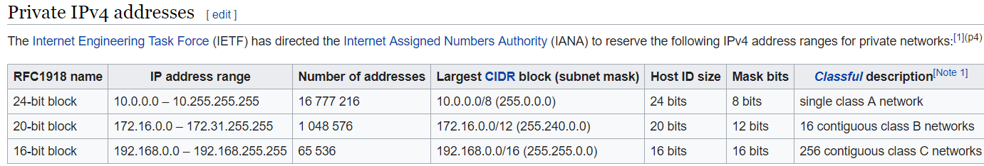

* What’s special about this ip-address: 127.0.0.1?

Localhost. [IPv4](https://da.wikipedia.org/wiki/IPv4) og ::1 med [IPv6](https://da.wikipedia.org/wiki/IPv6).  på den måde kan man koble en computer til, uden andre kan følge med.

* What kind of service would you expect to find on a server using these ports: 22, 23, 25, 53, 80, 443?

Tcp og udp. Er til host to host forbindelse

* What is the IP address of studypoints.dk and how did you find it?

157.230.21.145 en hjemmeside der hedder site 24x7

* If you write https://studypoints.dk in your browser, how did “it” figure out that it should go to the IP address you discovered above?

Dns lookup. It translatets domain name into a ip address.

* Explain shortly the purpose of an ip-address and a port-number and why we need both

IP address is use to identify a host or a group of hosts in a network while port number is used to identify a particular service running in a host

* What is your (nearest) DNS server,?

|  |  |
| --- | --- |
| 5.179.93.121 | Kongens Lyngby |

* What is (conceptually) the DNS system and the purpose with a DNS Server?

Domain Name **Servers** (**DNS**) are the Internet's equivalent of a phone book. They maintain a directory of domain names and translate them to Internet Protocol (IP) addresses. This is necessary because, although domain names are easy for people to remember, computers or machines, access websites based on IP addresses.

* What is your current Gateway, and how did you find it?

192.168.0.1. cmd ipconfig

* What is the address of your current DHCP-Server, and how did you find it?

40945998 ipconfig /all | findstr /C:"DHCP Server

* Explain (conceptually) about the TCP/IP-protocol stack

The OSI Reference **Model** that defines seven **protocol** layers is often called a **stack**, as is the set of **TCP**/**IP protocols** that define communication over the **internet**. The term **stack** also refers to the actual software that processes the **protocols**. ... Every NIC must have at least one **stack** bound to it.

* Explain about the HTTP Protocol (the following exercises will go much deeper into this protocol)

**HTTP** means HyperText Transfer **Protocol**. **HTTP is** the underlying **protocol** used by the World Wide Web and this **protocol** defines how messages are formatted and transmitted, and what actions Web servers and browsers should take in response to various commands.

* Explain (conceptually) how HTTP and TCP/IP are connected (what can HTTP do, and where does it fit into TCP/IP)

**HTTP** operates at the application layer of the **TCP**/**IP**networking model, and it implements communication between a client and a server. **HTTP** messages are, ultimately, delivered through **TCP**/**IP** connections. But the lower layers are obscured, and **HTTP** itself defines how commands and responses are formatted and delivered.

The "**IP**" part of the term, which stands for Internet **Protocol**, is used by **TCP** and UDP, to transport them from one network to another. ... **HTTP** (HyperText Transfer**Protocol**) is a **protocol** that utilizes **TCP** to transfer its information between computers (usually Web servers and clients)