[INSTITUTION NAME AND FACULTY]
Basic Calculator Application
Team A: Specialization Project Report
Course: Specialization Project (IN.MSA.CBS.006), Project-Based Learning
Team | Team A (five students)
Student 1 | [STUDENT 1: full name, student number]
Student 2 | [STUDENT 2: full name, student number]
Student 3 | [STUDENT 3: full name, student number]
Student 4 | [STUDENT 4: full name, student number]
Student 5 | [STUDENT 5: full name, student number]
Teacher | [PROFESSOR NAME, as it should appear]
Final defence | 18 December 2026
Submission date | [SUBMISSION DATE]
Version | Draft 0.2, corrected on 31 October 2026 after the academic audit
DRAFT. NOT SIGNED OFF AND NOT READY FOR SUBMISSION. This draft was prepared by an AI assistant (Claude Code) from the project documents and was not yet reviewed by the five students or by the professor. Yellow fields are missing information that only the students can supply. Human test results are marked PENDING.
About this draft
This is a draft of the final project report. It is written so that the five students can read it, correct it, and then make it their own. Please read the following notes before you edit it.
Table 1. How to read this draft
Mark | Meaning
[Yellow text in brackets] | Information that is missing and must be supplied by the students or the professor (names, hours, reflections, dates, results of human tests). Appendix H lists all of them.
[Element 1] to [Element 4] | The four mandatory development elements named on slide 8 of the professor's presentation: project card; literature and assumption review; design and prototyping; implementation and testing. The fifth element is this report and the presentation.
Automated | A result produced by a program that anyone can run again (unit tests, browser checks, documentation checks).
AI review | A review made by the AI assistant that also wrote the code. It is not independent.
PENDING | A check that needs a person or equipment that was not available. Nothing marked PENDING has been done.

Authorship and AI assistance. The source code, the automated tests, the project documents and this draft were produced by an AI assistant (Claude Code) working on the instructions of the project lead. They are not the independent work of the students. The students must read, understand, test and be able to explain everything in it before they present it as their own. The students' own contributions (hours, meetings, reviews, reflections) are not yet recorded; they appear here only as yellow placeholders. Whether and how AI assistance may be used is governed by the professor's policy, which is still unknown (open question Q4).
Contents
1 Introduction and objectives 8
1.1 The assignment 8
1.2 The driving question 8
1.3 Objectives 8
1.4 Scope 9
1.5 Structure of the report and the professor's required elements 9
1.6 How this report was prepared 9
2 Project card 10
2.1 Purpose 10
2.2 Scope of work 10
2.3 Technologies and methodologies 10
2.4 Schedule 10
2.5 Plan compared with what actually happened 12
2.6 Success criteria and their present status 12
3 Project organization 13
3.1 Work breakdown structure 13
3.2 Responsibilities 13
3.3 Communication and meetings 14
3.4 Resources, effort, cost and expenses 14
3.5 Records of working time 15
4 Literature and assumption review 16
4.1 Method and honest limits 16
4.2 The three calculators 16
4.3 Design lessons 17
4.4 Requirements 17
4.5 Standards used and a correction 19
4.6 Assumptions and limits 19
5 Design and prototyping 20
5.1 Design goals and constraints 20
5.2 Application architecture 20
5.3 Data-flow diagram 21
5.4 State diagram 22
5.5 Number policy: rounding and display (decision D3) 23
5.6 User interface design and prototype 24
5.7 Alternatives considered 25
6 Implementation 27
6.1 Application components 27
6.2 Development process 27
6.3 Important design decisions 28
6.4 Selected code examples 28
6.5 The finished application 28
6.6 Who did what 29
7 Testing and verification 30
7.1 Test approach and who verified what 30
7.2 Environment 30
7.3 Results 31
7.4 Requirement coverage 31
7.5 The negative-zero bug: found, fixed and tested 32
7.6 Boundary tests and a mutation check 32
7.7 The floating-point investigation 33
7.8 Accessibility assessment 33
7.9 Security assessment 33
8 Risk assessment and limitations 35
8.1 Risk register 35
8.2 Limitations of the product and of the verification 35
9 Project-Based Learning 37
9.1 PBL in this project 37
9.2 Investigation 37
9.3 Choices 37
9.4 Feedback and iteration 38
9.5 Teamwork 38
9.6 Reflection of each student 38
9.7 Course objectives and learning outcomes 39
9.8 Relationship with the earlier Team Project 39
10 Deployment and user instructions 40
10.1 How to run the calculator 40
10.2 How to use it 40
10.3 Things to know 40
10.4 For developers and examiners 41
11 Conclusions 42
11.1 What was achieved 42
11.2 What is not finished 42
11.3 Lessons learned 42
11.4 Possible future work 42
11.5 Final statement 42
12 References 43
Appendices 44
Appendix A. Traceability 44
Appendix B. Decision log summary 45
Appendix C. Tools, skills and AI assistance used 46
Appendix D. Test commands and results 47
Appendix E. Screenshots 48
Appendix F. Bug log 48
Appendix G. Human acceptance tests (PENDING) 49
Appendix H. Placeholder register 51
Appendix I. Time-log template (empty) 53
Appendix J. Browser check matrix 54
Appendix K. Code excerpts 54
Appendix L. Risk register 55

List of figures
Figure 1. Gantt chart of the project plan (source: docs/01-project-card/gantt.md) 11
Figure 2. Application architecture: the calculation layer never touches the page 20
Figure 3. Level-1 data-flow diagram 22
Figure 4. State diagram of the calculator 22
Figure 5. Static visual prototype (does not calculate): typing, error state and a 320 px frame 24
Figure 6. The calculator in Microsoft Edge: after typing 7 + 8 (the small line shows the pending operation), after 2 + 3 × 4 = (result 20, immediate execution), and after 5 ÷ 0 = (error message) 28
Figure 7. Keyboard focus ring on the 7 key (Edge); a very large result in exponential notation (Edge); the same error screen in Mozilla Firefox 159 29
Figure 8. At 320 px width: typing, error, emulated 400 % browser zoom (320 x 256 px viewport), and 200 % text size 48

List of tables
Table 1. How to read this draft 2
Table 2. Project objectives and where they are answered 8
Table 3. What is and is not part of the calculator 9
Table 4. The professor's five elements and the chapters of this report 9
Table 5. Technologies and methods used 10
Table 6. Weekly plan 11
Table 7. Milestones 11
Table 8. Success criteria 12
Table 9. Work breakdown structure, level 1 13
Table 10. Provisional responsibility by work package (L = lead, S = support, R = reviewer) 13
Table 11. Student roles and names 14
Table 12. Resources 14
Table 13. Effort estimate, financial cost estimate and actual expenses 15
Table 14. The products studied 16
Table 15. Comparison of the three calculators 16
Table 16. Lessons from the review and what the project did with them 17
Table 17. Functional requirements (requirements specification v0.3) 18
Table 18. Non-functional requirements 18
Table 19. WCAG criteria used (read from the W3C pages) 19
Table 20. Constraints that shaped the design 20
Table 21. Modules and their interfaces 21
Table 22. The five states 23
Table 23. Options for the number policy that were compared 23
Table 24. Design choices for the interface 24
Table 25. Keyboard map 25
Table 26. Colour contrast of the design (calculated with a script) 25
Table 27. Alternatives and why one was chosen 25
Table 28. Files of the application 27
Table 29. Phases and local Git commits 27
Table 30. Kinds of verification 30
Table 31. Test environment 30
Table 32. Final quality gate (31 October 2026) 31
Table 33. Coverage after Phase 4 31
Table 34. Bug report BUG-1 32
Table 35. Option A compared with option E 33
Table 36. Main threats and controls 34
Table 37. High-rated risks (full register in Appendix L) 35
Table 38. Known limitations (not bugs) 35
Table 39. PBL characteristics and this project 37
Table 40. Feedback rounds and what changed 38
Table 41. Individual reflections (to be written by the students) 38
Table 42. Course objectives C1 to C4 (slide 2 [14]) and what the project can show 39
Table 43. Selected course learning outcomes (slide 3 [14]) and evidence 39
Table 44. Using the calculator 40
Table 45. Commands (Node.js 22 or newer) 41
Table 46. References 43
Table 47. The professor's 17 draft items (slides 32 and 33) and where they are covered 44
Table 48. Requirements and the tests that check them (summary) 45
Table 49. Decision summary (full text in the decision log) 45
Table 50. Open questions (from the decision log) 46
Table 51. What was actually used (from the tool and AI usage log) 46
Table 52. Firefox: the 11 skipped checks 47
Table 53. Application bug 48
Table 54. Mistakes found in tests, scripts and documents (not application bugs) 49
Table 55. Human acceptance tests 49
Table 56. Placeholders to fill in before submission 51
Table 57. Weekly summary of working time (hours) 53
Table 58. What the browser checks cover, per browser 54
Table 59. Risk register 55

1 Introduction and objectives

1.1 The assignment
The course "Specialization Project" (IN.MSA.CBS.006) is taught with the Project-Based Learning (PBL) method [14]. The professor divided the student group into two teams. Team A was assigned the following application: a calculator that allows the user to perform basic mathematical operations (slide 10 [14]). The second team builds a notes application. The professor requires that the result is a working application and describes the final result as "very simple working applications with documentation" (slide 8 [14]).
The final defence takes place on 18 December 2026, in the last class of the course (slides 9 and 11 [14]). The professor gives, as an example, ten minutes to present the project and show a working demonstration (slide 8 [14]).

1.2 The driving question
Project-Based Learning starts from an open question [14]. The project is built around this question (set in the Phase 1 plan and approved by the project lead):
How can we build a calculator that a first-time user can trust to give correct results, and how can we prove it?
The question has two halves. The first half is about the product: a calculator must be simple to use and must not mislead. The second half is about evidence: it is not enough to say that the calculator works; the project must show how it was checked, and be honest about what was not checked.

1.3 Objectives
Table 2. Project objectives and where they are answered
No. | Objective | Chapter
O1 | Build a very simple working calculator for a web browser, with HTML, CSS and plain JavaScript, that runs offline. | 5, 6, 10
O2 | Study existing calculators, collect requirements and write them down so that they can be tested. | 4
O3 | Design the program so that the calculation rules are separate from the user interface, and document the design with diagrams. | 5
O4 | Verify the calculator with automated tests in several browsers, record real results and report problems honestly. | 7
O5 | Make the calculator usable with keyboard and touch, accessible, and secure to a level that fits a small page. | 5, 7
O6 | Organise the work as a team project, learn from the process (PBL) and present the results with a live demonstration. | 2, 3, 9, 11

1.4 Scope
Table 3. What is and is not part of the calculator
In scope | Out of scope (decided)
Addition, subtraction, multiplication, division | Percent key (removed by decision D10)
Decimal numbers, negative numbers, sign toggle | Operator precedence and brackets; scientific functions
Clear and backspace; keyboard input | Memory keys, history, themes, dark mode
Clear error messages and recovery (division by zero, too large, too small) | Repeat-equals, accounts, database, installable app
Responsive layout down to 320 px; accessibility basics | Languages other than English; currency or unit conversion

1.5 Structure of the report and the professor's required elements
Slide 8 [14] says that the documentation must contain five clearly defined elements. Elements 1 to 4 are the four mandatory development sections. They are marked with a blue label at the start of the matching chapters. The fifth element is the report and the presentation themselves.
Table 4. The professor's five elements and the chapters of this report
Element on slide 8 | What it asks for | Chapters
[Element 1] Project card | Purpose, scope of work, technologies and methodologies used, schedule (for example a Gantt chart) | 2 (and 3)
[Element 2] Literature and assumption review | Analysis of existing solutions and collection of requirements | 4
[Element 3] Design and prototyping | Application architecture, schematics, first versions of code or models | 5
[Element 4] Implementation and testing | Creating the final solution and its verification | 6 and 7
[Element 5] Documentation and defence | Preparation of the report and presentation of the results, with a working demo | This report; the presentation; the demo

The other material (organisation, risks, PBL reflection, deployment) comes from the list "the draft should include" on slides 32 and 33 and from the PBL slides [14]. It is supplementary project-management material. Appendix A maps all 17 items of that list to the chapters.

1.6 How this report was prepared
The report is based on the project documents in the Git repository (docs/), the source code (src/), the tests (tests/) and the evidence (evidence/). Every number comes from those files or from test runs recorded in them. Section 7.1 explains which results are automated, which are AI review and which are still waiting for a human.

2 Project card
[Element 1] Professor's element 1 of 5 (slide 8): purpose, scope, technologies and methodologies, schedule

2.1 Purpose
The purpose is to deliver a simple, reliable and accessible browser calculator, and to document honestly how it was researched, designed, built and verified. The project also trains the skills named in the course outcomes: working in a team, estimating time, leading a small team, and preparing and presenting a project (slide 3 [14]).

2.2 Scope of work
The calculator has 19 keys: ten digits and a decimal point, four operators, equals, clear (C), backspace, and a sign key. It accepts the same operations from the keyboard. It shows the pending operation on a small line above the result, and it shows clear messages for errors. The requirements are listed in Chapter 4 and the exclusions in Section 1.4.

2.3 Technologies and methodologies
Table 5. Technologies and methods used
Area | Choice | Note
Application | HTML, CSS and plain JavaScript | Team choice, not imposed by the professor. Classic scripts (no ES modules), so that the page opens by double-click without a server (decision D2).
Unit testing | Node.js built-in test runner | Command node --test. No package is installed.
Browser testing | A Node script that drives the browsers through their built-in protocols | tests/browser-check.js for Edge, Chrome and Firefox. Playwright was not installed.
Version control | Git | Five local commits. Nothing has been pushed to a remote repository.
Diagrams and documents | Markdown and Mermaid sources; this Word report | The Markdown files are the editable source (decision D5).
Project method | Project-Based Learning | Driving question, iteration with feedback, reflection (slides 12 to 28 [14]).
Assistance | AI assistant (Claude Code), with several skills | Every use is recorded in the tool and AI usage log (Appendix C).

2.4 Schedule
The plan runs from 31 October to 18 December 2026, seven weeks. The table below shows the weekly focus and Figure 1 shows the Gantt chart. The chart was drawn from docs/01-project-card/gantt.md; the red line marks the day the chart was drawn.
Table 6. Weekly plan
Week | Dates | Main focus
W1 | 31 Oct - 6 Nov | Project card, plan, risks. Class on 6 November
W2 | 7 - 13 Nov | Research, requirements baseline
W3 | 14 - 20 Nov | Design, diagrams, prototype
W4 | 21 - 27 Nov | Engine (test-first), first interface, team retrospective (proposed 27 Nov)
W5 | 28 Nov - 4 Dec | Feature complete, test execution
W6 | 5 - 11 Dec | Bug fixing, code freeze on 9 December, report finished
W7 | 12 - 18 Dec | Buffer, rehearsals, defence on 18 December

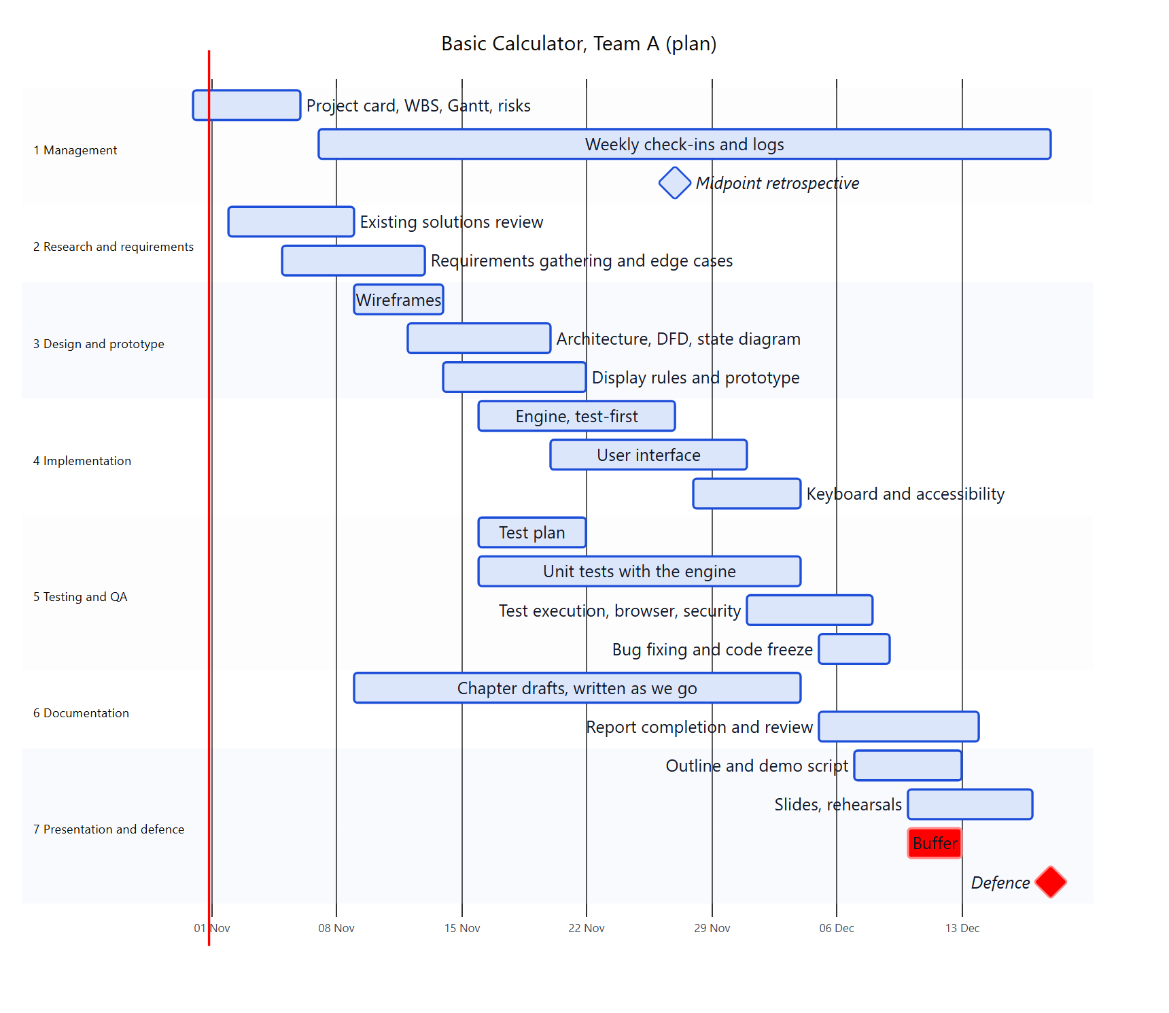
Figure 1. Gantt chart of the project plan (source: docs/01-project-card/gantt.md)
Table 7. Milestones
No. | Date | Milestone | Evidence expected
M1 | 6 Nov (Fri) | Project card and plan reviewed (class day) | Reviewed documents, notes
M2 | 13 Nov (Fri) | Requirements baseline | Approved requirements specification
M3 | 20 Nov (Fri) | Design and prototype review | Diagrams, wireframes
M4 | 27 Nov (Fri) | First working version and team retrospective | Running build, retrospective notes
M5 | 4 Dec (Fri) | Feature complete | Tests passing for Must items
M6 | 9 Dec (Wed) | Code freeze and test report | Test report from real runs
M7 | 14 Dec (Mon) | Documentation complete | Final report draft
M8 | 16 Dec (Wed) | Dress rehearsal | Rehearsal notes
M9 | 18 Dec (Fri) | Defence | Presentation and live demo

2.5 Plan compared with what actually happened
Important. The schedule above is the plan made on 31 October 2026. The documents, code and tests were all produced on 31 October 2026 by the AI assistant, far ahead of the plan, in four review rounds with the project lead (Section 9.4). That is not a record of student work. The students' own tasks (reviews, human tests, report writing, rehearsals, time log) are still ahead of them and are not shown by the chart. [Students: add what really happened week by week, with dates, here.]

2.6 Success criteria and their present status
Table 8. Success criteria
No. | Criterion (project card) | Status on 31 October 2026
1 | Every Must requirement is implemented | Done. 15 Must requirements pass the automated tests (Chapter 7). Not yet confirmed by human acceptance testing.
2 | Every planned test has been run with real results recorded | Automated tests: done and recorded. Human tests: PENDING (Appendix G).
3 | The live demo runs without errors on the defence day | Not yet possible to say. [Students: rehearsal results and the computer used]
4 | Each member can explain the code and documents they contributed to | [Each student: confirm after reading the code walkthrough]
5 | Documentation reflects what was actually done, including problems | Done in the logs and in this report; review by the team PENDING.

3 Project organization
Supplementary project-management material (slides 5, 32 and 33): organisation, communication, resources, budget

3.1 Work breakdown structure
The work was divided into seven work packages (WBS level 1). The hours are planning estimates, not recorded work. Their total of 198 hours lies inside the planning assumption of about 5 to 6 hours per student per week for seven weeks (175 to 210 person-hours).
Table 9. Work breakdown structure, level 1
WBS | Work package | Planned effort (h) | Lead (provisional) | Slide 8 element
1 | Project management | 20 | Student 1 | 1
2 | Research and requirements | 28 | Student 2 | 2
3 | Design and prototype | 32 | Student 3 | 3
4 | Implementation | 40 | Student 4 | 4
5 | Testing and quality assurance | 30 | Student 5 | 4
6 | Documentation | 30 | Student 5 (integration) | 5
7 | Presentation and defence | 18 | Student 1 | 5
 | Total | 198

3.2 Responsibilities
Each student leads one area and supports another, so that nothing depends on one person. The roles are provisional and have not been confirmed by the students.
Table 10. Provisional responsibility by work package (L = lead, S = support, R = reviewer)
WBS | Work package | S1 | S2 | S3 | S4 | S5
1 | Project management | L | R |  |  | S
2 | Research and requirements | S | L | R
3 | Design and prototype |  | S | L | R
4 | Implementation |  |  | S | L | R
5 | Testing and QA |  | S |  | R | L
6 | Documentation | S | S | S | S | L
7 | Presentation and defence | L | S | S | S | S

Reality note. The Phase 1 plan assigned code contributions to students. In fact, the code was written by the AI assistant. The students' real role is now to review, understand, verify and explain the work, and to write the report. [Students: describe who actually did what, in your own words.]
Table 11. Student roles and names
Student | Provisional lead area | Name
Student 1 | Project management, project card, schedule | [STUDENT 1 NAME]
Student 2 | Research, requirements, literature review | [STUDENT 2 NAME]
Student 3 | UI/UX design, architecture, diagrams, prototype | [STUDENT 3 NAME]
Student 4 | Engine, implementation, code quality | [STUDENT 4 NAME]
Student 5 | Testing, quality assurance, documentation integration | [STUDENT 5 NAME]

3.3 Communication and meetings
The team communication and meeting rules are a proposal that the team has not yet agreed (document team-communication-rules.md). The main ideas are listed below.
- Decisions count only when they are written in the decision log; a chat message alone is not a decision.
- A weekly check-in of 30 to 45 minutes, a milestone review at each milestone, and a midpoint retrospective (proposed for 27 November).
- Meeting notes are written only for real meetings and saved with the real attendees.
- Every change is reviewed by another member; small, frequent commits; no secrets in the repository.
- Disagreements are decided by agreement, then by vote; the project manager decides a tie.
Facts the team must supply: the chat tool [CHAT TOOL NAME], the weekly meeting day and time [MEETING DAY AND TIME], and whether meetings are in person or online [MEETING FORM]. Meetings actually held: [LIST OF REAL MEETINGS WITH DATES AND ATTENDEES, or "none yet"].

3.4 Resources, effort, cost and expenses
Table 12. Resources
Resource | Detail
People | Five students.
Equipment | The team members' own computers and current browsers (Microsoft Edge, Google Chrome, Mozilla Firefox). No purchases are recorded in the project documents.
Software | Node.js, Git, a text editor, the three browsers. All free to use. One program was installed during the project: Firefox 159.0, from the official Mozilla download, with the project lead's approval.

Effort, financial cost and expenses are three different quantities. They are kept apart in this report and no figure was invented.
Table 13. Effort estimate, financial cost estimate and actual expenses
Quantity | What it means | Status on 31 October 2026
Effort estimate (planned) | Person-hours of work planned in the work breakdown structure (Section 3.1). | 198 person-hours, about 40 per student. A planning estimate, not a measurement.
Actual effort | Hours really worked, taken from the time log (Section 3.5). | None recorded. [ACTUAL HOURS PER STUDENT, from the time log]
Financial cost estimate | The money the project would cost if the work were paid: hours multiplied by an hourly rate, plus equipment and licences. | Not prepared. No hourly rate was given. [Team: decide with the professor whether a cost estimate with an hourly rate is expected (slide 32, item 10).]
Actual expenses | Money that was really spent on the project. | None are recorded in the project documents. [Students: confirm that no money was spent, or list the real expenses]

3.5 Records of working time
The professor's list asks for records of the working time of each member, kept by the project manager (slide 32, item 5 [14]). The time log exists as an empty template. No hours have been recorded, and none were invented. The weekly table is repeated in Appendix I.

4 Literature and assumption review
[Element 2] Professor's element 2 of 5 (slide 8): analysis of existing solutions and collection of requirements

4.1 Method and honest limits
The AI assistant studied three existing basic calculators by reading their official documentation and, where it is public, their source code. The sources were fetched with web tools on 31 October 2026 and every quoted fact was checked again against the raw pages. The references are in Chapter 12.
What this review is not. No user research was done (no interviews, surveys or usability tests). The team members did not use the three calculators hands-on for this review, and the code of the open-source calculator was read but not run. Statements about it that come from reading code are marked "inferred". A short hands-on session by the students is proposed but not done [Students: hands-on notes, with names and dates, if you do it].

4.2 The three calculators
Table 14. The products studied
Product | What it is | Why it was chosen
A. Windows Calculator (Microsoft) [1][2][3] | The calculator of Windows, open source (MIT licence). Standard mode, with other modes and converters. | A mature, widely used calculator. Its public source lets the review check behaviour and accessibility strings.
B. Google Search calculator [4] | A calculator inside Google Search, described in Google's help page. | Many people meet it on the web. It shows a typed-expression model.
C. Mar-Issah JavaScript-Calculator [5] | A small open-source calculator in HTML, CSS and plain JavaScript (MIT licence). | Same technology as this project. One example only, found by a web search; not a representative sample.

Table 15. Comparison of the three calculators
Criterion | A. Windows (Standard) | B. Google | C. Open-source JS
Functionality | Basic operations plus modes, history, memory, converters [1] | Arithmetic and much more, including graphing [4] | Four operations, clear, delete, decimal [5]
Evaluation model | Immediate execution in Standard mode [1] | Not documented | Immediate execution [5]
Precision | Infinite precision for the four basic operations [1] | Not documented | Plain JavaScript numbers, no rounding [5]; float noise likely (inferred)
Input | Buttons, keyboard, shortcuts [3] | Typed expression in the search box [4] | Buttons only; no keyboard handler [5]
Input handling | Not examined in detail | Not documented | Ignores a second decimal point; ignores a second operator [5]
Error handling | Messages such as "Calculation failed" [3]; text for 5 ÷ 0 in Standard mode not confirmed | The calculator does not appear for 7*9/0 [4] | No division-by-zero check [5]; Infinity or NaN likely (inferred)
Accessibility | Screen-reader text such as "Display is %1" and "Minus" [3] | Not documented | No labels, no live region [5]
Reuse | MIT, but too large to reuse [2] | Not reusable | MIT [5]. Not reused: the code of this project was written separately by the AI assistant.

4.3 Design lessons
Table 16. Lessons from the review and what the project did with them
No. | Lesson | Decision taken
L1 | Windows Standard mode and the open-source example use immediate execution [1][5]. | Keep immediate execution (D1): 2 + 3 × 4 = gives 20. Say so in the help text.
L2 | Windows uses infinite precision [1]; the open-source example does not round at all. | An explicit number policy is needed (Section 5.5).
L3 | The open-source example has no division-by-zero check [5]; Google shows no result for it [4]. | Division by zero is a defined state with a message and a way out.
L4 | The open-source example ignores a second operator [5]. | Chosen: the second operator replaces the first.
L5 | The decimal-point rule must apply per number, not per calculation [5]. | Reset the check when a new number starts; test 1.5 + 2.5.
L6 | The open-source example has no keyboard support; WCAG 2.1.1 asks for full keyboard operation [5][9]. | Keyboard input is a Must requirement.
L7 | The open-source example has unnamed buttons; Windows reads "-" as "Minus" [3][5]; WCAG 4.1.2 [12]. | Every key has an accessible name in words.
L8 | Windows announces the display as "Display is %1" [3]; WCAG 4.1.3 [13]. | The display is a live region (<output>).
L9 | Windows shows shortcuts in tooltips [3]. | A short visible "Keyboard" help.
L10 | The other calculators offer far more than basic arithmetic [1][4]. | Do not copy features: the professor asks for "very simple".
L11 | Google has no keypad and uses a typed expression [4]. | The assignment is a button calculator that also accepts keys.

4.4 Requirements
The requirements were refined three times (v0.1 to v0.3) after the review and after the project lead's decisions. Priorities use MoSCoW: M must, S should, C could, W won't. Every requirement that was built has a named automated test (Appendix A).
Table 17. Functional requirements (requirements specification v0.3)
ID | Requirement | Priority
FR-01 | Enter digits 0 to 9 with buttons; a leading zero is not repeated | M
FR-02 | One decimal point per number | M
FR-03 | Addition, subtraction, multiplication, division | M
FR-04 | Equals shows the result; a digit starts a new number; an operator continues from the result | M
FR-05 | Chained operations use immediate execution (2+3×4= gives 20) | M
FR-06 | Clear resets everything, including an error | M
FR-07 | Backspace deletes the last digit; a single digit becomes 0 | M
FR-08 | A second operator replaces the first | M
FR-09 | Division by zero shows a clear message and the calculator recovers | M
FR-10 | Controlled display rounding; the stored value is never rounded (decision D3) | M
FR-11 | Very large and very small results are shown correctly; overflow and underflow are reported | M
FR-12 | Number entry is limited to 12 digits | M
FR-13 | Keyboard input; a comma works as a decimal point | M
FR-14 | Percent function. Retired on 31 Oct 2026 (decision D10); now out of scope | W
FR-15 | Sign toggle; zero stays 0 | M
FR-16 | A small line shows the pending operation | S
FR-17 | Session history of calculations | C (not built)
FR-18 | = with nothing pending, or an operator without a second number, is safe; no repeat-equals | M

Table 18. Non-functional requirements
ID | Category | Requirement
NFR-01 | Correctness | Every planned test passes; every requirement is linked to at least one test
NFR-02 | Reliability | The display never shows NaN, Infinity or undefined; random key sequences cause no crash
NFR-03 | Usability | A first-time user can calculate without instructions; keys are at least 48 x 48 CSS px (design value)
NFR-04 | Accessibility | WCAG 2.1 AA checks: keyboard, focus, names, live display, contrast, reduced motion
NFR-05 | Compatibility | Edge, Chrome and Firefox; no horizontal scrolling at 320 CSS px
NFR-06 | Security | No eval or Function; no innerHTML with dynamic data; no outside scripts; a restrictive Content Security Policy
NFR-07 | Portability | Runs by opening src/index.html, with no build step or server
NFR-08 | Maintainability | Calculation separate from the interface; changes reviewed by a second member
NFR-09 | Legal and ethical | Only original or licensed code; no personal data; AI assistance recorded

Out of scope (decided): scientific functions, memory keys, history and themes, backend, installable app, conversions, other languages, the percent key, repeat-equals, and snapping tiny results to zero.

4.5 Standards used and a correction
Table 19. WCAG criteria used (read from the W3C pages)
Criterion | Level | Threshold or rule | Ref.
1.4.3 Contrast (Minimum) | AA | Text contrast at least 4.5:1 (large text 3:1) | [6]
1.4.10 Reflow | AA | No two-dimensional scrolling at 320 CSS px width | [7]
1.4.11 Non-text Contrast | AA | Interface components at least 3:1 | [8]
2.1.1 Keyboard | A | All functionality operable through a keyboard interface | [9]
2.5.5 Target Size (Enhanced) | AAA | 44 by 44 CSS pixels | [10]
2.5.8 Target Size (Minimum) | AA (WCAG 2.2) | 24 by 24 CSS pixels (with exceptions) | [11]
4.1.2 Name, Role, Value | A | Name and role can be determined by software | [12]
4.1.3 Status Messages | AA | Status messages can be determined without receiving focus | [13]

A correction made during the project. The first plan treated a 44 px touch target as a Level AA rule. Reading the W3C pages showed that 44 px belongs to Level AAA (criterion 2.5.5) and that the AA minimum is 24 px (criterion 2.5.8 in WCAG 2.2). The keys are still designed at 48 px because large keys are good for touch use, but this is no longer called an AA requirement.

4.6 Assumptions and limits
- Users (assumed, not validated): anyone who needs quick everyday arithmetic, on a laptop with keyboard or on a phone with touch.
- The sources were read on 31 October 2026 and may change. One Windows resource file is very long (about 275,000 characters); it was searched for the strings quoted here only.
- A student must still open every URL and confirm the facts [Student 2: confirmation, with date].

5 Design and prototyping
[Element 3] Professor's element 3 of 5 (slide 8): application architecture, schematics, first versions of code or models

5.1 Design goals and constraints
Table 20. Constraints that shaped the design
Constraint | Effect on the design
The page must open by double-click, offline (NFR-07, decision D2) | Classic <script> files, no ES modules, no packages at run time
The calculation must be testable without a browser (NFR-08) | The calculation code never touches the page: no document, no window
Five students and seven weeks | Few files and few ideas, easy to explain in ten minutes
Correct results are the heart of the project | Number and state rules are written down before the code

5.2 Application architecture
The program has two layers. The interface layer is everything the user sees or touches: the HTML page, the CSS style sheet, and two small scripts (keymap.js and app.js). The calculation layer has two scripts that do the thinking: engine.js holds the rules of the calculator, and format.js turns numbers into display text. Figure 2 shows how they are connected.
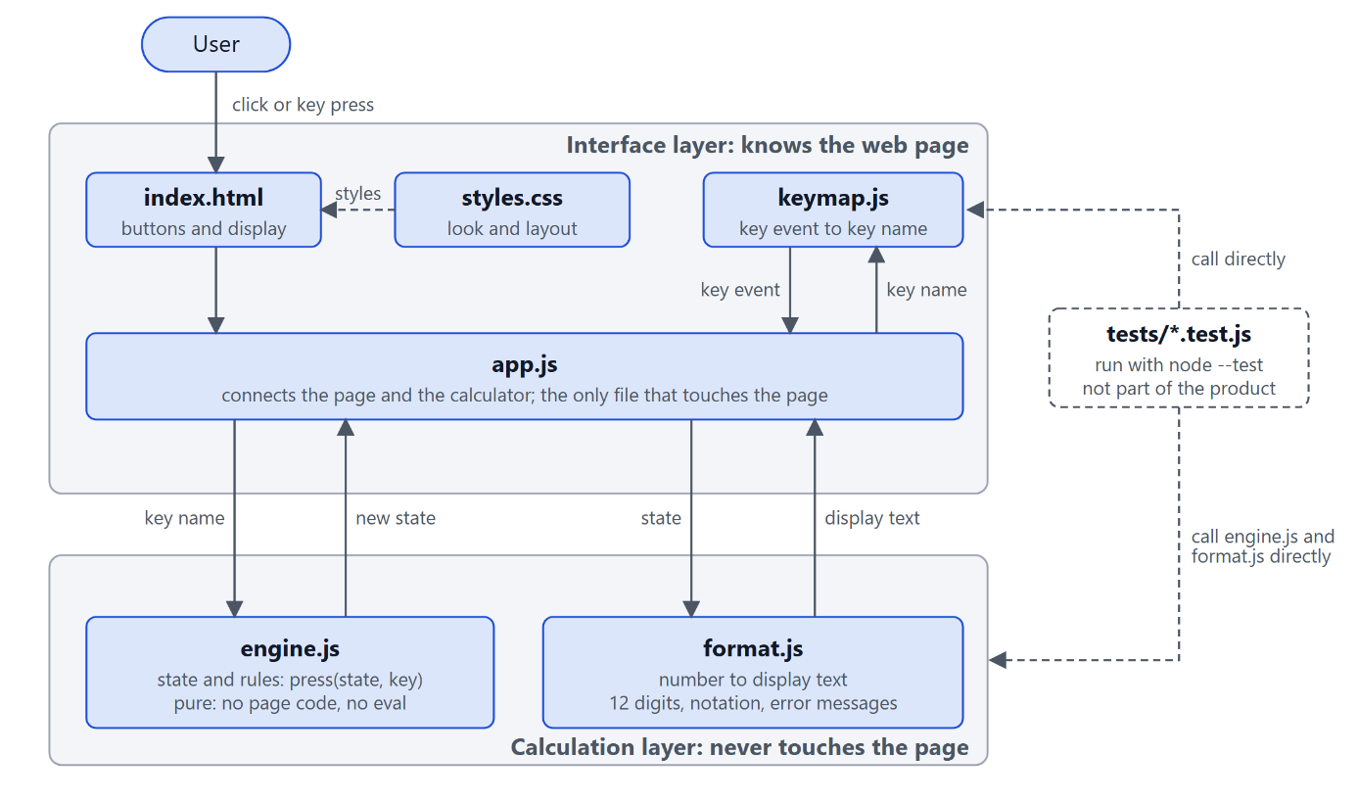
Figure 2. Application architecture: the calculation layer never touches the page
The separation has three benefits. The rules can be tested from the command line with thousands of key sequences and no browser. A change of colours or layout cannot break the rules. And two students can work on different layers without editing the same file. The tests are not part of the product; they call the calculation files directly.
Table 21. Modules and their interfaces
Module | Public interface | Rule
engine.js | initialState() and press(state, key) | Pure: never changes the state it receives, no clock, no randomness, no page code, no eval
format.js | formatNumber(value) and display(state) | Pure. Contains the display rules of section 5.5
keymap.js | commandForKey(event) | Pure. Returns a key name or nothing. Ignores keys with Ctrl, Alt or Meta
app.js | none (runs on page load) | The only file that touches the page. Holds one variable with the current state

The engine understands 19 key names: the digits 0-9, ., +, -, *, /, =, CLEAR, BACKSPACE and NEGATE. Any other key name is ignored. The state is a small frozen object with five fields: phase, entry (the digits typed, kept as text), accumulator (the stored number), operator and error.

5.3 Data-flow diagram
A data-flow diagram shows how information moves. Figure 3 is the level-1 diagram. A click or key press is captured, translated to a key name, applied to the state by the engine, formatted as text, and drawn on the page. The state (D1) is one variable in memory; it is never saved or sent anywhere, so the calculator collects no personal data.
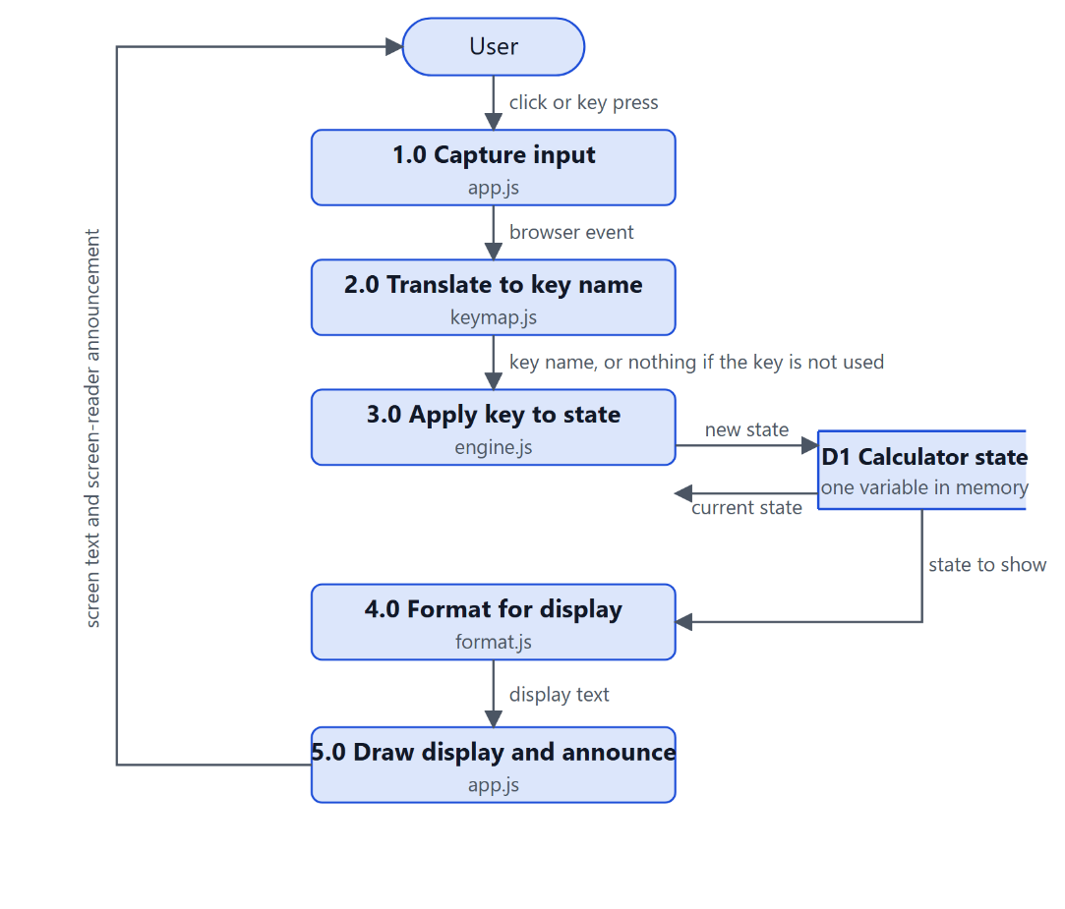
Figure 3. Level-1 data-flow diagram

5.4 State diagram
The calculator is in one of five situations (states). The same key means different things in different states, so the rules are drawn as a state diagram (Figure 4).
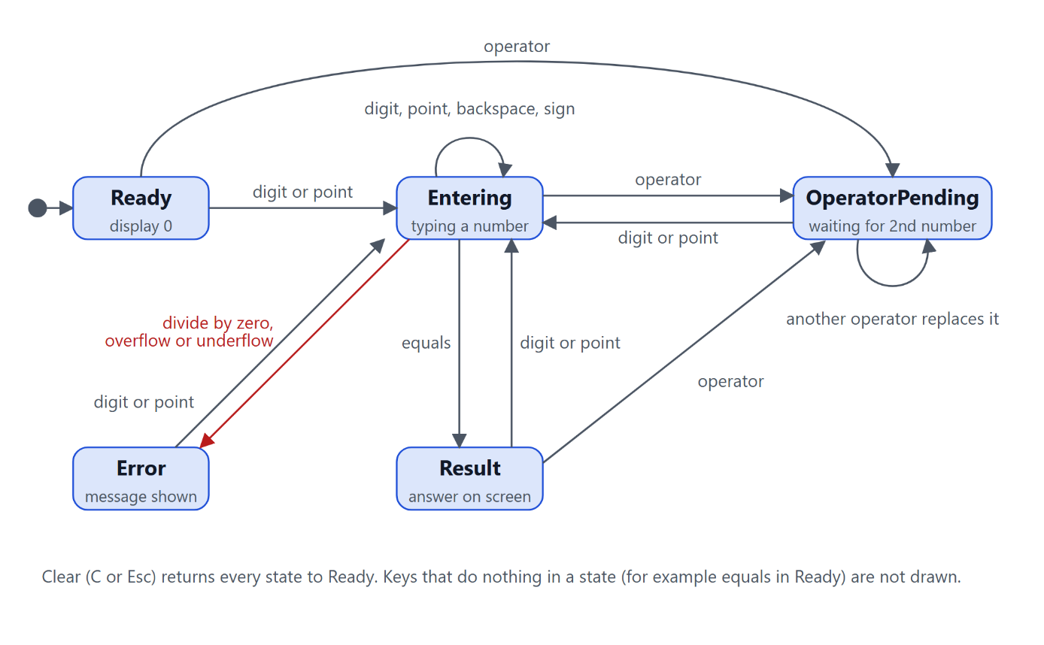
Figure 4. State diagram of the calculator
Table 22. The five states
State | Meaning | Display shows
Ready | Just started or cleared | 0
Entering | The user is typing a number | The digits typed so far
OperatorPending | An operator was pressed; waiting for the second number | The left number; the small line shows, for example, 7 +
Result | An answer is on the screen after = | The result
Error | Division by zero, overflow or underflow | Error and a message line

The most important rules, each tested automatically:
- Immediate execution (D1). With an operation pending, a new operator first calculates it. 2 + 3 × shows 5, then 4 = gives 20.
- Second operator replaces the first (FR-08). 5 + × becomes 5 ×.
- Safe equals (FR-18). = in Ready, in OperatorPending or after a result changes nothing.
- Errors recover (FR-09). In Error only a digit, a point or Clear is accepted.
- 12-digit limit (FR-12), one decimal point (FR-02), zero stays zero (FR-15).

5.5 Number policy: rounding and display (decision D3)
Computers store most decimals approximately. In JavaScript, 0.1 + 0.2 is 0.30000000000000004. Showing that would confuse users; hiding it carelessly could change results. The policy:
- The engine keeps the full numeric result and never rounds it.
- Only the display text is formatted: at most 12 significant digits, trailing zeros removed, exponential notation for very large and very small numbers (outside 0.0001 to 999999999999).
- A non-zero number is never shown as 0. Division by zero, overflow and underflow give an error state with a message.
Table 23. Options for the number policy that were compared
Option | Idea | 0.1+0.2-0.3 | (1÷3)×3-1 | Decision
A. Keep the raw result (decision D3) | Never change the stored number | 5.55111512313e-17 | 0 | Adopted
B. Normalise to 15 digits after each step | Store Number(r.toPrecision(15)) | 0 | -9.99e-16 | Not adopted: fixes one case, breaks another
D. Snap tiny add or subtract results to zero | Result 0 if tiny compared with the operands | 0 | 0 | Rejected by the project lead (D9)
E. Exact decimal arithmetic for + - × | Scaled integers (BigInt) | 0 | -1e-16 | Rejected for now (D17)
F. Decimal library | External dependency | 0 | (depends) | Rejected: conflicts with offline, no-dependency rule

The consequence is a known and documented limit: 0.1 + 0.2 - 0.3 shows 5.55111512313e-17, because the stored value of 0.1 + 0.2 is slightly above 0.3. This behaviour has its own test. A measured comparison of options A and E is in Section 7.7.

5.6 User interface design and prototype
The interface is a standard calculator grid: four columns and five rows, with a double-width zero, giving 19 keys. Function keys are grey, operators light blue, digits white, and the equals key is the only strong accent. The display has a fixed height so that the keys never move when an error message appears.
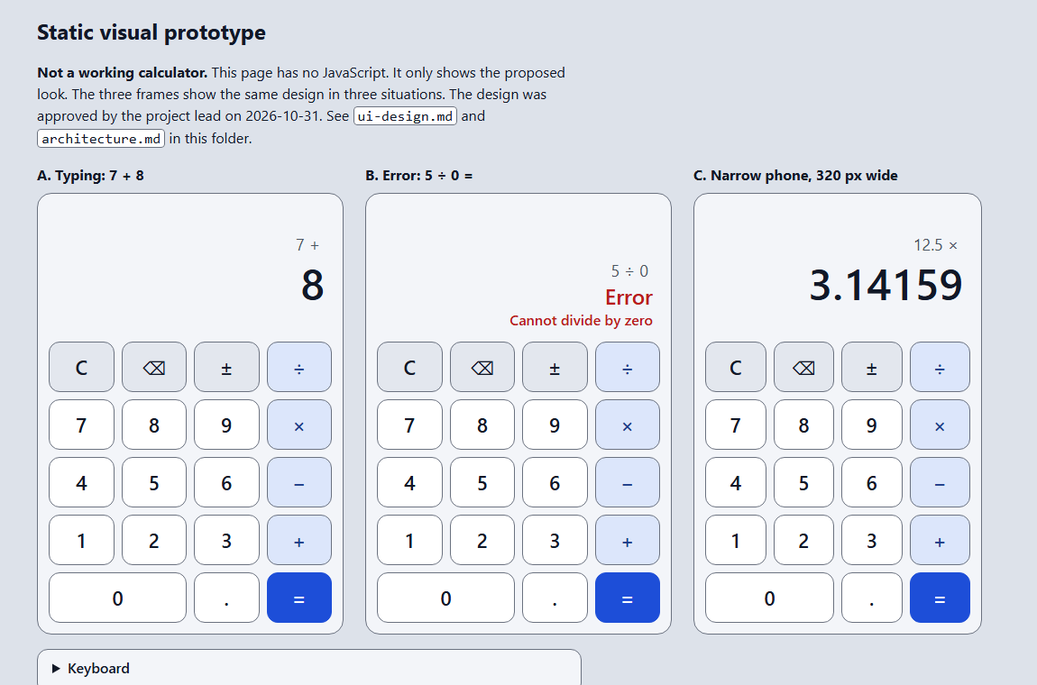
Figure 5. Static visual prototype (does not calculate): typing, error state and a 320 px frame
Table 24. Design choices for the interface
Topic | Choice
Colours | Light grey and blue. Text #111827, secondary text #4B5563, equals key #1D4ED8 with white text; no dark mode (decision D15).
Type | System font stack (no web fonts, so it works offline); display font steps down for long numbers.
Keys | Real <button> elements, at least 48 x 56 px, 8 px gap.
Focus | A 3 px dark ring, 3 px away from the key, on keyboard focus.
Names | Words for symbols: "Times", "Divided by", "Minus", "Plus", "Equals", "Decimal point", "Clear", "Delete last digit", "Change sign".
Live display | The display is an <output> element with aria-live="polite"; the error line has role="alert".
Motion | No animation; a reduced-motion rule is included.

Table 25. Keyboard map
Physical key | Action
0-9 (main row and numeric keypad) | Digit
. or , | Decimal point (the comma is an alias; the display always shows a period)
+ - * / | Operators
Enter or = | Equals (but Enter on a focused button presses that button)
Backspace | Delete the last digit
Escape | Clear
Tab, Shift+Tab, Space | Move between keys and press the focused key (browser behaviour)
Keys with Ctrl, Alt or Meta | Not taken; browser shortcuts keep working

Table 26. Colour contrast of the design (calculated with a script)
Element | Foreground / background | Ratio | Required
Main display text | #111827 on #F3F5F9 | 16.25 : 1 | 4.5 : 1
Expression line | #4B5563 on #F3F5F9 | 6.92 : 1 | 4.5 : 1
Operator key text | #1E3A8A on #DCE6FB | 8.26 : 1 | 4.5 : 1
Equals key text | #FFFFFF on #1D4ED8 | 6.70 : 1 | 4.5 : 1
Error text | #B91C1C on #F3F5F9 | 5.93 : 1 | 4.5 : 1
Key border on panel | #6B7280 on #F3F5F9 | 4.43 : 1 | 3 : 1
Focus ring on panel | #111827 on #F3F5F9 | 16.25 : 1 | 3 : 1

5.7 Alternatives considered
Table 27. Alternatives and why one was chosen
Decision | Chosen | Alternatives | Reason
Evaluation model | Immediate execution | Operator precedence with a parser | Windows Standard mode and the open-source example do the same; simpler state machine
Calculation model | State machine over key presses | Build a text expression and evaluate it | No eval or parser; every situation is testable
Code structure | Pure engine and formatter, interface glue | One mixed script; a framework | Testable without a browser; no dependency; fewer ideas
Loading | Classic scripts | ES modules | Modules fail from file:// in some browsers; risk for the live demo
State | One frozen object, replaced on each key | Several global variables | Easier to test; bugs are easier to find
Number entry | Keep the typed text | Keep a number while typing | Text keeps 0. and 1.50 and the 12-digit limit exactly
Prototype | Static HTML and Markdown wireframe | Figma | Lives in Git; no account (decision D13)
Diagrams | Data-flow and state diagram | Class diagram | Few objects; behaviour is the hard part (decision D4)

6 Implementation
[Element 4] Professor's element 4 of 5 (slide 8): creating the final solution (this chapter) and its verification (Chapter 7)

6.1 Application components
Table 28. Files of the application
File | Lines | Responsibility
src/index.html | 68 | The page: 19 buttons, the display, the help text, the Content Security Policy
src/css/styles.css | 133 | Colours, layout, focus ring, reduced motion
src/js/engine.js | 178 | The rules: states, key handling, arithmetic, errors
src/js/format.js | 77 | Display text: significant digits, notation, error messages
src/js/keymap.js | 34 | Which physical keys the calculator uses
src/js/app.js | 57 | Connects buttons and keys to the engine and draws the result

The whole application is about 350 lines of JavaScript (about 240 without comments and blank lines) in four files. There is no framework and no package. The line counts include comments.

6.2 Development process
The work was done in four phases on 31 October 2026, each ending with the project lead's review (Section 9.4):
Table 29. Phases and local Git commits
Phase | Content | Commit
1 | Project initialisation: project card, requirements v0.1, WBS, Gantt, responsibility matrix, risk register, decision log, tool log | 9501afb docs: initialize specialization calculator project
2 | Research and design: calculator review, requirements v0.3, architecture, UI design, static prototype | 2784c9a docs: add phase 2 research and design
3 | Implementation: engine, formatter, key map, page, tests written first | 602e34a feat: implement and test basic calculator
4 | Quality assurance: negative-zero bug fix, boundary and accessibility tests, Chrome and Firefox, security analysis | c76489f test: add QA tests and fix negative-zero entry bug
5 (planning) | Report outline, presentation plan, acceptance checklist; documentation audit | ac3fd76 docs: prepare final report and presentation plans

Test-first. For the engine, the tests were written before the code and were seen to fail (all test files failed because the source files did not exist). The code was then written until they passed. The same method was used to fix the bug described in Section 7.5. The Superpowers test-driven-development skill was not available, so the steps were followed by hand.

6.3 Important design decisions
The principal decisions are: immediate execution (D1), classic scripts so that the page opens from file:// (D2), display-only rounding with the full value kept (D3, confirmed on 31 October), data-flow and state diagrams instead of a class diagram (D4), the percent key removed (D10), keyboard input as a Must with a comma alias (D12), separate engine, formatter and interface (D14) and the sign key kept (D16). Two options were rejected: snapping tiny results to zero (D9) and exact decimal arithmetic (D17). The summary table is in Appendix B; the full text is in the decision log.

6.4 Selected code examples
Four short excerpts of the source are reproduced without change in Appendix K: the calculation of two numbers, the number formatting, the key map and the fix for the negative-zero bug. The engine reports errors instead of returning Infinity or NaN; the formatter chooses the notation from the rounded value and never shows a non-zero value as 0; the key map only reads the event and never takes keys with Ctrl, Alt or Meta.

6.5 The finished application
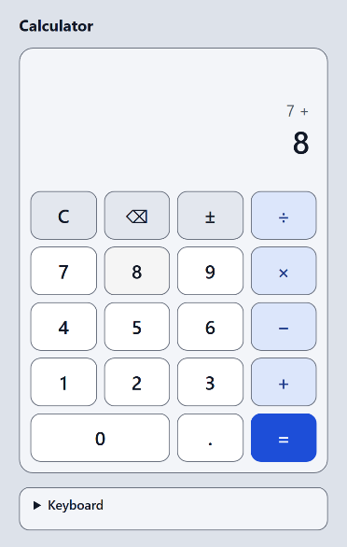 | 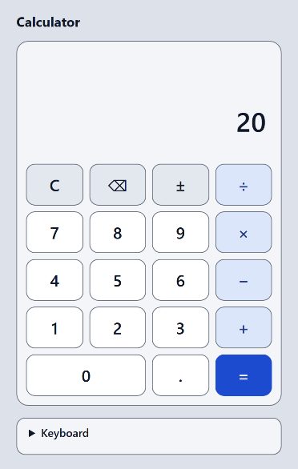 | 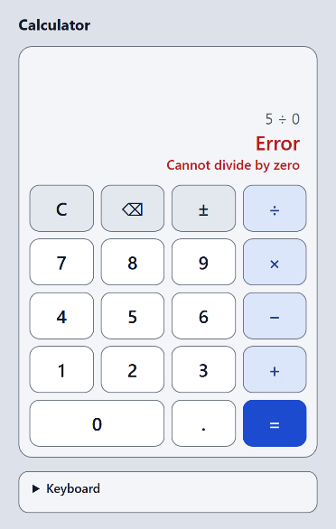

Figure 6. The calculator in Microsoft Edge: after typing 7 + 8 (the small line shows the pending operation), after 2 + 3 × 4 = (result 20, immediate execution), and after 5 ÷ 0 = (error message)
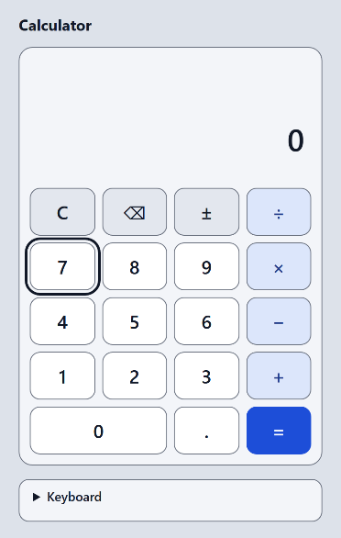 | 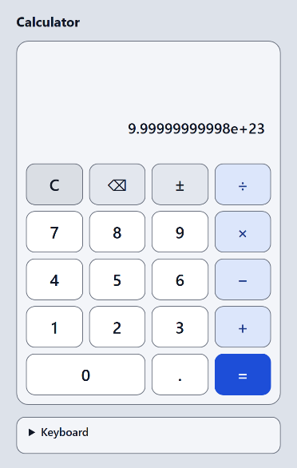 | 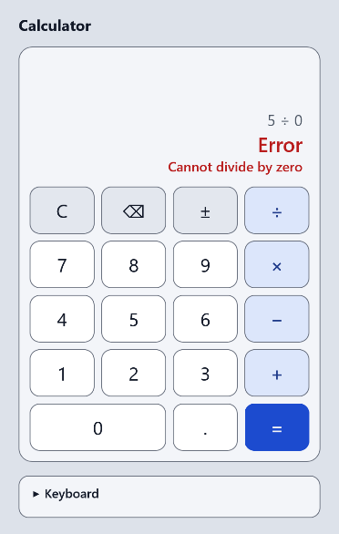

Figure 7. Keyboard focus ring on the 7 key (Edge); a very large result in exponential notation (Edge); the same error screen in Mozilla Firefox 159
All screenshots are real captures of the application made on 31 October 2026 by the test tool. The application runs by double-clicking src/index.html; no installation is needed.

6.6 Who did what
The code in src/ and tests/ was written by the AI assistant (Claude Code). The project lead gave instructions and approved each phase. The five students' own contributions to the implementation are not yet recorded. [Students: for each file, write who read it, who reviewed it, and what each student can explain. Do not claim authorship of code you did not write.]

7 Testing and verification
[Element 4] Professor's element 4 of 5 (slide 8): its verification

7.1 Test approach and who verified what
Table 30. Kinds of verification
Kind | What it covers | Status on 31 October 2026
Automated checks | Calculation rules, display text, key map, source-code rules, contrast, behaviour in three browsers, layout, zoom, offline, CSP | Done. All pass, with the skips in Section 7.3
AI review (not independent) | Code review, security analysis, floating-point study, screen-reader investigation | Done by the AI; needs human confirmation
Human verification | Screen reader, Lighthouse, real phone, a person using only the keyboard, Firefox keyboard focus, first-time users, independent code review, re-running the tests | PENDING. Not done

The test plan follows the usual test pyramid: many fast unit tests (Node.js built-in runner), some static checks of the source code, a smaller set of browser checks in real browsers, and a manual level for what a program cannot judge. The tests were written first. Every test name starts with the ID of the requirement it checks (for example T-FR-05), and a script fails if an active requirement has no test.

7.2 Environment
Table 31. Test environment
Item | Value
Date | 31 October 2026
Run by | The AI assistant, in the project lead's session. No student has run the tests yet.
Computer | Windows 11; Node.js v24.21.0
Browser 1 | Microsoft Edge 156.0.4314.50 (headless)
Browser 2 | Google Chrome 156.0.8078.74 (headless). Same engine family as Edge, so not independent of it
Browser 3 | Mozilla Firefox 159.0 (headless), installed from the official Mozilla download with the project lead's approval
How the page is opened | Directly from its local file, file:///.../src/index.html; no server
Not tested | Safari, mobile browsers, any real phone, any real screen reader

7.3 Results
Table 32. Final quality gate (31 October 2026)
Command | Result
node --test | 88 passed, 0 failed (engine 40, format 10, keymap 9, security 6, boundary 17, accessibility 6); 0.45 s
node tests/browser-check.js (Edge) | 102 passed, 0 failed
node tests/browser-check.js (Chrome) | 102 passed, 0 failed
node tests/browser-check.js --firefox | 88 passed, 0 failed, 11 skipped (reasons below)
node tests/docs-check.js --require-tests | Passed, 0 errors: links, requirement IDs, test counts, screenshot hashes agree

The table in Appendix J shows, area by area, what the browser checks cover in each browser.
Why 11 checks are skipped in Firefox. The automated Firefox window never receives keyboard focus (document.hasFocus() is false). A plain page with one button behaves the same way, so this is a property of the automated window, not a calculator problem. Eight focus-dependent checks are therefore skipped, together with three checks that need a Chromium-only command. The keyboard-focus behaviour of the calculator in Firefox is not verified. A person must test it in a normal Firefox window (Appendix G, AT-17, AT-18, AT-20).

7.4 Requirement coverage
Table 33. Coverage after Phase 4
Requirements | Automated result | Not verified
FR-01 to FR-12, FR-15, FR-16, FR-18 | Unit, boundary and browser tests pass in Edge, Chrome and Firefox | Real users
FR-13 Keyboard | Unit (key map) and browser typing pass in all three; keyboard-only script passes in Edge and Chrome | Focus behaviour in Firefox; a person using only the keyboard
FR-14 (retired), FR-17 (not built) | Unknown keys, including %, are ignored
NFR-02 Reliability | About 970,000 random key presses (unit) and 1,000 per browser
NFR-03 Usability | Key size measured: at least 61 x 56 px at 320 px width | A first-time-user check
NFR-04 Accessibility | Contrast, names, roles, live-region properties, focus order, keyboard-only script | Screen reader, Lighthouse, human keyboard test, Firefox focus
NFR-05 Compatibility | 320, 360, 768, 1280 px; zoom 200 % and 400 %; text 150 % and 200 % in three browsers | Real devices; Safari
NFR-06 Security, NFR-07 Portability | Static scan; CSP enforced in all three; no network; opens from file:// | Independent human review
NFR-08 Maintainability, NFR-09 Legal | Purity and separation tests; tool log kept | Independent review; human inspection

7.5 The negative-zero bug: found, fixed and tested
During the Phase 4 code review, the AI assistant tried unusual key sequences and found a defect that all 65 tests of Phase 3 had missed. After typing 0.5, pressing the sign key and then backspace twice, the display showed -0; typing 7 next showed -07 instead of 7.
Table 34. Bug report BUG-1
Field | Content
Keys | 0 . 5 ± ⌫ ⌫ then 7
Expected | 0 after the backspaces; 7 after the digit
Actual | -0, then -07
Cause | Backspace handled an empty entry and a lone minus sign but not -0; a new digit replaced only an entry equal to 0; the sign key refused to touch any zero entry, so a typed -0. could not lose its minus sign
Fix | Backspace turns -0 into 0; the sign key may remove the minus from a typed -0.; one helper, numberFromEntry, converts an entry to a number and never returns -0
Regression tests | Four tests named BUG-1 in boundary.test.js, and a random test that every typed entry has a valid shape (no -0, no leading zero) over about 410,000 key presses
Method | The failing tests were written first (red), then the fix (green): 88 of 88 pass afterwards

The code of the fix, as it is in the source file, is reproduced in Appendix K (K.4).
The lesson is that tests only check what someone thought of. The random test of the entry shape found the bug independently of the hand-written cases. The bug and the other mistakes found in tests and documents (for example a "400 % zoom" check that passed without testing anything because the keys were off-screen) are listed in Appendix F.

7.6 Boundary tests and a mutation check
- Boundaries: a 500-digit input is cut to 12 digits; 5,000 chained additions; repeated multiplication by 10 overflows at exactly the 309th step (last good value 1e+308); repeated halving underflows after exactly 1,074 good steps and the last good value is 4.94065645841e-324, never 0.
- Reference model: 2,000 random chains of operations give exactly the same results as plain left-to-right JavaScript arithmetic.
- Transition table: every key in every state moves to the state the design says (42 cases).
- Mutation check: 16 deliberate bugs were injected one at a time into a scratch copy; 15 of 16 were caught by node --test. The one miss (focus not released after a mouse click) is covered by a browser check instead.

7.7 The floating-point investigation
The project lead asked in Phase 4 for a comparison of reasonable options, without silently turning genuinely small values into zero. A scratch study compared option A (raw numbers, adopted) with option E (exact decimal arithmetic for +, -, ×) on 5,000 random chains of four typed numbers.
Table 35. Option A compared with option E
Measure | A (adopted) | E (exact decimals)
Display differs from the exact 12-digit answer | 2 of 5,000 (0.04 %); both differ in the 12th digit of a long product | 0 of 5,000
Chains whose exact answer is 0 | 11; A shows 0 in all 11 | 0 in all 11
0.1 + 0.2 - 0.3 | 5.55111512313e-17 | 0
1 ÷ 3 × 3 - 1 | 0 | -1e-16 (a new artifact)
1e-20 + 2e-20 (genuinely small) | 3e-20 | 3e-20
Cost | None | About 40 more lines and tests

Neither option is perfect. The project lead kept option A (decision D3) and rejected D17. No change was made to the arithmetic. If acceptance testing shows that the 0.1 + 0.2 - 0.3 display is unacceptable, the decision can be reopened.

7.8 Accessibility assessment
- Contrast: all colour pairs pass (Section 5.6). A unit test now reads the real colours from the style sheet and checks the ratios, so a later colour change cannot break contrast unnoticed.
- Keyboard: every key is a real button; Tab order equals the visual order (checked in all three browsers); a calculation typed with Tab, Shift+Tab, Space and Enter alone gives the right answer in Edge and Chrome.
- Names and roles: the accessibility tree has 19 named buttons; the display is a polite, atomic live region; the error line is an alert (Edge and Chrome).
- Zoom and size: no horizontal scrolling at 320 px, at emulated 200 % and 400 % zoom, or with 200 % text size; keys stay at least 48 x 48 px.
Possible double announcement of an error. When an error occurs, two live regions change: the polite display (Error) and the assertive alert (Cannot divide by zero). The texts differ, so nothing is repeated, but a screen reader may speak twice. What a screen reader does with them could not be tested because no screen reader was available to the assistant. The code was left unchanged. This is a task for a student with NVDA or VoiceOver (Appendix G, AT-25 and AT-26).

7.9 Security assessment
The application is a static page that is opened from disk. It has no server, no database, no account and no dependency, and it collects no personal data. The review (an AI review, not independent) found no injection path, data leak or dependency risk.
Table 36. Main threats and controls
Threat | Control | Evidence
Code injection through input | No eval, no Function; arithmetic uses four small functions | Static test; the CSP blocks eval (Edge, Chrome)
HTML injection | Text is written with textContent only | Static test: no innerHTML
Third-party or injected scripts | No third-party code; CSP script-src 'self' | Injected inline script and outside script blocked in all three browsers
Data leakage | CSP default-src 'none'; no storage or network APIs | Only local requests; works with all web access blocked
Input flood | 12-digit limit; constant work per key | 500-digit input; 5,000 operations; random tests
Wrong result | Error states; display formatter refuses non-finite numbers | 88 tests; reference-model comparison; BUG-1 fixed

The Content Security Policy is default-src 'none'; script-src 'self'; style-src 'self'; base-uri 'none'; form-action 'none'. It worked from file:// in all three browsers. It is defence in depth only. The built-in security-review skill could not run (Appendix C), so the review was manual. A student should repeat it [Student 5: security review, with date].

8 Risk assessment and limitations
Supplementary project-management material (slide 32, item 13)

8.1 Risk register
The register has 14 risks. Likelihood (L) and impact (I) are scored 1 to 3; scores of 6 to 9 are high. The ratings are the author's first judgement and have not been reviewed by the team. No weekly review has taken place, so every status is still "Open". [Students: review the register and record the date and the outcome of each review.]
9 of the 14 risks are rated high (score 6 to 9). They are listed below; the full register with mitigations and status is in Appendix L.
Table 37. High-rated risks (full register in Appendix L)
ID | Risk | L x I
RK-01 | Not enough time: seven weeks and only one project class before the defence | 3 x 3 = 9
RK-02 | Unequal contribution among members | 2 x 3 = 6
RK-03 | Grading rubric, report format or deadline unknown | 3 x 2 = 6
RK-04 | Documentation written at the end and not matching what was done | 3 x 3 = 9
RK-05 | Floating-point and display-rounding errors produce wrong or misleading results | 3 x 3 = 9
RK-07 | Live demo fails (browser, projector, laptop) | 2 x 3 = 6
RK-08 | Lost work or merge conflicts, including problems from keeping the repository inside a OneDrive folder | 2 x 3 = 6
RK-10 | AI assistance used in a way the course does not allow, or work presented as the team's own when it was not | 2 x 3 = 6
RK-11 | Fabricated, wrong or unread sources in the literature review | 2 x 3 = 6

8.2 Limitations of the product and of the verification
Table 38. Known limitations (not bugs)
No. | Limitation
L1 | 0.1+0.2-0.3 shows 5.55111512313e-17 (decision D3). 1-0.9999999999 shows 1.00000008274e-10 instead of 1e-10, because stored numbers are doubles.
L2 | The display shows at most 12 significant digits; the full value is kept internally.
L3 | A 13th typed digit is ignored. The 0 of 0.5 counts, so 0. allows 11 decimals.
L4 | After a mouse click the keyboard focus is released, so that Enter then means "equals".
L5 | Key names are words ("Times") while the visible text is a symbol ("×"); voice-control users may need to say the word. Untested.
L6 | An error causes two screen-reader announcements; the behaviour with a real screen reader is unknown.
L7 | Firefox keyboard-focus behaviour and Safari are not verified.
L8 | Browser zoom and larger text were emulated with the browser protocol, not set through the browser menu. All browsers were headless, and Edge and Chrome share an engine.
L9 | The tests were written by the same assistant that wrote the code; independent human review is outstanding.
L10 | No user research and no hands-on use of the three reference calculators were done.

9 Project-Based Learning
Supplementary: the method required by the course (slides 7 and 12 to 28)

9.1 PBL in this project
The professor describes PBL as a student-focused method with an open-ended challenge, own solutions, a choice in how to learn, clear assessment criteria, reflection and revision, and a final presentation to peers (slides 16 to 26 [14]). The table shows how the project relates to these characteristics and what is still missing.
Table 39. PBL characteristics and this project
Characteristic (slides 21 to 26) | In this project | Missing
An open-ended, appropriately complex question | The driving question in Section 1.2
Relates to knowledge from the lessons | Design, testing, security and project-management topics of the course | [Students: link to course lessons]
Students find their own solutions | The technology and design were chosen by the team and the project lead after comparing alternatives (Section 5.7) | [Students: your own design contributions]
A choice in how to learn | The team chose the calculator's details and tools
Clear assessment criteria | None given yet | [Professor's rubric (open question Q1)]
Reflection and revision, final presentation | Four review rounds; mistakes corrected (below); presentation planned | Retrospective; the students' reflections

9.2 Investigation
The investigation had three parts: studying three existing calculators (Chapter 4), studying number representation to decide how to show results (Section 5.5), and studying accessibility standards (Section 4.5). The investigation produced eleven design lessons and one correction of the plan itself (the 44 px rule).

9.3 Choices
The main choices (immediate execution, no framework, display-only rounding, keyboard as a must, no percent key) are recorded with options and reasons in the decision log (Appendix B). Each choice was compared with at least one alternative.

9.4 Feedback and iteration
Table 40. Feedback rounds and what changed
Round | Feedback from | What changed
Phase 1 | The project lead | Plan approved with adjustments (immediate execution, display rounding, state diagram, tools, browser tests later)
Phase 2 | The project lead | Decisions D9 to D16: percent removed, no snapping of tiny results, keyboard as a Must, static prototype, separate engine/formatter/interface, light theme
Phase 3 | The project lead | Approved implementation; asked for the Phase 2 clean-up and a local commit
Phase 4 | The project lead | Kept D3 and rejected D17; approved Firefox testing; asked for a clean test report; the negative-zero bug had been found and fixed
Phase 5 | The project lead | Approved the report outline and the 10-minute presentation structure

Feedback from the professor: [Professor's feedback, if any, with date and form (class, consultation, written)]. None has been received in the records so far.
Mistakes found and corrected (reflection material): a 44 px target size wrongly called Level AA; a rounding rule that fixed one case and broke another; a prototype layout that shifted when an error appeared; a keypad described as 18 keys that has 19; tests that read comments instead of code; a zoom check that passed without testing; a negative-zero display bug; and several documents that said "planned" after the work was done. Each was found by checking, not by assumption.

9.5 Teamwork
[Students: describe how the team really worked: meetings held, how tasks were shared, how disagreements were solved, what went well and what did not. Use the meeting notes and the time log as evidence. Do not describe teamwork that did not take place.]

9.6 Reflection of each student
Each student writes a short personal reflection in their own words: what you did, what you learned, what was difficult, what you would do differently, and what you can explain without help.
Table 41. Individual reflections (to be written by the students)
Student | Reflection
Student 1 [NAME] | [Reflection of Student 1]
Student 2 [NAME] | [Reflection of Student 2]
Student 3 [NAME] | [Reflection of Student 3]
Student 4 [NAME] | [Reflection of Student 4]
Student 5 [NAME] | [Reflection of Student 5]

9.7 Course objectives and learning outcomes
The professor's course objectives C1 to C4 (slide 2 [14]) are mapped below to the places where this project can show evidence. The table does not claim that any student has achieved an objective: that is for each student to show and for the professor to judge.
Table 42. Course objectives C1 to C4 (slide 2 [14]) and what the project can show
Objective | Where this project addresses it | Not yet shown
C1 Practical verification of knowledge | Chapters 4 to 7: requirements, design, implementation and verification of a real application | The students' own understanding of the code; human acceptance tests
C2 Professional competences: planning, organisation, cooperation | Chapters 2, 3 and 9: schedule, work packages, rules, feedback rounds | Real working hours, real meetings and real teamwork (all placeholders)
C3 Independence and creativity: critical thinking, design decisions | Sections 5.7 and 6.3 and Appendix B: alternatives compared and decisions recorded | Which decisions the students made themselves; the code and drafts were produced by the AI assistant
C4 Documentation and public presentation | This report, the slides and the live demo | The students' own writing, rehearsal and defence on 18 December

[Students: confirm which objectives you can show you achieved, and give your own evidence]
Table 43. Selected course learning outcomes (slide 3 [14]) and evidence
Outcome | Possible evidence in this project | Student confirmation
P_U02 Estimate the time needed for a task | WBS with planned hours; comparison with the real time log | [after the time log is filled]
P_U04 Prepare and deliver a presentation and lead a discussion | The 10-minute presentation and the questions on 18 December | [after the defence]
P_U05 Formulate a design specification | Requirements specification and design documents | [students]
P_U06 Integrate knowledge from different fields, including non-technical aspects | Accessibility, security and legal and ethical requirements | [students]
P_K02 Be critical about knowledge and content received | Sources re-checked; AI output reviewed and corrected | [students]

This table is a selection: five of the eleven outcomes on slide 3. The others (P_W01, P_W02, P_U01, P_U03, P_K01, P_K03) are not mapped in this draft.

9.8 Relationship with the earlier Team Project
The professor asked that this project be linked to the Team Project of the same group one year earlier (slide 7 [14]). The project documents do not describe that project. Open item. [Students: describe the earlier Team Project and how this project continues it]

10 Deployment and user instructions
Supplementary: method of delivery and training (slide 33, items 16 and 17)

10.1 How to run the calculator
1. Copy the project folder to your computer (or unpack the delivered archive). [Delivery method: Git repository link, archive, or other, as the professor requires]
2. Open the folder src and double-click index.html. The calculator opens in your browser.
3. No installation, no internet connection and no server are needed.

10.2 How to use it
Table 44. Using the calculator
To do this | Click or type | Example
Enter a number | Digits and . (a comma also works) | 1 2 . 5
Calculate | An operator, then a second number, then = | 7 + 8 = gives 15
Chain operations | Press the next operator instead of = | 2 + 3 × 4 = gives 20
Change the sign | ± | 5 ± gives -5
Delete the last digit | ⌫ or Backspace | 123 ⌫ gives 12
Clear everything, also an error | C or Esc
Use the keyboard | + - * /, Enter or =, Backspace, Esc | 12+30*2 Enter gives 84

10.3 Things to know
- Order of operations. The calculator works in the order you press the keys, like a pocket calculator: 2 + 3 × 4 = gives 20, not 14.
- Long numbers. You can type at most 12 digits. Results show at most 12 significant digits; the calculator still remembers the full value.
- Very large and very small results use exponential notation, for example 9.99999999998e+23.
- Errors. Cannot divide by zero, Number too large and Number too small appear on a red line. Press a digit or C to continue.
- A small surprise. 0.1 + 0.2 - 0.3 shows 5.55111512313e-17, not 0, because computers store 0.1 and 0.2 approximately. This is a documented decision.

10.4 For developers and examiners
Table 45. Commands (Node.js 22 or newer)
Command | Purpose
node --test | Run the 88 unit and static tests
node tests/browser-check.js | Run the browser checks in Edge or Chrome (set BROWSER to another browser)
node tests/browser-check.js --firefox | Run the browser checks in Firefox
node tests/docs-check.js --require-tests | Check that the documents agree with each other and with the tests

Supported browsers: tested in Edge 156, Chrome 156 and Firefox 159 (headless). Safari and mobile browsers were not tested. A one-page user guide for first-time users has not been written yet [Team: decide whether to write it, and who].

11 Conclusions

11.1 What was achieved
- A very simple working calculator for the browser, with 19 keys, keyboard input, clear errors, and a layout that works down to 320 px. It opens by double-click and works offline.
- Requirements based on a review of three existing calculators: 18 functional requirement IDs (one retired, one not built) and 9 non-functional requirements. Every requirement that was built has a named automated test.
- A design in which the calculation rules are separate from the page, documented with an architecture diagram, a data-flow diagram and a state diagram.
- 88 automated unit and static tests and 102 browser checks that pass in Edge and Chrome, and 88 that pass in Firefox with 11 skipped for stated reasons.
- One real bug (negative zero) found by review, fixed with tests written first, and recorded honestly.
- Records of decisions, tools and AI assistance, risks, and limitations.

11.2 What is not finished
- The human verification: Firefox keyboard focus, screen reader, Lighthouse, a real phone, first-time users, independent code review, and a student re-running the tests (Appendix G).
- The students' own records: time log, meeting notes, reflections, and who did what.
- The professor's answers on format, rubric, AI policy and the 17-item list.
- The one-page user guide, if the team decides to write it.

11.3 Lessons learned
- Tests only check what someone thought of; random tests and code review find the rest.
- A passing test must be checked for meaning: two of the checks passed without testing anything until the AI review looked at what they typed.
- Say "not tested" when something is not tested. Honest limits are part of the result.
- Small, written decisions with alternatives made it easy to change course (for example removing the percent key).
- AI assistance is fast, but the team must still understand, verify and be able to explain everything.

11.4 Possible future work
- Exact decimal arithmetic for addition, subtraction and multiplication (option E), if the display of 0.1 + 0.2 - 0.3 proves unacceptable.
- A screen-reader test and, if needed, a change so that an error is announced only once.
- A short user guide; session history (FR-17, Could); optional dark mode.

11.5 Final statement
[Students: write your own concluding statement after you have completed the human verification, reviewed this report and rehearsed the presentation.]

12 References
All web pages were accessed on 31 October 2026. Only sources that were actually read are listed. The citation style required by the professor is unknown [citation style, open question Q1]; these entries contain author, title, address and access date, so they can be reformatted.
Table 46. References
No. | Reference
[1] | Microsoft. Windows Calculator. README, microsoft/calculator repository (branch main). https://github.com/microsoft/calculator/blob/main/README.md
[2] | Microsoft. Windows Calculator. LICENSE (MIT). https://raw.githubusercontent.com/microsoft/calculator/main/LICENSE
[3] | Microsoft. Windows Calculator. English resource strings, Resources.resw. https://raw.githubusercontent.com/microsoft/calculator/main/src/Calculator/Resources/en-US/Resources.resw
[4] | Google. Manage calculator, unit converter & color codes. Google Search Help. https://support.google.com/websearch/answer/3284611
[5] | Mar-Issah (Siya). JavaScript-Calculator. GitHub repository, index.html, js/app.js, LICENSE (MIT). https://github.com/Mar-Issah/JavaScript-Calculator
[6] | W3C. Understanding Success Criterion 1.4.3: Contrast (Minimum). WCAG 2.1. https://www.w3.org/WAI/WCAG21/Understanding/contrast-minimum.html
[7] | W3C. Understanding Success Criterion 1.4.10: Reflow. WCAG 2.1. https://www.w3.org/WAI/WCAG21/Understanding/reflow.html
[8] | W3C. Understanding Success Criterion 1.4.11: Non-text Contrast. WCAG 2.1. https://www.w3.org/WAI/WCAG21/Understanding/non-text-contrast.html
[9] | W3C. Understanding Success Criterion 2.1.1: Keyboard. WCAG 2.1. https://www.w3.org/WAI/WCAG21/Understanding/keyboard.html
[10] | W3C. Understanding Success Criterion 2.5.5: Target Size (Enhanced). WCAG 2.1. https://www.w3.org/WAI/WCAG21/Understanding/target-size.html
[11] | W3C. Understanding Success Criterion 2.5.8: Target Size (Minimum). WCAG 2.2. https://www.w3.org/WAI/WCAG22/Understanding/target-size-minimum.html
[12] | W3C. Understanding Success Criterion 4.1.2: Name, Role, Value. WCAG 2.1. https://www.w3.org/WAI/WCAG21/Understanding/name-role-value.html
[13] | W3C. Understanding Success Criterion 4.1.3: Status Messages. WCAG 2.1. https://www.w3.org/WAI/WCAG21/Understanding/status-messages.html
[14] | Course material: "Specialization project", presentation of 2 October 2026 (37 slides), Specialization Project IN.MSA.CBS.006. Not publicly available. [Professor: how this source should be cited]

The obligatory literature on slide 6 of the professor's presentation (security books) is not cited, because nobody on the team has read it. [Students: add it only if you have read the relevant parts.] Web-security terms used in Section 7.9 (CSP, XSS) should be backed by an official source (for example the W3C Content Security Policy specification) that a student has read before the final report.

Appendices
A. Traceability of requirements and the professor's list · B. Decision log summary · C. Tools, skills and AI assistance · D. Test commands and results · E. Screenshots · F. Bug log · G. Human acceptance tests (pending) · H. Placeholder register · I. Time-log template · J. Browser check matrix · K. Code excerpts · L. Risk register

Appendix A. Traceability
Table 47. The professor's 17 draft items (slides 32 and 33) and where they are covered
No. | Item | Chapter or file | Missing
1 | Specification and analysis of user requirements | Chapter 4 | Real user input (none collected)
2 | Study of solutions, selection of technology | Chapters 4 and 5
3 | Project management method and justification | Chapter 2, Section 3.3 | Team's agreed rules
4 | Division of tasks | Section 3.2 | Real names, confirmed roles
5 | Records of working time | Section 3.5, Appendix I | All hours
6 | WBS, project charter, scope | Sections 2.2 and 3.1
7 | Data-flow diagrams | Section 5.3
8 | Class diagrams | Not planned; state diagram instead (D4) | Professor's view
9 | Gantt chart | Section 2.4 | Actual progress
10 | Budget estimate | Section 3.4 (effort in person-hours; no financial estimate yet) | Whether a money estimate is expected
11 | List of resources | Section 3.4
12 | Resource utilisation plan | Sections 3.1 and 3.2
13 | Risks | Chapter 8 | Real weekly reviews
14 | Prototype | Section 5.6; the working application
15 | Production management plan, test plan | Chapters 6 and 7 | Human test results
16 | Training plan | Section 10.2 (a one-page guide is planned, not written) | Decide scope and write it
17 | Method of delivery | Section 10.1 | Submission method

Table 48. Requirements and the tests that check them (summary)
Requirements | What is checked | Where
FR-01 to FR-12 | Digits, decimals, four operations, equals, chaining, clear, backspace, operator replacement, errors, rounding, limits | engine.test.js, format.test.js, browser checks
FR-13 | Keyboard and comma alias | keymap.test.js, browser keyboard checks
FR-14 (retired) | Unknown keys, including %, are ignored | engine.test.js
FR-15, FR-16, FR-18 | Sign toggle, expression line, safe equals | engine.test.js, boundary.test.js, browser checks
NFR-02 | Random key sequences | engine.test.js, boundary.test.js, browser (1,000 keys)
NFR-03, NFR-05 | Key size, layout, zoom | browser checks at four widths, zoom and text size
NFR-04 | Contrast, names, roles, focus, keyboard-only | accessibility.test.js, security.test.js, browser checks
NFR-06, NFR-07, NFR-08 | Security, portability, separation | security.test.js, browser checks (CSP, offline)

Appendix B. Decision log summary
The decision log records each decision with context, options and consequences. The first table summarises the decisions (Section 6.3 explains the principal ones). The second table lists the open questions that still wait for answers; Q10 and Q11 were answered on 31 October 2026 and are not listed.
Table 49. Decision summary (full text in the decision log)
ID | Decision | Status
D1 | Immediate-execution arithmetic, not operator precedence | Accepted
D2 | Classic scripts so that the page works from file:// | Accepted
D3 | Display-only rounding; the numeric result is preserved | Confirmed 31 Oct
D4 | Data-flow and state diagrams; no class diagram | Accepted
D9 | Snap tiny add or subtract results to zero | Rejected
D10 | Percent key removed from scope | Accepted
D11 | No repeat-equals | Accepted
D12 | Keyboard input is a Must; comma accepted as an alias | Accepted
D13 | Static HTML prototype instead of Figma | Accepted
D14 | Separate engine, formatting and interface (plus keymap.js) | Accepted
D15 | Light grey-and-blue interface, no dark mode | Accepted
D16 | Sign toggle kept and raised to Must | Accepted
D17 | Exact decimal arithmetic for + - × | Rejected (kept D3)

Table 50. Open questions (from the decision log)
No. | Question | For
Q1 | Grading rubric; required report format, length, language, citation style, submission method and deadline | Professor
Q2 | Are the 17 items on slides 32 and 33 required or guidance? | Professor
Q3 | Is the 10-minute presentation limit firm? | Professor
Q4 | What is the policy on AI-tool assistance? | Professor
Q5 | How should the 6 November class and consultations be used? | Professor
Q6 | Real names of the five students and confirmation of roles | Team
Q7 | Do the other four students agree with decisions D1 to D17? | Team
Q8 | Should the working copy move out of OneDrive to protect .git? | Project lead
Q9 | Is a security analysis expected for the calculator, and how deep? | Professor
Q12 | A student must open every URL in the calculator review and confirm the facts | Student 2
Q13 | Did the professor expect a specific citation style or a specific diagram notation? | Professor

Appendix C. Tools, skills and AI assistance used
Table 51. What was actually used (from the tool and AI usage log)
Tool or skill | Used for | Status
Claude Code (AI assistant, model Sonnet 5.5) | Analysis, documents, code, tests, this draft | Used throughout; all output needs human review
Skills engineering:documentation, engineering:architecture, engineering:system-design, engineering:testing-strategy, engineering:code-review, design:accessibility-review | Structure and checklists for documents, design, tests, review and accessibility | Invoked; they provide instructions, not results
Skills anthropic-skills:docx and anthropic-skills:pptx | Guidance for this report and the slides | pptx was invoked again in Phase 5 (31 October 2026); docx was not invoked in Phase 5. Their preferred libraries (docx-js, pptxgenjs, LibreOffice) were not installed, so Microsoft Word and PowerPoint were driven directly
Skill security-review | Intended security review | Did not run (failed to start: no remote repository)
Superpowers plugin: skill superpowers:verification-before-completion | Guidance for the final checks of this report, the slides and the demo | Invoked in the Phase 5 audit and correction sessions (31 October 2026). No other Superpowers skill was used
Context7 plugin | Enabled in settings | Not used
Node.js test runner, tests/browser-check.js, tests/docs-check.js | Automated verification | Written in this project; run by the AI
Edge, Chrome, Firefox 159 | Browsers under test | Firefox was installed from the official download with the project lead's approval
Mermaid (scratch) | Checking that the Mermaid diagrams in the Markdown files render | Downloaded to a scratch folder, not installed in the project
Microsoft Word and PowerPoint (COM automation) | Producing this report and the slides | Used

Appendix D. Test commands and results
See Section 7.3. To repeat everything, run from the project root: node --test; node tests/browser-check.js; node tests/browser-check.js --firefox; node tests/docs-check.js --require-tests. A student's repeat run is recorded here: [Date, student, commands, browser and computer, result].
Table 52. Firefox: the 11 skipped checks
Skipped check | Reason
Focus ring; Enter on a focused key; Space on a focused key; Enter on the help summary (4) | The automated Firefox window has no keyboard focus
Keyboard-only operation (4) | Same reason
Accessibility tree (2) and eval() blocked by CSP (1) | No accessibility-tree command in Firefox's protocol; evaluation through the protocol may bypass the policy

Appendix E. Screenshots
All screenshots were made by the test tool from the current files on 31 October 2026. The full set, with hashes that tie them to the source files, is in evidence/screenshots/.
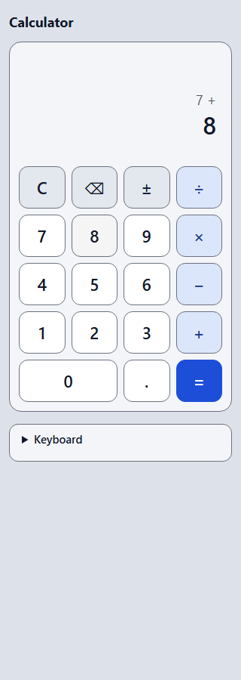 | 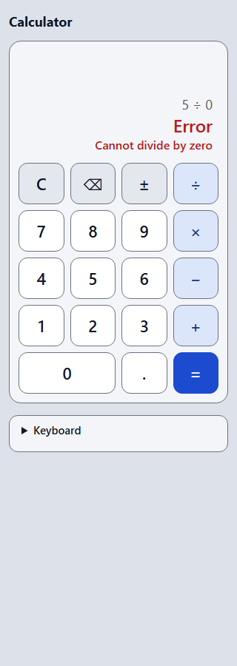 | 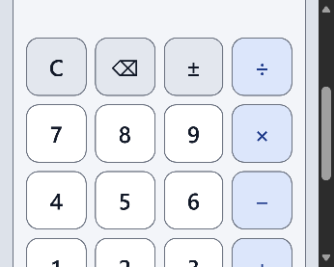 | 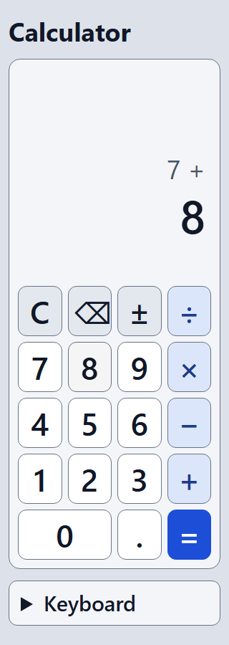

Figure 8. At 320 px width: typing, error, emulated 400 % browser zoom (320 x 256 px viewport), and 200 % text size

Appendix F. Bug log
Table 53. Application bug
ID | Description | Status
BUG-1 | After 0.5, ±, backspace, backspace the display showed -0; typing 7 then showed -07. Fixed in Phase 4 with regression tests. | Fixed

Table 54. Mistakes found in tests, scripts and documents (not application bugs)
ID | Phase | What happened
DOC-1 | 3 | Documents said the keypad has 18 keys; it has 19. Corrected.
DOC-2 | 3 | A requirement example needed 13 digits but entry is limited to 12. Example changed.
TEST-1 | 3 | A random test treated null (no error message) as invalid.
TEST-2 | 3 | Static security tests read comments such as "never innerHTML".
TEST-3 | 3 | A browser test counted Tab stops from the wrong start.
TEST-4 | 3 | The first mutation check was invalid ("0 passed" on every row).
TEST-5 | 4 | A random comparison treated a recovered division by zero as still an error.
TEST-6 | 4 | The 400 % zoom check passed without testing: keys below the visible area were not clicked.
TEST-7 | 4 | Three CSP reports were expected; the browser reports two (the eval block is an EvalError).
TEST-8 | 4 | A scratch mutation script had outdated patterns and was rewritten.
TEST-9 | 4 | First Firefox run: focus-dependent checks failed. Not a calculator bug: the automated window has no keyboard focus.
TEST-10 | 4 | Firefox reports no sub-resource requests for local files; the offline check was changed.
TEST-11 | 4 | Firefox did not log CSP violations through the driver; the check now listens for securitypolicyviolation.
TEST-12 | 4 | A Firefox focus screenshot would have shown no ring and misled; it is not taken.

Appendix G. Human acceptance tests (PENDING)
None of these tests has been done by a human. The expected results come from the requirements and from the automated tests. Each student or tester must perform the steps and write what they saw. The full template, with run columns and a sign-off table, is docs/05-final/acceptance-and-submission-checklist.md.
Table 55. Human acceptance tests
ID | Steps | Expected result | Result
AT-01 | Open src/index.html by double-click | Calculator appears, display 0, no error message | PENDING
AT-02 | 7 + 8 = | 15 | PENDING
AT-03 | 9 - 4 =; 6 × 7 =; 8 ÷ 2 = | 5; 42; 4 | PENDING
AT-04 | 1 . 5 + 2 . 2 5 = | 3.75 | PENDING
AT-05 | 2 - 5 =; then ± | -3; then 3 | PENDING
AT-06 | 2 + 3 × 4 = | 20 (step by step, not 14) | PENDING
AT-07 | 5 + × 3 = | 15 (second operator replaces the first) | PENDING
AT-08 | 5 ÷ 0 =; then 7; then C, 5 ÷ 0 = again; then C | Error and Cannot divide by zero; 7; the same error again; 0 | PENDING
AT-09 | 1 2 3 ⌫; 5 ⌫ | 12; 0 | PENDING
AT-10 | Type 13 digits 1234567890123 | 123456789012 (the 13th is ignored) | PENDING
AT-11 | 999999999999 × 999999999999 = | 9.99999999998e+23 | PENDING
AT-12 | 7 + 2 = = | 9 (no repeat) | PENDING
AT-13 | 0.1 + 0.2 = | 0.3 | PENDING
AT-14 | 0.1 + 0.2 - 0.3 = | 5.55111512313e-17 (a documented known limit, decision D3; write down your opinion) | PENDING
AT-15 | Press Esc, then type 12+30*2 and Enter | 84; Esc clears | PENDING
AT-16 | Type 1,5+1= (a comma) | 2.5 | PENDING
AT-17 | Keyboard only, no mouse: Tab to the keys; press Space or Enter on 7, +, 8, = | 15 | PENDING
AT-18 | Look at the focused key while tabbing | A clear 3 px dark ring is always visible | PENDING
AT-19 | Ctrl+R (reload) and F5 | The browser reloads (the calculator does not block them) | PENDING
AT-20 | Tab to "Keyboard" help, press Enter | The help opens and closes (it is not taken as "equals") | PENDING
AT-21 | Make the window narrow (about 320 px) or use the phone size in the browser tools | No sideways scrolling; all 19 keys visible and easy to hit | PENDING
AT-22 | Browser zoom 200 % and 400 % (browser menu) | Nothing cut off; you may need to scroll down | PENDING
AT-23 | Increase the browser font size (settings) | Still usable | PENDING
AT-24 | On a real phone: open the file (or a copy), tap 7 + 8 =, rotate | 15; layout adapts; taps hit the right key | PENDING
AT-25 | Screen reader (NVDA or VoiceOver): 7 + 8 = | The result 15 is read; keys are named ("Times", "Divided by" ...). Note exactly what is read | PENDING
AT-26 | Screen reader: 5 ÷ 0 = | Note whether the error is read once or twice, and in which order (Error, Cannot divide by zero) | PENDING
AT-27 | Chrome DevTools, Lighthouse, Accessibility | Record the score and every warning | PENDING
AT-28 | First-time user (two people outside the team): "calculate 12 + 30 × 2" without help | They get 84 (or 72 if they expect normal maths: write down what they said) | PENDING
AT-29 | Turn off Wi-Fi or unplug the network, open src/index.html, do AT-02 | Works exactly the same | PENDING

Appendix H. Placeholder register
There are 58 placeholders in this draft (yellow text in square brackets). Each is missing information that only a student or the professor can supply. The legend row in "How to read this draft" is not counted. Classes: A essential before submission (27); B needed from individual students (22); C needed from the professor (6); D optional or removable (3).
Table 56. Placeholders to fill in before submission
No. | Class | Where | What is needed
1 | A | Front matter | INSTITUTION NAME AND FACULTY
2 | A | Front matter | STUDENT 1: full name, student number
3 | A | Front matter | STUDENT 2: full name, student number
4 | A | Front matter | STUDENT 3: full name, student number
5 | A | Front matter | STUDENT 4: full name, student number
6 | A | Front matter | STUDENT 5: full name, student number
7 | C | Front matter | PROFESSOR NAME, as it should appear
8 | A | Front matter | SUBMISSION DATE
9 | A | 2 Project card | Students: add what really happened week by week, with dates, here.
10 | A | 2 Project card | Students: rehearsal results and the computer used
11 | B | 2 Project card | Each student: confirm after reading the code walkthrough
12 | A | 3 Project organization | Students: describe who actually did what, in your own words.
13 | A | 3 Project organization | STUDENT 1 NAME
14 | A | 3 Project organization | STUDENT 2 NAME
15 | A | 3 Project organization | STUDENT 3 NAME
16 | A | 3 Project organization | STUDENT 4 NAME
17 | A | 3 Project organization | STUDENT 5 NAME
18 | A | 3 Project organization | CHAT TOOL NAME
19 | A | 3 Project organization | MEETING DAY AND TIME
20 | A | 3 Project organization | MEETING FORM
21 | A | 3 Project organization | LIST OF REAL MEETINGS WITH DATES AND ATTENDEES, or "none yet"
22 | A | 3 Project organization | ACTUAL HOURS PER STUDENT, from the time log
23 | C | 3 Project organization | Team: decide with the professor whether a cost estimate with an hourly rate is expected (slide 32, item 10).
24 | A | 3 Project organization | Students: confirm that no money was spent, or list the real expenses
25 | D | 4 Literature and assumption review | Students: hands-on notes, with names and dates, if you do it
26 | B | 4 Literature and assumption review | Student 2: confirmation, with date
27 | B | 6 Implementation | Students: for each file, write who read it, who reviewed it, and what each student can explain. Do not claim authorsh...
28 | B | 7 Testing and verification | Student 5: security review, with date
29 | A | 8 Risk assessment and limitations | Students: review the register and record the date and the outcome of each review.
30 | B | 9 Project-Based Learning | Students: link to course lessons
31 | B | 9 Project-Based Learning | Students: your own design contributions
32 | C | 9 Project-Based Learning | Professor's rubric (open question Q1)
33 | C | 9 Project-Based Learning | Professor's feedback, if any, with date and form (class, consultation, written)
34 | A | 9 Project-Based Learning | Students: describe how the team really worked: meetings held, how tasks were shared, how disagreements were solved, w...
35 | B | 9 Project-Based Learning | NAME
36 | B | 9 Project-Based Learning | Reflection of Student 1
37 | B | 9 Project-Based Learning | NAME
38 | B | 9 Project-Based Learning | Reflection of Student 2
39 | B | 9 Project-Based Learning | NAME
40 | B | 9 Project-Based Learning | Reflection of Student 3
41 | B | 9 Project-Based Learning | NAME
42 | B | 9 Project-Based Learning | Reflection of Student 4
43 | B | 9 Project-Based Learning | NAME
44 | B | 9 Project-Based Learning | Reflection of Student 5
45 | B | 9 Project-Based Learning | Students: confirm which objectives you can show you achieved, and give your own evidence
46 | B | 9 Project-Based Learning | after the time log is filled
47 | B | 9 Project-Based Learning | after the defence
48 | B | 9 Project-Based Learning | students
49 | B | 9 Project-Based Learning | students
50 | B | 9 Project-Based Learning | students
51 | A | 9 Project-Based Learning | Students: describe the earlier Team Project and how this project continues it
52 | A | 10 Deployment and user instructions | Delivery method: Git repository link, archive, or other, as the professor requires
53 | D | 10 Deployment and user instructions | Team: decide whether to write it, and who
54 | A | 11 Conclusions | Students: write your own concluding statement after you have completed the human verification, reviewed this report a...
55 | C | 12 References | citation style, open question Q1
56 | C | 12 References | Professor: how this source should be cited
57 | D | 12 References | Students: add it only if you have read the relevant parts.
58 | A | Appendices | Date, student, commands, browser and computer, result

Appendix I. Time-log template (empty)
Each student records only their own real working time, rounded to 15 minutes. No hours have been recorded. The weekly summary is filled in by the project manager from the entries after the weekly check.
Table 57. Weekly summary of working time (hours)
Week | Dates | Student 1 | Student 2 | Student 3 | Student 4 | Student 5 | Team total
W1 | 31 Oct - 6 Nov
W2 | 7 - 13 Nov
W3 | 14 - 20 Nov
W4 | 21 - 27 Nov
W5 | 28 Nov - 4 Dec
W6 | 5 - 11 Dec
W7 | 12 - 18 Dec
Total

Appendix J. Browser check matrix
Technical evidence moved from Section 7.3. A skipped check was not run and is not counted as passed.
Table 58. What the browser checks cover, per browser
Area | Edge | Chrome | Firefox
Page load without console errors; file://; CSP present | pass | pass | pass
16 mouse calculations, the expression line, Clear | pass | pass | pass
Division by zero: message, keys do not move, recovery by digit and by Clear | pass | pass | pass
Overflow with the keyboard ("Number too large") | pass | pass | pass
Keyboard typing, Escape, comma, Backspace, browser shortcuts not blocked | pass | pass | pass
Layout at 320, 360, 768 and 1280 px: no sideways scrolling, keys at least 48 x 48 px, long numbers fit | pass | pass | pass
Browser zoom 200 % and 400 % (emulated); text size 150 % and 200 % | pass | pass | pass
Offline: only local files; CSP blocks inline and outside scripts | pass | pass | pass
1,000 random key presses never give an invalid display; no console errors | pass | pass | pass
Focus ring; Enter and Space on a focused key; keyboard-only calculation | pass | pass | skipped
Accessibility tree: 19 named buttons, status and alert roles; live-region properties | pass | pass | skipped (replaced by a markup check: pass)

Appendix K. Code excerpts
The excerpts are copied from the source files without change (src/js/engine.js, src/js/format.js, src/js/keymap.js).
K.1 The engine combines two numbers and reports errors instead of returning Infinity or NaN:
function calculate(left, operator, right) {
let result;
if (operator === '+') result = left + right;
else if (operator === '-') result = left - right;
else if (operator === '*') result = left * right;
else {
if (right === 0) return { error: 'DIV_ZERO' };
result = left / right;
}
if (!Number.isFinite(result)) return { error: 'OVERFLOW' };
// Two non-zero numbers can multiply or divide to something too small to store: it would become 0.
if (result === 0 && (operator === '*' || operator === '/') && left !== 0 && right !== 0) return { error: 'UNDERFLOW' };
return { value: result === 0 ? 0 : result }; // never keep -0
}
K.2 Number formatting chooses the notation from the rounded value, so that 999999999999.9 becomes 1e+12, and never shows a non-zero value as 0:
function formatNumber(value) {
if (typeof value !== 'number') throw new TypeError('formatNumber needs a number');
if (!Number.isFinite(value)) throw new RangeError('formatNumber needs a finite number');
if (value === 0) return '0';

// Round to 12 significant digits first, so that the choice of notation matches what the user will see.
const rounded = Math.abs(Number(value.toPrecision(SIGNIFICANT_DIGITS)));
if (rounded >= FIXED_MAX || rounded < FIXED_MIN) {
const [mantissa, exponent] = value.toExponential(SIGNIFICANT_DIGITS - 1).split('e'); // "1.00000000000", "+12"
return trimZeros(mantissa) + 'e' + exponent;
}
return trimZeros(value.toPrecision(SIGNIFICANT_DIGITS));
}
K.3 The key map only reads the event; it does not touch the page, so it can be unit-tested. Keys with Ctrl, Alt or Meta are never taken:
function commandForKey(event) {
if (!event || typeof event.key !== 'string') return null;
// Never take over browser shortcuts such as Ctrl+C, Ctrl+R or Alt+Left.
if (event.ctrlKey || event.altKey || event.metaKey || event.isComposing) return null;
const key = event.key;
if (key.length === 1 && key >= '0' && key <= '9') return key;
return Object.prototype.hasOwnProperty.call(SIMPLE_KEYS, key) ? SIMPLE_KEYS[key] : null;
}
K.4 The fix for BUG-1 (Section 7.5): backspace and the sign key no longer produce -0:
function pressBackspace(state) {
if (state.phase !== 'entering') return state; // only typed digits can be deleted
let entry = state.entry.slice(0, -1);
if (entry === '' || entry === '-' || entry === '-0') entry = '0'; // never leave "-0" (it would show as "-07" after a 7)
return makeState('entering', entry, state.accumulator, state.operator, null);
}

Appendix L. Risk register
The full register from docs/00-admin/risk-register.md. Likelihood (L) and impact (I) are scored 1 to 3. The ratings have not been reviewed by the team.
Table 59. Risk register
ID | Risk | L x I | Mitigation | Status
RK-01 | Not enough time: seven weeks and only one project class before the defence | 3 x 3 = 9 | Small scope (MoSCoW), weekly milestones, buffer 10-13 Dec, code freeze 9 Dec | Open
RK-02 | Unequal contribution among members | 2 x 3 = 6 | Everyone codes, reviews, writes a chapter and presents. Time log and repository history reviewed weekly | Open
RK-03 | Grading rubric, report format or deadline unknown | 3 x 2 = 6 | Ask the professor at the 6 Nov class or in a consultation. Build to slide 8 until answered | Open
RK-04 | Documentation written at the end and not matching what was done | 3 x 3 = 9 | Write chapters as work happens, review documents at each milestone, record real dates | Open
RK-05 | Floating-point and display-rounding errors produce wrong or misleading results | 3 x 3 = 9 | Rules in the requirements (D3). Tests for precision, large, small and overflow values written before the code | Open
RK-06 | Scope creep (extra features) | 2 x 2 = 4 | MoSCoW list, Could items only when Must and Should are tested | Open
RK-07 | Live demo fails (browser, projector, laptop) | 2 x 3 = 6 | Offline build (D2), rehearsals on the real set-up, second laptop, a backup recording made by the team | Open
RK-08 | Lost work or merge conflicts, including problems from keeping the repository inside a OneDrive folder | 2 x 3 = 6 | Push to a remote repository early, small commits, avoid editing the same file at once. The working copy is inside OneDrive (checked 2026-10-31). Do not run git while OneDrive is mid-sync, never edit the same file from two machines, and check for conflict copies such as file-DESKTOP-xxxx.md. Preferred fix, pending project lead decision (Q8): move the working copy outside OneDrive and push to a remote | Open
RK-09 | A member is unavailable for a period | 2 x 2 = 4 | Support roles (responsibility matrix), shared repository, notes in docs/ | Open
RK-10 | AI assistance used in a way the course does not allow, or work presented as the team's own when it was not | 2 x 3 = 6 | Ask for the AI policy. Record every use in the tool and AI usage log. Humans review and understand all content. Only real results go in documents | Open
RK-11 | Fabricated, wrong or unread sources in the literature review | 2 x 3 = 6 | Cite only sources the team actually opened. Reviewer checks each reference exists | Open
RK-12 | Enabled tools do not work as expected (plugins load only after a restart, Playwright needs a download) | 2 x 2 = 4 | Check availability before claiming use. Plan fallbacks: node --test and manual browser checks work without extra tools | Open
RK-13 | Accessibility, security or compatibility problems found late | 2 x 2 = 4 | Requirements NFR-04 to NFR-06 from the start, early checks in W5, buffer before freeze | Open
RK-14 | Requirements misunderstood: the professor expects more (for example the 17-item list) than planned | 2 x 2 = 4 | Proportionate coverage already planned, ask for clarification | Open

