2012
Wells Fargo & Co.

hkheman

[software change manager-R12]
[This document will provide the quick overview of the Software Change Manager/SCM for a administrator level information]

- How to Create a Project in Software Change Manager (SCM):
Go to Start→Programs→CA→SCM→Click on Administrator to login with ad-ent user account and password.
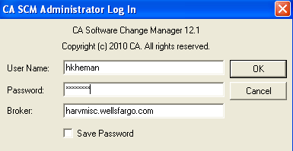
Once login you can see the below window in this expand Lifecycle Templates
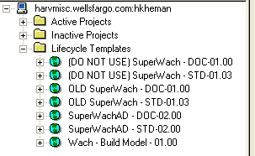
Here, the below three from the bottom is important to create the project.
SuperWachAD – DOC-02.00 (If the user needs to store vendor doc in SCM)
SuperWachAD – STD-02.00 (This is typically for creating the standard project in SCM for development to checkout and check-in)
Wach – Build Model – 01.00 (This is for typically for test and production related build project in SCM)

To Create a Project: Expand the Lifecycle Templates and right Click on SuperWachAD – STD-02.00, you can see Copy to…option, click on this will pop-up the below window. Now, you can provide the Name and choose the Copy to option with active/inactive (Always choose inactive) and select the check box mark for Duplicate Access and don’t check the box Create User Group leave as it is.

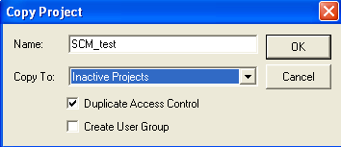

Now, you can expand the Inactive Projects and see your Project with the name “SCM_test”.
Highlight the “SCM_test” Project by one click and in left hand pane you can see Project Creation/Instantiation icon click on that will pop a window to analyze the project.
Click on Analyze.
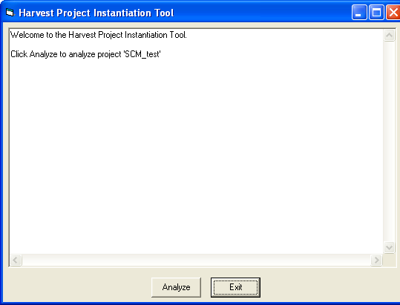

After some time you will get another tab with option “Instantiate” Click on this as well and close.

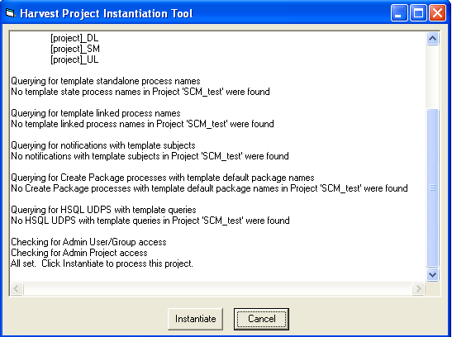
Expand the Inactive Projects right Click on the project “SCM_test” navigate to properties select the project TAB, you can see project attributes details in that checkout the box Active and click OK.
Note: The Lifecycle Tab is for to create the project in the SCM.

- How to Create a Repository in SCM
Now, select the “Repositories” tab (Next to the lifecycle tab), right click on Repository Template and select duplicate repository the below window will pop-up.
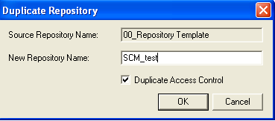

In the new repository name choose the name of the project you have created i.e. SCM_test
Go back to lifecycle Tab
Expand the SCM_test go to data views→baselines
Right click on baselines-→choose Configure Baseline…
Now, you can choose the desired baseline project i.e. SCM_test and click on add button once added there is an option for close the window.
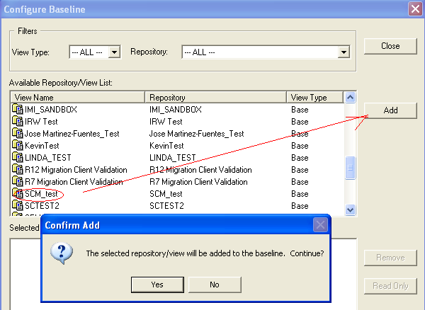
Go back to Inactive Projects and right click on project SCM_test and choose Access Report will generate the access report for the project.

Note: Repositories tab is for to create the repository for a project and allow the dev team to access the code for modification by checkout and check-in.

- Users Groups tab:
Expand the users tab, select your LAN ID i.e. hkheman right click go to properties. In Users Properties window select the Users groups tab and click on add button and search the project name you have created i.e. SCM_test_DEV and click OK to add. (This is the one way of adding the user to user groups list).

In another way expand User Groups-→select your project group name to add with the right group i.e. SCM_test_DEV right click on it and go to properties click on users tab and click on add button to choose the desired user group list to add into it ex: Eddie_Test_UserList
Double click on it and click ok.
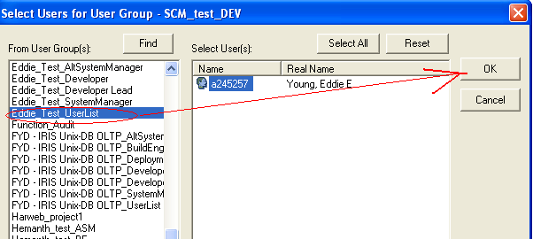

Another window User Group Properties will pop-up as below
click ok to add it.
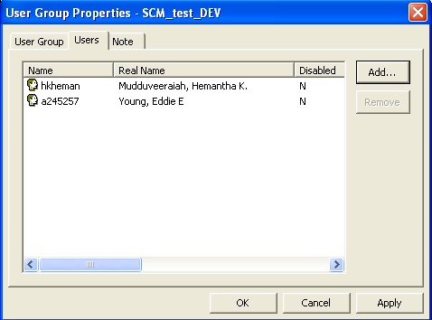

Note: The users’ groups tab is for to add user account in the development/testing/build list to get the access by their role of work.

- Install the Software Change Manager
Note: Please refer the installation doc in the SCM admin site.
- Adjust Computer Settings per Known Issues:
Note: Don’t copy and paste the package name it will lock the entire SCM and affect the SCM users to work. In CA SCM Administrator Window don’t use Copy User Profile it was using earlier older version R7
- 9 User groups/Role Types
Note: Please refer the document in the SCM admin site
- Different States of a project
Please refer the Doc Security Matrix in the SCM admin site.

- Properties of a Project/State Order/Access
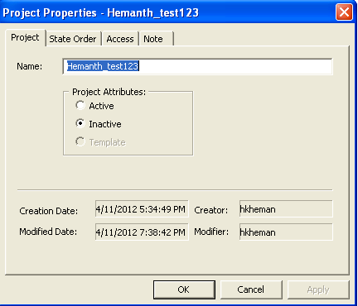
- State Properties/State Views/State Access

- Processes in States
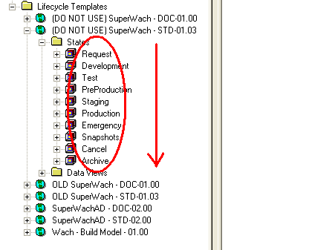
The processes are Request, Development, Pre-Production, Staging, Production, Emergency, Snapshots, Cancel and Archive.
- Baselines
Attach a repository to a project is called as baseline.
- Snapshot views - Login to work bench navigate to your project, expand the project now you can see Development, Test and Pre-Production etc… expand the Development/Test Right click on packages to create the package. Once the package is created
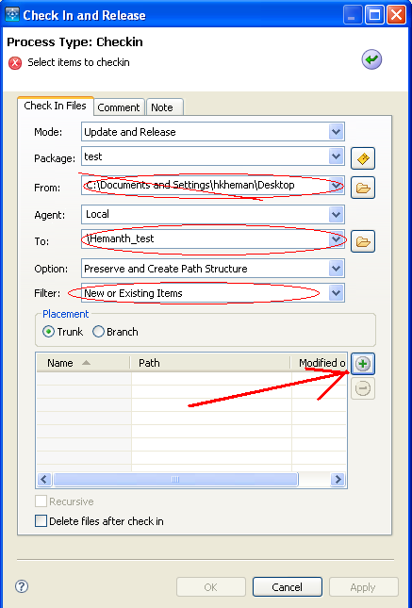

Click on the “+” button it will pop-up with another will there you can see Find button click to add the files you want it from the list and click on ok.
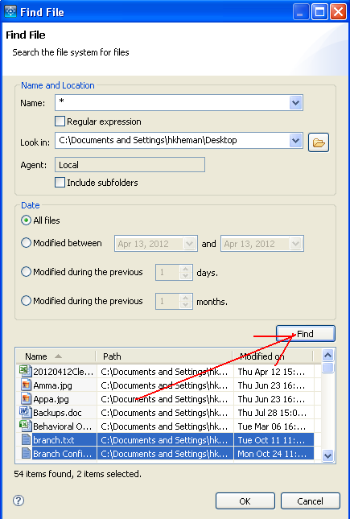
Then right click on the development and do click on promote to test option to move the package to Test processes. To take the snapshot of the project just right click on Test and select “Take Snapshot” and give a name to the snapshot. Once completed you can navigate to “Snapshots” will give the snapshot view which you have taken for the project.

Note: SCM is designed to look forward in the project development. It applies for the older project not for the newer one.
If a user can’t promote a package in that case ask him to take the help of Deployment Engg who is having the right to do the promote package.

14. Discuss Properties of processes including the tabs with access:
You can see the list of Process when you expand the project-→States→Development→Processes→
If you right click on the processes underneath the Processes tab and select the properties of the processes (In Administrator & Work bench window you will see these processes)
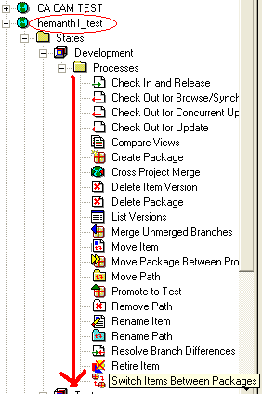

In Work Bench the processes look like as below:
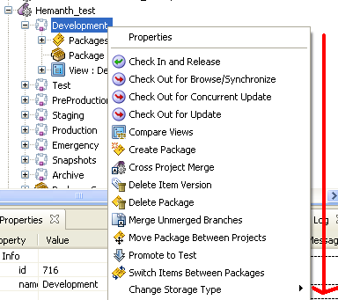

Note: Hum tool will provide the access to the users (Dev/tester/manager…) using Hum tool we can add the user ID into the project provide to access it.

15. Discuss Pre-linked and Post-linked Notify & UDP Processes: The pre-linked and post-linked notify tabs are using for the purpose to do a action required in their project specific. Developer/tester will add these link to these tab to generate/schedule any task in their project.
Pre-linked Notify: No more using it.
Post-linked Notify: Automated to take the snapshot for a project.
UDP Processes: User defined Processes – UDP processes are default values we never going to create it.
16. Showing Working Views: You never have to do create any working views in the project.

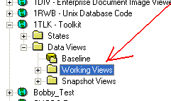
17. Snapshot views: In Work Bench you will find the snapshots column, if you expand it you will get the list of snapshot views in there.
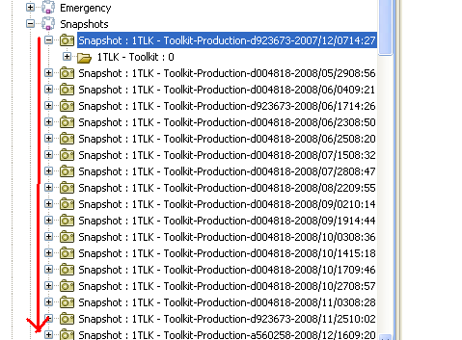
If a user unable to take the snapshot the error will display saying project name is more than 52 character something like that. If a user unable to take it you will suggest him to take manually.
If a user want to delete a file/snapshot ask him to first take the approval from the System manager through e-mail then will delete the snapshot later he can delete the file unless it will through the error. To get to know who the SM is, navigate to access tab to find out it.
How to create a user manually:
In Administrator console go to User groups tab, right click on Users→New user a window will pop-up. Now, in the user tab enter the user LAN ID for an instance matlocrd then click on apply will default select the password and all the information to the user.

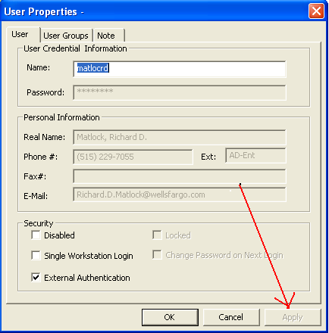
How to update a User groups:
If a user needs to add to be a part of a specific User Groups list, go to Users group tab next to the User and select on the add button to add a specific user group in the list.

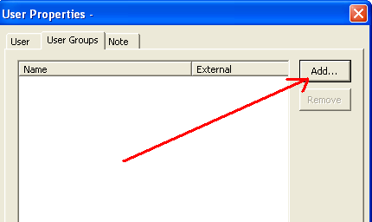
Tom’s Tools and how to use it and what are they for:
Using Tom’s tool we can install the admin access for administering the SCM tool.
How to Create a Broker Connection:
Please refer the below click link.
Create Broker Connection
The below are the Broker Connection using in SCM
harvest1.wellsfargo.com This Broker Connection is for live project
harvest2.wellsfargo.com This Broker Connection is for live project
harvesta.wellsfargo.com This Broker Connection is for archiving
harvmisc.wellsfargo.com This Broker Connection is for testing purpose.

Note: As an administrator we don’t know user need which broker connection to connect the SCM. The user will tell us which one he/she need to get the access.

How to Create a Package:
Go to work bench expand a project and expand Development then right click on packages and click create new package. In the Name space provide the specific name and if you wish to add package groups click on the radio button to select and add it. Now, the package is visible under the packages underneath the development.
Package creation
How to promote a package:
To promote a package from development to testing, right click on the package to select the option promote to test will promote it to test. You can do multiple package promotion by click on the green color radio button and select individually to promote to test then click on OK.
Now, the promoted packages will be visible under the test packages.
Note: If the users demote a package from test to development he/she can do that by right click on the package and select the option demote to development which will move back to development.
Click on the below hyperlink to see graphically.
Promote a package

Checkout for Update:
Refer the below hyperlink to see it graphically.
Checkout for update
Expand the View : Development :[None] under that Hemanth_test : 0 will have list of text files with zero versions. Edit and do some changes and save then Right click on it and click on checkout for update and from \Hemanth_test and to would be create one folder under C:\ drive and point there. Now, you can see
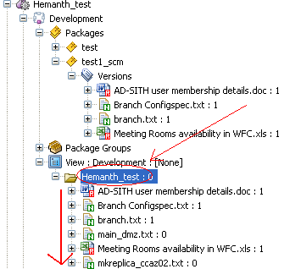
One version has been created for in the versions.
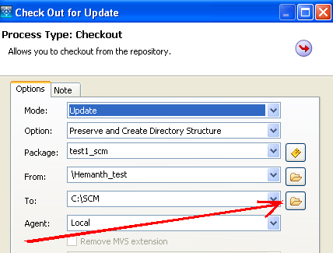

How to checkin:
Refer the below hyperlink to see it graphically.
To checkin
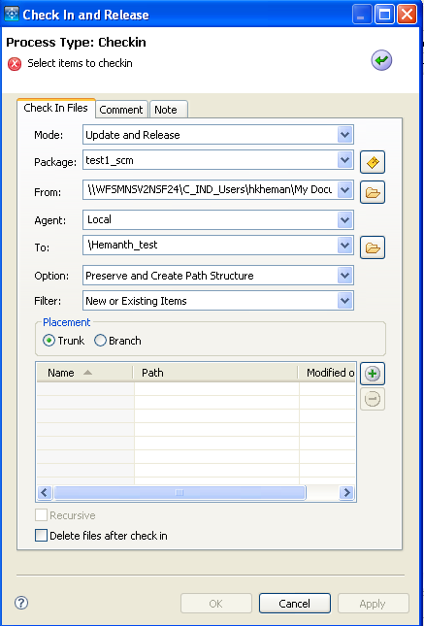

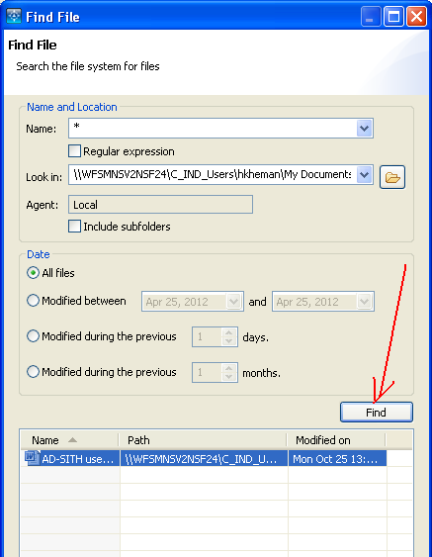
If you now expand the package and version you will find the checked in text files under the version

Version deletion - Delete version will never delete the file; it will delete a version in SCM.
Adding a work area - It will provide a workspace area for a package.
Work area Synchronize -
Commit work Area -
Move a path -
Remove a path -
Rename a path -
Create a path - To create a folder.

Checkout for concurrent update:
Merge Unmerged Branches:
Resolve Branch differences:
VS Plug-in setup: setup
VS Commit: commit
VS Context: context
Show Harweb link and how to access: In SCM administrator site at the right side you can see other helpful links underneath you can see Harweb logon
Give a walkthrough of Harweb: Harweb is a internet web for SCM. It’s similar to SCM software a user can login using those two links (But it’s careful to use those two links are production) Only system managers/user’s if you doesn’t have SCM software on their desktop will login and promote the packages/modification of files/do changes in their packages.

HUM: Adding Users and Updating Access to Roles in Projects:
HUM Tool allows you to do the following functions:
- Add a new user to Harvest
- Assign project specific role to a user in a Harvest
- Remove user from a project specific role assigned in Harvest
- View history of changes in the audit logs.

HUM Tool does not have following tasks in scope as of now:
- Manage user data e.g. credentials/contact information etc.
- Create Harvest Projects
- Create Roles.
- Delete a user from Harvest

In the SCM admin site HUM (Harvest User Maintenance) login link will be there HUM Login once login click on SCM R12
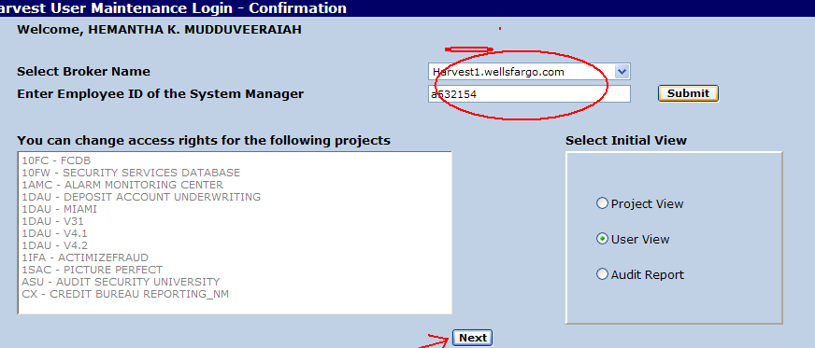
Here, select the Harvest1/Harvest2 and then enter the system manager/Alt system manager id and submit. After submission click on next will give the below window. Then enter the user ID to add.

Add New User - Broker Harvest1.wellsfargo.com
User (A252709 James L. Huggins) added to Harvest.
Use Project View to assign project specific roles to this user.
User ID: | 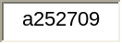

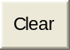 | 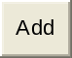

After adding the user now again goes back and selects the Project View to assign the user to the role and responsibilities as given window.
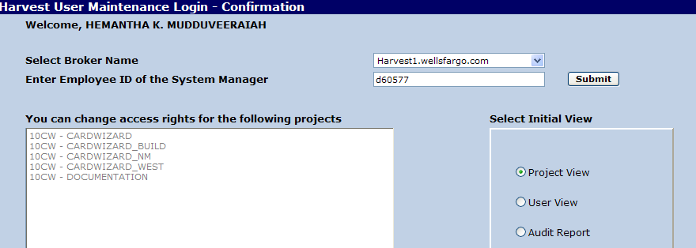

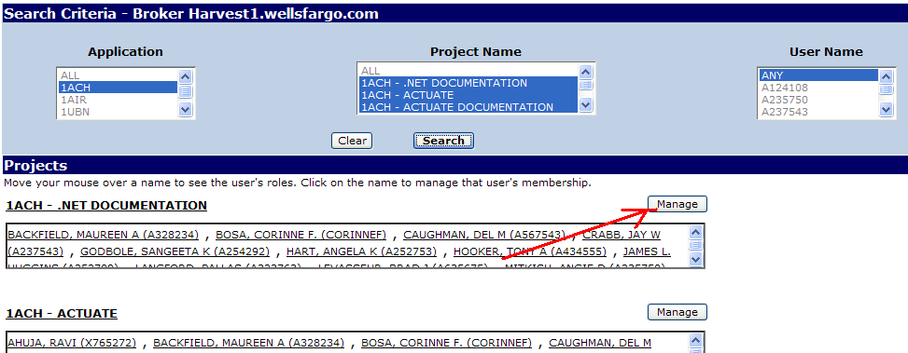

Click on manage will pop-up the below window, there is a space for adding a user you can enter the user ID
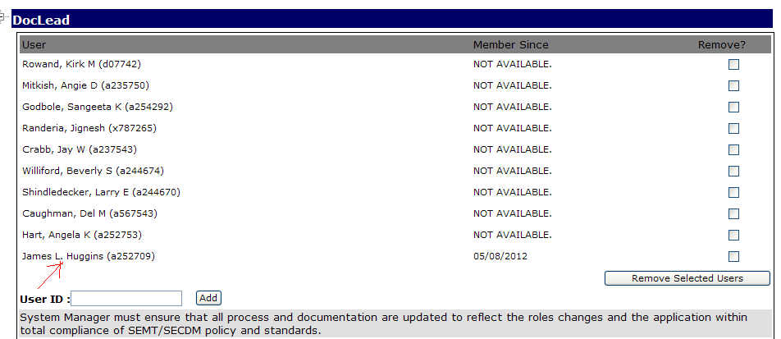
If you are adding user as a Doc Lead, then he should have in the Documenter list as well. If you want to remove a user from the HUM tool, you just need mark the checkbox and click on Remove Selected Users tab.
Even the user has removed from the HUM tool is ID is still exist on SCM administrator User database. Please follow the below step for the deletion.

Deletion of the HUM user from SCM:
In SCM administrator console click on user Groups tab, then highlight the user by selecting the ID and right click and click on delete option. Now, the user ID completely removed from SCM user database.

