# **Thyroid Disease Detection:**

## ***Wireframe Documentation***

| **Data Issued** | **Version** | **Description** | **Author** |
| --- | --- | --- | --- |
| 12-12-2024 | 1 | Wireframe-V1.0 | Shubham Chaudhary |
|  |  |  |  |

# **Homepage**

We will have a three page UI which will facilitate bulk prediction for Thyroid Disease Detection.

**Index page :**

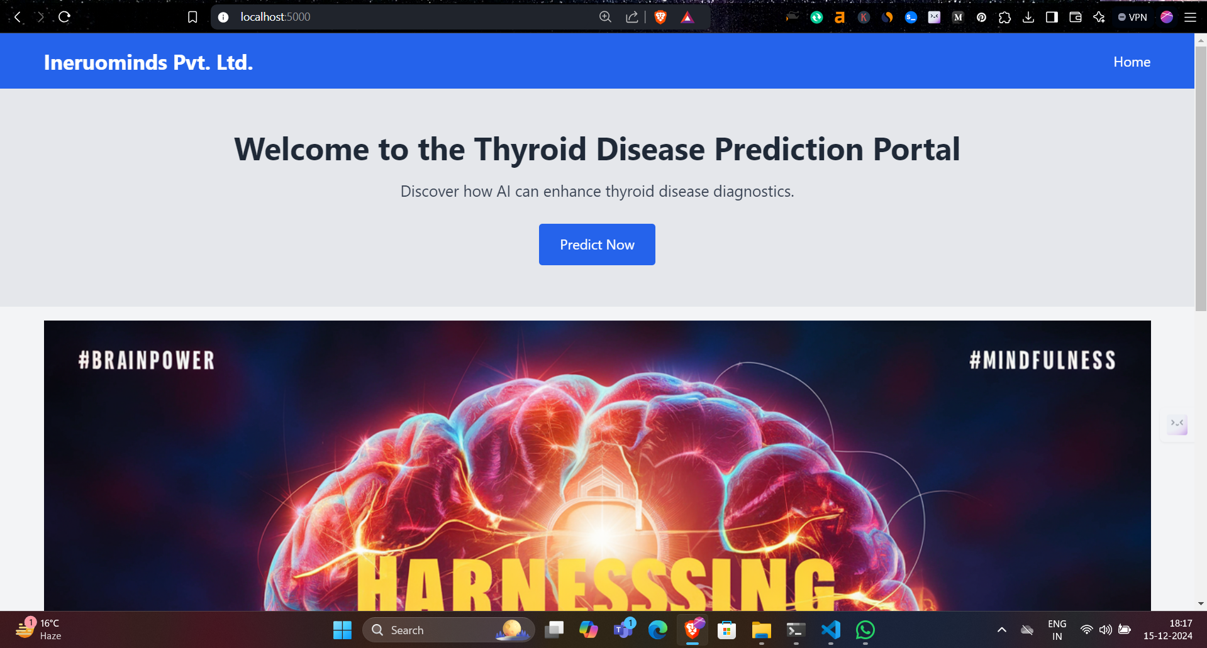

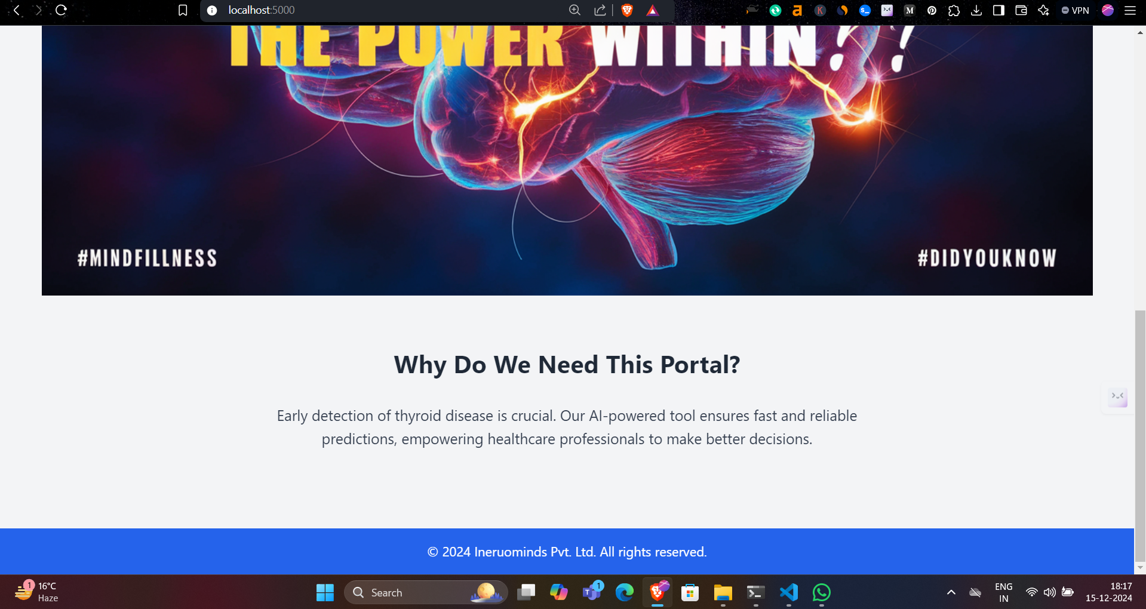

**Result page:**

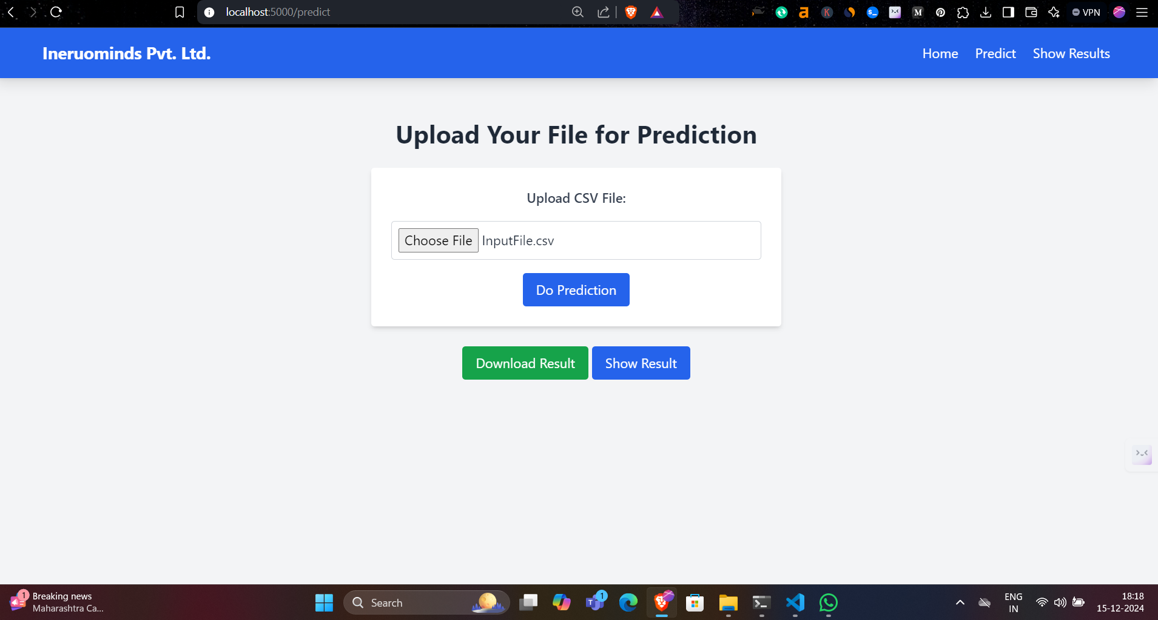

**At the Result page , There are two buttons , one for seeing Download Result(Bulk), and second one for seeing the Predicted Result here itself.**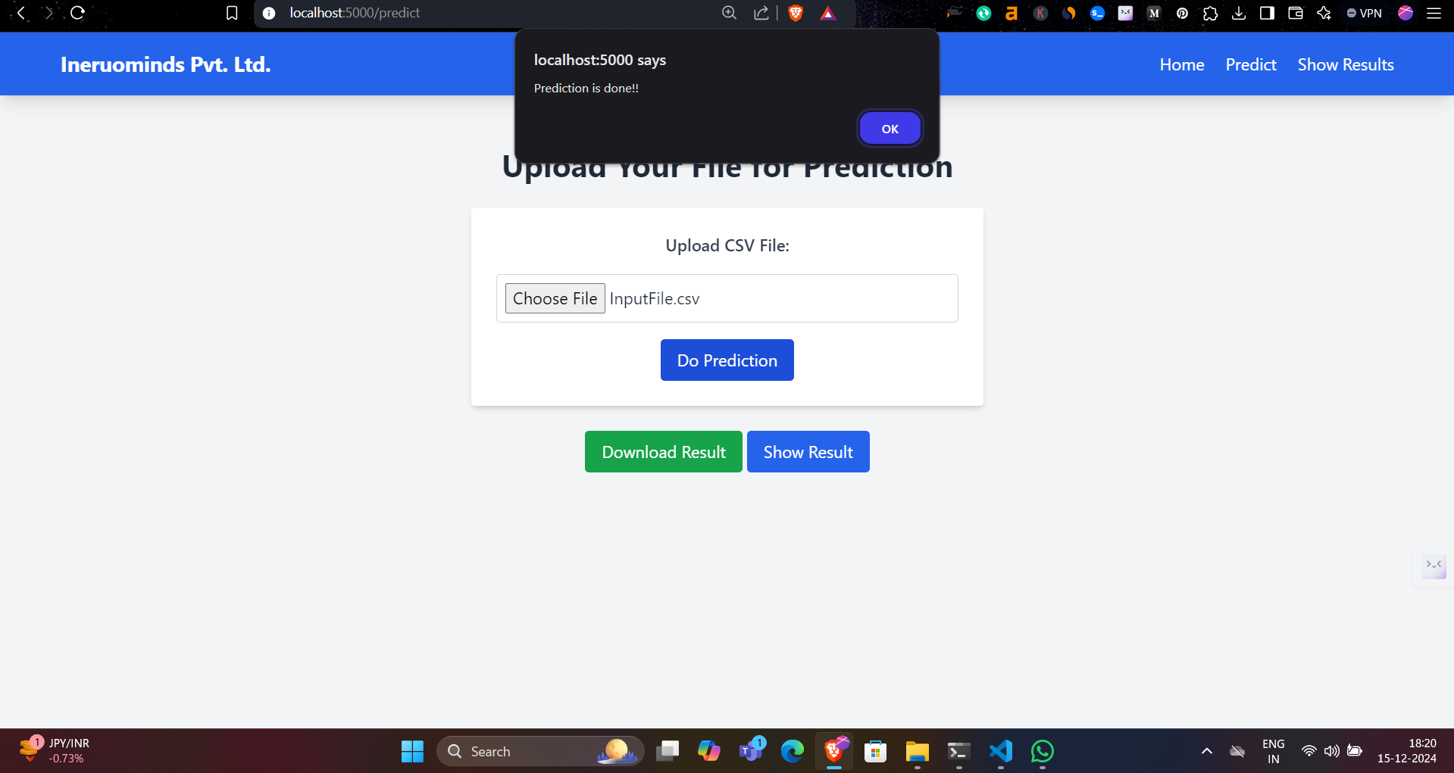

**At result page:**

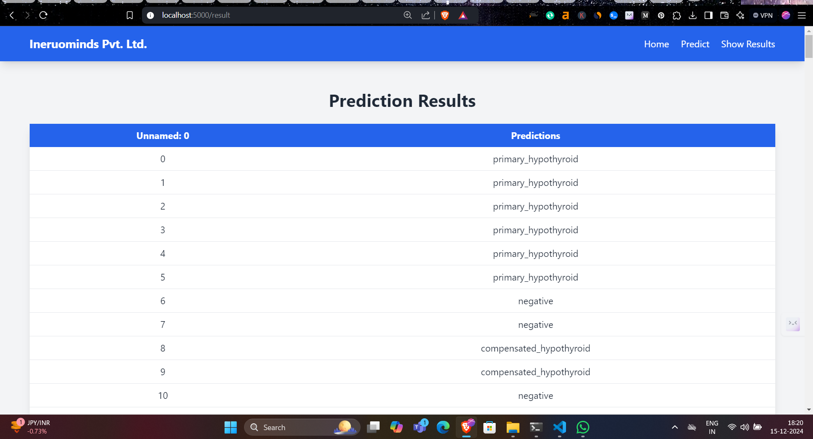

**We can also see that Predicted result:**

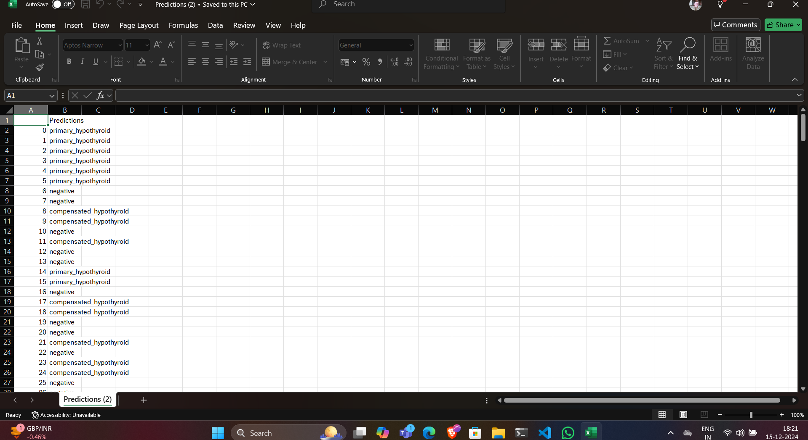**[1]**

1.