Titan Platform System Constitution ��� Volume 1
Table of Contents

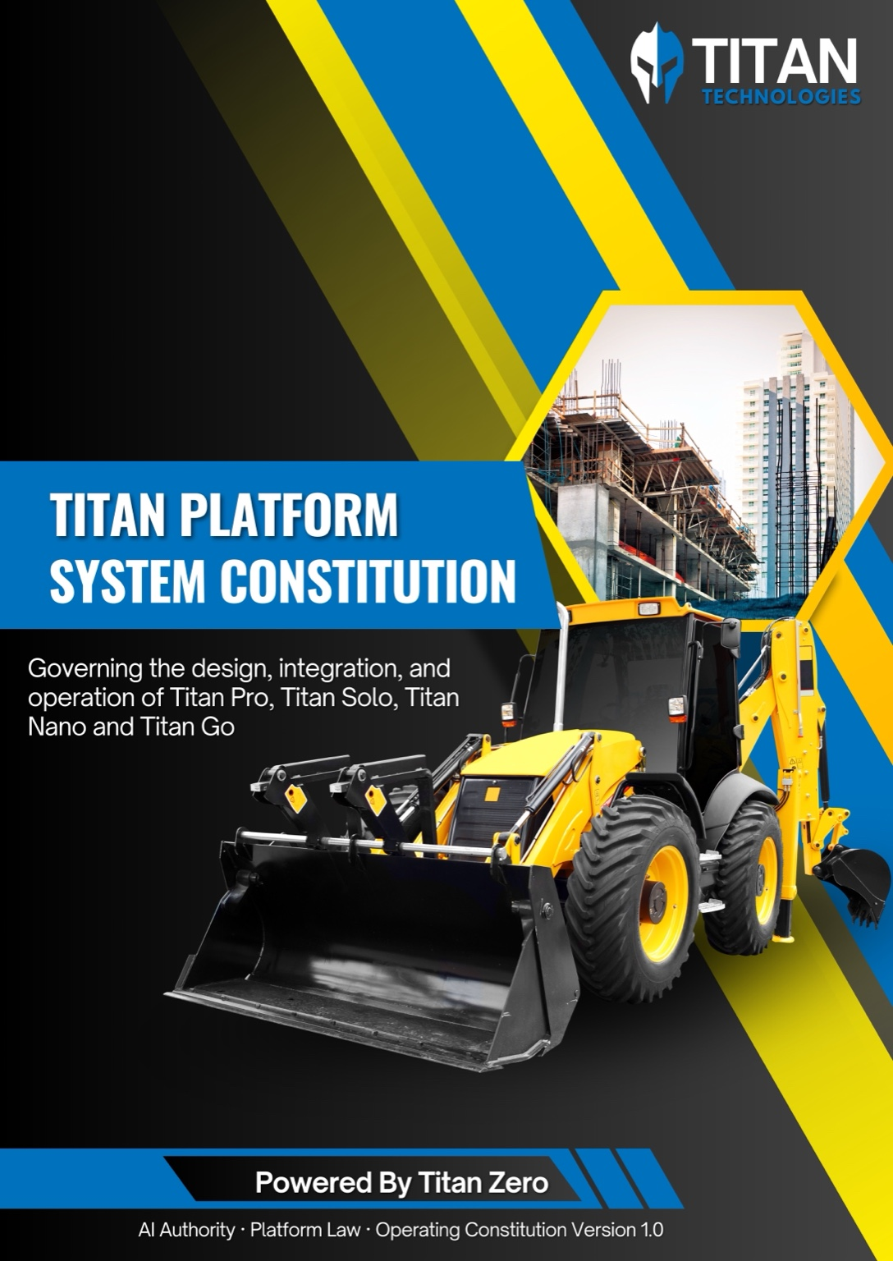
Titan Platform System Constitution Cover

Titan Platform System Constitution

Volume 1 — Platform Constitution & Authority Law

Table of Contents

Chapter 1 — Purpose, Scope, and Audience

1.1 Purpose of the Titan Platform
The Titan Platform exists as a governed, auditable and authority‑driven operating system for trade management. It unifies human workflows, automated systems and artificial intelligence under a single constitutional law. The platform does not merely host AI features or embed automation; it is designed to control authority, prevent architectural drift and enforce responsibility boundaries across modules, vendors and time. This constitution defines what must always remain true, regardless of feature growth, provider changes or implementation refactors.

1.2 Intended Audience
This volume is written for the technical personnel who build and govern the platform. It applies to:
- AI developers integrating intelligence into production systems.
- Platform engineers responsible for system integrity and safety.
- Architects designing extensions, studios or automation layers within the trade management system.
- Technical decision‑makers governing long‑lived SaaS platforms.
It is not written for end users, non‑technical stakeholders or feature‑level implementers. Reading this volume implies responsibility for upholding platform law, not merely consuming APIs.

1.3 Scope of This Volume
Volume 1 defines the constitutional foundation of the Titan Platform. It sets platform‑level authority laws, immutable architectural principles, ownership of data, decisions and execution, and enforcement responsibilities and consequences. It establishes constitutional truth, not implementation guidance. Only Chapters 1–7 appear here; subsequent chapters, modules, marketing rules, operating modes and implementation specifics are deferred to later volumes. Marketing exceptions, cost governance, user interface patterns, API schemas, tool lists and product variants do not belong to this volume.

1.4 What This Volume Explicitly Does Not Cover
This volume does not include:
- Modules, add‑ons, marketplaces or studio‑specific architecture.
- Detailed UI patterns, API endpoints, SDKs or implementation schemas.
- Lists of tools, models, providers or pricing structures.
- Voice channel controllers, customer service components or marketing exceptions.
- Any material beyond the authority law of Chapters 1–7.
Those belong to later volumes and are subordinate to this constitution.

1.5 How This Constitution Must Be Used
This constitution is binding. If any module, studio, workflow or integration conflicts with this volume:
- The implementation is invalid, regardless of functionality.
- The conflict must be resolved in favour of this constitution.
- No “temporary exceptions” are permitted.
This document is not advisory. It is law.

Chapter 2 — Core Platform Principles

2.1 Platform Design Philosophy
Uncontrolled capability is more dangerous than limited capability. The platform prioritises:
- Authority before power: decisions precede execution; capability without authority is forbidden.
- Safety before convenience: risk classification and confirmation rules override developer ease.
- Traceability before speed: every decision and execution must be logged and reconstructable.
- Governance before extensibility: extensions are allowed only when they honour the constitution.
Capabilities are allowed only when authority is clearly defined and enforced.

2.2 Single Source of Truth Principle
For every domain in the system there must be exactly one authoritative source. All other representations are derivative. Conflicting sources are prohibited. Worksuite (Titan Pro/Solo) serves as the system‑of‑record for operations: customers, jobsites, jobs, work orders, invoices, compliance, assets, scheduled services, jobsite issues and operational history. Other systems may read from Worksuite via controlled APIs but must never persist operational data independently. Duplication of authority is treated as a system defect, not a design choice.

2.3 Authority Before Capability
No component may act simply because it can. Every action must be justified by:
- Legitimate authority (system‑of‑record for the domain).
- Explicit permission via Titan Zero’s risk classification and confirmation rules.
- Valid context assembled by the authority.
Capability without authority is forbidden, even if technically possible. Unclear intent defaults to refusal.

2.4 Replaceability and Vendor Independence
The platform must remain operationally stable even if:
- An AI capability provider is removed or replaced.
- A tool vendor becomes unavailable.
- A service fails or is deprecated.
No external system may become structurally irreplaceable. All providers are abstracted behind Titan Core, and their removal must not require architectural change.

2.5 Enforcement Over Convenience
The platform explicitly favours:
- Hard refusal over silent failure.
- Explicit blocking over implicit allowance.
- Enforcement over developer convenience.
If a design choice weakens enforcement, it is invalid. No silent execution of external actions is permitted. All AI runs must be logged, risk‑classified and, where necessary, confirmed by the user.

Chapter 3 — System of Record Law

3.1 Definition of a System of Record
A system of record is the single authoritative system that owns canonical data, business state and lifecycle transitions for a given domain. It has the sole right to mutate that data and governs how derived data is produced and consumed.

3.2 Worksuite as the Sole System of Record
Worksuite (Titan Pro/Solo) — collectively referred to as the Titan Trade Management System (TMS) — is the sole system of record for all operational data, including but not limited to:
- Customers and their associated companies.
- Jobsites and jobs.
- Work orders, invoices, quotes and payments.
- Compliance records, safety documents and regulatory artefacts.
- Jobsite issues, scheduled services and operational history.
- Assets, equipment and inventory.
No other system may mutate this data independently. Studios, extensions or external providers may read via authorised context snapshots but must never maintain their own operational state.

3.3 Data Ownership and Mutation Rules
- All writes originate from the system of record. External components may request mutations, but the write must be performed by Worksuite’s modules under Titan Zero’s authorisation.
- External systems may read only. Context snapshots are immutable, versioned and redacted as necessary. Derived data must be traceable back to the source.
- No partial authority. A component either owns the domain or it does not. There is no shared write authority.
Any system performing unauthorised writes is violating platform law.

3.4 Prohibited Shadow Systems
Shadow systems are explicitly forbidden, including:
- Parallel databases with write authority.
- Duplicate business logic engines that replicate Worksuite’s functions.
- External tools maintaining independent operational state or workflows.
Synchronization does not legitimise a shadow system. Context snapshots and event backfeeds do not confer authority.

3.5 Read vs Write Authority
Read access does not imply write access. Reads may be broad and distributed; writes are tightly controlled and centralised. Write authority is never delegated implicitly. Any attempt to mutate operational data outside Worksuite, even if technically possible, is a violation.

3.6 Consequences of System‑of‑Record Violations
Violations result in:
- Immediate invalidation and deactivation of the offending component.
- Mandatory remediation or removal of the offending system.
- Potential rollback or deletion of affected data.
No grandfathering applies. Legacy integrations must be updated or disabled to comply.

Chapter 4 — AI Authority Law (Titan Zero)

4.1 Definition of AI Authority
AI authority is the right to interpret intent, assemble context, classify risk and decide whether an action may proceed. Execution is not authority. Titan Zero embodies this authority; it sits outside the user interface and is invoked programmatically. It encapsulates the constitution and enforcement logic for all AI behaviour.

4.2 Titan Zero as the Sole AI Authority
Titan Zero is the only component permitted to:
- Infer user intent and assemble context snapshots.
- Evaluate operational risk and classify intents into categories.
- Approve, refuse or require confirmation for AI‑driven actions.
- Log AI runs and link draft and final artefacts.
No module, studio, extension or external provider may bypass or replicate this authority. Titan Zero is implemented as a Worksuite module and cannot be disabled.

4.3 Intent Classification and Risk Assessment
Every AI‑initiated action must pass through Titan Zero’s risk assessment. Titan Zero classifies intents into three categories:
- Low risk – read‑only requests, drafts and internal planning. These may be executed immediately once Titan Zero approves, without additional confirmation.
- Medium risk – actions that may trigger customer communications or internal side effects. Titan Zero requires inline confirmation from the user before execution.
- High risk – financial mutations, compliance submissions, legal documents and other sensitive operations. These always require explicit confirmation via Worksuite’s interface and may be blocked or escalated to human review.
Risk classification rules may be updated by system administrators. Extensions cannot override risk levels. Unknown or ambiguous intents default to the highest required confirmation.

4.4 Permission Enforcement and Refusal
Titan Zero enforces permissions strictly. Lack of permission results in refusal. Partial permission does not confer additional authority. Silence is never approval. If Titan Zero disallows an action, no module or extension may override it. Attempts to disguise mutations as read‑only requests are forbidden and treated as violations.

4.5 Human‑in‑the‑Loop and Confirmation Rules
Higher‑risk actions require human confirmation. Titan Zero decides whether confirmation is required and which interface (inline or explicit) must be used. Confirmation screens reside in Worksuite, even when an action originates from an extension. The user must be presented with clear context and consequences before approving. Automation may never remove accountability.

4.6 Audit, Traceability and Accountability
Every AI decision and execution must be:
- Logged – Titan Zero writes a structured record into the ai_runs log for every AI call, capturing the tenant, user, intent, input, output, model used, risk classification and confirmation status.
- Attributable – The origin of every action must be traceable to a tenant, user and extension.
- Reconstructable – Drafts and final artefacts must be linked. It must be possible to reconstruct the sequence of approvals and executions.
If an action cannot be audited, it must not occur.

Chapter 5 — Execution Authority Law (Titan Core)

5.1 Definition of Execution Authority
Execution authority is the right to perform approved actions, invoke tools and mutate system state under instruction from Titan Zero. Execution does not include decision‑making; it follows the instructions approved by the AI authority and the system of record.

5.2 Titan Core as the Sole Execution Router
Titan Core is the only execution router permitted to:
- Invoke internal tools and workflows.
- Call external AI capability providers via pluggable adapters.
- Apply mutations to operational data once authorised by Titan Zero.
Direct execution paths are forbidden. Modules, studios and extensions must route all AI calls and tool invocations through Titan Core.

5.3 Separation of Decision and Execution
Decision and execution must never coexist in the same component. Titan Zero decides; Titan Core executes. Blurring this boundary invalidates the system. Any component that both decides and executes is disallowed.

5.4 Tool Abstraction and Capability Exposure
All tools and AI capabilities must be exposed through Titan Core. Tools are abstracted; providers are hidden; capabilities are standardised. Extensions call capabilities via Titan Core’s tool interface. No tool or provider is called directly. This ensures consistent cost controls, logging and model selection.

5.5 Idempotency, Replay and Safety Guarantees
Execution must support safe retries and idempotent operations. Titan Core must allow controlled replay of failed calls without duplicating side effects. Failure must not create ambiguity. Extensions must be prepared for idempotent responses and should not assume immediate side effects.

5.6 Prohibited Execution Patterns
Explicitly forbidden:
- Direct provider calls from modules, studios or extensions.
- Embedded execution logic inside AI components or context assemblers.
- Side‑effect execution during intent analysis.
- Retrying failed AI executions outside Titan Core.
- Modifying or deleting audit logs or run metadata.
Violations trigger immediate termination of the offending component and may disable the offending tenant until resolved.

Chapter 6 — External AI Capability Providers

6.1 External Provider Classification
External AI capability providers are capability suppliers, not platforms. They are classified as stateless service endpoints that perform specific tasks (e.g. text generation, image generation, voice synthesis, retrieval). They are not decision‑makers and do not own sessions, state or data.

6.2 API‑Only Access Model
All access to external providers must occur via APIs. There is no external UI, tenancy or system‑of‑record role. Providers are invoked through Titan Core using pluggable adapters. Embedded SDK logic or custom network calls are forbidden.

6.3 Provider Isolation and Replaceability
Providers must be swappable, isolated and non‑authoritative. Vendor lock‑in is a constitutional failure. Removal or replacement of a provider must not require changes to higher‑level components. Providers do not maintain tenant or user contexts; they process requests and return outputs.

6.4 Abstraction as Titan Core Tools
All external capabilities are surfaced as Titan Core tools. Extensions call tools, not providers. Capabilities are uniform, and provider differences are hidden. For example, text generation, image generation or retrieval appear as tool interfaces within Titan Core, each with defined input and output schemas.

6.5 Explicit Non‑Authority of External Providers
External providers:
- Do not decide what is permitted.
- Do not authorise or refuse requests.
- Do not override platform law.
They supply output, not judgement. If a provider fails or refuses, Titan Core must handle the error and report to Titan Zero; providers cannot change confirmation requirements or risk classification. References to MagicAI or any named provider must treat it only as an API‑accessible capability supplier. MagicAI is not an application, not a platform, not tenant‑aware and has no authority.

Chapter 7 — Non‑Negotiables, Prohibitions, and Enforcement

7.1 Non‑Negotiable Platform Rules
The following are absolute and may never be violated:
- Single system of record – Worksuite (Titan TMS) owns all operational data.
- Single AI authority – Titan Zero decides whether AI actions may proceed.
- Single execution router – Titan Core performs all authorised executions.
- Full auditability – Every AI run and mutation must be logged and reconstructable.
- Risk‑based confirmation – High‑risk actions always require explicit user confirmation via Worksuite.
No exceptions exist.

7.2 Explicitly Forbidden Architectures
The following patterns are explicitly forbidden:
- Multiple AI authorities or risk classifiers.
- Embedded execution inside modules, studios or context assemblers.
- Shadow data systems or duplicate business logic outside Worksuite.
- Provider‑driven logic flows that bypass Titan Core.
- Marketing or voice components that operate outside the authority pipeline.
If a pattern appears to solve a short‑term problem but violates these rules, it is invalid.

7.3 Enforcement Responsibilities
Enforcement responsibility lies with platform architects, core maintainers and module reviewers. Silence equals complicity. Reviewers must reject contributions that violate the constitution. Automated agents must perform self‑audits before executing actions.

7.4 Violation Handling and Remediation
Violations require:
- Immediate containment – stop the offending code, extension or module.
- Root cause analysis – identify where and why the violation occurred.
- Structural correction – adjust architecture, code or configuration to restore compliance.
- Data remediation – roll back or repair affected data if necessary.
Workarounds are not remediation. Temporary patches that leave the underlying violation unresolved are forbidden.

7.5 Constitutional Stability and Change Control
This constitution may evolve only through formal change control. Changes require:
- Explicit versioning – each revision is numbered and dated.
- Formal review – proposals must be reviewed by platform architects and approved by governance authorities.
- Backward compatibility analysis – evaluate the impact on existing modules and integrations.
Ad‑hoc or unilateral changes are prohibited. No agent, developer or provider may modify constitutional law without following the approved process.

