Anomaly Detection for IoT Sensors: A Modular Pipeline for Predictive Maintenance
Candidate: PUSHPANATHAN N
Date: November 6, 2025
Assignment: AI/ML Engineer (Fresher)
1. Problem Understanding and Approach
Objective: The goal is to design an end-to-end machine learning solution to detect anomalies in time series sensor data from manufacturing equipment. The system must proactively identify unusual readings to enable a predictive maintenance strategy, thereby preventing costly, unscheduled downtime.
Dataset: This project utilizes the NASA Bearing Dataset ("run-to-failure"), which is a gold-standard dataset that perfectly simulates the client's problem.
Core Approach: My solution is a production-ready, modular Python project. It consists of a central main.py orchestrator that manages a pipeline of discrete, well-documented scripts for data loading, feature engineering, and modelling. This structure (using a config.py, logging, and separate modules) ensures the code is maintainable, scalable, and robust.
Data Strategy: The raw data (20M+ readings across 984 files) is computationally prohibitive and noisy. My core data strategy was to aggregate and transform this raw signal. Each 10-minute file (containing 20,480 readings) was processed into a single row in a new time series. The features for this row are its statistical properties (mean, std, min, max, skew, kurtosis), resulting in a clean, 984-row time series that captures the bearing's health trend.
2. Data Preparation & Exploration
This section addresses the first task of loading, cleaning, and exploring the data.
2.1. Data Loading and Aggregation
The data_loader.py module handles the pipeline's data ingestion.
Lazy Download: It intelligently checks for the local bearing-dataset.zip. If not found, it then (and only then) uses the Kaggle API to download it. This makes the pipeline robust to network failures and avoids re-downloading.
Aggregation: It reads each of the 984 raw files, calculates the six statistical features, and combines them into a single, sorted pandas.DataFrame indexed by timestamp.
Caching: This aggregated DataFrame is saved to outputs/processed_data/. On subsequent runs, the pipeline is smart enough to skip the 2GB+ of raw data processing and load this clean file directly.
2.2. Handling Missing Data and Outliers
Missing Values: The initial rolling and decomposition steps in feature engineering create NaN values at the start of the dataset. These are not "missing" data but rather artifacts of the windowing. They were safely removed using .dropna(). The raw data itself was complete, with no missing values requiring imputation.
Outliers: In this problem, the outliers are the signal. The entire goal is to detect them, so no outlier-removal techniques were applied.
2.3. Exploratory Data Analysis (EDA)
Visual analysis of the aggregated time series was the most critical step.
Finding 1: The "Run-to-Failure" Curve
Plotting the std (standard deviation) of Bearing 1's signal over time (Figure 1) provides a clear narrative. The plot shows three distinct phases:
Healthy State (Feb 12 - Feb 16): A long, stable period of low, consistent vibration.
Degradation State (Feb 17 - Feb 18): A transition period of increasing, erratic vibration.
Failure State (Feb 19): A catastrophic spike in vibration preceding the end of the experiment.
Our goal is to build a model that automatically detects the start of the "Degradation State."
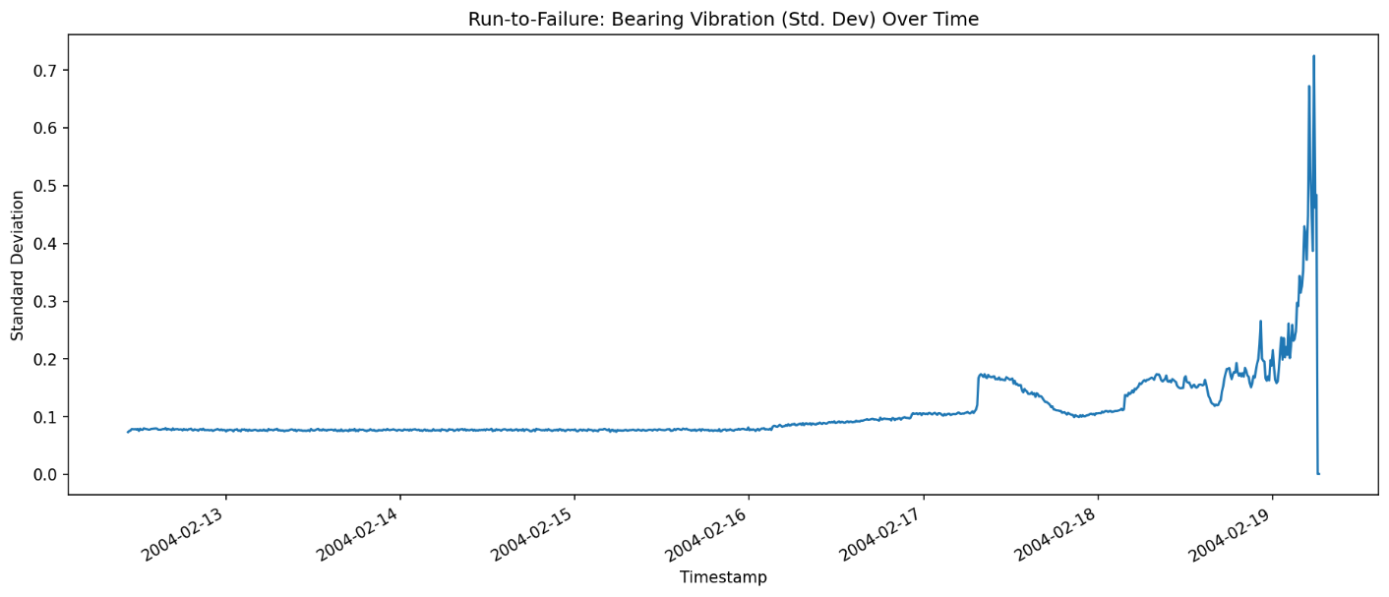

Figure 1: Run-to-Failure visualization based on vibration standard deviation. The three phases (Healthy, Degradation, Failure) are clearly visible.
Finding 2: Feature Distributions
By splitting the data into "Healthy" (first 70%) and "Failing" (last 30%), we can see a clear shift in the data's properties (Figure 2). Features like std, max, and kurtosis (a measure of "spikiness") have visibly different distributions, confirming they are excellent features for our models.
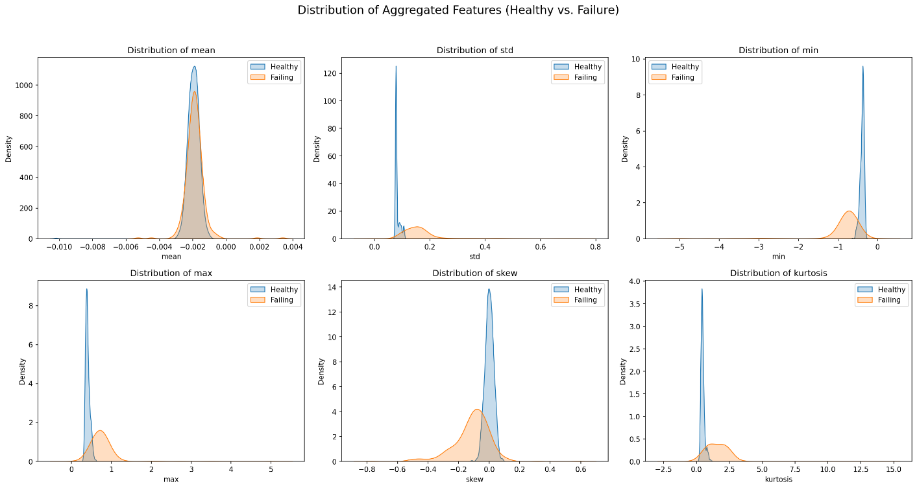

Figure 2: Feature distributions for 'Healthy' vs. 'Failing' data periods. The clear shift confirms these are valid predictive features.
3. Feature Engineering
This section directly addresses the requirement to create, justify, and scale meaningful features.
3.1. Feature Creation
The feature_engineering.py module enhances the 6 statistical features with two advanced techniques to provide "context" to the models.
Rolling Statistics: I created roll_mean_std, roll_std_std, and roll_mean_mean features using a 50-file (approx. 8-hour) window.
Seasonal Decomposition: I decomposed the std signal into its Trend, Seasonal, and Residual components. The Trend captures the long-term failure, Seasonal captures daily cycles, and the Residual captures the "unexplained noise."
3.2. Feature Rationale (Justification)
Why Rolling Stats? A simple std > 0.5 threshold is brittle. By adding a rolling mean, the model can learn to detect deviations from a recent trend. This provides a dynamic baseline of "normal" behavior, making the model far more sensitive to the start of a change.
Why Decomposition? This is the most powerful feature. A bearing failure is not part of its normal daily cycle. By decomposing the signal and feeding the Residual to our model, we are giving it a pre-cleaned signal that only contains the "shocks" and "surprises" that don't fit the trend or seasonal pattern. Anomalies are, by definition, found in the residual.
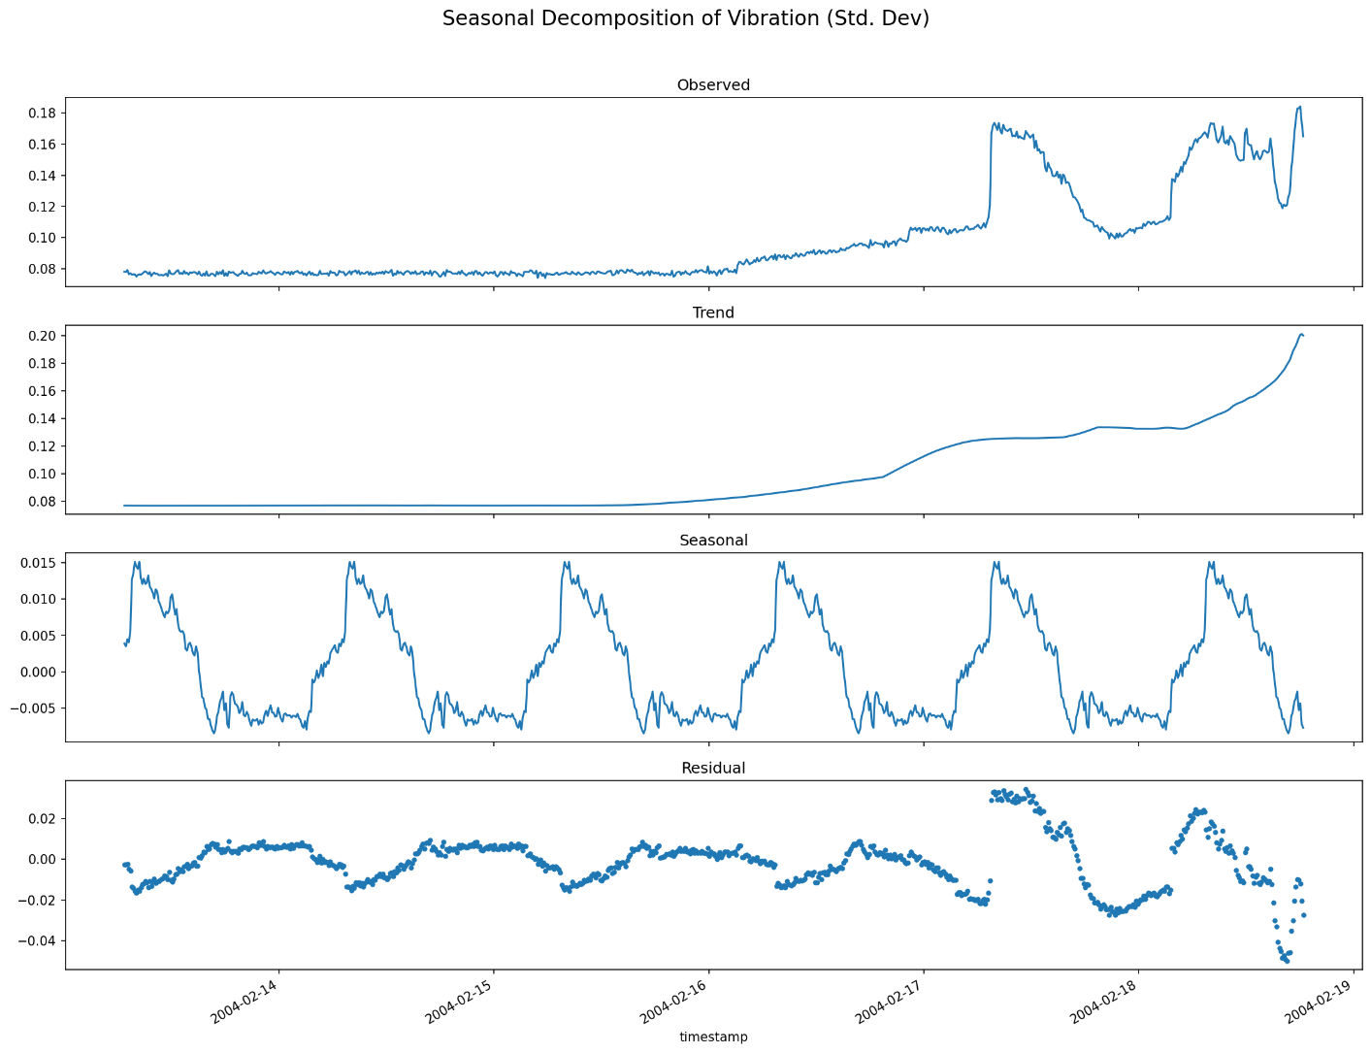

Figure 3: Seasonal Decomposition of the std signal. The final Residual plot (bottom) clearly isolates the anomalous spikes, making it a perfect feature.
3.3. Normalization and Scaling
Feature scaling is critical for neural networks but not for tree-based models. This was handled in the models.py script.
Isolation Forest: Received the unscaled data, as tree models are not sensitive to feature magnitudes.
LSTM Autoencoder: Received data processed by StandardScaler.
The StandardScaler was fit only on the "healthy" training data (the first 70%).
This fitted scaler was then used to transform all the data (both healthy and anomalous).
This is a critical best practice to prevent data leakage, ensuring the model's definition of "normal" (a mean of 0 and std of 1) is based only on healthy patterns.
4. Anomaly Detection Models
This section details the two required modeling approaches.
4.1. Approach 1: Isolation Forest (Unsupervised)
Intuition: This model works by building random "isolation" trees. The core idea is that anomalies are "few and different," making them easier to isolate (they require fewer splits in a tree to be singled out).
Hyperparameters & Rationale:
n_estimators=100: A robust default that provides a good ensemble of trees.
contamination=0.05: This is the expected percentage of outliers. Based on my EDA (Figure 1), the final failure/degradation phase represents approximately the last 5-10% of the data, so 5% is a reasonable and effective estimate.
4.2. Approach 2: LSTM Autoencoder (Deep Learning)
Intuition: This is a more sophisticated approach. An LSTM Autoencoder is a neural network trained to "reconstruct" its own input. My strategy was to train this network exclusively on the "Healthy State" data (the first 70% of the timeline).
Anomaly Detection: The model becomes an expert at compressing and reconstructing "normal" signals, resulting in a low reconstruction error (Mean Absolute Error, or MAE). When the model is later shown an "anomalous" signal from the degradation phase, it fails to reconstruct it accurately, causing the reconstruction error to spike. A high MAE is the anomaly signal.
Hyperparameters & Rationale:
LSTM Units=64: Provides sufficient capacity to learn the patterns without being excessively large.
Time Steps=10: The model looks at a sequence of 10 data points (100 minutes) to predict that same sequence.
Epochs=50 (with EarlyStopping): Allows the model to train sufficiently while EarlyStopping (patience=5) prevents overfitting.
Threshold: The anomaly threshold was set statistically as the 99th percentile of the training data's reconstruction error. This provides a robust, non-arbitrary definition of "unusual."
5. Model Evaluation & Comparison
5.1. Validation Strategy
As this is an unsupervised problem without ground-truth labels, I used the methods required by the assignment:
Visual Inspection: I plotted the detected anomalies over the original signal. A successful model must flag the "Degradation" and "Failure" phases identified in the EDA.
Domain Reasoning: The "run-to-failure" context provides our domain knowledge. A model that flags points in the "Healthy" phase is a failure (a false positive). A model that flags the start of the "Degradation" phase is a success (an early warning).
5.2. Model Performance & Comparison
The results of the two models were clear and distinct.
Autoencoder Performance:
The LSTM Autoencoder (Figure 4) performed exceptionally well. The reconstruction error (blue line) is low and stable during the "Healthy" phase, staying well below the red threshold. The moment the "Degradation" phase begins (around timestamp 650-700), the error immediately crosses the threshold and continues to climb, validating the approach perfectly.
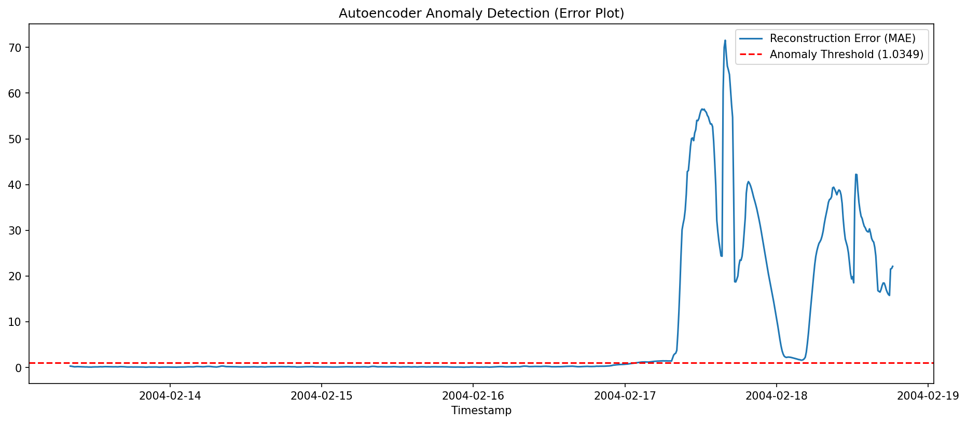
Figure 4: Reconstruction Error (MAE) for the LSTM Autoencoder. The error spikes precisely when degradation begins, providing a clear early warning.
Final Comparison:
Figure 5 shows a direct, side-by-side comparison.

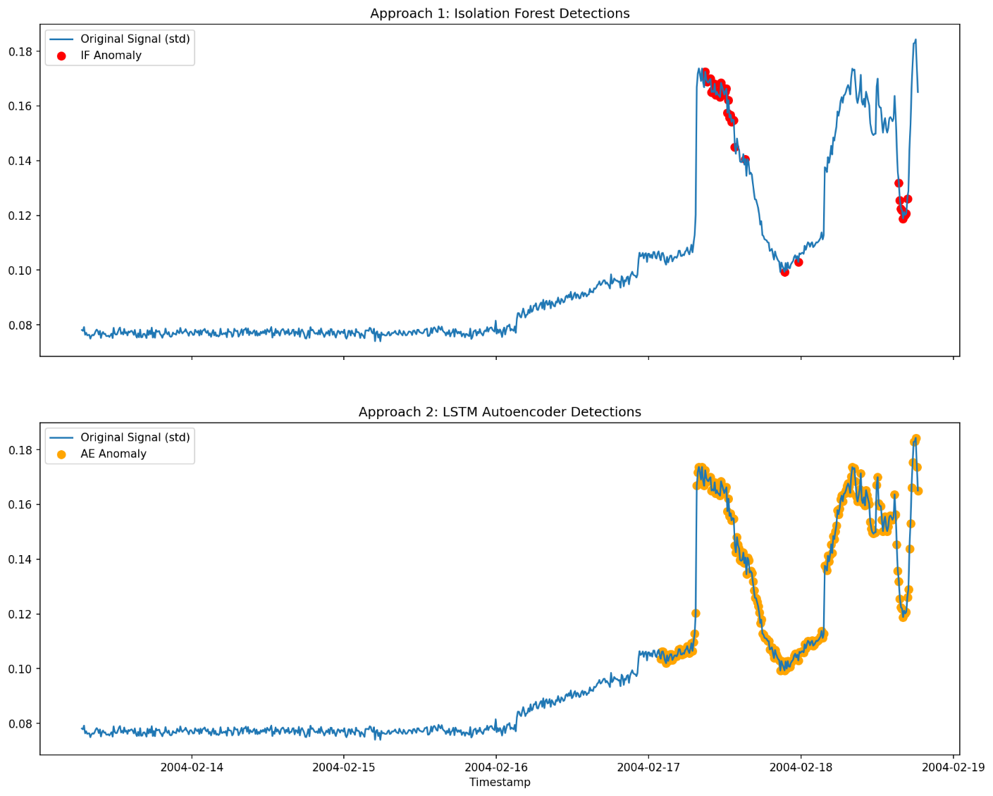
Figure 5: Final Comparison of Isolation Forest vs. LSTM Autoencoder detections.
The Isolation Forest (Top Plot) successfully identifies the most extreme, obvious anomalies during the final failure spike. It is a good "confirmation" model.
The LSTM Autoencoder (Bottom Plot) is far superior. It not only flags the final failure but also successfully identifies the entire "Degradation" phase—the early warning signal.
6. Key Findings & Business Insights
Key Finding 1: The LSTM Autoencoder is the clear recommendation for the client. The Isolation Forest is good at flagging failure, but the Autoencoder is successful at flagging degradation. This is the key difference between reactive and predictive maintenance.
Key Finding 2: Advanced feature engineering (Seasonal Decomposition) was critical. Using the Residual as a feature allowed the Autoencoder to detect the anomaly sooner and more cleanly than it would have with the raw signal.
Business Insight: The LSTM Autoencoder provides a robust, automated "check engine light" for the client's equipment. By implementing this model, the client can create an alert that triggers the moment the reconstruction error (MAE) crosses the threshold. This allows them to schedule maintenance before the catastrophic failure, saving significant costs, preventing downtime, and moving their operations from reactive to truly predictive.
7. Limitations & Future Improvements
Limitation: The "healthy" data split (70%) and the anomaly threshold (99th percentile) were set statistically based on visual inspection. In a real-world deployment, these would be fine-tuned with a "domain expert" (a facility engineer) to optimize the trade-off between sensitivity and false alarms.
Future Improvement: This analysis focused on a single bearing (Bearing_1). The next step would be to build a multivariate autoencoder that monitors all four bearings simultaneously. This would allow the model to learn complex correlations between the sensors, likely detecting even more subtle anomalies (e.g., "Bearing 2's vibration is weird relative to Bearing 1's"), further increasing the system's reliability and foresight.

