A
Mini-Project Report on

Study Share
Submitted in partial fulfillment of the requirements
for the degree of
BACHELOR OF ENGINEERIN
IN
Computer Science & Engineering Artificial Intelligence & Machine Learning
by
Siddhesh Akhadmal (23106004)
Prajwal Chaudhari (23106114)
Yash Bhale (23106069)
Kaif Ansari (23106088)

Under the guidance of

Prof. Kanchan Wankhede



Department of Computer Science & Engineering
(Artificial Intelligence & Machine Learning)
A.P.Shah Institute of Technology
G.B.Road , Kasarvadavali, Thane(W)-400615
University Of Mumbai
2024-2025


A. P. SHAH INSTITUTE OF TECHNOLOGY

CERTIFICATE

This is to certify that the project entitled “Study Share” is a bonafide work of Siddhesh Akhadmal (23106004),Prajwal Chaudhari (23106114),Yash Bhale (23106069) ,Kaif Ansari (23106088) submitted to the University of Mumbai in partial fulfillment of the requirement for the award of Bachelor of Engineering in Computer Science & Engineering (Artificial Intelligence & Machine Learning).

________________ | _______________
Prof. Kanchan Wankhede | Dr. Jaya Gupta
Mini Project Guide | Head of Department



A. P. SHAH INSTITUTE OF TECHNOLOGY

Project Report Approval

This Mini project report entitled “Study Share” by Siddhesh Akhadmal, Prajwal Chaudhari, Kaif Ansari and Yash Bhale is approved for the degree of Bachelor of Engineering in Computer Science &Engineering, (AIML) 2024-25.

External Examiner:

Internal Examiner:

Place: APSIT, Thane

Date:

Declaration

We declare that this written submission represents my ideas in my own words and where others' ideas or words have been included, I have adequately cited and referenced the original sources. I also declare that I have adhered to all principles of academic honesty and integrity and have not misrepresented or fabricated or falsified any idea/data/fact/source in my submission. I understand that any violation of the above will be cause for disciplinary action by the Institute and can also evoke penal action from the sources which have thus not been properly cited or from whom proper permission has not been taken when needed.

Siddhesh Akhadmal | Prajwal Chaudhari | Kaif Ansari | Yash Bhale
(23106004) | (23106114) | (23106088) | (23106069)

ABSTRACT

Students frequently experience issues while taking notes, which interferes with their ability to study. There are many reasons students miss to take notes in college. Without notes, they might miss on important information and it would be really hard for the students during their exam times. Students will have a place to congregate and engage in collaborative learning through our application. It is possible for students to their materials (both written notes and documents in PPT, PDF, DOC, etc. format) for free access by other students in any branch or semester. Each user will log in to the application using their individual account. This application will also help the students to earn money. Students who wish to earn money while studying can lock their notes and the other students who want to download the notes have to pay the uploader. This way the application will benefit students to earn part time and also encourage students to take notes in class. There are few existing models for the said application but users face many difficulties like access to notes only after payment, does not accept hand written notes, must upload notes regularly, allows upload only for a particular stream. The proposed method provide solutions like students from different streams can upload their notes, notes can be downloaded for free or paid version based on how the uploader has set the download option. The other important feature is that Student Performance Analysis is done using Random Forest Regressor. The future work of this application is to enable student credit other students for their work by including credit system which will motivate the students to do a better job. This website is intended to be an Educate and Share website.

Index

Index |  |  | Page no.
Chapter-1
 | Introduction |  | 6
Chapter-2
 | Literature Survey |  | 7
 | 2.1 | History
 | 2.2 | Literature Review
Chapter-3
 | Problem Statement |  | 9
Chapter-4
 | Experimental Setup |  | 11
 | 4.1 | Hardware setup
 | 4.2 | Software Setup
Chapter-5
 | Proposed system and Implementation |  | 14
 | 5.1 | Block Diagram of proposed system
 | 5.2 | Description of Block diagram
 | 5.3 | Implementation
 |  | Figure 1.1
 |  | Figure 2.1
 |  | Figure 2.2
Chapter-6
 | Conclusion |  | 19
References |  |  | 19

CHAPTER 1
INTRODUCTION

1. INTRODUCTION

Study share is a web based project which will be designed using the frontend and backend which will be done by using HTML/css/Javascript. This is a notes sharing platform in which students from different branch , colleges, school, and universities can share there notes and books in pdf or image format and also Previous year Question paper and discuss it within. Basically this is a platform like reddit / facebook for students. This is very beneficial for those universities, institute, collage, etc who share their notes between the students. On other hand students are also able to share their notes between their friends.

CHAPTER 2
LITERATURE SURVEY

2. LITERATURE SURVEY

History :
Over the years, several digital platforms have been developed to aid students and educators in managing and sharing educational resources. Initially, traditional file-sharing platforms like Google Drive and Dropbox to address these gaps by offering a streamlined, student-friendly experience specifically designed for managing educational content.

Literature Review :
On Developing and Deploying Large-File Upload Services of Personal Cloud Storage(Huan chen, 2015 IEEE International Conference on Services Computing, 27 June 2015 - 02 July 2015) : Personal cloud storage services, such as those by Google and Baidu, allow users to access files globally, which has become more prevalent with mobile internet and rich media. However, large files often exceed upload limits, necessitating specialized services. This paper presents a large-file upload solution without file size restrictions, strict data verification APIs, and extended capabilities for team collaboration. Additionally, it introduces a Docker-based deployment strategy to address security and performance concerns, enabling flexible, local replication of the upload service. The proposed methods are evaluated based on experimental results.

File sharing system encapsulated with customized social networking and learning management system (Aratrika Sarkar, 2015 International Conference and Workshop on Computing and Communication, 15-17 October 2015) : In the proposed system, we have developed an application which aids in file sharing coupled with security. The application is modeled in such a way that there exists a hierarchical classification of employees. A root is at the topmost position in the organization with levels below him. The application enables a user to create files and share them with other users depending upon his or her position in the hierarchy. This application encapsulates several security measures integrated with the flexibility of sharing files easily with a single or multiple users without the use of `email'. This application is simple, easy to use and secure. Security of files is implemented by the use of cryptography in various file modes. In this paper, we have created an application which aids in file sharing within an organization coupled with a security system.

CHAPTER 3

Problem Statement

3. Problem Statement

Today in this busy world everyone want to make things easy. Thus there is great challenge of sharing the notes between the students. The time like this pandemics all the things are shifted towards online so there needs of such platform where the students as well as teacher can share their notes, here online note sharing projects comes into the picture. This provide easy and safe way of sharing the notes.
Most of the colleges, universities, etc have problems while sharing the notes or any other files between their students, partner or any needy people. Sharing the notes or any files using social media is not too safe and effective that’s why this websites play important role while sharing the notes between the people. Here students can store their notes for future uses and able to download whenever they want to.

CHAPTER 4
Experimental Setup

4. Experimental Setup
4.1 Hardware Setup
In this project we have used simple VS code source code editor to run our program in windows operating system.

4.2 Software Setup

HTML
Hypertext Mark-up Language (HTML) is the standard mark-up language for creating web pages and web applications. HTML describes the structure of Web pages using mark-up. HTML elements are the building blocks of HTML pages.HTML elements are represented by tags.HTML
tags label pieces of content such as "heading", "paragraph", "table", and so on. Browsers do not display the HTML tags, but use them to render the content of the page.

CSS
Cascading Style Sheets, fondly referred to as CSS, is a simply designed language intended to simplify the process of making web pages presentable. CSS allows you to apply styles to web pages. More importantly, CSS enables you to do this independent of the HTML that makes up each web page. CSS is easy to learn and understood but it provides powerful control over the presentation of an HTML document.

JAVASCRIPT
JavaScript (sometimes abbreviated JS) is a prototype-based scripting language that is dynamic, weakly typed, general purpose programming language and has first-class functions. It is a multi-paradigm language, supporting object-oriented, imperative, and functional programming styles. JavaScript was formalized in the ECMA Script language standard and is primarily used in the form of client-side JavaScript, implemented as part of a Web browser in order to provide enhanced user interfaces and dynamic websites. This enables programmatic access to computational objects within a host environment. JavaScript's use in applications outside Web pages for example in PDF documents, site-specific browsers, and desktop widgets is also significant. In this application, JavaScript is used for validation purpose like text box validation, email validation, phone number validation. JavaScript is the good tool for validating the web- applications.

Firebase :
For your StudyShare project, Firebase offers several advantages:
- Real-time Document Sharing: Using Firestore or the Realtime Database, students can instantly share and access documents without delay.
- Cloud Storage: You can use Firebase Cloud Storage to handle the uploading and downloading of study materials, ensuring scalable storage for a wide range of file formats.
- Easy Authentication: Firebase Authentication makes managing user accounts simple, letting students log in and manage their own files and settings securely.
- Scalability: Firebase handles the backend infrastructure, so as StudyShare grows, you won’t need to worry about scaling the database or file storage

CHAPTER 5
Proposed System & Implementation

5.Proposed system & Implementation
5.1Block diagram of proposed system
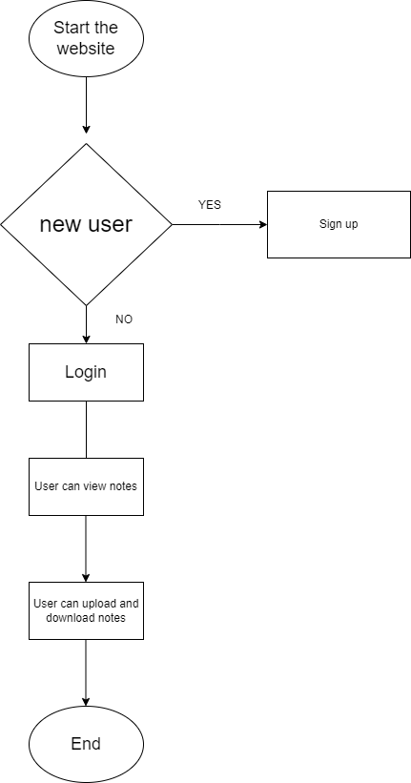
Figure 1.1

5.2 Description of block diagram

1. Start the application.
2. If you are a new user, sign up.
3. If you are an existing user, enter your credentials and login into the application.
4. You can view some shared notes and you can upload your notes to other users as well.
5. Stop

5.3 Implementation

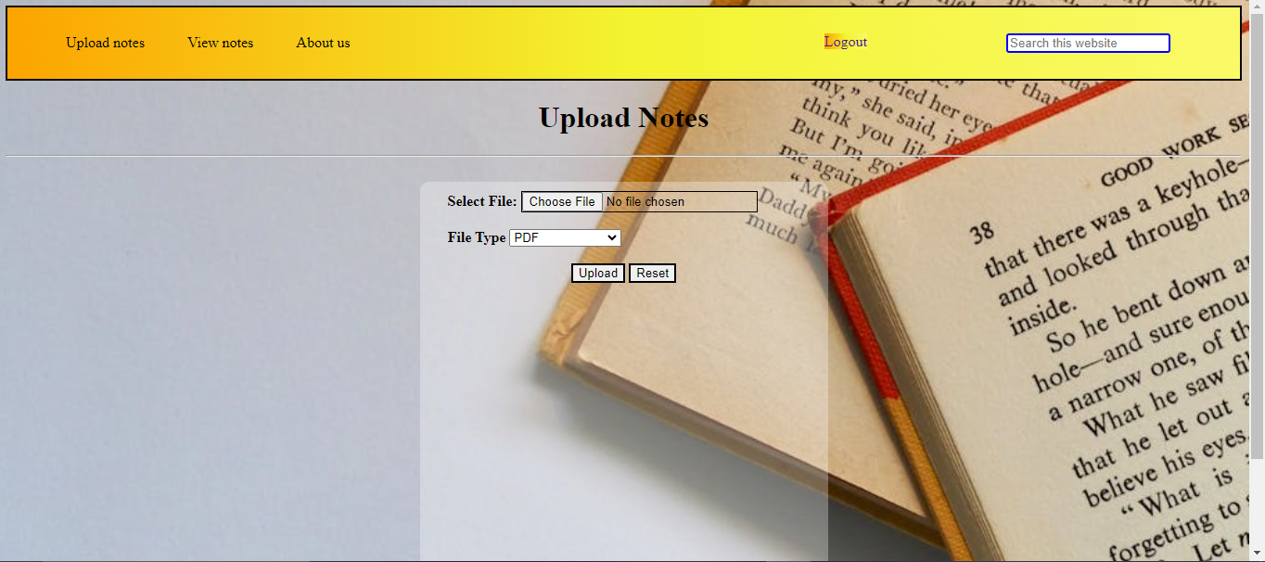
Figure 2.1

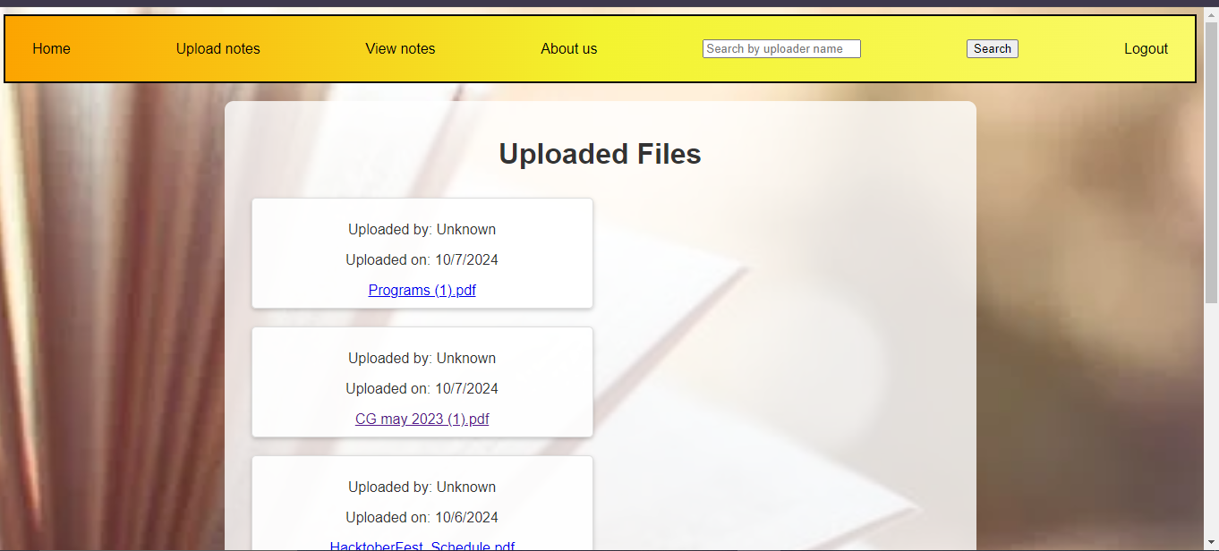
Figure 2.2

This JavaScript code utilizes the Firebase JavaScript SDK to upload files to Firebase Storage and retrieve download URLs. Here's a breakdown of the code:

Firebase Configuration
- Imports necessary Firebase modules from the CDN.
- Defines the Firebase project configuration object (firebaseConfig).
- Initializes the Firebase app with initializeApp(firebaseConfig).

Firebase Services
- Gets references to Firestore (db) and Storage (storage) services.
- Creates a reference to the Storage bucket (storageRef).

HTML Element References
- Gets references to HTML elements:
- fileInput (file upload input)
- uploadButton (upload button)
- statusDiv (status display div)
- filePreviewDiv (file preview div)

Upload Button Event Listener
- Listens for clicks on the upload button.
- When clicked:
1. Gets the selected file from fileInput.
2. Checks if a file was selected.
3. Creates a reference to the file in Firebase Storage (storageRef).
4. Uploads the file to Firebase Storage using uploadBytesResumable.
5. Listens for upload state changes.

Upload State Change Listener
- Listens for three states:
1. Progress: Updates the status div with upload progress (progress.toFixed(2)%).
2. Error: Displays an error message in the status div.
3. Success:
- Gets the download URL using getDownloadURL.
- Displays a success message with the download URL.
- Creates a download link or image preview.

File Preview
- If the uploaded file is an image, creates an img element to preview it.
- Otherwise, creates a download link (a element).

This code demonstrates the following Firebase Storage features:
- File uploads
- Upload progress tracking
- Error handling
- Download URL retrieval
- File preview

To use this code, ensure:
- You have a Firebase project set up.
- You replace the firebaseConfig object with your own project credentials.
- You have the necessary HTML elements (fileUpload, btn, status, and filePreview) in your HTML file.

5.4 Advantages/Applications

Advantages of a Website for Uploading, Sharing, and Downloading Study Documents:
- Convenient Access: Students can upload and download study materials from anywhere, making it easy to access notes, assignments, and study guides without geographical restrictions.
- Collaborative Learning: By allowing students to share their notes and study resources, the platform encourages peer-to-peer learning and knowledge sharing, fostering collaboration among students.
- Time-Saving: Instead of searching for resources across different platforms, students can find study materials in one centralized place, saving time and effort.
- Improved Study Resources: The platform can host a variety of study materials such as notes, sample papers, presentations, and research papers, enriching the pool of available resources for students.
- Organized Storage: The documents can be categorized by subjects, topics, or courses, making it easier for students to find specific materials when needed.
- Resource Sharing: Students can share documents that they have found useful, ensuring that quality materials are distributed across the student body, which improves learning outcomes.
- Free or Affordable: A platform like this can be made free or low-cost, reducing barriers for students to access high-quality study resources.
- Promotes Collaboration Among Diverse Students: It allows students from different regions, universities, or countries to connect and share documents, promoting diversity in learning.
- Eco-Friendly: By promoting digital sharing, the platform reduces the need for printing study materials, thus contributing to environmental sustainability.

Applications of a Document Sharing Website for Students:

- Educational Institutions: Schools, colleges, and universities can use the platform to provide resources, assignments, and lecture notes, ensuring every student has equal access to study materials.
- Study Groups: Students can create and manage private or public groups where they upload and share documents relevant to specific subjects or topics.
- Tutoring Services: Tutors can upload and share their notes, lesson plans, and other teaching materials with their students on a centralized platform.
- Competitive Exams: Students preparing for competitive exams can upload and download previous year’s papers, model answers, and study guides, making it a valuable resource hub.
- Research Collaboration: University or college students working on research projects can use the platform to share papers, references, and data with their peers or collaborators.
- Online Learning Platforms: E-learning websites can integrate document sharing functionality to supplement online courses with additional materials for students to download.
- Peer Review and Feedback: The platform can facilitate peer reviews where students upload essays, projects, or research papers for feedback from fellow students.
- Workshops and Webinars: Students can share documents related to workshops, seminars, and webinars, ensuring that all participants have access to relevant study materials.
- Student-Run Organizations: Student bodies or academic clubs can upload event-related documents, such as agendas, reports, and presentations, for members to download and review.
- Revision and Study Guides: The platform can serve as a repository for students to share summarized revision notes or guides before exams, helping others prepare more efficiently.

CHAPTER 6

Conclusion

6. Conclusion

In proposed system it allows a multiple type of users(teacher/student/admin) to login. It also allows admins to manage the whole system. It allows all users to create, read, update and delete their notes in a managed format. It allows users to update their profile/account details. Secure registration and login option for users. Allows students and teachers to download/upload their course notes easily .Allows users to recover their password using forgot password option
This project has a large scope as it has the following features which help in making it easy to use, understand and modify it is easy to share notes . There is no necessity of doing paper work. To save the environment by using paper free work. To increase the efficiency of the notes. It provides a easy and secure way for user log in and registration as well as easy password recovery through email and there will be a availability based on the departments.

References

- https://youtu.be/L5WWrGMsnpw?si=TF9W2PPyeMFp4wXx

- https://www.karunya.edu/aqar/2020-21/QIF/Criteria_1/1.3.4/417.pdf

- https://www.wix.com/website/templates

- On Developing and Deploying Large-File Upload Services of Personal Cloud Storage(Huan chen, 2015 IEEE International Conference on Services Computing, 27 June 2015 - 02 July 2015)

- File sharing system encapsulated with customized social networking and learning management system (Aratrika Sarkar, 2015 International Conference and Workshop on Computing and Communication, 15-17 October 2015)

