Collection Update: Tariffs and the Art Market

U.S. tariffs have many investors considering the adverse effects that economic protectionism might have on their portfolio. As it stands, new U.S. tariffs will not apply to artwork, which means that art can likely maintain its status as a resilient, uncorrelated asset. Here’s a full breakdown of how we’re thinking about tariffs:

- Art remains exempt from U.S. tariffs

Absent an act of Congress, new US tariffs do not apply to fine art, thanks to a long-standing carveout under the International Emergency Economic Powers Act (IEEPA).

As capital seeks refuge from punitive tariffs, this exemption could reinforce art’s role as a resilient, globally traded asset. This regulatory advantage not only preserves art’s status as a cross-border investment but may also drive heightened interest from those looking to hedge a slice of their portfolio against the broader economic impact of trade restrictions. With art’s historical ability to store and grow value independent of traditional markets, now may be an opportune moment to consider its potential within a well-diversified portfolio.

- Retaliatory tariffs are not expected to materially impact the art market for collectors living in China, UK, EU, or Asia

It is a common practice for non-U.S. residents to (a) hold wealth offshore, or (b) hold and trade art within freeports. Due to this, we do not expect retaliatory tariffs to have a large impact on demand.

We do remain concerned that investor sentiment remains impaired worldwide, which could have the largest impact on art buying broadly.

- Investor or collector sentiment remains the largest risk

Due to art having minimal structural exposure to tariff risk, we continue to believe that collector sentiment remains the largest risk to the art market. In times of uncertainty, collectors could stop buying. While we do not yet have a good feel for how this will play out, this remains top of mind for us as volatility in other asset classes continues to unfold.

- Art behaves differently than other asset classes

Postwar and contemporary art has been resilient in certain times of economic distress with historically low correlation to public equities. This means that when public equities swing up or down, art prices do not necessarily follow. This makes art a potentially excellent diversifier for client portfolios.

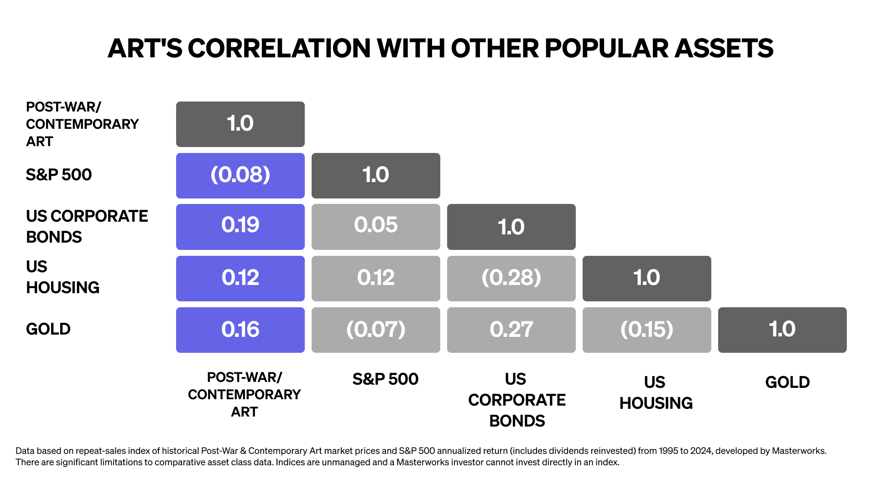

- A history of market growth

Since 1995, post-war and contemporary art has overall outpaced nearly all other alternative assets, while sharing minimal correlation to public equities.

This historical appreciation and lack of correlation gives us confidence that art is well-positioned to weather the current market volatility, making it an important allocation within a portion of investors’ portfolios.

