### A SEMINAR REPORT ON

### AGE AND GENDER DETECTION SYSTEM

**BACHELOR OF TECHNOLOGY**

### IN

**CSE (ARTIFICIAL INTELLIGENCE AND MACHINE LEARNING)**

### Submitted By

|  |  |
| --- | --- |
| **SK.MASTHANBEE** | **21S11A6625** |



**DEPARTMENT OF CSE (ARTIFICIAL INTELLIGENCE AND MACHINE LEARNING)**



**CERTIFICATE**

This is to certify that this is the bonafide record of the project entitled “**Age And Gender Detection using opencv ”,** submitted by **Shaik Masthanbee** of B.Tech in the partial fulfillment of the requirements for the degree of Bachelor of Technology in Computer Science and Engineering, Department of CSE during the year 2023-2024. The results embodied in this project report have not been submitted to any other university or institute for the award of any degree or diploma.

### Head of the Department

**Dr. Vinaya Kumari**

**DECLARATION**

We hereby declare that the major project titled **“Age and Gender Detection using opencv”,** submitted to Malla Reddy Institute of Technology & Sciences(UGC Autonomous), affiliated to Jawaharlal Nehru Technological University Hyderabad (JNTUH) for the award of the degree of Bachelor of Technology in Computer Science and Engineering is a result of original research carried- out in this thesis. It is further declared that the project report or any part thereof has not been previously submitted to any University or Institute for the award of a degree.

**SK MASTHANBEE (21S11A6625)**

# ABSTRACT

* In this fast-emerging world Artificial Intelligence plays a very vital role in every field of science . Everything is being automated from operating a remote to driving a car using Artificial Intelligence. We show a glimpse of such automated experience with this project. In this project we show how easy it is to detect faces and identify gender along with gender with the help of CNN(Convolutional Neural Networks) and OpenCV. Using these fields of Artificial Intelligence, we can reduce the use of hardware components and complexities in this project. Along with CNN and OpenCV we use Adience dataset so that the output is achieved with accurate values in training and validation. For the output to be determined even with multiple parameters we use pretrained model that is caffee model along with OpenCV. The proposed model can be used in surveillance purposes or in medical purposes

|  |  |  |
| --- | --- | --- |
|  | **TABLE OF CONTENTS** |  |
| **S.NO** | **TITLE** | **PG.NO** |
| **1** | **INTRODUCTION** | **08** |
|  | 1.1 PURPOSE AND OBJECTIVES | 08 |
|  | 1.2 EXISTING AND PROPOSED SYSTEM | 13 |
|  | 1.3 SCOPE OF PROJECT | 14 |
| **2** | **SYSTEM ANALYSIS** | **16** |
|  | 2.1 HARDWARE AND SOFTWARE REQUIREMENTS | 16 |
|  | 2.2 SOFTWARE REQUIREMENTS SPECIFICATION | 16 |
| **3** | **SYSTEM DESIGN** | **21** |
|  | 3.1 ARCHITECTURE | 23 |
|  | 3.2 UML DIAGRAMS | 25 |
| **4** | **METHODOLOGY** | **32** |
|  | 4.1 MODULE DESCRIPTION | 32 |
|  | 4.2 PROCESS/ALGORITHM | 32 |
| **5** | **IMPLEMENTATION** | **33** |
|  | 5.1 SAMPLE CODE | 33 |
|  | 5.2 OUTPUT SCREENS | 37 |
| **6** | **CONCLUSION & FUTURE SCOPE** | **38** |
| **7** | **BIBLIOGRAPHY** | **39** |

# LIST OF FIGURES

|  |  |  |
| --- | --- | --- |
| **FIGURE.NO** | **NAME** | **PG.NO** |
| **4.2** | **SYSTEM FLOW DIAGRAM** | **24** |
| **4.3.2.1** | **CLASS DIAGRAM** | **28** |
| **4.3.2.2** | **USE CASE DIAGRAM** | **29** |
| **4.3.2.3** | **SEQUENCE DIAGRAMS** | **29** |
| **4.3.2.4** | **ACTIVITY DIAGRAM** | **31** |
| **4.3.2.5** | **COMPONENT DIAGRAM** | **32** |

**LIST OF OUTPUTS**

|  |  |  |
| --- | --- | --- |
| **FIGURE.NO** | **NAME** | **PG.NO** |
| **8.1** | **UPLOADING THE IMAGE** | **50** |
| **82.** | **CONFIDENCE SCORE &TUMOUR TYPE PREDICTION** | **50** |

# INTRODUCTION

The project aims to explore the field of age and gender detection in computer vision, which has significant practical applications in various domains such as surveillance, marketing, and human-computer interaction. By accurately detecting age and gender from images or videos, we can enhance user experiences, improve targeted advertising, and contribute to overall data-driven decision-making.

* 1. **PURPOSE, AIM AND OBJECTIVES:**

### Purpose of the Project:

The purpose of age and gender detection using OpenCV is to analyze images or video streams and automatically determine the approximate age and gender of the individuals present.

* **Marketing and Advertising:** Businesses use these applications to target their advertising and marketing campaigns more effectively by understanding the demographics of their audience.
* **Content Personalization:** Content platforms use age and gender detection to customize content recommendations and user experiences based on the age and gender of the user.
* **Security:** Age and gender detection can be used in security systems to identify and verify individuals for access control or in surveillance applications.
* **Healthcare:** In healthcare, such applications can help in patient profiling and tracking demographic information for medical research and treatment.
* **Entertainment and Gaming:** Game developers and entertainment platforms can tailor their products to different age and gender groups
* **Social Media:** Social media platforms use this technology to offer personalized content and advertisements to their users.
* **Research and Insights:** Age and gender detection can provide valuable data for research purposes, such as studying population trends, analyzing customer behavior, or conducting user studies in various fields.

### Aim of the Project:

The aim of age and gender detection using OpenCV is to automatically analyze images or video streams and accurately determine the age and gender of individuals.

**1.Computer** **Vision Application**: It leverages computer vision techniques to extract relevant features from facial images, such as wrinkles, facial structure, and hair patterns, to estimate age and gender.

**2**.**Non-Intrusive Identification:** The goal is to achieve non-intrusive identification, eliminating the need for manual input or explicit user information.

**3.Diverse Use Cases:** It caters to diverse applications, including security systems, targeted advertising, and demographic analysis, by providing insights into the age and gender distribution of people in a given area.

**4.Enhanced User Experience:** In applications like virtual mirrors or personalized content delivery, age and gender detection contributes to a more personalized and user-friendly experience.

**5.Data-Driven Decision Making**: Enables data-driven decision-making by providing valuable demographic information, which can be utilized for marketing strategies, customer profiling, and understanding user preferences.

**6.Continuous Improvement:** The development of age and gender detection models using OpenCV is an ongoing process, aiming for increased accuracy and robustness through continuous training and refinement of algorithms.

### Objectives of the Project:

The "Age and Gender Detection using opencv" project has several specific objectives that drive its development and implementation:

**1.Automated Identification:** The primary objective is to automatically identify and classify individuals based on their age and gender through computer vision techniques using OpenCV.

**2.Enhanced Security:** Implementing age and gender detection in security systems contributes to enhanced surveillance by providing additional demographic information for identification purposes.

**3.Personalized User Experience:** In applications like interactive kiosks or digital signage, the goal is to deliver a more personalized user experience by tailoring content based on the detected age and gender of the viewer.

**4.Targeted Marketing:** Enable targeted marketing strategies by analyzing the age and gender demographics of individuals, helping businesses tailor their advertising efforts to specific target audiences.

**5.Facilitate Accessibility:** In user interfaces, especially for age-specific content or services, age detection can facilitate accessibility by automatically adapting the interface to suit the age group of the user.

**6.Demographic Analysis:** Contribute to demographic studies and urban planning by providing data on the age and gender distribution in different locations over time.

**7.Human-Computer Interaction:** Improve human-computer interaction by enabling systems to respond differently based on the age and gender of the user, creating a more intuitive and user-friendly interface.

**8.Social Media Analytics:** Age and gender detection can be applied in social media analytics to understand the demographics of users engaging with content, aiding content creators and marketers in refining their strategies.

**9.Healthcare Applications:** Assist in healthcare scenarios by automating the estimation of patient age and gender, potentially supporting medical research and diagnostics.

**10.Continuous Innovation:** Foster continuous innovation in computer vision and machine learning by refining algorithms for age and gender detection, contributing to advancements in the field and expanding its applications

**SCOPE OF PROJECT:**

The scope of Age and Gender Detection project encompasses several key areas:

**1.Security Systems:** Implementation in security systems for automated identification and monitoring, enhancing the capabilities of surveillance through age and gender profiling.

**2.Retail Analytics:** Utilization in retail environments for demographic analysis, enabling businesses to understand customer profiles and optimize marketing strategies.

**3.Human-Computer Interaction:** Integration into user interfaces to create more personalized and intuitive interactions based on the age and gender of the user.

**4.Healthcare Applications:** Potential applications in healthcare for automated patient demographic analysis, supporting medical research and improving patient care.

**5.Marketing and Advertising:** Valuable in targeted marketing and advertising campaigns, allowing businesses to tailor content to specific age and gender demographics.

**6.Entertainment Industry:** Implementation in entertainment applications for customized content delivery, enhancing user experience in areas such as streaming services and gaming.

**7.Social Media Analytics:** Integration into social media platforms for analyzing user demographics, aiding content creators and marketers in understanding their audience.

**8.Urban Planning and Demographic Studies:** Contribution to urban planning and demographic studies by providing data on age and gender distribution in different locations.

**9.Accessibility Features:** Integration into applications and interfaces to enhance accessibility features, adapting content or services based on the detected age group.

**10.Continuous Innovation:** Ongoing research and development in the field to improve algorithms, accuracy, and efficiency, contributing to continuous innovation in computer vision and machine learning.

## PROPOSED SYSTEM:

* + 1. **Deep Learning Architectures:** The proposed system aims to incorporate state-of-the-art deep learning architectures, such as ResNet, MobileNet, or EfficientNet, for more accurate and efficient age and gender detection.
    2. **Transfer Learning:** Leveraging transfer learning techniques to fine-tune pre-trained models on large datasets, enabling the model to generalize well to diverse age and gender characteristics.
    3. **Real-Time Processing:** Focus on optimizing the system for real-time processing, ensuring timely and responsive age and gender predictions in various applications.
    4. **Edge Computing:** Integration of edge computing capabilities to perform age and gender detection on edge devices, reducing the dependence on cloud services and enhancing privacy.
    5. **Explainable AI:** Incorporation of explainable AI techniques to provide insights into how the model arrives at age and gender predictions, enhancing transparency and interpretability.
    6. **Multimodal Approaches:** Exploration of multimodal approaches, combining facial features with other data sources like voice or gesture recognition, to improve the robustness and accuracy of age and gender predictions.
    7. **Dynamic Model Updating:** Implementation of mechanisms for dynamic model updating, allowing the system to adapt and improve over time with new data and evolving demographics.
    8. **Privacy-Preserving Techniques:** Integration of privacy-preserving techniques to handle sensitive information, ensuring that age and gender detection are performed without compromising individual privacy.
    9. **User Feedback Integration:** Incorporation of user feedback mechanisms to continuously improve the system's accuracy and address potential biases in age and gender predictions.
    10. **Customization and Configurability:** Designing the system with customization options, allowing users to configure and fine-tune parameters based on specific application requirements and environmental conditions.

# 2. SYSTEM ANALYSIS

System analysis in age and gender detection using OpenCV involves a thorough examination of various aspects to ensure effective design, development, and deployment.

**Requirement Analysis:**

* **User Requirements:** Identify user needs and expectations, considering the end-users of applications incorporating age and gender detection. This may involve understanding user demographics, preferences, and accessibility requirements.
* **Technical Requirements:** Technical requirements for age and gender detection using OpenCV encompass the specific tools, technologies, and configurations needed to develop and deploy the system.

## HARDWARE AND SOFTWARE REQUIREMENTS

* + 1. **HARDWARE REQUIREMENTS:**

**RAM** - Typically 4GB or more of RAM

**Storage** - SD card to store Applications

**Webcam** - 2.0mp

**Connectivity** - Wi-Fi connection

**Graphical Processing Unit(GPU)** - used in image and video processing

## SOFTWARE REQUIREMENTS:

**Programming Language** - Python 2.7-3.6 version

**Pycharm community edition**

**Algorithms like :** Convolutional neural networks

Regression Models are used

**Deep Learning Frameworks :** TensorFlow

PyTorch

OpenCv are used

### Hardware Requirements:

### 1. CPU: A multi-core processor is recommended for better performance, especially if you are processing real-time video feeds or multiple images simultaneously. Higher clock speeds can also help speed up the image processing.

### 2. RAM: The amount of RAM needed depends on the size of the images being processed and the complexity of the detection algorithms. Generally, having at least 4GB of RAM is a good starting point, but more RAM may be required for larger datasets or higher resolution images.

### 3. GPU: While OpenCV primarily relies on CPU processing, some machine learning frameworks integrated with OpenCV (such as TensorFlow or PyTorch) can benefit from GPU acceleration. Having a dedicated GPU with CUDA support can significantly speed up the age and gender detection process.

### 4. Storage: Sufficient storage space is needed to store the OpenCV library, your application code, and any necessary datasets or pre-trained models. Additionally, having enough disk space to store the captured or processed images is essential.

### 5. Camera: To perform real-time age and gender detection on live video feeds, you will need a webcam or any other camera supported by OpenCV. Make sure the camera has sufficient resolution and frame rate capabilities to capture clear and smooth video streams.

## ROLE OF SRS:

The purpose of the Software Requirement Specification is to reduce the communication gap between the clients and the developers. Software Requirement Specification is the medium through which the client and user needs are accurately specified. It forms the basis of software development. A good SRS should satisfy all the parties involved in the system.

## SCOPE:

The scope of the Age and gender detection using project encompasses several key areas and objectives:

**1.Security Systems:** Implementation in security systems for automated identification and monitoring, enhancing the capabilities of surveillance through age and gender profiling.

**2.Retail Analytics:** Utilization in retail environments for demographic analysis, enabling businesses to understand customer profiles and optimize marketing strategies.

**3.Human-Computer Interaction:** Integration into user interfaces to create more personalized and intuitive interactions based on the age and gender of the user.

**4.Healthcare Applications:** Potential applications in healthcare for automated patient demographic analysis, supporting medical research and improving patient care

**5.Marketing and Advertising:** Valuable in targeted marketing and advertising campaigns, allowing businesses to tailor content to specific age and gender demographics.

**6.Entertainment Industry:** Implementation in entertainment applications for customized content delivery, enhancing user experience in areas such as streaming services and gaming.

**7.Social Media Analytics:** Integration into social media platforms for analyzing user demographics, aiding content creators and marketers in understanding their audience.

**8.Urban Planning and Demographic Studies:** Contribution to urban planning and demographic studies by providing data on age and gender distribution in different locations.

**9.Accessibility Features:** Integration into applications and interfaces to enhance accessibility features, adapting content or services based on the detected age group.

**10.Continuous Innovation:** Ongoing research and development in the field to improve algorithms, accuracy, and efficiency, contributing to continuous innovation in computer vision and machine learning.

# 3. SYSTEM DESIGN & UML DIAGRAMS

System design is transition from a user oriented document to programmers or data base personnel. The design is a solution, how to approach to the creation of a new system. This is composed of several steps. It provides the understanding and procedural details necessary for implementing the system recommended in the feasibility study. Designing goes through logical and physical stages of development, logical design reviews the present physical system, prepare input and output specification, details of implementation plan and prepare a logical design walkthrough.

## SOFTWARE DESIGN:

The software design of the "Age and gender detection using open cv" project involves several components and architectural considerations. Below is an overview of the software design:

**1. Data Acquisition**: You'll need to acquire the input data, which can be images or video frames. This can be done using a webcam or by processing pre-recorded videos or images.

**2. Pre-processing:** Before feeding the data into the age and gender detection algorithm, pre-processing steps can be applied, such as resizing the image, normalizing pixel values, or applying noise reduction techniques.

**3. Face Detection**: Use OpenCV's face detection algorithms, such as Haar cascades or deep learning-based models like OpenCV's DNN module or the MTCNN model, to locate faces within the images or video frames.

**4. Face Alignment**: Align the detected faces to a standardized position and size. This can help improve the accuracy of age and gender estimation. Techniques like facial landmark detection or geometric transformations can be used for this purpose.

**5.** **Feature Extraction:** Extract relevant facial features like texture, shape, or appearance from the aligned faces. These features can serve as inputs to the age and gender prediction models.

**6. Age and Gender Prediction**: Employ machine learning or deep learning models to predict the age and gender from the extracted features. Commonly used approaches include classification models like SVM, random forests, or deep neural networks.

**7. Post-processing**: Once the predictions are obtained, you can apply post-processing techniques such as filtering, smoothing, or statistical analysis to refine the results and make them more reliable.

**8. Visualization:** Finally, provide a way to visualize the results by overlaying the estimated age and gender information on the original input images or videos.

## ARCHITECTURE:

The architecture of the "Age and Gnder detection using open cv" project can be described as a combination of software components and their interactions. Below is an architectural overview of the project:

**1. Data Acquisition**: Capture or acquire the input data, which can be images or video frames. This data can be obtained from a webcam, pre-recorded videos, or image datasets.

**2. Pre-processing**: Perform necessary pre-processing on the input data. This may involve resizing the images, converting them to grayscale, or applying normalization techniques to enhance the quality of the images.

**3. Face Detection**: Utilize OpenCV's face detection algorithms, such as Haar cascades or deep learning-based models, to locate and extract faces from the input data.

**4. Face Alignment**: Align the detected faces to a standardized position and size for consistent feature extraction. This step helps in improving the accuracy of age and gender estimation.

**5. Feature Extraction**: Extract relevant features from the aligned faces that are indicative of age and gender. These features can include texture, shape, or local facial features.

**6. Age and Gender Prediction**: Utilize machine learning techniques, such as classification models, to predict the age and gender based on the extracted features. This may involve training models using labeled datasets and applying them to new faces.

**7. Post-processing:** Perform any necessary post-processing steps on the predicted age and gender output. This can include filtering out outliers, smoothing the results, or applying statistical analysis to enhance the accuracy.

**8. Visualization**: Display the predicted age and gender information on the original input images or video frames to provide a visual representation of the results.

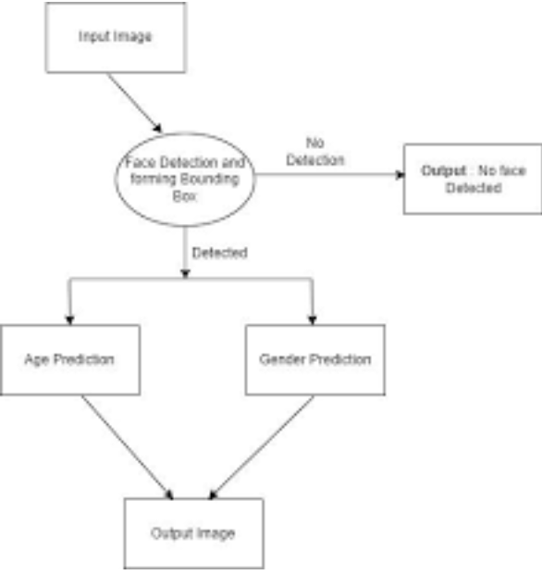

**FIGURE 4.2: SYSTEM FLOW DIAGRAM**

## UNIFIED MODELING LANGUAGE (UML) :

The unified modeling is a standard language for specifying, visualizing, constructing and documenting the system and its components is a graphical language which provides a vocabulary and set of semantics and rules. The UML focuses on the conceptual and physical representation of the system. It captures the decisions and understandings about systems that must be constructed. It is used to understand, design, configure and control information about the systems.

Depending on the development culture, some of these artifacts are treated more or less formally than others. Such artifacts are not only the deliverables of a project; they are also critical in controlling, measuring, and communicating about a system during its development and after its deployment.

The UML addresses the documentation of a system's architecture and all of its details. The UML also provides a language for expressing requirements and for tests. Finally, the UML provides a language for modeling the activities of project planning and release management.

## BUILDING BLOCKS OF UML:

The vocabulary of the UML encompasses three kinds of building blocks:

* + - * Things.
      * Relationships.
      * Diagrams.

## Things in the UML:

Things are the abstractions that are first-class citizens in a model; relationships tie these things together; diagrams group interesting collections of things.

There are four kinds of things in the UML:

* + - * + Structural things.
        + Behavioral things.
        + Grouping things.
        + Annotational things.

1. **Structural things** are the nouns of UML models. The structural things used in the project design are:
   * First, a **class** is a description of a set of objects that share the same attributes, operations, relationships and semantics.

|  |
| --- |
| Window |
| origin  size |
| open() close() move()  display() |

### Fig: Classes

* + Second, a **use case** is a description of set of sequence of actions that a system performs that yields an observable result of value to particular actor.



### Fig: Use Cases

* + Third, a node is a physical element that exists at runtime and represents a computational resource, generally having at least some memory and often processing capability.

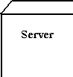

### Fig: Nodes

1. **Behavioral things** are the dynamic parts of UML models. The behavioral thing used is:
   * Interaction: An interaction is a behavior that comprises a set of messages exchanged among a set of objects within a particular context to accomplish a specific purpose. An interaction involves a number of other elements,

including messages, action sequences (the behavior invoked by a message, and links (the connection between objects).



**Fig: Messages**

## Relationships in the UML:

There are four kinds of relationships in the UML:

* + - * + Dependency.
        + Association.
        + Generalization.
        + Realization.
* A **dependency** is a semantic relationship between two things in which a change to one thing may affect the semantics of the other thing (the dependent thing).



### Fig: Dependencies

* An **association** is a structural relationship that describes a set links, a link being a connection among objects. Aggregation is a special kind of association, representing a structural relationship between a whole and its parts.



### Fig: Association

* A **generalization** is a specialization/ generalization relationship in which objects of thespecialized element (the child) are substitutable for objects of the generalized element(the parent).



### Fig: Generalization

* A **realization** is a semantic relationship between classifiers, where in one classifier specifies a contract that another classifier guarantees to carry out
* **Fig: Realization**

## UML DIAGRAMS:

* + - 1. **CLASS DIAGRAM:**

A class is a representation of an object and, in many ways; it is simply a template from which objects are created. Classes form the main building blocks of an object-oriented application. Although thousands of students attend the university, you would only model one class, called Student, which would represent the represent the entire collection of students.

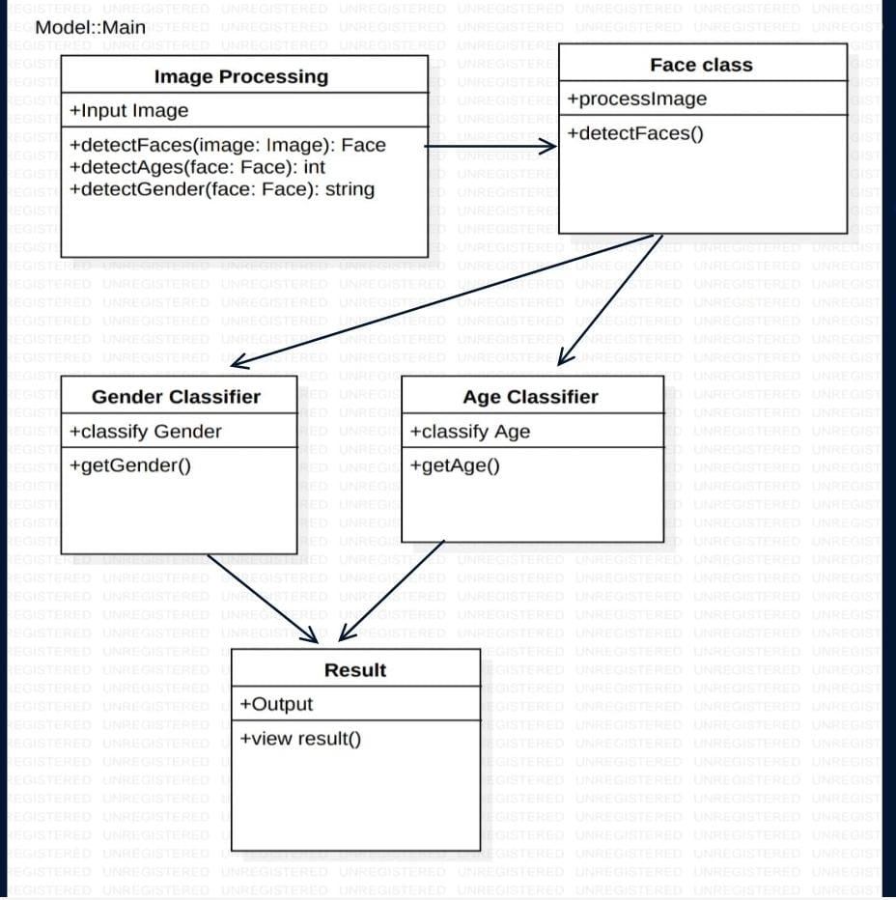

**FIGURE 4.3.2.1: CLASS DIAGRAM**

## USE CASE DIAGRAM:

A use case diagram is a graph of actors set of use cases enclosed by a system boundary, communication associations between the actors and users and generalization

among use cases. The use case model defines the outside (actors) and inside (use case) of the system’s behavior.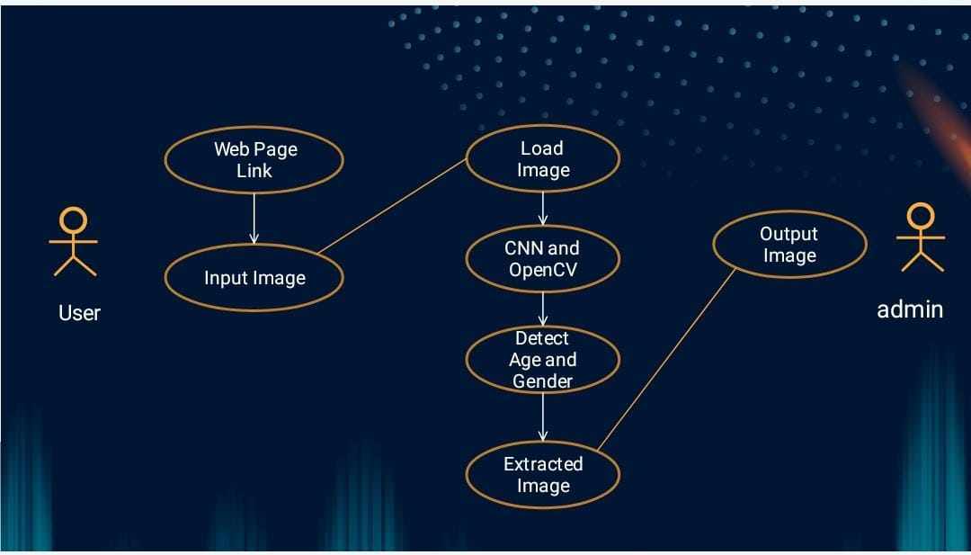

**FIGURE 3.3.2.2: USE CASE DIAGRAM**

## SEQUENCE DIAGRAM:

**Sequence diagram** are used to represent the flow of messages, events and actions between the objects or components of a system. Time is represented in the vertical direction showing the sequence of interactions of the header elements, which are displayed horizontally at the top of the diagram.

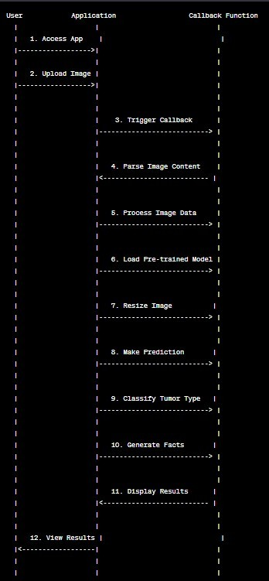

**FIGURE 4.3.2.3.1: SEQUENCE DIAGRAM**

## ACTIVITY DIAGRAM:

**Activity diagram** represent the business and operational workflows of a system. An Activity diagram is a dynamic diagram that shows the activity and the event that causes the object to be in the particular state.

These transitions depict the activities causing these transitions, shown by arrows.

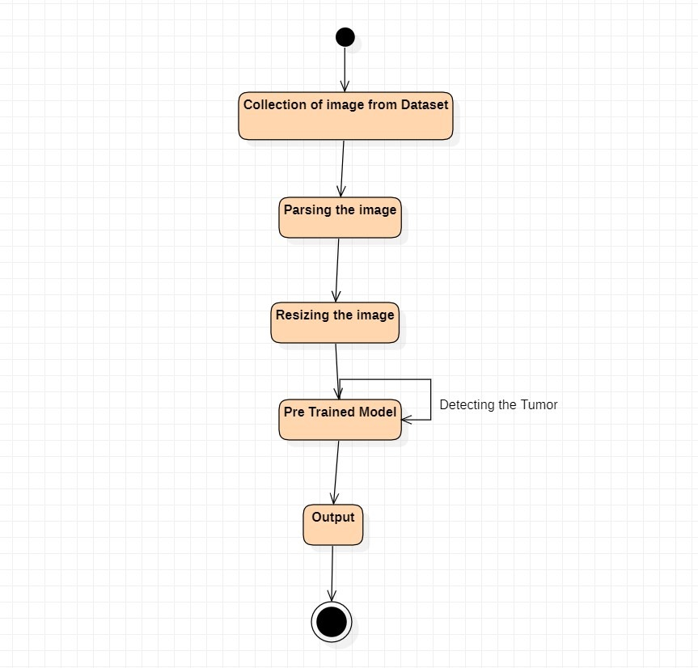

**FIGURE 4.3.2.4: ACTIVITY DIAGRAM**

## COMPONENT DIAGRAM:

In the Unified Modeling Language, a **Component diagram** depicts how components are wired together to form larger components and or software systems. They are used to illustrate the structure of arbitrarily complex systems.

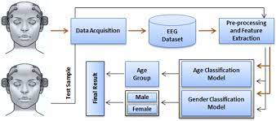

**FIGURE 3.3.2.5: COMPONENT DIAGRAM**

## MODULES DESCRIPTION:

In age and gender detection using OpenCV, various modules are employed to analyze and interpret facial features. Here's a brief description of key components:

1. **Face Detection Module:**

- Responsible for identifying and localizing faces within an image or video stream.

- Often utilizes pre-trained Haar cascades or deep learning-based models to achieve accurate face detection.

2. **Face Alignment Module:**

- Ensures that facial landmarks are properly aligned, improving the accuracy of subsequent age and gender estimation.

- Commonly employs algorithms like the dlib library to locate and align facial landmarks.

3. **Feature Extraction Module:**

- Extracts relevant features from the face, such as the region around eyes, nose, and mouth.

- These features are used as input for age and gender classification.

4. **Age Estimation Module:**

- Utilizes machine learning models to estimate the age of the detected face.

- Common approaches include regression-based models that predict a numerical age or classification models with age groups.

5. **Gender Classification Module:**

- Utilizes machine learning models to classify the gender of the detected face.

- Typically involves training a classifier on labeled datasets with male and female faces.

6. **Integration and Output Module:**

- Combines the results from age and gender estimation modules.

- Outputs may include annotated images or real-time information about detected faces, their estimated age, and gender.

# 5. IMPLEMENTATION

**# Import required modules**

import cv2 as cv

import math

import time

from google.colab.patches import cv2_imshow

**# import argparse**

**#Function to get face bounding box**

def getFaceBox(net, frame, conf_threshold=0.7):

frameOpencvDnn = frame.copy()

frameHeight = frameOpencvDnn.shape[0]

frameWidth = frameOpencvDnn.shape[1]

blob = cv.dnn.blobFromImage(frameOpencvDnn, 1.0, (300, 300), [104, 117, 123], True, False)

net.setInput(blob)

detections = net.forward()

bboxes = []

for i in range(detections.shape[2]):

confidence = detections[0, 0, i, 2]

if confidence > conf_threshold:

x1 = int(detections[0, 0, i, 3] * frameWidth)

y1 = int(detections[0, 0, i, 4] * frameHeight)

x2 = int(detections[0, 0, i, 5] * frameWidth)

y2 = int(detections[0, 0, i, 6] * frameHeight)

bboxes.append([x1, y1, x2, y2])

cv.rectangle(frameOpencvDnn, (x1, y1), (x2, y2), (0, 255, 0), int(round(frameHeight/150)), 8)

return frameOpencvDnn, bboxes

**#File paths for models**

faceProto = "modelNweight/opencv_face_detector.pbtxt"

faceModel = "modelNweight/opencv_face_detector_uint8.pb"

ageProto = "modelNweight/age_deploy.prototxt"

ageModel = "modelNweight/age_net.caffemodel"

genderProto = "modelNweight/gender_deploy.prototxt"

genderModel = "modelNweight/gender_net.caffemodel"

**#Constants and lists**

MODEL_MEAN_VALUES = (78.4263377603, 87.7689143744, 114.895847746)

ageList = ['(0-2)', '(4-6)', '(8-12)', '(15-20)', '(25-32)', '(38-43)', '(48-53)', '(60-100)']

genderList = ['Male', 'Female']

**# Load network models**

ageNet = cv.dnn.readNet(ageModel, ageProto)

genderNet = cv.dnn.readNet(genderModel, genderProto)

faceNet = cv.dnn.readNet(faceModel, faceProto)

**#padding value**

padding = 20

**#Function for age and gender detection**

def age_gender_detector(frame):

**# Read frame**

t = time.time()

frameFace, bboxes = getFaceBox(faceNet, frame)

for bbox in bboxes:

**# print(bbox)**

face = frame[max(0,bbox[1]-padding):min(bbox[3]+padding,frame.shape[0]-1),max(0,bbox[0]-padding):min(bbox[2]+padding, frame.shape[1]-1)]

blob = cv.dnn.blobFromImage(face, 1.0, (227, 227), MODEL_MEAN_VALUES, swapRB=False)

genderNet.setInput(blob)

genderPreds = genderNet.forward()

gender = genderList[genderPreds[0].argmax()]

# print("Gender Output : {}".format(genderPreds))

print("Gender : {}, conf = {:.3f}".format(gender, genderPreds[0].max()))

ageNet.setInput(blob)

agePreds = ageNet.forward()

age = ageList[agePreds[0].argmax()]

print("Age Output : {}".format(agePreds))

print("Age : {}, conf = {:.3f}".format(age, agePreds[0].max()))

label = "{},{}".format(gender, age)

cv.putText(frameFace, label, (bbox[0], bbox[1]-10), cv.FONT_HERSHEY_SIMPLEX, 0.8, (0, 255, 255), 2, cv.LINE_AA)

return frameFace

**Detect face from video:**

import cv2

cap = cv2.VideoCapture('video.mp4')

ret, frame = cap.read()

frame_height, frame_width, _ = frame.shape

out = cv2.VideoWriter('output.avi',cv2.VideoWriter_fourcc('M','J','P','G'), 10, (frame_width,frame_height))

print("Processing Video...")

while cap.isOpened():

ret, frame = cap.read()

if not ret:

out.release()

break

output = age_gender_detector(frame)

out.write(output)

out.release()

print("Done processing video")

# 5.3 OUTPUT SCREENS

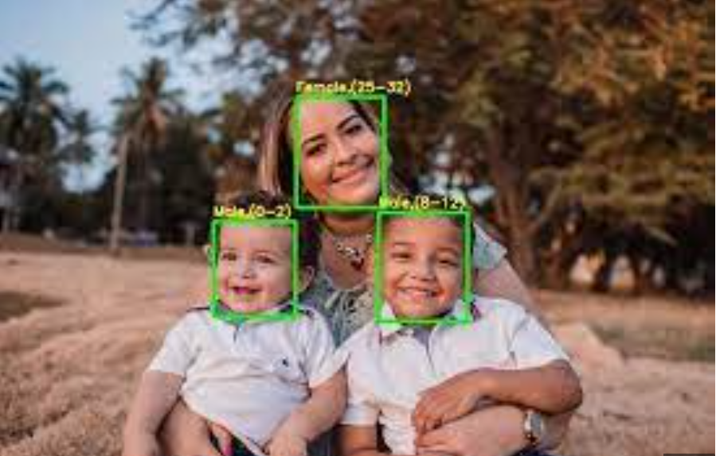

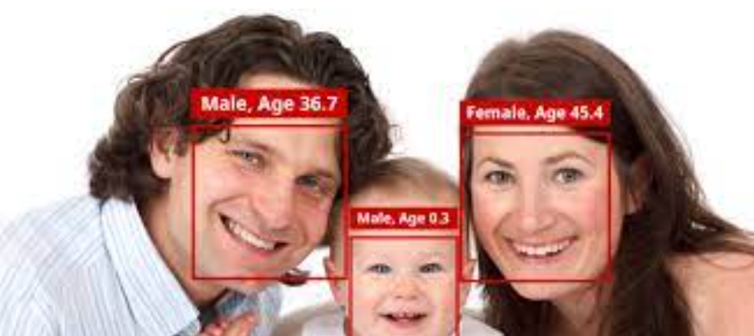

# 7. CONCLUSION & FUTURE SCOPE

## CONCLUSION:

In conclusion, age and gender detection using OpenCV is achieved by following a multi-step process. First, the input data, such as images or video frames, is acquired. Then, the faces are detected using OpenCV's face detection algorithms. The detected faces are aligned to a standardized position, and relevant features are extracted from them. Machine learning techniques are then used to predict the age and gender based on these features. Finally, the results are post-processed and visualized.

By using OpenCV, it becomes possible to accurately estimate age and gender from images or video. This technology has various applications, such as demographic analysis, personalized advertising, or enhancing user experiences in computer vision-based systems.

## FUTURE SCOPE:

The future scope of age and gender detection using OpenCV holds promising opportunities for advancements and applications. Some potential directions for future development include:

## 1. *Enhanced Accuracy through Deep Learning:* Integration of more advanced deep learning architectures, such as convolutional neural networks (CNNs) or attention mechanisms, can further improve the accuracy of age and gender estimation by leveraging hierarchical features.

## 2. *Real-time Processing:* Optimization for real-time processing, enabling the system to operate seamlessly in live video streams, can enhance its usability in applications like video analytics, surveillance, and interactive systems.

## 3. *Multi-modal Approaches:* Combining facial features with other modalities, like voice or body language analysis, could result in more comprehensive and accurate assessments of age and gender, especially in scenarios where facial features alone may be insufficient.

## 4. *Robustness to Varied Conditions:* Future development should focus on making the system more robust to challenging conditions, such as varying lighting, facial expressions, and occlusions, ensuring reliable performance in diverse real-world scenarios.

## 5. *Privacy-Preserving Techniques:* Implementing privacy-preserving techniques, such as federated learning or on-device processing, can address concerns related to data privacy by minimizing the need to transmit sensitive information across networks.

## 6. Customization for Specific Domains: Tailoring the system for specific domains, such as retail analytics, healthcare, or education, can lead to specialized solutions that cater to unique requirements and challenges in those sectors.

## 7. Continuous Dataset Improvement: Ongoing efforts to curate diverse and representative datasets for age and gender detection will contribute to the model's generalization capabilities across various demographics and ethnicities.

## 8. Human-Centric Applications: Exploring applications in human-computer interaction, personalized marketing, and user experience design can open up new avenues for integrating age and gender detection into innovative technologies.

## 9. Explainability and Trustworthiness:Future developments should focus on making the models more interpretable and providing insights into decision-making processes, contributing to the overall trustworthiness of the system.

## 10. Cross-Cultural Considerations: Adapting the system to account for cultural variations in facial features and expressions will enhance its effectiveness in a global context.