BJT: Important Biasing Rule; It may be noted that different potentials have been designated by double subscripts. The first subscript always represents the point or terminal which is more positive (or less negative) than the point or terminal represented by the second subscript.

**Op-Amp**

* ***Op-Amp: Difference amplifier, CMRR, ideal Op-Amp, inverting and non-inverting amplifier, General purpose of IC operational amplifier, integrator, differentiator, comparator and converter.***

1. What is an Op-Amp? What are the characteristics of an ideal Op-Amp?

An operational amplifier (Op-Amp) is a high-gain voltage amplifier with a differential input and a single-ended output. It is a fundamental building block in analog electronic circuits. It is used in a wide range of applications such as-

* Amplification
* Filtering
* Signal conditioning
* Feedback control.

The characteristics of an ideal Op-Amp are:

1. Infinite open-loop gain
2. Infinite input impedance.
3. Zero output impedance.
4. Infinite bandwidth.
5. Zero offset voltage.
6. Infinite common-mode rejection ratio (CMRR).
7. Infinite slew rate.
8. Prove that voltage gain Av of a non-inverting Op-Amp is Av=(1+R2/R1).

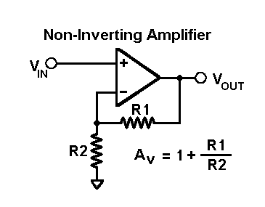

**2**

**1**

From KCL we can say,

Input signal at node 1(inverting) = output signal at node 2(non-inverting.

=> (0-Vi)/R1=(Vi-Vo)/R2

=> -Vi/R1=Vi/R2-Vo/R2

=> Vo/R2=Vi/R1+Vi/R2

=> Vo/R2=Vi(1/R1+1/R2)

=> Vo/Vi=R2(1/R1+1/R2)

i.g.

Av=1+R2/R1.

So, voltage gain of a non-inverting amplifier, Av=1+R2/R1.

1. What do you mean by virtual ground of an Op-Amp? Explain.

A virtual short-circuit (or simply virtual ground) refers to a condition of a differential input amplifier such as an op-amp in which its non-inverting and inverting inputs have almost the same voltage. This condition is called a virtual short-circuit because the differential inputs have the same voltage even though they are not connected together. This condition is met when a negative-feedback circuit is formed using a differential amplifier with a high open-loop gain. When the input terminal on one side is grounded to GND as shown in the figure, it is sometimes called virtual ground.  
  
Typical differential amplifiers have a finite output voltage. The output voltage of an op-amp is equal to its gain multiplied by a difference in voltage between the two inputs. The output voltage of a high-gain circuit becomes extremely large in the event of there being a large difference between the two input voltages. When the output voltage is finite, there is a very little difference in voltage (virtual short) between the two inputs.

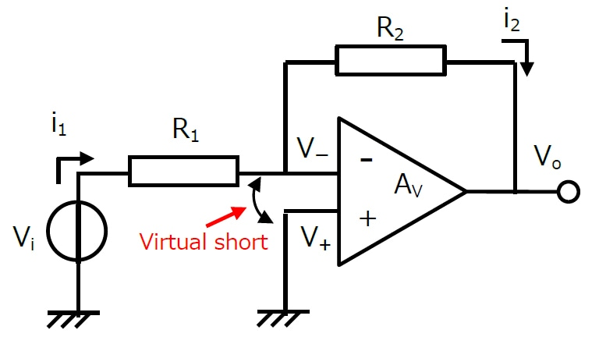

Let’s consider this condition using simple calculations. Figure 1 shows a negative-feedback amplifier (inverting amplifier) using an op-amp.  
Suppose that it is the ideal op-amp. Then, the following conditions are true:

1. The open-loop gain (AV) is infinite.
2. The input impedance is infinite.
3. The output impedance is zero.

Because the input impedance is infinite, all of the current flowing through R1 (i1) flows through R2.i1 ＝ (Vi – V**−**) / R1 = (V**−** - Vo) / R2 ………………………………..(1)  
The output voltage of the op-amp is given by the equation:  
Vo = AV(V**+** - V**−**) …………...............................................................(2)  
From Equation 1 and Equation 2, V+ is calculated as follows:  
V**+** ＝ {1 + (R1 + R2) / (AV * R1)} × V**-** - R2 × Vi / (AV × R1)……...(3)  
Because AV is infinite, we obtain

V**＋** = V**−**.  
Hence, the voltage at the negative inverting input (V**−**) is equal to the voltage at the grounded non-inverting input (V**+**).  
This condition of the V**−** input is called a virtual short.  
  
Using this concept of a virtual short, the closed loop gain of this circuit can be calculated easily. We can conclude that no current flows to the V**−** input since the V**−** voltage is equal to GND and the input impedance is infinite. Since i1 = i2,  
Vi / R2 = Vo / R ……………………………………………………..(4)  
Let the closed-loop gain of the inverting amplifier be

G (= Vo/Vi).

Then, G is calculated as R1/R2.

1. What is an operational amplifier? What do you know about input bias current, input offset voltage and input offset current?

An operational amplifier (Op-Amp) is a high-gain voltage amplifier with a differential input and a single-ended output. It is a fundamental building block in analog electronic circuits. It is used in a wide range of applications such as-

* Amplification
* Filtering
* Signal conditioning
* Feedback control.

Input bias current, input offset voltage, and input offset current are three key parameters that affect the performance of an Op-Amp.

**Input bias current:** This is the current that flows into the Op-Amp's input terminals when there is no input signal present. It is due to the small current that leaks through the input transistors of the Op-Amp. Input bias current can cause a voltage drop across input resistors and can lead to errors in the output voltage.

The input bias current (Ib) is the average of the input bias currents at the two input terminals of an Op-Amp. It can be expressed as:

Ib = (Ibp + Ibn)/2

Where Ibp is the bias current at the non-inverting input and Ibn is the bias current at the inverting input.

**Input offset voltage:** This is the voltage difference between the two input terminals of the Op-Amp when both inputs are at the same voltage level. Ideally, this voltage should be zero, but in reality, due to manufacturing imperfections and other factors, there can be a small voltage difference. This voltage difference can result in errors in the output voltage, even when the input voltage is zero.

The input offset voltage (Vos) is the voltage difference between the non-inverting and inverting inputs of an Op-Amp when the input voltages are zero. It can be expressed as:

Vos = Vn - Vi

Where Vn is the voltage at the non-inverting input and Vi is the voltage at the inverting input.

**Input offset current:** This is the difference between the input bias currents of the two input terminals of the Op-Amp. It can cause an imbalance in the input circuit, which can lead to errors in the output voltage.

The input offset current (Ios) is the difference between the input bias currents of the two input terminals of an Op-Amp. It can be expressed as:

Ios = Ibp - Ibn

Where Ibp is the bias current at the non-inverting input and Ibn is the bias current at the inverting input.

To minimize these errors, Op-Amps are designed with internal circuitry that compensates for these effects. For example, input bias current can be minimized by using input impedance matching and balanced input circuitry. Input offset voltage and offset current can be reduced by using techniques such as chopper stabilization and auto-zeroing.

1. What are the CMRR and Slew rate? Write some importance of these terms.

CMRR (Common-Mode Rejection Ratio) and Slew Rate are two important parameters of operational amplifiers (Op-Amps).

**CMRR**

It is a measure of the Op-Amp's ability to reject unwanted common-mode signals. CMRR is defined as the ratio of the differential gain to the common-mode gain. A high CMRR means that the Op-Amp is effective at rejecting common-mode signals, which are signals that are present equally on both input terminals. CMRR is important in applications where the Op-Amp is used to amplify a differential signal in the presence of common-mode interference, such as in biomedical applications, instrumentation, and communication systems.

**Slew Rate**

It is the maximum rate at which the output voltage of an Op-Amp can change in response to a step input voltage.

It is typically measured in volts per microsecond (V/μs). Slew rate is an important parameter in applications where the Op-Amp is required to amplify high-frequency signals, such as in audio and video applications. A high slew rate is necessary to avoid distortion of the output waveform due to the limited ability of the Op-Amp to respond to fast changes in the input signal.

Both CMRR and Slew Rate are important parameters to consider when selecting and using Op-Amps. A high CMRR is important to achieve accurate and reliable measurements in the presence of common-mode interference, while a high slew rate is important to avoid distortion and maintain signal fidelity in high-frequency applications. Therefore, selecting an Op-Amp with suitable CMRR and Slew Rate specifications is essential to ensure the performance and reliability of the overall circuit.

1. Draw the basic circuit of an inverting amplifier and summing amplifier and find out their output voltage and gain.

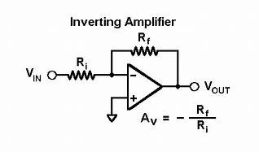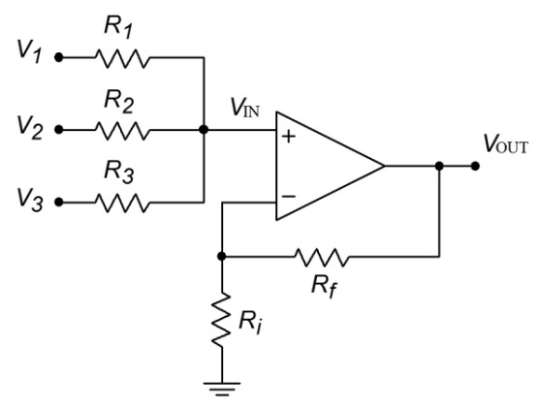

**Inverting amplifier:**

The output voltage (Vout) and voltage gain (Av) of an inverting amplifier can be calculated using the following formulas:

Vout = -Vin * (Rf/Rin)

* Av = -Rf/Rin

Where Vin is the input voltage, Rf is the feedback resistor, and Rin is the input resistor.

**Summing amplifier:**

The output voltage (Vout) and voltage gain (Av) of a summing amplifier can be calculated using the following formulas:

Vout = -[(Rf1/R1)*V1 + (Rf2/R2)*V2 + ... + (Rfn/Rn)*Vn]

* Av = -Rf/(R1+R2+...+Rn)

Where V1, V2, ..., Vn are the input voltages, R1, R2, ..., Rn are the input resistors, Rf is the feedback resistor, and n is the number of input voltages.

Note that the summing amplifier is an inverting amplifier with multiple inputs, and the output voltage is the weighted sum of the input voltages. The negative sign in the output voltage formula indicates that the output is inverted relative to the input.

1. What are the uses of Op-Amp? For the following amplifier (assume the Op-Amp is ideal) determine the following-
2. Voltage gain
3. Input resistance
4. Output resistance

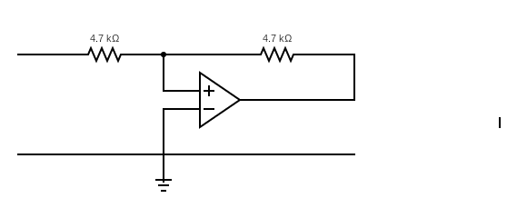

1MΩΩ

VoΩ

ViΩ

1kΩ

Operational amplifiers (Op-Amps) are versatile electronic devices that have a wide range of applications in electronic circuits. Some of the common uses of Op-Amps include:

* **Amplification:** Op-Amps are commonly used as voltage amplifiers to increase the amplitude of a signal. They can be configured in different ways, such as inverting amplifier, non-inverting amplifier, differential amplifier, etc. to achieve the desired gain and output characteristics.
* **Filtering:** Op-Amps are used to implement different types of filters, such as low-pass, high-pass, band-pass, and band-stop filters. These filters are used to pass or block specific frequency components of a signal, depending on the application requirements.
* **Signal Conditioning:** Op-Amps are used for signal conditioning, which involves modifying or preparing a signal for further processing. Signal conditioning can include amplification, filtering, rectification, and isolation of signals.
* **Oscillators:** Op-Amps can be used to build different types of oscillators, such as sine wave, square wave, and triangular wave generators. These oscillators are used in various applications such as clock signals, signal modulation, and frequency synthesis.
* **Comparators:** Op-Amps can be used as comparators to compare two input signals and generate an output signal that indicates which input is larger. Comparators are used in various applications such as overvoltage protection, current sensing, and signal level detection.
* **Voltage regulation:** Op-Amps can be used to build voltage regulators, which are used to maintain a constant output voltage regardless of changes in input voltage or load current. Voltage regulators are used in power supplies, battery chargers, and other applications that require a stable and regulated output voltage.
* **Instrumentation:** Op-Amps are widely used in instrumentation and measurement applications, such as amplifying and conditioning signals from sensors and transducers, measuring current and voltage, and performing signal processing functions.

For an inverting amplifier with feedback resistor (Rf) of 1 MΩ and input resistor (Ri) of 1 kΩ, the voltage gain (Av), input resistance (Rin), and output resistance (Rout) can be calculated as follows:

**Voltage gain (Av):**

Av = -Rf/Ri

* Av = -1MΩ/1kΩ
* Av = -1000

The voltage gain is negative, which means the output voltage is inverted relative to the input voltage. The magnitude of the voltage gain is 1000, which means the output voltage is 1000 times smaller than the input voltage.

**Input resistance (Rin):**

Rin = Ri

* Rin = 1kΩ

The input resistance is equal to the input resistor (Ri) and is independent of the feedback resistor (Rf).

**Output resistance (Rout):**

Rout = 0 Ω

The output resistance is very low and can be considered as zero, as the Op-Amp used in the inverting amplifier has a very high input impedance and a very low output impedance.

So, the voltage gain of the inverting amplifier is -1000, the input resistance is 1 kΩ, and the output resistance is 0 Ω.

1. How can an Op-Amp be used as a differentiator? Explain.

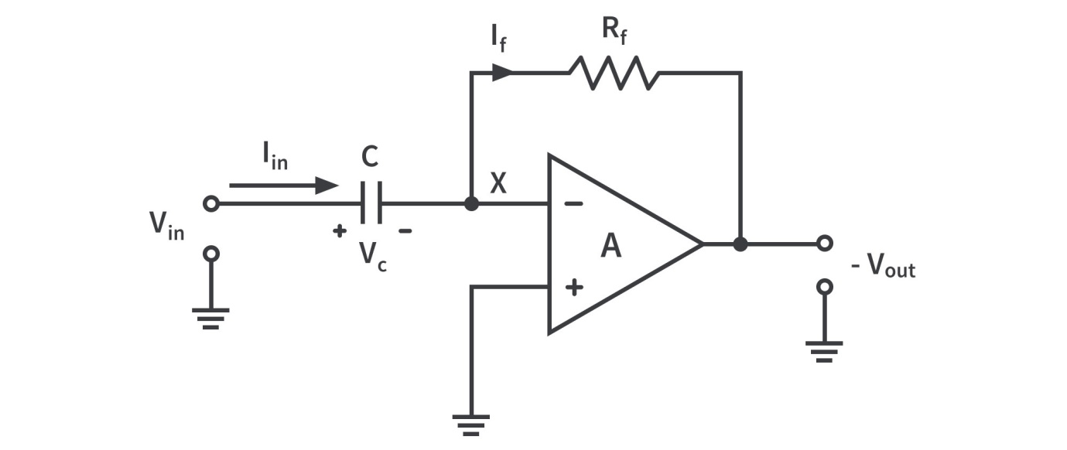

An Op-Amp can be used as a differentiator by connecting a capacitor in series with the input resistor. The circuit configuration is known as an Op-Amp differentiator circuit.

The differentiator circuit produces an output voltage that is proportional to the rate of change of the input voltage. Mathematically, the output voltage can be expressed as:

Vout = -Rf * C * d(Vin)/dt

Where Vout is the output voltage, Vin is the input voltage, Rf is the feedback resistor, C is the capacitor, and d(Vin)/dt is the rate of change of the input voltage.

In this circuit, the capacitor acts as a high-pass filter that blocks the DC component of the input voltage and allows the AC component to pass through. The Op-Amp amplifies the AC component of the input voltage and produces an output voltage that is proportional to the rate of change of the input voltage.

The gain of the differentiator circuit is determined by the values of the feedback resistor and the capacitor. The gain is given by the expression:

Av = -Rf *2πf*C

where Av is the voltage gain, f is the frequency of the input signal and C is the capacitor.

The Op-Amp differentiator circuit is commonly used in signal processing applications such as detecting the zero crossings of AC signals, detecting the frequency of periodic signals, and detecting the onset of transient signals.

1. What is inverting and non-inverting amplifiers? Explain with necessary figures.



Inverting and non-inverting amplifiers are two basic configurations of an operational amplifier (Op-Amp).

In an inverting amplifier configuration, the input signal is applied to the inverting input of the Op-Amp through a resistor. The output is taken from the output terminal and is fed back to the inverting input through another resistor. The non-inverting input is connected to ground. The gain of the inverting amplifier is negative and is determined by the ratio of the two resistors according to the following expression:

Av = -Rf/Rin

Where Av is the voltage gain, Rf is the feedback resistor, and Rin is the input resistor.

In a non-inverting amplifier configuration, the input signal is applied to the non-inverting input of the Op-Amp through a resistor. The output is taken from the output terminal and is fed back to the non-inverting input through another resistor. The inverting input is connected to ground. The gain of the non-inverting amplifier is positive and is determined by the ratio of the two resistors according to the following expression:

Av = 1 + (Rf/Rin)

Where Av is the voltage gain, Rf is the feedback resistor, and Rin is the input resistor.

The main difference between the inverting and non-inverting amplifier configurations is that the polarity of the output signal is inverted in the inverting amplifier, while it is not inverted in the non-inverting amplifier. The non-inverting amplifier has higher input impedance than the inverting amplifier, which makes it more suitable for applications where the input signal has high impedance.

Both inverting and non-inverting amplifiers are commonly used in various applications such as audio amplifiers, signal processing circuits, and instrumentation circuits.

10. A 10mV, 5 kHz sinusoidal signal is applied to the input of an Op-Amp integrator as shown below for which R=100kΩ and C=1μF. Find the output voltage.

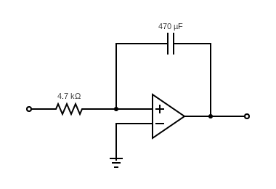

**+**

**-**

Vc

R

Vi

Vo

C

Given:

Vin = 10 mV

f = 5 kHz

R = 100 kΩ

C = 1 μF

To find the output voltage, we need to find the integration of the input signal with respect to time.

The transfer function of an Op-Amp integrator is given as:

Vout = -(1/RC) ∫Vin dt

where,

Vout = Output voltage

Vin = Input voltage

R = Resistance value

C = Capacitance value

Substituting the given values, we get:

Vout = -(1 / (100 kΩ x 1 μF)) ∫10 mV sin(2π x 5 kHz x t) dt

Integrating the above equation with respect to time, we get:

Vout = -(10 / π) cos(2π x 5 kHz x t)

The output voltage is a cosine wave with an amplitude of -(10/π) and a frequency of 5 kHz. The negative sign indicates that the output waveform is inverted relative to the input waveform.

Therefore, the output voltage is given by:

Vout = -(10/π) cos(2π x 5 kHz x t)

where t is the time in seconds.

**Optoelectronics Devices**

* ***Optoelectronic devices: PN photodiode, Phototransistor, Solar cell, Photoconductive cell, Photovoltaic cell, sensors, LED, LCD, Alphanumeric display, photo couplers, photodiode, LDR.***

1. Explain the principle of operation of photodiode and V-I characteristics of a photodiode.

A photodiode is a semiconductor device that converts light energy into electrical energy. It operates on the principle of the photoelectric effect, which is the emission of electrons from a material when it absorbs electromagnetic radiation, such as light.

The photodiode is constructed of a p-n junction in which the p-type region is doped with impurities that give it a surplus of holes, while the n-type region is doped with impurities that give it a surplus of electrons. When light falls on the photodiode, photons are absorbed by the semiconductor material, and their energy is transferred to the electrons in the valence band, causing them to be excited into the conduction band. This generates a flow of electrons and holes across the p-n junction, which creates an electrical current.

The amount of current produced by the photodiode is directly proportional to the intensity of the incident light, making it an excellent sensor for measuring light levels. Additionally, the photodiode can be biased with a voltage to improve its performance, and it can also be used in reverse bias mode to increase its sensitivity.

**V-I Characteristics of Photodiode**

Photodiode operates in reverse bias condition. Reverse voltages are plotted along X axis in volts and reverse current are plotted along Y-axis in microampere. Reverse current does not depend on reverse voltage. When there is no light illumination, reverse current will be almost zero. The minimum amount of current present is called as **Dark Current.** Once when the light illumination increases, reverse current also increases linearly.

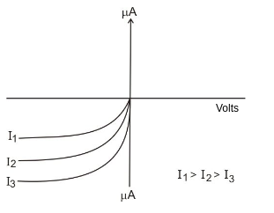

1. What are the applications of phototransistors?

Phototransistors are semiconductor devices that combine the light-sensing capabilities of a photodiode with the amplification capabilities of a transistor. Here are some of the common applications of phototransistors:

* **Optical communications:** Phototransistors are used in optical communication systems to detect and amplify optical signals in fiber optic cables. They can also be used in receivers for remote control systems and infrared communication devices.
* **Light sensors:** Phototransistors can be used as light sensors in applications such as automatic lighting control, street lighting, and security systems.
* **Industrial automation:** Phototransistors are used in automated systems for detecting the presence of objects, measuring distances, and detecting changes in light levels.
* **Medical instruments:** Phototransistors are used in medical instruments for measuring blood oxygen levels, monitoring heart rate, and detecting abnormalities in the retina.
* **Consumer electronics:** Phototransistors are used in consumer electronics products such as cameras, optical disk drives, and barcode scanners.

1. Write short notes on LCD and LED.

LCD (Liquid Crystal Display) and LED (Light Emitting Diode) are two different technologies used in display devices. Here are some short notes on each:

**LCD**

* LCD is a display technology that uses liquid crystals to produce images.
* It consists of a panel of pixels, each containing three sub-pixels (red, green, and blue) that are controlled by electrical signals to produce colour images.
* LCD displays are commonly used in televisions, computer monitors, smartphones, and other electronic devices.
* They offer high resolution, low power consumption, and are relatively inexpensive to manufacture.
* However, they can have slower refresh rates, limited viewing angles, and may suffer from image persistence (also known as "ghosting") if the same image is displayed for an extended period.

**LED**

* LED is a display technology that uses a matrix of tiny light-emitting diodes to produce images.
* It consists of an array of LEDs that emit light when an electrical current passes through them, creating bright and vibrant images.
* LED displays are commonly used in outdoor signage, sports arenas, and digital billboards.
* They offer high brightness, wide viewing angles, and are energy-efficient.
* However, they can be expensive to manufacture, and their pixel density is typically lower than that of LCD displays.

1. What are LCD and LED? Describe the working principle of LCD and LED. Why does it require extremely low power to operate LCDs?

LCD and LED are two different types of display technologies commonly used in electronic devices. Here's a brief description of how they work.

**LCD (Liquid Crystal Display)**

LCDs consist of a layer of liquid crystals sandwiched between two layers of transparent electrodes. The electrodes are connected to a circuit that controls the flow of electrical charges.

The liquid crystals in an LCD are able to rotate the polarization of light passing through them, depending on the electric field applied to them. By controlling the voltage across the liquid crystals, the LCD can control the amount of light that passes through them.

The LCD also has a backlight that provides a uniform light source behind the panel to illuminate the display.

By selectively blocking or allowing the backlight to pass through the liquid crystal layers, the LCD can create images with different colours and brightness levels.

**LED (Light Emitting Diode)**

LED displays use an array of light-emitting diodes to produce images.

LEDs emit light when an electric current flows through them in the forward direction. The light produced by the LED can be of different colours depending on the materials used to construct the LED.

LED displays typically use an array of red, green, and blue LEDs to produce a wide range of colours.

The brightness of each LED can be adjusted by varying the amount of current flowing through it, allowing the LED display to produce images with different brightness levels and colours.

LCDs require extremely low power to operate because they only use power when the display needs to be updated. Once the liquid crystals have been rotated to their desired positions, they do not require any further energy to maintain that state. The backlight used in LCDs is typically low power and can be turned off when the display is not in use, further reducing power consumption. Additionally, LCDs do not generate heat, making them more energy-efficient than other types of display technologies.

1. Compare between LCD and LED.

Or,

Advantages and disadvantages of LCD and LED.

LCD (Liquid Crystal Display) and LED (Light Emitting Diode) are two different types of display technologies that have their own advantages and disadvantages. Here are some comparisons between the two:

* **Image Quality:**

LCD displays typically offer better resolution and colour accuracy than LED displays, especially at higher pixel densities.

LED displays are known for their high brightness, making them ideal for outdoor signage and displays.

* **Power Consumption:**

LCD displays consume less power than LED displays, especially when displaying static images. This is because LCDs only use power when the display needs to be updated, while LEDs require constant power to maintain their brightness.

* **Viewing Angles:**

LCD displays have limited viewing angles, which means that the image quality can degrade when viewed from off-centre angles.

LED displays have wider viewing angles and can maintain image quality even when viewed from extreme angles.

* **Lifespan:**

LCD displays have a longer lifespan than LED displays, typically lasting around 50,000 to 100,000 hours.

LED displays have a shorter lifespan, typically lasting around 30,000 to 50,000 hours.

* **Cost:**

LCD displays are generally less expensive than LED displays, especially at smaller sizes.

LED displays can be more expensive than LCD displays, especially at larger sizes.

1. What is a P-N photodiode? Why it works in reverse condition? Explain different types of photodiodes according to their function and structure?

A P-N photodiode is a type of semiconductor device that converts light into an electrical current. It is made by sandwiching a P-type semiconductor (which has a positive charge) and an N-type semiconductor (which has a negative charge) together to form a P-N junction.

When light hits the P-N junction, it creates electron-hole pairs in the depletion region of the junction. These electron-hole pairs are separated by the electric field of the junction, which causes them to flow in opposite directions and generate a photocurrent.

The P-N photodiode works in reverse bias condition because this creates a larger depletion region in the junction, allowing more photons to be absorbed by the junction. When the P-N junction is reverse biased, the electric field is increased and the depletion region widens, allowing more light to be absorbed by the junction.

There are several different types of photodiodes according to their function and structure:

* **PIN Photodiode:** This type of photodiode has an intrinsic layer between the P and N regions, which increases its sensitivity to light and reduces its capacitance.
* **Avalanche Photodiode:** This type of photodiode uses the avalanche effect to amplify the photocurrent, which makes it more sensitive to low levels of light.
* **MSM Photodiode:** This type of photodiode uses a metal-semiconductor-metal structure to absorb light and generate a photocurrent. It has a high-speed response and low capacitance.
* **PSD (Position Sensitive Detector) Photodiode**: This type of photodiode is designed to detect the position of a light spot on its surface. It is commonly used in applications such as laser scanning and barcode reading.

1. Why Si or Ge is not used to fabricate LEDs?

Silicon (Si) and Germanium (Ge) are not commonly used to fabricate LEDs (Light Emitting Diodes) because they are indirect bandgap material, which means that the energy required to create a photon is much larger than the energy released during the radiative recombination process. This makes it difficult for Si and Ge to emit light efficiently.

In contrast, LEDs are typically made from direct bandgap materials such as Gallium Nitride (GaN) or Indium Gallium Nitride (InGaN), which have a more efficient radiative recombination process and can emit light at higher efficiencies. These materials have a narrower bandgap, which allows electrons to easily transition from the conduction band to the valence band, releasing energy in the form of light.

1. Why P-N photodiode is known as one of the fastest photo-detector? What are the other uses of P-N photodiode except photo-detector?

P-N photodiodes are known as one of the fastest photo-detectors because they have a short response time, typically in the nanosecond range. This is because the process of generating electron-hole pairs in the depletion region of the junction is a fast and efficient process. In addition, P-N photodiodes can operate at high frequencies and can detect light in the UV, visible, and near-infrared regions of the electromagnetic spectrum.

Apart from being used as photo-detectors, P-N photodiodes have several other uses, including:

* **Light sensors:** P-N photodiodes can be used as light sensors to measure the intensity of light in various applications such as cameras, light meters, and fiber optic communication systems.
* **Optical switches:** P-N photodiodes can be used as optical switches to control the transmission of light in fiber optic communication systems.
* **Radiation detectors:** P-N photodiodes can be used as radiation detectors to measure the intensity of ionizing radiation in applications such as medical imaging, nuclear power plants, and space exploration.
* **Temperature sensors:** P-N photodiodes can be used as temperature sensors by measuring the change in the forward voltage across the junction with temperature.
* **Solar cells:** P-N photodiodes can also be used as the basis for solar cells, which convert light into electrical energy.

**Instruments**

* ***Avometer, signal generator, oscilloscope.***

***NO questions on instruments.***