**Transistor**

* ***Transistor: BJT, Transistor action, Transistor biasing, DC characteristics of CE, CB and CC configurations.***
* ***Field effect transistor: FET, MOSFET, characteristics, biasing and applications.***

1. What is a transistor? Discuss the architecture of a transistor.

A transistor is a three terminal semiconductor device that can be used to amplify or switch electronic signals.

Transistor architecture refers to the physical structure and design of a transistor. There are several types of transistor architectures, but the most common is the bipolar junction transistor (BJT) and the field-effect transistor (FET).

**Bipolar Junction Transistor (BJT)**

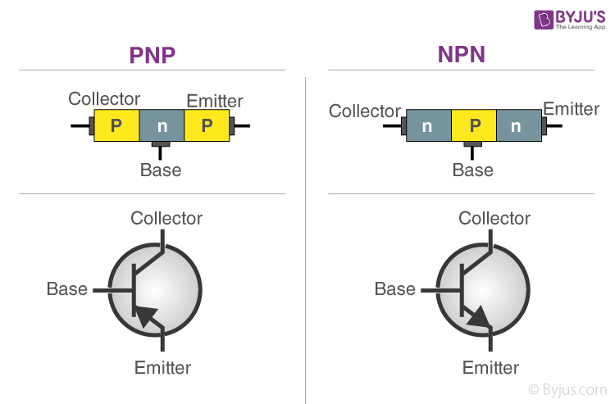

A BJT has three layers of semiconductors, each doped differently to create two p-n junctions. The two main types of BJT are NPN and PNP. In an NPN transistor, a thin layer of p-type material is sandwiched between two layers of n-type material. In a PNP transistor, the layers are reversed, with a thin layer of n-type material sandwiched between two layers of p-type material.

The three regions of a BJT are called the emitter, base, and collector. The base is located between the emitter and the collector, and it is very thin, which allows it to be controlled by small changes in voltage or current. When a small current flows into the base, it controls a much larger current that flows between the emitter and collector.

**Field-Effect Transistor (FET)**

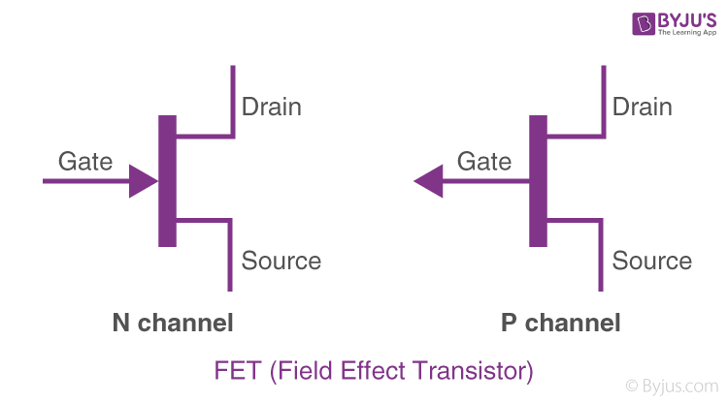An FET has a different architecture than a BJT. Instead of using two p-n junctions, an FET uses a single junction between a semiconductor material and a conducting material. There are two main types of FETs: the junction FET (JFET) and the metal-oxide-semiconductor FET (MOSFET).

In a JFET, the semiconductor is formed into a channel, and two layers of opposite-type doping are placed on either side of the channel. A voltage applied to the gate of the JFET changes the resistance of the channel, controlling the current flow between the source and drain.

In a MOSFET, the gate is separated from the channel by a thin layer of oxide. A voltage applied to the gate creates an electric field that controls the current flow between the source and drain.

1. Draw the structure and circuit diagram of an n-p-n transistor in CE configuration and discuss its input, output and constant current static characteristics.

An n-p-n transistor in CE (common-emitter) configuration is a type of bipolar junction transistor (BJT) that has the base terminal in between the emitter and collector. In this configuration, the emitter is connected to ground, the collector is connected to the supply voltage, and the input signal is applied to the base.

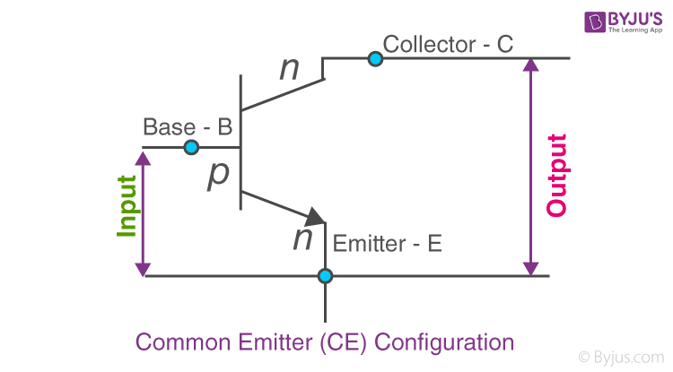

**Input Characteristics**

The input characteristics of an n-p-n transistor in CE configuration are typically plotted as a graph of the base-emitter voltage (Vbe) versus the base current (Ib) at a constant collector-emitter voltage (Vce). The input characteristic curve shows that the base current is very low until the base-emitter voltage reaches a certain threshold, called the turn-on voltage (Von). After this threshold, the base current increases rapidly with increasing base-emitter voltage. This relationship is generally exponential.

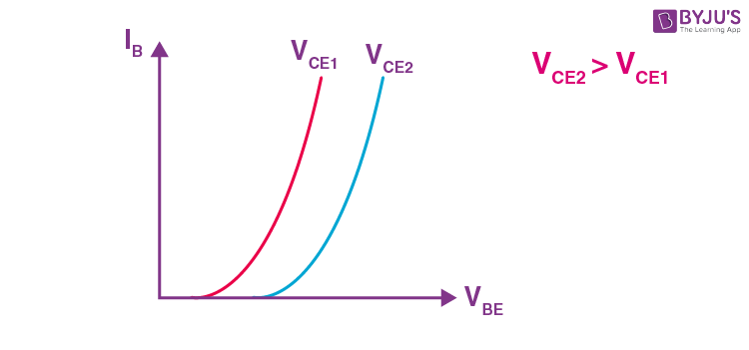

**Output Characteristics**

The output characteristics of an n-p-n transistor in CE configuration are typically plotted as a graph of the collector-emitter voltage (Vce) versus the collector current (Ic) at a constant base current (Ib). The output characteristic curve shows that the collector current increases with increasing collector-emitter voltage up to a certain point, called the saturation voltage (Vsat). Beyond this point, the collector current remains nearly constant and does not increase further.

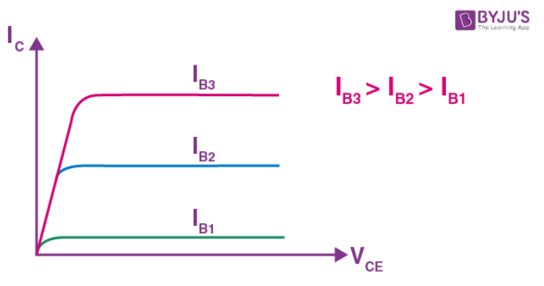

**Constant Current Static Characteristics**

The constant current static characteristics of an n-p-n transistor in CE configuration are the curves that show how the collector current varies with respect to the collector-emitter voltage for a constant base current. These curves are typically plotted for different values of base current. The constant current static characteristics show that the collector current is proportional to the base current over a certain range of collector-emitter voltage. Beyond this range, the collector current becomes independent of the collector-emitter voltage and remains constant.

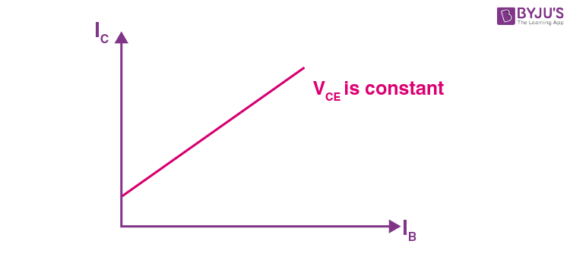

1. Differentiate between JFET and BJT.

 

Bipolar Junction Transistor

JFET (Junction Field-Effect Transistor) and BJT (Bipolar Junction Transistor) are two different types of transistors with different architectures and operating principles. Here are some of the key differences between the two:

* **Architecture**

A BJT has three regions of semiconductor material with two p-n junctions, while a JFET has a single channel made of one type of semiconductor material, with two regions of differently doped material on either side of the channel.

* **Operating principle**

In a BJT, a small current at the base terminal controls a much larger current flow between the collector and emitter. The current flow is controlled by the base-emitter voltage and the base current, which modify the conductivity of the base region, allowing or preventing the flow of current between the collector and emitter.

In a JFET, the current flow between the source and drain is controlled by a voltage applied to the gate, which changes the size of the conducting channel between the source and drain, thus altering the resistance of the channel and the amount of current that flows.

* **Amplification**

BJTs are typically used for amplification because they can provide high current gain, meaning a small change in the input current or voltage can produce a large change in the output current or voltage. JFETs, on the other hand, have lower gain and are usually used for switching or variable resistance applications.

* **Noise**

BJTs are more prone to noise than JFETs, especially at high frequencies, due to the presence of junctions in their structure. JFETs have a simpler structure and lower noise, which makes them useful for applications that require low noise levels.

1. Draw the drain characteristics of a JFET and show its different region.

**Characteristics of JFET**

The characteristics of JFET is defined by plotting a curve between the drain current and drain-source voltage. The variation of drain current with respect to the voltage applied at drain-source terminals to keep the gate-source voltage constant is termed as its characteristics. Basically, the characteristics are of two types:

* Output characteristics or drain characteristics
* Transfer characteristics.

## Output Characteristics or Drain Characteristics

**In the absence of external bias**

In this case, as there is no voltage between gate and source terminal, thus, the drain current will flow from drain terminal to source terminal. In JFET majority charge carriers flow from source to drain and as a consequence of which the current flows from drain to source.

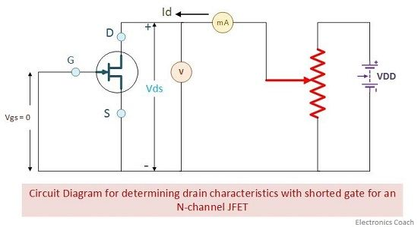

It implies that the channel width is more as the width of depletion layer will not vary initially because there is no external reverse biasing. This allows a large magnitude of current to flow through the channel.

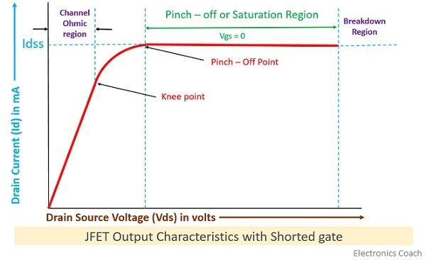

In this case, the N-type channel will simply behave as resistance region. The flow of current from drain to source will create the voltage drop between gate and source. This will eventually result in reverse biasing of the gate-source terminal. The reverse biasing will be more towards drain region that source region.

### Terminologies involved in JFET characteristics:

1. **Knee Point:** There exists a point in the characteristics curve where the variation of drain current with drain-source voltage appears to be linear. But after this point, the linearity changes into a curve.
2. **Channel Ohmic Region:** The region to the left of the knee point in the characteristics curve is the channel ohmic region.
3. **Pinch-off point:** The point in the curve above which the drain current does not increases further no matter how much we are increasing the drain to source voltage, this point is termed as the pinch-off point.
4. **Pinch-off Voltage:** The voltage at the pinch-off point is termed as pinch-off voltage because at this voltage the current is completely turned to be constant.
5. **Drain-Source Saturation Current:** The drain to source saturation current is the current which becomes constant or completely enters a saturation state.

The region after the pinch-off point in the curve is termed as saturation region. When the JFET is allowed to work as an amplification device, the JFET utilizes this region for operation.

**With external bias**

When the external bias is applied to the gate-source terminal, the gate-source terminal becomes reversed bias externally. Obviously, if we are supplying an external voltage, then we can achieve the pinch-off point quite early as compared to the circuit which is not biased.

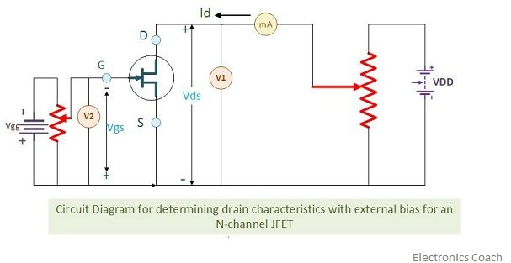

It is clearly evident from the characteristics curve of external bias. The different values of voltage give different values of current.It is to be remembered here that when we are observing the drain characteristics with respect to the variation in drain-source voltage, then the value of gate-source voltage should be kept constant.

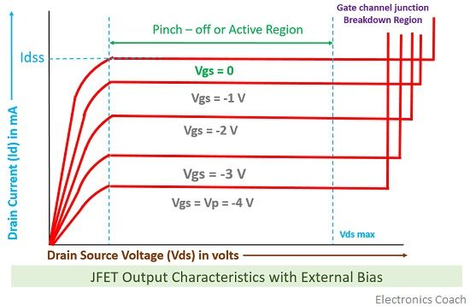

## *\*\*\*For more information\*\*\**

## Transfer Characteristics

The transfer characteristics can be determined by observing different values of drain current with variation in gate-source voltage provided that the drain-source voltage should be constant. The transfer characteristics are just opposite to drain characteristics.

One just needs to remember the concept that in drain characteristics we are keeping the gate-source voltage constant and determining the values of drain current at different values of drain-source voltage while in transfer characteristics we are keeping the value of drain-source voltage constant.

The characteristic curve of transfer characteristics of JFET is described below; it can be easily observed that the value of drain current varies inversely with respect to gate-source voltage when the drain-source voltage is constant.

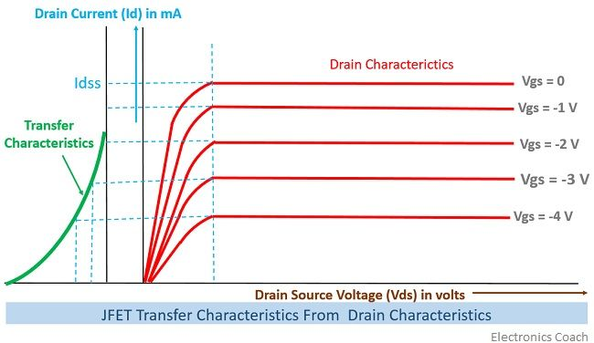

1. Describe the construction of an n-channel JFET.

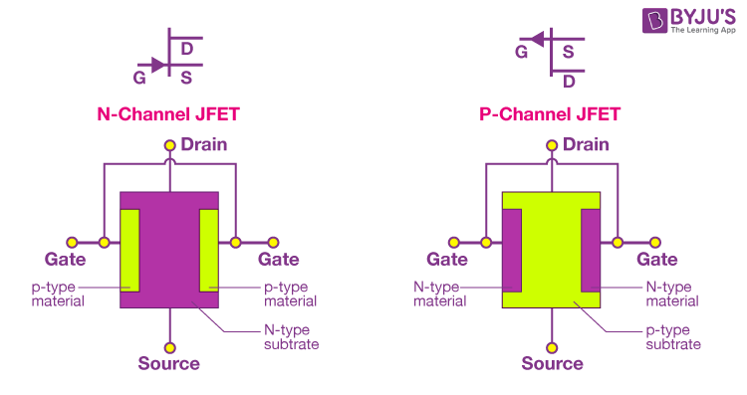

**JFET Construction**

In an N-channel JFET, the material is of P-type, and the substrate is N-type. JFET is made of a long channel of semiconductor material. Ohmic contacts are provided at each end of the semiconductor channels to form source and drain connections. If the JFET contains a large number of electrons, it is called an N-type JFET.

There are three main parts of a N-channel JFET.

* Drain
* Source
* Gate

**Drain**

The drain is the terminal through which current leaves the transistor. In an n-channel FET, the drain is connected to the n-type material, which has an excess of electrons.

**Source**

The source is the terminal through which current enters the transistor. In an n-channel FET, such as an n-channel JFET or an n-channel MOSFET, the source is connected to the n-type material, which has an excess of electrons.

**Gate**

The gate is the terminal that controls the flow of current between the source and drain. The gate is separated from the source and drain by a thin insulating layer. The gate voltage controls the electric field in the channel between the source and drain and modulates the current flow. In a JFET, the gate voltage determines the width of the conducting channel, while in a MOSFET, the gate voltage controls the formation of a conductive channel between the source and drain.

1. What will happen if a transistor is not biased properly?

Or,

What is transistor biasing? Why it is needed? Describe one method used for transistor biasing.

Transistor biasing is the process of setting the operating point of a transistor in its active region, where it can amplify a signal without distortion. The biasing is done by applying a suitable DC voltage to the transistor's base-emitter junction in the case of a bipolar junction transistor (BJT) or the gate-source junction in the case of a field-effect transistor (FET).

Transistor biasing is needed to ensure that the transistor operates in its desired region and provides the required amplification or switching function. A properly biased transistor ensures that the output signal faithfully reproduces the input signal without distortion, noise or other unwanted effects.

One common method of transistor biasing is the fixed bias configuration, also known as the base bias configuration, for a BJT. In this configuration, a resistor (RB) is connected between the base and a fixed voltage source, such as the positive terminal of a battery. The emitter is connected to ground, and the collector is connected to a load resistor (RC) and a power supply.

The resistor RB and the base-emitter junction of the BJT form a voltage divider, which sets the base voltage (VB) relative to ground. The collector current (IC) is determined by the base current (IB) and the transistor's gain (β). The fixed bias configuration sets the transistor's operating point and can provide stable biasing over a wide range of temperatures and transistor variations.

However, the fixed bias configuration has some limitations. For example, it is sensitive to changes in temperature and transistor characteristics, and it may not be suitable for high-frequency applications. To address these issues, other biasing configurations, such as emitter bias, collector feedback bias, and voltage divider bias, can be used.

1. What is BJT? Explain the architecture of a BJT.

**Bipolar Junction Transistor (BJT)**



A BJT has three layers of semiconductors, each doped differently to create two p-n junctions. The two main types of BJT are NPN and PNP. In an NPN transistor, a thin layer of p-type material is sandwiched between two layers of n-type material. In a PNP transistor, the layers are reversed, with a thin layer of n-type material sandwiched between two layers of p-type material.

The three regions of a BJT are called the emitter, base, and collector. The base is located between the emitter and the collector, and it is very thin, which allows it to be controlled by small changes in voltage or current. When a small current flows into the base, it controls a much larger current that flows between the emitter and collector.

1. How a transistor can be used as a switch?

Transistors can be used as electronic switches in a variety of applications, including digital circuits, power electronics, and control systems. When a transistor is used as a switch, it is operated in either the cutoff or saturation regions, where it acts as an open or closed switch, respectively.

For a bipolar junction transistor (BJT), a transistor switch can be constructed using an NPN or PNP transistor. When used as a switch, the base-emitter junction is forward-biased to turn the transistor on, allowing current to flow from the collector to the emitter. When the base-emitter voltage is reduced below a certain threshold, the transistor turns off, blocking current flow.

In an NPN transistor switch, a voltage source is connected to the collector, and the load is connected to the emitter. The base is connected to a control signal or voltage source through a current-limiting resistor. When the control signal is high, current flows through the base-emitter junction, turning on the transistor and allowing current to flow through the load. When the control signal is low, the transistor turns off, blocking current flow.

In a PNP transistor switch, the voltage source is connected to the emitter, and the load is connected to the collector. The base is connected to a control signal or voltage source through a current-limiting resistor. When the control signal is low, current flows through the base-emitter junction, turning on the transistor and allowing current to flow through the load. When the control signal is high, the transistor turns off, blocking current flow.

Field-effect transistors (FETs) can also be used as switches, and they are particularly well-suited for high-speed and high-frequency applications. In an FET switch, the gate-source voltage is used to control the current flow between the drain and source terminals. When the gate-source voltage is positive, the FET turns on and allows current to flow. When the gate-source voltage is zero or negative, the FET turns off and blocks current flow.

1. Show the relationship between α and β in case of BJT.

We know that,

The current gain, α = IC/IE

The current gain, β = IC/IB

The relationship between α and β can be derived from the following equation, which represents the conservation of charge in the BJT:

IC = βIB + (1 + β)ICBO ---------------------------(i)

Where, ICBO represents the reverse saturation current of the collector-base junction.

ICBO = IC- α*IE

Putting the value of ICBO in (i),

* IC = βIB + (1 + β)( IC- α*IE)
* IC = βIB + IC - α*IE + β*IC- β*α*IE
* 0 = β(IB+IC)- α*IE(1+β)
* β*IE = α*IE(1+β)
* α = β/(1+β)

Substituting this equation into the expression for β, we get:

β = α/(1 - α)

This shows that α and β are related to each other by a simple mathematical expression. For a typical BJT, the value of β can be several hundred or even thousand times larger than α.

10. What is FET and are its types?

Field-Effect Transistor (FET) is a semiconductor device that consists of a channel made of a semiconductor material, with two electrodes connected at either end, namely the drain and the source. The flow of current between the source and the drain terminals is controlled by a third electrode, known as the gate, which is placed in close proximity to the channel.

There are two types of Field Effect Transistors:

* Junction Field Effect Transistor (JFET)
* Metal oxide semiconductor Field Effect Transistor (MOSFET)

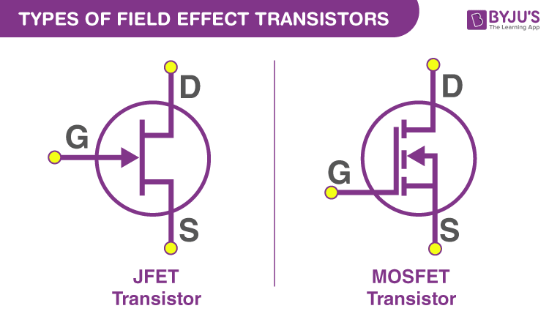

**Junction Field Effect Transistor (JFET)**

JFET is one of the most basic forms of field-effect transistors. They are three-terminal semiconductor electrical devices that can act as electronically controlled resistors or switches. Unlike a BJT (bipolar junction transistor), a JFET is voltage-controlled and does not require a biasing electrical current. The full-form JFET is Junction-gate Field Effect Transistor. The JFET controls the current flow between the source and the drain terminals by varying the voltage applied to the gate terminal. When a voltage is applied to the gate terminal, it creates an electric field that controls the width of the depletion region in the channel between the source and the drain terminals.

When the gate-to-source voltage is zero, the depletion region is narrow, and the channel offers low resistance to the current flow between the source and the drain terminals. This is called the “pinch-off” condition, and the JFET is said to be in saturation.

When the gate-to-source voltage is decreased in a JFET (junction field-effect transistor), the depletion region around the channel between the source and drain increases in width. This reduces the effective channel width, which in turn, decreases the conductivity of the channel. As a result, the drain current decreases, and the JFET becomes more resistive.

When the gate-to-source voltage increases in a JFET (junction field-effect transistor), the depletion region around the channel between the source and drain decreases in width. This increases the effective channel width, which in turn, increases the conductivity of the channel. As a result, the drain current also increases, and the JFET becomes less resistive.

**Metal-Oxide Semiconductor Field-Effect Transistor (MOSFET)**

The MOSFET is another type of field-effect transistor (FET) that can

switch electronic signals or amplify them. It is made of an insulated gate that controls the device’s conductivity per the voltage applied. This nature makes it useful for switching electronic signals or amplifying by adjusting its conductivity with changing voltage levels.

The crucial advantage of MOSFET is that they require almost no input current to regulate the load current relative to bipolar transistors (BJTs or bipolar junction transistors). There are two types of MOSFETs: enhancement mode and depletion mode. In the case of an enhancement mode MOSFET, the exerted voltage at the gate increases the conductivity. In depletion mode transistors, the voltage exerted at the gate decreases the conductivity.

11. Describe the basic operation of a MOSFET. Define enhancement mode and depletion mode.

**Basic operation of MOSFET:**

When voltage is applied to the gate, an electrical field is generated that changes the width of the channel region, where the electrons flow. The wider the channel region, the better conductivity of a device will be.

MOSFETs are of two classes:

* Enhancement mode
* Depletion mode.

**Depletion Mode**

When there is no voltage across the gate terminal, the channel shows maximum conductance. When the voltage across the gate terminal is either positive or negative, then the channel conductivity decreases.

**Enhancement Mode**

When there is no voltage across the gate terminal, then the device does not conduct. When there is the maximum voltage across the gate terminal, then the device shows enhanced conductivity.

12. Describe the general current-voltage characteristics for both enhancement mode and depletion mode MOSFETs.

## Depletion Mode

The depletion mode MOSFETs are generally known as ‘Switched ON’ devices, because these transistors are generally closed when there is no bias voltage at the gate terminal. If the gate voltage increases in positive, then the channel width increases in depletion mode.As a result the drain current ID through the channel increases. If the applied gate voltage more negative, then the channel width is very less and MOSFET may enter into the cutoff region. The depletion mode MOSFET is a rarely used type of transistor in the electronic circuits.

The following graph shows the Characteristic Curve of Depletion Mode MOSFET.

[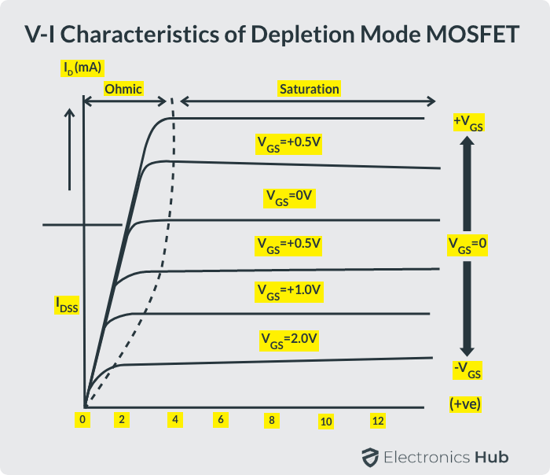](https://www.electronicshub.org/wp-content/uploads/2021/04/V-I-Characteristics-of-Depletion-Mode-MOSFET.png)

The V-I characteristics of the depletion mode MOSFET transistor are given above. This characteristic mainly gives the relationship between drain- source voltage (VDS) and drain current (ID). The small voltage at the gate controls the current flow through the channel.

**Enhancement Mode**

The Enhancement mode MOSFET is commonly used type of transistor. This type of MOSFET is equivalent to normally-open switch because it does not conduct when the gate voltage is zero. If the positive voltage (+VGS) is applied to the N-channel gate terminal, then the channel conducts and the drain current flows through the channel.

If this bias voltage increases to more positive then channel width and drain current through the channel increases to some more. But if the bias voltage is zero or negative (-VGS) then the transistor may switch OFF and the channel is in non-conductive state. So now we can say that the gate voltage of enhancement mode MOSFET enhances the channel.

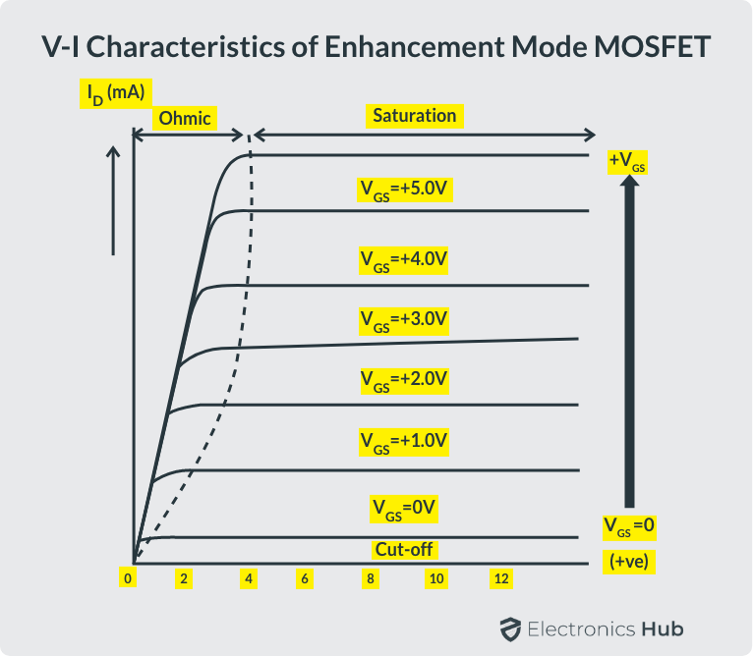

The V-I characteristics of enhancement mode MOSFET are shown above which gives the relationship between the drain current (ID) and the drain-source voltage (VDS). From the above figure we observed the behavior of an enhancement MOSFET in different regions, such as ohmic, saturation and cut-off regions.

13. For a certain transistor IC=5.505mA, IB=50μA, ICO=5μA. Determine-

1. The value of α, β and IE.
2. The new level of IB required to make IC=10mA.

(i) IE = IC+IB

= 5.505x10ˉ³+50x10ˉ⁶ A

= 5.555x10ˉ³ A

α = IC/IE

= 5.505x10ˉ³/5.555x10ˉ³

=0.99

β = IC/IB

= 5.505x10ˉ³/50x10ˉ⁶

= 110.1

(ii)

IB=IC/ β

= 10x10ˉ³/101.1

= 9.89x10ˉ⁵ A