have you ever thought about your mother's dreams at your age?
to enunciate what my mother's life could've been, and an attempt at minimizing my inescapable guilt

To start, the title is one of those quotes that made me want to rip my throat out, the first time i read it. Every once in a while, I’ll ponder and stumble across the thought, what about my mother’s dreams when she was just 23? Knowing her, i know she must have had dreams in which she wanted to become someone, have a say of her own. But instead, she got married, became a wife, and then became a mother; a mother of the kids who will never be able to compensate or repay her for her altruism. As i write this, i can’t help but pause to clear my mind off of the guilt, shame, and regret for all the times i’ve been nothing but disrespectful, apathetic, and ungrateful towards her and her awful amount of sacrifices, around which our lives are built. The woman who left her home, hopes, and dreams to build a home for herself; my mother, who deserves the world and nothing less. Yet, i can’t even give a mere act of selflessness.

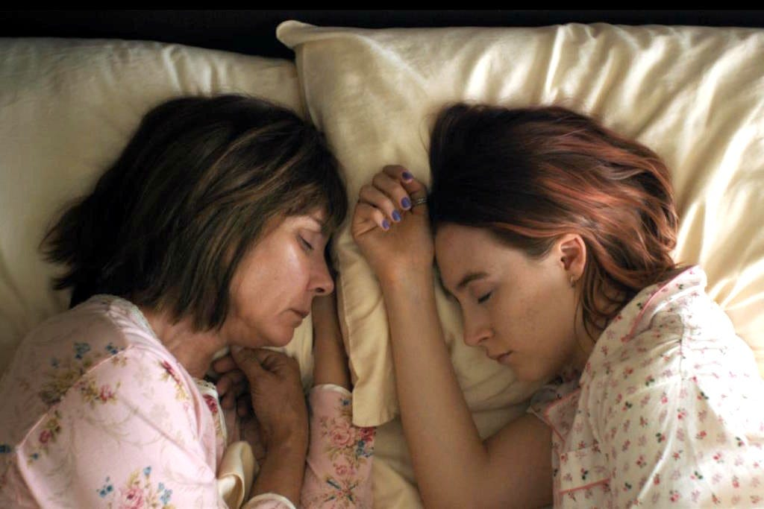
“either a mother and daughter know each other very well or they are strangers.”
To encapsulate the words i’ll never end up confessing to her, this is my small attempt of pouring out the words of this piece of writing, and for the words that struck me to the point where i had to stop and stare. Such as that one quote i read, somewhere down the rabbit-hole of the internet, that my thoughts keep circling back to:
“the world is not like your mother, you won’t storm off in her face in the morning and expect a dinner meal awaiting you on the table at the end of the day, the world will leave you starving”
And to end my unending rambling and use others’ words to fill the absence of my own, some of the quotes from one of my favorite books, “please look after mom” by Kyung-Sook Shin—the piece of media that actually started my endless loop of spirals—are filled within this piece of writing that i’m too cautious to call an article.
“to you, mom was always mom. It never occurred to you that she had once taken her first step, or had once been three or twelve or twenty years old. Mom was mom. She was born as mom. Until you saw her running to your uncle like that, it hadn’t dawned on you that she was a human being who harbored the exact same feeling you had for your own brothers, and this realization led to the awareness that she, too, had had a childhood. From then on, you sometimes thought of mom as a child, as a girl, as a young woman, as a newlywed, as a mother who had just given birth to you.”
A part of me will always wonder about the life she could’ve led, only if she didn’t have the burden of ours; only if she had the chance of pursuing her dreams, the things that make her happy.
“...i have so many dreams of my own, and i remember things from my childhood, from when i was a girl and a young woman, and i haven’t forgotten a thing. So why did we think of mom as a mom from the very beginning? She didn’t have the opportunity to pursue her dreams, and all by herself, faced everything the era dealt her, poverty and sadness, and she couldn’t do anything about her very bad lot in life other than suffer through it and get beyond it and live her life to the very best of her ability, giving her body and her heart to it completely. Why did i never give a thought to mom’s dreams?
The woman who raised me, created the home I call my own, yet the one I was always so hesitant and distant with to show my love, admiration to. The one I was supposed to be in debt my whole life, yet the one who always somehow got the worst of me.
“did mom know? That i, too, needed her my entire life?”
This is for the woman who made me the person i am today; i hope i become even a fraction of the woman that you are, and i hope you’re happy, ammu.

