**Chapter 1**

**Introduction**

* 1. **Introduction**

In every moment computer science is extending in different filed. By connecting with Internet through different devices people share their experience and get different services that changes their life and makes easier. We can access whole world by only a single touch or click. Nowadays without Internet we can’t move any single step.

At present most popular Information and Communication Technology (ICT) example is IoT. IoT is a recent technology that helps billions of devices to communicate with one other. By IoT devices not only can communicate but also compute, sense etc. [20]. Different kinds IoT applications are used for monitoring or sensing objects, animals and other things.

IoT based application development is increased day by day and those applications are used in wide range in our daily life. People able to access those applications in anytime and anyplace in the world [19].

* 1. **Background**

We are living in era of science. Everyday we feel rapid changes around us. Behind this changes Internet and IoT play an important role. From early morning to midnight we need Internet. That makes our everyday life easier. We are living in the ubiquitous computing and communication universe. Now a days the availability and popularity of mobile devices such as smart phones is very high and ubiquitous communication and information services are offered by this, that makes us dependent on mobile phones, no one can leave home without mobile phones [12]. So there is a huge area to research with IoT and Mobile Cloud Computing (MCC).

Mark Weiser [7] defines ubiquitous computing as “the method of enhancing computer use by making many computers available throughout the physical environment, but making them effectively invisible to the user”.

In IoT there are two terms, Internet and things. Internet is known as the network of networks where a network is a group of connected communication devices such as computer, mobile phones and so on [32]. In real ubiquitous computing and communication where many gadgets, such as sensors, smart phones, software, electrical/electromechanical devices, Radio Frequency Identification (RFID) tags, around us will be on the network [9], [4].These gadgets are called things.

IoT is the network of physical objects or things where things are interconnected by Internet to achieve a greater values or services by exchanging data with other connected things or devices. IoT will offer smart services and huge applications in a wide range to cope up with many of the challenges that in everyday lives any individuals and organizations may face via allowing humans and things to be connected with either anyone or anything, in any place at any time [9],[8].

In everyday life people usually interact with others in a large scale of relationship. And to improve their life quality they also use many smart services and applications of IoT. So quality of experience (QoE) of an application is very much important. As QoE of these smart services and applications is dependent on how to satisfy the need driven from the relations among people [1]. An individual user connects to other via a legacy network; on the other hand, sets of things communicate with each other via the Internet for offering information to smart services and applications, that each user uses them. The IoT follows two interactions systems: 1) human-to-human and 2) thing-to-thing, and then user may use data from things [11]. It clears that IoT doesn’t make true connection between humans and things, i.e.: human to thing, for real ubiquitous computing [3].

Smart phones and other mobile devices are heavily used in today’s world and almost every smart phone user uses mobile internet to his/her device. The rapid growth of developing smart services and applications of these devices show that there is a huge demand of mobile applications [10]. For all facilities and to solve the problem of all kinds of mobile application recently a new technology has been emerged in the information technology (IT) sector that is known as MCC. MCC is a part of IoT, which describes the mobile computing.

MCC is the form of cloud computing in combination with mobile devices. Cloud computing is a technology to provide resources to the user according to the user’s demand of networked infrastructure and software. Here all the information and data are stored in a centralized server. All application runs on the server and then sent to the user [2]. MCC is the rich mobile computing technology. Sometimes mobile devices face many challenges in their resource and communication, to solve this, MCC is emerged.

Nowadays ragging is a populer and enjoyable culture to the senior students in educational institutions. Freshers are the victims of this horrible culture. This degenerate culture is not only practiced in Bangladesh but also all over the world.

According to Wikipedia, “Ragging is a practice similir to hazing in educational institutions. The word is mainly used in India, Pakistan, Bangladesh and Sri Lanka. Ragging involves existing students baiting or bullying new students. It often takes a malignant form wherein the newcomers may be subjected to psychologiacal or physical tourture” [15].

According to the Urban Dictionary, “Ragging means the practice of tormenting freshmen at school. An initiation process involving harassment. The freshmen at school were subject to ragging”.

According to the Reader’s Digest Great Encyclopedia Dictionary, “Ragging means a noisy disorderly conduct, annual parade of students in fancy dress to collect money for charity, playing rough jocks, or throwing into wild disorder a person room etc.” [18].

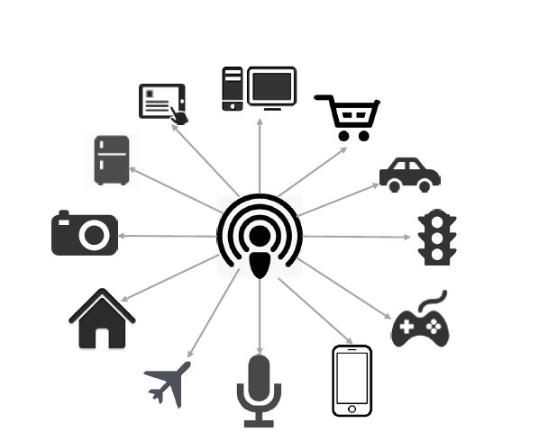

**Figure 1.1: Internet of Things (IoT)**

In our thesis by help of IoT we are going to make an application for university students, who are the victim of ragging or unwanted harasement. Our application will save the victim from awkward situation by informing his teacher and classmate about his loaction and other information. The system consists of a smart device (smart phone) is fully automated and internet based. By clicking a button victim may informed his well-wisher. And according of these information authority can take step to identify and for the punishment of ragger. Thus, the integration of the system with IoT provides an efficient control of real time synchronization of remote data into system database.

**1.3 Motivation**

Ragging is a terrible word for a first year student of college/university.It is also known as mental or physical harasement by seniors. Before known to the new environment they may face some awkward situation. There are many problems facing our educational institutions especially public universities. But recently harasement in the name of ragging is the most talked topic. This problem has installed itself at some of our public universities from the starting time of the university. Unlike eve-teasing, any student regardless of sex can be a victim to rag. In this sence, ragging is worse then eve-teasing. All the students of public universities often may face different forms of ragging or harasement in the campus. And this throw some questions to us: Are we really successful to give an quite atmosphere for studying to new students in our educational institutions or leading ourselves to dark or dangerous situation?

This is not new at our universities where ragging is a kind of entertainment for some students. And it is done in different ways. It reflects negetive impacts on the freshrers mind.

To prevent this situation and save the freshres from unwanted harasement in this thesis we are going to design an application. That waits for a click and takes step to informed well-wisher of the victim quickly as they can take step for saving the victim.

**1.4 Objectives of this Thesis**

Our main objective is to develop an IoT system that will help to prevent ragging from educational institutions and make a secure environment for the fresher’s. We want to show how a fresher will be benefited using this application. We’ll detect victim’s current location accurately and quickly. By which the anti-ragging committee can give feedback promptly.The primary objectives of this thesis are given below:

* Helping to prevent ragging from the educational institute.
* Designing a web server for storing all information about students.
* Developing a special button that will give the signal to track current position and send it to the server.
* Tracking the accurate location of the victim during raggaing.
* Recording a short range audio clip after clicking or pressing the button.
* Storing the audio clip in the user’s device in a hidden or password protected folder and also store audio clip information to the server for future investigation.

**1.5 Organizations of the Thesis Proposal**

This proposal has been organized into four chapters. Each chapter gives distinct concept.

Chapter 1 (Introduction): Introduction of our thesis area has been explored in this section.

Chapter 2 (Literature Review): This chapter presents the basic concept of IoT, SNs, SIoT and application development.

Chapter 3 (Related Works): This chapter presents existing anti-ragging applications.

Chapter 4 (Drawbacks of Existing Application): This chapter discusses about the drawbacks of existing applications.

Chapter 5 (Methodology): This chapter presents the system architecture of the application, about android, tools and technologies to be used in our proposed system.

Chapter 6 (Conclusion): Summarization of our thesis work.

**1.6 Time Plan for the Remaining Work**

Activities are

1. Develop android background activity.
2. Button activity.
3. Develop admin control website, hosting the website and adding bulk SMS service.
4. Complete whole application design and develop registration process.
5. Location tracking and Report writing.
6. Send victim current location, time and victim information to the web server. And web server send SMS from web server to victim friend or teacher. Report writing.
7. Report write, review and application testing.

|  |  |  |  |  |  |  |  |  |  |  |  |  |  |
| --- | --- | --- | --- | --- | --- | --- | --- | --- | --- | --- | --- | --- | --- |
| **Activities** | **Week** | | | | | | | | | | | |  |
| **1** | **2** | **3** | **4** | **5** | **6** | **7** | **8** | **9** | **10** | **11** | **12** | **13** |
| Background Activity |  |  |  |  |  |  |  |  |  |  |  |  |  |
| Button activity |  |  |  |  |  |  |  |  |  |  |  |  |  |
| Website Development |  |  |  |  |  |  |  |  |  |  |  |  |  |
| Complete Design and Registration process |  |  |  |  |  |  |  |  |  |  |  |  |  |
| Location Tracking |  |  |  |  |  |  |  |  |  |  |  |  |  |
| Send Information from Victim Phone to Server and Server to Authority Phone |  |  |  |  |  |  |  |  |  |  |  |  |  |
| Application Testing |  |  |  |  |  |  |  |  |  |  |  |  |  |
| Report Writing and Review |  |  |  |  |  |  |  |  |  |  |  |  |  |

**Figure 1.2: Time Plan**

* **Week 1:** Develop android background activity.
* **Week 2 and Week 3:** Button activity.
* **Week 4 and Week 5:** Develop admin control website, hosting and add bulk SMS service.
* **Week 6 and Week 7:** Complete whole application design and registration process.
* **Week 8 and Week 9:** Tracking current location quickly and accurately.
* **Week 10:** Victim information send from victim’s phone to server, store information in the server and send notification or SMS to authority from server.
* **Week 11, Week 12 and Week 13:** Testing developed application for different test case.
* **Week 8, Week 9, Week 10, Week 11 and Week 12:** Report writing and review that.

**Chapter 2**

**Literature Review**

**2.1 Introduction**

There are many researches on IoT and SIoT to invent better technology and application. In this chapter we will discuss about IoT, SNs, SIoT and Application Development. In section 2.2, 2.3, 2.4, 2.5 and 2.6 there will be a brief discussion about IoT, SNs, SIoT, Application development and MCC. In section 2.6 about ragging.

**2.2 IoT**

IoT is a technological revolution in computing and communications. Combination of the Internet and emerging technologies that transform objects into smart objects able to sense, interpret and react to the environment [6]. Human improve their life quality utilizing different kinds of smart services and applications from IoT. By collaborating between internet of things (heterogeneity regarding devices, local communication technologies and deployment goals) IoT can provide large scale, comprehensive and historical information [6].

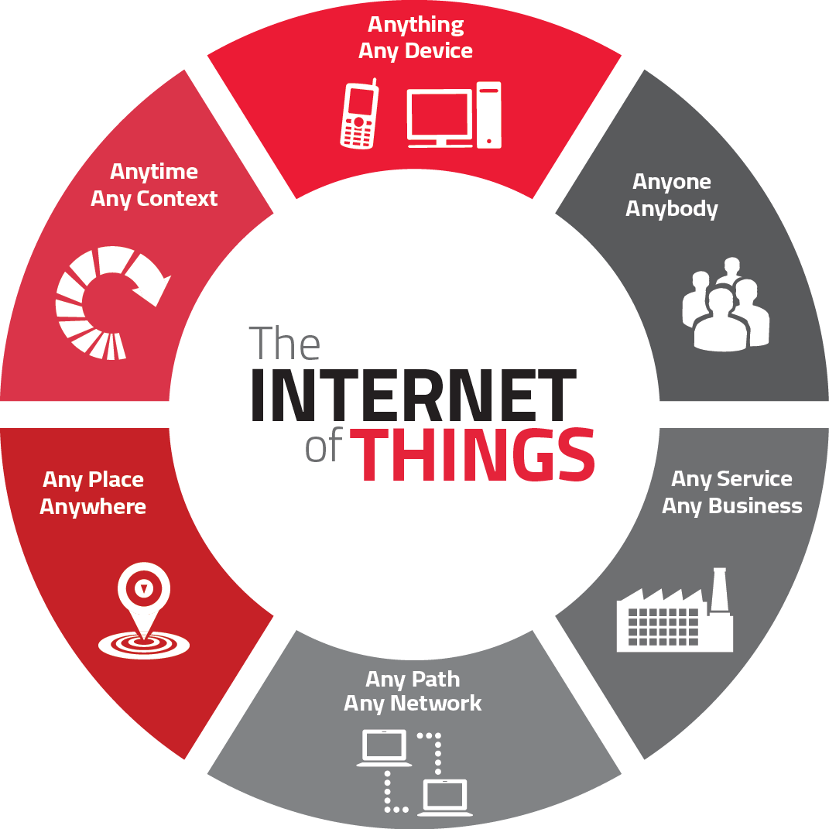

**Figure 2.1: IoT growing market cycle [17]**

Two interaction paradigms of IoT are human-to-human, things-to-things [11]. Radio-Frequency IDentification (RFID) system is a component of IoT. Which system able to sensing and communicate with other by unique identification. In RFID system there will be one or more RFID reader and many RFID tags which are characterized unique identification. Generally RFID systems can be used monitoring objects in real-time and mapping real world into virtual world [5]. There are three types of RFID system such as Active, Passive and BAP RFID system. In active RFID systems, tags have their own power source (battery). In passive RFID systems, the reader and reader antenna send a radio signal to the tag. The RFID tag then uses the transmitted signal to power on, and reflect energy back to the reader. A Battery-Assisted Passive RFID tag is a type of passive tag which incorporates a crucial active tag feature. While most passive RFID tags use the energy from the RFID reader’s signal to power on the tag’s chip and backscatter to the reader, BAP tags use an integrated power source (battery) to power on the chip, so all of the captured energy from the reader can be used for backscatter.

In the technological and application levels of IoT there is a middleware. Middleware is a software layer or the set of sub-layers. It interposed between the technologies and application levels. Applications are top of the Service Oriented Architecture (SOA) for IoT middleware. All the system’s functionalities to the final user are exported by the applications. Service composition layer also in the top of the SOA-based middleware architecture. For developing specific application service composition provides all functionality. Service management layer provides all expected and desired main feature or function. Object abstraction provides communication with different device through web service. Exchanging data from one to another it may be destroyed or lost. So middleware provides management of trust, privacy and security for exchanging data or information from one to another [5].

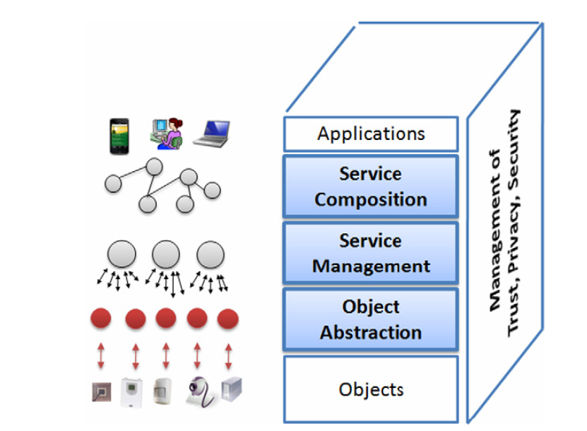

**Figure 2.2. SOA-based architecture for the IoT Middleware [5]**

**2.3 SNs**

SNs act as a glue in human-device interactions. By the IoT and SNs humans and things establish logical relationship among them easily. For the logical aspect of social communication there involve humans and things. Social communities improved their facilities constantly for their use or getting new user [6]. Commonly use SNs are Facebook, Google+, twitter etc. By using these networks user share their story, get information and perform various security based activates.

**2.4 SIoT**

SIoT is the combination of SNs and IoT. By SIoT we able to communicate with social communities through the human and things. Human able to share or transform data safely from one thing to another without any loss or change. Life quality has been improved by using different kinds of SIoT application.

Number of internet connected devices are increasing rapidly day by day. 50 billion devices or objects will be connected through internet in 2020 (According to CISCO). Using various social media applications, devices and objects humans are created humans–objects social communication among them. Combining Social media and IoT change our life in Healthcare, Traffic management and **qualified self (smartphone, big data, visualization, sensors etc.) sector [13].**

**2.5 Application Development**

For handling devices or objects applications are developed. Different types of applications are developed for controlling devices or objects. Mostly used applications are smartphone applications, web applications, devices/objects controlling applications and other applications which makes our life easy, comfortable and also change our life style.

Without applications all features in SIoT is pointless. Application development process depends on device or objects, service and users’ interest or requirements. Different types of open source APIs or Operation Systems (OS) are used for developing application [6].

**2.5.1 Smartphone Application**

Smartphone user increase day by day in world. More than 2 billion people will use smartphone in 2016 [14]. iOS, Android, Windows Phone, Symbian and Blackberry are commonly used smartphone operation system. Different kinds of applications are available for any kinds of smartphone OS.

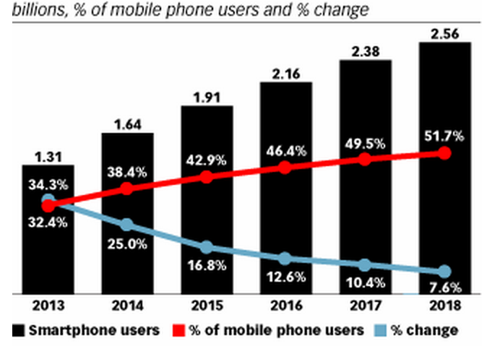

**Figure 2.5.1: Smartphone Users and Penetration Worldwide 2013-2018 [14]**

Recently Android OS become most popular than other smartphone OS. Android is a mobile phone operating system and it is open source. This operating system is developed by Google. Android operating system based smartphone user and application increased speedily. For developing android application eclipse and Android Studio editor are used.

* Android applications are developed using JAVA.
* For developing C and C++ application Android Native Development Kit (NDK) is used.

**2.5.2 Web Application**

Web application are developed by the combination of JavaScript, HTML and CSS. And which application runs in the web browser [16]. Web application are now integrating with smartphone or mobile phone and other application.

**2.5.3 Other Application**

For controlling sensors (RFID) or devices different types of application are developed. Those are send or get data from sensors or other devices such as web, smartphone etc.

**2.6 MCC**

If we want to work with IoT there is several technologies such as communication, backbone, hardware, software, protocols, data brokers/cloud platforms, machine learning [33]. On the other hand mobile computing is based on a collection of three major concepts: hardware, software and communication. The concepts of hardware can be considered as mobile devices such as smart phones and laptop, or their mobile components. Software of mobile computing is the numerous mobile applications in the devices, such as mobile browsers, anti-virus software and games. The communications issues includes the infrastructure of mobile networks, protocols and data delivery in their use [31].

MCC is the part of cloud computing with mobile devices. Day by day mobile devices are growing rapidly and is the most effective and essential part of our life. We are now trying to solve our problems by using mobile phone because it is the most compatible communication tool that doesn’t depend on time and place. Users allow their mobile devices for accessing cloud services anywhere and anytime. Each mobile devices has its own storage, sensor, computing ability and power source (battery) which are convenient. By using mobile cloud services user can know about a user’s location, context, other additional information and requested services to improve user experience. MCC help to solve some problem of cloud computing [25].

However for communication and resources mobile devices face some challenges such as security, mobility, storage, bandwidth, power source and so on. M. T. Nkosi and F. Mekuria SM in [26] have discussed about mobile devices which are used in health information communication challenges such as power, bandwidth and security. The proposed system shows that how we can use cloud computing in mobile devices to provide sensor signals and security.

M. Stojmenovic in [27] explains the Biometric application like fingerprint identification, face recognition or iris scanning. Here he has focused on the problem of battery power of the device and the throughput of the communication channel. The paper shows the MCC technique for biometric application such as fingerprint identification, face recognition or iris scanning.

K. S. Shetty and S. Singh in [28] explain about the services provided on the mobile devices. Services of mobile devices are increasing day by day. Among all the services Location Based Service (LBS) is one of the important services. LBS is dependent on the geographical position of the user to provide services to the end users.

H. Qi and A. Gani in [31] discuss about the following features of mobile computing:

1. Mobility
2. Diversity of network conditions
3. Frequent disconnection and consistency
4. Dis-symmetrical network communication
5. Low reliability

MCC is the development and extension of Cloud Computing and Mobile computing. And also solves obstacles related to as security, mobility, storage, bandwidth, power source and so on [29]. According to Cicco IBSG almost 80% of world population use smartphones and new devices like the Android smartphones, iPhone, Windows Phones and tablets have brought a huge number of application and services to the people [30].

**2.7 Ragging**

Originally ragging is a western concept. During the Olympics in Greece in the 8th century BC ragging was first recorded. Then it spread to the armed forces and educational institutions [21]. Ragging in educational institutions is started in certain European Universities. At the time of welcoming senior students played different kinds of jocks with fresh students. And day by day this degenerate culture becomes popular to all over the world. According to CURE research ragging exists in India and Sri Lanka [18]. But it also exists in Bangladeshi educational institutions where fresh students are physically or mentally tortured by their seniors.

At the introduction time fresh students are ragged with their seniors. One reason of ragging is he/she was ragged with his/her seniors so he/she do the same with his/her juniors. But sometimes it occurs if the anti-ragging committee members are not aware of it or not work properly [21].

Newcomers take admission in universities or colleges with full of new expectation. Their career is hampered by the unexpected mental or physical torture. In the extreme case sometimes they take suicide attempts. This degenerate culture not only hamper juniors life but also raggers. The guilty person may be suspended or permanently expelled from university or college [18].

**2.8 Conclusion**

In this chapter we have discussed about IoT, SNs, SIoT , Application development, MCC, Ragging and those impact in our daily life. All topics has a common goal and that is connected more and more devices anytime, anyplace. So we are going to develop an application which will connected with people and share user situation through phone to web server and web server to phone using Internet.

**Chapter 3**

**Related Works**

**3.1 Introduction**

There are many applications for helping to prevent ragging from the education institutions. Different type of applications are developed for helping freshers and anti-ragging committee. In this chapter we will discuss about anti-ragging applications. In next section we will see problems of current applications that are used.

**3.2 Related Works**

In this section we will show some previous application that are related to our research. These application will give us clear indication that what kind of application are already done.

**3.2.1 Indore Anti-Ragging App [22]**

In 2013 Codeware Technologies Private Limited developed “Indore Anti-Raging” application for stopping ragging from colleges in Indore city in India. Using this application victims able to contact with police stations and complain about ragging. Victim also able to see the nearest police station location. And general people can take action against ragging using this application. In this application national anti-ragging helpline number are stored for victims’ emergency call.

**3.2.2 SVN Anti-Ragging App [23]**

ASB technologies developed “SVN Anti-Ragging” android based smartphone application for stopping ragging from the Swami Vivekanand University. Using this application victim or other can contact with the anti-ragging committee of Swami Vivekanand University. Using their smartphone they also able to report instantly by sending photo, video or text to the anti-ragging committee.

**3.2.3 24 X 7 Anti Ragging Helpline [24]**

University Grants Commission of India added 24 X 7 Anti Ragging Helpline for stopping ragging. Using helpline number students can contact with anti-raging committee.

**3.3 Conclusion**

In this section we have discussed about existing anti ragging smartphone and web application. In the next section we will discuss about some problems and limitations.

**Chapter 4**

**Drawbacks of Existing Application**

**4.1 Introduction**

In this chapter in section 4.2 we will show existing anti-raging application activities for stopping ragging and helping newcomers. In this application freshers as well as anti-ragging committee have to face several problems. These drawbacks will be discussed briefly.

**4.2 Description of Drawbacks**

Ragging are stopped using anti-ragging applications and fresh students become free this degenerate culture. If they face ragging instanty they can contact with anti-ragging committee and teachers using smartphone web application with documents. But if he/she is unable to contact with anti-ragging committee over the phone then he/she can get help of via text message. In this situation the anti-ragging committee don’t find or indicate the victim and ragger instantly and appropiately. If the victim or viewer roports to the anti-ragging commmittee with victims current location then it will be easy to find out them. Sometimes it is hard to record video. Then victim or viwer can use audio clip for a certain amount of time and can send the recording to the anti-ragging committee as an evidence. Further he/she can preserve the recoring in his/her smartphone for future requirement.

**4.3 Conclusion**

In this chapter we have discussed anti-ragging application drawbacks which makes the anti-ragging application more effective. So we are going to develop an interactive anti-ragging application. In the next chapter we will discuss about this application.

**Chapter 5**

**Methodology**

**5.1 Introduction**

Here we are going to discuss about our proposed application. Section 5.2 illustrates the proposed application architecture and its description. In section 5.3 we will discuss about tools and technologies which are used for developing the application. In section 5.4 about challenges of this work.

**5.2 The System Architecture and Description** 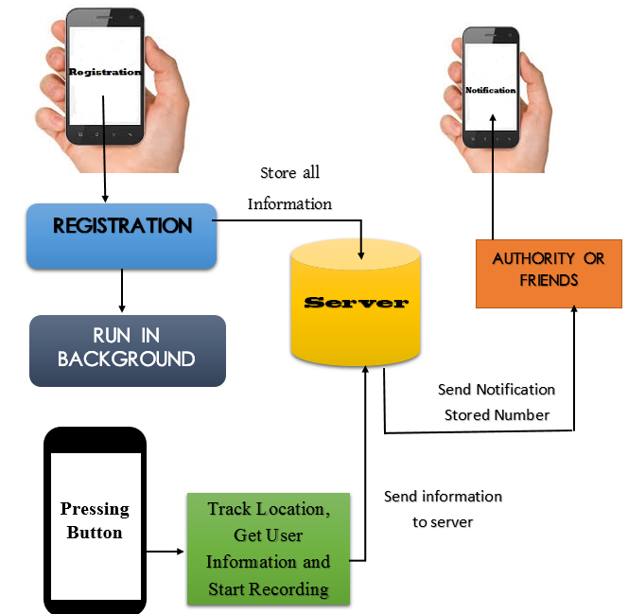

**Figure 5.1: Proposed Architecture**

After installing this application students have to complete registration process using their student ID and other relating information. Admin of the web server will maintain the web system and he/she will form anti-ragging committee mentoring number and name of the members and that will be organized for all newcomer students. The committee will take necessary step when the newcomer fall in any physical or mental harassment by his/her seniors. After completing the registration process the application will start working by pressing button.

Students will press the button of application then it will track current location using Global Position System (GPS) and send tracking location, other information to the server. After getting this information server will store all information into server database and send SMS to its stored number. After sending location and other information from phone to server application audio recording will go on for a certain period of time and save the audio clip in a hidden or password protected folder. Audio clip folder name or password will be send to the web server. Using the folder location or password that is informed over the victim phone anti-ragging committee can find out necessary data and information for investigation.

**5.3 Tools and Technologies to be used**

* Android SDK
* Google Map API
* My SQL Database
* SQLite Database
* Eclipse
* notepad++
* JESON Parsing
* Language
  + Java
  + PHP

**5.4 Challenges**

* Main challenge of our research is detecting correct location correctly and send data about user current situation to its friends or relative without any delay or loss.
* Our second challenge is creating a special customized button or switch for sending data by pressing it.

**5.5 Conclusion**

In this chapter we have discussed about our proposed application, its working and internal technology. There were two challenging issue that we are going to face in our research.

**Chapter 6**

**Conclusion**

**6.1 Conclusion**

By connecting billions of devices through Internet at anytime from anywhere the destination of IoT is to solve problems of human or organizations that they face daily by making a large amount of services and applications. IoT makes our environment more sophisticated by interacting virtual world with real world. With the high increasing rate of using smartphone, today MCC is a hot topic for research. To provide PC-like services in mobile phone MCC has been emerged. But for hardware features difference it is impossible to use a desktop application in a mobile phone. If anyone wants to work with mobile phone development, he must face some kinds of problem. To solve these problem MCC works. It is complicated but promising high impact result.

In this thesis, we have proposed an IoT system that will help to save fresher from ragging or any kind of unwanted physical or mental harassment at any time in anywhere. And the ragger also feel fear for punishment. As a result, ragging will be removed from our educational institutions. And we get the quet atmosphere for studying.

**References**

[1] A. M. Ortiz, D. Hussein, S. Park, S. N. Han, and N. Crespi, “The Cluster Between Internet of

Things and Social Networks: Review and Research Challenges*,” IEEE Internet of Things*

*Journal,* vol. 1, no. 3. June 2014.

[2] C. Sharavanthi, H. S. Guruprasd, “Mobile Cloud Computing as Future for Mobile

Applications,” in *International Journal of Research in Engineering and Technology,* vol. 3,

no. 5, May 2014.

[3] D. Uckelmann, M. Harrison, and F. Michahelles, “An architectural approach twords the

future Internet of Things,” *in Architecting the Internet of Things. Berlin, Germany:* Springer-

Verlag, 2011, pp. 1-24.

[4] J. Gubbi, R. Buyya, S. Marusic, and M. Palaniswami, “Internet of Things (IoT): A vision

architechral elements, and future directions,” *Future Gener. Comput. Syst.,* VOL. 29, NO. 7, pp.1645-1660, 2013

[5] L. Atzori, A. Iera, G. Morabito, “The Internet of Things: A survey,” in *Computer Networks,*

1st June 2010.

[6] M. C. Domingo, “An overview of the Internet of Things for people with disabilities,” in

*Journal of Network and Computer Applications,* 29th Oct. 2011.

[7] M. Weiser, “The computer for the 21st century,” *IEEE pervasive Computing,* vol. 99, no. 1,

pp. 19-25, 2002 Reprinted from 1991.

[8] M. Zorzi, A. Gulhak, S. Lange and A. Bassi, “From today’s Internet of Things to a future

Internet of Things: A wireless-and mobility-related view,” *IEEE Wireless Commun.,* vol.17,

no.6, pp. 44-51, Dec. 2010.

[9] P.-L. Ismeal, “ITU internet report 2005: The Internet of Things (IoT),” *Int. Telecommum.*

*Union (ITU), Geneva, Switzerland,* 2005*.*

[10] R. Kemp, “Cuckoo: a Computation Offloading Framework for Smartphones,” in

*Proceedings of the sixteenth annual conference of the Advanced School for Computing and*

*Imaging 2010.* 2010*:* Veldhoven, the Netherlands. Pp. 70-77.

[11] S. Hong, D. Kim, M. Ha, S. Bae, S. J. Park, W. jung, and J.-E. Kim, “SNAIL: An IP-based

wireless sensor network approach to The Internet of Things,” *IEEE Wireless Commun.,*

vol.17, no.6, pp. 34-42, Dec. 2010.

[12] Z. Sanaei, S. Abolfazil, A. Gani, R. Buyya, “Heterogeneity in Mobile Cloud Computing:

Taxonomy and Open Challenges,” in *IEEE communications serveys and tutorials,* vol. 16,

no.1, First Quarter 2014.

[13] The Internet of Social Things

http://www.oracle.com/us/corporate/profit/big-ideas/081214-mabramow-2264336.html.

[14] 2 Billion Consumers Worldwide to Get Smart (phones) by 2016

http://www.emarketer.com/Article/2-Billion-Consumers-Worldwide-Smartphones-by-

2016/1011694.

[15] Ragging

https://en.wikipedia.org/wiki/Ragging.

[16] Web application

https://en.wikipedia.org/wiki/Web_application.

[17] Internet of Things market is growing, with industry deals accelerating  
 http://www.tweaktown.com/news/41530/internet-of-things-market-is-growing-with-

industry-deals-accelerating/index.htm.

[18] Madhavi Chopra, “Ragging In Educational Institutes: A Human Rights Perspective”*,* 2013

[19] George Suciu, Alexandru Vulpe, Gyorgy Todoran, Janna Cropotova, Victor Suciu, “Cloud

Computing and Internet of Things for Smart City Deployments”

[20] Prahlada Rao B. B, Payal Saluja, Neetu Sharma, Ankit Mittal, Shivay Veer Sharma, “Cloud

Computing for Internet of Things & Sensing Based Applications”, *Sensing Technology*

*(ICST), 2012 Sixth International Conference,* 18-21 Dec. 2012*.*

[21] R. Garg, “Ragging: A public health problem in India,” *W.H.O- National Polio Surveillance*

*Project (NPSP)*, vol. 63, issue. 6, pp. 263-271, 2009.

[22] Indore Anti-Ragging App

https://play.google.com/store/apps/details?id=com.codewaretechnologies.antiragging.

[23] SVN – Anti-Ragging App

https://play.google.com/store/apps/details?id=com.asb.svn.antiragging&hl=en.

[24] 24 X 7 Anti Ragging Helpline

http://www.ugc.ac.in/page/Helpline.aspx.

[25] C. Shravanthi, H. S. Guruprasad, “Mobile Cloud Computing as Fiture for Mobile

Applications,” *International Journal of Research in Engineering and Technology,* vol. 03,

issue. 05, May. 2014.

[26] M. T. Nkosi, F. Mekuria SM, “Cloud Computing for Enhanced Mobile Health Application,”

*2nd IEEE International Conference on Cloud Computing Technology and Science*, pp. 629-

633, Nov. 30 2010-Dec. 3 2010.

[27] M. Stojmenovic, “Mobile Cloud Computing for Biometric Application,” *15th International*

*Conference on Network Based Information Systems,* pp. 654-659, 26-28 Sept. 2012.

[28] K. S. Shetty, S. Singh, “Cloud Based Application Development for Accessing Restaurant

Information on Mobile Device using LBS,” *International Journal of UbiComp,* vol. 02, pp.

37-49, Nov. 2011.

[29] P. Gupta, S. Gupta, “Mobile Cloud Computing: The Future of Cloud,” *International Journal*

*od Advanced Research in Electrical, Electronics and Instrumentation Engineering,* voi. 01,

issue. 03, Sept. 2012.

[30] IBSG Cisco, “Mobile Consumers reach for the cloud”.

[31] H. Qi, A. Gani, “Research on Mobile Computing: Review, Trend and Perspectives”, *Digital*

*Information and Communication Technology and it's Applications (DICTAP)*, pp. 195-202,

Second International Conference, 2012.

[32] A. S. Tanenbaum, D. J. Wetherall, 2011, “Computer Networks,” Prientice Hall, United

States of America, pp. 54-64.

[33] Internet of Things Technologies

http://postscapes.com/internet-of-things-technologies.