**Air Quality Index(AQI)**

**Table of contents:**

Healthy: 3

Moderate: 3

Unhealthy: 3

Effects of AQI 4

General Effects on Health: 4

Long-term Effects: 4

Average: 5

Maximum: 5

MInimum: 5

Find out specific field: 6

PivotTable and diagrams: 6

Bar chart: 7

Pie Chart: 7

Conditional Formatting: 8

Definition  
AQI stands for Air Quality Index. It’s a system used to measure and communicate the quality of the air in a specific area, indicating how clean or polluted the air is and what associated health effects might be a concern for the general population. The AQI typically takes into account various pollutants, such as:

* Particulate matter (PM10 and PM2.5)
* Ground-level ozone
* Carbon monoxide
* Sulfur dioxide
* Nitrogen dioxide

When the AQI rises, it can signal potential health risks, especially for vulnerable populations such as children, the elderly, and those with pre-existing health conditions.  
  
  
  
  
  
  
  
  
  
  
  
  
  
  
  
  
  
  
  
  
  
  
  
  
  
Scales of AQI  
The AQI is usually reported on a scale from 0 to 500, with lower values indicating better air quality. Here’s a general breakdown of the scale:

* 0-50: Healthy
* 51-150: Moderate
* 150+: Unhealthy

Healthy:  
A "healthy AQI" refers to an Air Quality Index reading that falls within the "Good" category, typically ranging from 0 to 50. In this range, air quality is considered satisfactory, and air pollution poses little or no risk to the general population.

Moderate:  
A "Moderate AQI" refers to an Air Quality Index reading between 51 and 100. In this range, air quality is acceptable; however, there may be a concern for some people, particularly those who are unusually sensitive to air pollution.

Unhealthy:  
An "Unhealthy AQI" refers to an Air Quality Index reading between 151 and 200. In this range, everyone may begin to experience health effects, and members of sensitive groups may experience more serious health effects.

# Effects of AQI

AQI may have 2 types of effect as follows:

## General Effects on Health:

* **Respiratory Issues:** Increased rates of asthma attacks, chronic bronchitis, and other respiratory problems.
* **Cardiovascular Effects:** Higher risk of heart attacks and other cardiovascular issues.
* **Mental Health:** Poor air quality has been linked to increased stress and anxiety levels.
* **Vulnerable Populations:** Children, the elderly, and those with pre-existing health conditions are particularly at risk.

## Long-term Effects:

Chronic exposure to poor air quality can lead to long-term health problems, including reduced lung function, cardiovascular disease, and even premature death. It's important to monitor AQI levels, especially in urban areas or during events like wildfires or high pollution days, to protect health.

Calculating some phenomenon of AQI

## Average:

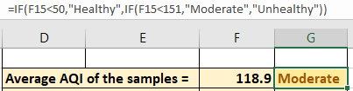

## Maximum:

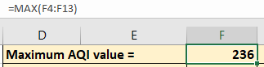

## MInimum:

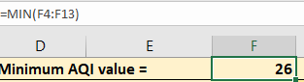

## Find out specific field:

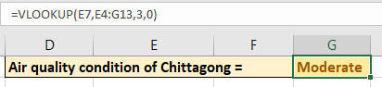

# PivotTable and diagrams:

## Bar chart:

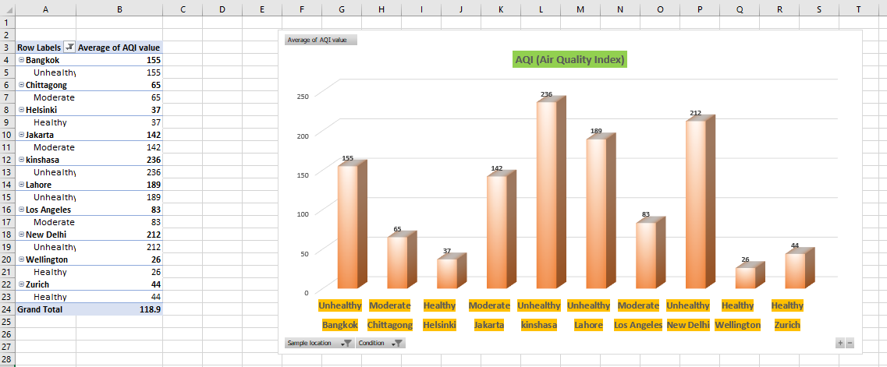

## Pie Chart:

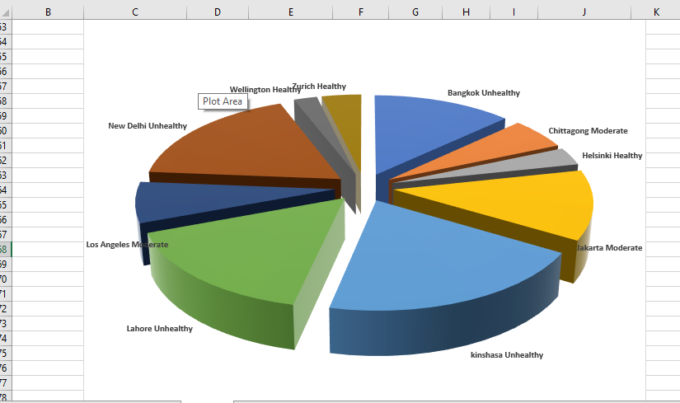

# Conditional Formatting:

Here we have applied conditional formatting on the field “condition”.

According to our command, those cells which is containing “Healthy” should be coloured as follows:  
shape fill : green  
text: dark green

According to our command, those cells which is containing “Moderate” should be coloured as follows:  
shape fill : yellow  
text: dark yellow

According to our command, those cells which is containing “Unhealthy” should be coloured as follows:  
shape fill : red  
text: dark red