** Department of Computer Science and Engineering, KUET**

ROOM TEMPERATURE DETECTOR AND MANAGEMENT

Course No. : CSE 3104 Report No. : 01

Date: 10-02-2016

***Remarks:***

Submitted To -- Submitted By --

Saifuddin Mahmud Nabil Sarwar Rahat (1207013)

Assistant professor, CSE, KUET. Md Masum Billah (1207002)

Mahtab Ahmed

Lecturer,CSE, KUET

Configuring the hardware:

We will now build the hardware part of the project. The following is a schematic of the project:

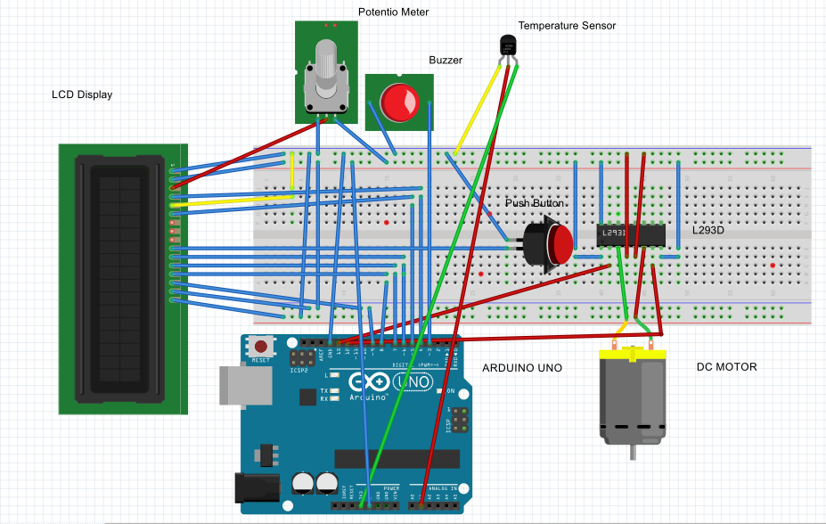

Fig-1:Connecting arduino uno, display module, temperature sensor,motor,L293D,buzzer

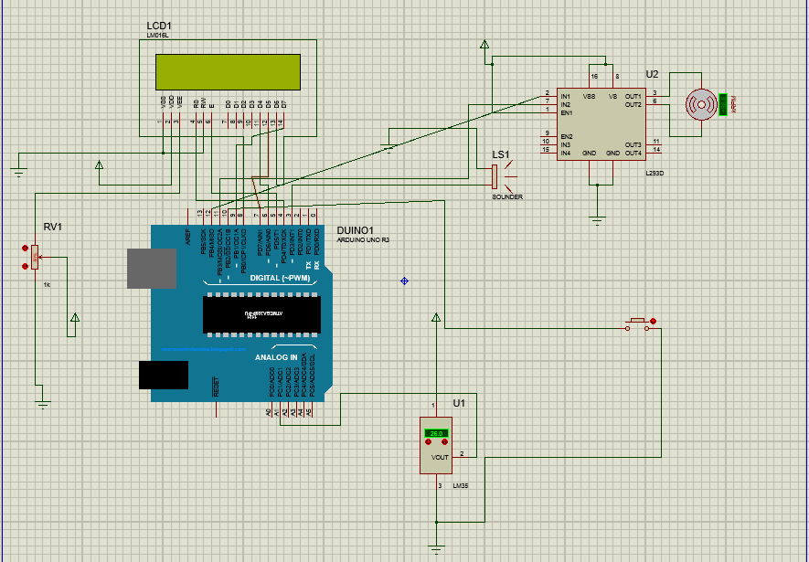

Fig-2:Connecting arduino uno, display module, temperature sensor, motor, L293D, buzzer