ReWear: Community-Based Clothing Exchange and Reuse Platform
A Mini Project Report Submitted in the partial fulfillment of the requirements for the award of the degree of

BACHELOR OF TECHNOLOGY

In
DEPARTMENT OF COMPUTER SCIENCE ENGINNERING
By
G. Divya Sree - 2420030287
Masuma Fathema - 2420030400
Avinash Yarukala – 2420030568

Under the Esteemed Guidance of

Dr. Lavanya Gottumukkala





K L (Deemed to be) University
DEPARTMENT OF COMPUTER SCIENCE ENGINEERING

DECLARATION

The Mini Project Report entitled “ReWear: Community-Based Clothing Exchange and Reuse Platform” is a record of Bonafide work of G. Divya Sree – 2420030287; Masuma Fathema – 2420030400; Avinash Yarukala – 2420030568 submitted in partial fulfillment for the award of B. Tech in Computer Science and to the K L University. The results embodied in this report have not been copied from any other departments/University/Institute.

G. Divya Sree - 2420030287
Masuma Fathema - 2420030400
Avinash Yarukala - 2420030568

K L (Deemed to be) University
DEPARTMENT OF COMPUTER SCIENCE ENGINEERING
CERTIFICATE

This is certify that the mini project based report entitled “ReWear: Community-Based Clothing Exchange and Reuse Platform” is a bonafide work done and submitted by G. Divya Sree – 2420030287; Masuma Fathema – 2420030400; Avinash Yarukala – 2420030568 in partial fulfillment of the requirements for the award of the degree of BACHELOR OF TECHNOLOGY in Department of Computer Science Engineering, K L (Deemed to be University), during the academic year 2026-2027.

Signature of the Course Co-ordinator Signature of HOD

ACKNOWLEDGEMENT

The success in this project would not have been possible but for the timely help and guidance rendered by many people. Our wish to express my sincere thanks to all those who has assisted us in one way or the other for the completion of my project.

Our greatest appreciation to my guide, Dr. Lavanya Gottumukkala, Department of Computer Science which cannot be expressed in words for his/her tremendous support, encouragement and guidance for this project.

We express our gratitude to Dr. P.Venkateshwar Sir (CSE), Head of the Department for Computer Science Engineering for providing us with adequate facilities, ways and means by which we are able to complete this project-based Lab.

We thank all the members of teaching and non-teaching staff members, and also who have assisted me directly or indirectly for successful completion of this project. Finally, I sincerely thank my parents, friends and classmates for their kind help and cooperation during my work.

G. Divya Sree - 2420030287
Masuma Fathema - 2420030400
Avinash Yarukala - 2420030568

TABLE OF CONTENTS

S.No. | Contents | Page no.
1. | Abstract | 6
2. | Introduction | 7
3. | Literature survey | 8
4. | Problem Statement and Objectives | 10
5. | Hardware and Software requirements | 11
6. | Implementation | 12
7. | Results & Discussion | 24
8. | Conclusion & Future Scope | 26
9. | References | 27

- ABSTRACT

ReWear is a web-based platform designed to promote sustainable fashion by enabling users to exchange, donate, and reuse pre-owned clothing. The platform provides a centralized space where users can register, upload clothing listings with images and details such as category, size, condition, and availability, and browse items shared by other community members. Users can search and filter listings and submit exchange or donation requests while tracking their request status. The platform also provides an administrative dashboard for managing users, listings, and reported content.
ReWear supports three listing types: Exchange, Donation, and Both. It operates as a non-monetary platform without an integrated payment or delivery system; users coordinate the physical handover themselves. The application is developed using HTML, CSS, JavaScript, and Thymeleaf for the frontend, Java 21 and Spring Boot for the backend, and H2 as the relational database. Spring Data JPA and Hibernate are used for database operations, while uploaded images are stored locally. By encouraging the reuse of wearable clothing, ReWear aims to reduce textile waste and promote responsible consumption.

Team Members:
- G. Divya Sree - 2420030287
- Masuma Fathema - 2420030400
- Avinash Yarukala - 2420030568

- INTRODUCTION

Project Overview and Context
In today's consumer-driven society, rapid garment production and fast fashion have led to a significant increase in clothing consumption. As a result, large quantities of wearable, high-quality garments are frequently discarded long before reaching the end of their usable life, contributing heavily to textile waste and environmental pollution. Concurrently, many individuals actively seek affordable and sustainable clothing alternatives. Existing informal clothing exchange methods—such as physical donation drives or unstructured social media groups—often suffer from scattered listings, time-consuming discovery, manual coordination, and a lack of organized request tracking. ReWear addresses these challenges by offering a centralized, web-based community platform designed to facilitate seamless clothing exchange, donation, and reuse.

Motivation and Core Objective
The primary purpose of ReWear is to promote environmental sustainability and responsible resource utilization through modern web technologies. By providing a digital marketplace interface, the platform connects community members wishing to pass along unused garments with those looking for pre-owned clothing. ReWear eliminates the inefficiencies of traditional donation and exchange models by allowing users to register accounts, publish detailed clothing listings with images and availability statuses, and discover items using specific search and filtering criteria such as size, category, and condition. Furthermore, an integrated exchange request mechanism allows users to send proposals, track request statuses, and coordinate handovers efficiently, supported by an administrative dashboard that moderates content and maintains platform integrity.

Platform Implementation and Document Structure
The ReWear platform is developed using a full-stack web application architecture. HTML5, CSS3, JavaScript, and Thymeleaf are used to create the frontend interface. The backend is implemented using Java 21 and the Spring Boot 3.2.5 framework. Spring Data JPA and Hibernate handle database operations, with H2 used as the relational database. Uploaded clothing images are stored locally. Maven is used for dependency management and project building, while Git and GitHub support version control. This architecture provides a structured approach to user authentication, clothing listing management, exchange request processing, and administrative operations.

- LITERATURE SURVEY

Freecycle Network Platform

The Freecycle Network is a grassroots, non-profit digital platform focused on reducing waste by facilitating localized, free item exchanges between community members. Users post unwanted pre-owned items, including clothing and household goods, while interested individuals coordinate directly to pick them up without monetary transactions. Although effective at promoting local circular economies, the platform relies heavily on broad mailing lists or simple message boards. It lacks structured clothing-specific metadata such as categorized size, fabric condition, and automated exchange request tracking.

Poshmark Social Commerce Engine

Poshmark is a major social commerce marketplace designed for buying, selling, and trading second-hand apparel and fashion accessories. The platform emphasizes social interaction by allowing users to follow virtual closets, attend digital parties, and directly negotiate item pricing. While it successfully streamlines clothing categorization, image uploads, and transaction handling, Poshmark is primarily built for commercial resale with commission fees. This paid transactional structure limits accessibility for users specifically seeking non-monetary clothing exchanges or direct peer-to-peer donations.

ThredUp Online Consignment Engine

ThredUp operates as a centralized online consignment and thrift platform focused on extending the life cycle of women’s and kids’ apparel. It uses an organized cataloging model where users ship unwanted garments in bulk, and the platform inspects, photographs, and lists accepted items. While ThredUp offers advanced search and category filtering to simplify discovery, it functions through a centralized warehouse system rather than direct community interactions. Furthermore, sellers have limited direct control over item pricing, listing approvals, or peer-to-peer exchange requests.

Vinted Peer-to-Peer Apparel Marketplace

Vinted is a dedicated C2C platform that allows users to list, swap, or sell pre-loved clothing and fashion accessories. Users can upload detailed garment listings with images, descriptions, and condition metrics, enabling buyers to browse through granular search filters. The platform includes messaging tools and request updates to handle user interactions. However, Vinted primarily emphasizes monetary purchase transactions and lacks integrated administrative workflows tailored specifically for non-profit donation tracking or direct community barter exchanges.

Share At Door Step (SADS) Donation Platform

Share At Door Step is a digital logistics platform designed to connect individuals wishing to donate pre-owned clothing and household goods directly with verified non-governmental organizations. The application schedules door-step pick-ups, making clothing donation seamless and reliable for individual donors. Despite its convenience for bulk donations, it operates on a one-way donation model. It does not support peer-to-peer clothing swaps, mutual exchange request approvals, or individual listing discovery between local community members.

Based on the reviewed platforms, ReWear focuses on combining community-based clothing listings, non-monetary exchange, free donation, and request management within a single application. Its primary objective is to provide a dedicated environment for peer-to-peer clothing reuse rather than conventional commercial resale.

- Problem Statement and Objectives

Problem Statement:
The continuous disposal of wearable garments due to fast fashion and the absence of a localized digital exchange system drives severe environmental textile pollution while limiting access to affordable clothing options.

Problem Description:
Traditional clothing disposal methods lack structured platforms for community-driven reuse, resulting in usable garments ending up in landfills instead of being shared. ReWear solves this by offering a centralized web application that automates clothing cataloging, filtering, and peer-to-peer exchange request management.

Objectives:
The project was initiated to address the growing environmental impact of textile waste by providing a accessible, non-monetary digital solution that enables communities to continuously reuse, donate, and swap pre-owned apparel.
- Develop a centralized web application for uploading, managing, and browsing clothing listings with details such as category, size, condition, and availability.
- Implement search, filtering, and request tracking mechanisms to streamline item discovery and facilitate peer-to-peer exchange approvals.
- Build secure user authentication and an administrative dashboard to moderate listings, handle reported content, and maintain platform reliability.
- Promote sustainable fashion consumption patterns within local communities to minimize unnecessary garment disposal and textile waste.

- HARDWARE AND SOFTWARE REQUIREMENTS

HARDWARE REQUIREMENTS
- Processor: Intel Core i5 / AMD Ryzen 5 or higher
- RAM: 8 GB minimum
- Storage: 256 GB SSD with 10 GB free space
- End-User Device: Any modern PC, laptop, or smartphone with an active internet connection

SOFTWARE REQUIREMENTS
- Operating System: Windows 10/11, macOS, or Linux
- Programming Language: Java 21
- Backend Framework: Spring Boot 3.2.5
- Frontend: HTML5, CSS3, JavaScript
- Template Engine: Thymeleaf
- Database: H2 Database
- ORM Framework: Hibernate
- Database Access: Spring Data JPA
- Password Hashing: BCrypt
- Build and Dependency Management: Maven
- Code Editor: Visual Studio Code or any Java-compatible IDE
- Version Control: Git and GitHub
- Web Browser: Google Chrome, Mozilla Firefox, or Microsoft Edge

- IMPLEMENTATION

Frontend:
The frontend of ReWear is developed using HTML, CSS, JavaScript, and Thymeleaf.
- HTML defines the structure of the webpages, forms, buttons, and content.
- CSS controls the layout, colors, typography, and responsive appearance.
- JavaScript provides client-side interactivity.
- Thymeleaf dynamically displays backend data within HTML templates.
The frontend templates are stored in src/main/resources/templates/. Static CSS and JavaScript files are stored in src/main/resources/static/css/ and src/main/resources/static/js/, respectively.

Important templates include index.html, login.html, register.html, listings.html, listing_detail.html, create_listing.html, dashboard.html, and admin.html. The following is the sample code:

{% block content %}
<div class="dashboard-header" style="background: #064E3B; color: white;">
<div class="container">
<div style="display: flex; justify-content: space-between; align-items: center; flex-wrap: wrap; gap: 1rem;">
<div>
<span class="badge badge-amber" style="margin-bottom: 0.5rem;">System Administration</span>
<h1 style="font-size: 2.2rem; color: white; margin-bottom: 0.35rem;">Community Moderation & Admin</h1>
<p style="color: #A7F3D0; font-size: 0.95rem; margin: 0;">
Monitor platform metrics, curate circular listings, review user reports, and maintain platform integrity.
</p>
</div>

<div>
<span class="badge badge-green" style="font-size: 0.85rem; padding: 0.4rem 0.85rem;">Platform Online</span>
</div>
</div>

<!-- Administrative Metrics Overview -->
<div style="display: grid; grid-template-columns: repeat(auto-fit, minmax(180px, 1fr)); gap: 1.25rem; margin-top: 2rem;">
<div style="background: rgba(255,255,255,0.08); border: 1px solid rgba(255,255,255,0.15); border-radius: var(--radius-lg); padding: 1.25rem;">
<div style="font-size: 0.78rem; text-transform: uppercase; color: #A7F3D0; font-weight: 600;">Registered Members</div>
<div style="font-size: 2.2rem; font-weight: 800; font-family: 'Outfit', sans-serif; color: white;">{{ total_users }}</div>
</div>

<div style="background: rgba(255,255,255,0.08); border: 1px solid rgba(255,255,255,0.15); border-radius: var(--radius-lg); padding: 1.25rem;">
<div style="font-size: 0.78rem; text-transform: uppercase; color: #A7F3D0; font-weight: 600;">Total Listings</div>
<div style="font-size: 2.2rem; font-weight: 800; font-family: 'Outfit', sans-serif; color: white;">{{ total_listings }}</div>
</div>

<div style="background: rgba(255,255,255,0.08); border: 1px solid rgba(255,255,255,0.15); border-radius: var(--radius-lg); padding: 1.25rem;">
<div style="font-size: 0.78rem; text-transform: uppercase; color: #A7F3D0; font-weight: 600;">Completed Handovers</div>
<div style="font-size: 2.2rem; font-weight: 800; font-family: 'Outfit', sans-serif; color: white;">{{ total_completed }}</div>
</div>

<div style="background: rgba(255,255,255,0.08); border: 1px solid rgba(255,255,255,0.15); border-radius: var(--radius-lg); padding: 1.25rem;">
<div style="font-size: 0.78rem; text-transform: uppercase; color: #A7F3D0; font-weight: 600;">Pending Reports</div>
<div style="font-size: 2.2rem; font-weight: 800; font-family: 'Outfit', sans-serif; color: {% if pending_reports|length > 0 %}#F87171{% else %}#34D399{% endif %};">
{{ pending_reports|length }}
</div>
</div>

<div style="background: rgba(255,255,255,0.08); border: 1px solid rgba(255,255,255,0.15); border-radius: var(--radius-lg); padding: 1.25rem;">
<div style="font-size: 0.78rem; text-transform: uppercase; color: #A7F3D0; font-weight: 600;">Textile Saved</div>
<div style="font-size: 2.2rem; font-weight: 800; font-family: 'Outfit', sans-serif; color: #34D399;">
{{ total_textile_saved }} kg
</div>
</div>
</div>
</div>
</div>

<div class="container" style="padding-bottom: 5rem;">

<!-- Admin Tabs -->
<div class="tabs-nav" data-tabs>
<button class="tab-btn active" data-target="admin-tab-reports">
<span>🚩</span> Reported Content ({{ pending_reports|length }})
</button>
<button class="tab-btn" data-target="admin-tab-listings">
<span>👗</span> All Listings ({{ all_listings|length }})
</button>
<button class="tab-btn" data-target="admin-tab-users">
<span>👥</span> User Accounts ({{ all_users|length }})
</button>
</div>

<!-- TAB 1: Reported Content -->
<div class="tab-pane active" id="admin-tab-reports">
{% if pending_reports|length > 0 %}
<div class="table-responsive">
<table class="table">
<thead>
<tr>
<th>Report ID</th>
<th>Flagged Garment</th>
<th>Reporter</th>
<th>Reason</th>
<th>Details</th>
<th>Date</th>
<th>Actions</th>
</tr>
</thead>
<tbody>
{% for rep in pending_reports %}
<tr>
<td><strong>#{{ rep.id }}</strong></td>
<td>
<div style="display: flex; gap: 0.75rem; align-items: center;">
<img src="{{ rep.listing.image_url }}" alt="" style="width: 40px; height: 40px; border-radius: 6px; object-fit: cover;">
<div>
<a href="{{ url_for('listing_detail', listing_id=rep.listing.id) }}" target="_blank" style="font-weight: 600; color: var(--text-main);">
{{ rep.listing.title }}
</a>
<div style="font-size: 0.75rem; color: var(--text-muted);">By {{ rep.listing.owner.name }}</div>
</div>
</div>
</td>
<td>{{ rep.reporter.name }}</td>
<td>
<span class="badge badge-red">{{ rep.reason }}</span>
</td>
<td style="max-width: 250px; font-size: 0.85rem;">{{ rep.details or 'No comments provided' }}</td>
<td>{{ rep.created_at.strftime('%b %d, %Y') }}</td>
<td>
<div style="display: flex; gap: 0.5rem;">
<!-- Dismiss -->
<form action="{{ url_for('admin_handle_report', report_id=rep.id) }}" method="POST">
<input type="hidden" name="action" value="dismiss">
<button type="submit" class="btn btn-secondary btn-sm" title="Dismiss report as invalid">Dismiss</button>
</form>
<!-- Delete item -->
<form action="{{ url_for('admin_handle_report', report_id=rep.id) }}" method="POST" onsubmit="return confirm('Remove this listing from the platform?');">
<input type="hidden" name="action" value="delete_listing">
<button type="submit" class="btn btn-danger btn-sm" title="Remove violating listing">Delete Item</button>
</form>
</div>
</td>
</tr>
{% endfor %}
</tbody>
</table>
</div>
{% else %}
<div style="text-align: center; padding: 4rem 1rem; background: white; border-radius: var(--radius-lg); border: 1px solid var(--border);">
<div style="font-size: 3rem; margin-bottom: 0.75rem;">🛡️</div>
<h3 style="font-size: 1.35rem; color: #064E3B; margin-bottom: 0.5rem;">No Pending Reports</h3>
<p style="color: var(--text-muted); font-size: 0.92rem;">The community wardrobe is clean and compliant with circular fashion standards.</p>
</div>
{% endif %}
</div>

<!-- TAB 2: All Listings -->
<div class="tab-pane" id="admin-tab-listings">
<div class="table-responsive">
<table class="table">
<thead>
<tr>
<th>ID</th>
<th>Item</th>
<th>Owner</th>
<th>Category</th>
<th>Type</th>
<th>Status</th>
<th>Listed Date</th>
<th>Actions</th>
</tr>
</thead>
<tbody>
{% for item in all_listings %}
<tr>
<td>#{{ item.id }}</td>
<td>
<div style="display: flex; gap: 0.75rem; align-items: center;">
<img src="{{ item.image_url }}" alt="" style="width: 36px; height: 36px; border-radius: 4px; object-fit: cover;">
<a href="{{ url_for('listing_detail', listing_id=item.id) }}" target="_blank" style="font-weight: 600; color: var(--text-main);">
{{ item.title }}
</a>
</div>
</td>
<td>{{ item.owner.name }}</td>
<td>{{ item.category }} ({{ item.size }})</td>
<td>
<span class="badge {% if item.listing_type == 'Donation' %}badge-amber{% else %}badge-blue{% endif %}">
{{ item.listing_type }}
</span>
</td>
<td>
<span class="badge {% if item.status == 'Available' %}badge-green{% elif item.status == 'Pending' %}badge-amber{% else %}badge-gray{% endif %}">
{{ item.status }}
</span>
</td>
<td>{{ item.created_at.strftime('%Y-%m-%d') }}</td>
<td>
<div style="display: flex; gap: 0.4rem;">
<a href="{{ url_for('edit_listing', listing_id=item.id) }}" class="btn btn-secondary btn-sm" target="_blank">Edit</a>
<form action="{{ url_for('admin_delete_listing', listing_id=item.id) }}" method="POST" onsubmit="return confirm('Admin delete this listing?');" style="display: inline;">
<button type="submit" class="btn btn-danger btn-sm">Delete</button>
</form>
</div>
</td>
</tr>
{% endfor %}
</tbody>
</table>
</div>
</div>

<!-- TAB 3: User Accounts -->
<div class="tab-pane" id="admin-tab-users">
<div class="table-responsive">
<table class="table">
<thead>
<tr>
<th>User ID</th>
<th>Name</th>
<th>Email</th>
<th>Location</th>
<th>Listings</th>
<th>Completed</th>
<th>Role</th>
<th>Status</th>
<th>Actions</th>
</tr>
</thead>
<tbody>
{% for usr in all_users %}
<tr>
<td>#{{ usr.id }}</td>
<td><strong>{{ usr.name }}</strong></td>
<td>{{ usr.email }}</td>
<td>{{ usr.location or 'Community' }}</td>
<td>{{ usr.total_items_listed }}</td>
<td>{{ usr.completed_count }}</td>
<td>
{% if usr.is_admin %}
<span class="badge badge-amber">Admin</span>
{% else %}
<span class="badge badge-gray">User</span>
{% endif %}
</td>
<td>
{% if usr.is_active %}
<span class="badge badge-green">Active</span>
{% else %}
<span class="badge badge-red">Suspended</span>
{% endif %}
</td>
<td>
<form action="{{ url_for('admin_toggle_user_status', user_id=usr.id) }}" method="POST" style="display:inline;">
{% if usr.is_active %}
<button type="submit" class="btn btn-danger btn-sm" {% if usr.id == current_user.id %}disabled title="Cannot ban yourself"{% endif %}>
Suspend
</button>
{% else %}
<button type="submit" class="btn btn-primary btn-sm">Activate</button>
{% endif %}
</form>
</td>
</tr>
{% endfor %}
</tbody>
</table>
</div>
</div>

</div>
{% endblock %}

Backend:
The backend is developed using Java 21 and Spring Boot 3.2.5. The application follows a layered architecture consisting of Controller, Service, Repository, and Model layers.
- Controller Layer: Receives HTTP requests and connects the frontend with backend operations.
- Service Layer: Implements business logic for user management, clothing listings, exchange requests, image storage, and reports.
- Repository Layer: Performs database operations using Spring Data JPA.
- Model Layer: Defines the entities representing users, listings, exchange requests, and reports.
The main application class is ReWearApplication.java, which starts the Spring Boot application.

package org.rewear.model;

import jakarta.persistence.*;
import java.time.LocalDateTime;
import java.util.ArrayList;
import java.util.List;

@Entity
@Table(name = "listings")
public class Listing {

@Id
@GeneratedValue(strategy = GenerationType.IDENTITY)
private Long id;
@ManyToOne(fetch = FetchType.EAGER)
@JoinColumn(name = "user_id", nullable = false)
private User owner;
@Column(nullable = false, length = 180)
private String title;
@Column(nullable = false, columnDefinition = "TEXT")
private String description;
@Column(nullable = false, length = 50)
private String category; // Men, Women, Kids, Unisex, Outerwear, Footwear, Accessories
@Column(nullable = false, length = 30)
private String size; // XS, S, M, L, XL, XXL, Free Size, etc.
@Column(nullable = false, length = 40)
private String condition; // New with tags, Like New, Gently Used, Well Worn

@Column(name = "listing_type", nullable = false, length = 30)
private String listingType; // Exchange, Donation, Both
@Column(length = 100)
private String brand = "Unbranded";
@Column(length = 50)
private String color;
@Column(length = 80)
private String material;
@Column(name = "image_url", length = 255)
private String imageUrl;
@Column(nullable = false, length = 30)
private String status = "Available"; // Available, Pending, Exchanged, Donated, Removed
@Column(nullable = false)
private int views = 0;
@Column(name = "created_at", nullable = false)
private LocalDateTime createdAt = LocalDateTime.now();
@Column(name = "updated_at", nullable = false)
private LocalDateTime updatedAt = LocalDateTime.now();
@OneToMany(mappedBy = "listing", cascade = CascadeType.ALL, orphanRemoval = true)
private List<ExchangeRequest> requests = new ArrayList<>();
@OneToMany(mappedBy = "listing", cascade = CascadeType.ALL, orphanRemoval = true)
private List<Report> reports = new ArrayList<>();
public Listing() {}
public Listing(User owner, String title, String description, String category, String size,
String condition, String listingType, String brand, String color, String material,
String imageUrl, String status, int views) {
this.owner = owner;
this.title = title;
this.description = description;
this.category = category;
this.size = size;
this.condition = condition;
this.listingType = listingType;
this.brand = (brand != null && !brand.isBlank()) ? brand : "Unbranded";
this.color = color;
this.material = material;
this.imageUrl = imageUrl;
this.status = status != null ? status : "Available";
this.views = views;
this.createdAt = LocalDateTime.now();
this.updatedAt = LocalDateTime.now();
}

// Getters and Setters
public Long getId() { return id; }
public void setId(Long id) { this.id = id; }
public User getOwner() { return owner; }
public void setOwner(User owner) { this.owner = owner; }
public String getTitle() { return title; }
public void setTitle(String title) { this.title = title; }
public String getDescription() { return description; }
public void setDescription(String description) { this.description = description; }
public String getCategory() { return category; }
public void setCategory(String category) { this.category = category; }

public String getSize() { return size; }
public void setSize(String size) { this.size = size; }
public String getCondition() { return condition; }
public void setCondition(String condition) { this.condition = condition; }
public String getListingType() { return listingType; }
public void setListingType(String listingType) { this.listingType = listingType; }
public String getBrand() { return brand; }
public void setBrand(String brand) { this.brand = brand; }
public String getColor() { return color; }
public void setColor(String color) { this.color = color; }
public String getMaterial() { return material; }
public void setMaterial(String material) { this.material = material; }
public String getImageUrl() {
if (imageUrl != null && !imageUrl.isBlank()) return imageUrl;
return "/static/img/placeholder_cloth.webp";
}
public void setImageUrl(String imageUrl) { this.imageUrl = imageUrl; }

public String getStatus() { return status; }
public void setStatus(String status) { this.status = status; }
public int getViews() { return views; }
public void setViews(int views) { this.views = views; }
public LocalDateTime getCreatedAt() { return createdAt; }
public void setCreatedAt(LocalDateTime createdAt) { this.createdAt = createdAt; }
public LocalDateTime getUpdatedAt() { return updatedAt; }
public void setUpdatedAt(LocalDateTime updatedAt) { this.updatedAt = updatedAt; }
public List<ExchangeRequest> getRequests() { return requests; }
public void setRequests(List<ExchangeRequest> requests) { this.requests = requests; }

public List<Report> getReports() { return reports; }
public void setReports(List<Report> reports) { this.reports = reports; }
// Helpers
public boolean isAvailable() { return "Available".equalsIgnoreCase(status); }
public boolean isDonation() { return "Donation".equalsIgnoreCase(listingType) || "Both".equalsIgnoreCase(listingType); }
public boolean isExchange() { return "Exchange".equalsIgnoreCase(listingType) || "Both".equalsIgnoreCase(listingType); }
}

Database:
ReWear currently uses the H2 relational database. Spring Data JPA and Hibernate are used to perform database operations by mapping Java entity classes to database tables.
The main entity classes are:
1. User.java – stores registered user information.
2. Listing.java – stores clothing listing details.
3. ExchangeRequest.java – stores requests made between users.
4. Report.java – stores reports submitted about listings.
The database connection and configuration settings are defined in src/main/resources/application.properties. The application uses a file-based H2 database, allowing data to persist between application restarts.
Image Storage: Clothing images uploaded by users are stored in the local uploads directory, while their corresponding paths are associated with listing records.

- RESULTS & DISCUSSION
The home page introduces the ReWear circular fashion movement with action buttons to explore or upload garments. It highlights real-time sustainability metrics, including textile waste diverted, clean water preserved, and garments in circulation.
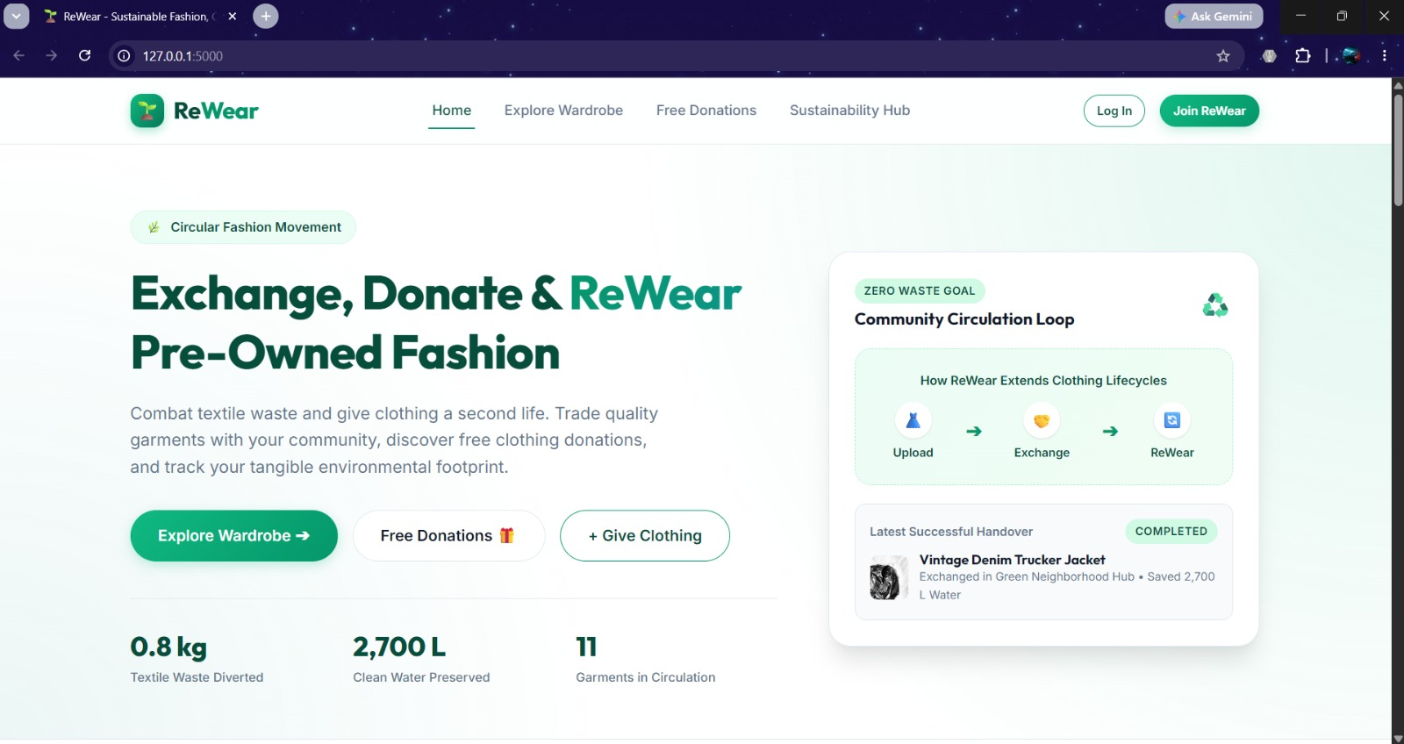

This page displays a catalog of pre-owned clothing listings categorized by size, condition, and location. Users can review item descriptions, owner details, and availability badges before initiating an exchange or request.
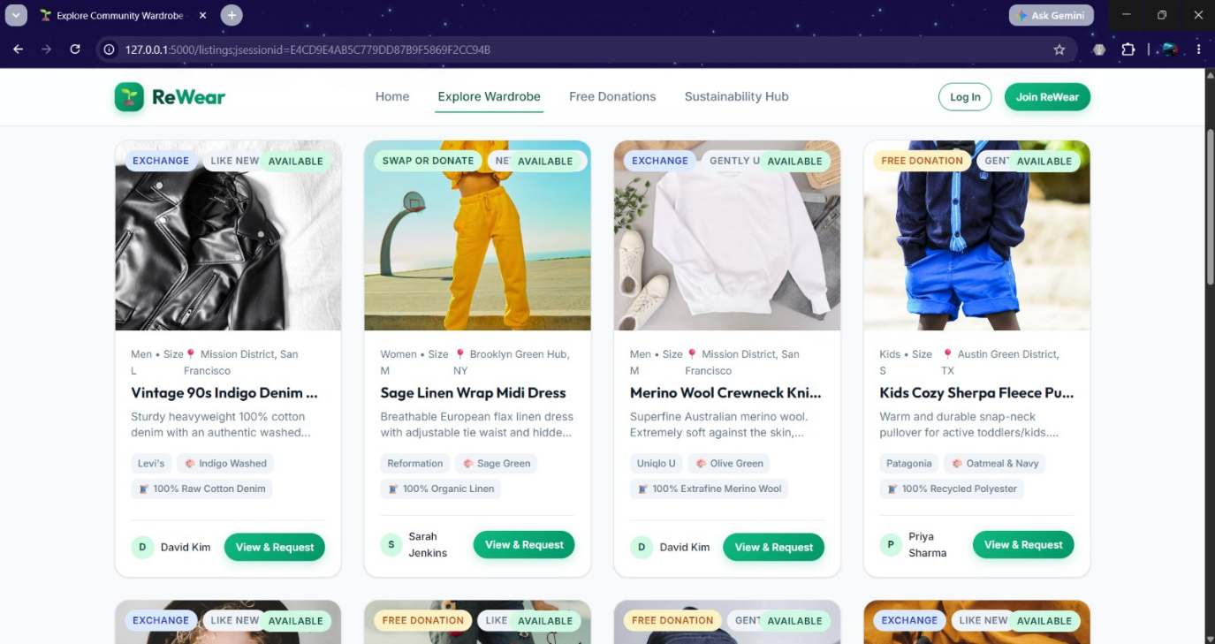
The community giving hub displays garments offered by platform members completely free of cost. It allows users to browse zero-cost clothing giveaways and directly request items for coordinate handovers.
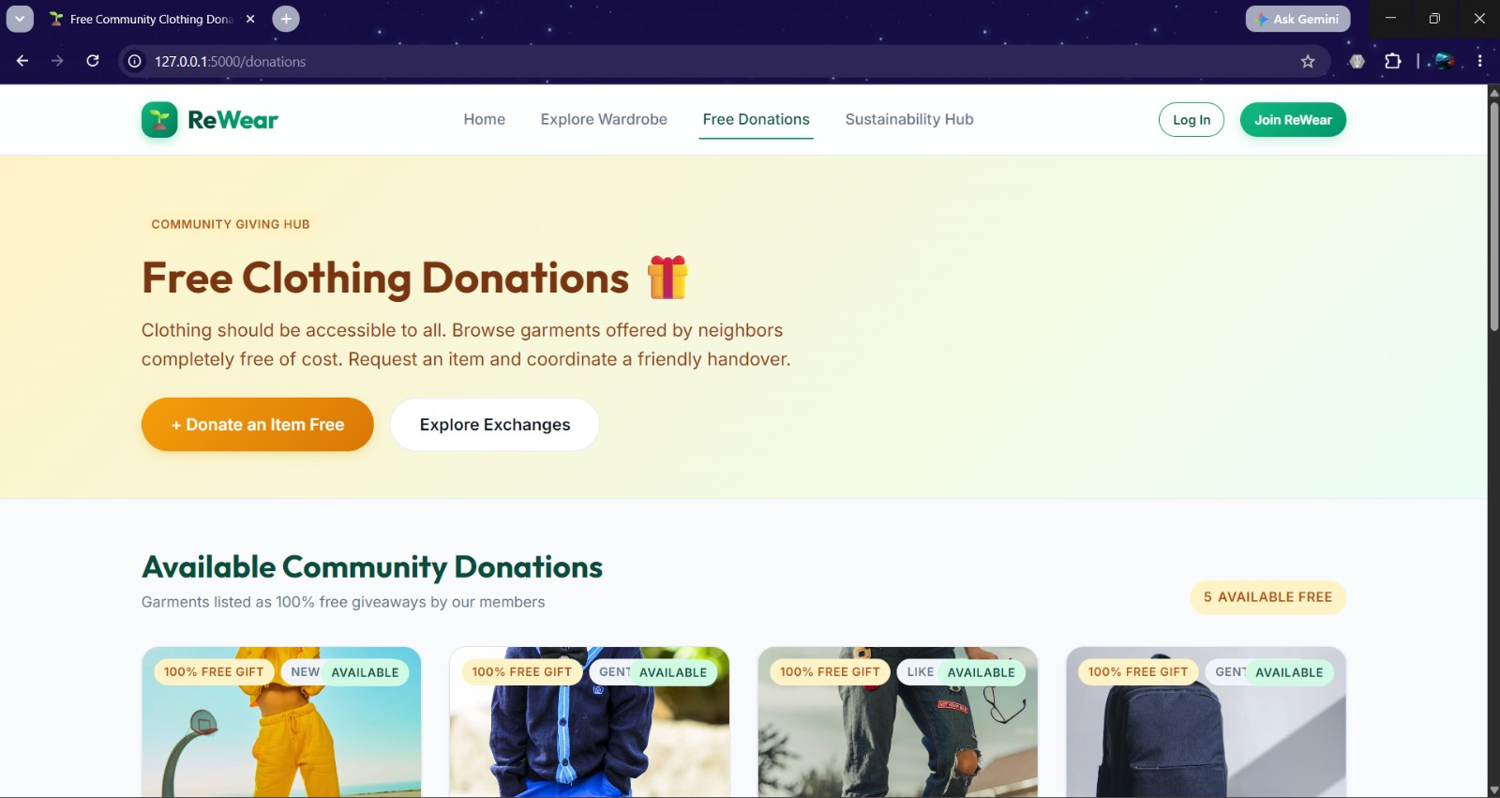

- CONCLUSION & FUTURE SCOPE

The ReWear platform successfully achieved its primary objective of developing a community-based, non-monetary digital marketplace to reduce textile waste and support sustainable fashion. All core functional requirements—including secure user authentication, clothing cataloging with detailed metadata (size, category, condition), advanced search and filtering, exchange request management, and administrative moderation—were fully implemented and verified. By providing a centralized solution for peer-to-peer exchanges and zero-cost donations, the platform simplifies clothing discovery, eliminates manual tracking friction, and offers tangible environmental impact tracking. Ultimately, ReWear demonstrates how modern web development and database management techniques can effectively address real-world environmental challenges through community-driven resource reuse.

Future Scope:
- In-App Messaging & Notifications: Integrate real-time chat between users to coordinate handovers, alongside automated email/push notifications for request status updates.
- Geolocation & Map Integration: Implement location-based search and interactive maps to help users easily discover clothing items available nearby.
- AI-Powered Recommendations & Auto-Tagging: Utilize AI to automatically tag garment attributes from uploaded photos and offer personalized clothing suggestions.
- User Ratings & Reviews: Introduce a community feedback system to build trust and accountability among trading partners.
- Mobile Applications & NGO Partnerships: Develop native mobile apps for iOS and Android, and partner with local recycling hubs or NGOs to streamline bulk donation logistics.

- REFERENCES

- Freecycle Network: https://www.freecycle.org
- Poshmark: https://poshmark.com
- ThredUp: https://www.thredup.com
- Vinted: https://www.vinted.com
- Share At Door Step (SADS): https://shareatdoorstep.com
- Python Software Foundation — Flask Documentation: https://flask.palletsprojects.com/
- MySQL Documentation & Reference Manual: https://dev.mysql.com/doc/
- MDN Web Docs — HTML, CSS, & JavaScript: https://developer.mozilla.org/
- Jinja2 Templating Engine Documentation: https://jinja.palletsprojects.com/
- Git Version Control System: https://git-scm.com/doc

