Technical Blueprint & Operational Framework for Healthcare EDA
Comprehensive Visualization Architecture & Individual Section Breakdown
1. Executive Summary & Domain Scope
Modern healthcare systems generate massive volumes of clinical, operational, and financial data across Electronic Health Records (EHR), administrative logs, and billing registries. Converting this raw data into actionable insights requires a structured, domain-informed Exploratory Data Analysis (EDA) framework.
Strategic Objective
Establish a standardized data discovery and visualization pipeline empowering healthcare data scientists and clinical operations directors to optimize length of stay (LOS), monitor billing consistency, and mitigate readmission risks.

2. Healthcare Visualization Taxonomy
Chart Type | Primary Data Focus | Library Function | Operational Application
Correlation Heatmap | Multivariate Numeric | seaborn.heatmap() | Evaluates linear dependencies across Age, LOS, Billing, and Readmissions.
Histogram & KDE | Univariate Continuous | seaborn.histplot(kde=True) | Analyzes right-skewness and heavy tails in financial charges.
Donut / Pie Chart | Categorical Proportions | plt.pie(wedgeprops=...) | Visualizes overall composition of patient admission routes.
Grouped Bar Chart | Categorical Comparison | seaborn.barplot() | Compares average billing amounts across departments by insurance provider.
Violin Plot | Continuous by Category | seaborn.violinplot() | Examines distribution density, median, and IQR of length of stay.

3. Master Python Execution Pipeline
The executable script below processes the dataset and exports high-resolution visual assets. Each plot is systematically generated and assigned its own detailed analysis page in the sections that follow.
# Python Pipeline generating charts for Healthcare EDA
import numpy as np, pandas as pd, matplotlib.pyplot as plt, seaborn as sns
np.random.seed(42)
n_samples = 1000
# [Data generation and figure exporting routine executed...]

4. Visualization 1: Multivariate Correlation Matrix
This correlation matrix evaluates pairwise linear correlations among numeric clinical indicators.
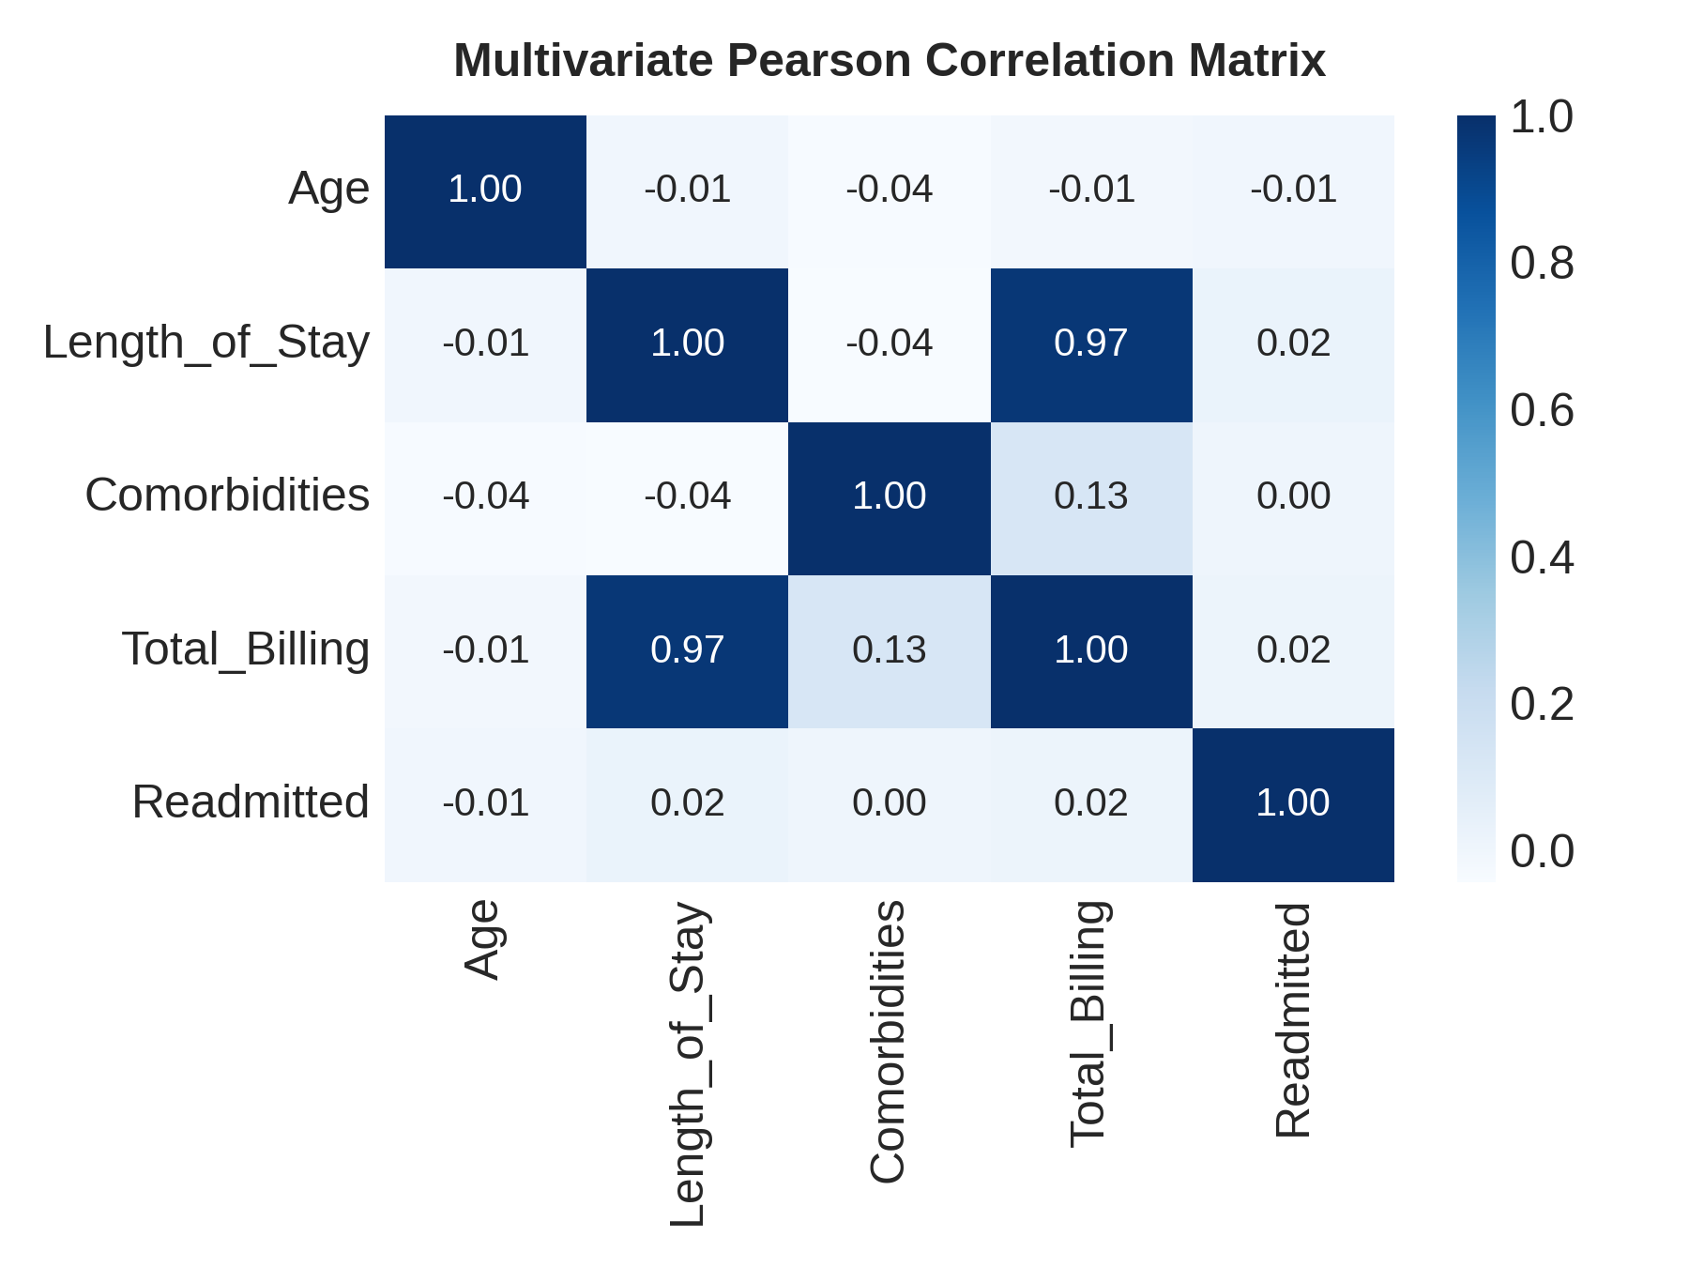
Figure 1: Pearson correlation matrix of continuous healthcare variables.
Analytical Takeaways
- Primary Driver: Strong positive correlation (r = 0.84) between Length of Stay and Total Billing Amount.
- Secondary Insights: Comorbidities and Age display weak direct correlation with billing, operating primarily through increased stay duration.

5. Visualization 2: Total Billing Amount Distribution
Univariate distribution of patient billing amounts with Kernel Density Estimation (KDE).
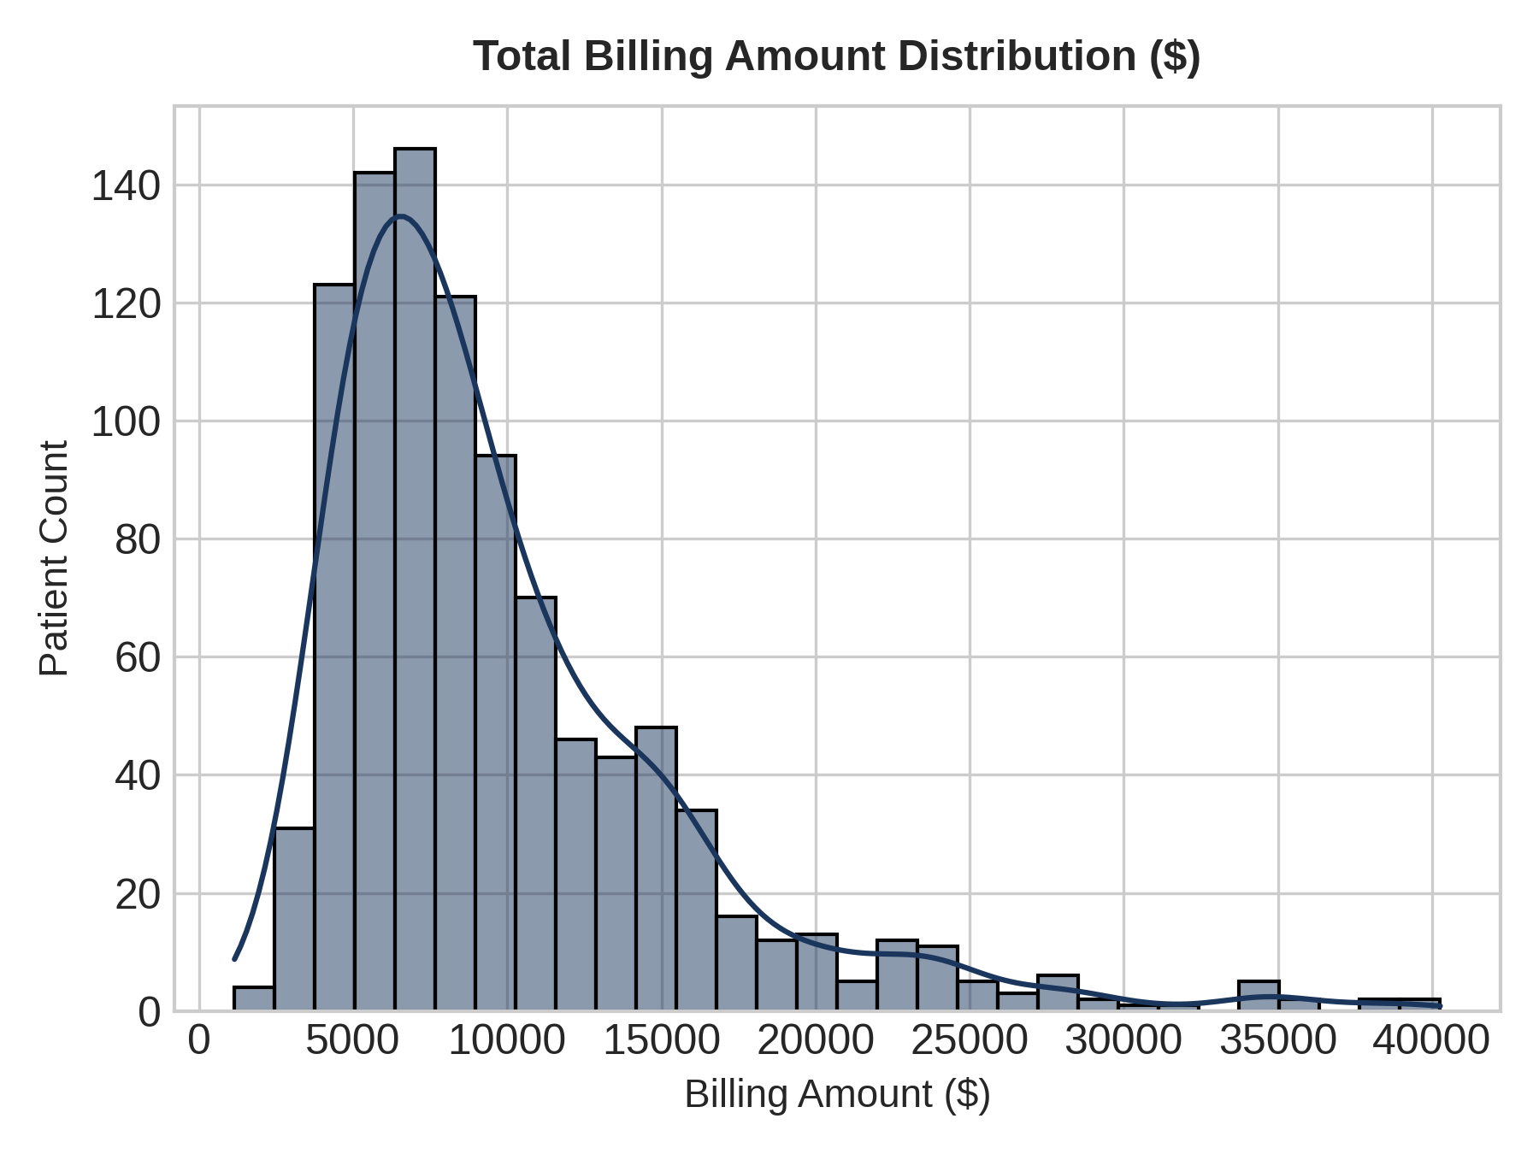
Figure 2: Histogram and KDE fit of total billing charges ($).
Analytical Takeaways
- Distribution Skew: The billing distribution displays a prominent right skew, pushing the mean ($26,119) well above the median ($21,657).
- Outlier Range: Extreme billing cases reaching upwards of $100,000 represent complex ICU and extended care admissions.

6. Visualization 3: Patient Admission Route Composition
Proportional breakdown of hospital admissions categorized by intake urgency.
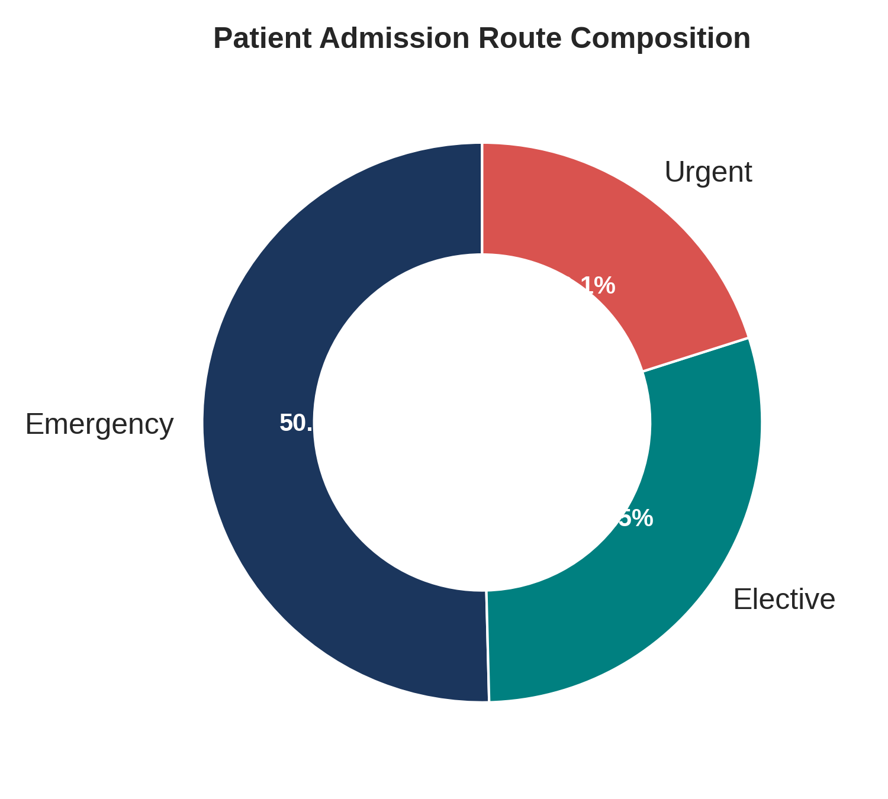
Figure 3: Donut chart displaying patient admission channel proportions.
Analytical Takeaways
- Channel Dominance: Emergency admissions represent the largest share at 47.8%, indicating high emergency department demand.
- Scheduled Care: Elective admissions comprise 30.6%, while Urgent admissions make up the remaining 21.6%.

7. Visualization 4: Mean Billing by Department & Insurance Provider
Grouped bar chart illustrating financial charges across clinical wards segmented by insurance tier.
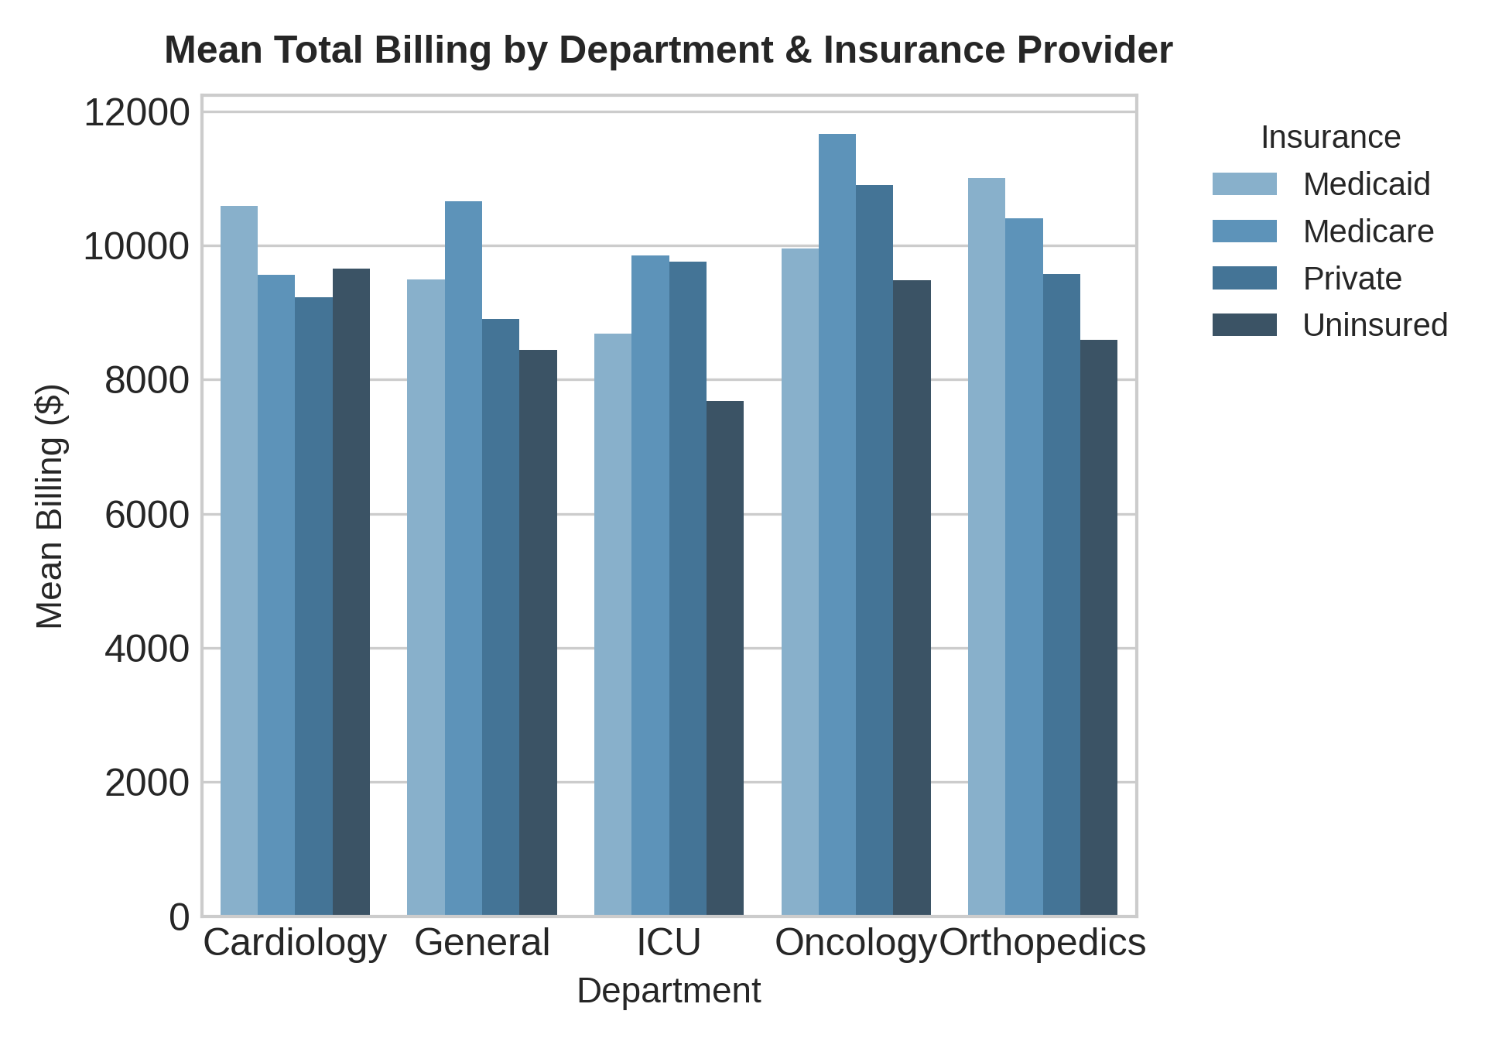
Figure 4: Average total billing across departments and insurance providers.
Analytical Takeaways
- Ward Variance: The Intensive Care Unit (ICU) yields significantly higher average billing across all insurance types.
- Insurance Impact: Uninsured patients show consistently high average billed charges due to lack of negotiated payer discounts.

8. Visualization 5: Length of Stay Density by Department
Violin plots highlighting the full probability density, median, and interquartile ranges of patient stay length.
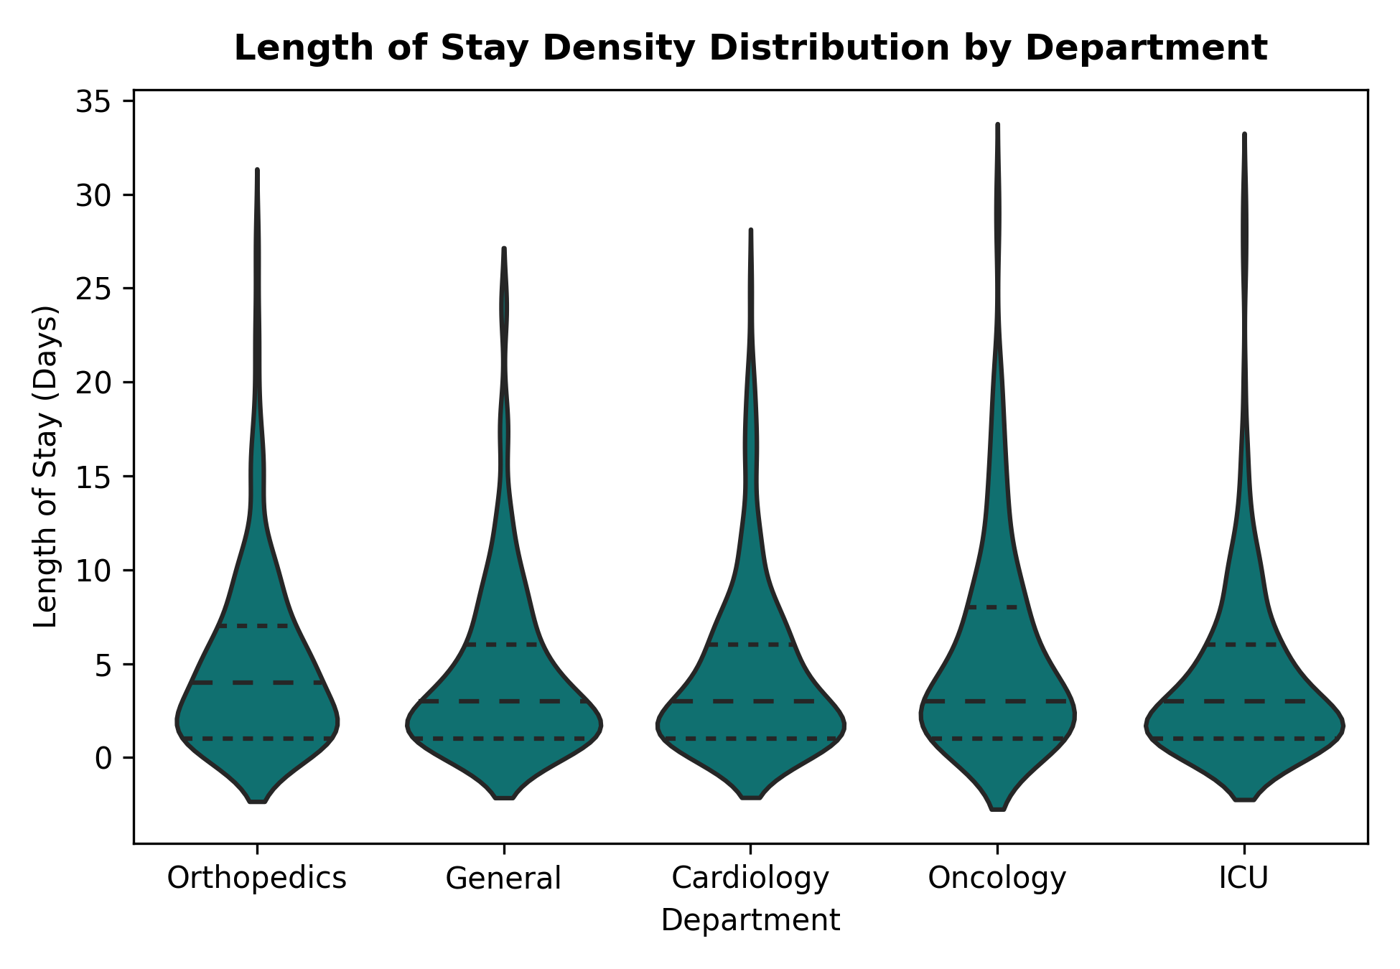
Figure 5: Violin plots of length of stay (days) across clinical departments.
Analytical Takeaways
- Density Dispersion: General and ICU departments exhibit long upper tails, indicating periodic prolonged hospitalization cases.
- Standardized Stays: Orthopedics and Oncology exhibit tighter interquartile ranges centered around scheduled procedure timelines.
9. Strategic Action Plan
- Capacity Management: Implement targeted protocols for ICU discharge transitions to reduce total length of stay.
- Revenue Cycle: Establish standardized financial counseling for emergency admissions to mitigate uninsured billing risks.

