**Pending no. 2**

**@HOI**

- Google ads conversion code is not available on order confirmation page yet - **Not working yet -** [**https://prnt.sc/vr7m0k**](https://prnt.sc/vr7m0k)

**Pending no. 3 -   
  
Bing Ads Conversion Tracking Dynamic Revenue - House Of Toners (HOT)**

We tested and found that the conversion is being tracked but the revenue (conversion value is not)

Could you please get it fixed?

These might help you & your dev team:

<https://support.bigcommerce.com/s/question/0D51B00003xd4zlSAA/finallya-working-solution-for-bing-ads-conversion-tracking>

<https://support.bigcommerce.com/s/article/Adding-Bing-Ads-Conversion-Tracking>

**For reference this below is the bing ads conversion code**

*<script>(function(w,d,t,r,u){var f,n,i;w[u]=w[u]||[],f=function(){var o={ti:"27008970"};o.q=w[u],w[u]=new UET(o),w[u].push("pageLoad")},n=d.createElement(t),n.src=r,n.async=1,n.onload=n.onreadystatechange=function(){var s=this.readyState;s&&s!=="loaded"&&s!=="complete"||(f(),n.onload=n.onreadystatechange=null)},i=d.getElementsByTagName(t)[0],i.parentNode.insertBefore(n,i)})(window,document,"script","//bat.bing.com/bat.js","uetq");window.uetq = window.uetq || [];window.uetq.push('event', '', { 'revenue_value': 'REPLACE_WITH_REVENUE_VALUE', 'currency': 'REPLACE_WITH_CURRENCY_CODE' });</script>*

**NOT WORKING - The revenue is not being tracked check the below screenshot:**

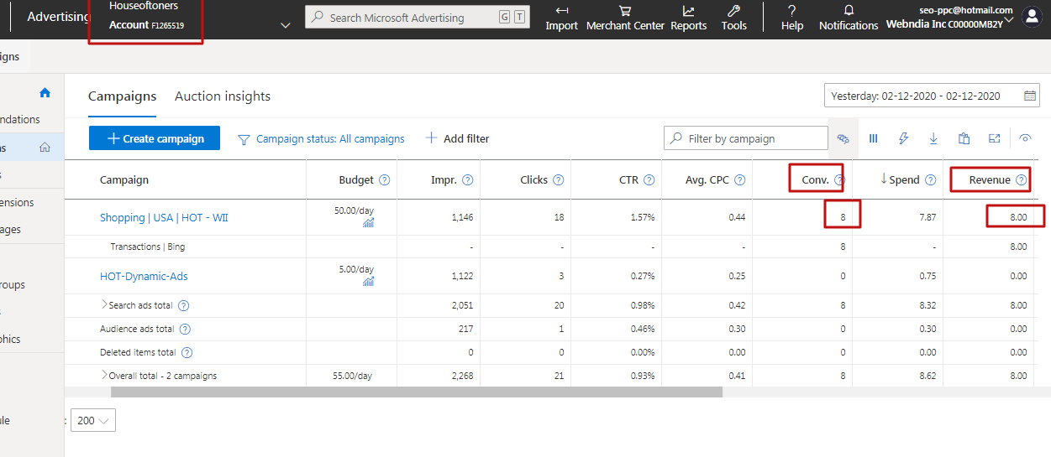

**Pending No. 5 - House Of Inks - Bing Ads Conversion Tag with dynamic revenue tracking**

Please add the below code to the order confirmation page only in the head section, in such a way that the total revenue can be tracked.  
*<script>*

*(function(w,d,t,r,u){var f,n,i;w[u]=w[u]||[],f=function(){var o={ti:"27012115"};o.q=w[u],w[u]=new UET(o),w[u].push("pageLoad")},n=d.createElement(t),n.src=r,n.async=1,n.onload=n.onreadystatechange=function(){var s=this.readyState;s&&s!=="loaded"&&s!=="complete"||(f(),n.onload=n.onreadystatechange=null)},i=d.getElementsByTagName(t)[0],i.parentNode.insertBefore(n,i)})(window,document,"script","//bat.bing.com/bat.js","uetq");*

*window.uetq = window.uetq || [];*

*window.uetq.push('event', '', { 'revenue_value': 'REPLACE_WITH_REVENUE_VALUE', 'currency': 'REPLACE_WITH_CURRENCY_CODE' });*

*</script>*

These might help you:

<https://support.bigcommerce.com/s/question/0D51B00003xd4zlSAA/finallya-working-solution-for-bing-ads-conversion-tracking>

<https://support.bigcommerce.com/s/article/Adding-Bing-Ads-Conversion-Tracking>

* **Not working**

**Pending No. 6**

<https://prnt.sc/vtkthw>

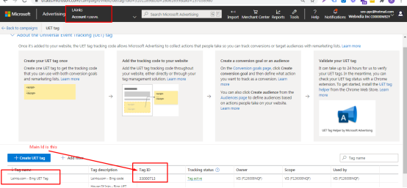

**Remove this script -**

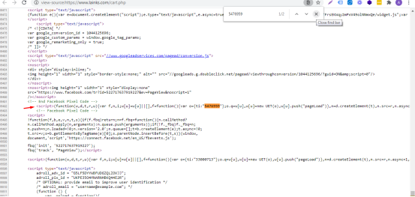

**Pending No. 7 - LAINKS - Bing Ads Conversion Tag with dynamic revenue tracking**

Please add the below code to the order confirmation page in the head section, in such a way that the total suborder (revenue) can be tracked.

*<script>(function(w,d,t,r,u){var f,n,i;w[u]=w[u]||[],f=function(){var o={ti:"33000713"};o.q=w[u],w[u]=new UET(o),w[u].push("pageLoad")},n=d.createElement(t),n.src=r,n.async=1,n.onload=n.onreadystatechange=function(){var s=this.readyState;s&&s!=="loaded"&&s!=="complete"||(f(),n.onload=n.onreadystatechange=null)},i=d.getElementsByTagName(t)[0],i.parentNode.insertBefore(n,i)})(window,document,"script","//bat.bing.com/bat.js","uetq");window.uetq = window.uetq || [];window.uetq.push('event', '', { 'revenue_value': 'REPLACE_WITH_REVENUE_VALUE', 'currency': 'REPLACE_WITH_CURRENCY_CODE' });</script>*

These might help you:

<https://support.bigcommerce.com/s/question/0D51B00003xd4zlSAA/finallya-working-solution-for-bing-ads-conversion-tracking>

<https://support.bigcommerce.com/s/article/Adding-Bing-Ads-Conversion-Tracking>

**Latest Feedback: 8th December**

**1. HOI - Google Analytics working now + Google ads pending**

**2. Lainks - Google Analytics + Google Ads both working now**

**3. HOT Bing ads - https://prnt.sc/vxzm0f - not working**

**4. HOI Bing ads - https://prnt.sc/vxznu2 - not working**

**5. Lainks Bing ads - https://prnt.sc/vxzpm4 - not working - as we can see google analytics shows there is 1 conversion that means no bing ads code on thank you order confirmation page**

**Thank you!**