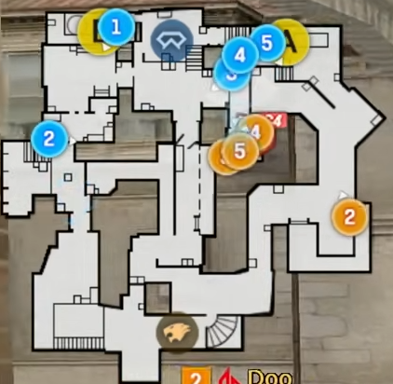
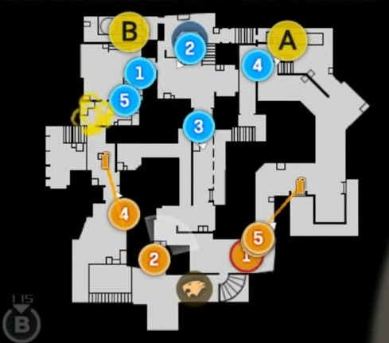
FORMATION 1-1-3
FORMATION 0-4-1
POS 2 (SNIPER) – MOVE TO CONTROL LA.
POS 1,3,4,5 – MOVE TO CONTROL S.
POS 3 – USE FLASH
REST – PREPARE FOR ENTRY/CLEAR.
POS 1,3,5 – CONTROL LA / SMOKE LA
POS 2 (SNIPER)– CONTROL MID
POS 4 – CONTROL SEW / SMOKE HOUSE
*/ HOLD FOR 30 SECONDS WAIT FOR INFO/RUSH
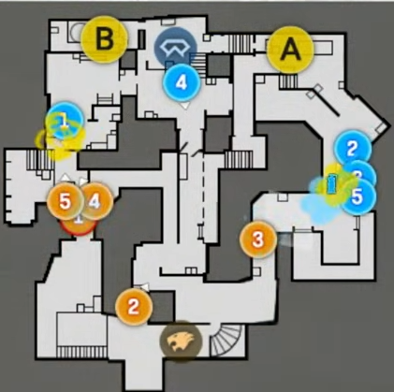
FORMATION 3-1-1
POS 1,4,5 – CONTROL LB / SMOKE HB
POS 2 (SNIPER)– CONTROL MID
POS 3 – INFO LA / SMOKE LA
*/ HOLD FOR 30 SECONDS WAIT FOR INFO/RUSH
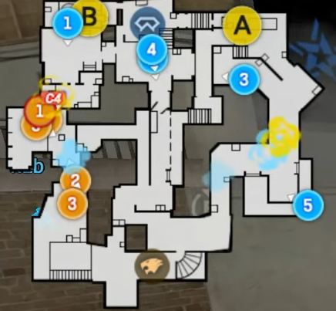

FORMATION ALL-B
POS 1,4,5 – ENTRY/CLEAR
POS 2 (SNIPER)– FLASH HB / BACKUP
POS 3 – SMOKE DOOR-BBACKUP
*/ HOLD FOR 30 SECONDS WAIT FOR INFO/RUSH

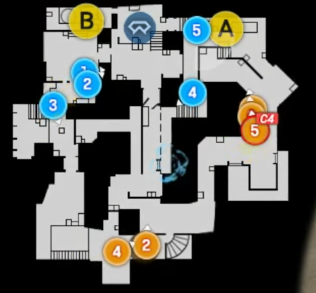

FORMATION 1-1-3
FORMATION 0-2-3
POS 1,3,5 – FAST CLEAR A
POS 2 (SNIPER)– CONTROL MID
POS 4 – BACKUP AT SHORT
*/ FAST A TAKE

POS 1,3,5 – CONTROL LA / SMOKE LA
POS 2 (SNIPER)– CONTROL MID
POS 4 – MAKE NOISE AT HB
*/ FAST A TAKE

