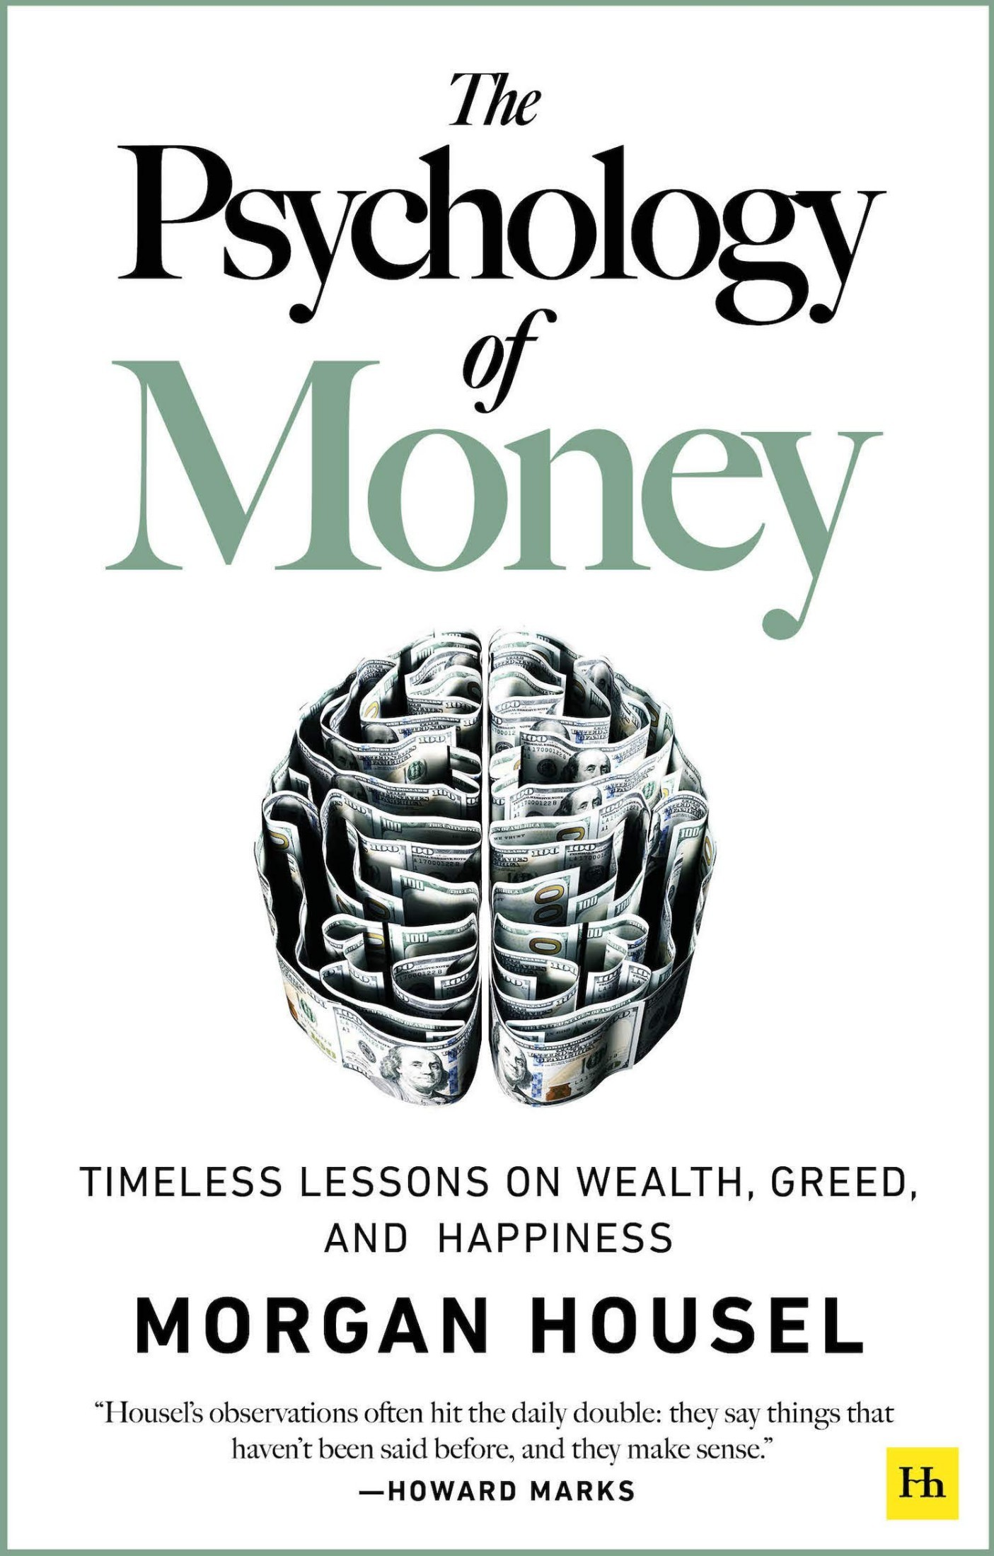

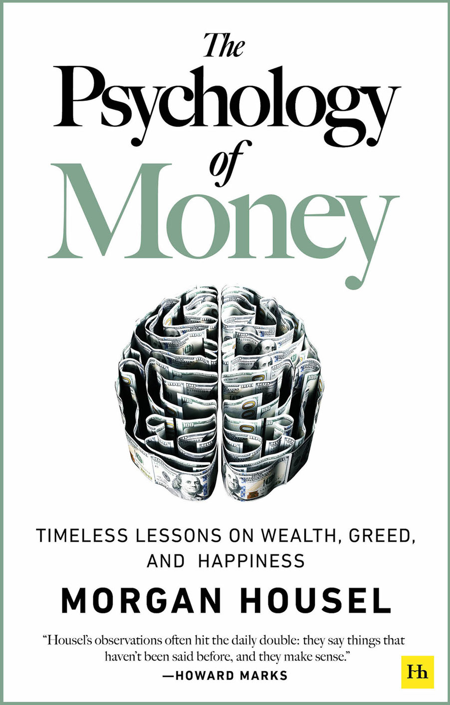

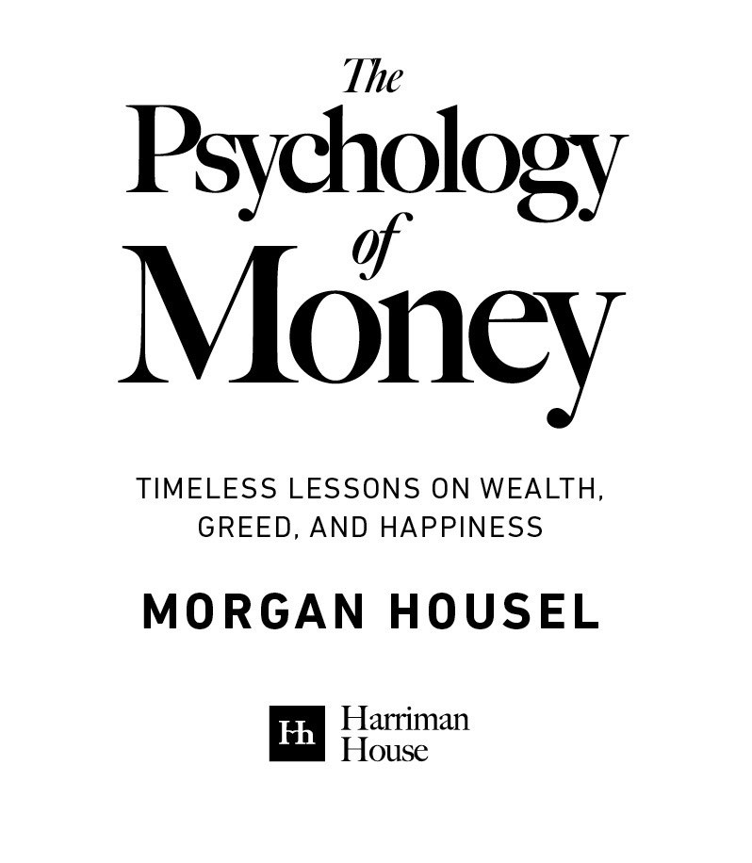

For

My parents, who teach me.

Gretchen, who guides me.

Miles and Reese, who inspire me.



Introduction: The Greatest Show On Earth

1. No One’s Crazy

2. Luck & Risk

3. Never Enough

4. Confounding Compounding

5. Getting Wealthy vs. Staying Wealthy

6. Tails, You Win

7. Freedom

8. Man in the Car Paradox

9. Wealth is What You Don’t See

10. Save Money

11. Reasonable > Rational

12. Surprise!

13. Room for Error

14. You’ll Change

15. Nothing’s Free

16. You & Me

17. The Seduction of Pessimism

18. When You’ll Believe Anything

19. All Together Now

20. Confessions

Postscript: A Brief History of Why the U.S. Consumer Thinks the Way They Do

Endnotes

Acknowledgements

Publishing details

“A genius is the man who can do the average thing when

everyone else around him is losing his mind.”

—Napoleon

“The world is full of obvious things which nobody by any

chance ever observes.”

—Sherlock Holmes

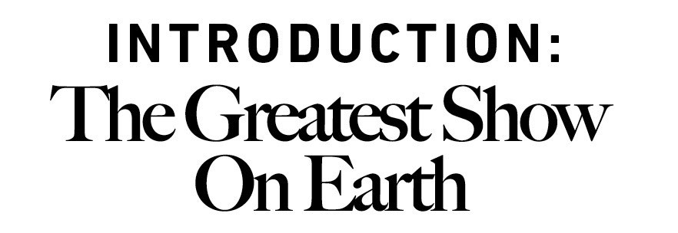

Ispent my college years working as a valet at a nice hotel in Los Angeles.

One frequent guest was a technology executive. He was a genius, having designed and

patented a key component in Wi-Fi routers in his 20s. He had started and sold several

companies. He was wildly successful.

He also had a relationship with money I’d describe as a mix of insecurity and childish

stupidity.

He carried a stack of hundred dollar bills several inches thick. He showed it to everyone

who wanted to see it and many who didn’t. He bragged openly and loudly about his wealth,

often while drunk and always apropos of nothing.

One day he handed one of my colleagues several thousand dollars of cash and said, “Go to

the jewelry store down the street and get me a few $1,000 gold coins.”

An hour later, gold coins in hand, the tech executive and his buddies gathered around by a

dock overlooking the Paciﬁc Ocean. They then proceeded to throw the coins into the sea,

skipping them like rocks, cackling as they argued whose went furthest. Just for fun.

Days later he shattered a lamp in the hotel’s restaurant. A manager told him it was a $500

lamp and he’d have to replace it.

“You want ﬁve hundred dollars?” the executive asked incredulously, while pulling a brick of

cash from his pocket and handing it to the manager. “Here’s ﬁve thousand dollars. Now get

out of my face. And don’t ever insult me like that again.”

You may wonder how long this behavior could last, and the answer was “not long.” I learned

years later that he went broke.

The premise of this book is that doing well with money has a little to do with how smart you

are and a lot to do with how you behave. And behavior is hard to teach, even to really smart

people.

A genius who loses control of their emotions can be a ﬁnancial disaster. The opposite is also

true. Ordinary folks with no ﬁnancial education can be wealthy if they have a handful of

behavioral skills that have nothing to do with formal measures of intelligence.

My favorite Wikipedia entry begins: “Ronald James Read was an American philanthropist,

investor, janitor, and gas station attendant.”

Ronald Read was born in rural Vermont. He was the ﬁrst person in his family to graduate

high school, made all the more impressive by the fact that he hitchhiked to campus each

day.

For those who knew Ronald Read, there wasn’t much else worth mentioning. His life was

about as low key as they come.

Read ﬁxed cars at a gas station for 25 years and swept ﬂoors at JCPenney for 17 years. He

bought a two-bedroom house for $12,000 at age 38 and lived there for the rest of his life.

He was widowed at age 50 and never remarried. A friend recalled that his main hobby was

chopping ﬁrewood.

Read died in 2014, age 92. Which is when the humble rural janitor made international

headlines.

2,813,503 Americans died in 2014. Fewer than 4,000 of them had a net worth of over $8

million when they passed away. Ronald Read was one of them.

In his will the former janitor left $2 million to his stepkids and more than $6 million to his

local hospital and library.

Those who knew Read were baﬄed. Where did he get all that money?

It turned out there was no secret. There was no lottery win and no inheritance. Read saved

what little he could and invested it in blue chip stocks. Then he waited, for decades on end,

as tiny savings compounded into more than $8 million.

That’s it. From janitor to philanthropist.

A few months before Ronald Read died, another man named Richard was in the news.

Richard Fuscone was everything Ronald Read was not. A Harvard-educated Merrill Lynch

executive with an MBA, Fuscone had such a successful career in ﬁnance that he retired in

his 40s to become a philanthropist. Former Merrill CEO David Komansky praised Fuscone’s

“business savvy, leadership skills, sound judgment and personal integrity.”¹ Crain’s

business magazine once included him in a “40 under 40” list of successful businesspeople.²

But then—like the gold-coin-skipping tech executive—everything fell apart.

In the mid-2000s Fuscone borrowed heavily to expand an 18,000-square foot home in

Greenwich, Connecticut that had 11 bathrooms, two elevators, two pools, seven garages,

and cost more than $90,000 a month to maintain.

Then the 2008 ﬁnancial crisis hit.

The crisis hurt virtually everyone’s ﬁnances. It apparently turned Fuscone’s into dust. High

debt and illiquid assets left him bankrupt. “I currently have no income,” he allegedly told a

bankruptcy judge in 2008.

First his Palm Beach house was foreclosed.

In 2014 it was the Greenwich mansion’s turn.

Five months before Ronald Read left his fortune to charity, Richard Fuscone’s home—where

guests recalled the “thrill of dining and dancing atop a see-through covering on the home’s

indoor swimming pool”—was sold in a foreclosure auction for 75% less than an insurance

company ﬁgured it was worth.³

Ronald Read was patient; Richard Fuscone was greedy. That’s all it took to eclipse the

massive education and experience gap between the two.

The lesson here is not to be more like Ronald and less like Richard—though that’s not bad

advice.

The fascinating thing about these stories is how unique they are to ﬁnance.

In what other industry does someone with no college degree, no training, no background,

no formal experience, and no connections massively outperform someone with the best

education, the best training, and the best connections?

I struggle to think of any.

It is impossible to think of a story about Ronald Read performing a heart transplant better

than a Harvard-trained surgeon. Or designing a skyscraper superior to the best-trained

architects. There will never be a story of a janitor outperforming the world’s top nuclear

engineers.

But these stories do happen in investing.

The fact that Ronald Read can coexist with Richard Fuscone has two explanations. One,

ﬁnancial outcomes are driven by luck, independent of intelligence and eﬀort. That’s true to

some extent, and this book will discuss it in further detail. Or, two (and I think more

common), that ﬁnancial success is not a hard science. It’s a soft skill, where how you

behave is more important than what you know.

I call this soft skill the psychology of money. The aim of this book is to use short stories to

convince you that soft skills are more important than the technical side of money. I’ll do this

in a way that will help everyone—from Read to Fuscone and everyone in between—make

better ﬁnancial decisions.

These soft skills are, I’ve come to realize, greatly underappreciated.

Finance is overwhelmingly taught as a math-based ﬁeld, where you put data into a formula

and the formula tells you what to do, and it’s assumed that you’ll just go do it.

This is true in personal ﬁnance, where you’re told to have a six-month emergency fund and

save 10% of your salary.

It’s true in investing, where we know the exact historical correlations between interest rates

and valuations.

And it’s true in corporate ﬁnance, where CFOs can measure the precise cost of capital.

It’s not that any of these things are bad or wrong. It’s that knowing what to do tells you

nothing about what happens in your head when you try to do it.

Two topics impact everyone, whether you are interested in them or not: health and money.

The health care industry is a triumph of modern science, with rising life expectancy across

the world. Scientiﬁc discoveries have replaced doctors’ old ideas about how the human

body works, and virtually everyone is healthier because of it.

The money industry—investing, personal ﬁnance, business planning—is another story.

Finance has scooped up the smartest minds coming from top universities over the last two

decades. Financial Engineering was the most popular major in Princeton’s School of

Engineering a decade ago. Is there any evidence it has made us better investors?

I have seen none.

Through collective trial and error over the years we learned how to become better farmers,

skilled plumbers, and advanced chemists. But has trial and error taught us to become

better with our personal ﬁnances? Are we less likely to bury ourselves in debt? More likely

to save for a rainy day? Prepare for retirement? Have realistic views about what money

does, and doesn’t do, to our happiness?

I’ve seen no compelling evidence.

Most of the reason why, I believe, is that we think about and are taught about money in

ways that are too much like physics (with rules and laws) and not enough like psychology

(with emotions and nuance).

And that, to me, is as fascinating as it is important.

Money is everywhere, it aﬀects all of us, and confuses most of us. Everyone thinks about it a

little diﬀerently. It oﬀers lessons on things that apply to many areas of life, like risk,

conﬁdence, and happiness. Few topics oﬀer a more powerful magnifying glass that helps

explain why people behave the way they do than money. It is one of the greatest shows on

Earth.

My own appreciation for the psychology of money is shaped by more than a decade of

writing on the topic. I began writing about ﬁnance in early 2008. It was the dawn of a

ﬁnancial crisis and the worst recession in 80 years.

To write about what was happening, I wanted to ﬁgure out what was happening. But the

ﬁrst thing I learned after the ﬁnancial crisis was that no one could accurately explain what

happened, or why it happened, let alone what should be done about it. For every good

explanation there was an equally convincing rebuttal.

Engineers can determine the cause of a bridge collapse because there’s agreement that if a

certain amount of force is applied to a certain area, that area will break. Physics isn’t

controversial. It’s guided by laws. Finance is diﬀerent. It’s guided by people’s behaviors.

And how I behave might make sense to me but look crazy to you.

The more I studied and wrote about the ﬁnancial crisis, the more I realized that you could

understand it better through the lenses of psychology and history, not ﬁnance.

To grasp why people bury themselves in debt you don’t need to study interest rates; you

need to study the history of greed, insecurity, and optimism. To get why investors sell out at

the bottom of a bear market you don’t need to study the math of expected future returns;

you need to think about the agony of looking at your family and wondering if your

investments are imperiling their future.

I love Voltaire’s observation that “History never repeats itself; man always does.” It applies

so well to how we behave with money.

In 2018, I wrote a report outlining 20 of the most important ﬂaws, biases, and causes of

bad behavior I’ve seen aﬀect people when dealing with money. It was called The Psychology

of Money, and over one million people have read it. This book is a deeper dive into the

topic. Some short passages from the report appear unaltered in this book.

What you’re holding is 20 chapters, each describing what I consider to be the most

important and often counterintuitive features of the psychology of money. The chapters

revolve around a common theme, but exist on their own and can be read independently.

It’s not a long book. You’re welcome. Most readers don’t ﬁnish the books they begin

because most single topics don’t require 300 pages of explanation. I’d rather make 20 short

points you ﬁnish than one long one you give up on.

On we go.

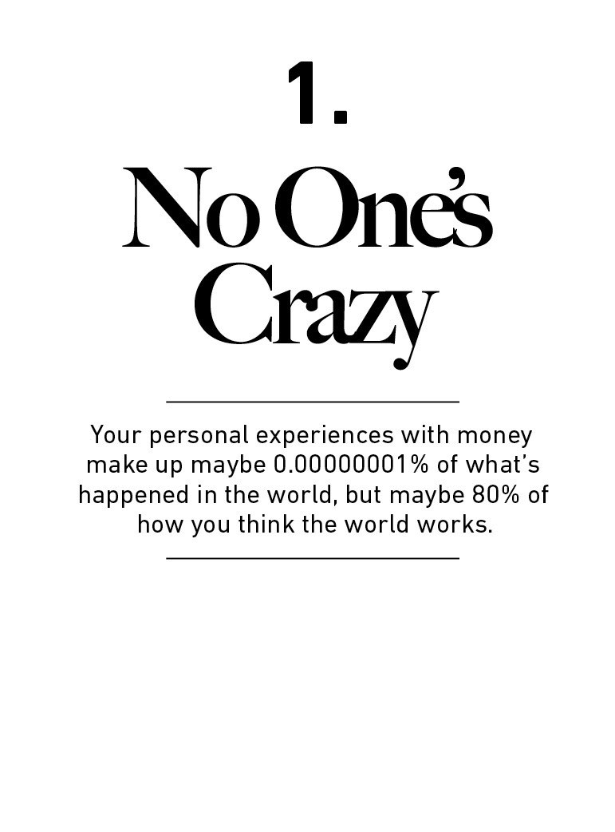

Let me tell you about a problem. It might make you feel better

about what you do with your money, and less judgmental

about what other people do with theirs.

People do some crazy things with money. But no one is crazy.

Here’s the thing: People from diﬀerent generations, raised by

diﬀerent parents who earned diﬀerent incomes and held

diﬀerent values, in diﬀerent parts of the world, born into

diﬀerent economies, experiencing diﬀerent job markets with

diﬀerent incentives and diﬀerent degrees of luck, learn very

diﬀerent lessons.

Everyone has their own unique experience with how the world

works. And what you’ve experienced is more compelling than

what you learn second-hand. So all of us—you, me, everyone—

go through life anchored to a set of views about how money

works that vary wildly from person to person. What seems

crazy to you might make sense to me.

The person who grew up in poverty thinks about risk and

reward in ways the child of a wealthy banker cannot fathom if

he tried.

The person who grew up when inﬂation was high experienced

something the person who grew up with stable prices never

had to.

The stock broker who lost everything during the Great

Depression experienced something the tech worker basking in

the glory of the late 1990s can’t imagine.

The Australian who hasn’t seen a recession in 30 years has

experienced something no American ever has.

On and on. The list of experiences is endless.

You know stuﬀ about money that I don’t, and vice versa. You go

through life with diﬀerent beliefs, goals, and forecasts, than I

do. That’s not because one of us is smarter than the other, or

has better information. It’s because we’ve had diﬀerent lives

shaped by diﬀerent and equally persuasive experiences.

Your personal experiences with money make up maybe

0.00000001% of what’s happened in the world, but maybe

80% of how you think the world works. So equally smart

people can disagree about how and why recessions happen,

how you should invest your money, what you should prioritize,

how much risk you should take, and so on.

In his book on 1930s America, Frederick Lewis Allen wrote that

the Great Depression “marked millions of Americans—inwardly

—for the rest of their lives.” But there was a range of

experiences. Twenty-ﬁve years later, as he was running for

president, John F. Kennedy was asked by a reporter what he

remembered from the Depression. He remarked:

I have no ﬁrst-hand knowledge of the Depression. My family

had one of the great fortunes of the world and it was worth

more than ever then. We had bigger houses, more servants, we

traveled more. About the only thing that I saw directly was

when my father hired some extra gardeners just to give them a

job so they could eat. I really did not learn about the

Depression until I read about it at Harvard.

This was a major point in the 1960 election. How, people

thought, could someone with no understanding of the biggest

economic story of the last generation be put in charge of the

economy? It was, in many ways, overcome only by JFK’s

experience in World War II. That was the other most

widespread emotional experience of the previous generation,

and something his primary opponent, Hubert Humphrey, didn’t

have.

The challenge for us is that no amount of studying or open-

mindedness can genuinely recreate the power of fear and

uncertainty.

I can read about what it was like to lose everything during the

Great Depression. But I don’t have the emotional scars of those

who actually experienced it. And the person who lived through

it can’t fathom why someone like me could come across as

complacent about things like owning stocks. We see the world

through a diﬀerent lens.

Spreadsheets can model the historic frequency of big stock

market declines. But they can’t model the feeling of coming

home, looking at your kids, and wondering if you’ve made a

mistake that will impact their lives. Studying history makes you

feel like you understand something. But until you’ve lived

through it and personally felt its consequences, you may not

understand it enough to change your behavior.

We all think we know how the world works. But we’ve all only

experienced a tiny sliver of it.

As investor Michael Batnick says, “some lessons have to be

experienced before they can be understood.” We are all

victims, in diﬀerent ways, to that truth.

In 2006 economists Ulrike Malmendier and Stefan Nagel from

the National Bureau of Economic Research dug through 50

years of the Survey of Consumer Finances—a detailed look at

what Americans do with their money.⁴

In theory people should make investment decisions based on

their goals and the characteristics of the investment options

available to them at the time.

But that’s not what people do.

The economists found that people’s lifetime investment

decisions are heavily anchored to the experiences those

investors had in their own generation—especially experiences

early in their adult life.

If you grew up when inﬂation was high, you invested less of

your money in bonds later in life compared to those who grew

up when inﬂation was low. If you happened to grow up when

the stock market was strong, you invested more of your money

in stocks later in life compared to those who grew up when

stocks were weak.

The economists wrote: “Our ﬁndings suggest that individual

investors’ willingness to bear risk depends on personal history.”

Not intelligence, or education, or sophistication. Just the dumb

luck of when and where you were born.

The Financial Times interviewed Bill Gross, the famed bond

manager, in 2019. “Gross admits that he would probably not

be where he is today if he had been born a decade earlier or

later,” the piece said. Gross’s career coincided almost perfectly

with a generational collapse in interest rates that gave bond

prices a tailwind. That kind of thing doesn’t just aﬀect the

opportunities you come across; it aﬀects what you think about

those opportunities when they’re presented to you. To Gross,

bonds were wealth-generating machines. To his father’s

generation, who grew up with and endured higher inﬂation,

they might be seen as wealth incinerators.

The diﬀerences in how people have experienced money are not

small, even among those you might think are pretty similar.

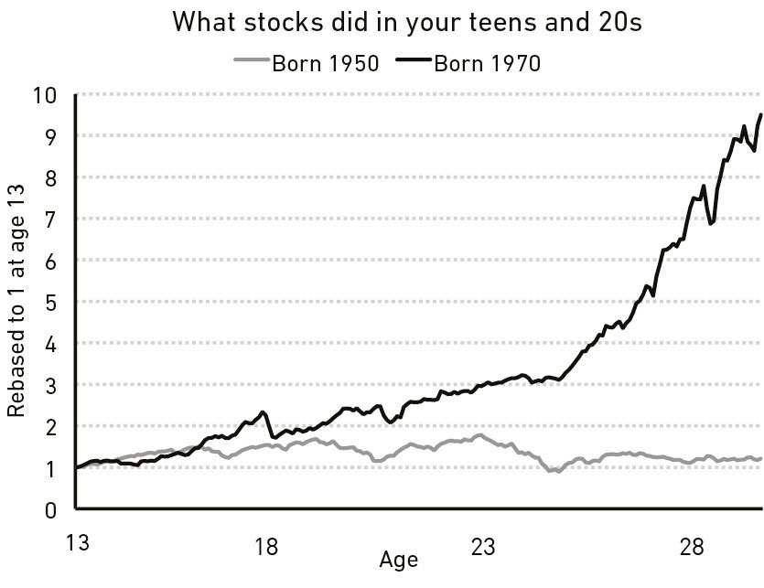

Take stocks. If you were born in 1970, the S&P 500 increased

almost 10-fold, adjusted for inﬂation, during your teens and

20s. That’s an amazing return. If you were born in 1950, the

market went literally nowhere in your teens and 20s adjusted

for inﬂation. Two groups of people, separated by chance of

their birth year, go through life with a completely diﬀerent

view on how the stock market works:

Or inﬂation. If you were born in 1960s America, inﬂation during

your teens and 20s—your young, impressionable years when

you’re developing a base of knowledge about how the

economy works—sent prices up more than threefold. That’s a

lot. You remember gas lines and getting paychecks that

stretched noticeably less far than the ones before them. But if

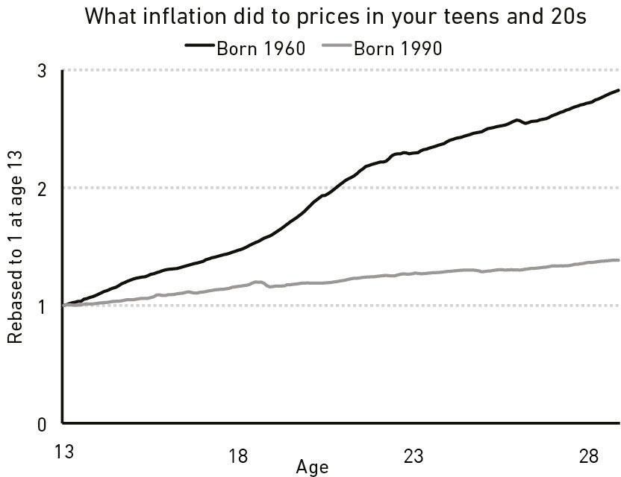

you were born in 1990, inﬂation has been so low for your whole

life that it’s probably never crossed your mind.

America’s nationwide unemployment in November 2009 was

around 10%. But the unemployment rate for African American

males age 16 to 19 without a high school diploma was 49%.

For Caucasian females over age 45 with a college degree, it

was 4%.

Local stock markets in Germany and Japan were wiped out

during World War II. Entire regions were bombed out. At the

end of the war German farms only produced enough food to

provide the country’s citizens with 1,000 calories a day.

Compare that to the U.S., where the stock market more than

doubled from 1941 through the end of 1945, and the economy

was the strongest it had been in almost two decades.

No one should expect members of these groups to go through

the rest of their lives thinking the same thing about inﬂation.

Or the stock market. Or unemployment. Or money in general.

No one should expect them to respond to ﬁnancial information

the same way. No one should assume they are inﬂuenced by

the same incentives.

No one should expect them to trust the same sources of advice.

No one should expect them to agree on what matters, what’s

worth it, what’s likely to happen next, and what the best path

forward is.

Their view of money was formed in diﬀerent worlds. And when

that’s the case, a view about money that one group of people

thinks is outrageous can make perfect sense to another.

A few years ago, The New York Times did a story on the working

conditions of Foxconn, the massive Taiwanese electronics

manufacturer. The conditions are often atrocious. Readers were

rightly upset. But a fascinating response to the story came

from the nephew of a Chinese worker, who wrote in the

comment section:

My aunt worked several years in what Americans call “sweat

shops.” It was hard work. Long hours, “small” wage, “poor”

working conditions. Do you know what my aunt did before she

worked in one of these factories? She was a prostitute.

The idea of working in a “sweat shop” compared to that old

lifestyle is an improvement, in my opinion. I know that my aunt

would rather be “exploited” by an evil capitalist boss for a

couple of dollars than have her body be exploited by several

men for pennies.

That is why I am upset by many Americans’ thinking. We do

not have the same opportunities as the West. Our

governmental infrastructure is diﬀerent. The country is

diﬀerent. Yes, factory is hard labor. Could it be better? Yes, but

only when you compare such to American jobs.

I don’t know what to make of this. Part of me wants to argue,

ﬁercely. Part of me wants to understand. But mostly it’s an

example of how diﬀerent experiences can lead to vastly

diﬀerent views within topics that one side intuitively thinks

should be black and white.

Every decision people make with money is justiﬁed by taking

the information they have at the moment and plugging it into

their unique mental model of how the world works.

Those people can be misinformed. They can have incomplete

information. They can be bad at math. They can be persuaded

by rotten marketing. They can have no idea what they’re doing.

They can misjudge the consequences of their actions. Oh, can

they ever.

But every ﬁnancial decision a person makes, makes sense to

them in that moment and checks the boxes they need to

check. They tell themselves a story about what they’re doing

and why they’re doing it, and that story has been shaped by

their own unique experiences.

Take a simple example: lottery tickets.

Americans spend more on them than movies, video games,

music, sporting events, and books combined.

And who buys them? Mostly poor people.

The lowest-income households in the U.S. on average spend

$412 a year on lotto tickets, four times the amount of those in

the highest income groups. Forty percent of Americans cannot

come up with $400 in an emergency. Which is to say: Those

buying $400 in lottery tickets are by and large the same people

who say they couldn’t come up with $400 in an emergency.

They are blowing their safety nets on something with a one-in-

millions chance of hitting it big.

That seems crazy to me. It probably seems crazy to you, too.

But I’m not in the lowest income group. You’re likely not, either.

So it’s hard for many of us to intuitively grasp the subconscious

reasoning of low-income lottery ticket buyers.

But strain a little, and you can imagine it going something like

this:

We live paycheck-to-paycheck and saving seems out of reach.

Our prospects for much higher wages seem out of reach. We

can’t aﬀord nice vacations, new cars, health insurance, or

homes in safe neighborhoods. We can’t put our kids through

college without crippling debt. Much of the stuﬀ you people

who read ﬁnance books either have now, or have a good

chance of getting, we don’t. Buying a lottery ticket is the only

time in our lives we can hold a tangible dream of getting the

good stuﬀ that you already have and take for granted. We are

paying for a dream, and you may not understand that because

you are already living a dream. That’s why we buy more tickets

than you do.

You don’t have to agree with this reasoning. Buying lotto

tickets when you’re broke is still a bad idea. But I can kind of

understand why lotto ticket sales persist.

And that idea—“What you’re doing seems crazy but I kind of

understand why you’re doing it.”—uncovers the root of many of

our ﬁnancial decisions.

Few people make ﬁnancial decisions purely with a

spreadsheet. They make them at the dinner table, or in a

company meeting. Places where personal history, your own

unique view of the world, ego, pride, marketing, and odd

incentives are scrambled together into a narrative that works

for you.

Another important point that helps explain why money

decisions are so diﬃcult, and why there is so much

misbehavior, is to recognize how new this topic is.

Money has been around a long time. King Alyattes of Lydia,

now part of Turkey, is thought to have created the ﬁrst oﬃcial

currency in 600 BC. But the modern foundation of money

decisions—saving and investing—is based around concepts

that are practically infants.

Take retirement. At the end of 2018 there was $27 trillion in

U.S. retirement accounts, making it the main driver of the

common investor’s saving and investing decisions.⁵

But the entire concept of being entitled to retirement is, at

most, two generations old.

Before World War II most Americans worked until they died.

That was the expectation and the reality. The labor force

participation rate of men age 65 and over was above 50% until

the 1940s:

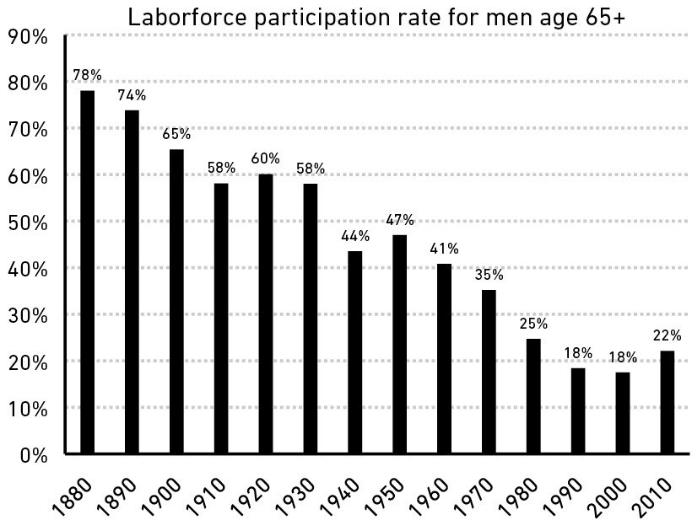

Social Security aimed to change this. But its initial beneﬁts

were nothing close to a proper pension. When Ida May Fuller

cashed the ﬁrst Social Security check in 1940, it was for

$22.54, or $416 adjusted for inﬂation. It was not until the

1980s that the average Social Security check for retirees

exceeded $1,000 a month adjusted for inﬂation. More than a

quarter of Americans over age 65 were classiﬁed by the Census

Bureau as living in poverty until the late 1960s.

There is a widespread belief along the lines of, “everyone used

to have a private pension.” But this is wildly exaggerated. The

Employee Beneﬁt Research Institute explains: “Only a quarter

of those age 65 or older had pension income in 1975.” Among

that lucky minority, only 15% of household income came from

a pension.

The New York Times wrote in 1955 about the growing desire,

but continued inability, to retire: “To rephrase an old saying:

everyone talks about retirement, but apparently very few do

anything about it.”⁶

It was not until the 1980s that the idea that everyone deserves,

and should have, a digniﬁed retirement took hold. And the way

to get that digniﬁed retirement ever since has been an

expectation that everyone will save and invest their own

money.

Let me reiterate how new this idea is: The 401(k)—the

backbone savings vehicle of American retirement—did not

exist until 1978. The Roth IRA was not born until 1998. If it

were a person it would be barely old enough to drink.

It should surprise no one that many of us are bad at saving and

investing for retirement. We’re not crazy. We’re all just

newbies.

Same goes for college. The share of Americans over age 25

with a bachelor’s degree has gone from less than 1 in 20 in

1940 to 1 in 4 by 2015.⁷ The average college tuition over that

time rose more than fourfold adjusted for inﬂation.⁸ Something

so big and so important hitting society so fast explains why, for

example, so many people have made poor decisions with

student loans over the last 20 years. There is not decades of

accumulated experience to even attempt to learn from. We’re

winging it.

Same for index funds, which are less than 50 years old. And

hedge funds, which didn’t take oﬀ until the last 25 years. Even

widespread use of consumer debt—mortgages, credit cards,

and car loans—did not take oﬀ until after World War II, when

the GI Bill made it easier for millions of Americans to borrow.

Dogs were domesticated 10,000 years ago and still retain

some behaviors of their wild ancestors. Yet here we are, with

between 20 and 50 years of experience in the modern ﬁnancial

system, hoping to be perfectly acclimated.

For a topic that is so inﬂuenced by emotion versus fact, this is a

problem. And it helps explain why we don’t always do what

we’re supposed to with money.

We all do crazy stuﬀ with money, because we’re all relatively

new to this game and what looks crazy to you might make

sense to me. But no one is crazy—we all make decisions based

on our own unique experiences that seem to make sense to us

in a given moment.

Now let me tell you a story about how Bill Gates got rich.

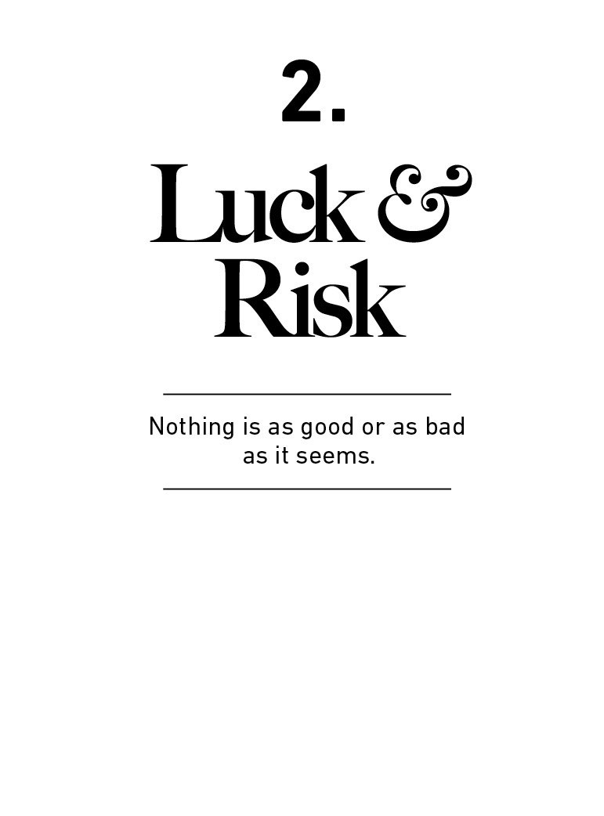

Luck and risk are siblings. They are both the reality that

every outcome in life is guided by forces other than

individual eﬀort.

NYU professor Scott Galloway has a related idea that is so

important to remember when judging success—both your

own and others’: “Nothing is as good or as bad as it seems.”

Bill Gates went to one of the only high schools in the world

that had a computer.

The story of how Lakeside School, just outside Seattle, even

got a computer is remarkable.

Bill Dougall was a World War II navy pilot turned high school

math and science teacher. “He believed that book study

wasn’t enough without real-world experience. He also

realized that we’d need to know something about

computers when we got to college,” recalled late Microsoft

co-founder Paul Allen.

In 1968 Dougall petitioned the Lakeside School Mothers’

Club to use the proceeds from its annual rummage sale—

about $3,000—to lease a Teletype Model 30 computer

hooked up to the General Electric mainframe terminal for

computer time-sharing. “The whole idea of time-sharing

only got invented in 1965,” Gates later said. “Someone was

pretty forwardlooking.” Most university graduate schools did

not have a computer anywhere near as advanced as Bill

Gates had access to in eighth grade. And he couldn’t get

enough of it.

Gates was 13 years old in 1968 when he met classmate Paul

Allen. Allen was also obsessed with the school’s computer,

and the two hit it oﬀ.

Lakeside’s computer wasn’t part of its general curriculum. It

was an independent study program. Bill and Paul could toy

away with the thing at their leisure, letting their creativity

run wild—after school, late into the night, on weekends.

They quickly became computing experts.

During one of their late-night sessions, Allen recalled Gates

showing him a Fortune magazine and saying, “What do you

think it’s like to run a Fortune 500 company?” Allen said he

had no idea. “Maybe we’ll have our own computer company

someday,” Gates said. Microsoft is now worth more than a

trillion dollars.

A little quick math.

In 1968 there were roughly 303 million high-school-age

people in the world, according to the UN.

About 18 million of them lived in the United States.

About 270,000 of them lived in Washington state.

A little over 100,000 of them lived in the Seattle area.

And only about 300 of them attended Lakeside School.

Start with 303 million, end with 300.

One in a million high-school-age students attended the high

school that had the combination of cash and foresight to

buy a computer. Bill Gates happened to be one of them.

Gates is not shy about what this meant. “If there had been

no Lakeside, there would have been no Microsoft,” he told

the school’s graduating class in 2005.

Gates is staggeringly smart, even more hardworking, and as

a teenager had a vision for computers that even most

seasoned computer executives couldn’t grasp. He also had a

one in a million head start by going to school at Lakeside.

Now let me tell you about Gates’ friend Kent Evans. He

experienced an equally powerful dose of luck’s close sibling,

risk.

Bill Gates and Paul Allen became household names thanks

to Microsoft’s success. But back at Lakeside there was a

third member of this gang of high-school computer

prodigies.

Kent Evans and Bill Gates became best friends in eighth

grade. Evans was, by Gates’ own account, the best student

in the class.

The two talked “on the phone ridiculous amounts,” Gates

recalls in the documentary Inside Bill’s Brain. “I still know

Kent’s phone number,” he says. “525-7851.”

Evans was as skilled with computers as Gates and Allen.

Lakeside once struggled to manually put together the

school’s class schedule—a maze of complexity to get

hundreds of students the classes they need at times that

don’t conﬂict with other courses. The school tasked Bill and

Kent—children, by any measure—to build a computer

program to solve the problem. It worked.

And unlike Paul Allen, Kent shared Bill’s business mind and

endless ambition. “Kent always had the big briefcase, like a

lawyer’s briefcase,” Gates recalls. “We were always

scheming about what we’d be doing ﬁve or six years in the

future. Should we go be CEOs? What kind of impact could

you have? Should we go be generals? Should we go be

ambassadors?” Whatever it was, Bill and Kent knew they’d

do it together.

After reminiscing on his friendship with Kent, Gates trails oﬀ.

“We would have kept working together. I’m sure we would

have gone to college together.” Kent could have been a

founding partner of Microsoft with Gates and Allen.

But it would never happen. Kent died in a mountaineering

accident before he graduated high school.

Every year there are around three dozen mountaineering

deaths in the United States.⁹ The odds of being killed on a

mountain in high school are roughly one in a million.

Bill Gates experienced one in a million luck by ending up at

Lakeside. Kent Evans experienced one in a million risk by

never getting to ﬁnish what he and Gates set out to achieve.

The same force, the same magnitude, working in opposite

directions.

Luck and risk are both the reality that every outcome in life

is guided by forces other than individual eﬀort. They are so

similar that you can’t believe in one without equally

respecting the other. They both happen because the world is

too complex to allow 100% of your actions to dictate 100%

of your outcomes. They are driven by the same thing: You

are one person in a game with seven billion other people

and inﬁnite moving parts. The accidental impact of actions

outside of your control can be more consequential than the

ones you consciously take.

But both are so hard to measure, and hard to accept, that

they too often go overlooked. For every Bill Gates there is a

Kent Evans who was just as skilled and driven but ended up

on the other side of life roulette.

If you give luck and risk their proper respect, you realize that

when judging people’s ﬁnancial success—both your own

and others’—it’s never as good or as bad as it seems.

Years ago I asked economist Robert Shiller, who won the

Nobel Prize in economics, “What do you want to know about

investing that we can’t know?”

“The exact role of luck in successful outcomes,” he

answered.

I love that response, because no one actually thinks luck

doesn’t play a role in ﬁnancial success. But since it’s hard to

quantify luck and rude to suggest people’s success is owed

to it, the default stance is often to implicitly ignore luck as a

factor of success.

If I say, “There are a billion investors in the world. By sheer

chance, would you expect 10 of them to become billionaires

predominantly oﬀ luck?” You would reply, “Of course.” But

then if I ask you to name those investors—to their face—you

will likely back down.

When judging others, attributing success to luck makes you

look jealous and mean, even if we know it exists. And when

judging yourself, attributing success to luck can be too

demoralizing to accept.

Economist Bhashkar Mazumder has shown that incomes

among brothers are more correlated than height or weight.

If you are rich and tall, your brother is more likely to also be

rich than he is tall. I think most of us intuitively know this is

true—the quality of your education and the doors that open

for you are heavily linked to your parents’ socioeconomic

status. But ﬁnd me two rich brothers and I’ll show you two

men who do not think this study’s ﬁndings apply to them.

Failure—which can be anything from bankruptcy to not

meeting a personal goal—is equally abused.

Did failed businesses not try hard enough? Were bad

investments not thought through well enough? Are wayward

careers due to laziness? Sometimes, yes. Of course.

But how much? It’s so hard to know. Everything worth

pursuing has less than 100% odds of succeeding, and risk is

just what happens when you end up on the unfortunate side

of that equation. Just as with luck, the story gets too hard,

too messy, too complex if we try to pick apart how much of

an outcome was a conscious decision versus a risk.

Say I buy a stock, and ﬁve years later it’s gone nowhere. It’s

possible that I made a bad decision by buying it in the ﬁrst

place. It’s also possible that I made a good decision that had

an 80% chance of making money, and I just happened to

end up on the side of the unfortunate 20%. How do I know

which is which? Did I make a mistake, or did I just

experience the reality of risk?

It’s possible to statistically measure whether some decisions

were wise. But in the real world, day to day, we simply don’t.

It’s too hard. We prefer simple stories, which are easy but

often devilishly misleading.

After spending years around investors and business leaders

I’ve come to realize that someone else’s failure is usually

attributed to bad decisions, while your own failures are

usually chalked up to the dark side of risk. When judging

your failures I’m likely to prefer a clean and simple story of

cause and eﬀect, because I don’t know what’s going on

inside your head. “You had a bad outcome so it must have

been caused by a bad decision” is the story that makes the

most sense to me. But when judging myself I can make up a

wild narrative justifying my past decisions and attributing

bad outcomes to risk.

The cover of Forbes magazine does not celebrate poor

investors who made good decisions but happened to

experience the unfortunate side of risk. But it almost

certainly celebrates rich investors who made OK or even

reckless decisions and happened to get lucky. Both ﬂipped

the same coin that happened to land on a diﬀerent side.

The dangerous part of this is that we’re all trying to learn

about what works and what doesn’t with money.

What investing strategies work? Which ones don’t?

What business strategies work? Which ones don’t?

How do you get rich? How do you avoid being poor?

We tend to seek out these lessons by observing successes

and failures and saying, “Do what she did, avoid what he

did.”

If we had a magic wand we would ﬁnd out exactly what

proportion of these outcomes were caused by actions that

are repeatable, versus the role of random risk and luck that

swayed those actions one way or the other. But we don’t

have a magic wand. We have brains that prefer easy

answers without much appetite for nuance. So identifying

the traits we should emulate or avoid can be agonizingly

hard.

Let me tell you another story of someone who, like Bill

Gates, was wildly successful, but whose success is hard to

pin down as being caused by luck or skill.

Cornelius Vanderbilt had just ﬁnished a series of business

deals to expand his railroad empire.

One of his business advisors leaned in to tell Vanderbilt that

every transaction he agreed to broke the law.

“My God, John,” said Vanderbilt, “You don’t suppose you can

run a railroad in accordance with the statutes of the State of

New York, do you?”¹⁰

My ﬁrst thought when reading this was: “That attitude is

why he was so successful.” Laws didn’t accommodate

railroads during Vanderbilt’s day. So he said “to hell with it”

and went ahead anyway.

Vanderbilt was wildly successful. So it’s tempting to view his

law-ﬂaunting—which was notorious and vital to his success

—as sage wisdom. That scrappy visionary let nothing get in

his way!

But how dangerous is that analysis? No sane person would

recommend ﬂagrant crime as an entrepreneurial trait. You

can easily imagine Vanderbilt’s story turning out much

diﬀerent—an outlaw whose young company collapsed under

court order.

So we have a problem here.

You can praise Vanderbilt for ﬂaunting the law with as much

passion as you criticize Enron for doing the same. Perhaps

one got lucky by avoiding the arm of the law while the other

found itself on the side of risk.

John D. Rockefeller is similar. His frequent circumventing of

the law—a judge once called his company “no better than a

common thief”—is often portrayed by historians as cunning

business smarts. Maybe it was. But when does the narrative

shift from, “You didn’t let outdated laws get in the way of

innovation,” to “You committed a crime?” Or how little

would the story have to shift for the narrative to have turned

from “Rockefeller was a genius, try to learn from his

successes,” to “Rockefeller was a criminal, try to learn from

his business failures.” Very little.

“What do I care about the law?” Vanderbilt once said. “Ain’t I

got the power?”

He did, and it worked. But it’s easy to imagine those being

the last words of a story with a very diﬀerent outcome. The

line between bold and reckless can be thin. When we don’t

give risk and luck their proper billing it’s often invisible.

Benjamin Graham is known as one of the greatest investors

of all time, the father of value investing and the early

mentor of Warren Buﬀett. But the majority of Benjamin

Graham’s investing success was due to owning an enormous

chunk of GEICO stock which, by his own admission, broke

nearly every diversiﬁcation rule that Graham himself laid out

in his famous texts. Where does the thin line between bold

and reckless fall here? I don’t know. Graham wrote about his

GEICO bonanza: “One lucky break, or one supremely shrewd

decision—can we tell them apart?” Not easily.

We similarly think Mark Zuckerberg is a genius for turning

down Yahoo!’s 2006 $1 billion oﬀer to buy his company. He

saw the future and stuck to his guns. But people criticize

Yahoo! with as much passion for turning down its own big

buyout oﬀer from Microsoft—those fools should have cashed

out while they could! What is the lesson for entrepreneurs

here? I have no idea, because risk and luck are so hard to

pin down.

There are so many examples of this.

Countless fortunes (and failures) owe their outcome to

leverage.

The best (and worst) managers drive their employees as

hard as they can.

“The customer is always right” and “customers don’t know

what they want” are both accepted business wisdom.

The line between “inspiringly bold” and “foolishly reckless”

can be a millimeter thick and only visible with hindsight.

Risk and luck are doppelgangers.

This is not an easy problem to solve. The diﬃculty in

identifying what is luck, what is skill, and what is risk is one

of the biggest problems we face when trying to learn about

the best way to manage money.

But two things can point you in a better direction.

Be careful who you praise and admire. Be careful

who you look down upon and wish to avoid

becoming.

Or, just be careful when assuming that 100% of outcomes

can be attributed to eﬀort and decisions. After my son was

born, I wrote him a letter that said, in part:

Some people are born into families that encourage

education; others are against it. Some are born into

ﬂourishing economies encouraging of entrepreneurship;

others are born into war and destitution. I want you to be

successful, and I want you to earn it. But realize that not all

success is due to hard work, and not all poverty is due to

laziness. Keep this in mind when judging people, including

yourself.

Therefore, focus less on speciﬁc individuals and case

studies and more on broad patterns.

Studying a speciﬁc person can be dangerous because we

tend to study extreme examples—the billionaires, the CEOs,

or the massive failures that dominate the news—and

extreme examples are often the least applicable to other

situations, given their complexity. The more extreme the

outcome, the less likely you can apply its lessons to your

own life, because the more likely the outcome was

inﬂuenced by extreme ends of luck or risk.

You’ll get closer to actionable takeaways by looking for

broad patterns of success and failure. The more common the

pattern, the more applicable it might be to your life. Trying

to emulate Warren Buﬀett’s investment success is hard,

because his results are so extreme that the role of luck in his

lifetime performance is very likely high, and luck isn’t

something you can reliably emulate. But realizing, as we’ll

see in chapter 7, that people who have control over their

time tend to be happier in life is a broad and common

enough observation that you can do something with it.

My favorite historian, Frederick Lewis Allen, spent his career

depicting the life of the average, median American—how

they lived, how they changed, what they did for work, what

they ate for dinner, etc. There are more relevant lessons to

take away from this kind of broad observation than there are

in studying the extreme characters that tend to dominate

the news.

Bill Gates once said, “Success is a lousy teacher. It seduces

smart people into thinking they can’t lose.”

When things are going extremely well, realize it’s not as

good as you think. You are not invincible, and if you

acknowledge that luck brought you success then you have

to believe in luck’s cousin, risk, which can turn your story

around just as quickly.

But the same is true in the other direction.

Failure can be a lousy teacher, because it seduces smart

people into thinking their decisions were terrible when

sometimes they just reﬂect the unforgiving realities of risk.

The trick when dealing with failure is arranging your

ﬁnancial life in a way that a bad investment here and a

missed ﬁnancial goal there won’t wipe you out so you can

keep playing until the odds fall in your favor.

But more important is that as much as we recognize the role

of luck in success, the role of risk means we should forgive

ourselves and leave room for understanding when judging

failures.

Nothing is as good or as bad as it seems.

Now let’s look at the stories of two men who pushed their

luck.

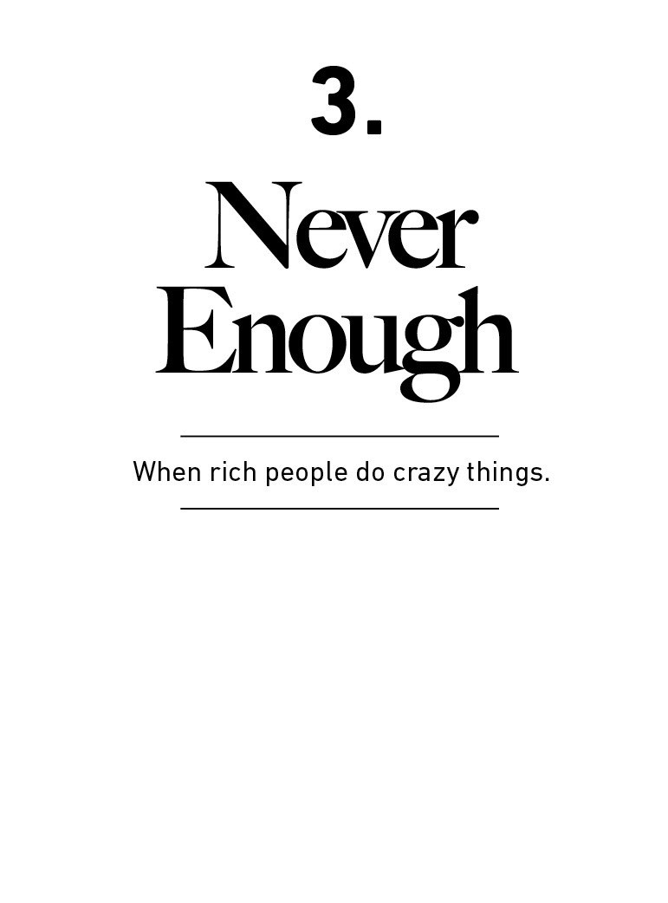

John Bogle, the Vanguard founder who passed away in 2019,

once told a story about money that highlights something we

don’t think about enough:

At a party given by a billionaire on Shelter Island, Kurt

Vonnegut informs his pal, Joseph Heller, that their host, a

hedge fund manager, had made more money in a single day

than Heller had earned from his wildly popular novel Catch-

22 over its whole history. Heller responds, “Yes, but I have

something he will never have … enough.”

Enough. I was stunned by the simple eloquence of that word

—stunned for two reasons: ﬁrst, because I have been given

so much in my own life and, second, because Joseph Heller

couldn’t have been more accurate.

For a critical element of our society, including many of the

wealthiest and most powerful among us, there seems to be

no limit today on what enough entails.

It’s so smart, and so powerful.

Let me oﬀer two examples of the dangers of not having

enough, and what they can teach us.

Rajat Gupta was born in Kolkata and orphaned as a

teenager. People talk about the privileged few who begin life

on third base. Gupta couldn’t even see the baseball

stadium.

What he went on to achieve from those beginnings was

simply phenomenal.

By his mid 40s Gupta was CEO of McKinsey, the world’s

most prestigious consulting ﬁrm. He retired in 2007 to take

on roles with the United Nations and the World Economic

Forum. He partnered on philanthropic work with Bill Gates.

He sat on the board of directors of ﬁve public companies.

From the slums of Kolkata, Gupta had quite literally become

one of the most successful businessmen alive.

With his success came enormous wealth. By 2008 Gupta

was reportedly worth $100 million.¹¹ It’s an unfathomable

sum of money to most. A ﬁve percent annual return on that

much money generates almost $600 an hour, 24 hours a

day.

He could have done anything he wanted in life.

And what he wanted, by all accounts, wasn’t to be a mere

centa-millionaire. Rajat Gupta wanted to be a billionaire.

And he wanted it badly.

Gupta sat on the board of directors of Goldman Sachs,

which surrounded him with some of the wealthiest investors

in the world. One investor, citing the paydays of private

equity tycoons, described Gupta like this: “I think he wants

to be in that circle. That’s a billionaire circle, right? Goldman

is like the hundreds of millions circle, right?”¹²

Right. So Gupta found a lucrative side hustle.

In 2008, as Goldman Sachs stared at the wrath of the

ﬁnancial crisis, Warren Buﬀett planned to invest $5 billion

into the bank to help it survive. As a Goldman board

member Gupta learned of this transaction before the public.

It was valuable information. Goldman’s survival was in

doubt and Buﬀett’s backing would surely send its stock

soaring.

Sixteen seconds after learning of the pending deal Gupta,

who was dialed into the Goldman board meeting, hung up

the phone and called a hedge fund manager named Raj

Rajaratnam. The call wasn’t recorded, but Rajaratnam

immediately bought 175,000 shares of Goldman Sachs, so

you can guess what was discussed. The Buﬀett-Goldman

deal was announced to the public hours later. Goldman

stock surged. Rajaratnam made a quick $1 million.

That was just one example of an alleged trend. The SEC

claims Gupta’s insider tips led to $17 million in proﬁts.

It was easy money. And, for prosecutors, it was an even

easier case.

Gupta and Rajaratnam both went to prison for insider

trading, their careers and reputations irrevocably ruined.

Now consider Bernie Madoﬀ. His crime is well known. Madoﬀ

is the most notorious Ponzi schemer since Charles Ponzi

himself. Madoﬀ swindled investors for two decades before

his crime was revealed—ironically just weeks after Gupta’s

endeavor.

What’s overlooked is that Madoﬀ, like Gupta, was more than

a fraudster. Before the Ponzi scheme that made Madoﬀ

famous he was a wildly successful and legitimate

businessman.

Madoﬀ was a market maker, a job that matches buyers and

sellers of stocks. He was very good at it. Here’s how The Wall

Street Journal described Madoﬀ’s market-making ﬁrm in

1992:

He has built a highly proﬁtable securities ﬁrm, Bernard L.

Madoﬀ Investment Securities, which siphons a huge volume

of stock trades away from the Big Board. The $740 million

average daily volume of trades executed electronically by

the Madoﬀ ﬁrm oﬀ the exchange equals 9% of the New York

exchange’s. Mr. Madoﬀ’s ﬁrm can execute trades so quickly

and cheaply that it actually pays other brokerage ﬁrms a

penny a share to execute their customers’ orders, proﬁting

from the spread between bid and ask prices that most

stocks trade for.

This is not a journalist inaccurately describing a fraud yet to

be uncovered; Madoﬀ’s market-making business was

legitimate. A former staﬀer said the market-making arm of

Madoﬀ’s business made between $25 million and $50

million per year.

Bernie Madoﬀ’s legitimate, non-fraudulent business was by

any measure a huge success. It made him hugely—and

legitimately—wealthy.

And yet, the fraud.

The question we should ask of both Gupta and Madoﬀ is why

someone worth hundreds of millions of dollars would be so

desperate for more money that they risked everything in

pursuit of even more.

Crime committed by those living on the edge of survival is

one thing. A Nigerian scam artist once told The New York

Times that he felt guilty for hurting others, but “poverty will

not make you feel the pain.”¹³

What Gupta and Madoﬀ did is something diﬀerent. They

already had everything: unimaginable wealth, prestige,

power, freedom. And they threw it all away because they

wanted more.

They had no sense of enough.

They are extreme examples. But there are non-criminal

versions of this behavior.

The hedge fund Long-Term Capital Management was staﬀed

with traders personally worth tens and hundreds of millions

of dollars each, with most of their wealth invested in their

own funds. Then they took so much risk in the quest for

more that they managed to lose everything—in 1998, in the

middle of the greatest bull market and strongest economy in

history. Warren Buﬀett later put it:

To make money they didn’t have and didn’t need, they

risked what they did have and did need. And that’s foolish. It

is just plain foolish. If you risk something that is important to

you for something that is unimportant to you, it just does

not make any sense.

There is no reason to risk what you have and need for what

you don’t have and don’t need.

It’s one of those things that’s as obvious as it is overlooked.

Few of us will ever have $100 million, as Gupta or Madoﬀ

did. But a measurable percentage of those reading this book

will, at some point in their life, earn a salary or have a sum

of money suﬃcient to cover every reasonable thing they

need and a lot of what they want.

If you’re one of them, remember a few things.

1. The hardest ﬁnancial skill is getting the goalpost

to stop moving.

But it’s one of the most important. If expectations rise with

results there is no logic in striving for more because you’ll

feel the same after putting in extra eﬀort. It gets dangerous

when the taste of having more—more money, more power,

more prestige—increases ambition faster than satisfaction.

In that case one step forward pushes the goalpost two steps

ahead. You feel as if you’re falling behind, and the only way

to catch up is to take greater and greater amounts of risk.

Modern capitalism is a pro at two things: generating wealth

and generating envy. Perhaps they go hand in hand; wanting

to surpass your peers can be the fuel of hard work. But life

isn’t any fun without a sense of enough. Happiness, as it’s

said, is just results minus expectations.

2. Social comparison is the problem here.

Consider a rookie baseball player who earns $500,000 a

year. He is, by any deﬁnition, rich. But say he plays on the

same team as Mike Trout, who has a 12-year, $430 million

contract. By comparison, the rookie is broke. But then think

about Mike Trout. Thirty-six million dollars per year is an

insane amount of money. But to make it on the list of the

top-ten highest-paid hedge fund managers in 2018 you

needed to earn at least $340 million in one year.¹⁴ That’s

who people like Trout might compare their incomes to. And

the hedge fund manager who makes $340 million per year

compares himself to the top ﬁve hedge fund managers, who

earned at least $770 million in 2018. Those top managers

can look ahead to people like Warren Buﬀett, whose

personal fortune increased by $3.5 billion in 2018. And

someone like Buﬀett could look ahead to Jeﬀ Bezos, whose

net worth increased by $24 billion in 2018—a sum that

equates to more per hour than the “rich” baseball player

made in a full year.

The point is that the ceiling of social comparison is so high

that virtually no one will ever hit it. Which means it’s a

battle that can never be won, or that the only way to win is

to not ﬁght to begin with—to accept that you might have

enough, even if it’s less than those around you.

A friend of mine makes an annual pilgrimage to Las Vegas.

One year he asked a dealer: What games do you play, and

what casinos do you play in? The dealer, stone-cold serious,

replied: “The only way to win in a Las Vegas casino is to exit

as soon as you enter.”

That’s exactly how the game of trying to keep up with other

people’s wealth works, too.

3. “Enough” is not too little.

The idea of having “enough” might look like conservatism,

leaving opportunity and potential on the table.

I don’t think that’s right.

“Enough” is realizing that the opposite—an insatiable

appetite for more—will push you to the point of regret.

The only way to know how much food you can eat is to eat

until you’re sick. Few try this because vomiting hurts more

than any meal is good. For some reason the same logic

doesn’t translate to business and investing, and many will

only stop reaching for more when they break and are forced

to. This can be as innocent as burning out at work or a risky

investment allocation you can’t maintain. On the other end

there’s Rajat Guptas and Bernie Madoﬀs in the world, who

resort to stealing because every dollar is worth reaching for

regardless of consequence.

Whatever it is, the inability to deny a potential dollar will

eventually catch up to you.

4. There are many things never worth risking, no

matter the potential gain.

After he was released from prison Rajat Gupta told The New

York Times he had learned a lesson:

Don’t get too attached to anything—your reputation, your

accomplishments or any of it. I think about it now, what

does it matter? O.K., this thing unjustly destroyed my

reputation. That’s only troubling if I am so attached to my

reputation.

This seems like the worst possible takeaway from his

experience, and what I imagine is the comforting self-

justiﬁcations of a man who desperately wants his reputation

back but knows it’s gone.

Reputation is invaluable.

Freedom and independence are invaluable.

Family and friends are invaluable.

Being loved by those who you want to love you is invaluable.

Happiness is invaluable.

And your best shot at keeping these things is knowing when

it’s time to stop taking risks that might harm them. Knowing

when you have enough.

The good news is that the most powerful tool for building

enough is remarkably simple, and doesn’t require taking

risks that could damage any of these things. That’s the next

chapter.

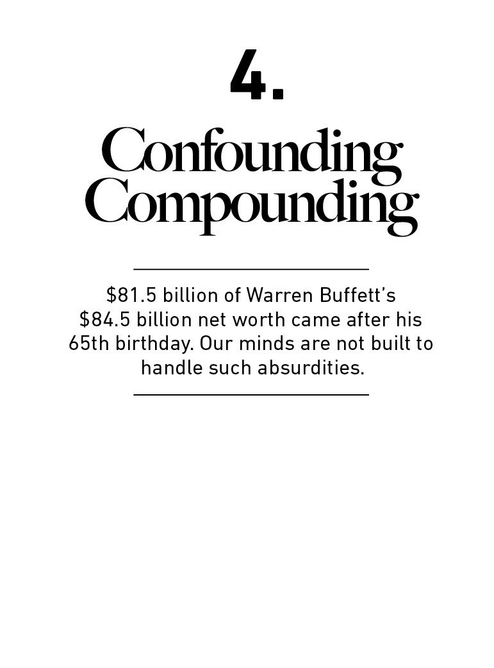

Lessons from one ﬁeld can often teach us something

important about unrelated ﬁelds. Take the billion-year

history of ice ages, and what they teach us about growing

your money.

Our scientiﬁc knowledge of Earth is younger than you might

think. Understanding how the world works often involves

drilling deep below its surface, something we haven’t been

able to do until fairly recently. Isaac Newton calculated the

movement of the stars hundreds of years before we

understood some of the basics of our planet.

It was not until the 19th century that scientists agreed that

Earth had, on multiple occasions, been covered in ice.¹⁵

There was too much evidence to argue otherwise. All over

the world sat ﬁngerprints of a previously frozen world: huge

boulders strewn in random locations; rock beds scraped

down to thin layers. Evidence became clear that there had

not been one ice age, but ﬁve distinct ones we could

measure.

The amount of energy needed to freeze the planet, melt it

anew, and freeze it over yet again is staggering. What on

Earth (literally) could be causing these cycles? It must be

the most powerful force on our planet.

And it was. Just not in the way anyone expected.

There were plenty of theories about why ice ages occurred.

To account for their enormous geological inﬂuence the

theories were equally grand. The uplifting of mountain

ranges, it was thought, may have shifted the Earth’s winds

enough to alter the climate. Others favored the idea that ice

was the natural state, interrupted by massive volcanic

eruptions that warmed us up.

But none of these theories could account for the cycle of ice

ages. The growth of mountain ranges or some massive

volcano may explain one ice age. It could not explain the

cyclical repetition of ﬁve.

In the early 1900s a Serbian scientist named Milutin

Milanković studied the Earth’s position relative to other

planets and came up with the theory of ice ages that we

now know is accurate: The gravitational pull of the sun and

moon gently aﬀect the Earth’s motion and tilt toward the

sun. During parts of this cycle—which can last tens of

thousands of years—each of the Earth’s hemispheres gets a

little more, or a little less, solar radiation than they’re used

to.

And that is where the fun begins.

Milanković’s theory initially assumed that a tilt of the Earth’s

hemispheres caused ravenous winters cold enough to turn

the planet into ice. But a Russian meteorologist named

Wladimir Köppen dug deeper into Milanković’s work and

discovered a fascinating nuance.

Moderately cool summers, not cold winters, were the icy

culprit.

It begins when a summer never gets warm enough to melt

the previous winter’s snow. The leftover ice base makes it

easier for snow to accumulate the following winter, which

increases the odds of snow sticking around in the following

summer, which attracts even more accumulation the

following winter. Perpetual snow reﬂects more of the sun’s

rays, which exacerbates cooling, which brings more

snowfall, and on and on. Within a few hundred years a

seasonal snowpack grows into a continental ice sheet, and

you’re oﬀ to the races.

The same thing happens in reverse. An orbital tilt letting

more sunlight in melts more of the winter snowpack, which

reﬂects less light the following years, which increases

temperatures, which prevents more snow the next year, and

so on. That’s the cycle.

The amazing thing here is how big something can grow

from a relatively small change in conditions. You start with a

thin layer of snow left over from a cool summer that no one

would think anything of and then, in a geological blink of an

eye, the entire Earth is covered in miles-thick ice. As

glaciologist Gwen Schultz put it: “It is not necessarily the

amount of snow that causes ice sheets but the fact that

snow, however little, lasts.”

The big takeaway from ice ages is that you don’t need

tremendous force to create tremendous results.

If something compounds—if a little growth serves as the fuel

for future growth—a small starting base can lead to results

so extraordinary they seem to defy logic. It can be so logic-

defying that you underestimate what’s possible, where

growth comes from, and what it can lead to.

And so it is with money.

More than 2,000 books are dedicated to how Warren Buﬀett

built his fortune. Many of them are wonderful. But few pay

enough attention to the simplest fact: Buﬀett’s fortune isn’t

due to just being a good investor, but being a good investor

since he was literally a child.

As I write this Warren Buﬀett’s net worth is $84.5 billion. Of

that, $84.2 billion was accumulated after his 50th birthday.

$81.5 billion came after he qualiﬁed for Social Security, in

his mid-60s.

Warren Buﬀett is a phenomenal investor. But you miss a key

point if you attach all of his success to investing acumen.

The real key to his success is that he’s been a phenomenal

investor for three quarters of a century. Had he started

investing in his 30s and retired in his 60s, few people would

have ever heard of him.

Consider a little thought experiment.

Buﬀett began serious investing when he was 10 years old.

By the time he was 30 he had a net worth of $1 million, or

$9.3 million adjusted for inﬂation.¹⁶

What if he was a more normal person, spending his teens

and 20s exploring the world and ﬁnding his passion, and by

age 30 his net worth was, say, $25,000?

And let’s say he still went on to earn the extraordinary

annual investment returns he’s been able to generate (22%

annually), but quit investing and retired at age 60 to play

golf and spend time with his grandkids.

What would a rough estimate of his net worth be today?

Not $84.5 billion.

$11.9 million.

99.9% less than his actual net worth.

Eﬀectively all of Warren Buﬀett’s ﬁnancial success can be

tied to the ﬁnancial base he built in his pubescent years and

the longevity he maintained in his geriatric years.

His skill is investing, but his secret is time.

That’s how compounding works.

Think of this another way. Buﬀett is the richest investor of all

time. But he’s not actually the greatest—at least not when

measured by average annual returns.

Jim Simons, head of the hedge fund Renaissance

Technologies, has compounded money at 66% annually

since 1988. No one comes close to this record. As we just

saw, Buﬀett has compounded at roughly 22% annually, a

third as much.

Simons’ net worth, as I write, is $21 billion. He is—and I

know how ridiculous this sounds given the numbers we’re

dealing with—75% less rich than Buﬀett.

Why the diﬀerence, if Simons is such a better investor?

Because Simons did not ﬁnd his investment stride until he

was 50 years old. He’s had less than half as many years to

compound as Buﬀett. If James Simons had earned his 66%

annual returns for the 70-year span Buﬀett has built his

wealth he would be worth—please hold your breath—sixty-

three quintillion nine hundred quadrillion seven hundred

eighty-one trillion seven hundred eighty billion seven

hundred forty-eight million one hundred sixty thousand

dollars.

These are ridiculous, impractical numbers. The point is that

what seem like small changes in growth assumptions can

lead to ridiculous, impractical numbers. And so when we are

studying why something got to become as powerful as it has

—why an ice age formed, or why Warren Buﬀett is so rich—

we often overlook the key drivers of success.

I have heard many people say the ﬁrst time they saw a

compound interest table—or one of those stories about how

much more you’d have for retirement if you began saving in

your 20s versus your 30s—changed their life. But it probably

didn’t. What it likely did was surprise them, because the

results intuitively didn’t seem right. Linear thinking is so

much more intuitive than exponential thinking. If I ask you

to calculate 8+8+8+8+8+8+8+8+8 in your head, you can

do it in a few seconds (it’s 72). If I ask you to calculate

8×8×8×8×8×8×8×8×8, your head will explode (it’s

134,217,728).

IBM made a 3.5 megabyte hard drive in the 1950s. By the

1960s things were moving into a few dozen megabytes. By

the 1970s, IBM’s Winchester drive held 70 megabytes. Then

drives got exponentially smaller in size with more storage. A

typical PC in the early 1990s held 200–500 megabytes.

And then … wham. Things exploded.

1999—Apple’s iMac comes with a 6 gigabyte hard drive.

2003—120 gigs on the Power Mac.

2006—250 gigs on the new iMac.

2011—ﬁrst 4 terabyte hard drive.

2017—60 terabyte hard drives.

2019—100 terabyte hard drives.

Put that all together: From 1950 to 1990 we gained 296

megabytes. From 1990 through today we gained 100 million

megabytes.

If you were a technology optimist in the 1950s you may

have predicted that practical storage would become 1,000

times larger. Maybe 10,000 times larger, if you were

swinging for the fences. Few would have said “30 million

times larger within my lifetime.” But that’s what happened.

The counterintuitive nature of compounding leads even the

smartest of us to overlook its power. In 2004 Bill Gates

criticized the new Gmail, wondering why anyone would

need a gigabyte of storage. Author Steven Levy wrote,

“Despite his currency with cutting-edge technologies, his

mentality was anchored in the old paradigm of storage

being a commodity that must be conserved.” You never get

accustomed to how quickly things can grow.

The danger here is that when compounding isn’t intuitive

we often ignore its potential and focus on solving problems

through other means. Not because we’re overthinking, but

because we rarely stop to consider compounding potential.

None of the 2,000 books picking apart Buﬀett’s success are

titled This Guy Has Been Investing Consistently for Three-

Quarters of a Century. But we know that’s the key to the

majority of his success. It’s just hard to wrap your head

around that math because it’s not intuitive.

There are books on economic cycles, trading strategies, and

sector bets. But the most powerful and important book

should be called Shut Up And Wait. It’s just one page with a

long-term chart of economic growth.

The practical takeaway is that the counterintuitiveness of

compounding may be responsible for the majority of

disappointing trades, bad strategies, and successful

investing attempts.

You can’t blame people for devoting all their eﬀort—eﬀort in

what they learn and what they do—to trying to earn the

highest investment returns. It intuitively seems like the best

way to get rich.

But good investing isn’t necessarily about earning the

highest returns, because the highest returns tend to be one-

oﬀ hits that can’t be repeated. It’s about earning pretty good

returns that you can stick with and which can be repeated

for the longest period of time. That’s when compounding

runs wild.

The opposite of this—earning huge returns that can’t be

held onto—leads to some tragic stories. We’ll need the next

chapter to tell them.

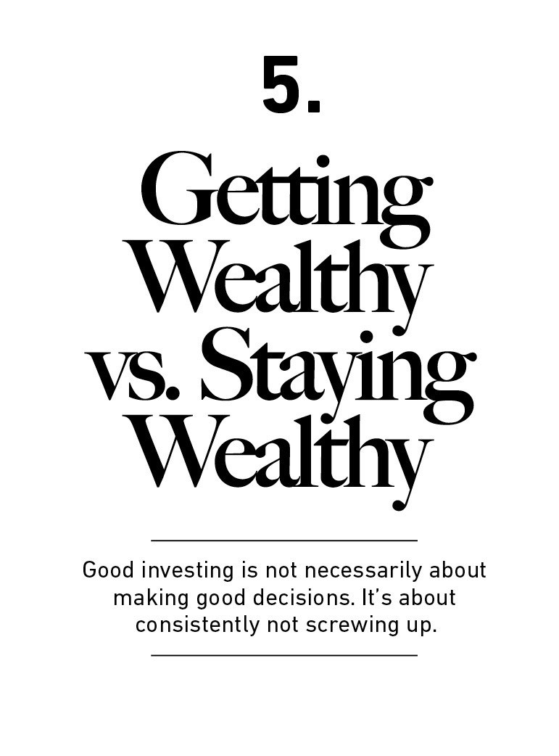

There are a million ways to get wealthy, and plenty of books

on how to do so.

But there’s only one way to stay wealthy: some combination

of frugality and paranoia.

And that’s a topic we don’t discuss enough.

Let’s begin with a quick story about two investors, neither of

whom knew the other, but whose paths crossed in an

interesting way almost a century ago.

Jesse Livermore was the greatest stock market trader of his

day. Born in 1877, he became a professional trader before

most people knew you could do such a thing. By age 30 he

was worth the inﬂation-adjusted equivalent of $100 million.

By 1929 Jesse Livermore was already one of the most well-

known investors in the world. The stock market crash that

year that ushered in the Great Depression cemented his

legacy in history.

More than a third of the stock market’s value was wiped out

in an October 1929 week whose days were later named Black

Monday, Black Tuesday, and Black Thursday.

Livermore’s wife Dorothy feared the worst when her husband

returned home on October 29th. Reports of Wall Street

speculators committing suicide were spreading across New

York. She and her children greeted Jesse at the door in tears,

while her mother was so distraught she hid in another room,

screaming.

Jesse, according to biographer Tom Rubython, stood confused

for a few moments before realizing what was happening.

He then broke the news to his family: In a stroke of genius

and luck, he had been short the market, betting stocks would

decline.

“You mean we are not ruined?” Dorothy asked.

“No darling, I have just had my best ever trading day—we are

fabulously rich and can do whatever we like,” Jesse said.

Dorothy ran to her mother and told her to be quiet.

In one day Jesse Livermore made the equivalent of more than

$3 billion.

During one of the worst months in the history of the stock

market he became one of the richest men in the world.

As Livermore’s family celebrated their unfathomable success,

another man wandered the streets of New York in

desperation.

Abraham Germansky was a multimillionaire real estate

developer who made a fortune during the roaring 1920s. As

the economy boomed, he did what virtually every other

successful New Yorker did in the late 1920s: bet heavily on

the surging stock market.

On October 26th, 1929, The New York Times published an

article that in two paragraphs portrays a tragic ending:

Bernard H. Sandler, attorney of 225 Broadway, was asked

yesterday morning by Mrs. Abraham Germansky of Mount

Vernon to help ﬁnd her husband, missing since Thursday

Morning. Germansky, who is 50 years old and an east side

real estate operator, was said by Sandler to have invested

heavily in stocks.

Sandler said he was told by Mrs. Germansky that a friend saw

her husband late Thursday on Wall Street near the stock

exchange. According to her informant, her husband was

tearing a strip of ticker tape into bits and scattering it on the

sidewalk as he walked toward Broadway.

And that, as far as we know, was the end of Abraham

Germansky.

Here we have a contrast.

The October 1929 crash made Jesse Livermore one of the

richest men in the world. It ruined Abraham Germansky,

perhaps taking his life.

But fast-forward four years and the stories cross paths again.

After his 1929 blowout Livermore, overﬂowing with

conﬁdence, made larger and larger bets. He wound up far

over his head, in increasing amounts of debt, and eventually

lost everything in the stock market.

Broke and ashamed, he disappeared for two days in 1933. His

wife set out to ﬁnd him. “Jesse L. Livermore, the stock market

operator, of 1100 Park Avenue missing and has not been seen

since 3pm yesterday,” The New York Times wrote in 1933.

He returned, but his path was set. Livermore eventually took

his own life.

The timing was diﬀerent, but Germansky and Livermore

shared a character trait: They were both very good at getting

wealthy, and equally bad at staying wealthy.

Even if “wealthy” is not a word you’d apply to yourself, the

lessons from that observation apply to everyone, at all income

levels.

Getting money is one thing.

Keeping it is another.

If I had to summarize money success in a single word it would

be “survival.”

As we’ll see in chapter 6, 40% of companies successful

enough to become publicly traded lost eﬀectively all of their

value over time. The Forbes 400 list of richest Americans has,

on average, roughly 20% turnover per decade for causes that

don’t have to do with death or transferring money to another

family member.¹⁷

Capitalism is hard. But part of the reason this happens is

because getting money and keeping money are two diﬀerent

skills.

Getting money requires taking risks, being optimistic, and

putting yourself out there.

But keeping money requires the opposite of taking risk. It

requires humility, and fear that what you’ve made can be

taken away from you just as fast. It requires frugality and an

acceptance that at least some of what you’ve made is

attributable to luck, so past success can’t be relied upon to

repeat indeﬁnitely.

Michael Moritz, the billionaire head of Sequoia Capital, was

asked by Charlie Rose why Sequoia was so successful. Moritz

mentioned longevity, noting that some VC ﬁrms succeed for

ﬁve or ten years, but Sequoia has prospered for four decades.

Rose asked why that was:

Moritz: I think we’ve always been afraid of going out of

business.

Rose: Really? So it’s fear? Only the paranoid survive?

Moritz: There’s a lot of truth to that … We assume that

tomorrow won’t be like yesterday. We can’t aﬀord to rest on

our laurels. We can’t be complacent. We can’t assume that

yesterday’s success translates into tomorrow’s good fortune.

Here again, survival.

Not “growth” or “brains” or “insight.” The ability to stick

around for a long time, without wiping out or being forced to

give up, is what makes the biggest diﬀerence. This should be

the cornerstone of your strategy, whether it’s in investing or

your career or a business you own.

There are two reasons why a survival mentality is so key with

money.

One is the obvious: few gains are so great that they’re worth

wiping yourself out over.

The other, as we saw in chapter 4, is the counterintuitive

math of compounding.

Compounding only works if you can give an asset years and

years to grow. It’s like planting oak trees: A year of growth will

never show much progress, 10 years can make a meaningful

diﬀerence, and 50 years can create something absolutely

extraordinary.

But getting and keeping that extraordinary growth requires

surviving all the unpredictable ups and downs that everyone

inevitably experiences over time.

We can spend years trying to ﬁgure out how Buﬀett achieved

his investment returns: how he found the best companies,

the cheapest stocks, the best managers. That’s hard. Less

hard but equally important is pointing out what he didn’t do.

He didn’t get carried away with debt.

He didn’t panic and sell during the 14 recessions he’s lived

through.

He didn’t sully his business reputation.

He didn’t attach himself to one strategy, one world view, or

one passing trend.

He didn’t rely on others’ money (managing investments

through a public company meant investors couldn’t withdraw

their capital).

He didn’t burn himself out and quit or retire.

He survived. Survival gave him longevity. And longevity—

investing consistently from age 10 to at least age 89—is what

made compounding work wonders. That single point is what

matters most when describing his success.

To show you what I mean, you have to hear the story of Rick

Guerin.

You’ve likely heard of the investing duo of Warren Buﬀett and

Charlie Munger. But 40 years ago there was a third member

of the group, Rick Guerin.

Warren, Charlie, and Rick made investments together and

interviewed business managers together. Then Rick kind of

disappeared, at least relative to Buﬀett and Munger’s success.

Investor Mohnish Pabrai once asked Buﬀett what happened to

Rick. Mohnish recalled:

[Warren said] “Charlie and I always knew that we would

become incredibly wealthy. We were not in a hurry to get

wealthy; we knew it would happen. Rick was just as smart as

us, but he was in a hurry.”

What happened was that in the 1973–1974 downturn, Rick

was levered with margin loans. And the stock market went

down almost 70% in those two years, so he got margin calls.

He sold his Berkshire stock to Warren—Warren actually said “I

bought Rick’s Berkshire stock”—at under $40 a piece. Rick

was forced to sell because he was levered.¹⁸

Charlie, Warren, and Rick were equally skilled at getting

wealthy. But Warren and Charlie had the added skill of

staying wealthy. Which, over time, is the skill that matters

most.

Nassim Taleb put it this way: “Having an ‘edge’ and surviving

are two diﬀerent things: the ﬁrst requires the second. You

need to avoid ruin. At all costs.”

Applying the survival mindset to the real world comes down

to appreciating three things.

1. More than I want big returns, I want to be

ﬁnancially unbreakable. And if I’m unbreakable I

actually think I’ll get the biggest returns, because I’ll

be able to stick around long enough for compounding

to work wonders.

No one wants to hold cash during a bull market. They want to

own assets that go up a lot. You look and feel conservative

holding cash during a bull market, because you become

acutely aware of how much return you’re giving up by not

owning the good stuﬀ. Say cash earns 1% and stocks return

10% a year. That 9% gap will gnaw at you every day.

But if that cash prevents you from having to sell your stocks

during a bear market, the actual return you earned on that

cash is not 1% a year—it could be many multiples of that,

because preventing one desperate, ill-timed stock sale can do

more for your lifetime returns than picking dozens of big-time

winners.

Compounding doesn’t rely on earning big returns. Merely

good returns sustained uninterrupted for the longest period

of time—especially in times of chaos and havoc—will always

win.

2. Planning is important, but the most important part

of every plan is to plan on the plan not going

according to plan.

What’s the saying? You plan, God laughs. Financial and

investment planning are critical, because they let you know

whether your current actions are within the realm of

reasonable. But few plans of any kind survive their ﬁrst

encounter with the real world. If you’re projecting your

income, savings rate, and market returns over the next 20

years, think about all the big stuﬀ that’s happened in the last

20 years that no one could have foreseen: September 11th, a

housing boom and bust that caused nearly 10 million

Americans to lose their homes, a ﬁnancial crisis that caused

almost nine million to lose their jobs, a record-breaking stock-

market rally that ensued, and a coronavirus that shakes the

world as I write this.

A plan is only useful if it can survive reality. And a future ﬁlled

with unknowns is everyone’s reality.

A good plan doesn’t pretend this weren’t true; it embraces it

and emphasizes room for error. The more you need speciﬁc

elements of a plan to be true, the more fragile your ﬁnancial

life becomes. If there’s enough room for error in your savings

rate that you can say, “It’d be great if the market returns 8%

a year over the next 30 years, but if it only does 4% a year I’ll

still be OK,” the more valuable your plan becomes.

Many bets fail not because they were wrong, but because

they were mostly right in a situation that required things to

be exactly right. Room for error—often called margin of safety

—is one of the most underappreciated forces in ﬁnance. It

comes in many forms: A frugal budget, ﬂexible thinking, and

a loose timeline—anything that lets you live happily with a

range of outcomes.

It’s diﬀerent from being conservative. Conservative is

avoiding a certain level of risk. Margin of safety is raising the

odds of success at a given level of risk by increasing your

chances of survival. Its magic is that the higher your margin

of safety, the smaller your edge needs to be to have a

favorable outcome.

3. A barbelled personality—optimistic about the

future, but paranoid about what will prevent you from

getting to the future—is vital.

Optimism is usually deﬁned as a belief that things will go

well. But that’s incomplete. Sensible optimism is a belief that

the odds are in your favor, and over time things will balance

out to a good outcome even if what happens in between is

ﬁlled with misery. And in fact you know it will be ﬁlled with

misery. You can be optimistic that the long-term growth

trajectory is up and to the right, but equally sure that the

road between now and then is ﬁlled with landmines, and

always will be. Those two things are not mutually exclusive.

The idea that something can gain over the long run while

being a basketcase in the short run is not intuitive, but it’s

how a lot of things work in life. By age 20 the average person

can lose roughly half the synaptic connections they had in

their brain at age two, as ineﬃcient and redundant neural

pathways are cleared out. But the average 20-year-old is

much smarter than the average two-year-old. Destruction in

the face of progress is not only possible, but an eﬃcient way

to get rid of excess.

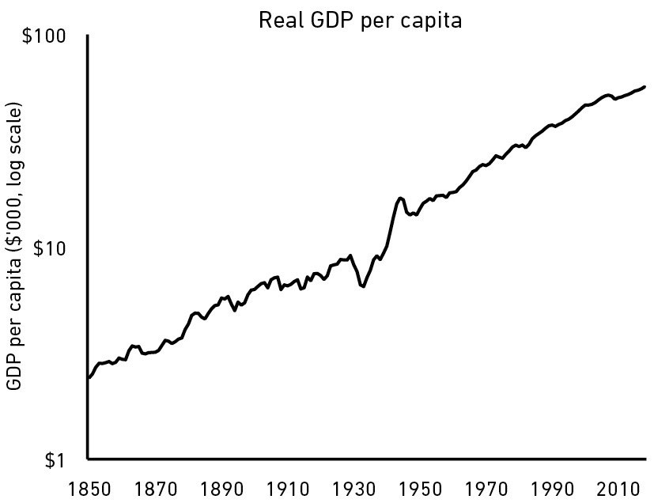

Imagine if you were a parent and could see inside your child’s

brain. Every morning you notice fewer synaptic connections

in your kid’s head. You would panic! You would say, “This

can’t be right, there’s loss and destruction here. We need an

intervention. We need to see a doctor!” But you don’t. What

you are witnessing is the normal path of progress.

Economies, markets, and careers often follow a similar path—

growth amid loss.

Here’s how the U.S. economy performed over the last 170

years:

But do you know what happened during this period? Where

do we begin ...

1.3 million Americans died while ﬁghting nine major wars.

Roughly 99.9% of all companies that were created went out

of business.

Four U.S. presidents were assassinated.

675,000 Americans died in a single year from a ﬂu pandemic.

30 separate natural disasters killed at least 400 Americans

each.

33 recessions lasted a cumulative 48 years.

The number of forecasters who predicted any of those

recessions rounds to zero.

The stock market fell more than 10% from a recent high at

least 102 times.

Stocks lost a third of their value at least 12 times.

Annual inﬂation exceeded 7% in 20 separate years.

The words “economic pessimism” appeared in newspapers at

least 29,000 times, according to Google.

Our standard of living increased 20-fold in these 170 years,

but barely a day went by that lacked tangible reasons for

pessimism.

A mindset that can be paranoid and optimistic at the same

time is hard to maintain, because seeing things as black or

white takes less eﬀort than accepting nuance. But you need

short-term paranoia to keep you alive long enough to exploit

long-term optimism.

Jesse Livermore ﬁgured this out the hard way.

He associated good times with the end of bad times. Getting

wealthy made him feel like staying wealthy was inevitable,

and that he was invincible. After losing nearly everything he

reﬂected:

I sometimes think that no price is too high for a speculator to

pay to learn that which will keep him from getting the

swelled head. A great many smashes by brilliant men can be

traced directly to the swelled head.

“It’s an expensive disease,” he said, “everywhere to

everybody.”

Next, we’ll look at another way growth in the face of adversity

can be so hard to wrap your head around.

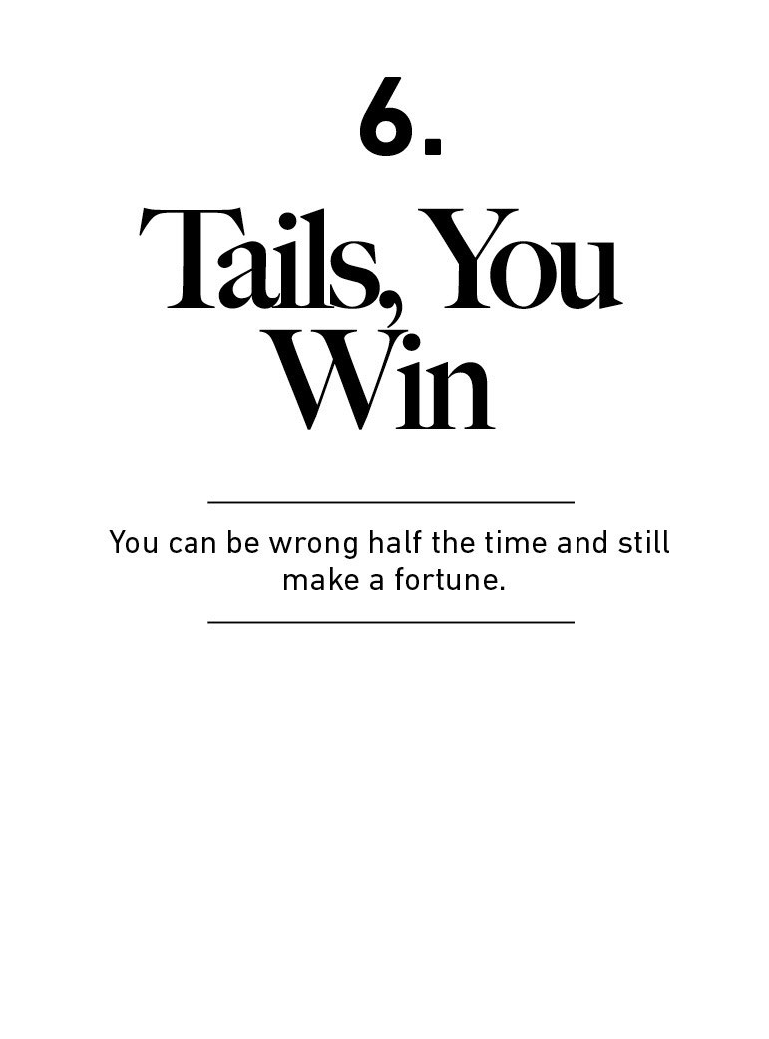

“I’ve been banging away at this thing for 30 years. I think the

simple math is, some projects work and some don’t. There’s no

reason to belabor either one. Just get on to the next.”

—Brad Pitt accepting a Screen Actors Guild Award

Heinz Berggruen ﬂed Nazi Germany in 1936. He settled in

America, where he studied literature at U.C. Berkeley.

By most accounts he did not show particular promise in his

youth. But by the 1990s Berggruen was, by any measure, one

of the most successful art dealers of all time.

In 2000 Berggruen sold part of his massive collection of

Picassos, Braques, Klees, and Matisses to the German

government for more than 100 million euros. It was such a

bargain that the Germans eﬀectively considered it a donation.

The private market value of the collection was well over a $1

billion.

That one person can collect huge quantities of masterpieces is

astounding. Art is as subjective as it gets. How could anyone

have foreseen, early in life, what were to become the most

sought-after works of the century?

You could say “skill.”

You could say “luck.”

The investment ﬁrm Horizon Research has a third explanation.

And it’s very relevant to investors.

“The great investors bought vast quantities of art,” the ﬁrm

writes.¹⁹ “A subset of the collections turned out to be great

investments, and they were held for a suﬃciently long period of

time to allow the portfolio return to converge upon the return of

the best elements in the portfolio. That’s all that happens.”

The great art dealers operated like index funds. They bought

everything they could. And they bought it in portfolios, not

individual pieces they happened to like. Then they sat and

waited for a few winners to emerge.

That’s all that happens.

Perhaps 99% of the works someone like Berggruen acquired in

his life turned out to be of little value. But that doesn’t

particularly matter if the other 1% turn out to be the work of

someone like Picasso. Berggruen could be wrong most of the

time and still end up stupendously right.

A lot of things in business and investing work this way. Long

tails—the farthest ends of a distribution of outcomes—have

tremendous inﬂuence in ﬁnance, where a small number of

events can account for the majority of outcomes.

That can be hard to deal with, even if you understand the math.

It is not intuitive that an investor can be wrong half the time

and still make a fortune. It means we underestimate how

normal it is for a lot of things to fail. Which causes us to

overreact when they do.

Steamboat Willie put Walt Disney on the map as an animator.

Business success was another story. Disney’s ﬁrst studio went

bankrupt. His ﬁlms were monstrously expensive to produce,

and ﬁnanced at outrageous terms. By the mid-1930s Disney

had produced more than 400 cartoons. Most of them were

short, most of them were beloved by viewers, and most of them

lost a fortune.

Snow White and the Seven Dwarfs changed everything.

The $8 million it earned in the ﬁrst six months of 1938 was an

order of magnitude higher than anything the company earned

previously. It transformed Disney Studios. All company debts

were paid oﬀ. Key employees got retention bonuses. The

company purchased a new state-of-the-art studio in Burbank,

where it remains today. An Oscar turned Walt from famous to

full-blown celebrity. By 1938 he had produced several hundred

hours of ﬁlm. But in business terms, the 83 minutes of Snow

White were all that mattered.

Anything that is huge, proﬁtable, famous, or inﬂuential is the

result of a tail event—an outlying one-in-thousands or millions

event. And most of our attention goes to things that are huge,

proﬁtable, famous, or inﬂuential. When most of what we pay

attention to is the result of a tail, it’s easy to underestimate

how rare and powerful they are.

Some tail-driven industries are obvious. Take venture capital. If

a VC makes 50 investments they likely expect half of them to

fail, 10 to do pretty well, and one or two to be bonanzas that

drive 100% of the fund’s returns. Investment ﬁrm Correlation

Ventures once crunched the numbers.²⁰ Out of more than

21,000 venture ﬁnancings from 2004 to 2014:

65% lost money.

Two and a half percent of investments made 10x–20x.

One percent made more than a 20x return.

Half a percent—about 100 companies out of 21,000—earned

50x or more. That’s where the majority of the industry’s returns

come from.

This, you might think, is what makes venture capital so risky.

And everyone investing in VC knows it’s risky. Most startups fail

and the world is only kind enough to allow a few mega

successes.

If you want safer, predictable, and more stable returns, you

invest in large public companies.

Or so you might think.

Remember, tails drive everything.

The distribution of success among large public stocks over time

is not much diﬀerent than it is in venture capital.

Most public companies are duds, a few do well, and a handful

become extraordinary winners that account for the majority of

the stock market’s returns.

J.P. Morgan Asset Management once published the distribution

of returns for the Russell 3000 Index—a big, broad, collection of

public companies—since 1980.²¹

Forty percent of all Russell 3000 stock components lost at least

70% of their value and never recovered over this period.

Eﬀectively all of the index’s overall returns came from 7% of

component companies that outperformed by at least two

standard deviations.

That’s the kind of thing you’d expect from venture capital. But

it’s what happened inside a boring, diversiﬁed index.

This thumping of most public companies spares no industry.

More than half of all public technology and telecom companies

lose most of their value and never recover. Even among public

utilities the failure rate is more than 1 in 10:

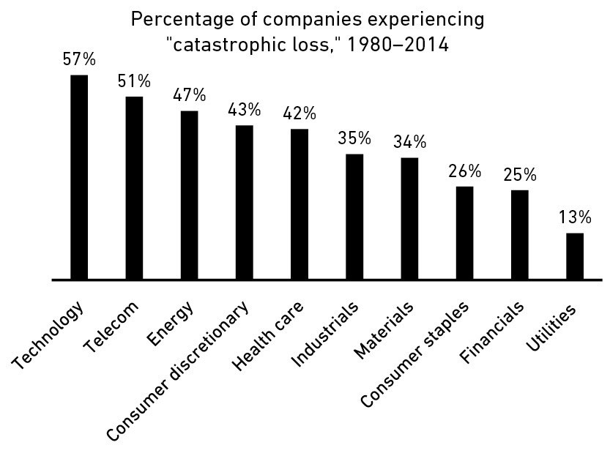

The interesting thing here is that you have to have achieved a

certain level of success to become a public company and a

member of the Russell 3000. These are established

corporations, not ﬂy-by-night startups. Even still, most have

lifespans measured in years, not generations.

Take an example one of these companies: Carolco, a former

member of the Russell 3000 Index.

It produced some of the biggest ﬁlms of the 1980s and 1990s,

including the ﬁrst three Rambo ﬁlms, Terminator 2, Basic

Instinct, and Total Recall.

Carolco went public in 1987. It was a huge success, churning

out hit after hit. It did half a billion dollars in revenue in 1991,

commanding a market cap of $400 million—big money back

then, especially for a ﬁlm studio.

And then it failed.

The blockbusters stopped, a few big-budget projects ﬂopped,

and by the mid-1990s Carolco was history. It went bankrupt in

1996. Stock goes to zero, have a nice day. A catastrophic loss.

And one that 4 in 10 public companies experience over time.

Carolco’s story is not worth telling because it’s unique, but

because it’s common.

Here’s the most important part of this story: The Russell 3000

has increased more than 73-fold since 1980. That is a

spectacular return. That is success.

Forty percent of the companies in the index were eﬀectively

failures. But the 7% of components that performed extremely

well were more than enough to oﬀset the duds. Just like Heinz

Berggruen, but with Microsoft and Walmart instead of Picasso

and Matisse.

Not only do a few companies account for most of the market’s

return, but within those companies are even more tail events.

In 2018, Amazon drove 6% of the S&P 500’s returns. And

Amazon’s growth is almost entirely due to Prime and Amazon

Web Services, which itself are tail events in a company that has

experimented with hundreds of products, from the Fire Phone

to travel agencies.

Apple was responsible for almost 7% of the index’s returns in

2018. And it is driven overwhelmingly by the iPhone, which in

the world of tech products is as tail-y as tails get.

And who’s working at these companies? Google’s hiring

acceptance rate is 0.2%.²² Facebook’s is 0.1%.²³ Apple’s is

about 2%.²⁴ So the people working on these tail projects that

drive tail returns have tail careers.

The idea that a few things account for most results is not just

true for companies in your investment portfolio. It’s also an

important part of your own behavior as an investor.

Napoleon’s deﬁnition of a military genius was, “The man who

can do the average thing when all those around him are going

crazy.”

It’s the same in investing.

Most ﬁnancial advice is about today. What should you do right

now, and what stocks look like good buys today?

But most of the time today is not that important. Over the

course of your lifetime as an investor the decisions that you

make today or tomorrow or next week will not matter nearly as

much as what you do during the small number of days—likely

1% of the time or less—when everyone else around you is going

crazy.

Consider what would happen if you saved $1 every month from

1900 to 2019.

You could invest that $1 into the U.S. stock market every

month, rain or shine. It doesn’t matter if economists are

screaming about a looming recession or new bear market. You

just keep investing. Let’s call an investor who does this Sue.

But maybe investing during a recession is too scary. So perhaps

you invest your $1 in the stock market when the economy is

not in a recession, sell everything when it’s in a recession and

save your monthly dollar in cash, and invest everything back

into the stock market when the recession ends. We’ll call this

investor Jim.

Or perhaps it takes a few months for a recession to scare you

out, and then it takes a while to regain conﬁdence before you

get back in the market. You invest $1 in stocks when there’s no

recession, sell six months after a recession begins, and invest

back in six months after a recession ends. We’ll call you Tom.

How much money would these three investors end up with over

time?

Sue ends up with $435,551.

Jim has $257,386.

Tom $234,476.

Sue wins by a mile.

There were 1,428 months between 1900 and 2019. Just over

300 of them were during a recession. So by keeping her cool

during just the 22% of the time the economy was in or near a

recession, Sue ends up with almost three-quarters more money

than Jim or Tom.

To give a more recent example: How you behaved as an

investor during a few months in late 2008 and early 2009 will

likely have more impact on your lifetime returns than

everything you did from 2000 to 2008.

There is the old pilot quip that their jobs are “hours and hours

of boredom punctuated by moments of sheer terror.” It’s the

same in investing. Your success as an investor will be

determined by how you respond to punctuated moments of

terror, not the years spent on cruise control.

A good deﬁnition of an investing genius is the man or woman

who can do the average thing when all those around them are

going crazy.

Tails drive everything.

When you accept that tails drive everything in business,

investing, and ﬁnance you realize that it’s normal for lots of

things to go wrong, break, fail, and fall.

If you’re a good stock picker you’ll be right maybe half the time.

If you’re a good business leader maybe half of your product and

strategy ideas will work.

If you’re a good investor most years will be just OK, and plenty

will be bad.

If you’re a good worker you’ll ﬁnd the right company in the

right ﬁeld after several attempts and trials.

And that’s if you’re good.

Peter Lynch is one of the best investors of our time. “If you’re

terriﬁc in this business, you’re right six times out of 10,” he

once said.

There are ﬁelds where you must be perfect every time. Flying a

plane, for example. Then there are ﬁelds where you want to be

at least pretty good nearly all the time. A restaurant chef, let’s

say.

Investing, business, and ﬁnance are just not like these ﬁelds.

Something I’ve learned from both investors and entrepreneurs

is that no one makes good decisions all the time. The most

impressive people are packed full of horrendous ideas that are

often acted upon.

Take Amazon. It’s not intuitive to think a failed product launch

at a major company would be normal and ﬁne. Intuitively,

you’d think the CEO should apologize to shareholders. But CEO

Jeﬀ Bezos said shortly after the disastrous launch of the

company’s Fire Phone:

If you think that’s a big failure, we’re working on much bigger

failures right now. I am not kidding. Some of them are going to

make the Fire Phone look like a tiny little blip.

It’s OK for Amazon to lose a lot of money on the Fire Phone

because it will be oﬀset by something like Amazon Web

Services that earns tens of billions of dollars. Tails to the rescue.

Netﬂix CEO Reed Hastings once announced his company was

canceling several big-budget productions. He responded:

Our hit ratio is way too high right now. I’m always pushing the

content team. We have to take more risk. You have to try more

crazy things, because we should have a higher cancel rate

overall.

These are not delusions or failures of responsibility. They are a

smart acknowledgement of how tails drive success. For every

Amazon Prime or Orange is The New Black you know, with

certainty, that you’ll have some duds.

Part of why this isn’t intuitive is because in most ﬁelds we only

see the ﬁnished product, not the losses incurred that led to the

tail-success product.

The Chris Rock I see on TV is hilarious, ﬂawless. The Chris Rock

that performs in dozens of small clubs each year is just OK.

That is by design. No comedic genius is smart enough to

preemptively know what jokes will land well. Every big

comedian tests their material in small clubs before using it in

big venues. Rock was once asked if he missed small clubs. He

responded:

When I start a tour, it’s not like I start out in arenas. Before this

last tour I performed in this place in New Brunswick called the

Stress Factory. I did about 40 or 50 shows getting ready for the

tour.

One newspaper proﬁled these small-club sessions. It described

Rock thumbing through pages of notes and fumbling with

material. “I’m going to have to cut some of these jokes,” he

says mid-skit. The good jokes I see on Netﬂix are the tails that

stuck out of a universe of hundreds of attempts.

A similar thing happens in investing. It’s easy to ﬁnd Warren

Buﬀett’s net worth, or his average annual returns. Or even his

best, most notable investments. They’re right there in the open,

and they’re what people talk about.

It’s much harder to piece together every investment he’s made

over his career. No one talks about the dud picks, the ugly

businesses, the poor acquisitions. But they’re a big part of

Buﬀett’s story. They are the other side of tail-driven returns.

At the Berkshire Hathaway shareholder meeting in 2013

Warren Buﬀett said he’s owned 400 to 500 stocks during his

life and made most of his money on 10 of them. Charlie Munger

followed up: “If you remove just a few of Berkshire’s top

investments, its long-term track record is pretty average.”

When we pay special attention to a role model’s successes we

overlook that their gains came from a small percent of their

actions. That makes our own failures, losses, and setbacks feel

like we’re doing something wrong. But it’s possible we are

wrong, or just sort of right, just as often as the masters are.

They may have been more right when they were right, but they

could have been wrong just as often as you.

“It’s not whether you’re right or wrong that’s important,”

George Soros once said, “but how much money you make when

you’re right and how much you lose when you’re wrong.” You

can be wrong half the time and still make a fortune.

There are 100 billion planets in our galaxy and only one, as far

as we know, with intelligent life.

The fact that you are reading this book is the result of the

longest tail you can imagine.

That’s something to be happy about. Next, let’s look at how

money can make you even happier.

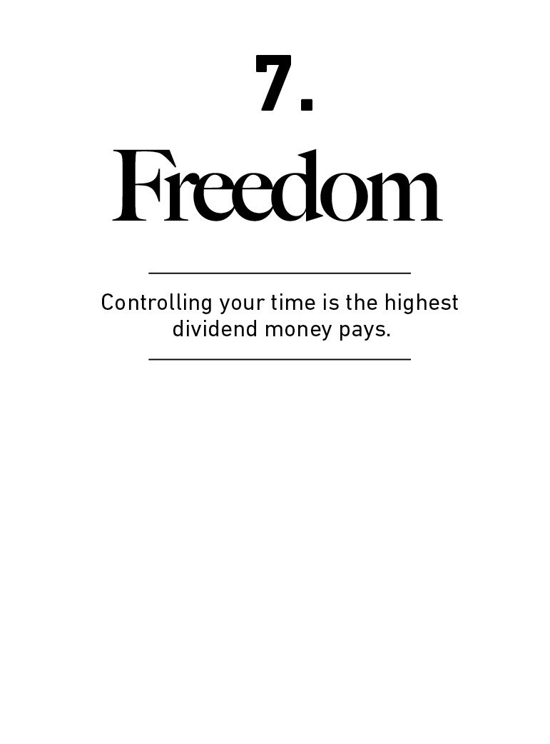

The highest form of wealth is the ability to wake up every

morning and say, “I can do whatever I want today.”

People want to become wealthier to make them happier.

Happiness is a complicated subject because everyone’s

diﬀerent. But if there’s a common denominator in happiness

—a universal fuel of joy—it’s that people want to control

their lives.

The ability to do what you want, when you want, with who

you want, for as long as you want, is priceless. It is the

highest dividend money pays.

Angus Campbell was a psychologist at the University of

Michigan. Born in 1910, his research took place during an

age when psychology was overwhelmingly focused on

disorders that brought people down—things like depression,

anxiety, schizophrenia.

Campbell wanted to know what made people happy. His

1981 book, The Sense of Wellbeing in America, starts by

pointing out that people are generally happier than many

psychologists assumed. But some were clearly doing better

than others. And you couldn’t necessarily group them by

income, or geography, or education, because so many in

each of those categories end up chronically unhappy.

The most powerful common denominator of happiness was

simple. Campbell summed it up:

Having a strong sense of controlling one’s life is a more

dependable predictor of positive feelings of wellbeing than

any of the objective conditions of life we have considered.

More than your salary. More than the size of your house.

More than the prestige of your job. Control over doing what

you want, when you want to, with the people you want to, is

the broadest lifestyle variable that makes people happy.

Money’s greatest intrinsic value—and this can’t be

overstated—is its ability to give you control over your time.

To obtain, bit by bit, a level of independence and autonomy

that comes from unspent assets that give you greater

control over what you can do and when you can do it.

A small amount of wealth means the ability to take a few

days oﬀ work when you’re sick without breaking the bank.

Gaining that ability is huge if you don’t have it.

A bit more means waiting for a good job to come around

after you get laid oﬀ, rather than having to take the ﬁrst one

you ﬁnd. That can be life changing.

Six months’ emergency expenses means not being terriﬁed

of your boss, because you know you won’t be ruined if you

have to take some time oﬀ to ﬁnd a new job.

More still means the ability to take a job with lower pay but

ﬂexible hours. Maybe one with a shorter commute. Or being

able to deal with a medical emergency without the added

burden of worrying about how you’ll pay for it.

Then there’s retiring when you want to, instead of when you

need to.

Using your money to buy time and options has a lifestyle

beneﬁt few luxury goods can compete with.

Throughout college I wanted to be an investment banker.

There was only one reason why: they made a lot of money.

That was the only drive, and one I was 100% positive would

make me happier once I got it. I scored a summer internship

at an investment bank in Los Angeles in my junior year, and

thought I won the career lottery. This is all I ever wanted.

On my ﬁrst day I realized why investment bankers make a

lot of money: They work longer and more controlled hours

than I knew humans could handle. Actually, most can’t

handle it. Going home before midnight was considered a

luxury, and there was a saying in the oﬃce: “If you don’t

come to work on Saturday, don’t bother coming back on

Sunday.” The job was intellectually stimulating, paid well,

and made me feel important. But every waking second of

my time became a slave to my boss’s demands, which was

enough to turn it into one of the most miserable experiences

of my life. It was a four-month internship. I lasted a month.

The hardest thing about this was that I loved the work. And I

wanted to work hard. But doing something you love on a

schedule you can’t control can feel the same as doing

something you hate.

There is a name for this feeling. Psychologists call it

reactance. Jonah Berger, a marketing professor at the

University of Pennsylvania, summed it up well:

People like to feel like they’re in control—in the drivers’ seat.

When we try to get them to do something, they feel

disempowered. Rather than feeling like they made the

choice, they feel like we made it for them. So they say no or

do something else, even when they might have originally

been happy to go along.²⁵

When you accept how true that statement is, you realize

that aligning money towards a life that lets you do what you

want, when you want, with who you want, where you want,

for as long as you want, has incredible return.

Derek Sivers, a successful entrepreneur, once wrote about a

friend who asked him to tell the story about how he got rich:

I had a day job in midtown Manhattan paying $20

k

per year—about minimum wage ... I never ate out, and

never took a taxi. My cost of living was about $1000/month,

and I was earning $1800/month. I did this for two years, and

saved up $12,000. I was 22 years old.

Once I had $12,000 I could quit my job and become a full-

time musician. I knew I could get a few gigs per month to

pay my cost of living. So I was free. I quit my job a month

later, and never had a job again.

When I ﬁnished telling my friend this story, he asked for

more. I said no, that was it. He said, “No, what about when

you sold your company?”

I said no, that didn’t make a big diﬀerence in my life. That

was just more money in the bank. The diﬀerence happened

when I was 22.²⁶

The United States is the richest nation in the history of the

world. But there is little evidence that its citizens are, on

average, happier today than they were in the 1950s, when

wealth and income were much lower—even at the median

level and adjusted for inﬂation. A 2019 Gallup poll of

150,000 people in 140 countries found that about 45% of

Americans said they felt “a lot of worry” the previous day.²⁷

The global average was 39%. Fifty-ﬁve percent of Americans

said they felt “a lot of stress” the previous day. For the rest of

the world, 35% said the same.

Part of what’s happened here is that we’ve used our greater

wealth to buy bigger and better stuﬀ. But we’ve

simultaneously given up more control over our time. At best,

those things cancel each other out.

Median family income adjusted for inﬂation was $29,000 in

1955.²⁸ In 2019 it was just over $62,000. We’ve used that

wealth to live a life hardly conceivable to the 1950s

American, even for a median family. The median American

home increased from 983 square feet in 1950 to 2,436

square feet in 2018. The average new American home now

has more bathrooms than occupants. Our cars are faster and

more eﬃcient, our TVs are cheaper and sharper.

What’s happened to our time, on the other hand, barely

looks like progress. And a lot of the reason has to do with

the kind of jobs more of us now have.

John D. Rockefeller was one of the most successful

businessmen of all time. He was also a recluse, spending

most of his time by himself. He rarely spoke, deliberately

making himself inaccessible and staying quiet when you

caught his attention.

A reﬁnery worker who occasionally had Rockefeller’s ear

once remarked: “He lets everybody else talk, while he sits

back and says nothing.”

When asked about his silence during meetings, Rockefeller

often recited a poem:

A wise old owl lived in an oak,

The more he saw the less he spoke,

The less he spoke, the more he heard,

Why aren’t we all like that wise old bird?

Rockefeller was a strange guy. But he ﬁgured out something

that now applies to tens of millions of workers.

Rockefeller’s job wasn’t to drill wells, load trains, or move

barrels. It was to think and make good decisions.

Rockefeller’s product—his deliverable—wasn’t what he did

with his hands, or even his words. It was what he ﬁgured out

inside his head. So that’s where he spent most of his time

and energy. Despite sitting quietly most of the day in what

might have looked like free time or leisure hours to most

people, he was constantly working in his mind, thinking

problems through.

This was unique in his day. Almost all jobs during

Rockefeller’s time required doing things with your hands. In

1870, 46% of jobs were in agriculture, and 35% were in

crafts or manufacturing, according to economist Robert

Gordon. Few professions relied on a worker’s brain. You

didn’t think; you labored, without interruption, and your

work was visible and tangible.

Today, that’s ﬂipped.

Thirty-eight percent of jobs are now designated as

“managers, oﬃcials, and professionals.” These are decision-

making jobs. Another 41% are service jobs that often rely on

your thoughts as much as your actions.

More of us have jobs that look closer to Rockefeller than a

typical 1950s manufacturing worker, which means our days

don’t end when we clock out and leave the factory. We’re

constantly working in our heads, which means it feels like

work never ends.

If your job is to build cars, there is little you can do when

you’re not on the assembly line. You detach from work and

leave your tools in the factory. But if your job is to create a

marketing campaign—a thought-based and decision job—

your tool is your head, which never leaves you. You might be

thinking about your project during your commute, as you’re

making dinner, while you put your kids to sleep, and when

you wake up stressed at three in the morning. You might be

on the clock for fewer hours than you would in 1950. But it

feels like you’re working 24/7.

Derek Thompson of The Atlantic once described it like this:

If the operating equipment of the 21st century is a portable

device, this means the modern factory is not a place at all. It

is the day itself. The computer age has liberated the tools of

productivity from the oﬃce. Most knowledge workers, whose

laptops and smartphones are portable all-purpose media-

making machines, can theoretically be as productive at 2

p.m. in the main oﬃce as at 2 a.m. in a Tokyo WeWork or at

midnight on the couch.²⁹

Compared to generations prior, control over your time has

diminished. And since controlling your time is such a key

happiness inﬂuencer, we shouldn’t be surprised that people

don’t feel much happier even though we are, on average,

richer than ever.

What do we do about that?

It’s not an easy problem to solve, because everyone’s

diﬀerent. The ﬁrst step is merely acknowledging what does,

and does not, make almost everyone happy.

In his book 30 Lessons for Living, gerontologist Karl Pillemer

interviewed a thousand elderly Americans looking for the

most important lessons they learned from decades of life

experience. He wrote:

No one—not a single person out of a thousand—said that to

be happy you should try to work as hard as you can to make

money to buy the things you want.

No one—not a single person—said it’s important to be at

least as wealthy as the people around you, and if you have

more than they do it’s real success.

No one—not a single person—said you should choose your

work based on your desired future earning power.

What they did value were things like quality friendships,

being part of something bigger than themselves, and

spending quality, unstructured time with their children.

“Your kids don’t want your money (or what your money

buys) anywhere near as much as they want you. Speciﬁcally,

they want you with them,” Pillemer writes.

Take it from those who have lived through everything:

Controlling your time is the highest dividend money pays.

Now, a short chapter on one of the lowest dividends money

pays.

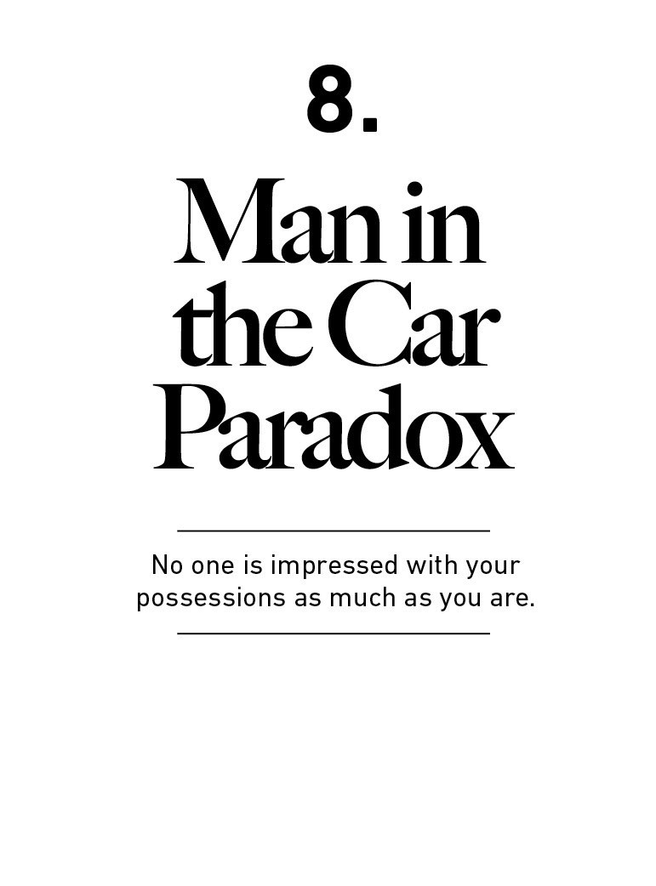

The best part of being a valet is getting to drive some of the

coolest cars to ever touch pavement. Guests came in driving

Ferraris, Lamborghinis, Rolls-Royces—the whole aristocratic

ﬂeet.

It was my dream to have one of these cars of my own,

because (I thought) they sent such a strong signal to others

that you made it. You’re smart. You’re rich. You have taste.

You’re important. Look at me.

The irony is that I rarely if ever looked at them, the drivers.

When you see someone driving a nice car, you rarely think,

“Wow, the guy driving that car is cool.” Instead, you think,

“Wow, if I had that car people would think I’m cool.”

Subconscious or not, this is how people think.

There is a paradox here: people tend to want wealth to

signal to others that they should be liked and admired. But

in reality those other people often bypass admiring you, not

because they don’t think wealth is admirable, but because

they use your wealth as a benchmark for their own desire to

be liked and admired.

The letter I wrote after my son was born said, “You might

think you want an expensive car, a fancy watch, and a huge

house. But I’m telling you, you don’t. What you want is

respect and admiration from other people, and you think

having expensive stuﬀ will bring it. It almost never does—

especially from the people you want to respect and admire

you.”

I learned that as a valet, when I began thinking about all the

people driving up to the hotel in their Ferraris, watching me

gawk. People must gawk everywhere they went, and I’m

sure they loved it. I’m sure they felt admired.

But did they know I did not care about them, or even notice

them? Did they know I was only gawking at the car, and

imagining myself in the driver’s seat?

Did they buy a Ferrari thinking it would bring them

admiration without realizing that I—and likely most others—

who are impressed with the car didn’t actually give them,

the driver, a moment’s thought?

Does this same idea apply to those living in big homes?

Almost certainly.

Jewelry and clothes? Yep.

My point here is not to abandon the pursuit of wealth. Or

even fancy cars. I like both.

It’s a subtle recognition that people generally aspire to be

respected and admired by others, and using money to buy

fancy things may bring less of it than you imagine. If respect

and admiration are your goal, be careful how you seek it.

Humility, kindness, and empathy will bring you more

respect than horsepower ever will.

We’re not done talking about Ferraris. Another story about

the paradox of fast cars in the next chapter.

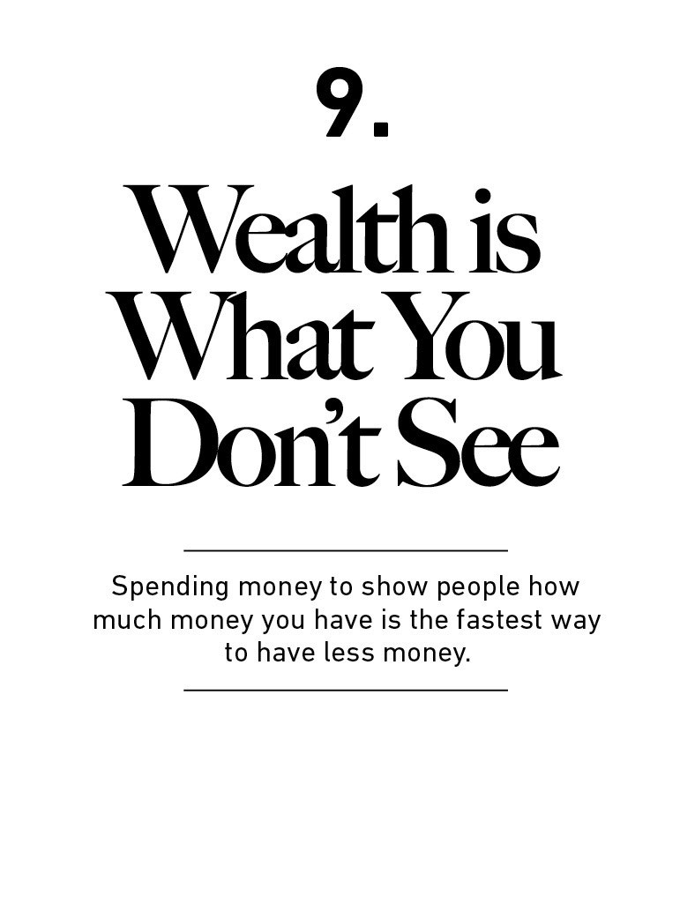

Money has many ironies. Here’s an important one: Wealth is

what you don’t see.

My time as a valet was in the mid-2000s in Los Angeles,

when material appearance took precedence over everything

but oxygen.

If you see a Ferrari driving around, you might intuitively

assume the owner of the car is rich—even if you’re not

paying much attention to them. But as I got to know some

of these people I realized that wasn’t always the case. Many

were mediocre successes who spent a huge percentage of

their paycheck on a car.

I remember a fellow we’ll call Roger. He was about my age. I

had no idea what Roger did. But he drove a Porsche, which

was enough for people to draw assumptions.

Then one day Roger arrived in an old Honda. Same the next

week, and the next.

“What happened to your Porsche?” I asked. It was

repossessed after defaulting on his car loan, he said. There

was not a morsel of shame. He responded like he was telling

the next play in the game. Every assumption you might have

had about him was wrong. Los Angeles is full of Rogers.

Someone driving a $100,000 car might be wealthy. But the

only data point you have about their wealth is that they

have $100,000 less than they did before they bought the car

(or $100,000 more in debt). That’s all you know about them.

We tend to judge wealth by what we see, because that’s the

information we have in front of us. We can’t see people’s

bank accounts or brokerage statements. So we rely on

outward appearances to gauge ﬁnancial success. Cars.

Homes. Instagram photos.

Modern capitalism makes helping people fake it until they

make it a cherished industry.

But the truth is that wealth is what you don’t see.

Wealth is the nice cars not purchased. The diamonds not

bought. The watches not worn, the clothes forgone and the

ﬁrst-class upgrade declined. Wealth is ﬁnancial assets that

haven’t yet been converted into the stuﬀ you see.

That’s not how we think about wealth, because you can’t

contextualize what you can’t see.

Singer Rihanna nearly went bankrupt after overspending

and sued her ﬁnancial advisor. The advisor responded: “Was

it really necessary to tell her that if you spend money on

things, you will end up with the things and not the

money?”³⁰

You can laugh, and please do. But the answer is, yes, people

do need to be told that. When most people say they want to

be a millionaire, what they might actually mean is “I’d like

to spend a million dollars.” And that is literally the opposite

of being a millionaire.

Investor Bill Mann once wrote: “There is no faster way to feel

rich than to spend lots of money on really nice things. But

the way to be rich is to spend money you have, and to not

spend money you don’t have. It’s really that simple.”³¹

It is excellent advice, but it may not go far enough. The only

way to be wealthy is to not spend the money that you do

have. It’s not just the only way to accumulate wealth; it’s

the very deﬁnition of wealth.

We should be careful to deﬁne the diﬀerence between

wealthy and rich. It is more than semantics. Not knowing

the diﬀerence is a source of countless poor money decisions.

Rich is a current income. Someone driving a $100,000 car is

almost certainly rich, because even if they purchased the

car with debt you need a certain level of income to aﬀord

the monthly payment. Same with those who live in big

homes. It’s not hard to spot rich people. They often go out of

their way to make themselves known.

But wealth is hidden. It’s income not spent. Wealth is an

option not yet taken to buy something later. Its value lies in

oﬀering you options, ﬂexibility, and growth to one day

purchase more stuﬀ than you could right now.

Diet and exercise oﬀer a useful analogy. Losing weight is

notoriously hard, even among those putting in the work of

vigorous exercise. In his book The Body, Bill Bryson explains

why:

One study in America found that people overestimate the

number of calories they burned in a workout by a factor of

four. They also then consumed, on average, about twice as

many calories as they had just burned oﬀ … the fact is, you

can quickly undo a lot of exercise by eating a lot of food, and

most of us do.

Exercise is like being rich. You think, “I did the work and I

now deserve to treat myself to a big meal.” Wealth is turning

down that treat meal and actually burning net calories. It’s

hard, and requires self-control. But it creates a gap between

what you could do and what you choose to do that accrues

to you over time.

The problem for many of us is that it is easy to ﬁnd rich role

models. It’s harder to ﬁnd wealthy ones because by

deﬁnition their success is more hidden.

There are, of course, wealthy people who also spend a lot of

money on stuﬀ. But even in those cases what we see is their

richness, not their wealth. We see the cars they chose to buy

and perhaps the school they choose to send their kids to. We

don’t see the savings, retirement accounts, or investment

portfolios. We see the homes they bought, not the homes

they could have bought had they stretched themselves thin.

The danger here is that I think most people, deep down,

want to be wealthy. They want freedom and ﬂexibility, which

is what ﬁnancial assets not yet spent can give you. But it is

so ingrained in us that to have money is to spend money

that we don’t get to see the restraint it takes to actually be

wealthy. And since we can’t see it, it’s hard to learn about it.

People are good at learning by imitation. But the hidden

nature of wealth makes it hard to imitate others and learn

from their ways. After he died, Ronald Read became many

people’s ﬁnancial role model. He was lionized in the media

and cherished on social media. But he was nobody’s

ﬁnancial role model while he was living because every

penny of his wealth was hidden, even to those who knew

him.

Imagine how hard it would be to learn how to write if you

couldn’t read the works of great authors. Who would be your

inspiration? Who would you admire? Whose nuanced tricks

and tips would you follow? It would make something that is

already hard even harder. It’s diﬃcult to learn from what you

can’t see. Which helps explain why it’s so hard for many to

build wealth.

The world is ﬁlled with people who look modest but are

actually wealthy and people who look rich who live at the

razor’s edge of insolvency. Keep this in mind when quickly

judging others’ success and setting your own goals.

If wealth is what you don’t spend, what good is it? Well, let

me convince you to save money.

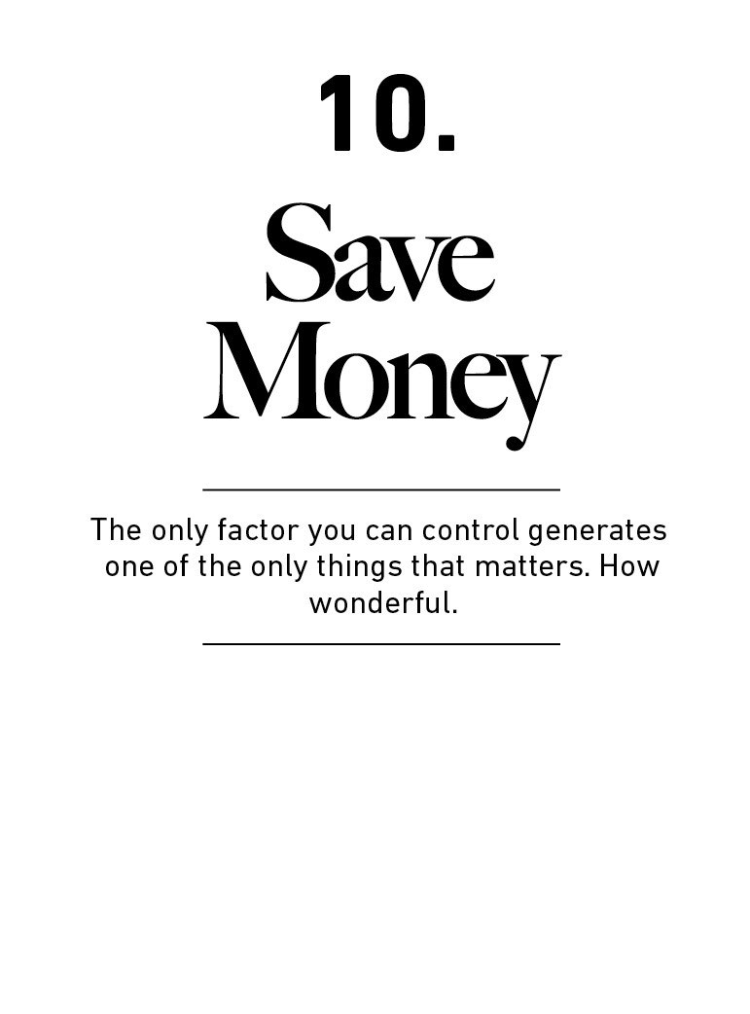

Let me convince you to save money.

It won’t take long.

But it’s an odd task, isn’t it?

Do people need to be convinced to save money?

My observation is that, yes, many do.

Past a certain level of income people fall into three groups:

Those who save, those who don’t think they can save, and

those who don’t think they need to save.

This is for the latter two.

The ﬁrst idea—simple, but easy to overlook—is that

building wealth has little to do with your income or

investment returns, and lots to do with your savings

rate.

A quick story about the power of eﬃciency.

In the 1970s the world looked like it was running out of oil.

The calculation wasn’t hard: The global economy used a lot

of oil, the global economy was growing, and the amount of

oil we could drill couldn’t keep up.

We didn’t run out of oil, thank goodness. But that wasn’t just

because we found more oil, or even got better at taking it

out of the ground.

The biggest reason we overcame the oil crisis is because we

started building cars, factories, and homes that are more

energy eﬃcient than they used to be. The United States

uses 60% less energy per dollar of GDP today than it did in

1950.³² The average miles per gallon of all vehicles on the

road has doubled since 1975. A 1989 Ford Taurus (sedan)

averaged 18.0 MPG. A 2019 Chevy Suburban (absurdly large

SUV) averages 18.1 MPG.

The world grew its “energy wealth” not by increasing the

energy it had, but by decreasing the energy it needed. U.S.

oil and gas production has increased 65% since 1975, while

conservation and eﬃciency has more than doubled what we

can do with that energy. So it’s easy to see which has

mattered more.

The important thing here is that ﬁnding more energy is

largely out of our control and shrouded in uncertainty,

because it relies on a slippery mix of having the right

geology, geography, weather, and geopolitics. But becoming

more eﬃcient with the energy we use is largely in our

control. The decision to buy a lighter car or ride a bike is up

to you and has a 100% chance of improving eﬃciency.

The same is true with our money.

Investment returns can make you rich. But whether an

investing strategy will work, and how long it will work for,

and whether markets will cooperate, is always in doubt.

Results are shrouded in uncertainty.

Personal savings and frugality—ﬁnance’s conservation and

eﬃciency—are parts of the money equation that are more in

your control and have a 100% chance of being as eﬀective

in the future as they are today.

If you view building wealth as something that will require

more money or big investment returns, you may become as

pessimistic as the energy doomers were in the 1970s. The

path forward looks hard and out of your control.

If you view it as powered by your own frugality and

eﬃciency, the destiny is clearer.

Wealth is just the accumulated leftovers after you spend

what you take in. And since you can build wealth without a

high income, but have no chance of building wealth without

a high savings rate, it’s clear which one matters more.

More importantly, the value of wealth is relative to

what you need.

Say you and I have the same net worth.

And say you’re a better investor than me. I can earn 8%

annual returns and you can earn 12% annual returns.

But I’m more eﬃcient with my money. Let’s say I need half

as much money to be happy while your lifestyle compounds

as fast as your assets.

I’m better oﬀ than you are, despite being a worse investor.

I’m getting more beneﬁt from my investments despite lower

returns.

The same is true for incomes. Learning to be happy with less

money creates a gap between what you have and what you

want—similar to the gap you get from growing your

paycheck, but easier and more in your control.

A high savings rate means having lower expenses than you

otherwise could, and having lower expenses means your

savings go farther than they would if you spent more.

Think about this in the context of how much time and eﬀort

goes into achieving 0.1% of annual investment

outperformance—millions of hours of research, tens of

billions of dollars of eﬀort from professionals—and it’s easy

to see what’s potentially more important or worth chasing.

There are professional investors who grind 80 hours a week

to add a tenth of a percentage point to their returns when

there are two or three full percentage points of lifestyle

bloat in their ﬁnances that can be exploited with less eﬀort.

Big investment returns and fat paychecks are amazing when

they can be achieved, and some can achieve them. But the

fact that there’s so much eﬀort put into one side of the

ﬁnance equation and so little put into the other is an

opportunity for most people.

Past a certain level of income, what you need is just

what sits below your ego.

Everyone needs the basics. Once they’re covered there’s

another level of comfortable basics, and past that there’s

basics that are both comfortable, entertaining, and

enlightening.

But spending beyond a pretty low level of materialism is

mostly a reﬂection of ego approaching income, a way to

spend money to show people that you have (or had) money.

Think of it like this, and one of the most powerful ways to

increase your savings isn’t to raise your income. It’s to raise

your humility.

When you deﬁne savings as the gap between your ego and

your income you realize why many people with decent

incomes save so little. It’s a daily struggle against instincts

to extend your peacock feathers to their outermost limits

and keep up with others doing the same.

People with enduring personal ﬁnance success—not

necessarily those with high incomes—tend to have a

propensity to not give a damn what others think about

them.

So people’s ability to save is more in their control

than they might think.

Savings can be created by spending less.

You can spend less if you desire less.

And you will desire less if you care less about what others

think of you.

As I argue often in this book, money relies more on

psychology than ﬁnance.

And you don’t need a speciﬁc reason to save.

Some people save money for a downpayment on a house, or

a new car, or for retirement.

That’s great, of course.

But saving does not require a goal of purchasing something

speciﬁc.

You can save just for saving’s sake. And indeed you should.

Everyone should.

Only saving for a speciﬁc goal makes sense in a predictable

world. But ours isn’t. Saving is a hedge against life’s

inevitable ability to surprise the hell out of you at the worst

possible moment.

Another beneﬁt of savings that isn’t attached to a spending

goal is what we discussed in chapter 7: gaining control over

your time.

Everyone knows the tangible stuﬀ money buys. The

intangible stuﬀ is harder to wrap your head around, so it

tends to go unnoticed. But the intangible beneﬁts of money

can be far more valuable and capable of increasing your

happiness than the tangible things that are obvious targets

of our savings.

Savings without a spending goal gives you options and

ﬂexibility, the ability to wait and the opportunity to pounce.

It gives you time to think. It lets you change course on your

own terms.

Every bit of savings is like taking a point in the future that

would have been owned by someone else and giving it back

to yourself.

That ﬂexibility and control over your time is an

unseen return on wealth.

What is the return on cash in the bank that gives you the

option of changing careers, or retiring early, or freedom from

worry?

I’d say it’s incalculable.

It’s incalculable in two ways. It’s so large and important that

we can’t put a price on it. But it’s also literally incalculable—

we can’t measure it like we can measure interest rates—and

what we can’t measure we tend to overlook.

When you don’t have control over your time, you’re forced to

accept whatever bad luck is thrown your way. But if you

have ﬂexibility you have the time to wait for no-brainer

opportunities to fall in your lap. This is a hidden return on

your savings.

Savings in the bank that earn 0% interest might actually

generate an extraordinary return if they give you the

ﬂexibility to take a job with a lower salary but more purpose,

or wait for investment opportunities that come when those

without ﬂexibility turn desperate.

And that hidden return is becoming more important.

The world used to be hyper-local. Just over 100 years ago

75% of Americans had neither telephones nor regular mail

service, according to historian Robert Gordon. That made

competition hyper-local. A worker with just average

intelligence might be the best in their town, and they got

treated like the best because they didn’t have to compete

with the smarter worker in another town.

That’s now changed.

A hyper-connected world means the talent pool you

compete in has gone from hundreds or thousands spanning

your town to millions or billions spanning the globe. This is

especially true for jobs that rely on working with your head

versus your muscles: teaching, marketing, analysis,

consulting, accounting, programming, journalism, and even

medicine increasingly compete in global talent pools. More

ﬁelds will fall into this category as digitization erases global

boundaries—as “software eats the world,” as venture

capitalist Marc Andreesen puts it.

A question you should ask as the range of your competition

expands is, “How do I stand out?”

“I’m smart” is increasingly a bad answer to that question,

because there are a lot of smart people in the world. Almost

600 people ace the SATs each year. Another 7,000 come

within a handful of points. In a winner-take-all and

globalized world these kinds of people are increasingly your

direct competitors.

Intelligence is not a reliable advantage in a world that’s

become as connected as ours has.

But ﬂexibility is.

In a world where intelligence is hyper-competitive and many

previous technical skills have become automated,

competitive advantages tilt toward nuanced and soft skills—

like communication, empathy, and, perhaps most of all,

ﬂexibility.

If you have ﬂexibility you can wait for good opportunities,

both in your career and for your investments. You’ll have a

better chance of being able to learn a new skill when it’s

necessary. You’ll feel less urgency to chase competitors who

can do things you can’t, and have more leeway to ﬁnd your

passion and your niche at your own pace. You can ﬁnd a new

routine, a slower pace, and think about life with a diﬀerent

set of assumptions. The ability to do those things when most

others can’t is one of the few things that will set you apart in

a world where intelligence is no longer a sustainable

advantage.

Having more control over your time and options is becoming

one of the most valuable currencies in the world.

That’s why more people can, and more people should, save

money.

You know what else they should do? Stop trying to be so

rational. Let me tell you why.

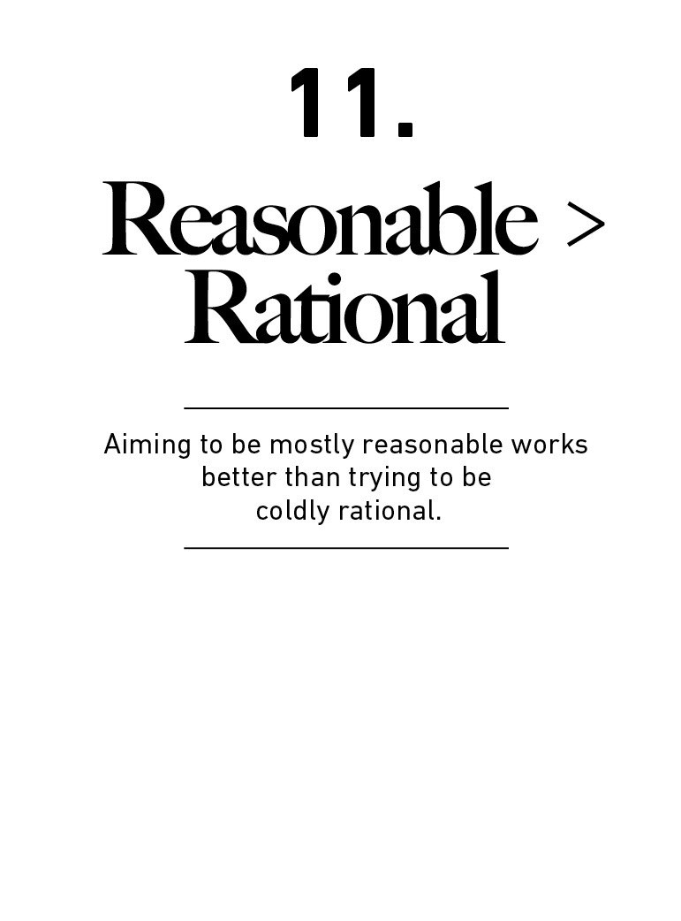

You’re not a spreadsheet. You’re a person. A screwed up,

emotional person.

It took me a while to ﬁgure this out, but once it clicked I

realized it’s one of the most important parts of ﬁnance.

With it comes something that often goes overlooked: Do not

aim to be coldly rational when making ﬁnancial decisions.

Aim to just be pretty reasonable. Reasonable is more

realistic and you have a better chance of sticking with it for

the long run, which is what matters most when managing

money.

To show you what I mean, let me tell you the story of a guy

who tried to cure syphilis with malaria.

Julius Wagner-Jauregg was a 19th-century psychiatrist with

two unique skills: He was good at recognizing patterns, and

what others saw as “crazy” he found merely “bold.”

His specialty was patients with severe neurosyphilis—then a

fatal diagnosis with no known treatment. He began noticing

a pattern: syphilis patients tended to recover if they had the

added misfortune of having prolonged fevers from an

unrelated ailment.

Wagner-Jauregg assumed this was due to a hunch that had

been around for centuries but doctors didn’t understand

well: fevers play a role in helping the body ﬁght infection.

So he jumped to the logical conclusion.

In the early 1900s Wagner-Jauregg began injecting patients

with low-end strains of typhoid, malaria, and smallpox to

trigger fevers strong enough to kill oﬀ their syphilis. This

was as dangerous as it sounds. Some of his patients died

from the treatment. He eventually settled on a weak version

of malaria, since it could be eﬀectively countered with

quinine after a few days of bone-rattling fevers.

After some tragic trial and error his experiment worked.

Wagner-Jauregg reported that 6 in 10 syphilis patients

treated with “malariotherapy” recovered, compared to

around 3 in 10 patients left alone. He won the Nobel Prize in

medicine in 1927. The organization today notes: “The main

work that concerned Wagner-Jauregg throughout his

working life was the endeavour to cure mental disease by

inducing a fever.”³³

Penicillin eventually made malariotherapy for syphilis

patients obsolete, thank goodness. But Wagner-Jauregg is

one of the only doctors in history who not only recognized

fever’s role in ﬁghting infection, but also prescribed it as a

treatment.

Fevers have always been as feared as they are mysterious.

Ancient Romans worshiped Febris, the Goddess who

protected people from fevers. Amulets were left at temples

to placate her, hoping to stave oﬀ the next round of shivers.

But Wagner-Jauregg was onto something. Fevers are not

accidental nuisances. They do play a role in the body’s road

to recovery. We now have better, more scientiﬁc evidence of

fever’s usefulness in ﬁghting infection. A one-degree

increase in body temperature has been shown to slow the

replication rate of some viruses by a factor of 200.

“Numerous investigators have identiﬁed a better outcome

among patients who displayed fever,” one NIH paper

writes.³⁴ The Seattle Children’s Hospital includes a section

on its website to educate parents who may panic at the

slightest rise in their child’s temperature: “Fevers turn on

the body’s immune system. They help the body ﬁght

infection. Normal fevers between 100° and 104° f are good

for sick children.”³⁵

But that’s where the science ends and reality takes over.

Fever is almost universally seen as a bad thing. They’re

treated with drugs like Tylenol to reduce them as quickly as

they appear. Despite millions of years of evolution as a

defense mechanism, no parent, no patient, few doctors, and

certainly no drug company views fever as anything but a

misfortune that should be eliminated.

These views do not match the known science. One study

was blunt: “Treatment of fever is common in the ICU setting

and likely related to standard dogma rather than evidence-

based practice.”³⁶ Howard Markel, director of the Center for

the History of Medicine, once said of fever phobia: “These

are cultural practices that spread just as widely as the

infectious diseases that are behind them.”³⁷

Why does this happen? If fevers are beneﬁcial, why do we

ﬁght them so universally?

I don’t think it’s complicated: Fevers hurt. And people don’t

want to hurt.

That’s it.

A doctor’s goal is not just to cure disease. It’s to cure disease

within the conﬁnes of what’s reasonable and tolerable to the

patient. Fevers can have marginal beneﬁts in ﬁghting

infection, but they hurt. And I go to the doctor to stop

hurting. I don’t care about double-blind studies when I’m

shivering under a blanket. If you have a pill that can make a

fever stop, give it to me now.

It may be rational to want a fever if you have an infection.

But it’s not reasonable.

That philosophy—aiming to be reasonable instead of

rational—is one more people should consider when making

decisions with their money.

Academic ﬁnance is devoted to ﬁnding the mathematically

optimal investment strategies. My own theory is that, in the

real world, people do not want the mathematically optimal

strategy. They want the strategy that maximizes for how

well they sleep at night.

Harry Markowitz won the Nobel Prize for exploring the

mathematical tradeoﬀ between risk and return. He was once

asked how he invested his own money, and described his

portfolio allocation in the 1950s, when his models were ﬁrst

developed:

I visualized my grief if the stock market went way up and I

wasn’t in it—or if it went way down and I was completely in

it. My intention was to minimize my future regret. So I split

my contributions 50/50 between bonds and equities.

Markowitz eventually changed his investment strategy,

diversifying the mix. But two things here are important.

One is that “minimizing future regret” is hard to rationalize

on paper but easy to justify in real life. A rational investor

makes decisions based on numeric facts. A reasonable

investor makes them in a conference room surrounded by

co-workers you want to think highly of you, with a spouse

you don’t want to let down, or judged against the silly but

realistic competitors that are your brother-in-law, your

neighbor, and your own personal doubts. Investing has a

social component that’s often ignored when viewed through

a strictly ﬁnancial lens.

The second is that this is ﬁne. Jason Zweig, who conducted

the interview when Markowitz described how he invested,

later reﬂected:

My own view is that people are neither rational nor

irrational. We are human. We don’t like to think harder than

we need to, and we have unceasing demands on our

attention. Seen in that light, there’s nothing surprising

about the fact that the pioneer of modern portfolio theory

built his initial portfolio with so little regard for his own

research. Nor is it surprising that he adjusted it later.³⁸

Markowitz is neither rational or irrational. He’s reasonable.

What’s often overlooked in ﬁnance is that something can be

technically true but contextually nonsense.

In 2008 a pair of researchers from Yale published a study

arguing young savers should supercharge their retirement

accounts using two-to-one margin (two dollars of debt for

every dollar of their own money) when buying stocks. It

suggests investors taper that leverage as they age, which

lets a saver take more risk when they’re young and can

handle a magniﬁed market rollercoaster, and less when

they’re older.

Even if using leverage left you wiped out when you were

young (if you use two-to-one margin a 50% market drop

leaves you with nothing) the researchers showed savers

would still be better oﬀ in the long run so long as they

picked themselves back up, followed the plan, and kept

saving in a two-to-one leveraged account the day after being

wiped out.

The math works on paper. It’s a rational strategy.

But it’s almost absurdly unreasonable.

No normal person could watch 100% of their retirement

account evaporate and be so unphased that they carry on

with the strategy undeterred. They’d quit, look for a

diﬀerent option, and perhaps sue their ﬁnancial advisor.

The researchers argued that when using their strategy “the

expected retirement wealth is 90% higher compared to life-

cycle funds.” It is also 100% less reasonable.

There is, in fact, a rational reason to favor what look like

irrational decisions.

Here’s one: Let me suggest that you love your investments.

This is not traditional advice. It’s almost a badge of honor for

investors to claim they’re emotionless about their

investments, because it seems rational.

But if lacking emotions about your strategy or the stocks you

own increases the odds you’ll walk away from them when

they become diﬃcult, what looks like rational thinking

becomes a liability. The reasonable investors who love their

technically imperfect strategies have an edge, because

they’re more likely to stick with those strategies.

There are few ﬁnancial variables more correlated to

performance than commitment to a strategy during its lean

years—both the amount of performance and the odds of

capturing it over a given period of time. The historical odds

of making money in U.S. markets are 50/50 over one-day

periods, 68% in one-year periods, 88% in 10-year periods,

and (so far) 100% in 20-year periods. Anything that keeps

you in the game has a quantiﬁable advantage.

If you view “do what you love” as a guide to a happier life, it

sounds like empty fortune cookie advice. If you view it as the

thing providing the endurance necessary to put the

quantiﬁable odds of success in your favor, you realize it

should be the most important part of any ﬁnancial strategy.

Invest in a promising company you don’t care about, and

you might enjoy it when everything’s going well. But when

the tide inevitably turns you’re suddenly losing money on

something you’re not interested in. It’s a double burden, and

the path of least resistance is to move onto something else.

If you’re passionate about the company to begin with—you

love the mission, the product, the team, the science,

whatever—the inevitable down times when you’re losing

money or the company needs help are blunted by the fact

that at least you feel like you’re part of something

meaningful. That can be the necessary motivation that

prevents you from giving up and moving on.

There are several other times when it’s ﬁne to be reasonable

instead of rational with money.

There’s a well-documented “home bias,” where people

prefer to invest in companies from the country they live in

while ignoring the other 95%+ of the planet. It’s not

rational, until you consider that investing is eﬀectively

giving money to strangers. If familiarity helps you take the

leap of faith required to remain backing those strangers, it’s

reasonable.

Day trading and picking individual stocks is not rational for

most investors—the odds are heavily against your success.

But they’re both reasonable in small amounts if they scratch

an itch hard enough to leave the rest of your more

diversiﬁed investments alone. Investor Josh Brown, who

advocates and mostly owns diversiﬁed funds, once

explained why he also owns a smattering of individual

stocks: “I’m not buying individual stocks because I think I’m

going to generate alpha [outperformance]. I just love stocks

and have ever since I was 20 years old. And it’s my money, I

get to do whatever.” Quite reasonable.

Most forecasts about where the economy and the stock

market are heading next are terrible, but making forecasts is

reasonable. It’s hard to wake up in the morning telling

yourself you have no clue what the future holds, even if it’s

true. Acting on investment forecasts is dangerous. But I get

why people try to predict what will happen next year. It’s

human nature. It’s reasonable.

Jack Bogle, the late founder of Vanguard, spent his career on

a crusade to promote low-cost passive index investing. Many

thought it interesting that his son found a career as an

active, high-fee hedge fund and mutual fund manager.

Bogle—the man who said high-fee funds violate “the

humble rules of arithmetic”—invested some of his own

money in his son’s funds. What’s the explanation?

“We do some things for family reasons,” Bogle told The Wall

Street Journal. “If it’s not consistent, well, life isn’t always

consistent.”³⁹

Indeed, it rarely is.

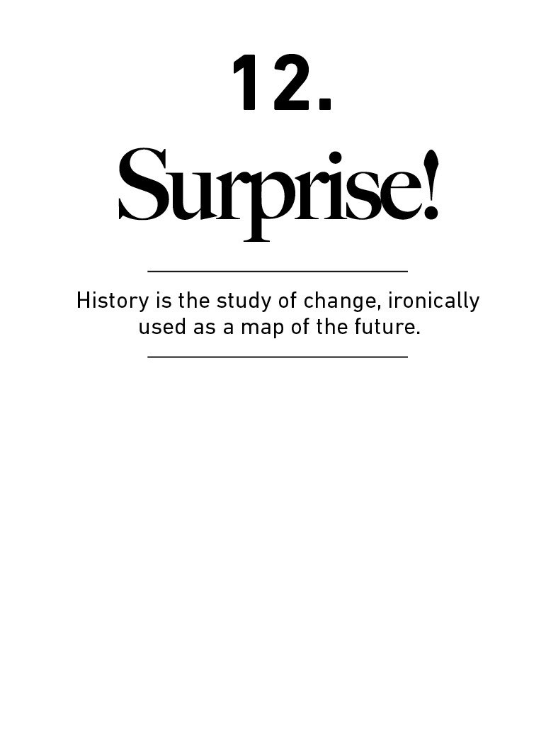

Stanford professor Scott Sagan once said something

everyone who follows the economy or investment markets

should hang on their wall: “Things that have never

happened before happen all the time.”

History is mostly the study of surprising events. But it is

often used by investors and economists as an unassailable

guide to the future.

Do you see the irony?

Do you see the problem?

It is smart to have a deep appreciation for economic and

investing history. History helps us calibrate our expectations,

study where people tend to go wrong, and oﬀers a rough

guide of what tends to work. But it is not, in any way, a map

of the future.

A trap many investors fall into is what I call “historians as

prophets” fallacy: An overreliance on past data as a signal to

future conditions in a ﬁeld where innovation and change are

the lifeblood of progress.

You can’t blame investors for doing this. If you view

investing as a hard science, history should be a perfect

guide to the future. Geologists can look at a billion years of

historical data and form models of how the earth behaves.

So can meteorologists. And doctors—kidneys operate the

same way in 2020 as they did in 1020.

But investing is not a hard science. It’s a massive group of

people making imperfect decisions with limited information

about things that will have a massive impact on their

wellbeing, which can make even smart people nervous,

greedy and paranoid.

Richard Feynman, the great physicist, once said, “Imagine

how much harder physics would be if electrons had

feelings.” Well, investors have feelings. Quite a few of them.

That’s why it’s hard to predict what they’ll do next based

solely on what they did in the past.

The cornerstone of economics is that things change over

time, because the invisible hand hates anything staying too

good or too bad indeﬁnitely. Investor Bill Bonner once

described how Mr. Market works: “He’s got a ‘Capitalism at

Work’ T-shirt on and a sledgehammer in his hand.” Few

things stay the same for very long, which means we can’t

treat historians as prophets.

The most important driver of anything tied to money is the

stories people tell themselves and the preferences they have

for goods and services. Those things don’t tend to sit still.

They change with culture and generation. They’re always

changing and always will.

The mental trick we play on ourselves here is an over-

admiration of people who have been there, done that, when

it comes to money. Experiencing speciﬁc events does not

necessarily qualify you to know what will happen next. In

fact it rarely does, because experience leads to

overconﬁdence more than forecasting ability.

Investor Michael Batnick once explained this well.

Confronted with the argument that few investors are

prepared for rising interest rates because they’ve never

experienced them—the last big period of rising interest

rates occurred almost 40 years ago—he argued that it didn’t

matter, because experiencing or even studying what

happened in the past might not serve as any guide to what

will happen when rates rise in the future:

So what? Will the current rate hike look like the last one, or

the one before that? Will diﬀerent asset classes behave

similarly, the same, or the exact opposite?

On the one hand, people that have been investing through

the events of 1987, 2000 and 2008 have experienced a lot

of diﬀerent markets. On the other hand, isn’t it possible that

this experience can lead to overconﬁdence? Failing to admit

you’re wrong? Anchoring to previous outcomes?

Two dangerous things happen when you rely too heavily on

investment history as a guide to what’s going to happen

next.

1. You’ll likely miss the outlier events that move the

needle the most.

The most important events in historical data are the big

outliers, the record-breaking events. They are what move

the needle in the economy and the stock market. The Great

Depression. World War II. The dot-com bubble. September

11th. The housing crash of the mid-2000s. A handful of

outlier events play an enormous role because they inﬂuence

so many unrelated events in their wake.

Fifteen billion people were born in the 19th and 20th

centuries. But try to imagine how diﬀerent the global

economy—and the whole world—would be today if just

seven of them never existed:

Adolf Hitler

Joseph Stalin

Mao Zedong

Gavrilo Princip

Thomas Edison

Bill Gates

Martin Luther King

I’m not even sure that’s the most meaningful list. But almost

everything about the world today—from borders to

technology to social norms—would be diﬀerent if these

seven people hadn’t left their mark. Another way to put this

is that 0.00000000004% of people were responsible for

perhaps the majority of the world’s direction over the last

century.

The same goes for projects, innovations, and events.

Imagine the last century without:

The Great Depression

World War II

The Manhattan Project

Vaccines

Antibiotics

ARPANET

September 11th

The fall of the Soviet Union

How many projects and events occurred in the 20th

century? Billions, trillions—who knows. But those eight

alone impacted the world orders upon orders of magnitude

more than others.

The thing that makes tail events easy to underappreciate is

how easy it is to underestimate how things compound. How,

for example, 9/11 prompted the Federal Reserve to cut

interest rates, which helped drive the housing bubble, which

led to the ﬁnancial crisis, which led to a poor jobs market,

which led tens of millions to seek a college education, which

led to $1.6 trillion in student loans with a 10.8% default

rate. It’s not intuitive to link 19 hijackers to the current

weight of student loans, but that’s what happens in a world

driven by a few outlier tail events.

The majority of what’s happening at any given moment in

the global economy can be tied back to a handful of past

events that were nearly impossible to predict.

The most common plot of economic history is the role of

surprises. The reason surprises occur is not because our

models are wrong or our intelligence is low. It’s because the

odds that Adolf Hitler’s parents argued on the evening nine

months before he was born were the same as them

conceiving a child. Technology is hard to predict because Bill

Gates may have died from polio if Jonas Salk got cranky and

gave up on his quest to ﬁnd a vaccine. The reason we

couldn’t predict the student loan growth is because an

airport security guard may have conﬁscated a hijacker’s

knife on 9/11. That’s all there is to it.

The problem is that we often use events like the Great

Depression and World War II to guide our views of things like

worst-case scenarios when thinking about future investment

returns. But those record-setting events had no precedent

when they occurred. So the forecaster who assumes the

worst (and best) events of the past will match the worst

(and best) events of the future is not following history;

they’re accidentally assuming that the history of

unprecedented events doesn’t apply to the future.

Nassim Taleb writes in his book Fooled By Randomness:

In Pharaonic Egypt … scribes tracked the high-water mark of

the Nile and used it as an estimate for a future worst-case

scenario. The same can be seen in the Fukushima nuclear

reactor, which experienced a catastrophic failure in 2011

when a tsunami struck. It had been built to withstand the

worst past historical earthquake, with the builders not

imagining much worse—and not thinking that the worst

past event had to be a surprise, as it had no precedent.

This is not a failure of analysis. It’s a failure of imagination.

Realizing the future might not look anything like the past is

a special kind of skill that is not generally looked highly

upon by the ﬁnancial forecasting community.

At a 2017 dinner I attended in New York, Daniel Kahneman

was asked how investors should respond when our forecasts

are wrong. He said:

Whenever we are surprised by something, even if we admit

that we made a mistake, we say, ‘Oh I’ll never make that

mistake again.’ But, in fact, what you should learn when you

make a mistake because you did not anticipate something is

that the world is diﬃcult to anticipate. That’s the correct

lesson to learn from surprises: that the world is surprising.

The correct lesson to learn from surprises is that the world is

surprising. Not that we should use past surprises as a guide

to future boundaries; that we should use past surprises as

an admission that we have no idea what might happen next.

The most important economic events of the future—things

that will move the needle the most—are things that history

gives us little to no guide about. They will be unprecedented

events. Their unprecedented nature means we won’t be

prepared for them, which is part of what makes them so

impactful. This is true for both scary events like recessions

and wars, and great events like innovation.

I’m conﬁdent in that prediction because surprises moving

the needle the most is the one forecast that’s been accurate

at virtually every point in history.

2. History can be a misleading guide to the future of

the economy and stock market because it doesn’t

account for structural changes that are relevant to

today’s world.

Consider a few big ones.

The 401(k) is 42 years old. The Roth IRA is younger, created

in the 1990s. So personal ﬁnancial advice and analysis

about how Americans save for retirement today is not

directly comparable to what made sense just a generation

ago. We have new options. Things changed.

Or take venture capital. It barely existed 25 years ago. There

are single venture capital funds today that are larger than

the entire industry was a generation ago.⁴⁰ In his memoir,

Nike founder Phil Knight wrote about his early days in

business:

There was no such thing as venture capital. An aspiring

young entrepreneur had very few places to turn, and those

places were all guarded by risk-averse gatekeepers with

zero imagination. In other words, bankers.

What this means, in eﬀect, is that all historical data going

back just a few decades about how startups are ﬁnanced is

out of date. What we know about investment cycles and

startup failure rates is not a deep base of history to learn

from, because the way companies are funded today is such

a new historical paradigm.

Or take public markets. The S&P 500 did not include

ﬁnancial stocks until 1976; today, ﬁnancials make up 16%

of the index. Technology stocks were virtually nonexistent 50

years ago. Today, they’re more than a ﬁfth of the index.

Accounting rules have changed over time. So have

disclosures, auditing, and the amount of market liquidity.

Things changed.

The time between U.S. recessions has changed dramatically

over the last 150 years:

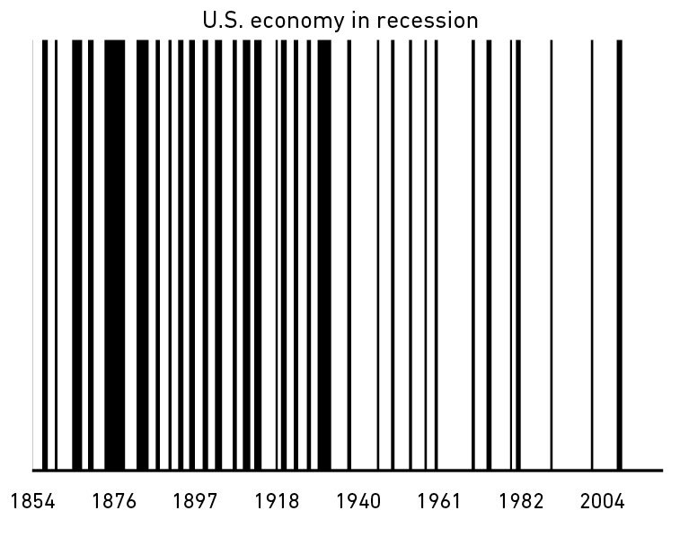

The average time between recessions has grown from about

two years in the late 1800s to ﬁve years in the early 20th

century to eight years over the last half-century.

As I write this it looks like we’re going into recession—12

years since the last recession began in December 2007.

That’s the longest gap between recessions since before the

Civil War.

There are plenty of theories on why recessions have become

less frequent. One is that the Fed is better at managing the

business cycle, or at least extending it. Another is that heavy

industry is more prone to boom-and-bust overproduction

than the service industries that dominated the last 50 years.

The pessimistic view is that we now have fewer recessions,

but when they occur they are more powerful than before.

For our argument it doesn’t particularly matter what caused

the change. What matters is that things clearly changed.

To show how these historic changes should aﬀect investing

decisions, consider the work of a man many believe to be

one of the greatest investment minds of all time: Benjamin

Graham.

Graham’s classic book, The Intelligent Investor, is more than

theory. It gives practical directions like formulas investors

can use to make smart investing decisions.

I read Graham’s book when I was a teenager, learning about

investing for the ﬁrst time. The formulas presented in the

book were appealing to me, because they were literally

step-by-step instructions on how to get rich. Just follow the

instructions. It seemed so easy.

But something becomes clear when you try applying some

of these formulas: few of them actually work.

Graham advocated purchasing stocks trading for less than

their net working assets—basically cash in the bank minus

all debts. This sounds great, but few stocks actually trade

that cheaply anymore—other than, say, a penny stock

accused of accounting fraud.

One of Graham’s criteria instructs conservative investors to

avoid stocks trading for more than 1.5 times book value. If

you followed this rule over the last decade you would have

owned almost nothing but insurance and bank stocks. There

is no world where that is OK.

The Intelligent Investor is one of the greatest investing

books of all time. But I don’t know a single investor who has

done well implementing Graham’s published formulas. The

book is full of wisdom—perhaps more than any other

investment book ever published. But as a how-to guide, it’s

questionable at best.

What happened? Was Graham a showman who sounded

good but whose advice didn’t work? Not at all. He was a

wildly successful investor himself.

But he was practical. And he was a true contrarian. He

wasn’t so wedded to investing ideas that he’d stick with

them when too many other investors caught onto those

theories, making them so popular as to render their

potential useless. Jason Zweig—who annotated a later

version of Graham’s book—once wrote:

Graham was constantly experimenting and retesting his

assumptions and seeking out what works—not what worked

yesterday but what works today. In each revised edition of

The Intelligent Investor, Graham discarded the formulas he

presented in the previous edition and replaced them with

new ones, declaring, in a sense, that “those do not work

anymore, or they do not work as well as they used to; these

are the formulas that seem to work better now.”

One of the common criticisms made of Graham is that all

the formulas in the 1972 edition are antiquated. The only

proper response to this criticism is to say: “Of course they

are! They are the ones he used to replace the formulas in

the 1965 edition, which replaced the formulas in the 1954

edition, which, in turn, replaced the ones from the 1949

edition, which were used to augment the original formulas

that he presented in Security Analysis in 1934.”

Graham died in 1976. If the formulas he advocated were

discarded and updated ﬁve times between 1934 and 1972,

how relevant do you think they are in 2020? Or will be in

2050?

Just before he died Graham was asked whether detailed

analysis of individual stocks—a tactic he became famous for

—remained a strategy he favored. He answered:

In general, no. I am no longer an advocate of elaborate

techniques of security analysis in order to ﬁnd superior value

opportunities. This was a rewarding activity, say, 40 years

ago, when our textbook was ﬁrst published. But the

situation has changed a great deal since then.⁴¹

What changed was: Competition grew as opportunities

became well known; technology made information more

accessible; and industries changed as the economy shifted

from industrial to technology sectors, which have diﬀerent

business cycles and capital uses.

Things changed.

An interesting quirk of investing history is that the further

back you look, the more likely you are to be examining a

world that no longer applies to today. Many investors and

economists take comfort in knowing their forecasts are

backed up by decades, even centuries, of data. But since

economies evolve, recent history is often the best guide to

the future, because it’s more likely to include important

conditions that are relevant to the future.

There’s a common phrase in investing, usually used

mockingly, that “It’s diﬀerent this time.” If you need to rebut

someone who’s predicting the future won’t perfectly mirror

the past, say, “Oh, so you think it’s diﬀerent this time?” and

drop the mic. It comes from investor John Templeton’s view

that “The four most dangerous words in investing are, ‘it’s

diﬀerent this time.’”

Templeton, though, admitted that it is diﬀerent at least 20%

of the time. The world changes. Of course it does. And those

changes are what matter most over time. Michael Batnick

put it: “The twelve most dangerous words in investing are,

‘The four most dangerous words in investing are, ‘it’s

diﬀerent this time.’”

That doesn’t mean we should ignore history when thinking

about money. But there’s an important nuance: The further

back in history you look, the more general your takeaways

should be. General things like people’s relationship to greed

and fear, how they behave under stress, and how they

respond to incentives tend to be stable in time. The history

of money is useful for that kind of stuﬀ.

But speciﬁc trends, speciﬁc trades, speciﬁc sectors, speciﬁc

causal relationships about markets, and what people should

do with their money are always an example of evolution in

progress. Historians are not prophets.

The question, then, is how should we think about and plan

for the future? Let’s take a look in the next chapter.

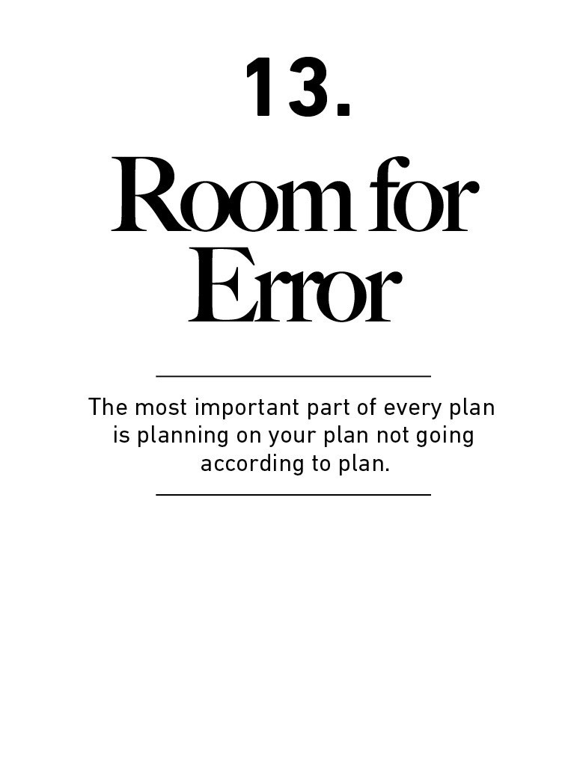

Some of the best examples of smart ﬁnancial behavior can

be found in an unlikely place: Las Vegas casinos.

Not among all players, of course. But a tiny group of

blackjack players who practice card counting can teach

ordinary people something extraordinarily important about

managing money: the importance of room for error.

The fundamentals of blackjack card counting are simple:

No one can know with certainty what card the dealer will

draw next.

But by tracking what cards have already been dealt you can

calculate what cards remain in the deck.

Doing so can tell you the odds of a particular card being

drawn by the dealer.

As a player, you bet more when the odds of getting a card

you want are in your favor and less when they are against

you.

The mechanics of how this is done don’t matter here. What

matters is that a blackjack card counter knows they are

playing a game of odds, not certainties. In any particular

hand they think they have a good chance of being right, but

know there’s a decent chance they’re wrong. It might sound

strange given their profession, but their strategy relies

entirely on humility—humility that they don’t know, and

cannot know exactly what’s going to happen next, so play

their hand accordingly. The card counting system works

because it tilts the odds ever so slightly from the house to

the player. But bet too heavily even when the odds seem in

your favor and, if you’re wrong, you might lose so much that

you don’t have enough money to keep playing.

There is never a moment when you’re so right that you can

bet every chip in front of you. The world isn’t that kind to

anyone—not consistently, anyways. You have to give yourself

room for error. You have to plan on your plan not going

according to plan.

Kevin Lewis, a successful card counter portrayed in the book

Bringing Down the House, wrote more about this

philosophy:

Although card counting is statistically proven to work, it

does not guarantee you will win every hand—let alone every

trip you make to the casino. We must make sure that we

have enough money to withstand any swings of bad luck.

Let’s assume you have roughly a 2 percent edge over the

casino. That still means the casino will win 49 percent of the

time. Therefore, you need to have enough money to

withstand any variant swings against you. A rule of thumb is

that you should have at least a hundred basic units.

Assuming you start with ten thousand dollars, you could

comfortably play a hundred-dollar unit.

History is littered with good ideas taken too far, which are

indistinguishable from bad ideas. The wisdom in having

room for error is acknowledging that uncertainty,

randomness, and chance—“unknowns”—are an ever-present

part of life. The only way to deal with them is by increasing

the gap between what you think will happen and what can

happen while still leaving you capable of ﬁghting another

day.

Benjamin Graham is known for his concept of margin of

safety. He wrote about it extensively and in mathematical

detail. But my favorite summary of the theory came when he

mentioned in an interview that “the purpose of the margin

of safety is to render the forecast unnecessary.”

It’s hard to overstate how much power lies in that simple

statement.

Margin of safety—you can also call it room for error or

redundancy—is the only eﬀective way to safely navigate a

world that is governed by odds, not certainties. And almost

everything related to money exists in that kind of world.

Forecasting with precision is hard. This is obvious to the card

counter, because no one could possibly know where a

particular card lies in a shuﬄed deck. It’s less obvious to

someone asking, “What will the average annual return of

the stock market be over the next 10 years?” or “On what

date will I be able to retire?” But they are fundamentally the

same. The best we can do is think about odds.

Graham’s margin of safety is a simple suggestion that we

don’t need to view the world in front of us as black or white,

predictable or a crapshoot. The grey area—pursuing things

where a range of potential outcomes are acceptable—is the

smart way to proceed.

But people underestimate the need for room for error in

almost everything they do that involves money. Stock

analysts give their clients price targets, not price ranges.

Economic forecasters predict things with precise ﬁgures;

rarely broad probabilities. The pundit who speaks in

unshakable certainties will gain a larger following than the

one who says “We can’t know for sure,” and speaks in

probabilities.⁴²

We do this in all kinds of ﬁnancial endeavors, especially

those related to our own decisions. Harvard psychologist

Max Bazerman once showed that when analyzing other

people’s home renovation plans, most people estimate the

project will run between 25% and 50% over budget.⁴³ But

when it comes to their own projects, people estimate that

renovations will be completed on time and at budget. Oh,

the eventual disappointment.

Two things cause us to avoid room for error. One is the idea

that somebody must know what the future holds, driven by

the uncomfortable feeling that comes from admitting the

opposite. The second is that you’re therefore doing yourself

harm by not taking actions that fully exploit an accurate

view of that future coming true.

But room for error is underappreciated and misunderstood.

It’s often viewed as a conservative hedge, used by those

who don’t want to take much risk or aren’t conﬁdent in their

views. But when used appropriately, it’s quite the opposite.

Room for error lets you endure a range of potential

outcomes, and endurance lets you stick around long enough

to let the odds of beneﬁting from a low-probability outcome

fall in your favor. The biggest gains occur infrequently, either

because they don’t happen often or because they take time

to compound. So the person with enough room for error in

part of their strategy (cash) to let them endure hardship in

another (stocks) has an edge over the person who gets

wiped out, game over, insert more tokens, when they’re

wrong.

Bill Gates understood this well. When Microsoft was a young

company, he said he “came up with this incredibly

conservative approach that I wanted to have enough money

in the bank to pay a year’s worth of payroll even if we didn’t

get any payments coming in.” Warren Buﬀett expressed a

similar idea when he told Berkshire Hathaway shareholders

in 2008: “I have pledged—to you, the rating agencies and

myself—to always run Berkshire with more than ample cash

... When forced to choose, I will not trade even a night’s

sleep for the chance of extra proﬁts.”⁴⁴

There are a few speciﬁc places for investors to think about

room for error.

One is volatility. Can you survive your assets declining by

30%? On a spreadsheet, maybe yes—in terms of actually

paying your bills and staying cash-ﬂow positive. But what

about mentally? It is easy to underestimate what a 30%

decline does to your psyche. Your conﬁdence may become

shot at the very moment opportunity is at its highest. You—

or your spouse—may decide it’s time for a new plan, or new

career. I know several investors who quit after losses

because they were exhausted. Physically exhausted.

Spreadsheets are good at telling you when the numbers do

or don’t add up. They’re not good at modeling how you’ll

feel when you tuck your kids in at night wondering if the

investment decisions you’ve made were a mistake that will

hurt their future. Having a gap between what you can

technically endure versus what’s emotionally possible is an

overlooked version of room for error.

Another is saving for retirement. We can look at history and

see, for example, that the U.S. stock market has returned an

annual average of 6.8% after inﬂation since the 1870s. It’s a

reasonable ﬁrst approximation to use that as an estimate of

what to expect on your own diversiﬁed portfolio when saving

for retirement. You can use those return assumptions to

back into the amount of money you’ll need to save each

month to achieve your target nestegg.

But what if future returns are lower? Or what if long-term

history is a good estimate of the long-term future, but your

target retirement date ends up falling in the middle of a

brutal bear market, like 2009? What if a future bear market

scares you out of stocks and you end up missing a future

bull market, so the returns you actually earn are less than

the market average? What if you need to cash out your

retirement accounts in your 30s to pay for a medical

mishap?

The answer to those what ifs is, “You won’t be able to retire

like you once predicted.” Which can be a disaster.

The solution is simple: Use room for error when estimating

your future returns. This is more art than science. For my

own investments, which I’ll describe more in chapter 20, I

assume the future returns I’ll earn in my lifetime will be ⅓

lower than the historic average. So I save more than I would

if I assumed the future will resemble the past. It’s my

margin of safety. The future may be worse than ⅓ lower

than the past, but no margin of safety oﬀers a 100%

guarantee. A one-third buﬀer is enough to allow me to sleep

well at night. And if the future does resemble the past, I’ll be

pleasantly surprised. “The best way to achieve felicity is to

aim low,” says Charlie Munger. Wonderful.

An important cousin of room for error is what I call optimism

bias in risk-taking, or “Russian roulette should statistically

work” syndrome: An attachment to favorable odds when the

downside is unacceptable in any circumstances.

Nassim Taleb says, “You can be risk loving and yet

completely averse to ruin.” And indeed, you should.

The idea is that you have to take risk to get ahead, but no

risk that can wipe you out is ever worth taking. The odds are

in your favor when playing Russian roulette. But the

downside is not worth the potential upside. There is no

margin of safety that can compensate for the risk.

Same with money. The odds of many lucrative things are in

your favor. Real estate prices go up most years, and during

most years you’ll get a paycheck every other week. But if

something has 95% odds of being right, the 5% odds of

being wrong means you will almost certainly experience the

downside at some point in your life. And if the cost of the

downside is ruin, the upside the other 95% of the time likely

isn’t worth the risk, no matter how appealing it looks.

Leverage is the devil here. Leverage—taking on debt to

make your money go further—pushes routine risks into

something capable of producing ruin. The danger is that

rational optimism most of the time masks the odds of ruin

some of the time. The result is we systematically

underestimate risk. Housing prices fell 30% last decade. A

few companies defaulted on their debt. That’s capitalism. It

happens. But those with high leverage had a double

wipeout: Not only were they left broke, but being wiped out

erased every opportunity to get back in the game at the very

moment opportunity was ripe. A homeowner wiped out in

2009 had no chance of taking advantage of cheap mortgage

rates in 2010. Lehman Brothers had no chance of investing

in cheap debt in 2009. They were done.

To get around this, I think of my own money as barbelled. I

take risks with one portion and am terriﬁed with the other.

This is not inconsistent, but the psychology of money would

lead you to believe that it is. I just want to ensure I can

remain standing long enough for my risks to pay oﬀ. You

have to survive to succeed. To repeat a point we’ve made a

few times in this book: The ability to do what you want,

when you want, for as long as you want, has an inﬁnite ROI.

Room for error does more than just widen the target around

what you think might happen. It also helps protect you from

things you’d never imagine, which can be the most

troublesome events we face.

The Battle of Stalingrad during World War II was the largest

battle in history. With it came equally staggering stories of

how people dealt with risk.

One came in late 1942, when a German tank unit sat in

reserve on grasslands outside the city. When tanks were

desperately needed on the front lines, something happened

that surprised everyone: Almost none of them worked.

Out of 104 tanks in the unit, fewer than 20 were operable.

Engineers quickly found the issue. Historian William Craig

writes: “During the weeks of inactivity behind the front lines,

ﬁeld mice had nested inside the vehicles and eaten away

insulation covering the electrical systems.”

The Germans had the most sophisticated equipment in the

world. Yet there they were, defeated by mice.

You can imagine their disbelief. This almost certainly never

crossed their minds. What kind of tank designer thinks

about mouse protection? Not a reasonable one. And not one

who studied tank history.

But these kinds of things happen all the time. You can plan

for every risk except the things that are too crazy to cross

your mind. And those crazy things can do the most harm,

because they happen more often than you think and you

have no plan for how to deal with them.

In 2006 Warren Buﬀett announced a search for his eventual

replacement. He said he needed someone “genetically

programmed to recognize and avoid serious risks, including

those never before encountered.”⁴⁵

I have seen this skill at work with startups my ﬁrm,

Collaborative Fund, has backed. Ask a founder to list the

biggest risks they face, and the usual suspects are

mentioned. But beyond the predictable struggles of running

a startup, here are a few issues we’ve dealt with among our

portfolio companies:

Water pipes broke, ﬂooding and ruining a company’s oﬃce.

A company’s oﬃce was broken into three times.

A company was kicked out of its manufacturing plant.

A store was shut down after a customer called the health

department because she didn’t like that another customer

brought a dog inside.

A CEO’s email was spoofed in the middle of a fundraise that

required all of his attention.

A founder had a mental breakdown.

Several of these events were existential to the company’s

future. But none were foreseeable, because none had

previously happened to the CEOs dealing with these

problems—or anyone else they knew, for that matter. It was

unchartered territory.

Avoiding these kinds of unknown risks is, almost by

deﬁnition, impossible. You can’t prepare for what you can’t

envision.

If there’s one way to guard against their damage, it’s

avoiding single points of failure.

A good rule of thumb for a lot of things in life is that

everything that can break will eventually break. So if many

things rely on one thing working, and that thing breaks, you

are counting the days to catastrophe. That’s a single point of

failure.

Some people are remarkably good at avoiding single points

of failure. Most critical systems on airplanes have backups,

and the backups often have backups. Modern jets have four

redundant electrical systems. You can ﬂy with one engine

and technically land with none, as every jet must be capable

of stopping on a runway with its brakes alone, without thrust

reverse from its engines. Suspension bridges can similarly

lose many of their cables without falling.

The biggest single point of failure with money is a sole

reliance on a paycheck to fund short-term spending needs,

with no savings to create a gap between what you think

your expenses are and what they might be in the future.

The trick that often goes overlooked—even by the wealthiest

—is what we saw in chapter 10: realizing that you don’t

need a speciﬁc reason to save. It’s ﬁne to save for a car, or a

home, or for retirement. But it’s equally important to save

for things you can’t possibly predict or even comprehend—

the ﬁnancial equivalent of ﬁeld mice.

Predicting what you’ll use your savings for assumes you live

in a world where you know exactly what your future

expenses will be, which no one does. I save a lot, and I have

no idea what I’ll use the savings for in the future. Few

ﬁnancial plans that only prepare for known risks have

enough margin of safety to survive the real world.

In fact, the most important part of every plan is planning on

your plan not going according to plan.

Now, let me show you how this applies to you.

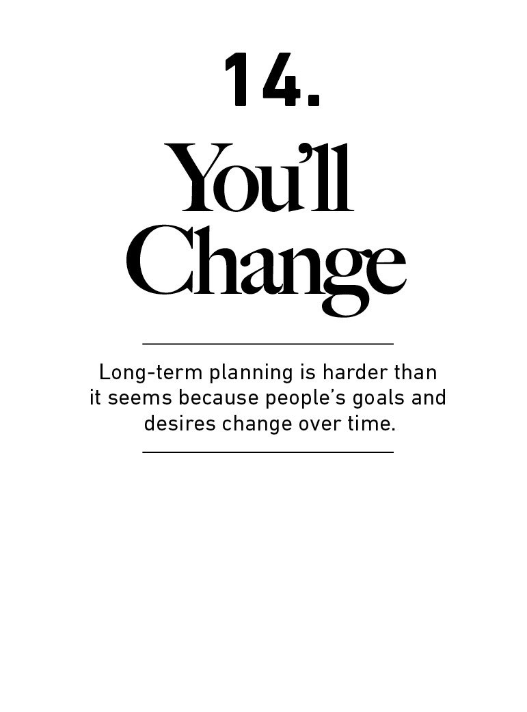

Igrew up with a friend who came from neither privilege nor

natural intellect, but was the hardest-working guy I knew.

These people have a lot to teach because they have an

unﬁltered understanding of every inch of the road to

success.

His life’s mission and dream as a teenager was to be a

doctor. To say the odds were stacked against him is being

charitable. No reasonable person at the time would consider

it a possibility.

But he pushed. And—a decade older than his classmates—

he eventually became a doctor.

How much fulﬁllment comes from starting from nothing,

bulldozing your way to the top of medical school, and

achieving one of the most noble professions against all

odds?

I spoke to him a few years ago. The conversation went like

this:

Me: “Long time no talk! How you doi—”

Him: “Awful career.”

Me: “Haha, well—”

Him: “Awful career, man.”

This went on for 10 minutes. The stress and hours had worn

him into the ground. He seemed as disappointed in where

he is today as he was driven toward where he wanted to be

15 years ago.

An underpinning of psychology is that people are poor

forecasters of their future selves.

Imagining a goal is easy and fun. Imagining a goal in the

context of the realistic life stresses that grow with

competitive pursuits is something entirely diﬀerent.

This has a big impact on our ability to plan for future

ﬁnancial goals.

Every ﬁve-year-old boy wants to drive a tractor when they

grow up. Few jobs look better in the eyes of a young boy

whose idea of a good job begins and ends with “Vroom

vroom, beep beep, big tractor, here I come!”

Then many grow up and realize that driving a tractor maybe

isn’t the best career. Maybe they want something more

prestigious or lucrative.

So as a teenager they dream of being a lawyer. Now they

think—they know—their plan is set. Law school and its costs,

here we come.

Then, as a lawyer, they face such long working hours that

they rarely see their families.

So perhaps they take a lower-paying job with ﬂexible hours.

Then they realize that childcare is so expensive that it

consumes most of their paycheck, and they opt to be a stay-

at-home parent. This, they conclude, is ﬁnally the right

choice.

Then, at age 70, they realize that a lifetime of staying home

means they’re unprepared to aﬀord retirement.

Many of us wind through life on a similar trajectory. Only

27% of college grads have a job related to their major,

according to the Federal Reserve.⁴⁶ Twenty-nine percent of

stay-at-home parents have a college degree.⁴⁷ Few likely

regret their education, of course. But we should

acknowledge that a new parent in their 30s may think about

life goals in a way their 18-year-old self making career goals

would never imagine.

Long-term ﬁnancial planning is essential. But things change

—both the world around you, and your own goals and

desires. It is one thing to say, “We don’t know what the

future holds.” It’s another to admit that you, yourself, don’t

know today what you will even want in the future. And the

truth is, few of us do. It’s hard to make enduring long-term

decisions when your view of what you’ll want in the future is

likely to shift.

The End of History Illusion is what psychologists call the

tendency for people to be keenly aware of how much they’ve

changed in the past, but to underestimate how much their

personalities, desires, and goals are likely to change in the

future. Harvard psychologist Daniel Gilbert once said:

At every stage of our lives we make decisions that will

profoundly inﬂuence the lives of the people we’re going to

become, and then when we become those people, we’re not

always thrilled with the decisions we made. So young

people pay good money to get tattoos removed that

teenagers paid good money to get. Middle-aged people

rushed to divorce people who young adults rushed to marry.

Older adults work hard to lose what middle-aged adults

worked hard to gain. On and on and on.⁴⁸

“All of us,” he said, “are walking around with an illusion—an

illusion that history, our personal history, has just come to

an end, that we have just recently become the people that

we were always meant to be and will be for the rest of our

lives.” We tend to never learn this lesson. Gilbert’s research

shows people from age 18 to 68 underestimate how much

they will change in the future.

You can see how this can impact a long-term ﬁnancial plan.

Charlie Munger says the ﬁrst rule of compounding is to

never interrupt it unnecessarily. But how do you not

interrupt a money plan—careers, investments, spending,

budgeting, whatever—when what you want out of life

changes? It’s hard. Part of the reason people like Ronald

Read—the wealthy janitor we met earlier in the book—and

Warren Buﬀett become so successful is because they kept

doing the same thing for decades on end, letting

compounding run wild. But many of us evolve so much over

a lifetime that we don’t want to keep doing the same thing

for decades on end. Or anything close to it. So rather than

one 80-something-year lifespan, our money has perhaps

four distinct 20-year blocks.

I know young people who purposefully live austere lives with

little income, and they’re perfectly happy with it. Then there

are those who work their tails oﬀ to pay for a life of luxury,

and they’re perfectly happy with that. Both have risks—the

former risks being unprepared to raise a family or fund

retirement, the latter risks regret that you spent your

youthful and healthy years in a cubicle.

There is no easy solution to this problem. Tell a ﬁve-year-old

boy he should be a lawyer instead of a tractor driver and he

will disagree with every cell in his body.

But there are two things to keep in mind when making what

you think are long-term decisions.

We should avoid the extreme ends of ﬁnancial

planning. Assuming you’ll be happy with a very low

income, or choosing to work endless hours in pursuit

of a high one, increases the odds that you’ll one day

ﬁnd yourself at a point of regret. The fuel of the End

of History Illusion is that people adapt to most

circumstances, so the beneﬁts of an extreme plan—

the simplicity of having hardly anything, or the thrill

of having almost everything—wear oﬀ. But the

downsides of those extremes—not being able to

aﬀord retirement, or looking back at a life spent

devoted to chasing dollars—become enduring

regrets. Regrets are especially painful when you

abandon a previous plan and feel like you have to

run in the other direction twice as fast to make up

for lost time.

Compounding works best when you can give a plan years or

decades to grow. This is true for not only savings but careers

and relationships. Endurance is key. And when you consider

our tendency to change who we are over time, balance at

every point in your life becomes a strategy to avoid future

regret and encourage endurance.

Aiming, at every point in your working life, to have moderate

annual savings, moderate free time, no more than a

moderate commute, and at least moderate time with your

family, increases the odds of being able to stick with a plan

and avoid regret than if any one of those things fall to the

extreme sides of the spectrum.

We should also come to accept the reality of

changing our minds. Some of the most miserable

workers I’ve met are people who stay loyal to a

career only because it’s the ﬁeld they picked when

deciding on a college major at age 18. When you

accept the End of History Illusion, you realize that

the odds of picking a job when you’re not old enough

to drink that you will still enjoy when you’re old

enough to qualify for Social Security are low.

The trick is to accept the reality of change and move on as

soon as possible.

Jason Zweig, the Wall Street Journal investment columnist,

worked with psychologist Daniel Kahneman on writing

Kahneman’s book Thinking, Fast and Slow. Zweig once told

a story about a personality quirk of Kahneman’s that served

him well: “Nothing amazed me more about Danny than his

ability to detonate what we had just done,” Zweig wrote. He

and Kahneman could work endlessly on a chapter, but:

The next thing you know, [Kahneman] sends a version so

utterly transformed that it is unrecognizable: It begins

diﬀerently, it ends diﬀerently, it incorporates anecdotes and

evidence you never would have thought of, it draws on

research that you’ve never heard of.

“When I asked Danny how he could start again as if we had

never written an earlier draft,” Zweig continued, “he said

the words I’ve never forgotten: ‘I have no sunk costs.’”⁴⁹

Sunk costs—anchoring decisions to past eﬀorts that can’t be

refunded—are a devil in a world where people change over

time. They make our future selves prisoners to our past,

diﬀerent, selves. It’s the equivalent of a stranger making

major life decisions for you.

Embracing the idea that ﬁnancial goals made when you

were a diﬀerent person should be abandoned without mercy

versus put on life support and dragged on can be a good

strategy to minimize future regret.

The quicker it’s done, the sooner you can get back to

compounding.

Next, let’s talk about compounding’s price of admission.

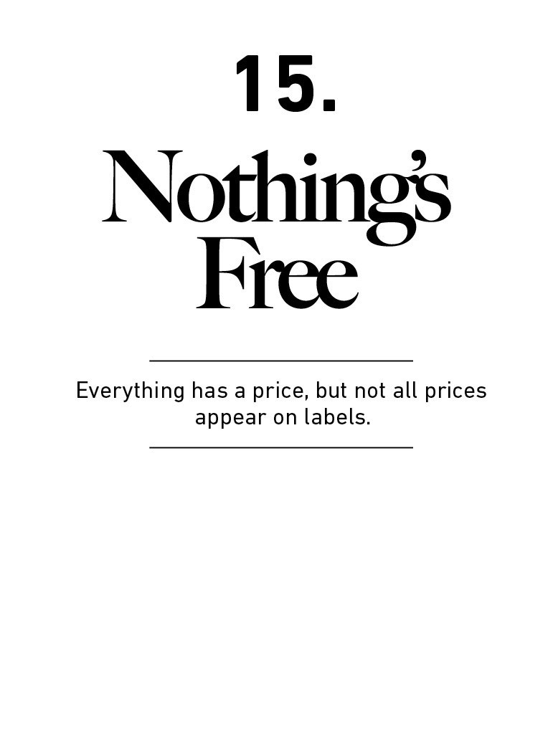

Everything has a price, and the key to a lot of things with

money is just ﬁguring out what that price is and being

willing to pay it.

The problem is that the price of a lot of things is not obvious

until you’ve experienced them ﬁrsthand, when the bill is

overdue.

General Electric was the largest company in the world in

2004, worth a third of a trillion dollars. It had either been

ﬁrst or second each year for the previous decade,

capitalism’s shining example of corporate aristocracy.

Then everything fell to pieces.

The 2008 ﬁnancial crisis sent GE’s ﬁnancing division—which

supplied more than half the company’s proﬁts—into chaos.

It was eventually sold for scrap. Subsequent bets in oil and

energy were disasters, resulting in billions in writeoﬀs. GE

stock fell from $40 in 2007 to $7 by 2018.

Blame placed on CEO Jeﬀ Immelt—who ran the company

since 2001—was immediate and harsh. He was criticized for

his leadership, his acquisitions, cutting the dividend, laying

oﬀ workers and—of course—the plunging stock price.

Rightly so: those rewarded with dynastic wealth when times

are good hold the burden of responsibility when the tide

goes out. He stepped down in 2017.

But Immelt said something insightful on his way out.

Responding to critics who said his actions were wrong and

what he should have done was obvious, Immelt told his

successor, “Every job looks easy when you’re not the one

doing it.”

Every job looks easy when you’re not the one doing it

because the challenges faced by someone in the arena are

often invisible to those in the crowd.

Dealing with the conﬂicting demands of sprawling bloat,

short-term investors, regulators, unions, and entrenched

bureaucracy is not only hard to do, but it’s hard to even

recognize the severity of the problems until you’re the one

dealing with them. Immelt’s successor, who lasted 14

months, learned this as well.

Most things are harder in practice than they are in theory.

Sometimes this is because we’re overconﬁdent. More often

it’s because we’re not good at identifying what the price of

success is, which prevents us from being able to pay it.

The S&P 500 increased 119-fold in the 50 years ending

2018. All you had to do was sit back and let your money

compound. But, of course, successful investing looks easy

when you’re not the one doing it.

“Hold stocks for the long run,” you’ll hear. It’s good advice.

But do you know how hard it is to maintain a long-term

outlook when stocks are collapsing?

Like everything else worthwhile, successful investing

demands a price. But its currency is not dollars and cents.

It’s volatility, fear, doubt, uncertainty, and regret—all of

which are easy to overlook until you’re dealing with them in

real time.

The inability to recognize that investing has a price can

tempt us to try to get something for nothing. Which, like

shoplifting, rarely ends well.

Say you want a new car. It costs $30,000. You have three

options: 1) Pay $30,000 for it, 2) ﬁnd a cheaper used one, or

3) steal it. In this case, 99% of people know to avoid the

third option, because the consequences of stealing a car

outweigh the upside.

But say you want to earn an 11% annual return over the

next 30 years so you can retire in peace. Does this reward

come free? Of course not. The world is never that nice.

There’s a price tag, a bill that must be paid. In this case it’s

a never-ending taunt from the market, which gives big

returns and takes them away just as fast. Including

dividends the Dow Jones Industrial Average returned about

11% per year from 1950 to 2019, which is great. But the

price of success during this period was dreadfully high. The

shaded lines in the chart show when it was at least 5%

below its previous all-time high.

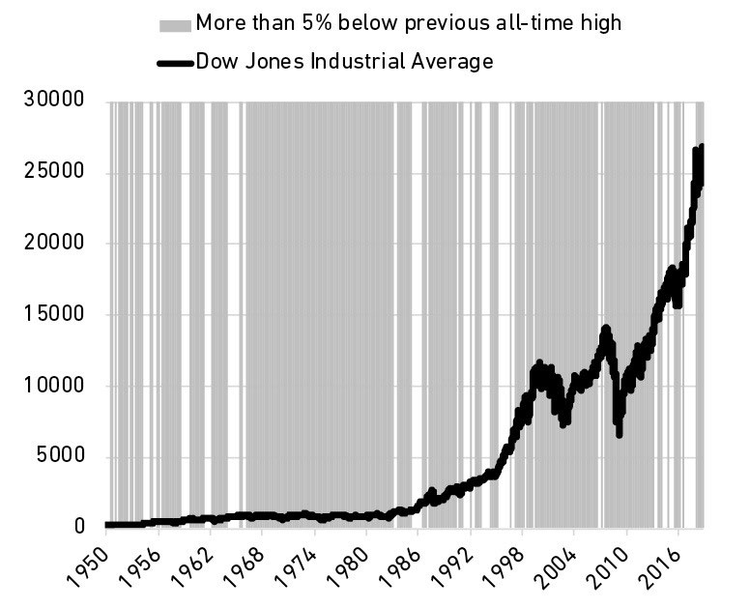

This is the price of market returns. The fee. It is the cost of

admission. And it hurts.

Like most products, the bigger the returns, the higher the

price. Netﬂix stock returned more than 35,000% from 2002

to 2018, but traded below its previous all-time high on 94%

of days. Monster Beverage returned 319,000% from 1995 to

2018—among the highest returns in history—but traded

below its previous high 95% of the time during that period.

Now here’s the important part. Like the car, you have a few

options: You can pay this price, accepting volatility and

upheaval. Or you can ﬁnd an asset with less uncertainty and

a lower payoﬀ, the equivalent of a used car. Or you can

attempt the equivalent of grand-theft auto: Try to get the

return while avoiding the volatility that comes along with it.

Many people in investing choose the third option. Like a car

thief—though well-meaning and law-abiding—they form

tricks and strategies to get the return without paying the

price. They trade in and out. They attempt to sell before the

next recession and buy before the next boom. Most investors

with even a little experience know that volatility is real and

common. Many then take what seems like the next logical

step: trying to avoid it.

But the Money Gods do not look highly upon those who seek

a reward without paying the price. Some car thieves will get

away with it. Many more will be caught and punished.

Same thing with investing.

Morningstar once looked at the performance of tactical

mutual funds, whose strategy is to switch between stocks

and bonds at opportune times, capturing market returns

with lower downside risk.⁵⁰ They want the returns without

paying the price. The study focused on the mid-2010

through late 2011 period, when U.S. stock markets went

wild on fears of a new recession and the S&P 500 declined

more than 20%. This is the exact kind of environment the

tactical funds are supposed to work in. It was their moment

to shine.

There were, by Morningstar’s count, 112 tactical mutual

funds during this period. Only nine had better risk-adjusted

returns than a simple 60/40 stock-bond fund. Less than a

quarter of the tactical funds had smaller maximum

drawdowns than the leave-it-alone index. Morningstar

wrote: “With a few exceptions, [tactical funds] gained less,

were more volatile, or were subject to just as much

downside risk” as the hands-oﬀ fund.

Individual investors fall for this when making their own

investments, too. The average equity fund investor

underperformed the funds they invested in by half a percent

per year, according to Morningstar—the result of buying and

selling when they should have just bought and held.⁵¹

The irony is that by trying to avoid the price, investors end

up paying double.

Back to GE. One of its many faults stems from an era under

former CEO Jack Welch. Welch became famous for ensuring

quarterly earnings per share beat Wall Street estimates. He

was the grandmaster. If Wall Street analysts expected $0.25

per share, Jack would deliver $0.26 no matter the state of

business or the economy. He’d do that by massaging the

numbers—that description is charitable—often pulling gains

from future quarters into the current quarter to make the

obedient numbers salute their master.

Forbes reported one of dozens of examples: “[General

Electric] for two years in a row ‘sold’ locomotives to

unnamed ﬁnancial partners instead of end users in

transactions that left most of the risks of ownership with

GE.”⁵²

Welch never denied this game. He wrote in his book Straight

From the Gut:

The response of our business leaders to the crises was

typical of the GE culture. Even though the books had closed

on the quarter, many immediately oﬀered to pitch in to

cover the [earnings] gap. Some said they could ﬁnd an extra

$10 million, $20 million, and even $30 million from their

business to oﬀset the surprise.

The result was that under Welch’s leadership, stockholders

didn’t have to pay the price. They got consistency and

predictability—a stock that surged year after year without

the surprises of uncertainty. Then the bill came due, like it

always does. GE shareholders have suﬀered through a

decade of mammoth losses that were previously shielded by

accounting maneuvers. The penny gains of Welch’s era

became dime losses today.

The strangest example of this comes from failed mortgage

giants Freddie Mac and Fannie Mae, which in the early

2000s were caught under-reporting current earnings by

billions of dollars with the intention of spreading those gains

out over future periods to give investors the illusion of

smoothness and predictability.⁵³ The illusion of not having to

pay the price.

The question is: Why do so many people who are willing to

pay the price of cars, houses, food, and vacations try so hard

to avoid paying the price of good investment returns?

The answer is simple: The price of investing success is not

immediately obvious. It’s not a price tag you can see, so

when the bill comes due it doesn’t feel like a fee for getting

something good. It feels like a ﬁne for doing something

wrong. And while people are generally ﬁne with paying fees,

ﬁnes are supposed to be avoided. You’re supposed to make

decisions that preempt and avoid ﬁnes. Traﬃc ﬁnes and IRS

ﬁnes mean you did something wrong and deserve to be

punished. The natural response for anyone who watches

their wealth decline and views that drop as a ﬁne is to avoid

future ﬁnes.

It sounds trivial, but thinking of market volatility as a fee

rather than a ﬁne is an important part of developing the

kind of mindset that lets you stick around long enough for

investing gains to work in your favor.

Few investors have the disposition to say, “I’m actually ﬁne

if I lose 20% of my money.” This is doubly true for new

investors who have never experienced a 20% decline.

But if you view volatility as a fee, things look diﬀerent.

Disneyland tickets cost $100. But you get an awesome day

with your kids you’ll never forget. Last year more than 18

million people thought that fee was worth paying. Few felt

the $100 was a punishment or a ﬁne. The worthwhile

tradeoﬀ of fees is obvious when it’s clear you’re paying one.

Same with investing, where volatility is almost always a fee,

not a ﬁne.

Market returns are never free and never will be. They

demand you pay a price, like any other product. You’re not

forced to pay this fee, just like you’re not forced to go to

Disneyland. You can go to the local county fair where tickets

might be $10, or stay home for free. You might still have a

good time. But you’ll usually get what you pay for. Same

with markets. The volatility/uncertainty fee—the price of

returns—is the cost of admission to get returns greater than

low-fee parks like cash and bonds.

The trick is convincing yourself that the market’s fee is

worth it. That’s the only way to properly deal with volatility

and uncertainty—not just putting up with it, but realizing

that it’s an admission fee worth paying.

There’s no guarantee that it will be. Sometimes it rains at

Disneyland.

But if you view the admission fee as a ﬁne, you’ll never enjoy

the magic.

Find the price, then pay it.

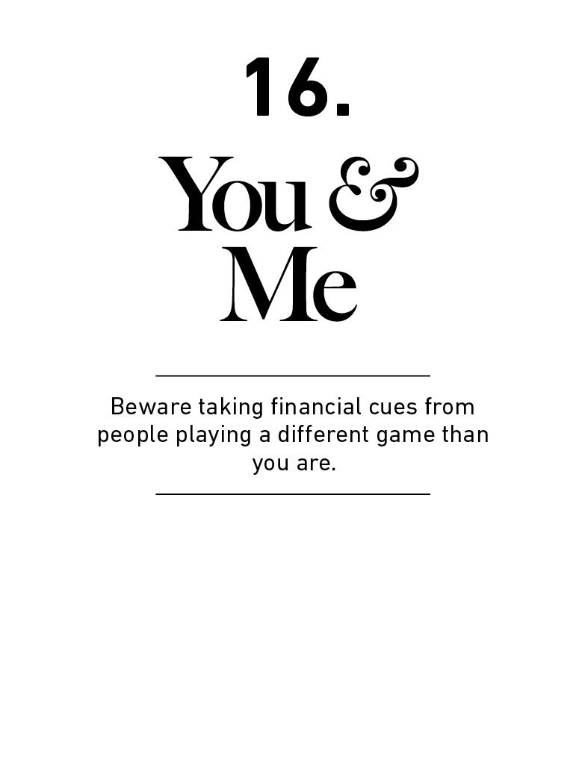

The implosion of the dot-com bubble in the early 2000s

reduced household wealth by $6.2 trillion.

The end of the housing bubble cut away more than $8

trillion.

It’s hard to overstate how socially devastating ﬁnancial

bubbles can be. They ruin lives.

Why do these things happen?

And why do they keep happening?

Why can’t we learn our lessons?

The common answer here is that people are greedy, and

greed is an indelible feature of human nature.

That may be true, and it’s a good enough answer for most.

But remember from chapter 1: no one is crazy. People make

ﬁnancial decisions they regret, and they often do so with

scarce information and without logic. But the decisions

made sense to them when they were made. Blaming

bubbles on greed and stopping there misses important

lessons about how and why people rationalize what in

hindsight look like greedy decisions.

Part of why bubbles are hard to learn from is that they are

not like cancer, where a biopsy gives us a clear warning and

diagnosis. They are closer to the rise and fall of a political

party, where the outcome is known in hindsight but the

cause and blame are never agreed upon.

Competition for investment returns is ﬁerce, and someone

has to own every asset at every point in time. That means

the mere idea of bubbles will always be controversial,

because no one wants to think they own an overvalued

asset. In hindsight we’re more likely to point cynical ﬁngers

than to learn lessons.

I don’t think we’ll ever be able to fully explain why bubbles

occur. It’s like asking why wars occur—there are almost

always several reasons, many of them conﬂicting, all of

them controversial.

It’s too complicated a subject for simple answers.

But let me propose one reason they happen that both goes

overlooked and applies to you personally: Investors often

innocently take cues from other investors who are playing a

diﬀerent game than they are.

An idea exists in ﬁnance that seems innocent but has done

incalculable damage.

It’s the notion that assets have one rational price in a world

where investors have diﬀerent goals and time horizons.

Ask yourself: How much should you pay for Google stock

today?

The answer depends on who “you” are.

Do you have a 30-year time horizon? Then the smart price to

pay involves a sober analysis of Google’s discounted cash

ﬂows over the next 30 years.

Are you looking to cash out within 10 years? Then the price

to pay can be ﬁgured out by an analysis of the tech

industry’s potential over the next decade and whether

Google management can execute on its vision.

Are you looking to sell within a year? Then pay attention to

Google’s current product sales cycles and whether we’ll

have a bear market.

Are you a day trader? Then the smart price to pay is “who

cares?” because you’re just trying to squeeze a few bucks

out of whatever happens between now and lunchtime,

which can be accomplished at any price.

When investors have diﬀerent goals and time horizons—and

they do in every asset class—prices that look ridiculous to

one person can make sense to another, because the factors

those investors pay attention to are diﬀerent.

Take the dot-com bubble in the 1990s.

People can look at Yahoo! stock in 1999 and say “That was

crazy! A zillion times revenue! The valuation made no

sense!”

But many investors who owned Yahoo! stock in 1999 had

time horizons so short that it made sense for them to pay a

ridiculous price. A day trader could accomplish what they

need whether Yahoo! was at $5 a share or $500 a share as

long as it moved in the right direction that day. And it did,

for years.

An iron rule of ﬁnance is that money chases returns to the

greatest extent that it can. If an asset has momentum—it’s

been moving consistently up for a period of time—it’s not

crazy for a group of short-term traders to assume it will keep

moving up. Not indeﬁnitely; just for the short period of time

they need it to. Momentum attracts short-term traders in a

reasonable way.

Then it’s oﬀ to the races.

Bubbles form when the momentum of short-term returns

attracts enough money that the makeup of investors shifts

from mostly long term to mostly short term.

That process feeds on itself. As traders push up short-term

returns, they attract even more traders. Before long—and it

often doesn’t take long—the dominant market price-setters

with the most authority are those with shorter time

horizons.

Bubbles aren’t so much about valuations rising. That’s just a

symptom of something else: time horizons shrinking as

more short-term traders enter the playing ﬁeld.

It’s common to say the dot-com bubble was a time of

irrational optimism about the future. But one of the most

common headlines of that era was announcing record

trading volume, which is what happens when investors are

buying and selling in a single day. Investors—particularly the

ones setting prices—were not thinking about the next 20

years. The average mutual fund had 120% annual turnover

in 1999, meaning they were, at most, thinking about the

next eight months. So were the individual investors who

bought those mutual funds. Maggie Mahar wrote in her book

Bull!:

By the mid-nineties, the press had replaced annual

scorecards with reports that appeared every three months.

The change spurred investors to chase performance, rushing

to buy the funds at the top of the charts, just when they

were most expensive.

This was the era of day trading, short-term option contracts,

and up-to-the minute market commentary. It’s not the kind

of thing you’d associate with long-term views.

The same thing happened during the housing bubble of the

mid-2000s.

It’s hard to justify paying $700,000 for a two-bedroom

Florida track home to raise your family in for the next 10

years. But it makes perfect sense if you plan on ﬂipping the

home in a few months into a market with rising prices to

make a quick proﬁt. Which is exactly what many people

were doing during the bubble.

Data from Attom, a company that tracks real estate

transactions, shows the number of houses in America that

sold more than once in a 12-month period—they were

ﬂipped—rose ﬁvefold during the bubble, from 20,000 in the

ﬁrst quarter of 2000 to over 100,000 in the ﬁrst quarter of

2004.⁵⁴ Flipping plunged after the bubble to less than

40,000 per quarter, where it’s roughly remained since.

Do you think these ﬂippers cared about long-term price-to-

rent ratios? Or whether the prices they paid were backed up

by long-term income growth? Of course not. Those numbers

weren’t relevant to their game. The only thing that mattered

to ﬂippers was that the price of the home would be more

next month than it was this month. And for many years, it

was.

You can say a lot about these investors. You can call them

speculators. You can call them irresponsible. You can shake

your head at their willingness to take huge risks.

But I don’t think you can call all of them irrational.

The formation of bubbles isn’t so much about people

irrationally participating in long-term investing. They’re

about people somewhat rationally moving toward short-

term trading to capture momentum that had been feeding

on itself.

What do you expect people to do when momentum creates

a big short-term return potential? Sit and watch patiently?

Never. That’s not how the world works. Proﬁts will always be

chased. And short-term traders operate in an area where the

rules governing long-term investing—particularly around

valuation—are ignored, because they’re irrelevant to the

game being played.

That’s where things get interesting, and where the problems

begin.

Bubbles do their damage when long-term investors playing

one game start taking their cues from those short-term

traders playing another.

Cisco stock rose 300% in 1999 to $60 per share. At that

price the company was valued at $600 billion, which is

insane. Few actually thought it was worth that much; the

day-traders were just having their fun. Economist Burton

Malkiel once pointed out that Cisco’s implied growth rate at

that valuation meant it would become larger than the entire

U.S. economy within 20 years.

But if you were a long-term investor in 1999, $60 was the

only price available to buy. And many people were buying it

at that price. So you may have looked around and said to

yourself, “Wow, maybe these other investors know

something I don’t.” Maybe you went along with it. You even

felt smart about it.

What you don’t realize is that the traders who were setting

the marginal price of the stock were playing a diﬀerent

game than you were. Sixty dollars a share was a reasonable

price for the traders, because they planned on selling the

stock before the end of the day, when its price would

probably be higher. But sixty dollars was a disaster in the

making for you, because you planned on holding shares for

the long run.

These two investors rarely even know that each other exist.

But they’re on the same ﬁeld, running toward each other.

When their paths blindly collide, someone gets hurt. Many

ﬁnance and investment decisions are rooted in watching

what other people do and either copying them or betting

against them. But when you don’t know why someone

behaves like they do you won’t know how long they’ll

continue acting that way, what will make them change their

mind, or whether they’ll ever learn their lesson.

When a commentator on CNBC says, “You should buy this

stock,” keep in mind that they do not know who you are. Are

you a teenager trading for fun? An elderly widow on a

limited budget? A hedge fund manager trying to shore up

your books before the quarter ends? Are we supposed to

think those three people have the same priorities, and that

whatever level a particular stock is trading at is right for all

three of them?

It’s crazy.

It’s hard to grasp that other investors have diﬀerent goals

than we do, because an anchor of psychology is not realizing

that rational people can see the world through a diﬀerent

lens than your own. Rising prices persuade all investors in

ways the best marketers envy. They are a drug that can turn

value-conscious investors into dewy-eyed optimists,

detached from their own reality by the actions of someone

playing a diﬀerent game than they are.

Being swayed by people playing a diﬀerent game can also

throw oﬀ how you think you’re supposed to spend your

money. So much consumer spending, particularly in

developed countries, is socially driven: subtly inﬂuenced by

people you admire, and done because you subtly want

people to admire you.

But while we can see how much money other people spend

on cars, homes, clothes, and vacations, we don’t get to see

their goals, worries, and aspirations. A young lawyer aiming

to be a partner at a prestigious law ﬁrm might need to

maintain an appearance that I, a writer who can work in

sweatpants, have no need for. But when his purchases set

my own expectations, I’m wandering down a path of

potential disappointment because I’m spending the money

without the career boost he’s getting. We might not even

have diﬀerent styles. We’re just playing a diﬀerent game. It

took me years to ﬁgure this out.

A takeaway here is that few things matter more with money

than understanding your own time horizon and not being

persuaded by the actions and behaviors of people playing

diﬀerent games than you are.

The main thing I can recommend is going out of your way to

identify what game you’re playing.

It’s surprising how few of us do. We call everyone investing

money “investors” like they’re basketball players, all playing

the same game with the same rules. When you realize how

wrong that notion is you see how vital it is to simply identify

what game you’re playing. How I invest my own money is

detailed in chapter 20, but years ago I wrote out “I am a

passive investor optimistic in the world’s ability to generate

real economic growth and I’m conﬁdent that over the next

30 years that growth will accrue to my investments.”

This might seem quaint, but once you write that mission

statement down you realize everything that’s unrelated to it

—what the market did this year, or whether we’ll have a

recession next year—is part of a game I’m not playing. So I

don’t pay attention to it, and am in no danger of being

persuaded by it.

Next, let’s talk about pessimism.

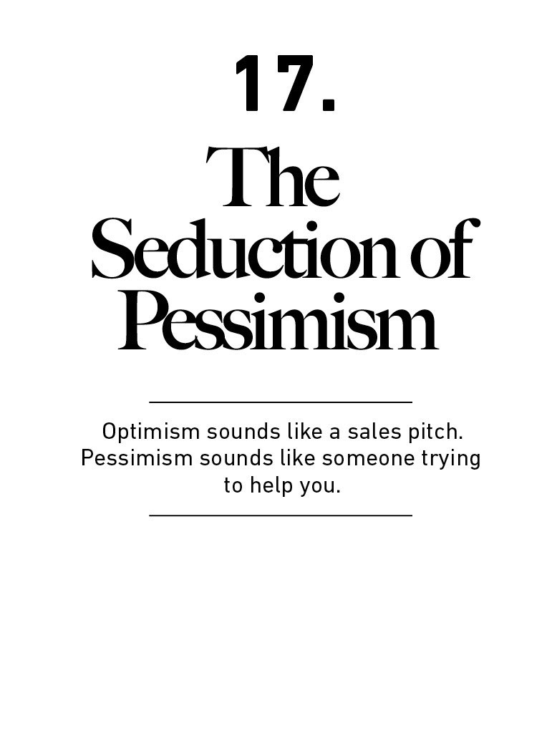

“For reasons I have never understood, people like to hear

that the world is going to hell.”

—Historian Deirdre McCloskey

Optimism is the best bet for most people because the world

tends to get better for most people most of the time.

But pessimism holds a special place in our hearts.

Pessimism isn’t just more common than optimism. It also

sounds smarter. It’s intellectually captivating, and it’s paid

more attention than optimism, which is often viewed as

being oblivious to risk.

Before we go further we should deﬁne what optimism is.

Real optimists don’t believe that everything will be great.

That’s complacency. Optimism is a belief that the odds of a

good outcome are in your favor over time, even when there

will be setbacks along the way. The simple idea that most

people wake up in the morning trying to make things a little

better and more productive than wake up looking to cause

trouble is the foundation of optimism. It’s not complicated.

It’s not guaranteed, either. It’s just the most reasonable bet

for most people, most of the time. The late statistician Hans

Rosling put it diﬀerently: “I am not an optimist. I am a very

serious possibilist.”

Now we can discuss optimism’s more compelling sibling:

pessimism.

December 29th, 2008.

The worst year for the economy in modern history is about

to close. Stock markets around the world had collapsed. The

global ﬁnancial system was on day-to-day life support.

Unemployment was surging.

As things looked like they couldn’t get worse, The Wall

Street Journal published a story arguing that we hadn’t seen

anything yet. It ran a front-page article on the outlook of a

Russian professor named Igor Panarin whose economic

views rival the ﬂair of science ﬁction writers.

The Journal wrote:

Around the end of June 2010, or early July, [Panarin] says,

the U.S. will break into six pieces—with Alaska reverting to

Russian control ... California will form the nucleus of what he

calls “The Californian Republic,” and will be part of China or

under Chinese inﬂuence. Texas will be the heart of “The

Texas Republic,” a cluster of states that will go to Mexico or

fall under Mexican inﬂuence. Washington, D.C., and New

York will be part of an “Atlantic America” that may join the

European Union. Canada will grab a group of Northern

states Prof. Panarin calls “The Central North American

Republic.” Hawaii, he suggests, will be a protectorate of

Japan or China, and Alaska will be subsumed into Russia.⁵⁵

This was not the ramblings of a backroom blog or tinfoil-hat

newsletter. This was on the front page of the most

prestigious ﬁnancial newspaper in the world.

It is ﬁne to be pessimistic about the economy. It’s even OK to

be apocalyptic. History is full of examples of countries

experiencing not just recessions, but disintegrations.

The interesting thing about Panarin-type stories is that their

polar opposite—forecasts of outrageous optimism—are

rarely taken as seriously as prophets of doom.

Take Japan in the late 1940s. The nation was gutted by

defeat from World War II in every way—economically,

industrially, culturally, socially. A brutal winter in 1946

caused a famine that limited food to less than 800 calories

per person per day.⁵⁶

Imagine if a Japanese academic had written a newspaper

article during this time that said:

Chin up, everyone. Within our lifetime our economy will

grow to almost 15 times the size it was before the end of the

war. Our life expectancy will nearly double. Our stock market

will produce returns like any country in history has rarely

seen. We will go more than 40 years without ever seeing

unemployment top 6%. We will become a world leader in

electronic innovation and corporate managerial systems.

Before long we will be so rich that we will own some of the

most prized real estate in the United States. Americans, by

the way, will be our closest ally and will try to copy our

economic insights.

They would have been summarily laughed out of the room

and asked to seek a medical evaluation.

Keep in mind the description above is what actually

happened in Japan in the generation after the war. But the

mirror opposite of Panarin looks absurd in a way a forecast

of doom doesn’t.

Pessimism just sounds smarter and more plausible than

optimism.

Tell someone that everything will be great and they’re likely

to either shrug you oﬀ or oﬀer a skeptical eye. Tell someone

they’re in danger and you have their undivided attention.

If a smart person tells me they have a stock pick that’s going

to rise 10-fold in the next year, I will immediately write them

oﬀ as full of nonsense.

If someone who’s full of nonsense tells me that a stock I own

is about to collapse because it’s an accounting fraud, I will

clear my calendar and listen to their every word.

Say we’ll have a big recession and newspapers will call you.

Say we’re headed for average growth and no one

particularly cares. Say we’re nearing the next Great

Depression and you’ll get on TV. But mention that good

times are ahead, or markets have room to run, or that a

company has huge potential, and a common reaction from

commentators and spectators alike is that you are either a

salesman or comically aloof of risks.

The investing newsletter industry has known this for years,

and is now populated by prophets of doom despite

operating in an environment where the stock market has

gone up 17,000-fold in the last century (including

dividends).

This is true beyond ﬁnance. Matt Ridley wrote in his book

The Rational Optimist:

A constant drumbeat of pessimism usually drowns out any

triumphalist song ... If you say the world has been getting

better you may get away with being called naïve and

insensitive. If you say the world is going to go on getting

better, you are considered embarrassingly mad. If, on the

other hand, you say catastrophe is imminent, you may

expect a McArthur genius award or even the Nobel Peace

Prize. In my own adult lifetime ... the fashionable reasons for

pessimism changed, but the pessimism was constant.

“Every group of people I ask thinks the world is more

frightening, more violent, and more hopeless—in short,

more dramatic—than it really is,” Hans Rosling wrote in his

book Factfulness.

When you realize how much progress humans can make

during a lifetime in everything from economic growth to

medical breakthroughs to stock market gains to social

equality, you would think optimism would gain more

attention than pessimism. And yet.

The intellectual allure of pessimism has been known for

ages. John Stuart Mill wrote in the 1840s: “I have observed

that not the man who hopes when others despair, but the

man who despairs when others hope, is admired by a large

class of persons as a sage.”

The question is, why? And how does it impact how we think

about money?

Let’s repeat the premise that no one is crazy.

There are valid reasons why pessimism is seductive when

dealing with money. It just helps to know what they are to

ensure we don’t take them too far.

Part of it is instinctual and unavoidable. Kahneman says the

asymmetric aversion to loss is an evolutionary shield. He

writes:

When directly compared or weighted against each other,

losses loom larger than gains. This asymmetry between the

power of positive and negative expectations or experiences

has an evolutionary history. Organisms that treat threats as

more urgent than opportunities have a better chance to

survive and reproduce.

But a few other things make ﬁnancial pessimism easy,

common, and more persuasive than optimism.

One is that money is ubiquitous, so something bad

happening tends to aﬀect everyone and captures

everyone’s attention.

That isn’t true of, say, weather. A hurricane barreling down

on Florida poses no direct risk to 92% of Americans. But a

recession barreling down on the economy could impact

every single person—including you, so pay attention.

This goes for something as speciﬁc as the stock market.

More than half of all American households directly own

stocks.⁵⁷ Even among those that don’t, the stock market’s

gyrations are promoted so heavily in the media that the Dow

Jones Industrial Average might be the stock-less household’s

most-watched economic barometer.

Stocks rising 1% might be brieﬂy mentioned in the evening

news. But a 1% fall will be reported in bold, all-caps letters

usually written in blood red. The asymmetry is hard to avoid.

And while few question or try to explain why the market

went up—isn’t it supposed to go up?—there is almost always

an attempt to explain why it went down.

Are investors worried about economic growth?

Did the Fed screw things up again?

Are politicians making bad decisions?

Is there another shoe to drop?

Narratives about why a decline occurred make them easier

to talk about, worry about, and frame a story around what

you think will happen next—usually, more of the same.

Even if you don’t own stocks, those kind of things will grab

your attention. Only 2.5% of Americans owned stocks on the

eve of the great crash of 1929 that sparked the Great

Depression. But the majority of Americans—if not the world

—watched in amazement as the market collapsed,

wondering what it signaled about their own fate. This was

true whether you were a lawyer or a farmer or a car

mechanic.

Historian Eric Rauchway writes:

This fall in value immediately aﬄicted only a few Americans.

But so closely had the others watched the market and

regarded it as an index of their fates that they suddenly

stopped much of their economic activity. As the economist

Joseph Schumpeter later wrote, “people felt that the ground

under their feet was giving way.”⁵⁸

There are two topics that will aﬀect your life whether you

are interested in them or not: money and health. While

health issues tend to be individual, money issues are more

systemic. In a connected system where one person’s

decisions can aﬀect everyone else, it’s understandable why

ﬁnancial risks gain a spotlight and capture attention in a

way few other topics can.

Another is that pessimists often extrapolate present

trends without accounting for how markets adapt.

In 2008 environmentalist Lester Brown wrote: “By 2030

China would need 98 million barrels of oil a day. The world is

currently producing 85 million barrels a day and may never

produce much more than that. There go the world’s oil

reserves.”⁵⁹

He’s right. The world would run out of oil in that scenario.

But that’s not how markets work.

There is an iron law in economics: extremely good and

extremely bad circumstances rarely stay that way for long

because supply and demand adapt in hard-to-predict ways.

Consider what happened to oil immediately after Brown’s

prediction.

Oil prices surged in 2008 as growing global demand—much

of it from China—crept up to potential output. A barrel of oil

sold for $20 in 2001 and $138 by 2008.⁶⁰

The new price meant drilling oil was like pulling gold out of

the ground. The incentives for oil producers changed

dramatically. Hard-to-tap oil supplies that weren’t worth the

ﬁght at $20 a barrel—the cost of drilling didn’t oﬀset the

price you could sell it for—became the bonanza of a lifetime

now that you could sell a barrel for $138.

That sparked a surge of new fracking and horizontal drilling

technologies.

The Earth has had roughly the same amount of oil reserves

for all of human history. And we’ve known where the big oil

deposits are for some time. What changes is the technology

we have that lets us economically pull the stuﬀ out of the

ground. Oil historian Daniel Yergin writes: “86% of oil

reserves in the United States are the result not of what is

estimated at time of discovery but of the revisions” that

come when our technology improves.

That’s what happened as fracking took oﬀ in 2008. In the

United States alone oil production went from roughly ﬁve

million barrels per day in 2008 to 13 million by 2019.⁶¹

World oil production is now over 100 million barrels per day

—some 20% above what Brown assumed was the high

mark.

To a pessimist extrapolating oil trends in 2008, of course

things looked bad. To a realist who understood that

necessity is the mother of all invention, it was far less scary.

Assuming that something ugly will stay ugly is an easy

forecast to make. And it’s persuasive, because it doesn’t

require imagining the world changing. But problems correct

and people adapt. Threats incentivize solutions in equal

magnitude. That’s a common plot of economic history that

is too easily forgotten by pessimists who forecast in straight

lines.

A third is that progress happens too slowly to notice,

but setbacks happen too quickly to ignore.

There are lots of overnight tragedies. There are rarely

overnight miracles.

On January 5th, 1889, the Detroit Free Press pushed back

against the long-held dream that man could one day ﬂy like

a bird. Airplanes, the paper wrote, “appear impossible”:

The smallest possible weight of a ﬂying machine, with the

necessary fuel and engineer, could not be less than 300 or

400 pounds … but there is a low limit of weight, certainly

not much beyond ﬁfty pounds, beyond which it is impossible

for an animal to ﬂy. Nature has reached this limit, and with

her utmost eﬀort has failed to pass it.

Six months later, Orville Wright dropped out of high school

to help his brother, Wilbur, tinker in their backyard shed to

build a printing press. It was the brothers’ ﬁrst joint

invention. It would not be their last.

If you had to make a list of the most important inventions of

the 20th century, the airplane would be at least top ﬁve, if

not number one. The airplane changed everything. It started

world wars, it ended world wars. It connected the world,

bridging gaps between cities and rural communities; oceans

and countries.

But the story of the Wright Brothers’ quest to build the ﬁrst

plane has a fascinating twist.

After they conquered ﬂight, no one seemed to notice.

Nobody seemed to care.

In his 1952 book on American history, Frederick Lewis Allen

wrote:

Several years went by before the public grasped what the

Wrights were doing; people were so convinced that ﬂying

was impossible that most of those who saw them ﬂying

about Dayton [Ohio] in 1905 decided that what they had

seen must be some trick without signiﬁcance—somewhat as

most people today would regard a demonstration of, say,

telepathy. It was not until May, 1908—nearly four and a half

years after the Wright’s ﬁrst ﬂight—that experienced

reporters were sent to observe what they were doing,

experienced editors gave full credence to these reporters’

excited dispatches, and the world at last woke up to the fact

that human ﬂight had been successfully accomplished.

Even after people caught on to the plane’s wonder, they

underestimated it for years.

First it was seen mainly as a military weapon. Then a rich

person’s toy. Then, perhaps, used to transport a few people.

The Washington Post wrote in 1909: “There will never be

such a thing as commercial aerial freighters. Freight will

continue to drag its slow weight across the patient earth.”

The ﬁrst cargo plane took oﬀ ﬁve months later.

Now compare that slow, years-long awakening to becoming

optimistic about the airplane to how quickly people pay

attention to drivers of pessimism, like a corporate

bankruptcy.

Or a major war.

Or a plane crash. Some of the ﬁrst mentions of the Wright’s

plane came in 1908 when an Army Lieutenant named

Thomas Selfridge was killed during a demonstration ﬂight.⁶²

Growth is driven by compounding, which always takes time.

Destruction is driven by single points of failure, which can

happen in seconds, and loss of conﬁdence, which can

happen in an instant.

It’s easier to create a narrative around pessimism because

the story pieces tend to be fresher and more recent.

Optimistic narratives require looking at a long stretch of

history and developments, which people tend to forget and

take more eﬀort to piece together.

Consider the progress of medicine. Looking at the last year

will do you little good. Any single decade won’t do much

better. But looking at the last 50 years will show something

extraordinary. For example, the age-adjusted death rate per

capita from heart disease has declined more than 70% since

1965, according to the National Institute of Health.⁶³ A 70%

decline in heart-disease death is enough to save something

like half a million American lives per year. Picture the

population of Atlanta saved every year. But since that

progress happened so slowly, it captures less attention than

quick, sudden losses like terrorism, plane crashes, or natural

disasters. We could have a Hurricane Katrina ﬁve times a

week, every week—imagine how much attention that would

receive—and it would not oﬀset the number of annual lives

saved by the decline in heart disease in the last 50 years.

This same thing applies to business, where it takes years to

realize how important a product or company is, but failures

can happen overnight.

And in stock markets, where a 40% decline that takes place

in six months will draw congressional investigations, but a

140% gain that takes place over six years can go virtually

unnoticed.

And in careers, where reputations take a lifetime to build

and a single email to destroy.

The short sting of pessimism prevails while the powerful pull

of optimism goes unnoticed.

This underscores an important point made previously in this

book: In investing you must identify the price of success—

volatility and loss amid the long backdrop of growth—and

be willing to pay it.

In 2004 The New York Times interviewed Stephen Hawking,

the scientist whose incurable motor-neuron disease left him

paralyzed and unable to talk at age 21.

Through his computer, Hawking told the interviewer how

excited he was to sell books to lay people.

“Are you always this cheerful?” the Times asked.

“My expectations were reduced to zero when I was 21.

Everything since then has been a bonus,” he replied.

Expecting things to be great means a best-case scenario

that feels ﬂat. Pessimism reduces expectations, narrowing

the gap between possible outcomes and outcomes you feel

great about.

Maybe that’s why it’s so seductive. Expecting things to be

bad is the best way to be pleasantly surprised when they’re

not.

Which, ironically, is something to be optimistic about.

Now, a short story about stories.

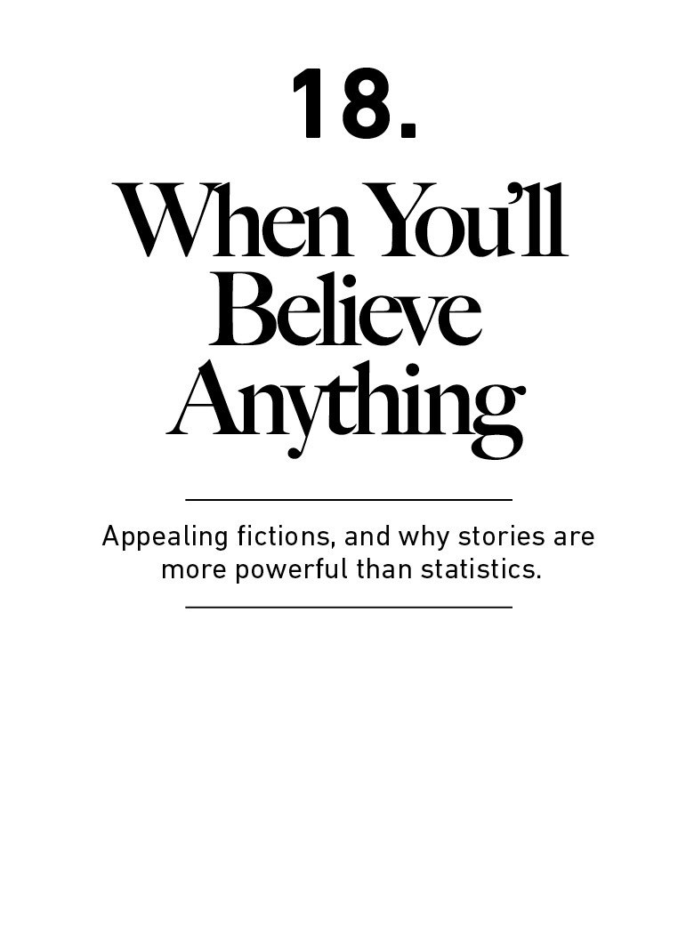

Imagine an alien dispatched to Earth. His job is to keep tabs

on our economy.

He circles above New York City, trying to size up the

economy and how it changed between 2007 and 2009.

On New Year’s Eve 2007 he hovers over Times Square. He

sees tens of thousands of happy partygoers surrounded by

bright lights, monstrous billboards, ﬁreworks, and TV

cameras.

He comes back to Times Square on New Year’s Eve 2009. He

sees tens of thousands of happy partygoers surrounded by

bright lights, monstrous billboards, ﬁreworks, and TV

cameras.

It looks about the same. He cannot see much diﬀerence.

He sees roughly the same number of New Yorkers hustling

around the city. Those people are surrounded by the same

number of oﬃce buildings, which house the same number

of desks with the same number of computers, hooked up to

the same number of internet connections.

Outside the city he sees the same number of factories and

warehouses, connected by the same highways, carrying the

same number of trucks.

He gets a little closer to the ground and sees the same

universities teaching the same topics and handing out the

same degrees to the same number of people.

He sees the same number of patents protecting the same

groundbreaking ideas.

He notices that technology has improved. Everyone in 2009

carries smartphones that didn’t exist in 2007. Computers

are now faster. Medicine is better. Cars get better gas

mileage. Solar and fracking technology has advanced. Social

media has grown exponentially.

As he ﬂies around the country he sees the same. Around the

globe, more of the same.

The economy is in about the same shape, maybe even

better, in 2009 as it was in 2007, he concludes.

Then he looks at the numbers.

He’s shocked that U.S. households are $16 trillion poorer in

2009 than they were in 2007.

He’s dumbfounded that 10 million more Americans are

unemployed.

He’s in disbelief when he learns the stock market is worth

half of what it was two years before.

He can’t believe that people’s forecast of their economic

potential has plunged.

“I don’t get it,” he says. “I’ve seen the cities. I’ve looked at

the factories. You guys have the same knowledge, the same

tools, the same ideas. Nothing has changed! Why are you

poorer? Why are you more pessimistic?”

There was one change the alien couldn’t see between 2007

and 2009: The stories we told ourselves about the economy.

In 2007, we told a story about the stability of housing prices,

the prudence of bankers, and the ability of ﬁnancial markets

to accurately price risk.

In 2009 we stopped believing that story.

That’s the only thing that changed. But it made all the

diﬀerence in the world.

Once the narrative that home prices will keep rising broke,

mortgage defaults rose, then banks lost money, then they

reduced lending to other businesses, which led to layoﬀs,

which led to less spending, which led to more layoﬀs, and

on and on.

Other than clinging to a new narrative, we had an identical

—if not greater—capacity for wealth and growth in 2009 as

we did in 2007. Yet the economy suﬀered its worst hit in 80

years.

This is diﬀerent from, say, Germany in 1945, whose

manufacturing base had been obliterated. Or Japan in the

2000s, whose working-age population was shrinking. That’s

tangible economic damage. In 2009 we inﬂicted narrative

damage on ourselves, and it was vicious. It’s one of the most

potent economic forces that exists.

When we think about the growth of economies, businesses,

investments and careers, we tend to think about tangible

things—how much stuﬀ do we have and what are we

capable of?

But stories are, by far, the most powerful force in the

economy. They are the fuel that can let the tangible parts of

the economy work, or the brake that holds our capabilities

back.

At the personal level, there are two things to keep in mind

about a story-driven world when managing your money.

1. The more you want something to be true, the

more likely you are to believe a story that

overestimates the odds of it being true.

What was the happiest day of your life?

The documentary How to Live Forever asks that innocent

question to a centenarian who oﬀered an amazing response.

“Armistice Day,” she said, referring to the 1918 agreement

that ended World War I.

“Why?” the producer asks.

“Because we knew there would be no more wars ever

again,” she says.

World War II began 21 years later, killing 75 million people.

There are many things in life that we think are true because

we desperately want them to be true.

I call these things “appealing ﬁctions.” They have a big

impact on how we think about money—particularly

investments and the economy.

An appealing ﬁction happens when you are smart, you want

to ﬁnd solutions, but face a combination of limited control

and high stakes.

They are extremely powerful. They can make you believe

just about anything.

Take a short example.

Ali Hajaji’s son was sick. Elders in his Yemeni village

proposed a folk remedy: shove the tip of a burning stick

through his son’s chest to drain the sickness from his body.

After the procedure, Hajaji told The New York Times: “When

you have no money, and your son is sick, you’ll believe

anything.”⁶⁴

Medicine predates useful medicine by thousands of years.

Before the scientiﬁc method and the discovery of germs

there was blood-letting, starvation therapy, cutting holes in

your body to let the evils out, and other treatments that did

nothing but hasten your demise.

It seems crazy. But if you desperately need a solution and a

good one isn’t known or readily available to you, the path of

least resistance is toward Hajaji’s reasoning: willing to

believe anything. Not just try anything, but believe it.

Chronicling the Great Plague of London, Daniel Defoe wrote

in 1722:

The people were more addicted to prophecies and

astrological conjurations, dreams, and old wives’ tales than

ever they were before or since … almanacs frighted them

terribly … the posts of houses and corners of streets were

plastered over with doctors’ bills and papers of ignorant

fellows, quacking and inviting the people to come to them

for remedies, which was generally set oﬀ with such

ﬂourishes as these: ‘Infallible preventive pills against the

plague.’ ‘Neverfailing preservatives against the infection.’

‘Sovereign cordials against the corruption of the air.’

The plague killed a quarter of Londoners in 18 months. You’ll

believe just about anything when the stakes are that high.

Now think about how the same set of limited information

and high stakes impact our ﬁnancial decisions.

Why do people listen to TV investment commentary that has

little track record of success? Partly because the stakes are

so high in investing. Get a few stock picks right and you can

become rich without much eﬀort. If there’s a 1% chance

that someone’s prediction will come true, and it coming true

will change your life, it’s not crazy to pay attention—just in

case.

And there are so many ﬁnancial opinions that once you pick

a strategy or side, you become invested in them both

ﬁnancially and mentally. If you want a certain stock to rise

10-fold, that’s your tribe. If you think a certain economic

policy will spark hyperinﬂation, that’s your side.

These may be low-probability bets. The problem is that

viewers can’t, or don’t, calibrate low odds, like a 1% chance.

Many default to a ﬁrm belief that what they want to be true

is unequivocally true. But they’re only doing that because

the possibility of a huge outcome exists.

Investing is one of the only ﬁelds that oﬀers daily

opportunities for extreme rewards. People believe in

ﬁnancial quackery in a way they never would for, say,

weather quackery because the rewards for correctly

predicting what the stock market will do next week are in a

diﬀerent universe than the rewards for predicting whether it

will be sunny or rainy next week.

Consider that 85% of active mutual funds underperformed

their benchmark over the 10 years ending 2018.⁶⁵ That

ﬁgure has been fairly stable for generations. You would think

an industry with such poor performance would be a niche

service and have a hard time staying in business. But there’s

almost ﬁve trillion dollars invested in these funds.⁶⁶ Give

someone the chance of investing alongside “the next

Warren Buﬀett” and they’ll believe with such faith that

millions of people will put their life savings behind it.

Or take Bernie Madoﬀ. In hindsight his Ponzi scheme should

have been obvious. He reported returns that never varied,

they were audited by a relatively unknown accounting ﬁrm,

and he refused to release much information on how the

returns were achieved. Yet Madoﬀ raised billions of dollars

from some of the most sophisticated investors in the world.

He told a good story, and people wanted to believe it.

This is a big part of why room for error, ﬂexibility, and

ﬁnancial independence—important themes discussed in

previous chapters—are indispensable.

The bigger the gap between what you want to be true and

what you need to be true to have an acceptable outcome,

the more you are protecting yourself from falling victim to

an appealing ﬁnancial ﬁction.

When thinking about room for error in a forecast it is

tempting to think that potential outcomes range from you

being just right enough to you being very, very right. But the

biggest risk is that you want something to be true so badly

that the range of your forecast isn’t even in the same

ballpark as reality.

In its last 2007 meeting the Federal Reserve predicted what

economic growth would be in 2008 and 2009.⁶⁷ Already

weary of a weakening economy, it was not optimistic. It

predicted a range of potential growth—1.6% growth on the

low end, 2.8% on the high end. That was its margin of

safety, its room for error. In reality the economy contracted

by more than 2%, meaning the Fed’s low-end estimate was

oﬀ by almost threefold.

It’s hard for a policymaker to predict an outright recession,

because a recession will make their careers complicated. So

even worst-case projections rarely expect anything worse

than just “slow-ish” growth. It’s an appealing ﬁction, and it’s

easy to believe because expecting anything worse is too

painful to consider.

Policymakers are easy targets for criticism, but all of us do

this to some extent. And we do it in both directions. If you

think a recession is coming and you cash out your stocks in

anticipation, your view of the economy is suddenly going to

be warped by what you want to happen. Every blip, every

anecdote, will look like a sign that doom has arrived—maybe

not because it has, but because you want it to.

Incentives are a powerful motivator, and we should always

remember how they inﬂuence our own ﬁnancial goals and

outlooks. It can’t be overstated: there is no greater force in

ﬁnance than room for error, and the higher the stakes, the

wider it should be.

2. Everyone has an incomplete view of the world. But

we form a complete narrative to ﬁll in the gaps.

My daughter is about a year old as I write this. She’s curious

about everything and learns so fast.

But sometimes I think about all the stuﬀ she can’t

comprehend.

She has no idea why her dad goes to work every morning.

The concept of bills, budgets, careers, promotions, and

saving for retirement are completely foreign to her.

Imagine trying to explain the Federal Reserve, credit

derivatives, or NAFTA to her. Impossible.

But her world isn’t dark. She does not wander around in

confusion.

Even at a year old, she’s written her own internal narrative

of how everything works. Blankets keep you warm, mom

snuggles keep you safe, and dates taste good.

Everything she comes across ﬁts into one of a few dozen

mental models she’s learned. When I go to work she doesn’t

stop in confusion, wondering what salary and bills are. She

has a crystal clear explanation of the situation: Dad isn’t

playing with me, and I wanted him to play with me, so I’m

sad.

Even though she knows little, she doesn’t realize it, because

she tells herself a coherent story about what’s going on

based on the little she does know.

All of us, no matter our age, do the same thing.

Just like my daughter, I don’t know what I don’t know. So I

am just as susceptible to explaining the world through the

limited set of mental models I have at my disposal.

Like her, I look for the most understandable causes in

everything I come across. And, like her, I’m wrong about a

lot of them, because I know a lot less about how the world

works than I think I do.

This is true for the most fact-based of subjects.

Take history. It’s just the recounting of stuﬀ that already

happened. It should be clear and objective. But as B. H.

Liddell Hart writes in the book Why Don’t We Learn From

History?:

[History] cannot be interpreted without the aid of

imagination and intuition. The sheer quantity of evidence is

so overwhelming that selection is inevitable. Where there is

selection there is art. Those who read history tend to look for

what proves them right and conﬁrms their personal

opinions. They defend loyalties. They read with a purpose to

aﬃrm or to attack. They resist inconvenient truth since

everyone wants to be on the side of the angels. Just as we

start wars to end all wars.

Daniel Kahneman once told me about the stories people tell

themselves to make sense of the past. He said:

Hindsight, the ability to explain the past, gives us the

illusion that the world is understandable. It gives us the

illusion that the world makes sense, even when it doesn’t

make sense. That’s a big deal in producing mistakes in

many ﬁelds.

Most people, when confronted with something they don’t

understand, do not realize they don’t understand it because

they’re able to come up with an explanation that makes

sense based on their own unique perspective and

experiences in the world, however limited those experiences

are. We all want the complicated world we live in to make

sense. So we tell ourselves stories to ﬁll in the gaps of what

are eﬀectively blind spots.

What these stories do to us ﬁnancially can be both

fascinating and terrifying.

When I’m blind to parts of how the world works I might

completely misunderstand why the stock market is

behaving like it is, in a way that gives me too much

conﬁdence in my ability to know what it might do next. Part

of the reason forecasting the stock market and the economy

is so hard is because you are the only person in the world

who thinks the world operates the way you do. When you

make decisions for reasons that I can’t even comprehend, I

might follow you blindly into a decision that’s right for you

and disastrous to me. This, as we saw in chapter 16, is how

bubbles form.

Coming to terms with how much you don’t know means

coming to terms with how much of what happens in the

world is out of your control. And that can be hard to accept.

Think about market forecasts. We’re very, very bad at them.

I once calculated that if you just assume that the market

goes up every year by its historic average, your accuracy is

better than if you follow the average annual forecasts of the

top 20 market strategists from large Wall Street banks. Our

ability to predict recessions isn’t much better. And since big

events come out of nowhere, forecasts may do more harm

than good, giving the illusion of predictability in a world

where unforeseen events control most outcomes. Carl

Richards writes: “Risk is what’s left over when you think

you’ve thought of everything.”

People know this. I have not met an investor who genuinely

thinks market forecasts as a whole are accurate or useful.

But there’s still tremendous demand for forecasts, in both

the media and from ﬁnancial advisors.

Why?

Psychologist Philip Tetlock once wrote: “We need to believe

we live in a predictable, controllable world, so we turn to

authoritative-sounding people who promise to satisfy that

need.”

Satisfying that need is a great way to put it. Wanting to

believe we are in control is an emotional itch that needs to

be scratched, rather than an analytical problem to be

calculated and solved. The illusion of control is more

persuasive than the reality of uncertainty. So we cling to

stories about outcomes being in our control.

Part of this has to do with confusing ﬁelds of precision with

ﬁelds of uncertainty.

NASA’s New Horizons spacecraft passed by Pluto two years

ago. It was a three-billion mile trip that took nine and a half

years. According to NASA, the trip “took about one minute

less than predicted when the craft was launched in January

2006.”⁶⁸

Think about that. In an untested, decade-long journey,

NASA’s forecast was 99.99998% accurate. That’s like

forecasting a trip from New York to Boston and being

accurate to within four millionths of a second.

But astrophysics is a ﬁeld of precession. It isn’t impacted by

the vagaries of human behavior and emotions, like ﬁnance

is. Business, economics, and investing, are ﬁelds of

uncertainty, overwhelmingly driven by decisions that can’t

easily be explained with clean formulas, like a trip to Pluto

can. But we desperately want it to be like a trip to Pluto,

because the idea of a NASA engineer being in 99.99998%

control of an outcome is beautiful and comforting. It’s so

comforting that we’re tempted to tell ourselves stories about

how much control we have in other parts of our life, like

money.

Kahneman once laid out the path these stories take:

When planning we focus on what we want to do and can do,

neglecting the plans and skills of others whose decisions

might aﬀect our outcomes.

Both in explaining the past and in predicting the future, we

focus on the causal role of skill and neglect the role of luck.

We focus on what we know and neglect what we do not

know, which makes us overly conﬁdent in our beliefs.

He described how this impacts businesses:

I have had several occasions to ask founders and

participants in innovative start-ups a question: To what

extent will the outcome of your eﬀort depend on what you

do in your ﬁrm? This is evidently an easy question; the

answer comes quickly and it has never been less than 80%.

Even when they are not sure they will succeed, these bold

people think their fate is almost entirely in their own hands.

They are surely wrong: the outcome of a start-up depends as

much on the achievements of its competitors and on

changes in the market as on its own eﬀorts. However,

entrepreneurs naturally focus on what they know best—their

plans and actions and the most immediate threats and

opportunities, such as the availability of funding. They know

less about their competitors and therefore ﬁnd it natural to

imagine a future in which the competition plays little part.

We all do this to some extent.

And like my daughter, it doesn’t bother us a bit.

We don’t wander around blind and confused. We have to

think the world we operate in makes sense based on what

we happen to know. It’d be too hard to get out of bed in the

morning if you felt otherwise.

But the alien circling over Earth?

The one who’s conﬁdent he knows what’s happening based

on what he sees but turns out to be completely wrong

because he can’t know the stories going on inside everyone

else’s head?

He’s all of us.



Congratulations, you’re still reading.

It’s time to tie together a few things we’ve learned.

This chapter is a bit of a summary; a few short and

actionable lessons that can help you make better ﬁnancial

decisions.

First, let me tell you a story about a dentist appointment

gone horribly awry. It teaches us something vital about the

dangers of giving advice about what to do with your money.

Clarence Hughes went to the dentist in 1931. His mouth was

radiating pain. His dentist put him under crude anesthesia

to ease the pain. When Clarence awoke hours later he had

16 fewer teeth and his tonsils removed.

And then everything went wrong. Clarence died a week later

from his surgery’s complications.

His wife sued the dentist, but not because the surgery went

awry. Every surgery risked death in 1931.

Clarence, she said, never consented to the procedures in the

ﬁrst place, and wouldn’t if he were asked.

The case wove through courts, but went nowhere. Consent

between doctor and patient wasn’t black and white in 1931.

One court summed up the idea that doctors require freedom

to make the best medical decisions: “Without such, we

could not enjoy the advancement of science.”

For most of history the ethos of medicine was that the

doctor’s job was to ﬁx the patient, and what the patient

thought about the doctor’s treatment plans wasn’t relevant.

Dr. Jay Katz wrote about the philosophy in his book The

Silent World Between Doctor and Patient:

Doctors felt that in order to accomplish that objective they

were obligated to attend to their patients’ physical and

emotional needs and to do so on their own authority,

without consulting with their patients about the decisions

that needed to be made. The idea that patients may also be

entitled to sharing the burdens of decisions with their

doctors was never part of the ethos of medicine.

This wasn’t ego or malice. It was a belief in two points:

Every patient wants to be cured.

There is a universal and right way to cure them.

Not requiring patient consent in treatment plans makes

sense if you believe in those two points.

But that’s not how medicine works.

In the last 50 years medical schools subtly shifted teaching

away from treating disease and toward treating patients.

That meant laying out the options of treatment plans, and

then letting the patient decide the best path forward.

This trend was partly driven by patient-protection laws,

partly by Katz’s inﬂuential book, which argued that patients

have wildly diﬀerent views about what’s worth it in

medicine, so their beliefs have to be taken into

consideration. Katz wrote:

It is dangerous nonsense to assert that in the practice of

their art and science physicians can rely on their benevolent

intentions, their abilities to judge what is the right thing to

do ... It is not that easy. Medicine is a complex profession

and the interactions between physicians and patients are

also complex.

That last line is important. “Medicine is a complex profession

and the interactions between physicians and patients are

also complex.”

You know what profession is the same? Financial advice.

I can’t tell you what to do with your money, because I don’t

know you.

I don’t know what you want. I don’t know when you want it.

I don’t know why you want it.

So I’m not going to tell you what to do with your money. I

don’t want to treat you like a dentist treated Clarence

Hughes.

But doctors and dentists aren’t useless, obviously. They have

knowledge. They know the odds. They know what tends to

work, even if patients come to diﬀerent conclusions about

what kind of treatment is right for them.

Financial advisors are the same. There are universal truths in

money, even if people come to diﬀerent conclusions about

how they want to apply those truths to their own ﬁnances.

With that caveat in place, let’s look at a few short

recommendations that can help you make better decisions

with your money.

Go out of your way to ﬁnd humility when things are

going right and forgiveness/compassion when they

go wrong. Because it’s never as good or as bad as it

looks. The world is big and complex. Luck and risk

are both real and hard to identify. Do so when

judging both yourself and others. Respect the power

of luck and risk and you’ll have a better chance of

focusing on things you can actually control. You’ll

also have a better chance of ﬁnding the right role

models.

Less ego, more wealth. Saving money is the gap

between your ego and your income, and wealth is

what you don’t see. So wealth is created by

suppressing what you could buy today in order to

have more stuﬀ or more options in the future. No

matter how much you earn, you will never build

wealth unless you can put a lid on how much fun you

can have with your money right now, today.

Manage your money in a way that helps you sleep at

night. That’s diﬀerent from saying you should aim to

earn the highest returns or save a speciﬁc

percentage of your income. Some people won’t sleep

well unless they’re earning the highest returns;

others will only get a good rest if they’re

conservatively invested. To each their own. But the

foundation of, “does this help me sleep at night?” is

the best universal guidepost for all ﬁnancial

decisions.

If you want to do better as an investor, the single

most powerful thing you can do is increase your time

horizon. Time is the most powerful force in

investing. It makes little things grow big and big

mistakes fade away. It can’t neutralize luck and risk,

but it pushes results closer towards what people

deserve.

Become OK with a lot of things going wrong. You can

be wrong half the time and still make a fortune,

because a small minority of things account for the

majority of outcomes. No matter what you’re doing

with your money you should be comfortable with a

lot of stuﬀ not working. That’s just how the world is.

So you should always measure how you’ve done by

looking at your full portfolio, rather than individual

investments. It is ﬁne to have a large chunk of poor

investments and a few outstanding ones. That’s

usually the best-case scenario. Judging how you’ve

done by focusing on individual investments makes

winners look more brilliant than they were, and

losers appear more regrettable than they should.

Use money to gain control over your time, because

not having control of your time is such a powerful

and universal drag on happiness. The ability to do

what you want, when you want, with who you want,

for as long as you want to, pays the highest dividend

that exists in ﬁnance.

Be nicer and less ﬂashy. No one is impressed with

your possessions as much as you are. You might

think you want a fancy car or a nice watch. But what

you probably want is respect and admiration. And

you’re more likely to gain those things through

kindness and humility than horsepower and chrome.

Save. Just save. You don’t need a speciﬁc reason to

save. It’s great to save for a car, or a downpayment,

or a medical emergency. But saving for things that

are impossible to predict or deﬁne is one of the best

reasons to save. Everyone’s life is a continuous

chain of surprises. Savings that aren’t earmarked for

anything in particular is a hedge against life’s

inevitable ability to surprise the hell out of you at

the worst possible moment.

Deﬁne the cost of success and be ready to pay it.

Because nothing worthwhile is free. And remember

that most ﬁnancial costs don’t have visible price

tags. Uncertainty, doubt, and regret are common

costs in the ﬁnance world. They’re often worth

paying. But you have to view them as fees (a price

worth paying to get something nice in exchange)

rather than ﬁnes (a penalty you should avoid).

Worship room for error. A gap between what could

happen in the future and what you need to happen in

the future in order to do well is what gives you

endurance, and endurance is what makes

compounding magic over time. Room for error often

looks like a conservative hedge, but if it keeps you in

the game it can pay for itself many times over.

Avoid the extreme ends of ﬁnancial decisions.

Everyone’s goals and desires will change over time,

and the more extreme your past decisions were the

more you may regret them as you evolve.

You should like risk because it pays oﬀ over time. But

you should be paranoid of ruinous risk because it

prevents you from taking future risks that will pay

oﬀ over time.

Deﬁne the game you’re playing, and make sure your

actions are not being inﬂuenced by people playing a

diﬀerent game.

Respect the mess. Smart, informed, and reasonable

people can disagree in ﬁnance, because people have

vastly diﬀerent goals and desires. There is no single

right answer; just the answer that works for you.

Now let me tell you what works for me.

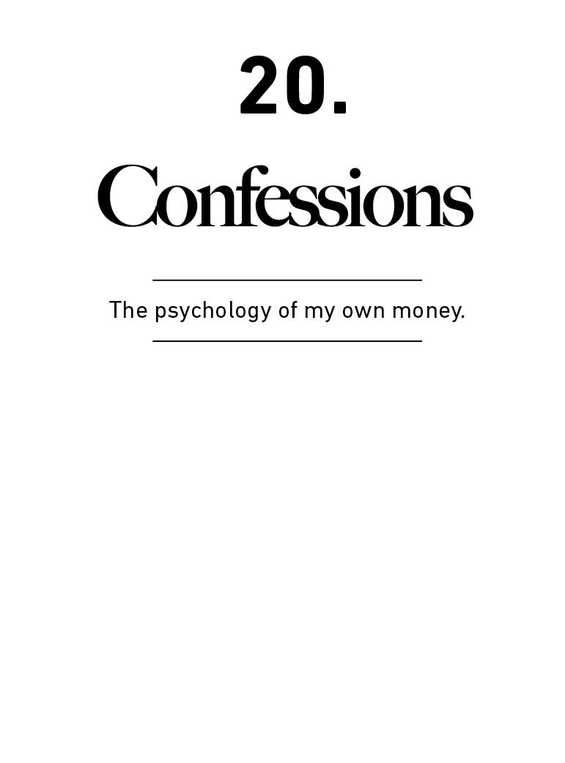

Sandy Gottesman, a billionaire investor who founded the

consulting group First Manhattan, is said to ask one question

when interviewing candidates for his investment team:

“What do you own, and why?”

Not, “What stocks do you think are cheap?” or “What

economy is about to have a recession?”

Just show me what you do with your own money.

I love this question because it highlights what can often be a

mile-wide gap between what makes sense—which is what

people suggest you do—and what feels right to them—

which is what they actually do.

Half of all U.S. mutual fund portfolio managers do not invest

a cent of their own money in their funds, according to

Morningstar.⁶⁹ This might seem atrocious, and surely the

statistic uncovers some hypocrisy.

But this kind of stuﬀ is more common than you’d think. Ken

Murray, a professor of medicine at USC, wrote an essay in

2011 titled “How Doctors Die” that showed the degree to

which doctors choose diﬀerent end-of-life treatments for

themselves than they recommend for their patients.⁷⁰

“[Doctors] don’t die like the rest of us,” he wrote. “What’s

unusual about them is not how much treatment they get

compared to most Americans, but how little. For all the time

they spend fending oﬀ the deaths of others, they tend to be

fairly serene when faced with death themselves. They know

exactly what is going to happen, they know the choices, and

they generally have access to any sort of medical care they

could want. But they go gently.” A doctor may throw the

kitchen sink at her patient’s cancer, but choose palliative

care for herself.

The diﬀerence between what someone suggests you do and

what they do for themselves isn’t always a bad thing. It just

underscores that when dealing with complicated and

emotional issues that aﬀect you and your family, there is no

one right answer. There is no universal truth. There’s only

what works for you and your family, checking the boxes you

want checked in a way that leaves you comfortable and

sleeping well at night.

There are basic principles that must be adhered to—this is

true in ﬁnance and in medicine—but important ﬁnancial

decisions are not made in spreadsheets or in textbooks.

They are made at the dinner table. They often aren’t made

with the intention of maximizing returns, but minimizing

the chance of disappointing a spouse or child. Those kinds

of things are diﬃcult to summarize in charts or formulas,

and they vary widely from person to person. What works for

one person may not work for another.

You have to ﬁnd what works for you. Here’s what works for

me.

How my family thinks about savings

Charlie Munger once said “I did not intend to get rich. I just

wanted to get independent.”

We can leave aside rich, but independence has always been

my personal ﬁnancial goal. Chasing the highest returns or

leveraging my assets to live the most luxurious life has little

interest to me. Both look like games people do to impress

their friends, and both have hidden risks. I mostly just want

to wake up every day knowing my family and I can do

whatever we want to do on our own terms. Every ﬁnancial

decision we make revolves around that goal.

My parents lived their adult years in two stages: dirt poor

and moderately well oﬀ. My father became a doctor when he

was 40 and already had three kids. Earning a doctor’s salary

did not oﬀset the frugal mentality that is forced when

supporting three hungry kids while in medical school, and

my parents spent the good years living well below their

means with a high savings rate. This gave them a degree of

independence. My father was an Emergency Room doctor,

one of the highest-stress professions I can imagine and one

that requires a painful toggling of circadian rhythms

between night and day shifts. After two decades he decided

he’d had enough, so he stopped. Just quit. Moved onto the

next phase of his life.

That stuck with me. Being able to wake up one morning and

change what you’re doing, on your own terms, whenever

you’re ready, seems like the grandmother of all ﬁnancial

goals. Independence, to me, doesn’t mean you’ll stop

working. It means you only do the work you like with people

you like at the times you want for as long as you want.

And achieving some level of independence does not rely on

earning a doctor’s income. It’s mostly a matter of keeping

your expectations in check and living below your means.

Independence, at any income level, is driven by your savings

rate. And past a certain level of income your savings rate is

driven by your ability to keep your lifestyle expectations

from running away.

My wife and I met in college and moved in with each other

years before we got married. After school we both had entry-

level jobs with entry-level pay, and settled into a moderate

lifestyle. All lifestyles exist on a spectrum, and what is

decent to one person can feel like royalty or poverty to

another. But at our incomes we got what we considered a

decent apartment, a decent car, decent clothes, decent

food. Comfortable, but nothing close to fancy.

Despite more than a decade of rising incomes—myself in

ﬁnance, my wife in health care—we’ve more or less stayed

at that lifestyle ever since. That’s pushed our savings rate

continuously higher. Virtually every dollar of raise has

accrued to savings—our “independence fund.” We now live

considerably below our means, which tells you little about

our income and more about our decision to maintain a

lifestyle that we established in our 20s.

If there’s a part of our household ﬁnancial plan I’m proud of

it’s that we got the goalpost of lifestyle desires to stop

moving at a young age. Our savings rate is fairly high, but

we rarely feel like we’re repressively frugal because our

aspirations for more stuﬀ haven’t moved much. It’s not that

our aspirations are nonexistent—we like nice stuﬀ and live

comfortably. We just got the goalpost to stop moving.

This would not work for everyone, and it only works for us

because we both agree to it equally—neither of us are

compromising for the other. Most of what we get pleasure

from—going for walks, reading, podcasts—costs little, so we

rarely feel like we’re missing out. On the rare occasion when

I question our savings rate I think of the independence my

parents earned from years of high savings, and I quickly

come back. Independence is our top goal. A secondary

beneﬁt of maintaining a lifestyle below what you can aﬀord

is avoiding the psychological treadmill of keeping up with

the Joneses. Comfortably living below what you can aﬀord,

without much desire for more, removes a tremendous

amount of social pressure that many people in the modern

ﬁrst world subject themselves to. Nassim Taleb explained:

“True success is exiting some rat race to modulate one’s

activities for peace of mind.” I like that.

We’re so far committed to the independence camp that

we’ve done things that make little sense on paper. We own

our house without a mortgage, which is the worst ﬁnancial

decision we’ve ever made but the best money decision

we’ve ever made. Mortgage interest rates were absurdly low

when we bought our house. Any rational advisor would

recommend taking advantage of cheap money and

investing extra savings in higher-return assets, like stocks.

But our goal isn’t to be coldly rational; just psychologically

reasonable.

The independent feeling I get from owning our house

outright far exceeds the known ﬁnancial gain I’d get from

leveraging our assets with a cheap mortgage. Eliminating

the monthly payment feels better than maximizing the long-

term value of our assets. It makes me feel independent.

I don’t try to defend this decision to those pointing out its

ﬂaws, or those who would never do the same. On paper it’s

defenseless. But it works for us. We like it. That’s what

matters. Good decisions aren’t always rational. At some

point you have to choose between being happy or being

“right.”

We also keep a higher percentage of our assets in cash than

most ﬁnancial advisors would recommend—something

around 20% of our assets outside the value of our house.

This is also close to indefensible on paper, and I’m not

recommending it to others. It’s just what works for us.

We do it because cash is the oxygen of independence, and—

more importantly—we never want to be forced to sell the

stocks we own. We want the probability of facing a huge

expense and needing to liquidate stocks to cover it to be as

close to zero as possible. Perhaps we just have a lower risk

tolerance than others.

But everything I’ve learned about personal ﬁnance tells me

that everyone—without exception—will eventually face a

huge expense they did not expect—and they don’t plan for

these expenses speciﬁcally because they did not expect

them. The few people who know the details of our ﬁnances

ask, “What are you saving for? A house? A boat? A new car?”

No, none of those. I’m saving for a world where curveballs

are more common than we expect. Not being forced to sell

stocks to cover an expense also means we’re increasing the

odds of letting the stocks we own compound for the longest

period of time. Charlie Munger put it well: “The ﬁrst rule of

compounding is to never interrupt it unnecessarily.”

How my family thinks about investing

I started my career as a stock picker. At the time we only

owned individual stocks, mostly large companies like

Berkshire Hathaway and Procter & Gamble, mixed with

smaller stocks I considered deep value investments. Go back

to my 20s and at any given point I held something like 25

individual stocks.

I don’t know how I did as a stock picker. Did I beat the

market? I’m not sure. Like most who try, I didn’t keep a good

score. Either way, I’ve shifted my views and now every stock

we own is a low-cost index fund.

I don’t have anything against actively picking stocks, either

on your own or through giving your money to an active fund

manager. I think some people can outperform the market

averages—it’s just very hard, and harder than most people

think.

If I had to summarize my views on investing, it’s this: Every

investor should pick a strategy that has the highest odds of

successfully meeting their goals. And I think for most

investors, dollar-cost averaging into a low-cost index fund

will provide the highest odds of long-term success.

That doesn’t mean index investing will always work. It

doesn’t mean it’s for everyone. And it doesn’t mean active

stock picking is doomed to fail. In general, this industry has

become too entrenched on one side or the other—

particularly those vehemently against active investing.

Beating the market should be hard; the odds of success

should be low. If they weren’t, everyone would do it, and if

everyone did it there would be no opportunity. So no one

should be surprised that the majority of those trying to beat

the market fail to do so. (The statistics show 85% of large-

cap active managers didn’t beat the S&P 500 over the

decade ending 2019.)⁷¹

I know people who think it’s insane to try to beat the market

but encourage their kids to reach for the stars and try to

become professional athletes. To each their own. Life is

about playing the odds, and we all think about odds a little

diﬀerently.

Over the years I came around to the view that we’ll have a

high chance of meeting all of our family’s ﬁnancial goals if

we consistently invest money into a low-cost index fund for

decades on end, leaving the money alone to compound. A

lot of this view comes from our lifestyle of frugal spending. If

you can meet all your goals without having to take the

added risk that comes from trying to outperform the market,

then what’s the point of even trying? I can aﬀord to not be

the greatest investor in the world, but I can’t aﬀord to be a

bad one. When I think of it that way, the choice to buy the

index and hold on is a no-brainer for us. I know not everyone

will agree with that logic, especially my friends whose job it

is to beat the market. I respect what they do. But this is

what works for us.

We invest money from every paycheck into these index

funds—a combination of U.S. and international stocks.

There’s no set goal—it’s just whatever is leftover after we

spend. We max out retirement accounts in the same funds,

and contribute to our kids’ 529 college savings plans.

And that’s about it. Eﬀectively all of our net worth is a

house, a checking account, and some Vanguard index funds.

It doesn’t need to be more complicated than that for us. I

like it simple. One of my deeply held investing beliefs is that

there is little correlation between investment eﬀort and

investment results. The reason is because the world is

driven by tails—a few variables account for the majority of

returns. No matter how hard you try at investing you won’t

do well if you miss the two or three things that move the

needle in your strategy. The reverse is true. Simple

investment strategies can work great as long as they

capture the few things that are important to that strategy’s

success. My investing strategy doesn’t rely on picking the

right sector, or timing the next recession. It relies on a high

savings rate, patience, and optimism that the global

economy will create value over the next several decades. I

spend virtually all of my investing eﬀort thinking about

those three things—especially the ﬁrst two, which I can

control.

I’ve changed my investment strategy in the past. So of

course there’s a chance I’ll change it in the future.

No matter how we save or invest I’m sure we’ll always have

the goal of independence, and we’ll always do whatever

maximizes for sleeping well at night.

We think it’s the ultimate goal; the mastery of the

psychology of money.

But to each their own. No one is crazy.

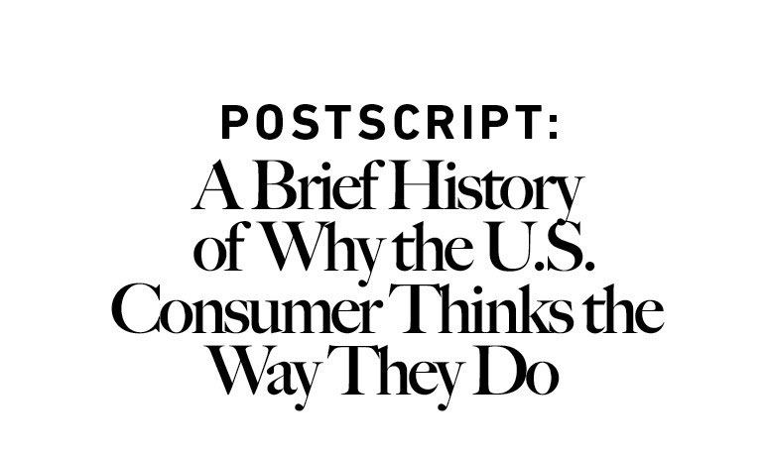

To understand the psychology of the modern consumer and to grasp where they might be

heading next, you have to know how they got here.

How we all got here.

If you fell asleep in 1945 and woke up in 2020 you would not recognize the world around

you.

The amount of economic growth that took place during that period is virtually

unprecedented. If you saw the level of wealth in New York and San Francisco, you’d be

shocked. If you compared it to the poverty of Detroit, you’d be shocked. If you saw the price

of homes, college tuition, and health care, you’d be shocked. If you saw how average

Americans think about savings and spending in general, you’d be shocked. And if you tried

to think of a reasonable narrative of how it all happened, my guess is you’d be totally

wrong. Because it isn’t intuitive, and it wasn’t foreseeable.

What happened in America since the end of World War II is the story of the American

consumer. It’s a story that helps explain why people think about money the way they do

today.

The short story is this: Things were very uncertain, then they were very good, then pretty

bad, then really good, then really bad, and now here we are. And there is, I think, a

narrative that links all those events together. Not a detailed account. But a story of how

things ﬁt together.

Since this is an attempt to link the big events together, it leaves out many details of what

happened during this period. I’m likely to agree with anyone who points out what I’ve

missed. The goal here is not to describe every play; it’s to look at how one game inﬂuenced

the next.

Here’s how the modern consumer got here.

1. August, 1945. World War II ends.

Japan surrendering was “The Happiest Day in American History,” The New York Times wrote.

But there’s the saying, “History is just one damn thing after another.”

The joy of the war ending was quickly met with the question, “What happens now?”

Sixteen million Americans—11% of the population—served in the war. About eight million

were overseas at the end. Their average age was 23. Within 18 months all but 1.5 million of

them would be home and out of uniform.

And then what?

What were they going to do next?

Where were they going to work?

Where were they going to live?

Those were the most important questions of the day, for two reasons. One, no one knew the

answers. Two, if they couldn’t be answered quickly, the most likely scenario—in the eyes of

many economists—was that the economy would slip back into the depths of the Great

Depression.

Three forces had built up during the war:

Housing construction ground to a halt, as virtually all production capacity was shifted to

building war supplies. Fewer than 12,000 homes per month were built in 1943, equivalent

to less than one new home per American city. Returning soldiers faced a severe housing

shortage.

The speciﬁc jobs created during the war—building ships, tanks, and planes—were very

suddenly not necessary after it, stopping with a speed and magnitude rarely seen in private

business. It was unclear where soldiers could work.

The marriage rate spiked during and immediately after the war. Soldiers didn’t want to

return to their mother’s basement. They wanted to start a family, in their own home, with a

good job, right away.

This worried policymakers, especially since the Great Depression was still a recent memory,

having ended just ﬁve years prior.

In 1946 the Council of Economic Advisors delivered a report to President Truman warning of

“a full-scale depression some time in the next one to four years.”

They wrote in a separate 1947 memo, summarizing a meeting with Truman:

We might be in some sort of recession period where we should have to be very sure of our

ground as to whether recessionary forces might be in danger of getting out of hand …

There is a substantial prospect which should not be overlooked that a further decline may

increase the danger of a downward spiral into depression conditions.

This fear was exacerbated by the fact that exports couldn’t be immediately relied upon for

growth, as two of the largest economies—Europe and Japan—sat in ruins dealing with

humanitarian crises. And America itself was buried in more debt than ever before, limiting

direct government stimulus.

So we did something about it.

2. Low interest rates and the intentional birth of the American consumer.

The ﬁrst thing we did to keep the economy aﬂoat after the war was keep interest rates low.

This wasn’t an easy decision, because when soldiers came home to a shortage of

everything from clothes to cars it temporarily sent inﬂation into double digits.

The Federal Reserve was not politically independent before 1951.⁷² The president and the

Fed could coordinate policy. In 1942 the Fed announced it would keep short-term rates at

0.38% to help ﬁnance the war. Rates didn’t budge a single basis point for the next seven

years. Three-month Treasury yields stayed below 2% until the mid-1950s.

The explicit reason for keeping rates down was to keep the cost of ﬁnancing the equivalent

of the $6 trillion we spent on the war low.

But low rates also did something else for all the returning GIs. It made borrowing to buy

homes, cars, gadgets, and toys really cheap.

Which, from a paranoid policymaker’s perspective, was great. Consumption became an

explicit economic strategy in the years after World War II.

An era of encouraging thrift and saving to fund the war quickly turned into an era of

actively promoting spending. Princeton historian Sheldon Garon writes:

After 1945, America again diverged from patterns of savings promotion in Europe and East

Asia … Politicians, businessmen and labor leaders all encouraged Americans to spend to

foster economic growth.⁷³

Two things fueled this push.

One was the GI Bill, which oﬀered unprecedented mortgage opportunities. Sixteen million

veterans could buy a home often with no money down, no interest in the ﬁrst year, and

ﬁxed rates so low that monthly mortgage payments could be lower than a rental.

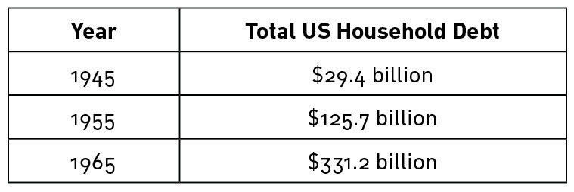

The second was an explosion of consumer credit, enabled by the loosening of Depression-

era regulations. The ﬁrst credit card was introduced in 1950. Store credit, installment

credit, personal loans, payday loans—everything took oﬀ. And interest on all debt, including

credit cards, was tax deductible at the time.

It tasted delicious. So we ate a lot of it. A simple story in a simple table:

Household debt in the 1950s grew 1.5 times faster than it did during the 2000s debt

splurge.

3. Pent-up demand for stuﬀ fed by a credit boom and a hidden 1930s

productivity boom led to an economic boom.

The 1930s were the hardest economic decade in American history. But there was a silver

lining that took two decades to notice: By necessity, the Great Depression had

supercharged resourcefulness, productivity, and innovation.

We didn’t pay that much attention to the productivity boom in the ’30s, because everyone

was focused on how bad the economy was. We didn’t pay attention to it in the ’40s,

because everyone was focused on the war.

Then the 1950s came around and we suddenly realized, “Wow, we have some amazing

new inventions. And we’re really good at making them.”

Appliances, cars, phones, air conditioning, electricity.

It was nearly impossible to buy many household goods during the war, because factories

were converted to make guns and ships. That created pent-up demand from GIs for stuﬀ

after the war ended. Married, eager to get on with life, and emboldened with new cheap

consumer credit, they went on a buying spree like the country had never seen.

Frederick Lewis Allen writes in his book The Big Change:

During these postwar years the farmer bought a new tractor, a corn picker, an electric

milking machine; in fact he and his neighbors, between them, assembled a formidable

array of farm machinery for their joint use. The farmer’s wife got the shining white electric

refrigerator she had always longed for and never during the Great Depression had been

able to aﬀord, and an up-to-date washing machine, and a deep-freeze unit. The suburban

family installed a dishwashing machine and invested in a power lawnmower. The city

family became customers of a laundromat and acquired a television set for the living room.

The husband’s oﬃce was air-conditioned. And so on endlessly.

It’s hard to overstate how big this surge was.

Commercial car and truck manufacturing virtually ceased from 1942 to 1945. Then 21

million cars were sold from 1945 to 1949. Another 37 million were sold by 1955.

Just under two million homes were built from 1940 to 1945. Then seven million were built

from 1945 to 1950. Another eight million were built by 1955.

Pent-up demand for stuﬀ, and our newfound ability to make stuﬀ, created the jobs that put

returning GIs back to work. And they were good jobs, too. Mix that with consumer credit,

and America’s capacity for spending exploded.

The Federal Reserve wrote to President Truman in 1951: “By 1950, total consumer

expenditures, together with residential construction, amounted to about 203 billion dollars,

or in the neighborhood of 40 percent above the 1944 level.”⁷⁴

The answer to the question, “What are all these GIs going to do after the war?” was now

obvious. They were going to buy stuﬀ, with money earned from their jobs making new stuﬀ,

helped by cheap borrowed money to buy even more stuﬀ.

4. Gains are shared more equally than ever before.

The deﬁning characteristic of economics in the 1950s is that the country got rich by

making the poor less poor.

Average wages doubled from 1940 to 1948, then doubled again by 1963.

And those gains focused on those who had been left behind for decades before. The gap

between rich and poor narrowed by an extraordinary amount.

Lewis Allen wrote in 1955:

The enormous lead of the well-to-do in the economic race has been considerably reduced.

It is the industrial workers who as a group have done best—people such as a steelworker’s

family who used to live on $2,500 and now are getting $4,500, or the highly skilled

machine-tool operator’s family who used to have $3,000 and now can spend an annual

$5,500 or more.

As for the top one percent, the really well-to-do and the rich, whom we might classify very

roughly indeed as the $16,000-and-over group, their share of the total national income,

after taxes, had come down by 1945 from 13 percent to 7 percent.

This was not a short-term trend. Real income for the bottom 20% of wage-earners grew by

a nearly identical amount as the top 5% from 1950 to 1980.

The equality went beyond wages.

Women held jobs outside the home in record numbers. Their labor force participation rate

went from 31% after the war to 37% by 1955, and to 40% by 1965.

Minorities gained, too. After the 1945 inauguration Eleanor Roosevelt wrote about an

African American reporter who told her:

Do you realize what twelve years have done? If at the 1933 reception a number of colored

people had gone down the line and mixed with everyone else in the way they did today,

every paper in the country would have reported it. We do not even think it is news and none

of us will mention it.

Women and minority rights were still a fraction of what they are today. But the progress

toward equality in the late ’40s and ’50s was extraordinary.

The leveling out of classes meant a leveling out of lifestyles. Normal people drove Chevys.

Rich people drove Cadillacs. TV and radio equalized the entertainment and culture people

enjoyed regardless of class. Mail-order catalogs equalized the clothes people wore and the

goods they bought regardless of where they lived. Harper’s Magazine noted in 1957:

The rich man smokes the same sort of cigarettes as the poor man, shaves with the same

sort of razor, uses the same sort of telephone, vacuum cleaner, radio, and TV set, has the

same sort of lighting and heating equipment in his house, and so on indeﬁnitely. The

diﬀerences between his automobile and the poor man’s are minor. Essentially they have

similar engines, similar ﬁttings. In the early years of the century there was a hierarchy of

automobiles.

Paul Graham wrote in 2016 about what something as simple as there only being three TV

stations did to equalize culture:

It’s diﬃcult to imagine now, but every night tens of millions of families would sit down

together in front of their TV set watching the same show, at the same time, as their next

door neighbors. What happens now with the Super Bowl used to happen every night. We

were literally in sync.⁷⁵

This was important. People measure their well-being against their peers. And for most of

the 1945–1980 period, people had a lot of what looked like peers to compare themselves

to. Many people—most people—lived lives that were either equal or at least fathomable to

those around them. The idea that people’s lives equalized as much as their incomes is an

important point of this story we’ll come back to.

5. Debt rose tremendously. But so did incomes, so the impact wasn’t a big deal.

Household debt increased ﬁvefold from 1947 to 1957 due to the combination of the new

consumption culture, new debt products, and interest rates subsidized by government

programs, and held low by the Federal Reserve.

But income growth was so strong during this period that the impact on households wasn’t

severe. And household debt was so low to begin with after the war. The Great Depression

wiped out a lot of it, and household spending was so curtailed during the war that debt

accumulation was restricted. So the growth in household debt-to-income from 1947–1957

was manageable.

Household debt-to-income today is just over 100%. Even after rising in the 1950s, 1960s,

and 1970s, it stayed below 60%.

Driving a lot of this debt boom was a surge in home ownership.

The homeownership rate in 1900 was 47%. It stayed right about there for the next four

decades. Then it took oﬀ, hitting 53% by 1945 and 62% by 1970. A substantial portion of

the population was now using debt that previous generations would not—could not—have

accessed. And they were mostly OK with it.

David Halberstam writes in his book The Fifties:

They were conﬁdent in themselves and their futures in a way that [those] growing up in

harder times found striking. They did not fear debt as their parents had … They diﬀered

from their parents not just in how much they made and what they owned but in their belief

that the future had already arrived. As the ﬁrst homeowners in their families, they brought

a new excitement and pride with them to the store as they bought furniture or appliances—

in other times young couples might have exhibited such feelings as they bought clothes for

their ﬁrst baby. It was as if the very accomplishment of owning a home reﬂected such an

immense breakthrough that nothing was too good to buy for it.

Now’s a good time to connect a few things, as they’ll become increasingly important:

America is booming.

It’s booming together like never before.

It’s booming with debt that isn’t a big deal at the time because it’s still low relative to

income and there’s a cultural acceptance that debt isn’t a scary thing.

6. Things start cracking.

1973 was the ﬁrst year where it became clear the economy was walking down a new path.

The recession that began that year brought unemployment to the highest it had been since

the 1930s.

Inﬂation surged. But unlike the post-war spikes, it stayed high.

Short-term interest rates hit 8% in 1973, up from 2.5% a decade earlier.

And you have to put all of that in the context of how much fear there was between

Vietnam, riots, and the assassinations of Martin Luther King, and John and Bobby Kennedy.

It got bleak.

America dominated the world economy in the two decades after the war. Many of the

largest countries had their manufacturing capacity bombed into rubble. But as the 1970s

emerged, that changed. Japan was booming. China’s economy was opening up. The Middle

East was ﬂexing its oil muscles.

A combination of lucky economic advantages and a culture shared by the Greatest

Generation—hardened by the Depression and anchored in systematic cooperation from the

war—shifted when Baby Boomers began coming of age. A new generation that had a

diﬀerent view of what’s normal hit at the same time a lot of the economic tailwinds of the

previous two decades ended.

Everything in ﬁnance is data within the context of expectations. One of the biggest shifts of

the last century happened when the economic winds began blowing in a diﬀerent, uneven

direction, but people’s expectations were still rooted in a post-war culture of equality. Not

necessarily equality of income, although there was that. But equality in lifestyle and

consumption expectations; the idea that someone earning a 50th percentile income

shouldn’t live a life dramatically diﬀerent than someone in the 80th or 90th percentile. And

that someone in the 99th percentile lived a better life, but still a life that someone in the

50th percentile could comprehend. That’s how America worked for most of the 1945–1980

period. It doesn’t matter whether you think that’s morally right or wrong. It just matters

that it happened.

Expectations always move slower than facts. And the economic facts of the years between

the early 1970s through the early 2000s were that growth continued, but became more

uneven, yet people’s expectations of how their lifestyle should compare to their peers did

not change.

7. The boom resumes, but it’s diﬀerent than before.

Ronald Reagan’s 1984 “Morning in America” ad declared:

It’s morning again in America. Today more men and women will go to work than ever

before in our country’s history. With interest rates at about half the record highs of 1980,

nearly 2,000 families today will buy new homes, more than at any time in the past four

years. This afternoon 6,500 young men and women will be married, and with inﬂation at

less than half of what it was just four years ago, they can look forward with conﬁdence to

the future.

That wasn’t hyperbole. GDP growth was the highest it had been since the 1950s. By 1989

there were six million fewer unemployed Americans than there were seven years before.

The S&P 500 rose almost fourfold between 1982 and 1990. Total real GDP growth in the

1990s was roughly equal to that of the 1950s—40% vs. 42%.

President Clinton boasted in his 2000 State of the Union speech:

We begin the new century with over 20 million new jobs; the fastest economic growth in

more than 30 years; the lowest unemployment rates in 30 years; the lowest poverty rates in

20 years; the lowest African-American and Hispanic unemployment rates on record; the

ﬁrst back-to-back surpluses in 42 years; and next month, America will achieve the longest

period of economic growth in our entire history. We have built a new economy.

His last sentence was important. It was a new economy. The biggest diﬀerence between the

economy of the 1945–1973 period and that of the 1982–2000 period was that the same

amount of growth found its way into totally diﬀerent pockets.

You’ve probably heard these numbers but they’re worth rehashing. The Atlantic writes:

Between 1993 and 2012, the top 1 percent saw their incomes grow 86.1 percent, while the

bottom 99 percent saw just 6.6 percent growth.

Joseph Stiglitz in 2011:

While the top 1 percent have seen their incomes rise 18 percent over the past decade,

those in the middle have actually seen their incomes fall. For men with only high-school

degrees, the decline has been precipitous—12 percent in the last quarter-century alone.

It was nearly the opposite of the ﬂattening that occurred after the war.

Why this happened is one of the nastiest debates in economics, topped only by the debate

over what we should do about it. Lucky for the purpose of this discussion, neither matters.

All that matters is that sharp inequality became a force over the last 35 years, and it

happened during a period where, culturally, Americans held onto two ideas rooted in the

post-WW2 economy: That you should live a lifestyle similar to most other Americans, and

that taking on debt to ﬁnance that lifestyle is acceptable.

8. The big stretch.

Rising incomes among a small group of Americans led to that group breaking away in

lifestyle.

They bought bigger homes, nicer cars, went to expensive schools, and took fancy vacations.

And everyone else was watching—fueled by Madison Avenue in the ’80s and ’90s, and the

internet after that.

The lifestyles of a small portion of legitimately rich Americans inﬂated the aspirations of the

majority of Americans, whose incomes weren’t rising.

A culture of equality and togetherness that came out of the 1950s–1970s innocently

morphs into a Keeping Up With The Joneses eﬀect.

Now you can see the problem.

Joe, an investment banker making $900,000 a year, buys a 4,000 square foot house with

two Mercedes and sends three of his kids to Pepperdine. He can aﬀord it.

Peter, a bank branch manager making $80,000 a year, sees Joe and feels a subconscious

sense of entitlement to live a similar lifestyle, because Peter’s parents believed—and

instilled in him—that Americans’ lifestyles weren’t that diﬀerent even if they had diﬀerent

jobs. His parents were right during their era, because incomes fell into a tight distribution.

But that was then. Peter lives in a diﬀerent world. But his expectations haven’t changed

much from his parents’, even if the facts have.

So what does Peter do?

He takes out a huge mortgage. He has $45,000 of credit card debt. He leases two cars. His

kids will graduate with heavy student loans. He can’t aﬀord the stuﬀ Joe can, but he’s

pushed to stretch for the same lifestyle. It is a big stretch.

This would have seemed preposterous to someone in the 1930s. But we’ve spent 75 years

since the end of the war fostering a cultural acceptance of household debt.

During a time when median wages were ﬂat, the median new American home grew 50%

larger.

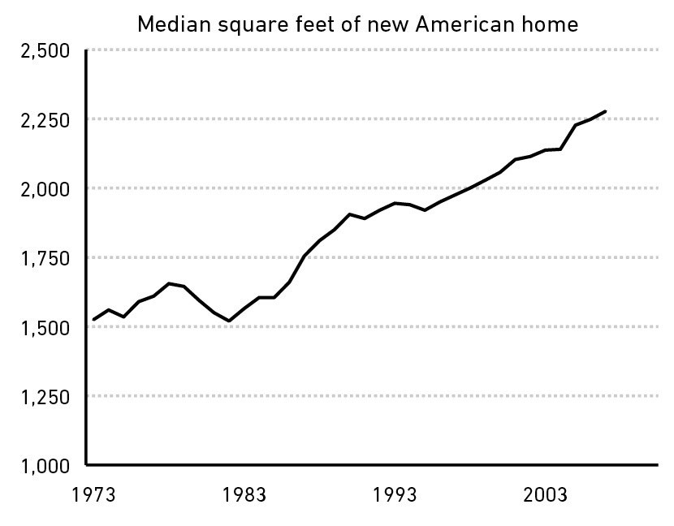

The average new American home now has more bathrooms than occupants. Nearly half

have four or more bedrooms, up from 18% in 1983.

The average car loan adjusted for inﬂation more than doubled between 1975 and 2003,

from $12,300 to $27,900.

And you know what happened to college costs and student loans.

Household debt-to-income stayed about ﬂat from 1963 to 1973. Then it climbed, and

climbed, and climbed, from around 60% in 1973 to more than 130% by 2007.

Even as interest rates plunged from the early 1980s through 2020, the percentage of

income going to debt service payments rose. And it skewed toward lower-income groups.

The share of income going toward debt and lease payments is just over 8% for the highest

income groups—those with the biggest income gains—but over 21% for those below the

50th percentile.

The diﬀerence between this climbing debt and the debt increase that took place during the

1950s and ’60s is that the recent jump started from a high base.

Economist Hyman Minsky described the beginning of debt crises: The moment when

people take on more debt than they can service. It’s an ugly, painful moment. It’s like Wile

E. Coyote looking down, realizing he’s screwed, and falling precipitously.

Which, of course, is what happened in 2008.

9. Once a paradigm is in place it is very hard to turn it around.

A lot of debt was shed after 2008. And then interest rates plunged. Household debt

payments as a percentage of income are now at the lowest levels in 35 years.

But the response to 2008, necessary as it may have been, perpetuated some of the trends

that got us here.

Quantitative easing both prevented economic collapse and boosted asset prices, a boon for

those who owned them—mostly rich people.

The Fed backstopped corporate debt in 2008. That helped those who owned that debt—

mostly rich people.

Tax cuts over the last 20 years have predominantly gone to those with higher incomes.

People with higher incomes send their kids to the best colleges. Those kids can go on to

earn higher incomes and invest in corporate debt that will be backstopped by the Fed, own

stocks that will be supported by various government policies, and so on.

None of these things are problems in and of themselves, which is why they stay in place.

But they’re symptomatic of the bigger thing that’s happened since the early 1980s: The

economy works better for some people than others. Success isn’t as meritocratic as it used

to be and, when success is granted, it’s rewarded with higher gains than in previous eras.

You don’t have to think that’s morally right or wrong.

And, again, in this story it doesn’t matter why it happened.

It just matters that it did happen, and it caused the economy to shift away from people’s

expectations that were set after the war: That there’s a broad middle class without

systematic inequality, where your neighbors next door and a few miles down the road live a

life that’s pretty similar to yours.

Part of the reason these expectations have stuck around for 35 years after they shifted away

from reality is because they felt so good for so many people when they were valid.

Something that good—or at least the impression that it was that good—isn’t easy to let go

of.

So people haven’t let go of it. They want it back.

10. The Tea Party, Occupy Wall Street, Brexit, and Donald Trump each

represents a group shouting, “Stop the ride, I want oﬀ.”

The details of their shouting are diﬀerent, but they’re all shouting—at least in part—

because stuﬀ isn’t working for them within the context of the post-war expectation that

stuﬀ should work roughly the same for roughly everyone.

You can scoﬀ at linking the rise of Trump to income inequality alone. And you should. These

things are always layers of complexity deep. But it’s a key part of what drives people to

think, “I don’t live in the world I expected. That pisses me oﬀ. So screw this. And screw you!

I’m going to ﬁght for something totally diﬀerent, because this—whatever it is—isn’t

working.”

Take that mentality and raise it to the power of Facebook, Instagram, and cable news—

where people are more keenly aware of how other people live than ever before. It’s gasoline

on a ﬂame. Benedict Evans says, “The more the Internet exposes people to new points of

view, the angrier people get that diﬀerent views exist.” That’s a big shift from the post-war

economy where the range of economic opinions were smaller, both because the actual

range of outcomes was lower and because it wasn’t as easy to see and learn what other

people thought and how they lived.

I’m not pessimistic. Economics is the story of cycles. Things come, things go.

The unemployment rate is now the lowest it’s been in decades. Wages are now actually

growing faster for low-income workers than the rich.⁷⁶ College costs by and large stopped

growing once grants are factored in.⁷⁷ If everyone studied advances in health care,

communication, transportation, and civil rights since the Glorious 1950s, my guess is most

wouldn’t want to go back.

But a central theme of this story is that expectations move slower than reality on the

ground. That was true when people clung to 1950s expectations as the economy changed

over the next 35 years. And even if a middle-class boom began today, expectations that the

odds are stacked against everyone but those at the top may stick around.

So the era of “This isn’t working” may stick around.

And the era of “We need something radically new, right now, whatever it is” may stick

around.

Which, in a way, is part of what starts events that led to things like World War II, where this

story began.

History is just one damned thing after another.



1 J. Pressler, “Former Merrill Lynch Executive Forced to Declare Bankruptcy Just to Keep a

$14 Million Roof Over His Head,” New York magazine (April 9, 2010).

2 Ibid.

3 L. Thomas Jr., “The Tale of the $8 Million ‘Bargain’ House in Greenwich,” The New York

Times (January 25, 2014).

4 U. Malmendier, S. Nagel, “Depression Babies: Do Macroeconomic Experiences Aﬀect Risk-

Taking?” (August 2007).

5 “How large are 401(k)s?” Investment Company Institute (December 2019).

6 R. Butler, “Retirement Pay Often Is Scanty,” The New York Times (August 14, 1955).

7 “Higher education in the United States,” Wikipedia.

8 K. Bancalari, “Private college tuition is rising faster than inﬂation .... again,” USA Today

(June 9, 2017).

9 “How Many People Die Rock Climbing?” The Rockulus.

10 A. T. Vanderbilt II, Fortune’s Children: The Fall of the House of Vanderbilt (William

Morrow Paperbacks, 2012).

11 D. McDonald, “Rajat Gupta: Touched by scandal,” Fortune (October 1, 2010).

12 “Did millionaire Rajat Gupta suﬀer from billionaire envy?” The Economic Times (March

27, 2011).

13 J. Nicas, “Facebook Connected Her to a Tattooed Soldier in Iraq. Or So She Thought,” The

New York Times (July 28, 2019).

14 T. Maloney, “The Best-Paid Hedge Fund Managers Made $7.7 Billion in 2018,” Bloomberg

(February 15, 2019).

15 S. Weart, “The Discovery of Global Warming,” history.aip.org/climate/cycles.htm (January

2020). (January 2020).

16 S. Langlois, “From $6,000 to $73 billion: Warren Buﬀett’s wealth through the ages,”

MarketWatch (January 6, 2017).

17 D. Boudreaux, “Turnover in the Forbes 400, 2008–2013,” Cafe Hayek (May 16, 2014).

18 M. Pabrai, www.youtube.com/watch?time_continue=200&v=YmmIbrKDYbw..

19 “Art Dealers: The Other Vincent van Gogh,” Horizon Research Group (June 2010).

20 www.collaborativefund.com/uploads/venture-returns.png

21 “The Agony and the Ecstasy: The Risks and Rewards of a Concentrated Stock Position,”

Eye on the Market, J.P. Morgan (2014).

22 L. Eadicicco, “Here’s Why You Probably Won’t Get Hired At Google,” Business Insider

(October 23, 2014).

23 “What is the oﬀer acceptance rate for Facebook software engineering positions?”

Quora.com..

24 W. Fulton, “If You Want to Build a Great Team, Hire Apple Employees,” Forbes (June 22,

2012).

25 J. Berger, “How to Change Anyone’s Mind,” The Wall Street Journal (February 21, 2020).

26 D. Sivers, “How I got rich on the other hand,” sivers.org (October 30, 2019). (October 30,

2019).

27 N. Chokshi, “Americans Are Among the Most Stressed People in the World, Poll Finds,”

The New York Times (April 25, 2019).

28 Russell Sage Foundation—Chartbook of Social Inequality.

29 D. Thompson, “Why White-Collar Workers Spend All Day at the Oﬃce,” The Atlantic

(December 4, 2019).

30 “Rihanna’s ex-accountant ﬁres back,” News24 (March 24, 2014).

31 B. Mann, “Want to Get Rich and Stay Rich?” The Motley Fool (March 7, 2017).

32 “U.S. energy intensity projected to continue its steady decline through 2040,” U.S.

Energy Information Administration (March 1, 2013).

33 Julius Wagner-Jauregg—Biographical, nobelprize.org..

34 J. M. Cavaillon, “Good and bad fever,” Critical Care 16:2 (2012).

35 “Fever—Myths Versus Facts,” Seattle Children’s.

36 J. J. Ray, and C. I. Schulman, “Fever: suppress or let it ride?” Journal of Thoracic Disease

7:12 (2015).

37 A. LaFrance, “A Cultural History of the Fever,” The Atlantic (September 16, 2015).

38 J. Zweig, “What Harry Markowitz Meant,” jasonzweig.com (October 2, 2017). (October 2,

2017).

39 L. Pleven, “In Bogle Family, It’s Either Passive or Aggressive,” The Wall Street Journal

(November 28, 2013).

40 C. Shapiro and M. Housel, “Disrupting Investors’ Own Game,” The Collaborative Fund.

41 www.bylo.org

42 Washington State University, “For pundits, it’s better to be conﬁdent than correct,”

ScienceDaily (May 28, 2013).

43 “Daniel Kahneman’s Favorite Approach For Making Better Decisions,” Farnham Street

(January 2014).

44 W. Buﬀett, Letter to the Shareholders of Berkshire Hathaway Inc. (2008).

45 W. Buﬀett, Letter to the Shareholders of Berkshire Hathaway Inc. (2006).

46 B. Plumer, “Only 27 percent of college grads have a job related to their major,” The

Washington Post (May 20, 2013).

47 G. Livingston, “Stay-at-home moms and dads account for about one-in-ﬁve U.S.

parents,” Pew Research Center (September 24, 2018).

48 D. Gilbert, “The psychology of your future self,” TED2014.

49 J. Zweig, “What I Learned From Daniel Kahneman,” jasonzweig.com (March 30, 2014).

(March 30, 2014).

50 J. Ptak “Tactical Funds Miss Their Chance,” Morningstar (February 2, 2012).

51 R. Kinnel, “Mind the Gap 2019,” Morningstar (August 15, 2019).

52 M. Desmond. “Accounting Tricks Catch Up With GE,” Forbes (August 4, 2009).

53 A. Berenson, “Freddie Mac Says It Understated Proﬁts by Up to $6.9 Billion,” The New

York Times (June 25, 2003).

54 “U.S. Home Flipping Rate Reaches a Nine-Year High in Q1 2019,” Attom Data Solutions

(June 4, 2019).

55 A. Osborn, “As if Things Weren’t Bad Enough, Russian Professor Predicts End of U.S.,”

The Wall Street Journal (December 29, 2008).

56 “Food in the Occupation of Japan,” Wikipedia.

57 J. M. Jones, “U.S. Stock Ownership Down Among All but Older, Higher-Income,” Gallup

(May 27, 2017).

58 E. Rauchway, The Great Depression and the New Deal: A Very Short Introduction (Oxford

University Press, 2008).

59 L. R. Brown, Plan B 3.0: Mobilizing to Save Civilization (W. W. Norton & Company, 2008).

60 FRED, Federal Reserve Bank of St. Louis.

61 “U.S. Crude Oil Production—Historical Chart,” Macro Trends.

62 “Thomas Selfridge,” Wikipedia.

63 www.nhlbi.nih.gov

64 D. Walsh, “The Tragedy of Saudi Arabia’s War,” The New York Times (October 26, 2018).

65 B. Pisani, “Active fund managers trail the S&P 500 for the ninth year in a row in triumph

for indexing,” CNBC (March 15, 2019).

66 2019 Investment Company Factbook, Investment Company Institute.

67 “Minutes of the Federal Open Market Committee,” Federal Reserve (October 30–31,

2007).

68 www.nasa.gov

69 A. Ram, “Portfolio managers shun investing in own funds,” Financial Times (September

18, 2016).

70 K. Murray “How Doctors Die,” Zócalo Public Square (November 30, 2011).

71 B. Pisani, “Active fund managers trail the S&P 500 for the ninth year in a row in triumph

for indexing,” CNBC (March 15, 2019).

72 “Treasury-Fed Accord,” federalreservehistory.org..

73 S. Garon, “Beyond Our Means: Why America Spends While the World Saves,” Federal

Reserve Bank of St. Louis (July 1, 2012).

74 “Economic Report of the President,” FRASER, St. Louis Federal Reserve (1951).

75 P. Graham, “The Refragmentation,” paulgraham.com (2016). (2016).

76 P. Davidson, “Jobs in high-wage industries are growing fastest,” USA Today (December

14, 2019).

77 R. Channick, “Average college costs ﬂat nationwide, at just under $15K, as universities

increase grants,” Chicago Tribune (October 16, 2018).



Like all books, The Psychology of Money wouldn’t have been possible without the help of

countless people who helped me along the way. There are too many to list them all. But a

few who have been particularly supportive:

Brian Richards, who bet on me before anyone else.

Craig Shapiro, who bet on me when he didn’t have to.

Gretchen Housel, whose support is unwavering.

Jenna Abdou, who helps while asking for nothing in return.

Craig Pearce, who encourages, guides, and grounds me.

Jamie Catherwood, Josh Brown, Brent Beshore, Barry Ritholtz, Ben Carlson, Chris Hill,

Michael Batnick, James Osorne, whose feedback is invaluable.

Thank you.

harriman house ltd

3 Viceroy Court

Bedford Road

Petersﬁeld

Hampshire

GU32 3LJ

GREAT BRITAIN

Tel: +44 (0)1730 233870

Email: enquiries@harriman-house.com

Website: harriman.house

First published in 2020.

Copyright © Morgan Housel

The right of Morgan Housel to be identiﬁed as the Author

has been asserted in accordance with the Copyright, Design

and Patents Act 1988.

Paperback ISBN: 978-0-85719-768-9

eBook ISBN: 978-0-85719-769-6

British Library Cataloguing in Publication Data

A CIP catalogue record for this book can be obtained from

the British Library.

All rights reserved; no part of this publication may be

reproduced, stored in a retrieval system, or transmitted in

any form or by any means, electronic, mechanical,

photocopying, recording, or otherwise without the prior

written permission of the Publisher. This book may not be

lent, resold, hired out or otherwise disposed of by way of

trade in any form of binding or cover other than that in

which it is published without the prior written consent of the

Publisher.

Whilst every eﬀort has been made to ensure that

information in this book is accurate, no liability can be

accepted for any loss incurred in any way whatsoever by any

person relying solely on the information contained herein.

No responsibility for loss occasioned to any person or

corporate body acting or refraining to act as a result of

reading material in this book can be accepted by the

Publisher, by the Author, or by the employers of the Author.