Report on Physical Activity and Gait Analysis using body fixed inertial sensors

Patient ID: CP_Perform_01
Evaluation date: 06.11.2017

- Physical activity metrics:
- Global assessment
- Duration of episodes
- Temporal pattern
- Gait metrics:
- Spatiotemporal parameters
- Asymmetry
- Kinematical curves
- Summary of performance measures

Patient characteristics
Age (y): 11
Gender: f m
CP Subtype: diplegic
GMFCS level: I II III
Height (cm):
Weight (kg):
Thigh length (cm): 37
Shank length (cm): 42

Evaluation
BASELINE
Monitoring day: school day week day, no school week-end
Configuration: TR LT RT LS RS
Duration (min): 637
Start & end time: 07:30 – 18:00
Weather: sun and rain (cold – ca 4-6C°)
Remarks:
PRE
Monitoring day: school day week day, no school week-end
Configuration: TR LT RT LS RS
Duration (min):
Start & end time:
Weather:
Remarks:
POST
Monitoring day: school day week day, no school week-end
Configuration: TR LT RT LS RS
Duration (min):
Start & end time:
Weather:
Remarks:
FOLLOW-UP
Monitoring day: school day week day, no school week-end
Configuration: TR LT RT LS RS
Duration (min):
Start & end time:
Weather:
Remarks:
- Physical activity metrics
- Global assessment
 | 

Metrics | TD  group(mean) | TD  group(SD) | CP  (baseline) | CP  (Followup1) | CP  (Followup2) | CP  (Followup3)
Time spent Walking (%) | 16 | 5 | 2
Time spent Standing (%) | 23 | 4 | 9
Time spent Sedentary (%) | 61 | 6 | 89
Statistics Walking Periods:
10th Percentile(sec) | 2.8 | 0.4 | 3
20th Percentile(sec) | 3.5 | 0.5 | 4
30th Percentile(sec) | 4.3 | 0.8 | 4.9
40th Percentile(sec) | 5.2 | 1.0 | 5
50th Percentile(sec) | 6.5 | 1.0 | 6.5
60th Percentile(sec) | 8.0 | 1.7 | 7.3
70th Percentile(sec) | 10.8 | 3.1 | 9
80th Percentile(sec) | 16.2 | 4.7 | 11
90th Percentile(sec) | 30.9 | 16.5 | 14
Maximal Walking period (sec) | 462.5 | 255.5 | 26
Statistics Standing Periods:
10th Percentile(sec) | 1.0 | 0.0 | 2
20th Percentile(sec) | 1.8 | 0.4 | 4
30th Percentile(sec) | 2.5 | 0.5 | 5.2
40th Percentile(sec) | 4.3 | 1.0 | 11
50th Percentile(sec) | 6.7 | 2.3 | 13
60th Percentile(sec) | 10.2 | 4.4 | 15.9
70th Percentile(sec) | 16.7 | 8.4 | 21.8
80th Percentile(sec) | 31.9 | 13.8 | 32
90th Percentile(sec) | 56.5 | 33.8 | 48.2
Maximal Standing period (sec) | 494.2 | 230.6 | 438
Statistics Sedentary Periods:
10th Percentile(sec) | 5.4 | 1.9 | 14.5
20th Percentile(sec) | 9.6 | 5.5 | 36
30th Percentile(sec) | 21.4 | 17.4 | 95.5
40th Percentile(sec) | 42.0 | 40.5 | 186.5
50th Percentile(sec) | 80.9 | 64.4 | 311
60th Percentile(sec) | 166.5 | 127.1 | 459
70th Percentile(sec) | 418.6 | 320.1 | 744
80th Percentile(sec) | 832.4 | 520.0 | 972
90th Percentile(sec) | 1535.5 | 1024.3 | 1705.5
Maximal Sedentary period (sec) | 3304.0 | 1490.8 | 3464
Kolmogorov_Smirnov stat Dist:
Stat Dist Walking periods |  | 0.150
Stat Dist Standing periods |  | 0.251
Stat Dist Sedentary periods |  | 0.296

- Duration of episodes
 | 

- Temporal pattern
 | 

Barcode states | TD group (%,mean) | TD group (%,SD) | CP  (%,baseline) | CP  (%,Followup1) | CP  (%,Followup2) | CP  (%,Followup3)
1 | 60.7 | 6.4 | 88.8
2 | 0.1 | 0.0 | 0.1
3 | 22.7 | 3.5 | 8.6
4 | 0.3 | 0.3 | 0.1
5 | 0.2 | 0.2 | 0.0
6 | 0.2 | 0.3 | 0.0
7 | 0.7 | 0.8 | 1.3
8 | 3.5 | 2.5 | 0.8
9 | 3.9 | 2.7 | 0.1
10 | 2.7 | 5.0 | 0.0
11 | 0.1 | 0.2 | 0.0
12 | 0.1 | 0.2 | 0.0
13 | 1.1 | 1.1 | 0.0
14 | 0.1 | 0.4 | 0.0
15 | 0.0 | 0.0 | 0.0
16 | 0.1 | 0.2 | 0.0
17 | 1.6 | 1.5 | 0.0
18 | 0.3 | 0.5 | 0.0
19 | 0.0 | 0.0 | 0.0
20 | 0.0 | 0.0 | 0.0
21 | 1.7 | 1.1 | 0.0
22 | 0.0 | 0.0 | 0.0

- Gait metrics
- Spatiotemporal parameters
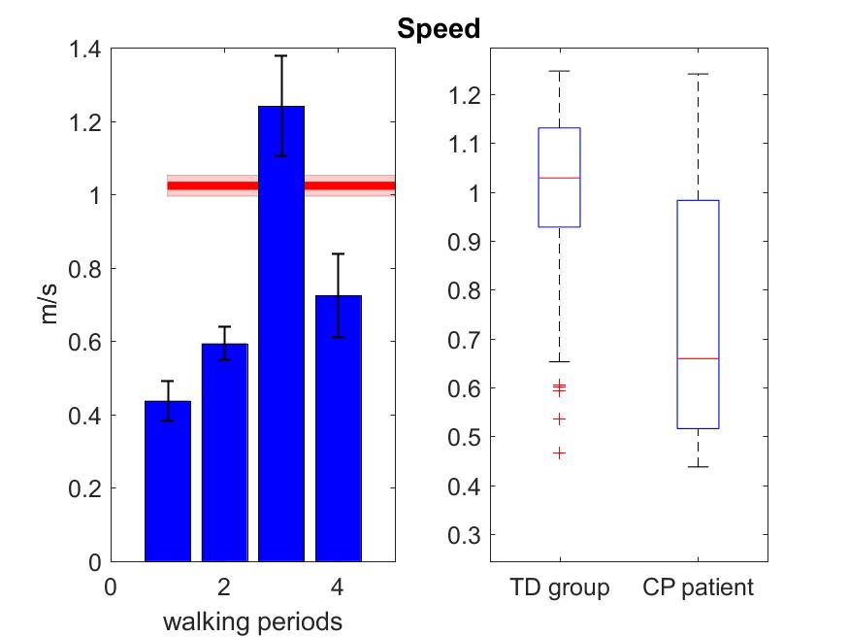 | 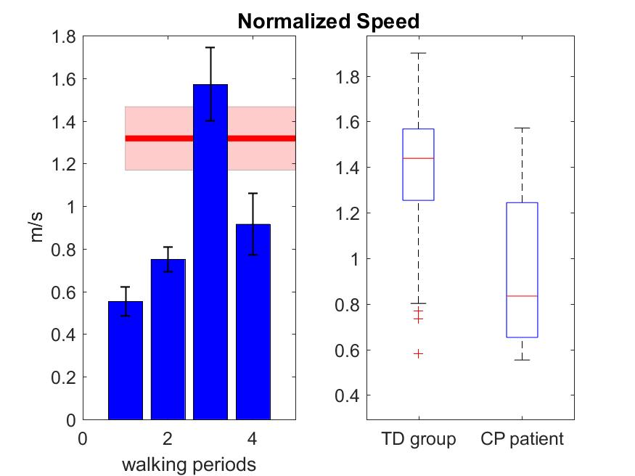
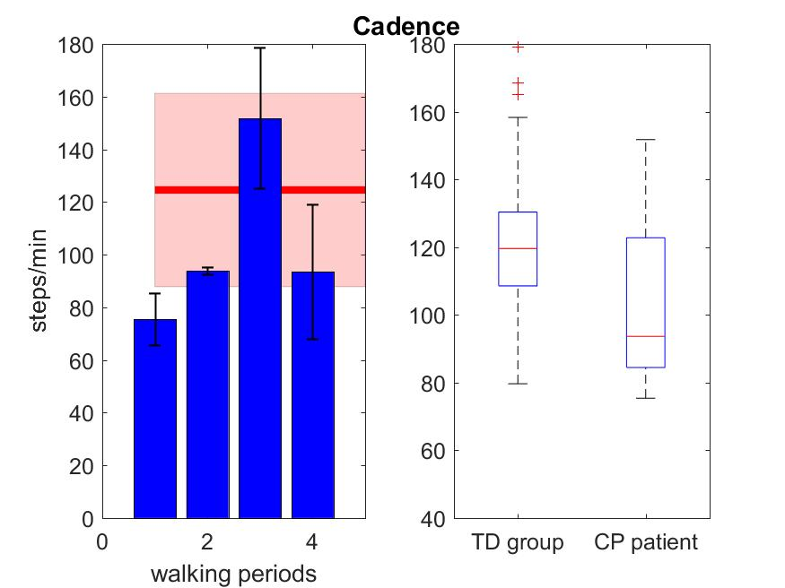 | 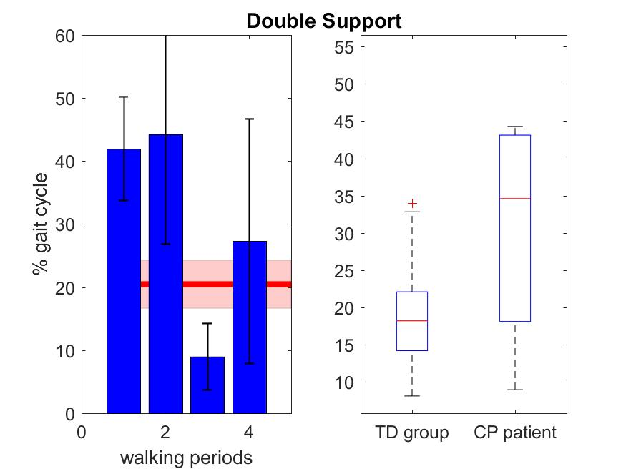

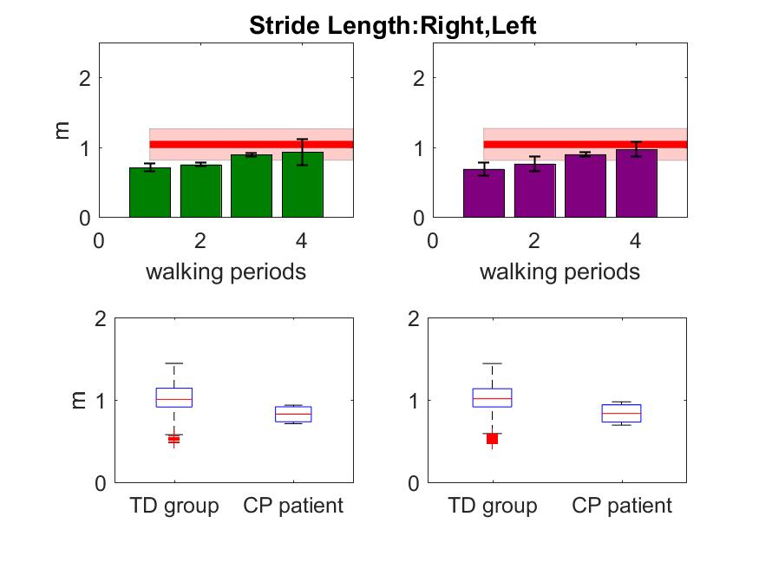 | 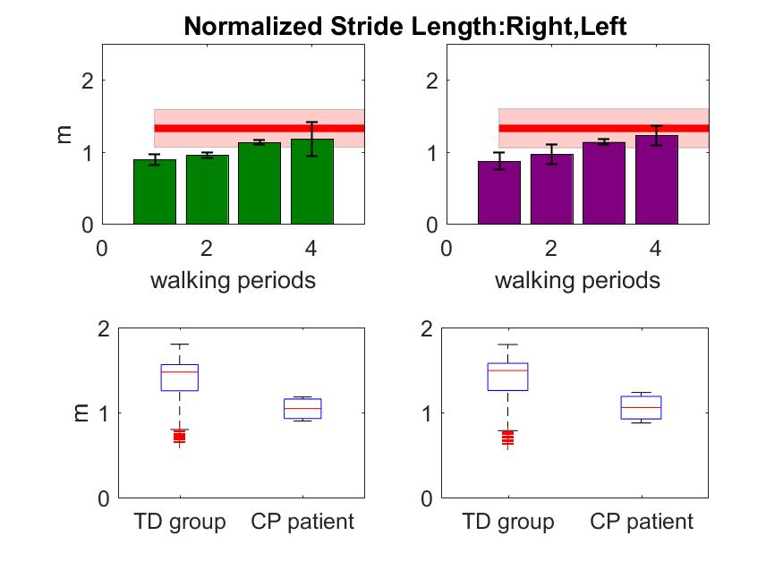
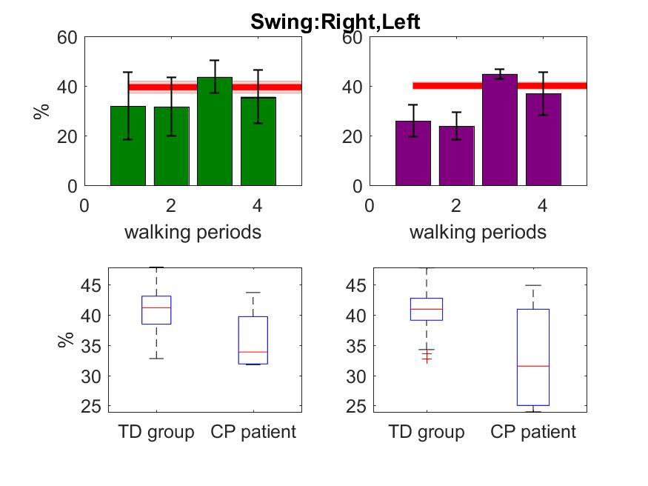 | 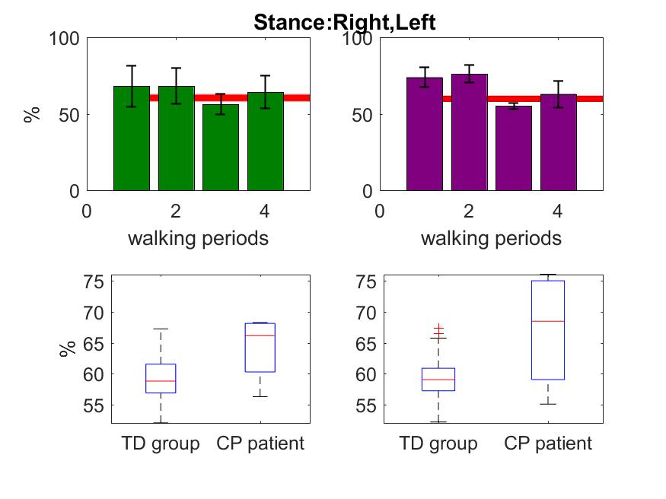
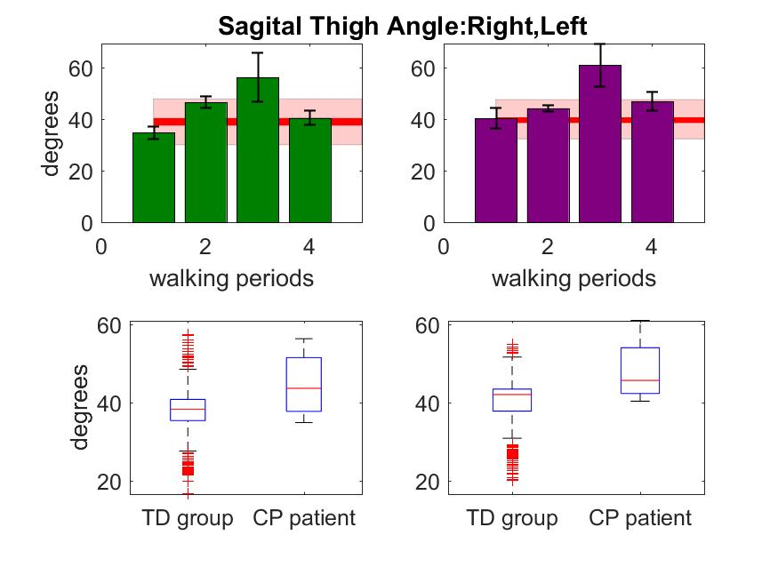 | 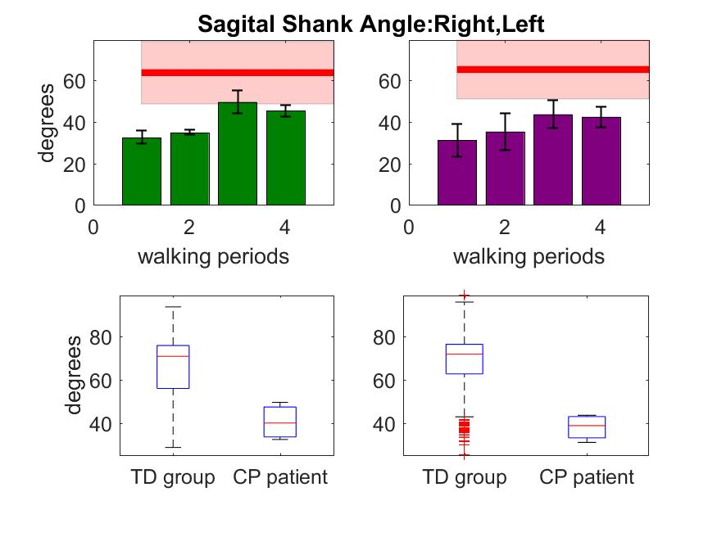
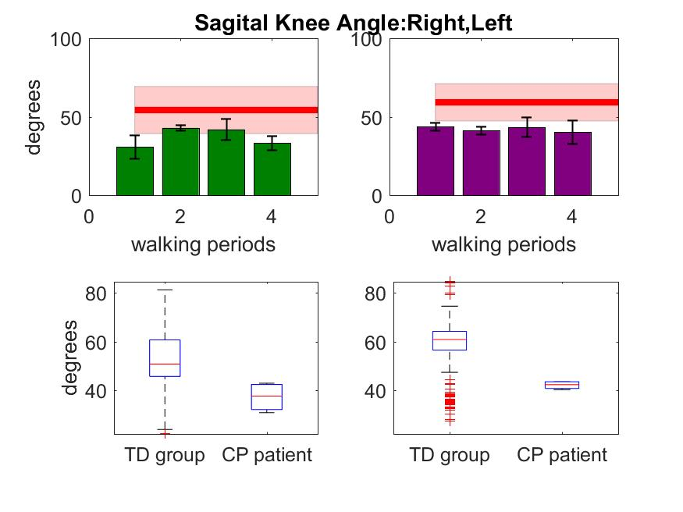
 | TD group | CP Baseline | CP FollowUp 1 | CP FollowUp 2 | CP FollowUp 3
Mean Cadence (steps/min) | 128.3 | 103.6
Median Cadence (steps/min) | 119.6 | 93.6
Maximum Cadence (steps/min) | 223.5 | 151.8
Mean Normalized Speed (m/s) | 1.0 | 0.7
Median Normalized Speed (m/s) | 1.0 | 0.7
Maximum Normalized Speed (m/s) | 1.2 | 1.2
Mean Normalized Stride Length RL (m) | 1.4 | 0.9
Median Normalized Stride Length RL (m) | 1.4 | 0.8
Mean Normalized Stride Length LL (m) | 1.9 | 1.6
Median Normalized Stride Length LL (m) | 1.4 | 1.0
Mean Swing RL(%gct) | 1.5 | 1.0
Median Swing RL(%gct) | 1.4 | 1.1
Mean Swing LL(%gct) | 1.5 | 1.1
Median Swing LL(%gct) | 40.7 | 35.8
Mean Stance RL(%gct) | 41.2 | 33.9
Median Stance RL(%gct) | 40.9 | 33.0
Mean Stance LL(%gct) | 40.9 | 31.5
Median Stance LL(%gct) | 59.3 | 64.2
Statistical Distance Cadence | 58.8 | 66.1
Statistical Distance Normalized Speed | 59.1 | 67.0
Statistical Distance Normalized Stride Length RL | 59.1 | 68.5
Statistical Distance Normalized Stride Length LL |  | 0.701
Statistical Distance Swing RL |  | 0.712
Statistical Distance Swing LL |  | 0.795
Statistical Distance Stance RL |  | 0.769
Statistical Distance Stance LL |  | 0.670

- Asymmetry
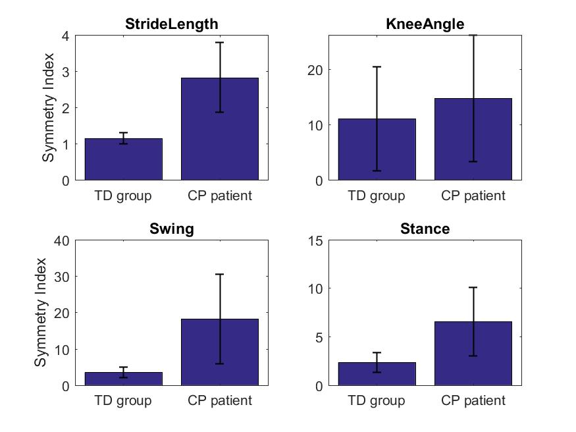

- Kinematical curves for maximal walking distance recorded during monitoring day
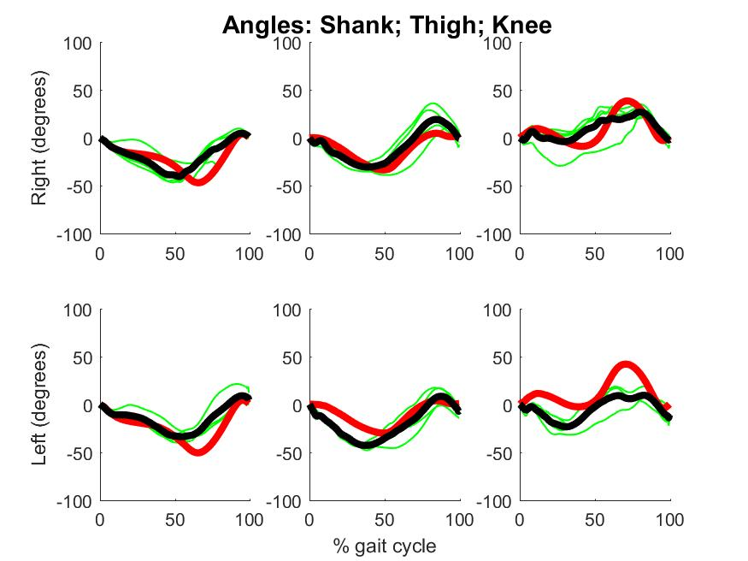

- Summary of performance measures
