**Report on Gait Analysis using body fixed inertial sensors**

**Patient ID:** ID_43

**Patient Name:** Matteo Ciprian

**Analysis ID:** Patient_ID_43_Gait_Analysis_ID_8

**Evaluation date:** 06-Dec-2017

1. **Patient details**
2. **Gait metrics:**
3. *Spatiotemporal parameters*
4. *Asymmetry*
5. *Kinematical curves*
6. **Summary of performance measures**
7. **Patient details:**

**Date of birth:** 30/09/1994

**Gender:** M

**CP Subtype:** 0

**GMFCS level:** 2

**Height (cm):** 182

**Weight (kg):** 78

**Evaluation**

**Type:**  79

**Monitoring day:** sda

**Configuration:** Left-Thigh Right-Thigh Left-Shank Right-Shank

**Duration (min):** asdas

**Start & end time:** asda

**Weather:** asd

**Remarks:** asd

1. **Gait metrics**
2. ***Spatiotemporal parameters***

|  |  |
| --- | --- |
|  |  |
|  |  |

|  |  |
| --- | --- |
|  |  |
|  |  |
|  |  |
|  |  |

|  |  |  |
| --- | --- | --- |
|  | TD group | CP This Analysis |
| Mean Cadence (steps/min) | 126.7076 | 109.3968 |
| Median Cadence (steps/min) | 118.1336 | 110.3994 |
| Maximum Cadence (steps/min) | 223.5121 | 136.248 |
| Mean Speed (m/s) | 1.0549 | 0.7358 |
| Median Speed (m/s) | 1.0598 | 0.76063 |
| Maximum Speed (m/s) | 1.3994 | 1.0474 |
| Mean Normalized Speed (m/s) | 1.4363 | 0.93139 |
| Median Normalized Speed (m/s) | 1.4893 | 0.96282 |
| Maximum Normalized Speed (m/s) | 1.9349 | 1.3259 |
| Mean Normalized Stride Length RL (m) | 1.4141 | 1.0094 |
| Median Normalized Stride Length RL (m) | 1.5022 | 1.0357 |
| Mean Normalized Stride Length LL (m) | 1.4164 | 1.0147 |
| Median Normalized Stride Length LL (m) | 1.5121 | 1.0314 |
| Mean Swing RL(%gct) | 40.719 | 42.806 |
| Median Swing RL(%gct) | 40.9886 | 43.0894 |
| Mean Swing LL(%gct) | 40.898 | 39.5632 |
| Median Swing LL(%gct) | 40.9159 | 40.6798 |
| Mean Stance RL(%gct) | 59.281 | 57.194 |
| Median Stance RL(%gct) | 59.0114 | 56.9106 |
| Mean Stance LL(%gct) | 59.102 | 60.4368 |
| Median Stance LL(%gct) | 59.0841 | 59.3202 |
| Statistical Distance Cadence |  | 0.34953 |
| Statistical Distance Normalized Speed |  | 0.79764 |
| Statistical Distance Normalized Stride Length RL |  | 0.80592 |
| Statistical Distance Normalized Stride Length LL |  | 0.80624 |
| Statistical Distance Swing RL |  | 0.30051 |
| Statistical Distance Swing LL |  | 0.14007 |
| Statistical Distance Stance RL |  | 0.30051 |
| Statistical Distance Stance LL |  | 0.14007 |

1. ***Asymmetry***

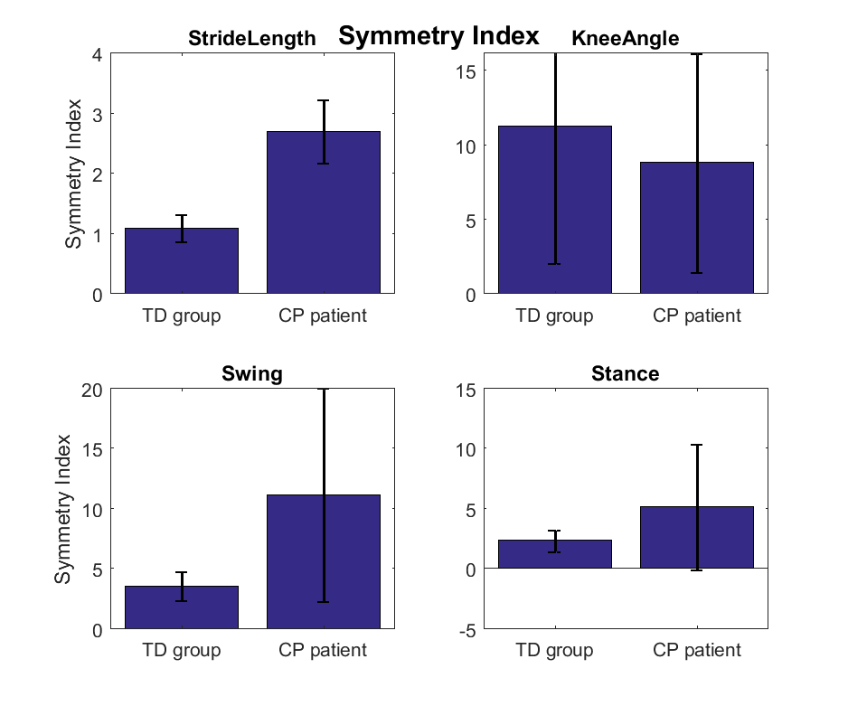

1. ***Kinematical curves for maximal walking distance recorded during monitoring day***

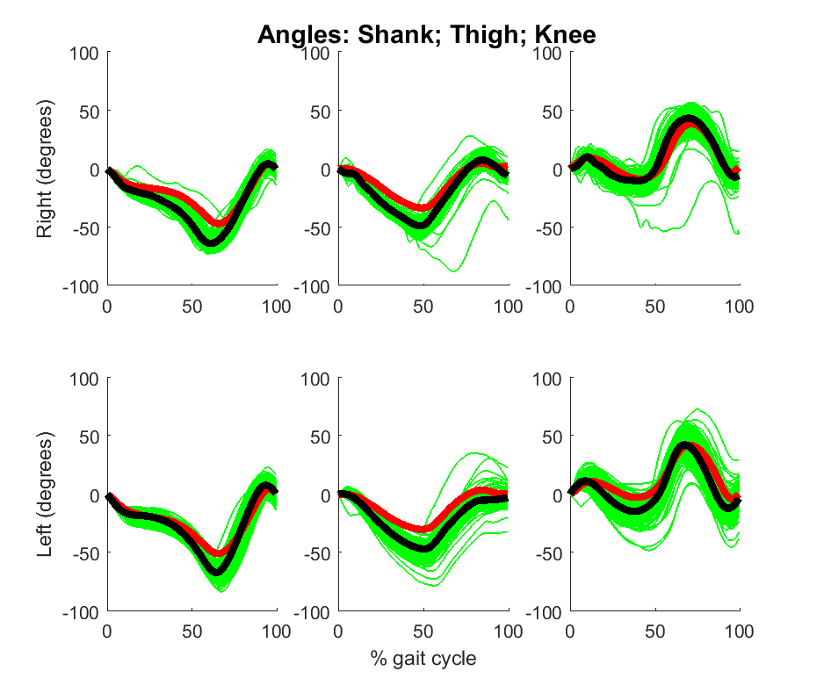

1. **Summary of performance measures**

