**Final Report on Gait Analysis and Physical Analysis considering multiple perform**

**Patient ID:** ID_1

**Patient Name:** Matteo Ciprian

1. **Patient details**
2. **Posture:**
3. *Daily posture allocation*
4. *Duration of periods without TD*
5. *Duration of periods with TD*
6. *Duration of periods CDF*
7. **Gait parameters:**
   1. *Knee Angle*
   2. *Limp*
   3. *Speed*
   4. *Normalized Speed*
   5. *Cadence*
8. **Symmetry Indexes:**
   1. *Knee Angle*
   2. *Stance*
   3. *Stride Length*
   4. *Swing*
9. **Tables**
10. **Summary of performance measures**
11. **Patient details:**

**Date of birth:** 30/09/1994

**Gender:** M

**CP Subtype:** 2

**GMFCS level:** 3

**Height (cm):** 182

**Weight (kg):** 78

**Analysis details:**

**ID Analysis :**

Baseline PA Analysis: Patient_ID_1_PA_Analysis_ID_1

Baseline Gait Analysis: Patient_ID_1_Gait_Analysis_ID_9

Follow-up 1 (pre) PA Analysis: Patient_ID_1_PA_Analysis_ID_2

Follow-up 1 (pre) Gait Analysis: Patient_ID_1_Gait_Analysis_ID_10

Follow-up 2 (post) PA Analysis: Patient_ID_1_PA_Analysis_ID_3

Follow-up 2 (post) Gait Analysis: Patient_ID_1_Gait_Analysis_ID_11

Follow-up 3 (follow-up) PA Analysis: Patient_ID_1_PA_Analysis_ID_4

Follow-up 3 (follow-up) Gait Analysis: Patient_ID_1_Gait_Analysis_ID_12

1. **Posture**
2. *Daily posture allocation*

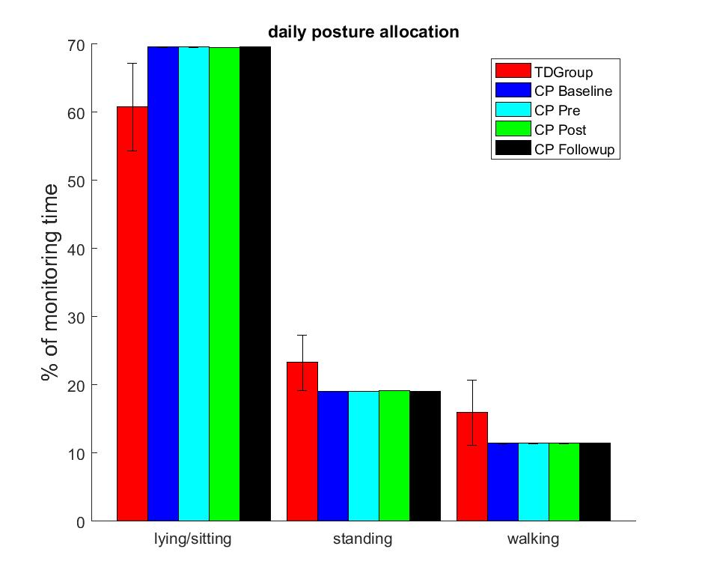

1. *Duration of periods without TD*

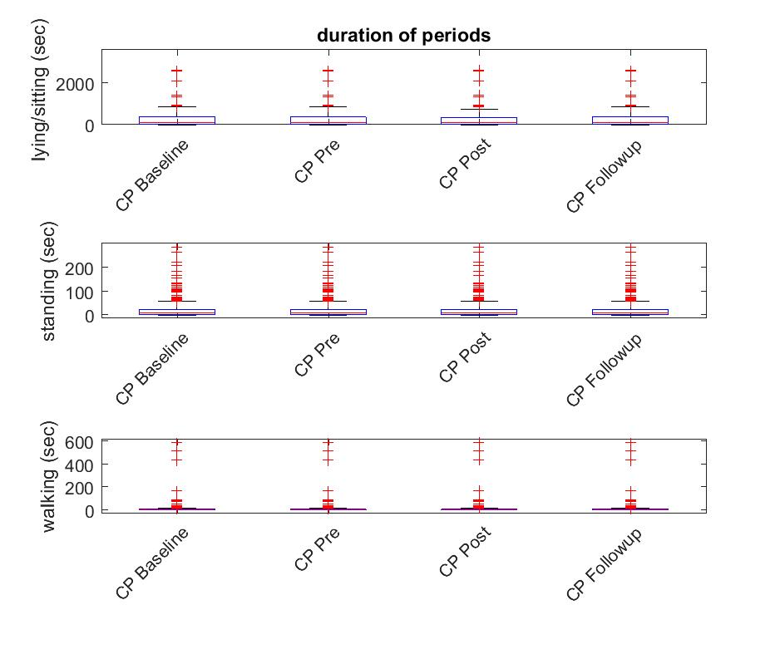

1. *Duration of periods with TD*

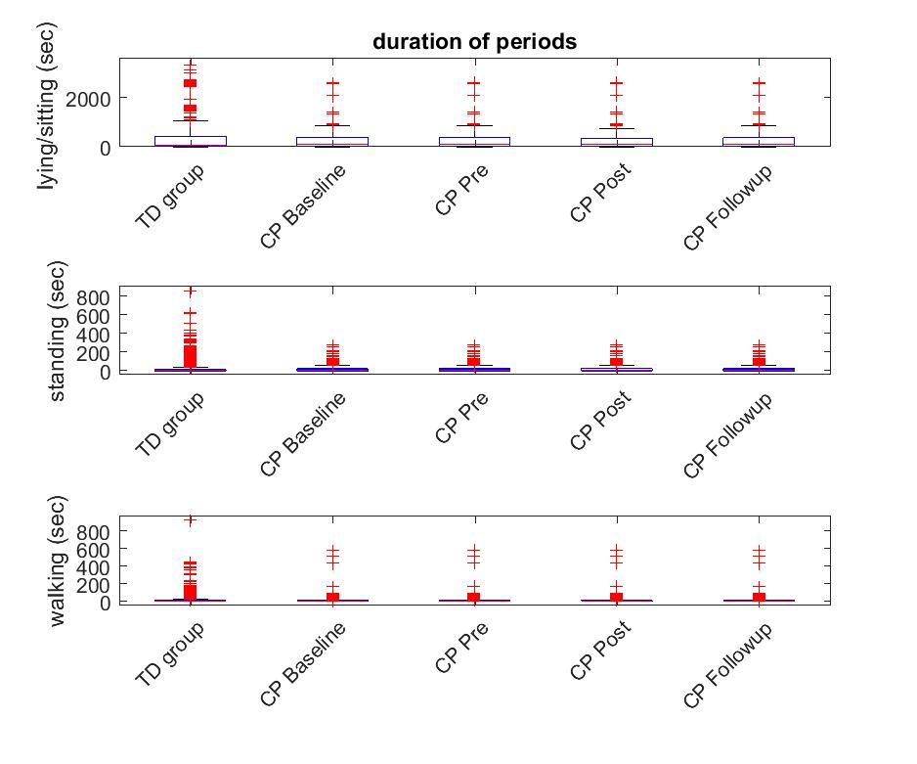

1. *Duration of periods CDF*

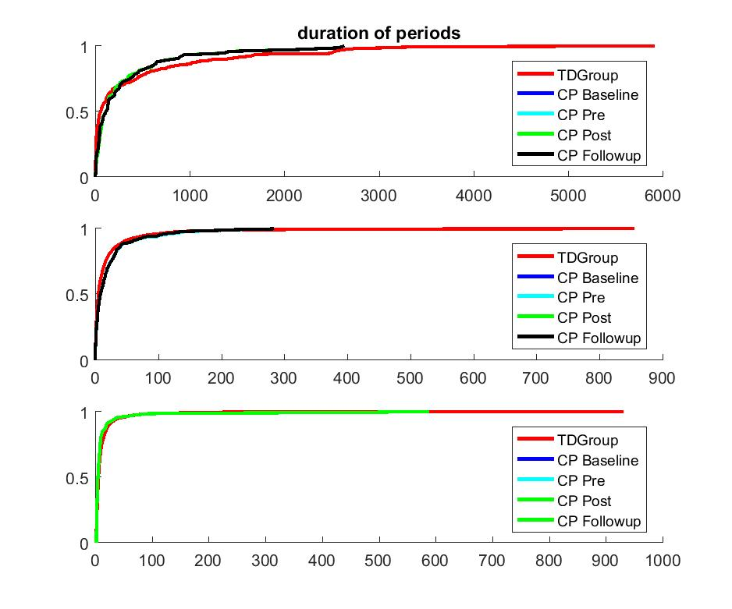

1. **Gait parameters:**
2. *Knee Angle*

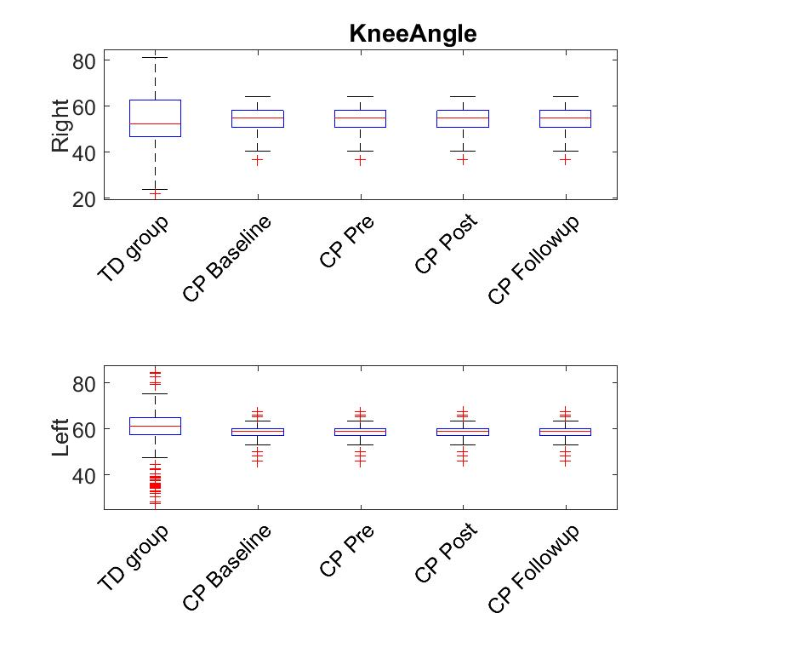

1. *Limp*

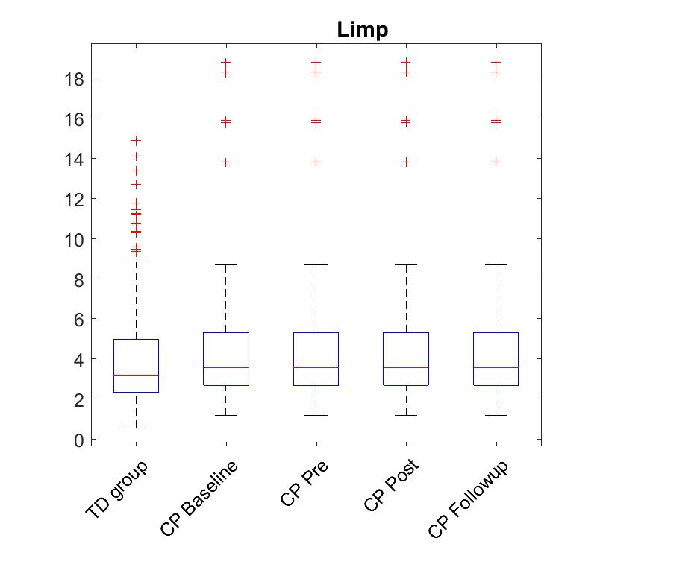

1. *Speed*

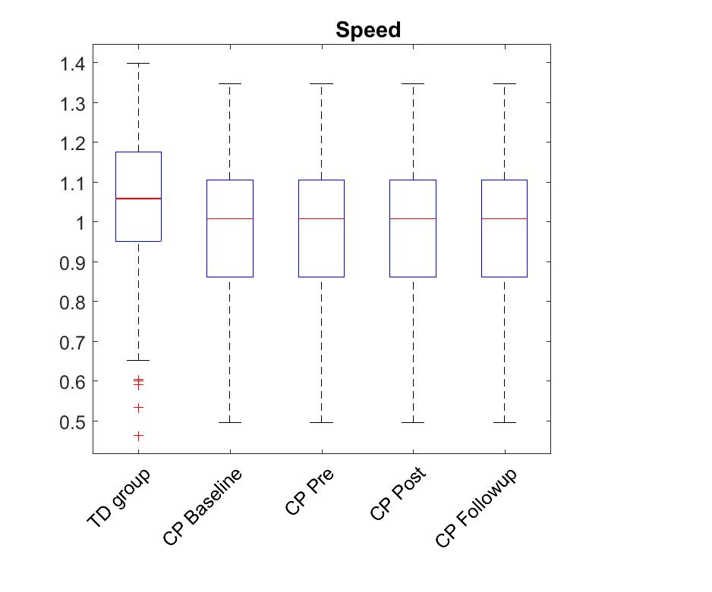

1. *Normalized Speed*

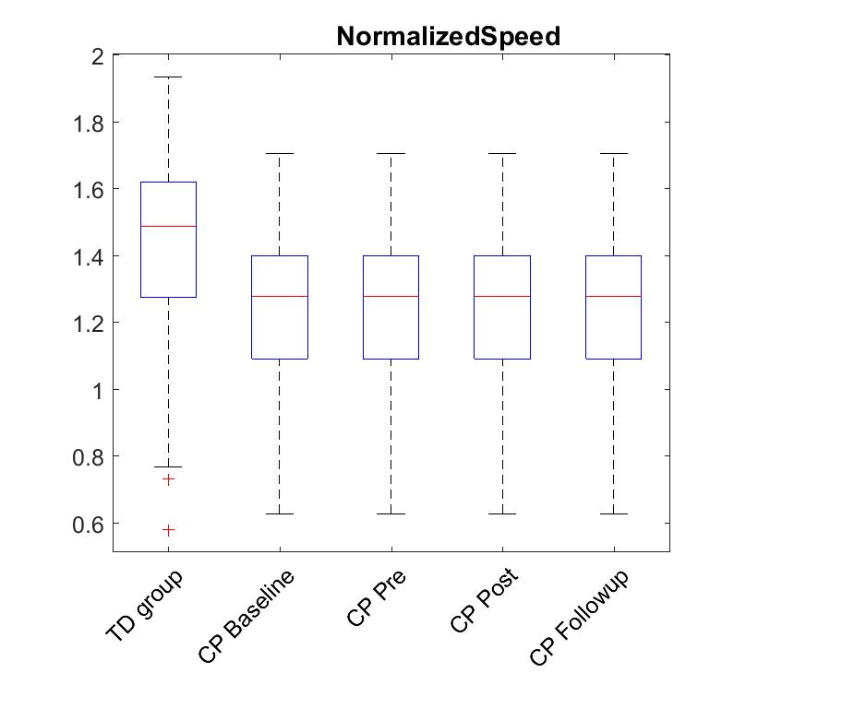

1. *Cadence*

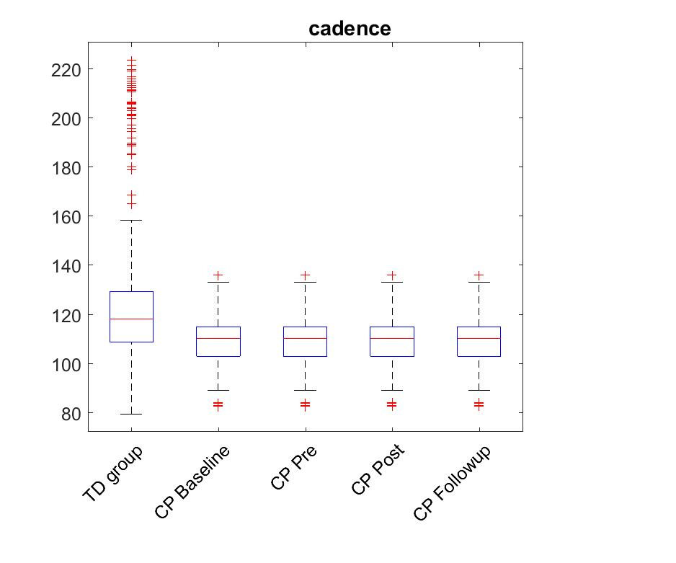

1. *Steps*

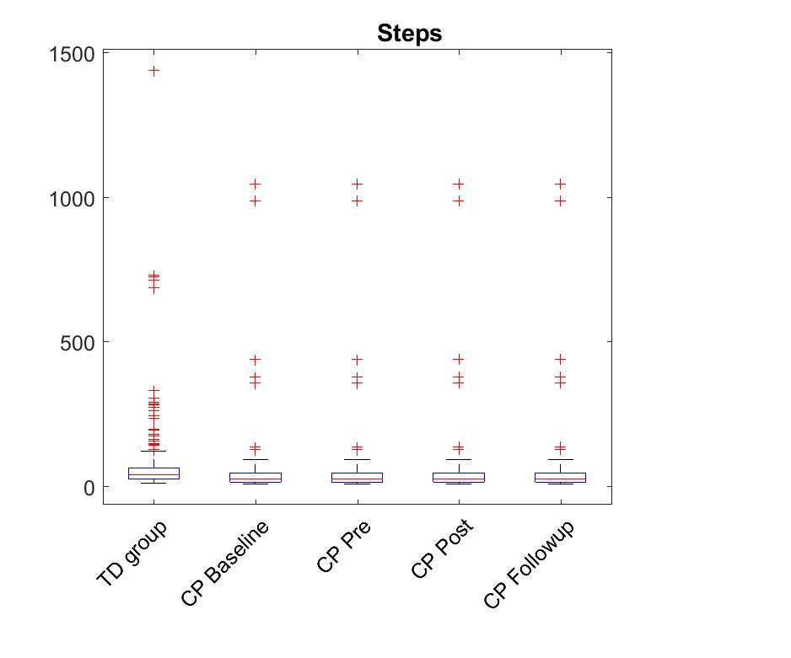

1. **Symmetry Indexes:**
   1. *Knee Angle*

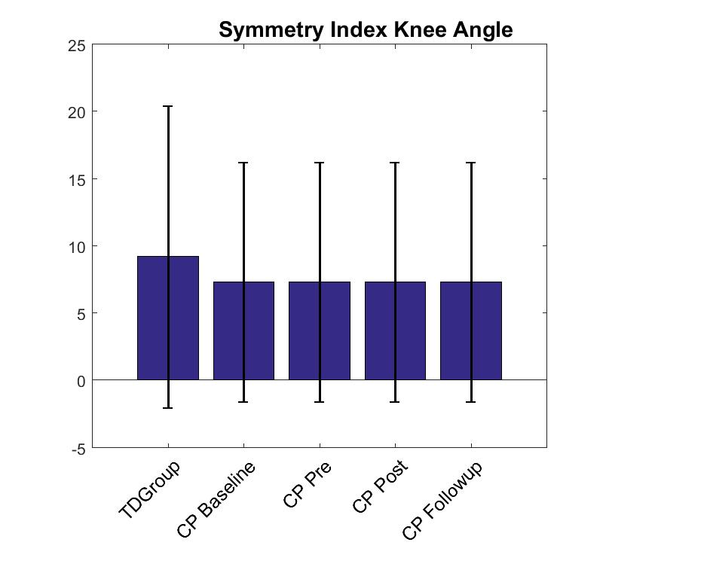

* 1. *Stance*

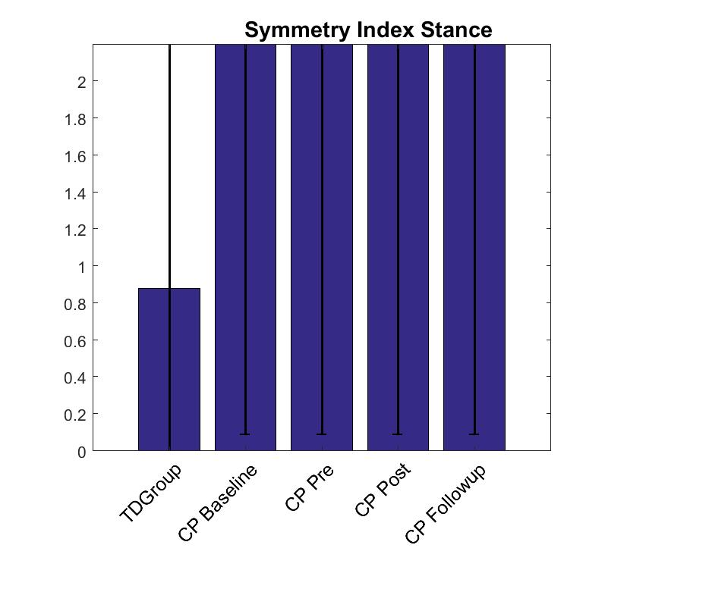

* 1. *Stride Length*

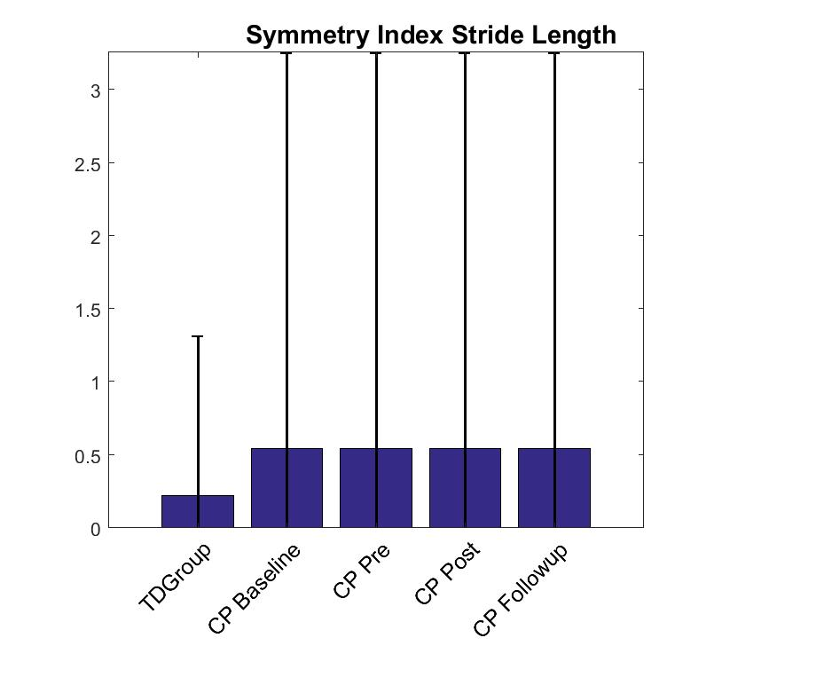

* 1. *Swing*

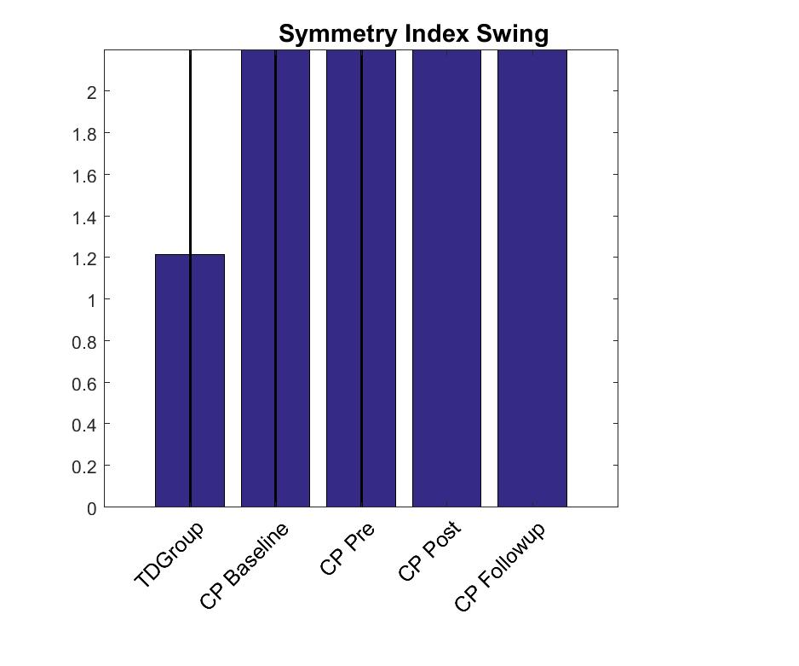

1. **Tables**
2. Gait Parameters

|  |  |  |  |  |  |
| --- | --- | --- | --- | --- | --- |
|  | TD group | CP Baseline | CP Pre | CP Post | CP Followup |
| Mean Cadence (steps/min) | 126.7076 | 108.9726 | 108.9726 | 108.9726 | 108.9726 |
| Median Cadence (steps/min) | 118.1336 | 110.2992 | 110.2992 | 110.2992 | 110.2992 |
| Maximum Cadence (steps/min) | 223.5121 | 136.248 | 136.248 | 136.248 | 136.248 |
| Mean Speed (m/s) | 1.0549 | 0.97818 | 0.97818 | 0.97818 | 0.97818 |
| Median Speed (m/s) | 1.0598 | 1.0102 | 1.0102 | 1.0102 | 1.0102 |
| Maximum Speed (m/s) | 1.3994 | 1.3486 | 1.3486 | 1.3486 | 1.3486 |
| Mean Normalized Speed (m/s) | 1.4363 | 1.2382 | 1.2382 | 1.2382 | 1.2382 |
| Median Normalized Speed (m/s) | 1.4893 | 1.2787 | 1.2787 | 1.2787 | 1.2787 |
| Maximum Normalized Speed (m/s) | 1.9349 | 1.7071 | 1.7071 | 1.7071 | 1.7071 |
| Mean Normalized Stride Length RL (m) | 1.4141 | 1.3477 | 1.3477 | 1.3477 | 1.3477 |
| Median Normalized Stride Length RL (m) | 1.5022 | 1.3864 | 1.3864 | 1.3864 | 1.3864 |
| Mean Normalized Stride Length LL (m) | 1.4164 | 1.355 | 1.355 | 1.355 | 1.355 |
| Median Normalized Stride Length LL (m) | 1.5121 | 1.3661 | 1.3661 | 1.3661 | 1.3661 |
| Mean Swing RL(%gct) | 40.719 | 42.7529 | 42.7529 | 42.7529 | 42.7529 |
| Median Swing RL(%gct) | 40.9886 | 43.0379 | 43.0379 | 43.0379 | 43.0379 |
| Mean Swing LL(%gct) | 40.898 | 39.4908 | 39.4908 | 39.4908 | 39.4908 |
| Median Swing LL(%gct) | 40.9159 | 40.6672 | 40.6672 | 40.6672 | 40.6672 |
| Mean Stance RL(%gct) | 59.281 | 57.2471 | 57.2471 | 57.2471 | 57.2471 |
| Median Stance RL(%gct) | 59.0114 | 56.9621 | 56.9621 | 56.9621 | 56.9621 |
| Mean Stance LL(%gct) | 59.102 | 60.5092 | 60.5092 | 60.5092 | 60.5092 |
| Median Stance LL(%gct) | 59.0841 | 59.3328 | 59.3328 | 59.3328 | 59.3328 |

1. Pa parameters

|  |  |  |  |  |  |  |
| --- | --- | --- | --- | --- | --- | --- |
| States | TD group(%,mean) | TD group(%,SD) | CP Baseline | CP Pre | CP Post | CP Followup |
| Walking (%) | 16 | 5 | 11 | 11 | 11 | 11 |
| Standing (%) | 23 | 4 | 19 | 19 | 19 | 19 |
| Sedentary (%) | 61 | 6 | 70 | 70 | 69 | 69 |
| Statistics Walking Periods: |  |  |  |  |  |  |
| 10th Percentile(sec) | 2.8333 | 0.40825 | 3 | 3 | 3 | 3 |
| 20th Percentile(sec) | 3.5167 | 0.53072 | 3 | 3 | 3 | 3 |
| 30th Percentile(sec) | 4.3333 | 0.8165 | 4 | 4 | 4 | 4 |
| 40th Percentile(sec) | 5.1667 | 0.98319 | 4 | 4 | 4 | 4 |
| 50th Percentile(sec) | 6.5 | 1.0488 | 5 | 5 | 5 | 5 |
| 60th Percentile(sec) | 8 | 1.6733 | 7 | 7 | 7 | 7 |
| 70th Percentile(sec) | 10.8333 | 3.0605 | 8 | 8 | 8 | 8 |
| 80th Percentile(sec) | 16.1667 | 4.7081 | 10 | 10 | 10 | 10 |
| 90th Percentile(sec) | 30.9 | 16.5464 | 20 | 20 | 20 | 20 |
| Maximal Walking period (sec) | 462.5 | 255.4852 | 589 | 589 | 589 | 589 |
| Statistics Standing Periods: |  |  |  |  |  |  |
| 10th Percentile(sec) | 1 | 0 | 1 | 1 | 1 | 1 |
| 20th Percentile(sec) | 1.8333 | 0.40825 | 2 | 2 | 2 | 2 |
| 30th Percentile(sec) | 2.5 | 0.54772 | 4 | 4 | 4 | 4 |
| 40th Percentile(sec) | 4.3333 | 1.0328 | 5.5 | 5.5 | 5 | 5.5 |
| 50th Percentile(sec) | 6.6667 | 2.2509 | 9 | 9 | 9 | 9 |
| 60th Percentile(sec) | 10.1667 | 4.3775 | 14 | 14 | 14 | 14 |
| 70th Percentile(sec) | 16.6667 | 8.4351 | 21 | 21 | 20 | 21 |
| 80th Percentile(sec) | 31.85 | 13.8447 | 31 | 31 | 31.9 | 31 |
| 90th Percentile(sec) | 56.5 | 33.7598 | 59.5 | 59.5 | 58.4 | 59.5 |
| Maximal Standing period (sec) | 494.1667 | 230.6065 | 284 | 284 | 284 | 284 |
| Statistics Sedentary Periods: |  |  |  |  |  |  |
| 10th Percentile(sec) | 5.35 | 1.8674 | 9.8 | 9.8 | 12 | 9.8 |
| 20th Percentile(sec) | 9.6167 | 5.496 | 25.1 | 25.1 | 33 | 25.1 |
| 30th Percentile(sec) | 21.3833 | 17.3655 | 44.1 | 44.1 | 48 | 44.1 |
| 40th Percentile(sec) | 42.0167 | 40.4907 | 67.2 | 67.2 | 74.5 | 67.2 |
| 50th Percentile(sec) | 80.9167 | 64.4379 | 120 | 120 | 116 | 120 |
| 60th Percentile(sec) | 166.5167 | 127.0745 | 175.5 | 175.5 | 142 | 175.5 |
| 70th Percentile(sec) | 418.5667 | 320.056 | 265.8 | 265.8 | 255 | 265.8 |
| 80th Percentile(sec) | 832.3667 | 520.0245 | 463.7 | 463.7 | 458.5 | 463.7 |
| 90th Percentile(sec) | 1535.4667 | 1024.338 | 880.4 | 880.4 | 878 | 880.4 |
| Maximal Sedentary period (sec) | 3304 | 1490.7581 | 2636 | 2636 | 2636 | 2636 |
| Kolmogorov_Smirnov stat Dist: |  |  |  |  |  |  |
| Stat Dist Walking periods |  |  | 0.10254 | 0.10254 | 0.10254 | 0.10254 |
| Stat Dist Standing periods |  |  | 0.12097 | 0.12097 | 0.12275 | 0.12275 |
| Stat Dist Sedentary periods |  |  | 0.19747 | 0.19747 | 0.22756 | 0.19747 |

1. Barcode states table

|  |  |  |  |  |  |  |
| --- | --- | --- | --- | --- | --- | --- |
| States | TD group(%,mean) | TD group(%,SD) | CP Baseline | CP Pre | CP Post | CP Followup |
| 1 | 60.6668 | 6.4137 | 69.3785 | 69.3785 | 69.3083 | 69.3785 |
| 2 | 0.077372 | 0.037942 | 0.14611 | 0.14611 | 0.11981 | 0.14611 |
| 3 | 22.6955 | 3.489 | 18.5529 | 18.5529 | 18.6318 | 18.5529 |
| 4 | 0.25312 | 0.26163 | 0.33313 | 0.33313 | 0.33021 | 0.33313 |
| 5 | 0.15974 | 0.21357 | 0.13442 | 0.13442 | 0.1578 | 0.13442 |
| 6 | 0.16405 | 0.28032 | 0.087665 | 0.087665 | 0.087665 | 0.087665 |
| 7 | 0.74142 | 0.80769 | 0.32436 | 0.32436 | 0.32144 | 0.32436 |
| 8 | 3.5078 | 2.4513 | 2.4225 | 2.4225 | 2.4225 | 2.4225 |
| 9 | 3.8631 | 2.7315 | 2.3611 | 2.3611 | 2.3611 | 2.3611 |
| 10 | 2.7155 | 5.0248 | 0.046755 | 0.046755 | 0.046755 | 0.046755 |
| 11 | 0.078952 | 0.18465 | 0.0029222 | 0.0029222 | 0.0029222 | 0.0029222 |
| 12 | 0.14762 | 0.22729 | 0.488 | 0.488 | 0.488 | 0.488 |
| 13 | 1.0881 | 1.0874 | 0.66918 | 0.66918 | 0.66918 | 0.66918 |
| 14 | 0.14957 | 0.35763 | 0.0029222 | 0.0029222 | 0.0029222 | 0.0029222 |
| 15 | 0.0034626 | 0.0013238 | 0.0029222 | 0.0029222 | 0.0029222 | 0.0029222 |
| 16 | 0.068725 | 0.1596 | 0.0029222 | 0.0029222 | 0.0029222 | 0.0029222 |
| 17 | 1.6306 | 1.4551 | 0.51138 | 0.51138 | 0.51138 | 0.51138 |
| 18 | 0.32085 | 0.4926 | 0.0029222 | 0.0029222 | 0.0029222 | 0.0029222 |
| 19 | 0.0034626 | 0.0013238 | 0.0029222 | 0.0029222 | 0.0029222 | 0.0029222 |
| 20 | 0.0034626 | 0.0013238 | 0.0029222 | 0.0029222 | 0.0029222 | 0.0029222 |

1. **Summary of performance measures**

