1. **Synchronize Physilog Files**

>> syncAndSavePhysilog('C:\Users\ionescu\Projects\PA_Gait_CP\TestData\05_D2', 200)

1. **Save Synchronized .BIN files as .MAT files**
   1. Go to the folder ‘processed’

>> >> cd('C:\Users\ionescu\Projects\PA_Gait_CP\TestData\05_D2\processed')

>> [RShank] = loadSynchronized('RF228109sync.BIN');

>>save RShank RShank

>> [LShank] = loadSynchronized('LF227107sync.BIN');

>>save LShank LShank

>> [LThigh] = loadSynchronized('LT305087sync.BIN');

>>save LThigh LThigh

>> [RThigh] = loadSynchronized('RT306094sync.BIN');

>>save RThigh RThigh

>> [trunk] = loadSynchronized('TR307085sync.BIN');

>>save trunk trunk

1. **>> AnalysePA_FullConfig**
   1. 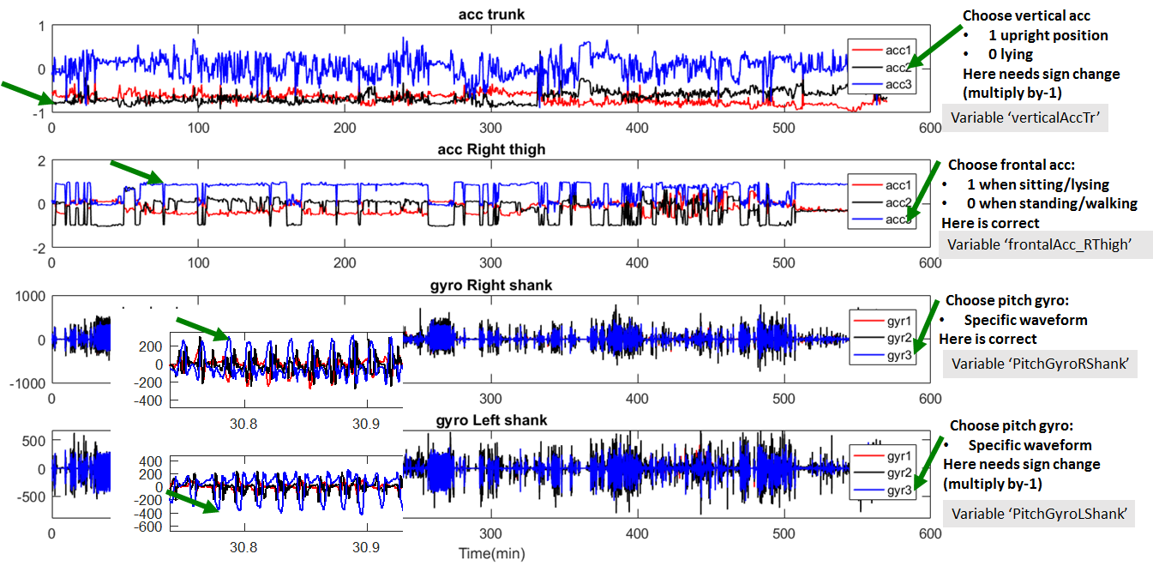Illustrate and identify correct channels
   2. Choose the appropriate channels in source file, lignes 138-142

verticalAccTr40=**-acc2**_trunk40;

verticalAccTr=**-acc2**_trunk;

frontalAcc_RThigh=**acc3**_RThigh;

PitchGyroRShank=**gyr3**_RShank;

PitchGyroLShank=**-gyr3**_LShank;

* 1. Save, exit(Ctrl_C) and Run again
  2. Enter (to continue after Pause)
  3. Check again if the selected signals are correct

* 1. Enter (to continue after Pause)

1. >>**AnalyseGait_ShTh(39.4,39.6)**

(inputs are femur & tibia length in cm)

1. Illustrate and identify correct channels (zoom & look for the patterns illustrated in next figure)

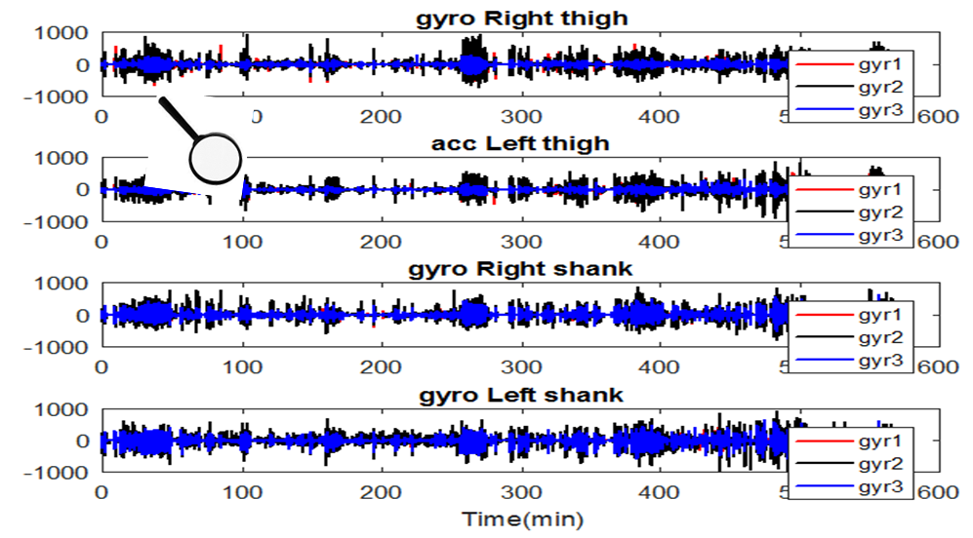

1. Choose the appropriate channels in source file, lignes 61-65

61 Pitch_RShank=**gyr3**_RShank;

62 Pitch_RThigh=**gyr1**_RThigh;

64 Pitch_LShank=-**gyr3**_LShank;

65 Pitch_LThigh=**gyr1**_LThigh;

1. Save, exit(Ctrl_C) and Run again
2. Enter (to continue after Pause)
3. Check again if the selected signals are correct

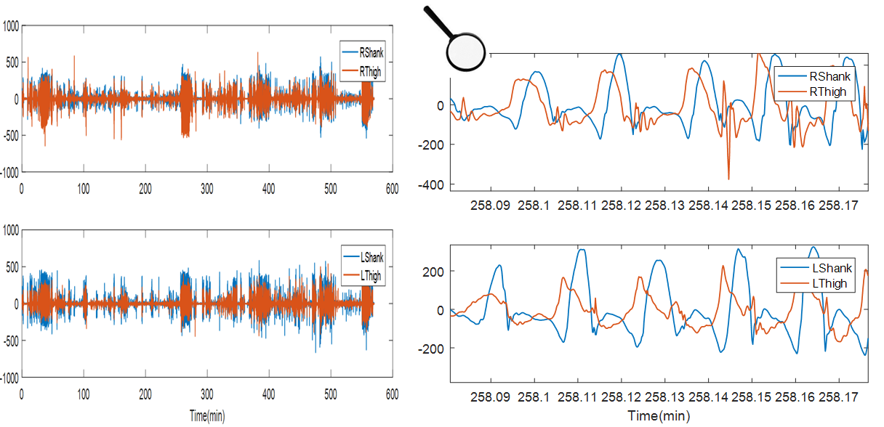

1. Enter (to continue after Pause)
2. Confirm to save detailed results in Excel File GaitAnalysisReport.xls
3. Confirm if necessary overwrite (if analysis resumed many times)

%%%%%%%%%%%%%%%%%%%%

>> PlotPAResults

>>PlotGaitResults(76,78)

Inputs are: RightLegLength,LeftLegLength