**Pattern of physical behaviour**

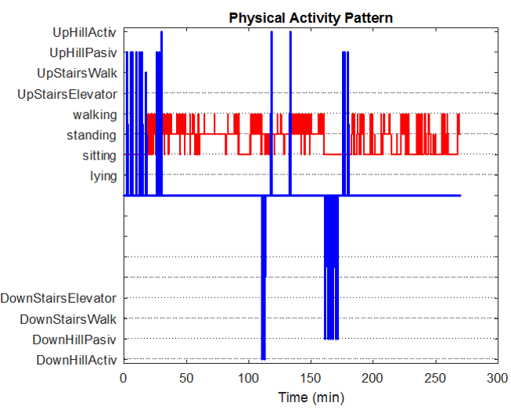

**Global metrics**



**Performance metrics**

