The Difference Between Joint Probability and Conditional Probability

Joint probability is a measure of two events happening at the same time. For example, from a deck of 52 cards, the joint probability of picking up a card that is both red and 6 is
P(6∩red)=P(6)×P(red)=4/52×26/52=1/26

For example, from a deck of cards, the probability that you get a six, given that you drew a red card is P(6│red) = 2/26 = 1/13
P(X∩Y) = P(X,Y) =P(X∣Y)×P(Y)

Bayes Rule
Naïve Bayes
Learning:
Test:

Continues:

What is a BN?
A Bayesian network (BN) is a graphical model for depicting probabilistic relationships among a set of variables.
- Each node has a conditional probability table quantifying the effects from the parents.

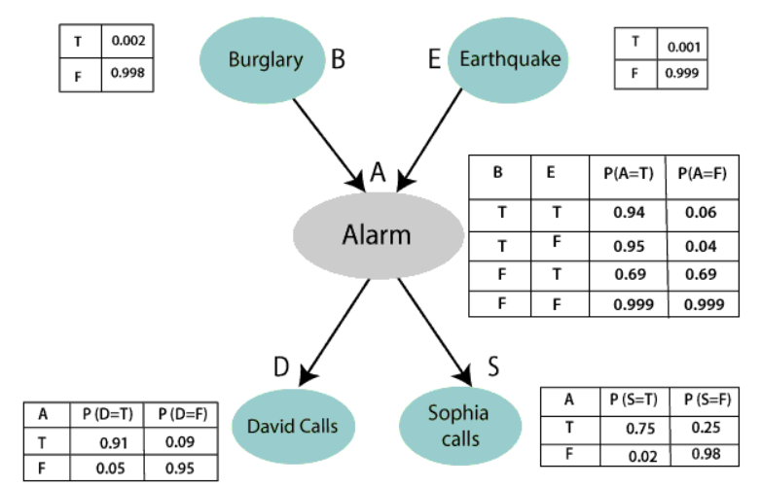

A Bayesian network is made up of:
- A Directed Acyclic Graph
2. A set of tables for each node in the graph

Bayesian network inference
Using a Bayesian network to compute probabilities is called inference.
- Diagnostic (evidential, abductive): from effect to cause
  - P(Buglary|JonhCalls), P(B|J)=0.016
  - P(B|J,M)=0.29
  - P(A|J,M)=0.76
- Causal (predictive): From cause to effect
  - P(J|B)=0.86
  - P(M|B)=0.67
- Intercausal (explaining away): common effect
  - P(B|A)=0.38
  - P(B|A, E)=0.003
Learning Bayesian network structure
- ‘Search and score’ approach (Search for all possible DAGs)
Search for all possible DAGs Score each DAG with a scoring function
The DAG with the highest score (best fit the data)
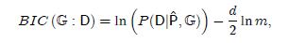
- Constraint based approach
Use statistical tests to evaluate the dependency between variables PC (Peter & Clark)

Estimate the causal effect from data
By manipulation of x, measure the change in c
IDA method
We need to find causal effect which can be obtain from causal structure, but we only have data.
- Use the PC algorithm to learn the CPDAG (causal structure)
- Infer the causal effects, e.g. eff(X2, Y), in all DAGs in the equivalent class
- Find the lower bound of causal effects.

Local structure learning algorithms
Pc-simple
Hiton

