9.7 Self-Attention Networks: Transformers (attention is all you need)
http://jalammar.github.io/illustrated-transformer/

9.8 Transformers as Language Models

Encoder-decoder networks consist of three components:
1. An encoder that accepts an input sequence, xn 1, and generates a corresponding sequence of contextualized representations, hn 1. LSTMs, convolutional networks, and Transformers can all be employed as encoders.
2. A context vector, c, which is a function of hn 1, and conveys the essence of the input to the decoder.
3. A decoder, which accepts c as input and generates an arbitrary length sequence of hidden states hm 1, from which a corresponding sequence of output states ym 1, can be obtained. Just as with encoders, decoders can be realized by any kind of sequence architecture

Training the Encoder-Decoder Model

Attention

Encoder-Decoder with Transformers

transfer learning:
We call pretraining the process of learning some sort of representation of meaning for words or sentences by processing very large amounts of text. We’ll call these pretrained models pretrained language models.
We call fine-tuning the process of taking the representations from these pretrained models, and further training the model, often via an added neural net classifier, to perform some downstream task like named entity tagging or question answering or coreference.
The pretrain-finetune paradigm is an instance of what is called transfer learning in machine learning: the method of acquiring knowledge from one task or domain, and then applying it (transferring it) to solve a new task.
Bidirectional Transformer Encoders
To make this more concrete, the original bidirectional transformer encoder model, BERT (Devlin et al., 2019), consisted of the following:
• A subword vocabulary consisting of 30,000 tokens generated using the WordPiece algorithm (Schuster and Nakajima, 2012),
• Hidden layers of size of 768,
• 12 layers of transformer blocks, with 12 multihead attention layers each.
The result is a model with over 100M parameters.
Training Bidirectional Encoders
Instead of trying to predict the next word, the model learns to perform a fill-in-the-blank task, technically called the cloze task.

1- Masking Words
- Application: fill in the blank,
- Approach: Masked Language Modeling (MLM)
In BERT, 15% of the input tokens in a training sequence are sampled for learning. Of these, 80% are replaced with [MASK], 10% are replaced with randomly selected tokens, and the remaining 10% are left unchanged
The Masked Language Modeling (MLM) training objective is to predict the original inputs for each of the masked tokens using a bidirectional encoder. The cross-entropy loss from these predictions drives the training process for all the parameters in the model.
To produce a probability distribution over the vocabulary for each of the masked tokens, the output vector from the final transformer layer for each of the masked tokens is multiplied by a learned set of classification weights WV ∈ R|V|× dh and then through a softmax to yield the required predictions over the vocabulary.
2- Masking Spans
- Application: Question answering, syntactic parsing
- Approach: SpanBERT work originated this technique.

3- Next Sentence Prediction
- Application: paraphrase detection (detecting if two sentences have similar meanings), entailment (detecting if the meanings of two sentences entail or contradict each other) or discourse coherence.
- Approach: BERT introduced a second learning objective called Next Sentence Prediction (NSP).
5- Contextual Embeddings
Contextual embeddings are thus vectors representing some aspect of the meaning of a token in context. For example, given a sequence of input tokens x1,...,xn, we can use the output vector yi from the final layer of the model as a representation of the meaning of token xi in the context of sentence x1,...,xn.

Transfer Learning through Fine-Tuning
Fine-tuning facilitates the creation of applications on top of pretrained models through the addition of a small set of application-specific parameters. Typically, this training will either freeze or make only minimal adjustments to the pretrained language model parameters.
- Sequence Classification
Finetuning the values in WC requires supervised training data consisting of input sequences labeled with the appropriate class. Training proceeds in the usual way; cross-entropy loss between the softmax output and the correct answer is used to drive the learning that produces WC.
Akey difference from what we’ve seen earlier with neural classifiers is that this loss can be used to not only learn the weights of the classifier, but also to update the weights for the pretrained language model itself.

teacher forcing
This idea that we always give the model the correct history sequence to predict the next word (rather than feeding the model its best case from the previous time step) is called teacher forcing.

NLU task BERT ( a bi-directional approach to reading and representing the text) predicting [MASK] first part of BART uses the bi-directional encoder of BERT to find the best representation of its input sequence For every text sequence in its input, the BERT encoder outputs an embedding vector for each token in the sequence as well as an additional vector containing sentence-level information BERT was trained by using a simple token masking technique, BART empowers the BERT encoder by using more challenging kinds of masking mechanisms in its pre-training semi-supervised approach to learning :
1-First, the model is pre-trained on tokens “t” looking back to “k” tokens in the past to compute the current token. This is done unsupervised on a vast text corpus to allow the model to “learn the language.”
2-Next, to make the model robust on a specific task, it is fine-tuned in a supervised manner to maximize the likelihood of label “y” given feature vectors x1…xn.
3-Combining 1 and 2, we get the objective in 3. Lambda represents a learned weight parameter to control the influence of language modeling.

BART model:
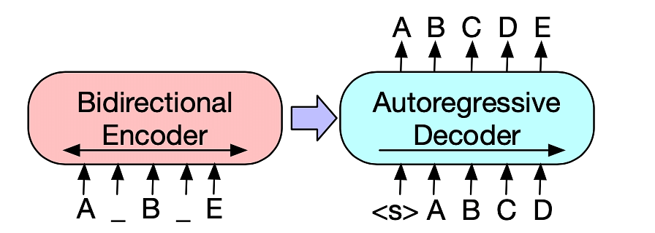

Machine translator evaluation:
- human evaluation: can be time consuming and expensive
- character F-score (chrF): chrF is given a parameter k indicating the length of character n-grams to be considered, and computes the average of the k precisions (unigram precision, bigram, and so on) and the average of the k recalls (unigram recall, bigram recall, etc.)

