ARMA Modelling

Time Series analysis is concerned with data that are not independent, but serially correlated, and where the relationships between consecutive observations are of interest.
After we have identified and removed trends and seasonality, we assume that the residuals thus formed are a stationary time series.
• We then utilise particular methods to ascertain whether this residual series is the realisation of a purely random process, or if it contains serial correlation of some nature.
• We are going to examine the Autoregressive Moving Average ARMA Process (Box-Jenkins (BJ) Methodology).
Often this model is referred to as the ARMA(p,q) model; where:
p is the order of the autoregressive polynomial,
q is the order of the moving average polynomial.
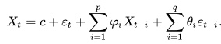
AR(2,3) -.> y_{t} = ϕ₁ y_{t-1} + ϕ₂ y_{t-2} + θ₁ ϵ _{t-1} + + θ₂ ϵ _{t-2} + θ₃ ϵ _{t-3} + ϵ _{t}
The Sample Autocorrelation (SACF) and Partial Autocorrelation Functions(PACF)
SACF and PACF provide a useful measure of the degree of dependence between values of a time series at specific interval of separation and thus play an important role in prediction of future values of a time series.
Thus, the ACF is a measure of the linear relationship between time series observations separated by some time period, denoted the lag k.
• Let’s consider a lag of 1. A value close to 1 means that there is a strong correlation between xt and xt−1, xt−1 and xt−2 and so on down to the last observation.
The PACF describes the correlation between observations at some time period, the lag, with the influence of the serial correlation removed.
Order of AR(p) ACF MA(q) PACF
autocorrelation function (ACF) : is a measure of the linear relationship between time series observations separated by some time(the correlation between a time series and its own past observations) AR(p)
it answers:
- Is the time series autocorrelated or not?
- What is the lag structure of the autocorrelation?
- What is the appropriate order of an AR model for the time series?

partial autocorrelation function (PACF) : measure the direct relationship between a time series and its lags or past observations, after removing the correlation explained by the previous lags.( In other words, it measures the unique contribution of a particular lag to the correlation between the time series and its past observations.) MA(q)
It answers:
- What is the appropriate order of an AR model for the time series?
- What is the lag structure of the direct relationship between the time series and its past observations?

Once we have a stationary time series we can use these functions to determine whether to fit
1. A moving average process or;
2. An autoregressive process or;
3. An autoregressive moving average process
We use (1) when the SACF has spikes at lags 1, 2, , q and the SPACF dies down gradually.
We use (2) when the SACF dies down gradually and the SPACF has spikes at lags 1, 2, , p.
We use (3) when we do not have either of these patterns.
SACF and SPACF If we define the original data as L(t), and the quadratic trend as T(t), the next step after estimating the trend equation is to subtract it from the original data to form the residual series R(t) = L(t) − T(t). The question then is whether there is any serial correlative structure in R(t).
SACF
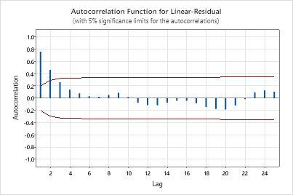

SPACF
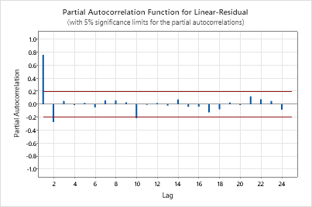
This would imply that an AR(2) model might well fit the series. The next step is to see if we can verify this conjecture or if we need to alter it. To do so, we first try overfitting, that is, we try to fit an AR(3) model with a constant term included in the specification.
The final model consists of the AR(2) part for the detrended data plus the liner model, as compared to the original series.

ARIMA

ARIMA is a class of time series prediction models, and the name is an abbreviation for AutoRegressive Integrated Moving Average. The backbone of ARIMA is a mathematical model that represents the time series values using its past values. This model is based on two main features:
- Past Values: Clearly, past behaviour is a good predictor of the future. The only question is how many past values we should use. The model uses the last p time series values as features. Here p is a hyperparameter that needs to be determined when we design the model.
- Past Errors: The model can use the information on how well it has performed in the past. Thus, we add as features the most recent q errors the model made. Again, q is a hyperparameter.
An important aspect here is that the time series needs to be standardized such that the model becomes independent from seasonal or temporary trends. The formal term for this is that we want the model to be trained on a stationary time series. In the most intuitive sense, stationarity means that the statistical properties of a process generating a time series do not change over time. It does not mean that the series does not change over time, just that the way it changes does not itself change over time.
There are several approaches to making a time series stationary, the most popular being differencing. By replacing the n values in the series with the n-1 differences, we force the model to learn more advanced patterns. When the model predicts a new value, we simply add the last observed value to it in order to obtain a final prediction. Stationarity can be somewhat confusing if you encounter the concept for the first time, you can refer to this tutorial for more details.

https://www.youtube.com/watch?v=3UmyHed0iYE

