ARMA Model
stationary
• Essentially, we describe a series as stationary if there is no change in mean or variance over time.
• One of the initial phases of time series analysis is to identify and somehow model the seasonal component of the series, if one exists. Then, one removes that seasonality, in order to transform the original series into a stationary one, in preparation for further analysis.
Detrending
A Time Series is a set of observations ordered in time.
• Most of the probability theory of time series is concerned with stationary time series(remove trend or seasonality).
Linear:
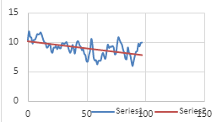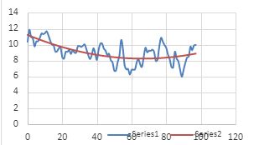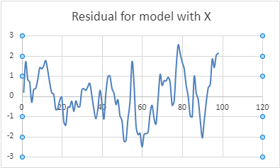

Seasonality:

If data have seasonality, we can model a furrier series to deseason data.
Model of original data:

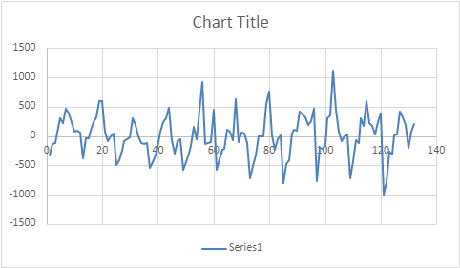
Build Fourier Series Model:
Fourier Series Representation
dt = a0 +
a1 cos(2πnt/T) + b1 sin(2πnt/T) +
a2 cos(2πnt/12) + b2 sin(2πnt/12) +
a3 cos(2πnt/12) + b3 sin(2πnt/12)
First find Power Spectrum to assign t in above formula

• We do this by identifying the most important frequencies to include via using the so-called Power Spectrum. To construct the model that fits the data best with the least number of coefficients.
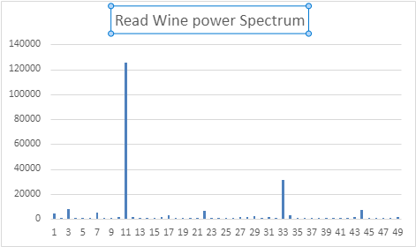

A significant spike on 11 implies that there are 11 cycles in 11 years(132 months) which means once a year and is a significant frequency in the data. Some smaller spike on 22 and 33 signify that there are less significant frequency 2 times a year as well as three times a year in the data.
We have: n1= 1 , n2= 2 , n3=3
a0 is average of data
t is time
dt = 0.001+
a1 cos(2π/12) + b1 sin(2πt/12) +
a2 cos(4πt/12) + b2 sin(4πt/12) +
a3 cos(6πt/12) + b3 sin(6πt/12)
then calculate SSE=(real data – dt)^2 and estimate the coefficients parameters with a method of optimization/direct calculation.
The following plots show furrier series on data and residual.

