Data and data processing | Clustering basics
Numeric Attribute: Discrete / Continuous  Three main types of data sets  - Record data : matrix, document, transaction  - Graph  - Ordered  Characteristics of Data  Dimensionality (Curse of dimensionality/Dimension reduction )  Distribution and sparsity (SkewnessSparse data)  Resolution (Patterns depend on the scale) | Cluster Analysis  - For understanding  - For utility  Types of Clustering  - Partitional clustering: A division of data objects into “non-overlapping” subsets  - Hierarchical clustering: A set of nested clusters organized as a hierarchical tree  Clustering Variations  - Non-exclusive vs. Exclusive: Exclusive: each object is assigned to a single cluster  - Fuzzy vs. Non-fuzzy: Fuzzy clustering: a data point is associated with a “degree of belongingness” to a cluster  - Partial vs. Complete: we only want to cluster some of the data  Types of Clusters  - Well-separated clusters  - Center-based or prototype-based clusters  - Contiguous clusters  - Density-based clusters  - Property or Conceptual  - Described by an objective function  Major Clustering Approaches  - Partitioning approach: Partition and then evaluate them by some criterion, e.g., minimizing the SSE  - Hierarchical approach: Create a hierarchical decomposition of the set of data (or objects) using some criterion  - Density-based approach: Based on connectivity and density functions  - Others: Grid-based, Model-based, Frequent pattern-based, link-based
  Attribute type
  Categorical/qualitative |  | Numeric/quantitative
  Nominal  (eye color) | Ordinal  (grades) | Interval  (date) | Ratio  (age)
  Major Tasks in Data Preprocessing
  1- Data cleaning
  incomplete (missing data) | Ignore the record |  | Estimate missing values |  | noisy and outliers
  inconsistent | Duplicated |  | Intentional
  2- Data integration
  (combine data from multiple sources)
  Schema integration | Entity identification problem |  | Detecting and resolving data value conflicts |  | Handling Redundancy
  3- Data reduction
  Curse of dimensionality | Dimensionality reduction  e.g.Transform(PCA), Subset selection |  |  | Data Compression  (string compression)
  Parametric methods (e.g., regression) |  | Non-parametric methods  (histograms, clustering, sampling)
  4- Data Transformation
  A- Normalization  min-max normalization  z-score normalization  normalization by decimal scaling  C- Binarization |  | B- Discretization
  - Binning method
  Partition into equal-width (bins)
  bin width = (highest–lowest)/N
  Partition into equal-depth (equal-frequency)
  each bin have same number of samples
  - Clustering
  - Classification
  - Correlation analysis
Proximity and distance
Proximity refers to a similarity or dissimilarity  - Similarity Numerical measure of how alike two data objects are, in the range [0,1]  - Dissimilarity: Numerical measure of how different are two data objects  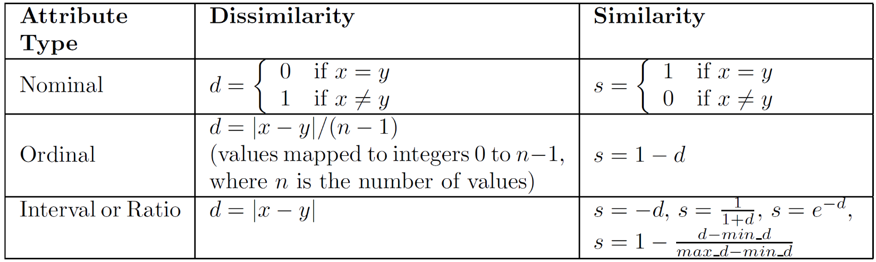  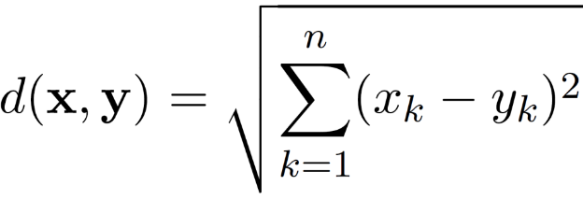  Distance:  - Euclidean Distance  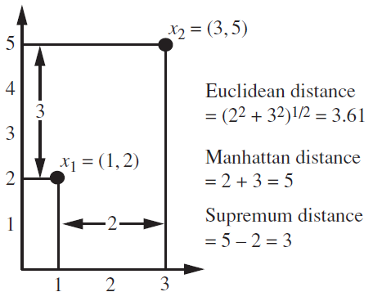  - Minkowski Distance: a generalization of Euclidean Distance  r a parameter,  n dimensions (attributes)  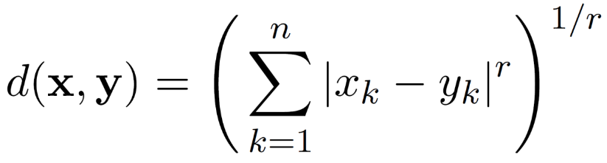  Mahalanobis Distance: It accounts for:  - the differences of variances in different directions/dimensions.  - The covariance/correlation between variables  Similarity Between Binary Vectors  - Simple Matching Coefficient (SMC), or  - Jaccard Coefficient (JC)  x = 1 0 0 0 0 0 0 0 0 0  y = 0 0 0 0 0 0 1 0 0 1  M01 = 2 M10 = 1 M00 = 7 M11 = 0  SMC = (M11 + M00)/(M01 + M10 + M11 + M00)  = (0+7) / (2+1+0+7) = 0.7  JC = (M11) / (M01 + M10 + M11)  = 0 / (2 + 1 + 0) = 0  Cosine Similarity  Document - keyword frequency vector  - frequency of the keywords  - zero for most keywords  - can be much greater than 1  If d1 and d2 are two document vectors, then  cos( d1, d2 ) = (d1 • d2) / ||d1|| ||d2|| ,  d1 = 3 2 0 5 0 0 0 2 0 0  d2 = 1 0 0 0 0 0 0 1 0 2  d1 • d2= 3*1 + 2*0 + 0*0 + 5*0 + 0*0 + 0*0 + 0*0 + 2*1 + 0*0 + 0*2 = 5 ||d1|| = (3*3+2*2+0*0+5*5+0*0+0*0+0*0+2*2+0*0+0*0)0.5 = (42) 0.5 = 6.481  ||d2|| = (1*1+0*0+0*0+0*0+0*0+0*0+0*0+1*1+0*0+2*2) 0.5 = (6) 0.5 = 2.449  cos( d1, d2 ) = 0.3150 | Correlation  Measures the linear relationship between two objects(x,y)  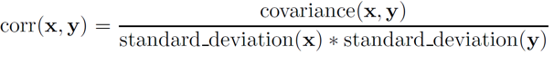  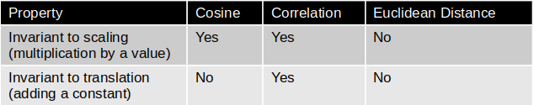  General Approach for Combining Similarities  - A straightforward approach is to compute similarity between each attribute of the two objects separately, then combine these similarities such that the final similarity is between [0,1].  - Using Weights to Combine Similarities  Density  - Euclidean Density – Grid-based approach  - Euclidean Density – Center-based

Partition based method
Clustering Variations  Non-exclusive vs. Exclusive  Non-exclusive (or overlapping): an object can belong to multiple clusters simultaneously  Exclusive: each object is assigned to a single cluster  Fuzzy vs. Non-fuzzy:Fuzzy clustering a data point is associated with a “degree of belongingness” to a cluster  Partial vs. Complete: In some cases, we only want to cluster some of the data, e.g., discard outliers or data points that are not of interest  Center-based partitioning approach  K-means: Each cluster is represented by the center of the cluster  K-medoids: Each cluster is represented by one of the objects in the cluster (most centrally located)  The goal is to find an optimal solution to the objective function, e.g., “minimize the SSE”  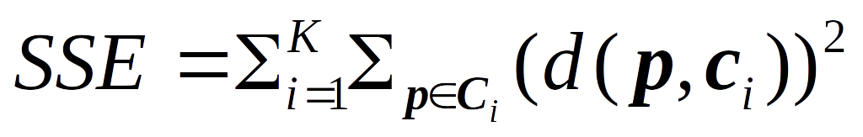  -Although K-means aims to minimize the objective function, it does not always find the optimal solution  -A good clustering with smaller K can have a lower SSE than a poor clustering with higher K  -“Closeness” can be measured by different proximity measures  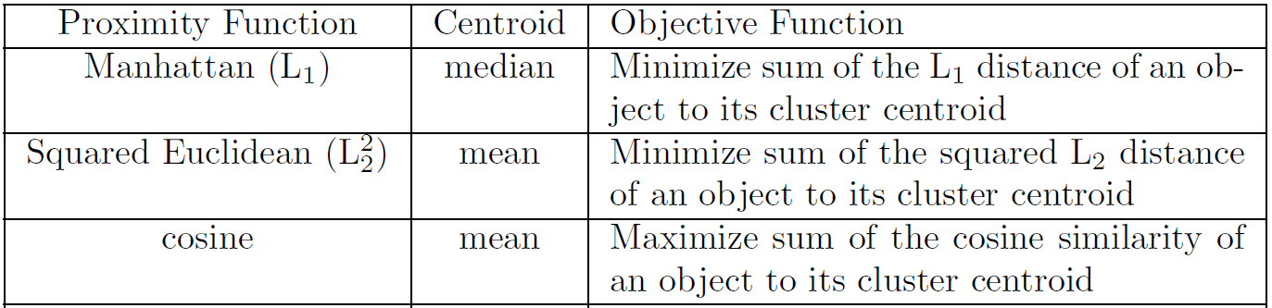  Issues with K-means Clustering  - Initial centroids  - K-means are only guaranteed to find a local minimum (not global)  - If there are K ‘real’ clusters, then the chance of selecting one centroid from each (real) cluster is small  - Chance is relatively small when K is large  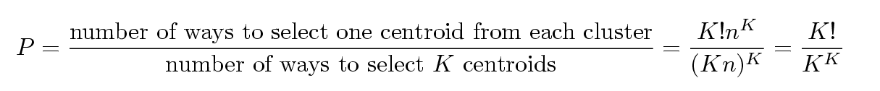  solution  - Multiple runs and select the set of clusters with minimum SSE  - Sample the original data set and use hierarchical clustering (HC) to determine initial centroids  - Select more than K initial centroids and then select among these initial centroids  - Bisecting K-means | - Empty clusters  solution: a strategy to choose a replacement centroid → Choose the point that contributes most to SSE  - Outliers  When outliers are present, the resulting cluster centroids may not be as representative as they otherwise would be  -The K-means algorithm is sensitive to outliers !  Since an object with an extremely large value may substantially distort the distribution of the data(K-medoids is suggested)  Variations/Extensions to K-means  - Updating Centers Incrementally  An alternative is to update the centroids after each assignment (incremental approach)  Each assignment updates zero or two centroids  More expensive  Introduces an order dependency  Never get an empty cluster – if a cluster ever has only one point, then that point will always be reassigned to the same cluster  Can work with objective functions other than “minimizing SSE” – compute the  - Post-processing  - Post-processing to reduce SSE  - Eliminate small clusters that may represent outliers  - Split ‘loose’ clusters, i.e., clusters with relatively high SSE  - Merge clusters that are ‘close’ and that have relatively low SSE  - Bisecting K-means  - Variant of K-means that can produce a partitioning or a hierarchical clustering  - Idea: Split all points into two clusters, select one of these clusters to split and so on, until K clusters have been produced  - Less susceptible to initialization problem  Limitations of K-means  - K-means has problems when clusters are of differing sizes, densities, or non-globular shapes  - K-means cannot handle nominal data K-modes  - K has to be given by users
Hierarchical Clustering | - Ward  Distance between two clusters is defined as the increase of SSE  Pros: Less susceptible to noise and outliers  Cons: Biased towards globular clusters  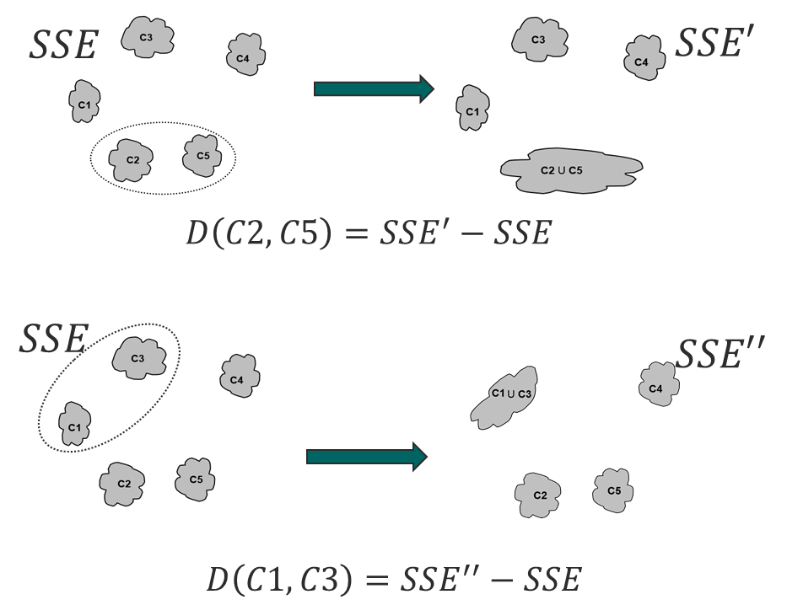  - Time and space complexity are O(N2) and O(N3)  Limitation of Hierarchical Clustering:  - Once a decision is made to combine two clusters, it cannot be undone  - No objective function is directly minimized  Different schemes have problems with one or more of the following:  - Sensitivity to noise and outliers  - Difficulty handling different sized clusters and convex shapes  - Breaking large clusters
a set of nested clusters organized as a hierarchical tree
X axis: data objects;
Y axis:distance between clusters
Do not have to assume any particular number of clusters (K)
Any desired number of clusters can be obtained by ‘cutting’ the dendogram at the proper level
Two main approaches:
- Agglomerative (bottom-up):
More popular than divisive hierarchical clustering
- Let each data point be a cluster
Repeat
- Merge the two closest clusters
- Update the proximity matrix
Until only a single cluster remains
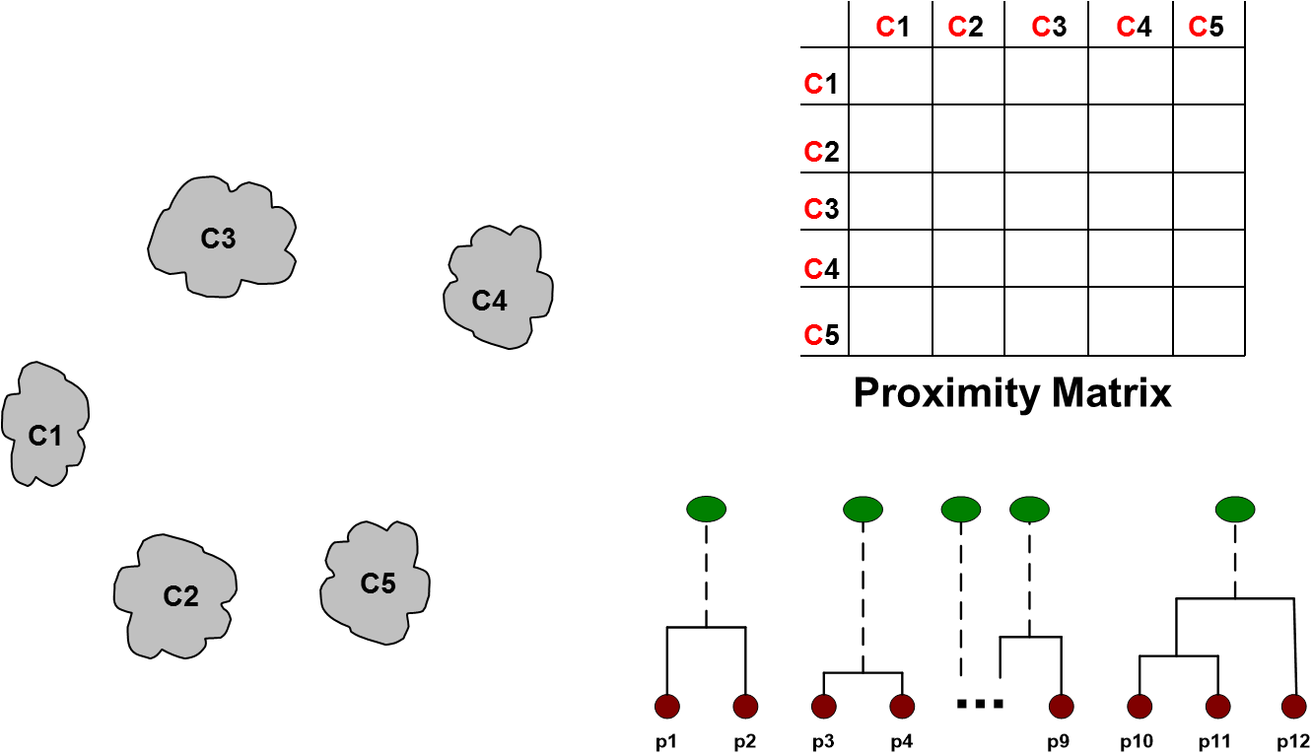

- Divisive (top-down):
Start with one, all-inclusive cluster
At each step, split a cluster until each cluster contains a point (or there are k clusters)
Different approaches to defining the distance between clusters distinguish the different algorithms
How to Define Inter-Cluster Similarity
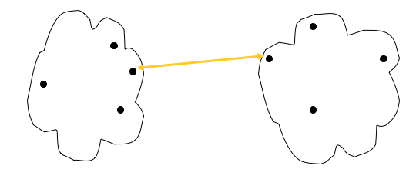
- MIN (Single link)
Distance between the closest two points in different clusters
Pros: Can handle non-elliptical shapes
Cons: Sensitive to noise and outliers

- MAX (Complete link or Clique)
Pros: Less susceptible to noise and outliers
Cons: Tends to break large clusters

- Distance between centroids
- Group average
Average of pair-wise distances of all pairs of points in different clusters
Pros: Less susceptible to noise and outliers

- Cons: Biased towards globular clusters

 | Density-Based Clustering Methods
Major features:
- Discover clusters of arbitrary shape
- Handle noise
- One scan
- Need density parameters as termination condition
DBSCAN is a density-based algorithm
core point: it has more than number of points (MinPts) within Eps
border point:fewer than MinPts within Eps
noise point: is not a core point or a border point
Algorithm
- Label all points as core, border, or noise points.
- Eliminate noise points
- Perform clustering on the remaining points
Pros: Resistant to Noise
Can handle clusters of different shapes and sizes
Cons: Varying densities
High-dimensional data
DBSCAN: Determining Eps and MinPts
- For a k, for points in a cluster, their k-th nearest neighbors are at roughly the same distance
- Noise points have the k-th nearest neighbor at farther distance
- Plot sorted distance of every point to its k-th nearest neighbor
Validation of clusters | - SSE  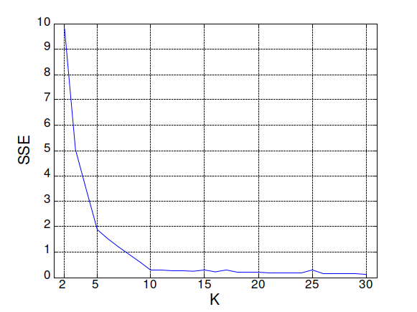  SSE is good for comparing two clusterings or two clusters  - External: supervised, employ criteria not inherent to the dataset  - Entropy  - Purity  - Relative: use either supervised or unsupervised
Measuring Clustering Quality/Validity
- Internal: unsupervised, criteria derived from data itself
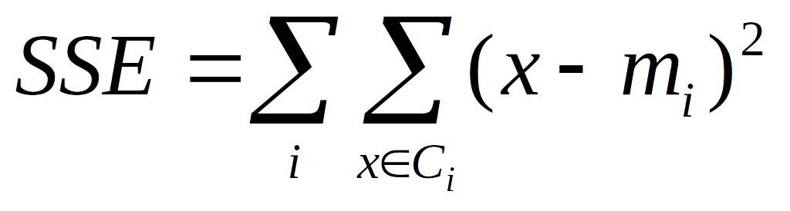
Cluster Cohesion: Measures how closely objects are related in a cluster

Cluster Separation: Measure how distinct or well-separated a cluster is from other clusters
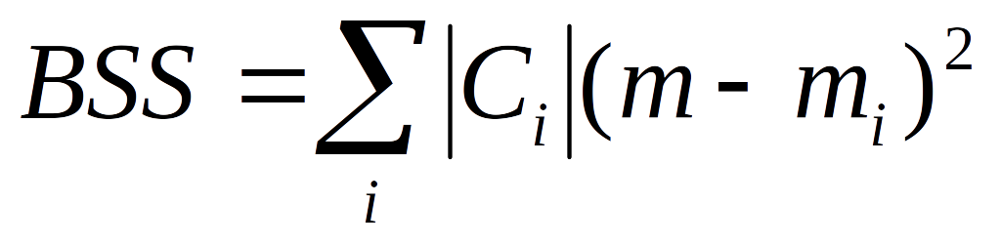
Between cluster Sum of Squares
|Ci| is the size of cluster i , m is the overall mean, and mi is the centroid of cluster Ci
Validity
- Proximity graph based approach
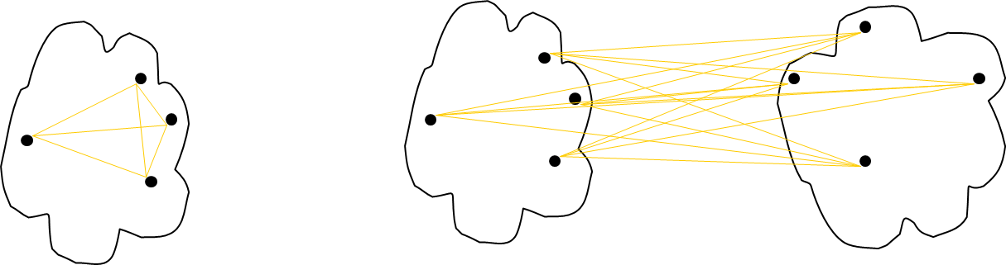

- Silhouette Coefficient
combine ideas of both cohesion and separation
a = average distance of i to the points in its cluster
b = min (the average distance of i to all points in another cluster, w.r.t. all clusters)
s = 1 – a/b if a < b; or s = b/a - 1 if a > b
s vary between -1 and 1, but typically between 0 and 1. The closer to 1, the better
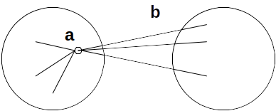
- Correlation
High correlation indicates that points that belong to the same cluster are close to each other
Proximity Matrix “Incidence” Matrix
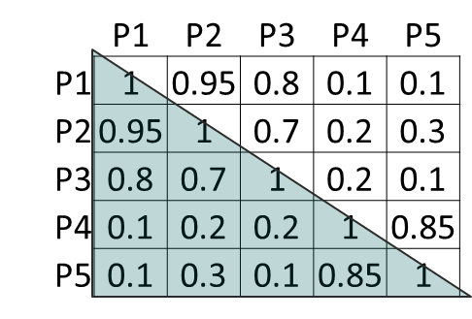
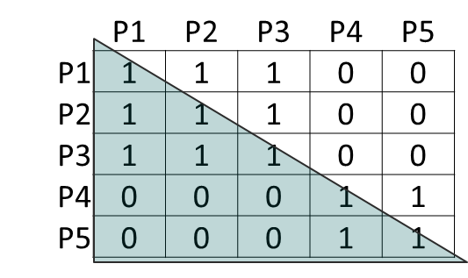

Calculate the correlation between the two matrices

The higher the correlation, the better is the clustering
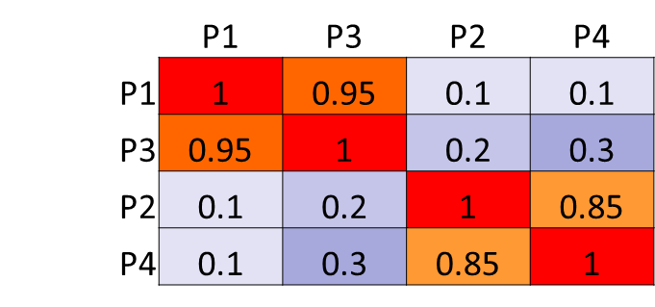
- Similarity matrix
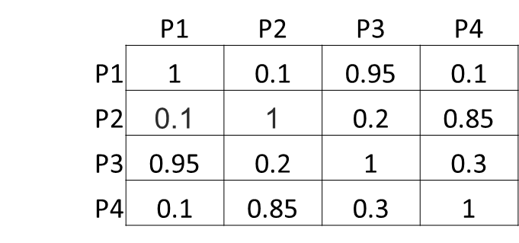

 | Segmentation
Customer segmentation vs. clustering:
- Segmentation: partition the data in a way that is convenient and useful
- Clustering: to find out if a data set is composed of natural groups
- Clustering normally uses sophisticated algorithms/tools
- Clustering is an important technique for customer segmentation
To better meet customer needs and wants
Types of segmentation
- Customer profiling: To gain insight or understanding about customers.
- Customer likeness clustering To know how customers are similar
- RFM cell classification grouping
- Purchase affinity clustering

Methods for segmentation
- Business rules – this does not include the use of clustering
- Creating segments based on quantile membership. (does not use clustering, grouping is performed by the univariate statistics of customer attributes.)
- Classification – decision trees and so on
- Clustering

Anomaly detection
Types of Anomalies  - Global anomalies (point anomalies) _focus of this course  - contextual anomalies (conditional anomalies)  - collective anomalies  Global anomalies  Anomaly Detection Methods  - user-labeled examples of anomalies  - Supervised  - Labels of training data are known  - Consider anomaly detection as a classification problem  - For anomaly detection, recall is more important  - Based on assumptions about normal data and anomalies  - semi-supervised  - the number of labeled data is often small  - Use the labeled examples and the proximate unlabeled objects to train a model for normal objects  - Those not fitting the model of normal objects are detected as anomalies  - statistical methods  parametric  - Learn the parameters (μ, σ) from the input data, and identify the points with low probability as outliers  - the 3-sigma method  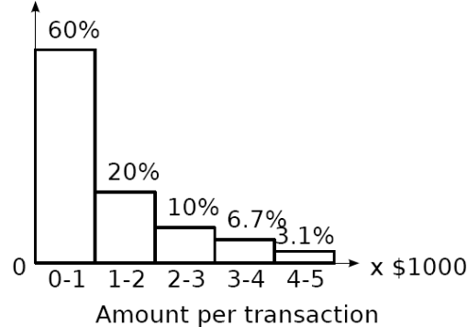  Transform to z-score, z=(x- μ)/σ  Then if |z|>= 3, x is an outlier  non-parametric  frequency(counting)-based  Limitations of Statistical Approaches  - Data distribution may not be known  - For high dimensional data, it may be difficult to estimate the true distribution  - Transforming multivariate anomaly detection into univariate task is unable to capture the interactions between attributes  - proximity-based methods  the proximity of the object significantly deviates from the proximity of most of the other objects  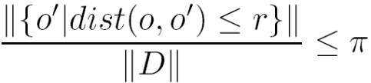  Distance-based outlier detection  An object o is a DB(r, π) outlier if  Density-based outlier detection  Use the relative density of an object against its neighbors as the indicator of the degree of the object being outliers.  LOF (Local outlier factor)  Reachability distance from o to p: | - clustering-based methods  Case 1: it does not belong to any cluster, DBSCAN  Case 2: there is a large distance between the object and its closest cluster  assign an outlier score based on its distance from its closest center  Case 3: it belongs to a small or sparse cluster FindCBLOF  Strength and Weakness  Strength  Detect outliers without requiring any labeled data  Work for many types of data  Clusters can be regarded as summaries of the data  Once the cluster are obtained, need only compare any object against the clusters to determine whether it is an outlier (fast)  Weakness  Effectiveness depends highly on the clustering method used - they may not be optimized for outlier detection  High computational cost: Need to first find clusters  contextual anomalies  - If the contexts can be clearly identified, transform it to conventional outlier detection  - Model the “normal” behavior with respect to contexts  collective anomalies  - For temporal data , we explore the structures formed by time, which occur in segments of the time series or subsequences  - For spatial data, explore local areas  - For graph and network data, we explore subgraphs  Challenges for Outlier Detection in High-Dimensional Data  - Interpretation of outliers  - Data sparsity  - Data subspaces  - Scalable with respect to dimensionality  Standard measures for evaluating anomaly detection:  - Recall (Detection rate) - R=TP/(TP + FN)‏  - False alarm (false positive) rate FA=FP/(FP+TN)‏  - Area under the ROC curve (AUC)
Association Analysis
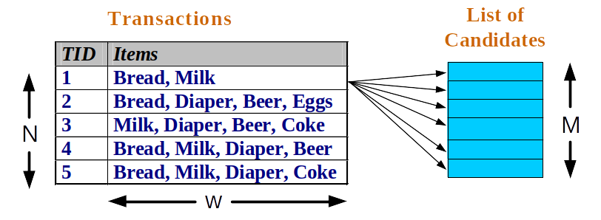  N: number of transaction w:maximum width of transaction d or M: number of item in the dataset  Itemset  A collection of one or more items  {Milk, Bread, Diaper}  k-itemset  An itemset that contains k items,  2-itemset: {milk, bread}  Support count of an itemset  Frequency of occurrence of an itemset  sigma ({Milk, Bread, Diaper}) = 2  Support of an itemset  Fraction of transactions that contain an itemset  s({Milk, Bread, Diaper}) = 2/5  Frequent Itemset  An itemset whose support >= minsup  Rule Evaluation Metrics  Support of a rule (s)  Fraction of transactions that contain both X and Y  Confidence of a rule (c)  Measures how often items in Y appear in transactions  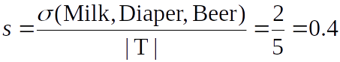  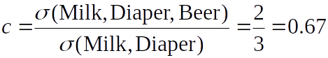  Why use support and confidence?  High support = Rules not occurred by chance  High confidence = Reliable inference | Apriori algorithm  Generate frequent itemsets efficiently  Generate high confidence rules  Brute-force approach:  Frequent Itemset Generation  Count the support of each candidate(itemset)  Match each transaction against every candidate  Complexity ~ O(NMw) => M = 2d  Reduce the number of candidates (M)  Complete search: M=2d  Use pruning  Reduce the number of comparisons (NM)  Use efficient data structures  The Apriori principle: (decrease time complexity)  Itemset is frequent → all of its subsets frequent  Itemset is infrequent → none of supersets frequent  1- Frequent Itemset Generation  Generate all itemsets whose support > minsup  Support of an itemset is Anti-monotone and never exceeds the support of its subsets  F3={abc, abd, acd, ace, bcd}  Step 1: self-joining Fk-1 (Fk-1 : Frequent (K-1) itemsets). In this example K=4, merge the two items in F3 whose first two items_(K-2) items _ are the same  abcd from abc and abd  acde from acd and ace  Step 2: Pruning:  acde is removed because ade is not in F3 . C4={abcd}  2- Rule Generation  Generate high confidence rules from frequent itemset.  Brute-force approach:  If |F| = k, → 2k – 2 candidate non-empty association rules.  efficiently generate rules  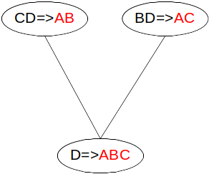  confidence of rules generated from the same itemset has an anti-monotone property w.r.t. number of items on the RHS of the rule  e.g., F = {A,B,C,D}, then  c(ABC → D) ≥> c(AB → CD) ≥> c(A → BCD)  If ABC→ D is not a high confidence rule, all the rules generated from F whose RHS contains D can be discarded (pruned).  We can merge RHS of two high confidence rules.
Brute-force approach:
List all possible association rules
Compute the support and confidence for each rule
Prune rules that fail the minsup and minconf thresholds
Computationally prohibitive!
Given d unique items:
Total number of itemsets = 2d
R:Total number of possible association rules:

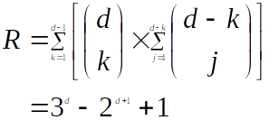

Factors Affecting Complexity  - Choice of minimum support threshold minsup  - Dimensionality d or M  - Size of database N  - Average transaction width W  Apriori takes a transaction, search the candidate list for candidates that are contained in the transaction.  To reduce the number of comparisons, the Apriori algorithm stores the candidates in a hash tree.  We need:  - Hash function  - Max leaf size, i.e. max number of itemsets stored in a leaf node (if number of candidate itemsets exceeds max leaf size, split the node)  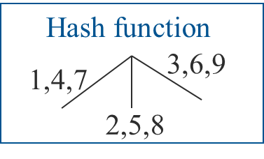  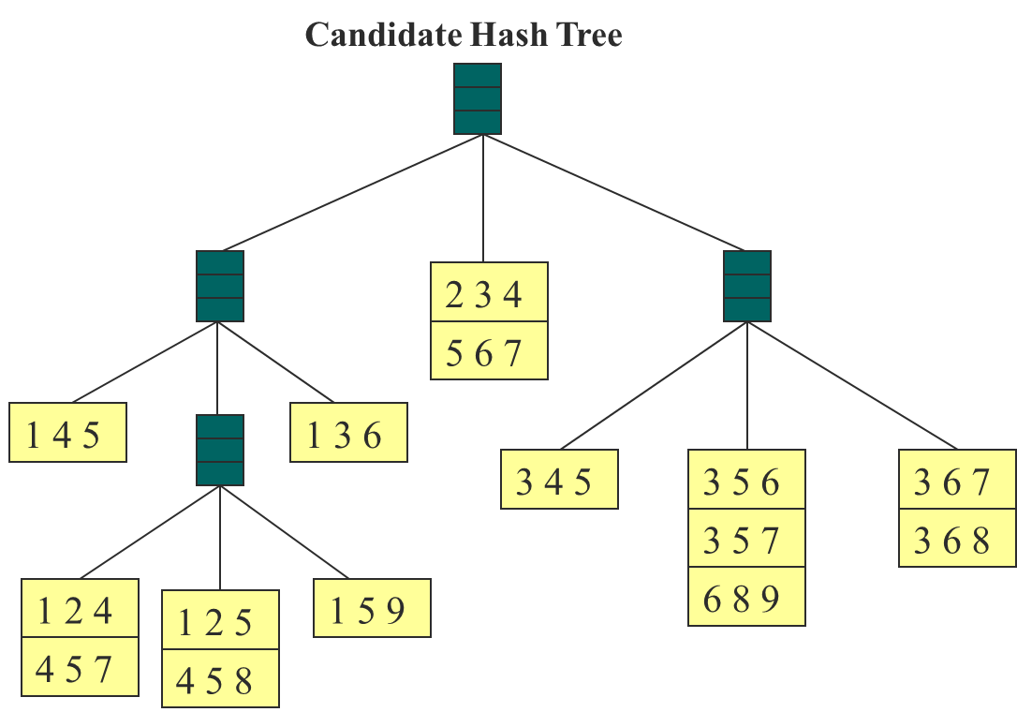  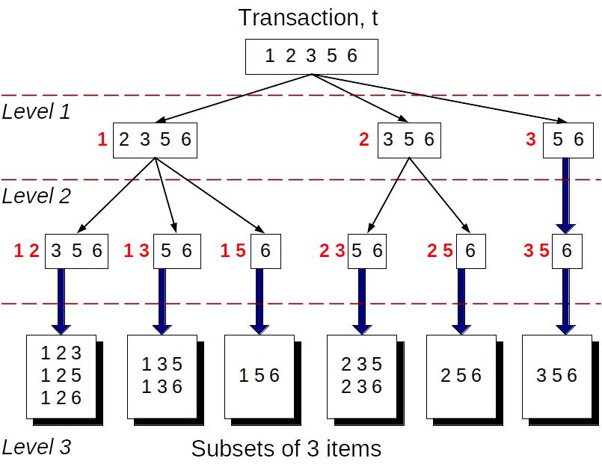  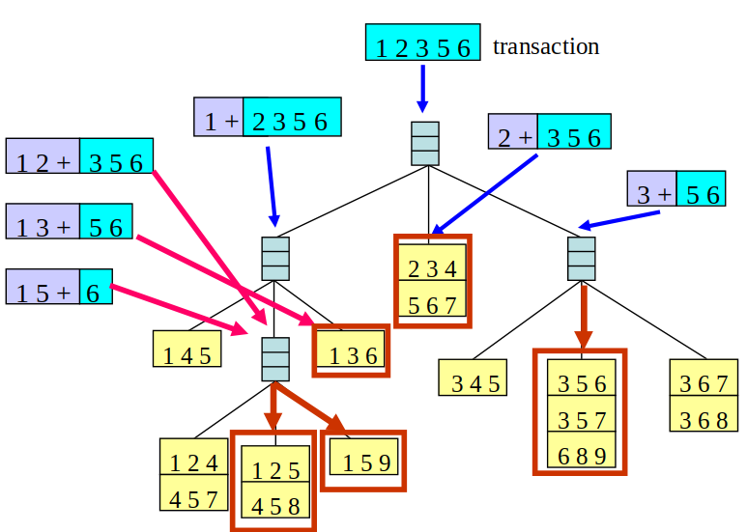  Compact Representation of Frequent Itemsets  1- Maximal Frequent Itemset  An itemset is maximal frequent if none of its immediate supersets is frequent  2- Closed Itemset  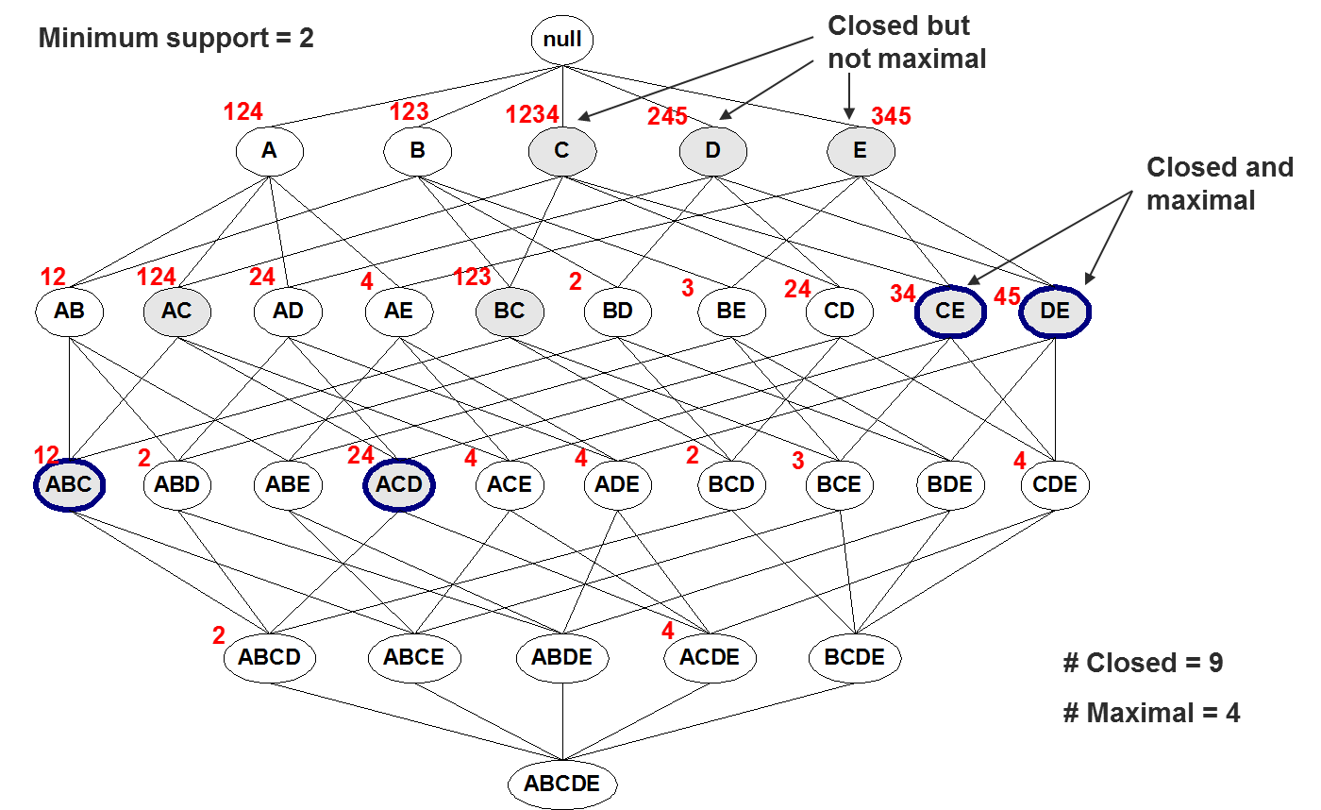  An itemset is closed if none of its immediate supersets has the same support as the itemset(without losing their support information)  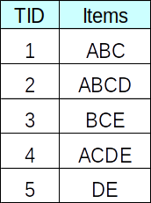 | Drawback of Confidence  The tea-coffee example shows that high-confidence rules can sometimes be misleading because the confidence measure ignores the support of the itemset appearing in the rule consequent.  Lift computes the ratio between the rule’s confidence and the support of the itemset in the rule consequent.  If Lift = p(Y|X)/P(Y) <1, X and Y negatively associated.  Similarly, if Lift >1, X and Y positively associated.

