# LOE

**Lösungen – Tag 03**

**zum Seminar 16962 (SAPUI und Fiori)**

##### Lösungen 3

1. **Lösungen**
2. **Aufgabe 1**

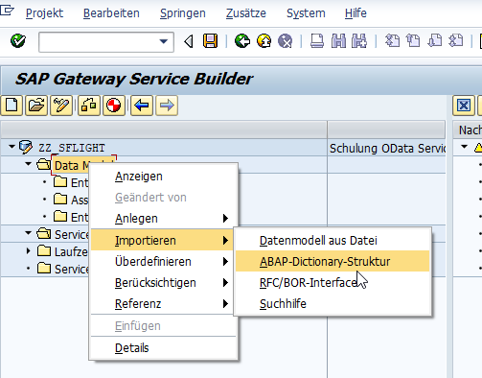  
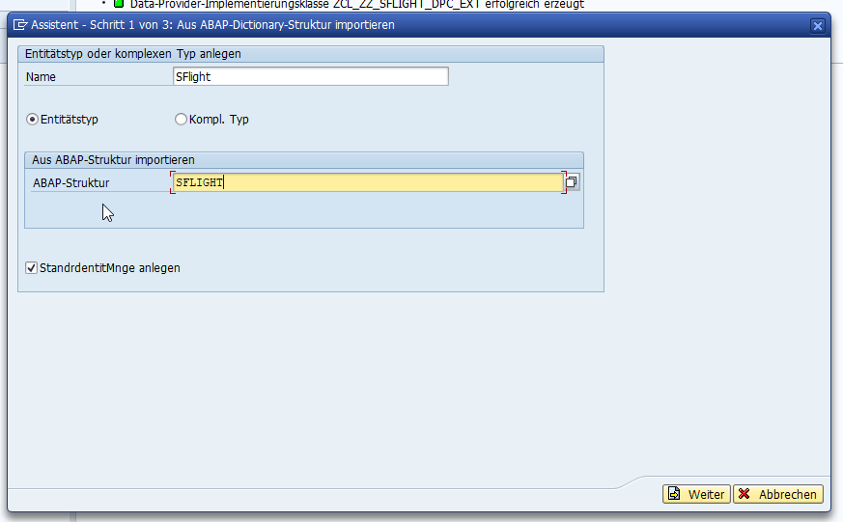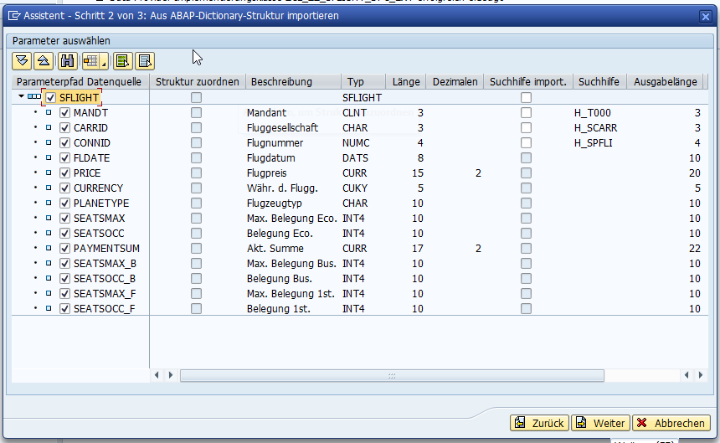

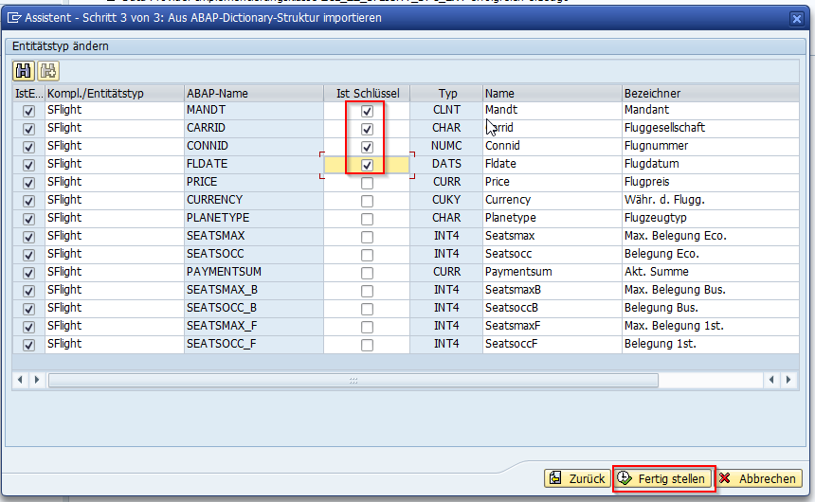

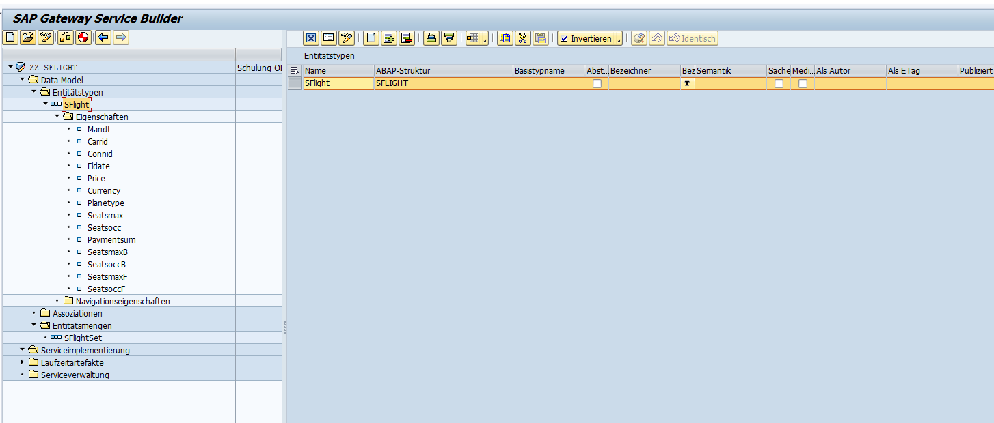  
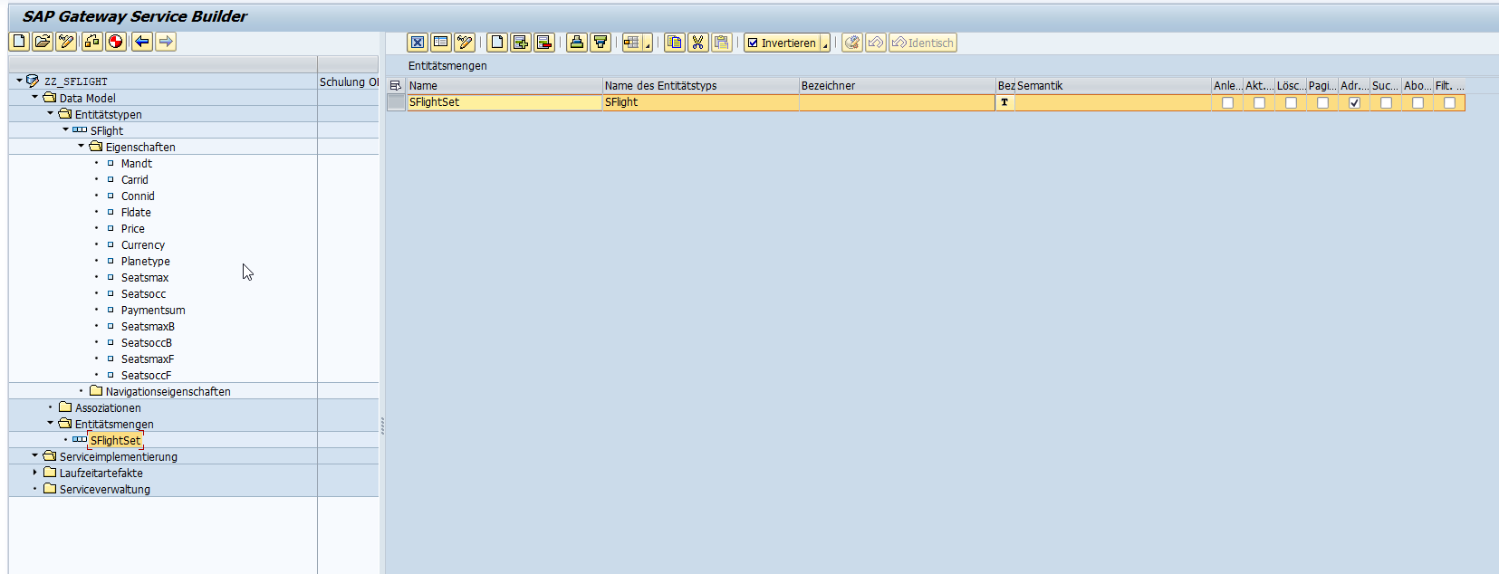

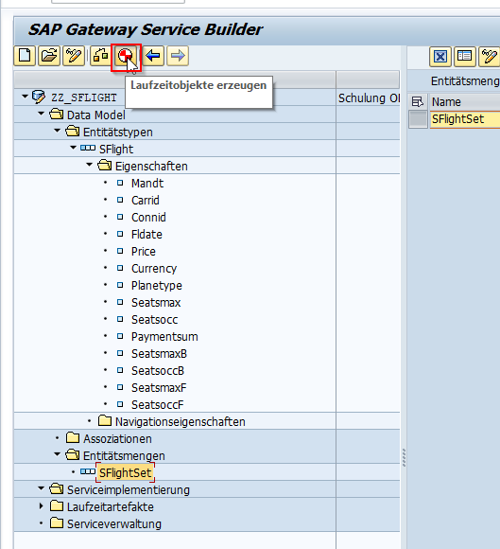

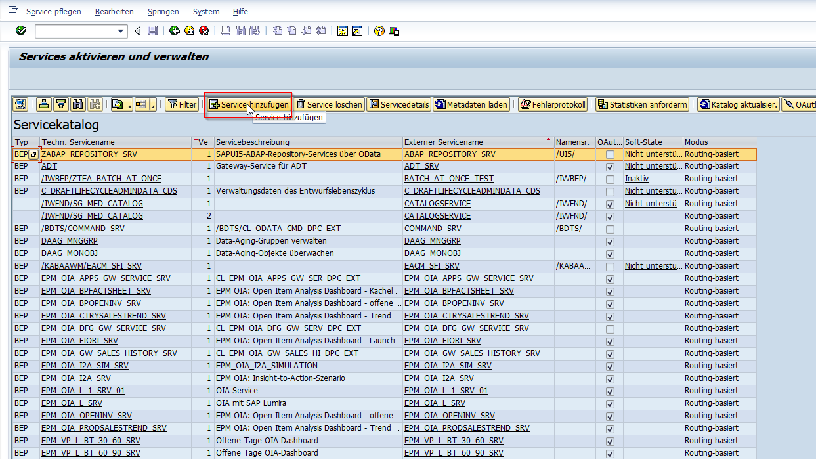

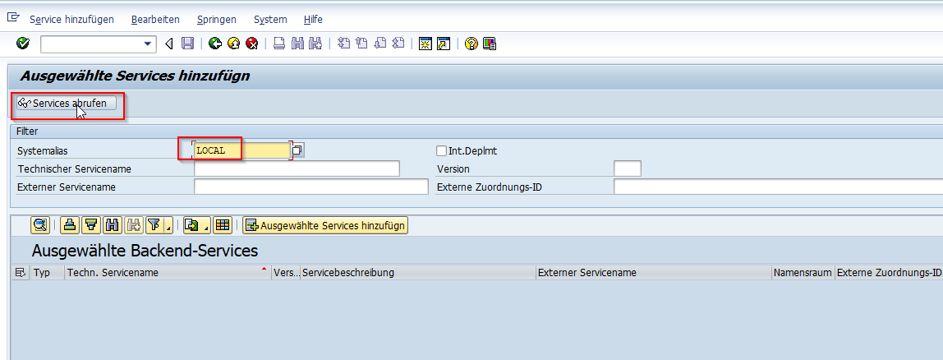

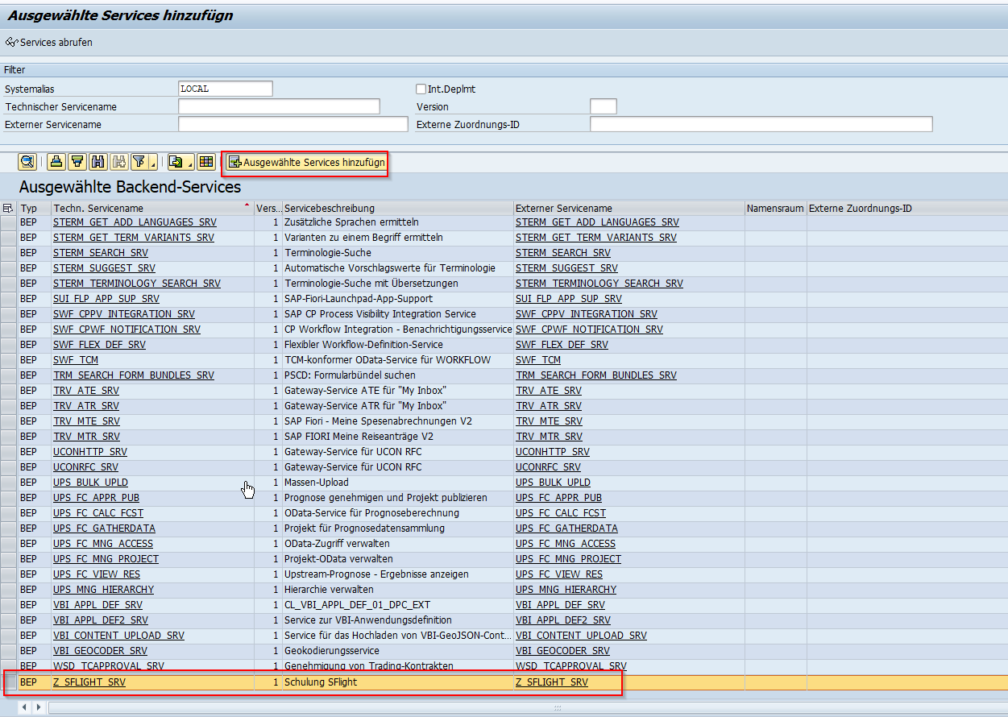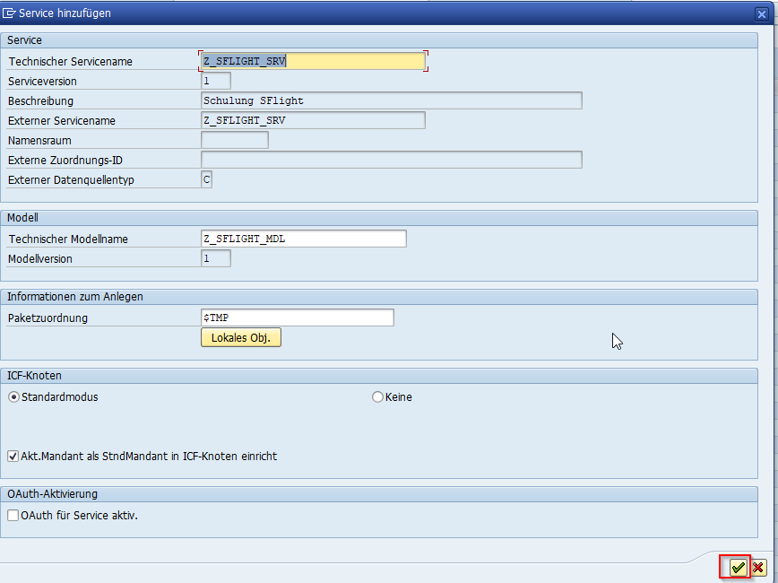  
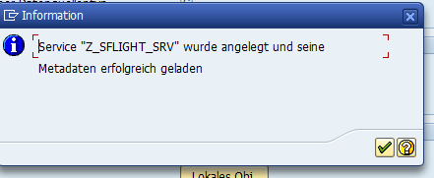

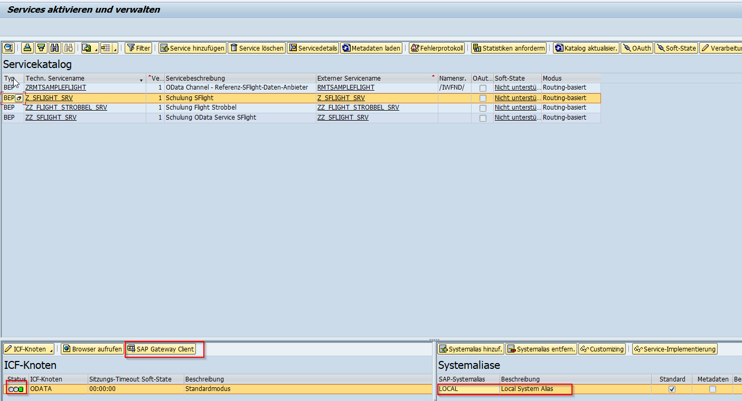

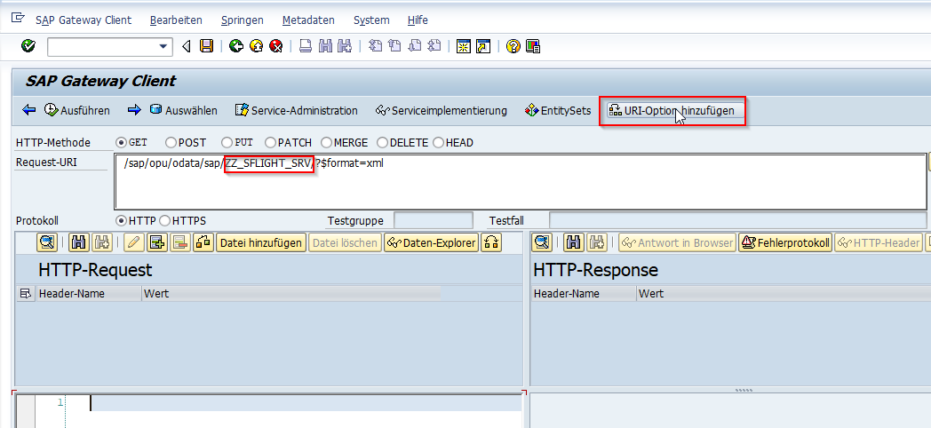

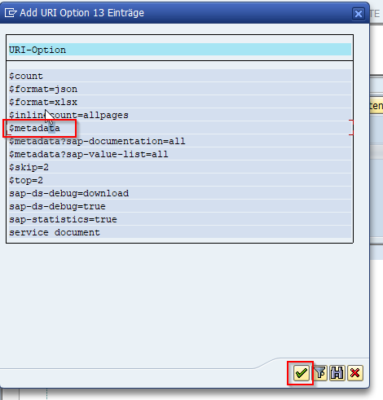

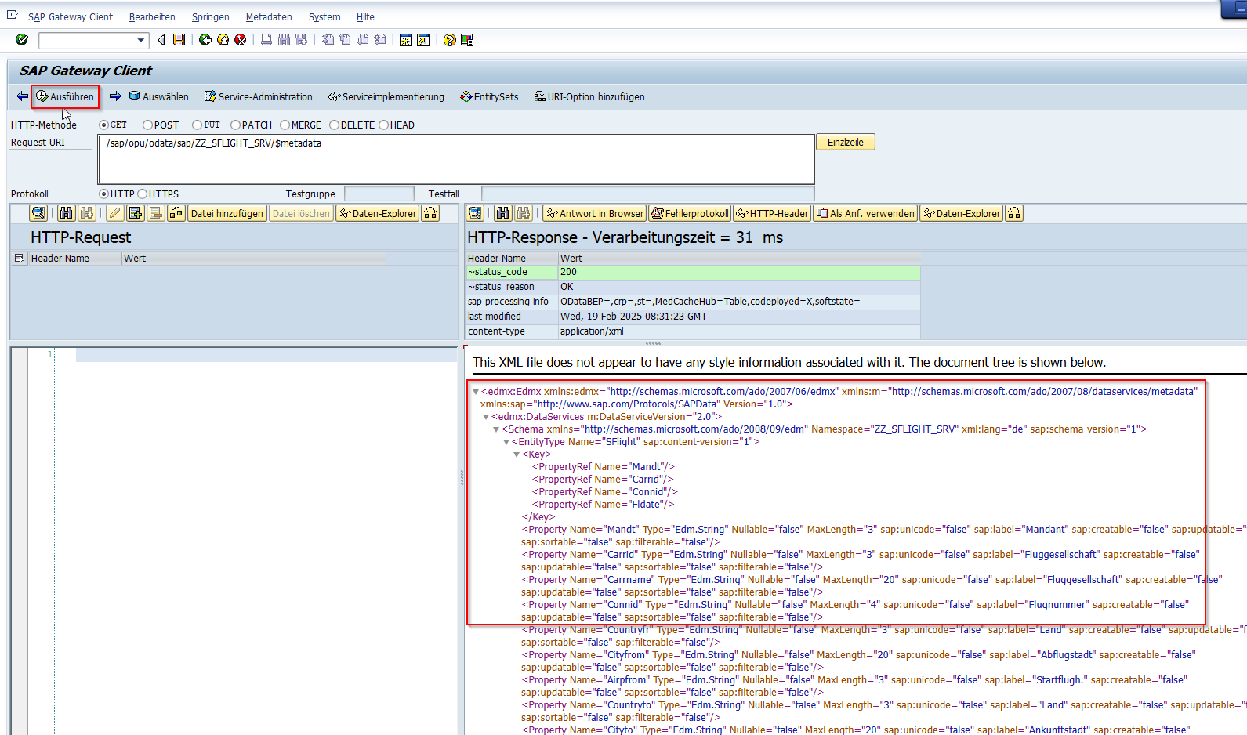

1. **Aufgabe 2**

method sflightset_get_entity.

loop at it_key_tab assigning field-symbol(<ls_keys>).

case <ls_keys>-name.

when 'Carrid'.

er_entity-carrid = conv s_carr_id( |{ conv s_carr_id( <ls_keys>-value ) alpha = in }| ).

when 'Connid'.

er_entity-connid = conv s_conn_id( |{ conv s_conn_id( <ls_keys>-value ) alpha = in }| ).

when 'Fldate'.

er_entity-fldate = conv s_date( |{ conv s_date( <ls_keys>-value ) }| ).

endcase.

endloop.

if er_entity-carrid is initial or er_entity-connid is initial or er_entity-fldate is initial.

"Schlüsselfelder leer - wird einfach ignoriert

return.

endif.

SELECT SINGLE * FROM sflight INTO @er_entity

WHERE carrid = @er_entity-carrid

AND fldate = @er_entity-fldate

AND connid = @er_entity-connid

.

endmethod.

method SFLIGHTSET_GET_ENTITYSET.

SELECT * FROM sflight INTO TABLE @DATA(lt_sflight).

.

IF sy-subrc <> 0.

ENDIF.

MOVE-CORRESPONDING lt_sflight TO ET_ENTITYSET.

endmethod.

  method sflightset_create_entity.

    io_data_provider->read_entry_data( importing es_data = er_entity ).

    if er_entity-carrid is initial or er_entity-connid is initial or er_entity-fldate is initial.

      "Schlüsselfelder leer - wird einfach ignoriert

      return.

    endif.

    SELECT SINGLE carrid

      FROM sflight

      INTO @DATA(lv_carrid)

      WHERE carrid = @er_entity-carrid

        AND fldate = @er_entity-fldate

        AND connid = @er_entity-connid.

    IF sy-subrc = 0.

      "Datensatz bereits vorhanden.

      MESSAGE e028(/gkv/rm90_ud) WITH lv_carrid INTO DATA(lv_dummy_msg).

      "/gkv/rm50_cl_odata_tools=>raise_error_message( CAST #( /iwbep/if_mgw_conv_srv_runtime~get_message_container( ) ) ).

      "raise exception

      RAISE EXCEPTION TYPE /iwbep/cx_mgw_busi_exception

        EXPORTING

          "http_status_code  = iv_http_status_code

          textid            = /iwbep/cx_mgw_tech_exception=>internal_error

          message_container = CAST #( /iwbep/if_mgw_conv_srv_runtime~get_message_container( ) ).

    ENDIF.

    "Mappen in Datenbank-Update-Struktur

    data(ls_db_update) = value sflight(          carrid      = er_entity-carrid

                                                 connid      = er_entity-connid

                                                 fldate     = er_entity-fldate

                                                 price      = er_entity-price

                                                 currency   = er_entity-currency

                                                 planetype  = er_entity-planetype

                                                 seatsmax   = er_entity-seatsmax

                                                 seatsocc   = er_entity-seatsocc

                                                 paymentsum = er_entity-paymentsum

                                                 seatsmax_b = er_entity-seatsmax_b

                                                 seatsocc_b = er_entity-seatsocc_b

                                                 seatsmax_f = er_entity-seatsmax_f

                                                 seatsocc_f = er_entity-seatsocc_f ).

    "Create

    try.

        modify sflight from ls_db_update.

      catch /iwbep/cx_mgw_busi_exception .

      catch /iwbep/cx_mgw_tech_exception .

    endtry.

  endmethod.

  method sflightset_update_entity.

    io_data_provider->read_entry_data( importing es_data = er_entity ).

    LOOP AT it_key_tab ASSIGNING FIELD-SYMBOL(<ls_keys>).

      CASE <ls_keys>-name.

        WHEN 'Carrid'.

          er_entity-carrid = CONV S_CARR_ID( |{ CONV S_CARR_ID( <ls_keys>-value ) ALPHA = IN }| ).

        WHEN 'Connid'.

          er_entity-connid = CONV S_CONN_ID( |{ CONV S_CONN_ID( <ls_keys>-value ) ALPHA = IN }| ).

        WHEN 'Fldate'.

          er_entity-fldate = CONV S_DATE( |{ CONV S_DATE( <ls_keys>-value ) }| ).

      ENDCASE.

    ENDLOOP.

    if er_entity-carrid is initial or er_entity-connid is initial or er_entity-fldate is initial.

      "Schlüsselfelder leer - wird einfach ignoriert

      return.

    endif.

    SELECT SINGLE carrid

      FROM sflight

      INTO @DATA(lv_carrid)

      WHERE carrid = @er_entity-carrid

        AND fldate = @er_entity-fldate

        AND connid = @er_entity-connid.

    IF sy-subrc <> 0.

      "Datensatz existiert nicht

      MESSAGE e028(/gkv/rm90_ud) WITH lv_carrid INTO DATA(lv_dummy_msg).

      "/gkv/rm50_cl_odata_tools=>raise_error_message( CAST #( /iwbep/if_mgw_conv_srv_runtime~get_message_container( ) ) ).

      "raise exception

      RAISE EXCEPTION TYPE /iwbep/cx_mgw_busi_exception

        EXPORTING

          "http_status_code  = iv_http_status_code

          textid            = /iwbep/cx_mgw_tech_exception=>internal_error

          message_container = CAST #( /iwbep/if_mgw_conv_srv_runtime~get_message_container( ) ).

    ENDIF.

    "Mappen in Datenbank-Update-Struktur

    data(ls_db_update) = value sflight(          carrid      = er_entity-carrid

                                                 connid      = er_entity-connid

                                                 fldate      = er_entity-fldate

                                                 price      = er_entity-price

                                                 currency   = er_entity-currency

                                                 planetype  = er_entity-planetype

                                                 seatsmax   = er_entity-seatsmax

                                                 seatsocc   = er_entity-seatsocc

                                                 paymentsum = er_entity-paymentsum

                                                 seatsmax_b = er_entity-seatsmax_b

                                                 seatsocc_b = er_entity-seatsocc_b

                                                 seatsmax_f = er_entity-seatsmax_f

                                                 seatsocc_f = er_entity-seatsocc_f ).

    "Update

    TRY.

    modify sflight from ls_db_update.

      CATCH /iwbep/cx_mgw_busi_exception .

      CATCH /iwbep/cx_mgw_tech_exception .

    ENDTRY.

  endmethod.

    method SFLIGHTSET_DELETE_ENTITY.

    LOOP AT it_key_tab ASSIGNING FIELD-SYMBOL(<ls_keys>).

      CASE <ls_keys>-name.

        WHEN 'Carrid'.

          DATA(lv_carrid) = CONV S_CARR_ID( |{ CONV S_CARR_ID( <ls_keys>-value ) ALPHA = IN }| ).

        WHEN 'Connid'.

          DATA(lv_connid) = CONV S_CONN_ID( |{ CONV S_CONN_ID( <ls_keys>-value ) ALPHA = IN }| ).

        WHEN 'Fldate'.

          DATA(lv_fldate) = CONV S_DATE( |{ CONV S_DATE( <ls_keys>-value ) }| ).

      ENDCASE.

    ENDLOOP.

    if lv_carrid is initial or lv_connid is initial or lv_fldate is initial.

      "Schlüsselfelder leer - wird einfach ignoriert

      return.

    endif.

    SELECT SINGLE carrid

      FROM sflight

      INTO @DATA(lv_carrid_exist)

      WHERE carrid = @lv_carrid

        AND fldate = @lv_fldate

        AND connid = @lv_connid.

    IF sy-subrc <> 0.

      "Datensatz existiert nicht

      MESSAGE e028(/gkv/rm90_ud) WITH lv_carrid_exist INTO DATA(lv_dummy_msg).

      "/gkv/rm50_cl_odata_tools=>raise_error_message( CAST #( /iwbep/if_mgw_conv_srv_runtime~get_message_container( ) ) ).

      "raise exception

      RAISE EXCEPTION TYPE /iwbep/cx_mgw_busi_exception

        EXPORTING

          "http_status_code  = iv_http_status_code

          textid            = /iwbep/cx_mgw_tech_exception=>internal_error

          message_container = CAST #( /iwbep/if_mgw_conv_srv_runtime~get_message_container( ) ).

    ENDIF.

    "Delete

    TRY.

      DELETE FROM sflight

      WHERE carrid = @lv_carrid

        AND fldate = @lv_fldate

        AND connid = @lv_connid.

      CATCH /iwbep/cx_mgw_busi_exception .

      CATCH /iwbep/cx_mgw_tech_exception .

    ENDTRY.

  endmethod.

1. **Aufgabe 3**
2. **Aufgabe 4 – 10 – Siehe Quellcode**