QUERIES FOR DB:

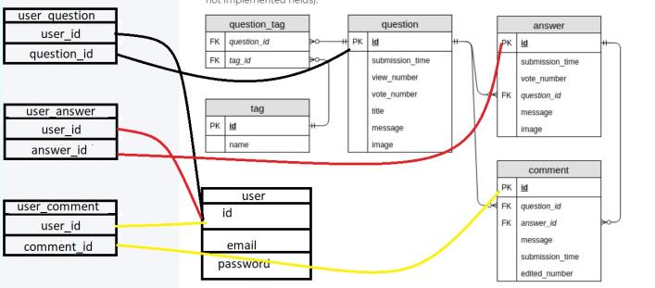

###########################################################################

CREATE TABLE users (

id serial NOT null,

login text,

password text,

registered timestamp NOT null );

CREATE TABLE user_question (

user_id integer,

question_id integer

);

CREATE TABLE user_answer (

user_id integer,

answer_id integer

);

CREATE TABLE user_comment (

user_id integer,

comment_id integer

);

*Add column into user_answer [added 02.01.2021]:*

ALTER TABLE user_answer

ADD answer_status text;

*Result:*

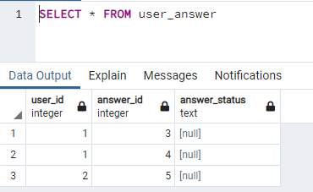

ALTER TABLE user_answer

ADD question_id integer

ALTER TABLE user_comment

ADD question_id integer