This file explains what I’ve done. This is the first design for the 3DGraphics Builder.

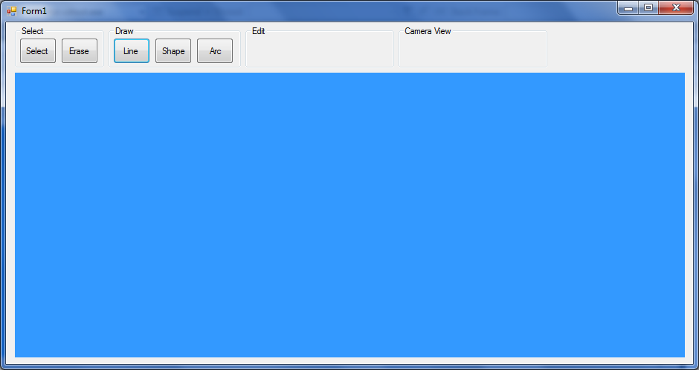

Here is a screen shot of an early stage of the 3D Graphics Editor.

It is very basic at this stage because it doesn’t have the 3D library implemented yet and only allows you to draw black lines.

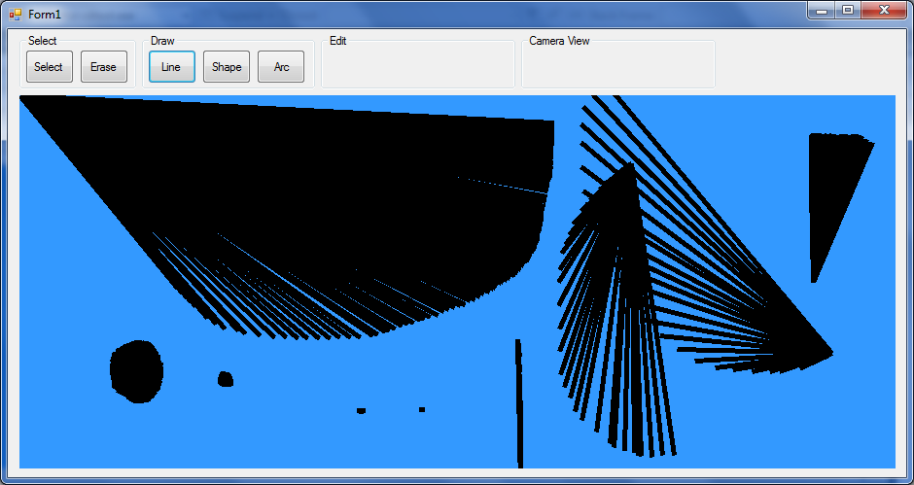When the mouse is clicked and the mouse is on canvas an event is triggered to draw a line. The line is drawn by calling and creating an instance of a ‘drawing’ class which I’ve written. A method then draws a line between two points.

I’ve added the 2D drawing libraries into my program.

Right now I trying to getting to know the 3D graphics library called under System.Windows.Media.Media3D.

Here is some of the code that I’ve written with the help of Visual Studio Express.

