|  |  |
| --- | --- |
| TravelConn | User  Manual |
| How to set up and use TravelConn? | For tourists’ office workers |

## TravelConn - User Manual (Extended)

This is a user manual designed for the set up and use of the application.

Welcome to TravelConn. This program was designed to calculate the quickest bus journey between two bus stops after a given time.

## Instilalisation from a CD disk

Insert the TravelConn CD disk into the disk drive. Copy and paste the files into a convient directory. Open setup file and the program will run automatically.

**Hardware and software configuration**

Here is a list of required hardware and software configuration:

* Windows XP or above
* 1 GB of RAM
* 1 MB of free hard disk space
* Monitor capable of at least 600x800 resolution
* .NET Runtime 4.5.1

## Main Window

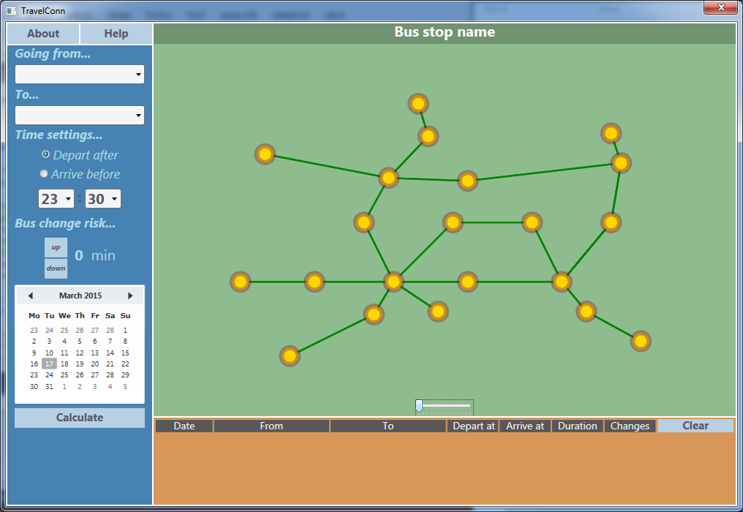

This is the Main Window from which you can navigate in the application.

## Basic Lay Out

The Main Window is made up of three main parts:

## Search Panel – Selecting your journey

– you specify all of the your journey details here.

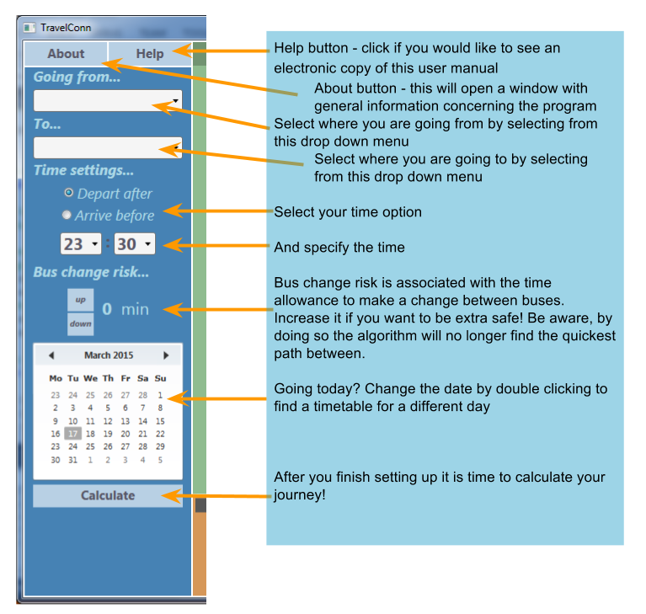

## C:\Users\Mateusz\Downloads\MapControl.pngMap

* Abstract graphical representation of the bus network

1. 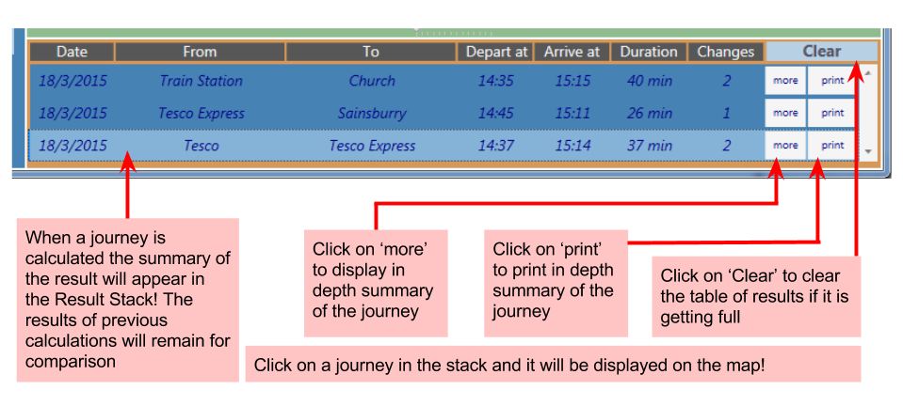**Result Stack – Viewing the results**

– where you see your results

**Printing**

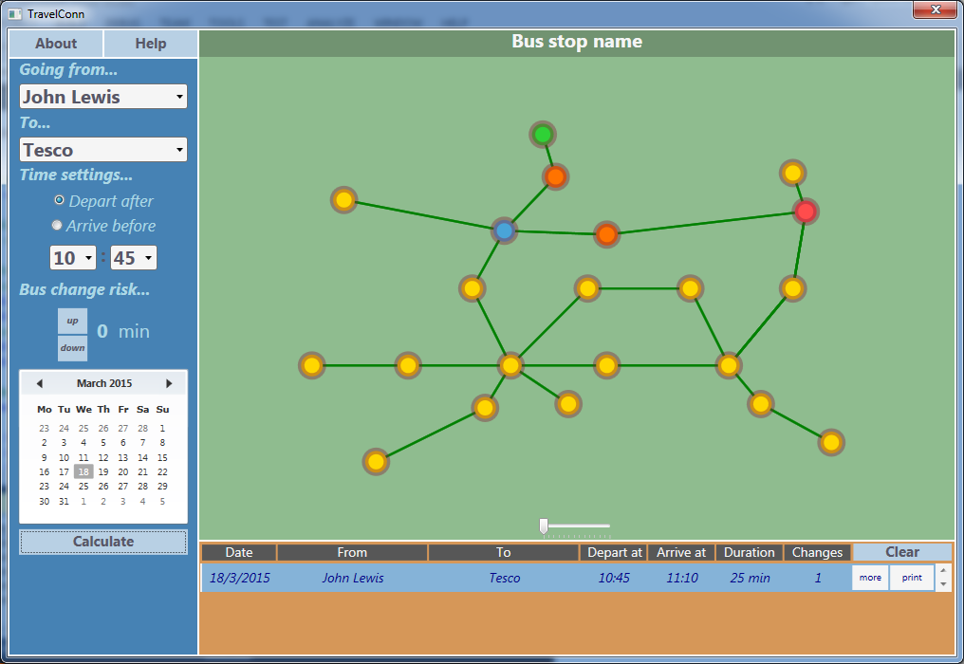You can print the result of a calculation by clicking the print button next to your bus journey result.

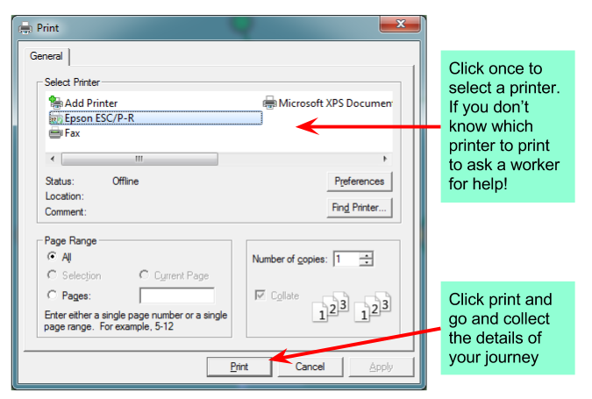

A print dialog will appear:

**Error Messeges**

There are several error messages that you can encounter.

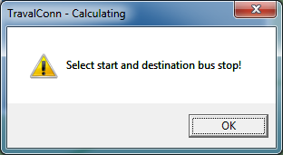You will encounter this error when if you didn’t set your start and destination bus stops. When this error comes up, click OK and select your bus stops either from the drop down menus or on the map.

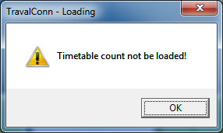You will encounter this error when the timetable file is broken and can not be loaded. To solve the problem deploy the appropriate timetable file again

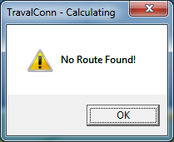You will enconter this error if the journey between the selected stops for the specified time does not exist.

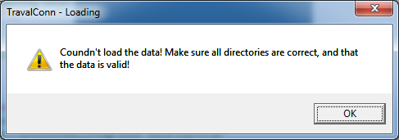This error message will come up if initially program failed to load the data from the source. This error message is not inclueded in the tourists manual. If you are having trouble loading any data, contact the developer.

Contact Details

Developer: Mateusz Ochal, Hillsroad Sixth Form College Student

Email: [mateusz.ochal8@gmail.com](mailto:mateusz.ochal8@gmail.com)

Phone: ++447445484212